**TIME BASED ATTENDANCE MANAGEMENT SYSTEM BASED ON FACE RECOGNITION**

**ABSTRACT:**

This paper introduces a Time-Based Attendance Management System that aims to streamline and modernize the traditional manual attendance tracking method, which is both time-consuming and challenging to maintain. The proposed system leverages advanced biometric technology, particularly Deep Learning (DL) based Face Recognition algorithms. Human faces serve as the primary dataset for training, employing the LBPH Face Recognizer. The user interface is developed through the Flask framework, providing a user-friendly web page. Notably, as an enhancement to this system, it offers the capability to store attendance data in a database, including timestamps. Furthermore, an innovative feature has been integrated to notify parents about attendance, marks, and behavior of their children using the Fast to SMS website. This enhancement not only enhances efficiency but also strengthens the communication between educational institutions and parents, fostering a more informed and engaged educational environment.

**Keywords**: Attendance Management, Computer Vision, Deep Learning, Human Face Images, sending SMS.

**STATEMENT ABOUT THE PROBLEM**

Traditional manual attendance management in educational institutions is time-consuming, error-prone, and challenging to maintain, adversely affecting class efficiency and data accuracy. This project addresses these issues by developing a Time-Based Attendance Management System that utilizes Deep Learning-based Face Recognition to automate attendance tracking accurately. The main challenge is creating a reliable facial recognition system capable of efficiently identifying and recording student attendance, which will be securely stored in a database. Additionally, the system will send automated messages to parents via the Fast to SMS website, enhancing communication between schools and parents to improve student management and engagement.

**SCOPE:**

The scope of this project encompasses the design and implementation of a Time-Based Attendance Management System for educational institutions. It involves the development of a robust Deep Learning-based Face Recognition system for automated and accurate attendance tracking. The system will store attendance data securely in a database for future analysis. Additionally, it will integrate a feature to send automated notifications to parents through the Fast to SMS website, providing real-time updates on attendance, marks, and behavior. This project aims to streamline attendance management, enhance communication, and contribute to efficient student monitoring and parental involvement in education.

**OBJECTIVE OF THE PROJECT:**

The objectives of this project can be summarized in five key points:

1. Develop a reliable and accurate Deep Learning-based Face Recognition system to automate the attendance tracking process in educational institutions.

2. Create a secure database infrastructure for storing attendance data, including timestamps and relevant student information.

3. Implement a user-friendly web-based interface using the Flask framework for easy access and management of attendance records.

4. Integrate a messaging feature through the Fast to SMS website to automatically notify parents about their children's attendance, marks, and behavior.

5. Enhance efficiency, reduce errors, and improve communication between educational institutions and parents, fostering a more informed and engaged educational environment.

**EXISTING SYSTEM**

The existing system for attendance management in educational institutions relies on manual methods, where educators manually mark and record students' attendance during each class. This manual process is time-consuming, prone to errors, and lacks real-time tracking capabilities. To address these challenges, our project introduces a modernized approach that leverages Face Recognition technology. By implementing Deep Learning-based Face Recognition, the system aims to automate the attendance tracking process. Students' faces are scanned, identified, and their attendance is recorded in real-time. This transition from the traditional manual system to automated Face Recognition offers a more efficient and accurate means of managing attendance, improving the overall educational experience.

**DISADVANTAGES**

Face recognition-based attendance tracking systems have disadvantages:

**1.Privacy Concerns:** These systems can raise privacy issues as they involve biometric data collection, which individuals may find invasive.

**2.Accuracy:** Accuracy may be compromised due to variations in lighting, facial expressions, or occlusions.

**3.Costly Implementation:** Setting up face recognition systems can be expensive due to the need for specialized hardware and software.

**4.Security Vulnerabilities:** Face recognition can be vulnerable to spoofing or hacking attempts.

**5.Ethical Concerns:** Concerns about consent and misuse of biometric data must be addressed.

**6.Dependency on Technology:** Technical failures or outages can disrupt attendance tracking.

**7.Cultural Sensitivity:** Different cultural norms may affect acceptance and usage.

**PROPOSED SYSTEM**

The proposed system aims to revolutionize attendance management in educational institutions by implementing Deep Learning-based Face Recognition for automated attendance tracking. This modernized approach eliminates the drawbacks of the manual system, offering efficiency and accuracy. Additionally, as an enhancement, the system will integrate with the Fast to SMS website, enabling automatic notifications to parents regarding their children's attendance, academic marks, and behavior. This feature fosters better communication between the institution and parents, enhancing parental involvement and ensuring that they stay informed about their child's educational progress. Overall, the proposed system combines cutting-edge technology with improved communication for a more efficient and engaged educational environment.

**ADVANTAGES**

Advantages of the Proposed Time-Based Attendance Management System:

1. Enhanced Accuracy: The Deep Learning-based Face Recognition system ensures precise attendance tracking, reducing the chances of errors in recording attendance data.

2. Real-time Monitoring: The system allows for real-time attendance updates, enabling educators to promptly address attendance-related issues and maintain class efficiency.

3. Improved Parental Engagement: Integration with the Fast to SMS website provides parents with timely notifications about attendance, marks, and behavior, fostering active parental involvement in their child's education.

4. Time Efficiency: Automation reduces the time spent on manual attendance-taking, allowing educators to allocate more time to instructional activities.

5. Data Security: The secure database infrastructure safeguards attendance records, ensuring the confidentiality and integrity of sensitive student data.

**FLOW**

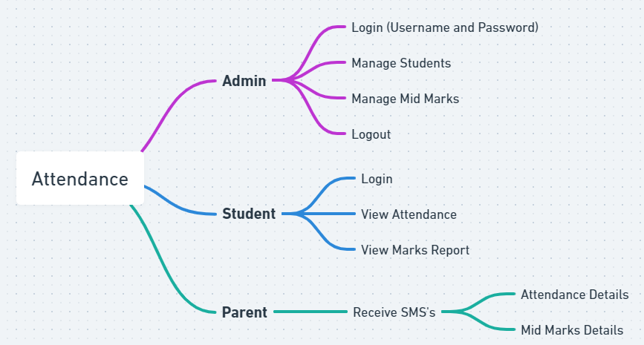

**SOFTWARE FRONT END REQUIREMENTS**

# H/W CONFIGURATION:

# Processor - I3/Intel Processor

Hard Disk - 160GB

Key Board - Standard Windows Keyboard

Mouse - Two or Three Button Mouse

Monitor - SVGA

RAM - 8GB

**S/W CONFIGURATION:**

* Operating System : Windows 7/8/10
* Server side Script : HTML, CSS, Bootstrap & JS
* Programming Language : Python
* Libraries : Flask, Pandas, Mysql.connector, Os, Smtplib, Numpy
* IDE/Workbench : PyCharm
* Technology : Python 3.6+

**MODULES/IMPLEMENTATION**

**Enter Data:**

* Add the details like Roll number and Name and parent mobile number.
* After entering the details click on the image capture button.

**Data Gathering:**

* After clicking the capture button the web cam will be opened for taking images and it captures 200 frames, after completion of taking images web cam will be automatically closed.

**Training:**

* All captured images are saved in a "Training image" folder. The LBPH (Local Binary Patterns Histograms) Face Recognizer_create() function is utilized to recognize facial features for training purposes.

**Testing and considering the attendance**

* Whenever a student made a click on the button provided, a web cam will gets opened.
* The web cam has ability to capture the image of the particular students face and then the image is converted into greyscale and it undergoes for scaling
* The scaled image is converted into the form of vectors with the help of LBPH Face Recognizer_create
* Now the converted data will be helpful to predict the outcomes.
* There are 4 conditions to collect the attendance
* 1. Before 10AM – Early come 2. After 10AM – Late
* 3. Before 4PM – Early out 4. After 4PM- Normal out
* After checking the conditions data will be stored in database. And system automatically send a SMS to student parents through mobile regarding timings of attendance.

**ADMIN**

* Admin will add the marks
* Here we will send an sms to parents about the Marks and Behaviour of student by using the Fast to SMS website as an enhancement.

**STUDENT**

**Take Attendance**

* Student attendance will be captured through web cam which was installed and will be capturing continuously.
* Once after recognizing face of a student data will be stored in server and it will send a sms to student parent.
* Here student can select the options like take attendance button then only system can access the attendance. After that system stores the information into MYSQL database.

**View Attendance**

* After entering the roll number student can view their attendance details.