**PSG COLLEGE OF TECHNOLOGY**

**EMBEDDED SYSTEMS LABORATORY**

**(15Z610)**

**CAR PARKING ASSISTANCE**



**DEPARTMENT OF COMPUTER SCIENCE AND ENGINEERING**

**S.HARI VISHNU(17Z319)**

**R.NANDAGOPAL(17Z331)**

**P.PAVITHRAN(17Z335)**

**CAR PARKING ASSISTANCE**

**INTRODUCTION:**

Cars play a major part of our day to day life. And wherever we travel parking the cars in the parking needs someone to assist us. Instead we can arrive at a solution of something better and cheaper so that we don’t need any person to assist us while parking using ARDUINO UNO.

**PROBLEM STATEMENT:**

Around 2.17 million passenger cars were sold in India 2017-2018. And wherever we travel by car we need a good parking facility. Now a days most places such as malls, theatres, colleges, schools , companies, etc have sufficient place for parking. But when we are in a hurry we need someone to assist us in parking the car in a heavily packed car parking. And we cannot always expect a person assisting us in parking cars. So we need an effective system that helps us avoid bumping into other cars, objects, and even children by detecting the distance between your vehicle and **rear** obstructions. So develop an effective and cheapest system for car parking assistance using ARDUINO UNO.

**COMPONENTS REQUIRED:**

* Arduino UNO
* IR Sensor
* Relay module
* Breaking motor
* LED strip
* Jumping wires
* Bread board
* Toy Car
* Power supply
* Servomotor
* Buzzer
* Ultrasonic sensor

**SCHEMATIC DIAGRAM:**

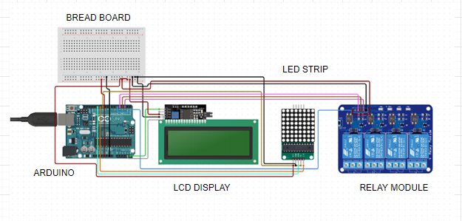**BLOCK DIAGRAM:**

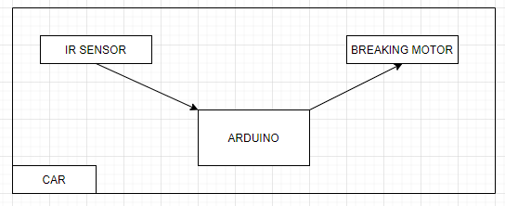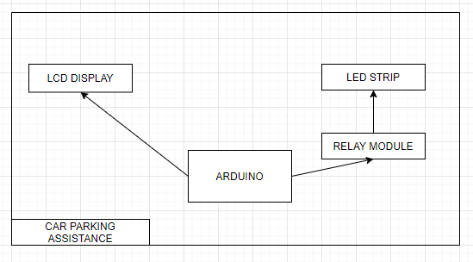

**CODE:**

#include <LiquidCrystal.h>

// defines pins numbers

const int tp = 9;

const int ep = 10;

const int led= 11;

const int bz = 12;

// defines variables

long duration;

int distance;

int safetyDistance;

LiquidCrystal lcd(1, 2, 4, 5, 6, 7);

void setup() {

lcd.begin(16,2);

pinMode(tp, OUTPUT); // Sets the tp as an Output

pinMode(ep, INPUT); // Sets the ep as an Input

pinMode(led, OUTPUT);

pinMode(bz, OUTPUT);

Serial.begin(9600); // Starts the serial communication

}

void loop() {

// Clears the tp

digitalWrite(tp, LOW);

delayMicroseconds(2);

// Sets the tp on HIGH state for 10 micro seconds

digitalWrite(tp, HIGH);

delayMicroseconds(10);

digitalWrite(tp, LOW);

// Reads the ep, returns the sound wave travel time in microseconds

duration = pulseIn(ep, HIGH);

// Calculating the distance

distance= duration*0.034/2;

safetyDistance = distance;

if (safetyDistance<10){

digitalWrite(led, HIGH);

digitalWrite(bz,HIGH);

digitalWrite(bz,HIGH);

digitalWrite(bz,HIGH);

}

else{

digitalWrite(led, LOW);

digitalWrite(bz,LOW);

}

lcd.setCursor(0,0); // Sets the location at which subsequent text written to the LCD will be displayed

lcd.print("Distance: "); // Prints string "Distance" on the LCD

lcd.print(distance); // Prints the distance value from the sensor

lcd.print(" cm");

delay(10);

// Prints the distance on the Serial Monitor

Serial.print("Distance: ");

Serial.println(distance);

}

**CHALLENGES FACED:**

* ULTRA SONIC SENSOR:

Distance has not been read correctly by the sensors.

Values of the pressure sensor changes with respect to the size of the car.

* COMBINING THE PROGRAMS:

Due to multiple sensors, the multiple readings from those sensors confuses the Arduino.

**CONTRIBUTION OF TEAM MEMBERS:**

We studied about the components used separately for a week then worked on the project together.

* DESIGN(CIRCUIT.IO) : Nandagopal , Hari Vishnu , Pavithran
* IMPLEMENTATION : Nandagopal , Hari Vishnu , Pavithran
* CODING : Nandagopal , Hari Vishnu , Pavithran
* DOCUMENTATION : Nandagopal , Hari Vishnu , Pavithran

**REFERENCES:**

1.https://www.arduinolibraries.info/categories/sensors

2. <https://www.electronicshub.org/arduino-car-reverse-parking-sensor/>

3.circuit.io