Date: 29-12-2025 à Day 2 – Querying & Modifying Data
Create Sample Insurance database named InsuranceDB with tables, constraints, and initial sample data. Based on following er diagram and descriptions.
Entities we’ll model:
- Customers – people who buy insurance
- Policies – insurance products (Health, Motor, Life)
- Agents – insurance agents
- PolicyAssignments – which customer bought which policy
- Claims – claims raised against policies
Relationship Explanation
- One Customer → Many PolicyAssignments
- One Policy → Many PolicyAssignments
- One Agent → Many PolicyAssignments
- One PolicyAssignment → Many Claims

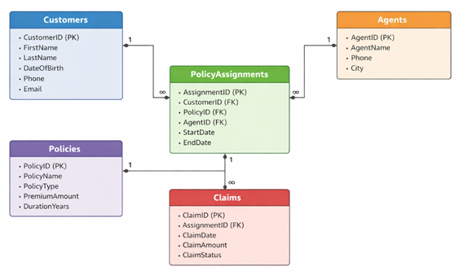
Submit following:
- Create Database command.
Query: create database insuranceDB;

- Create table commands for all the tables with constraints, relationships etc.
Query:

CREATE TABLE Customers (
CustomerID INT IDENTITY(1,1) PRIMARY KEY,
FirstName VARCHAR(50) NOT NULL,
LastName VARCHAR(50) NOT NULL,
DateOfBirth DATE NULL,
Phone VARCHAR(20) NULL,
Email VARCHAR(100) NULL
);

CREATE TABLE Policies (
PolicyID INT IDENTITY(1,1) PRIMARY KEY,
PolicyName VARCHAR(100) NOT NULL,
PolicyType VARCHAR(50) NOT NULL,
PremiumAmount DECIMAL(10,2) NOT NULL,
DurationYears INT NOT NULL
);

CREATE TABLE Agents (
AgentID INT IDENTITY(1,1) PRIMARY KEY,
AgentName VARCHAR(100) NOT NULL,
Phone VARCHAR(20) NULL,
City VARCHAR(50) NULL
);

CREATE TABLE PolicyAssignments (
AssignmentID INT IDENTITY(1,1) PRIMARY KEY,
CustomerID INT NOT NULL,
PolicyID INT NOT NULL,
AgentID INT NOT NULL,
StartDate DATE NOT NULL,
EndDate DATE NULL,

CONSTRAINT FK_PolicyAssignments_Customers
FOREIGN KEY (CustomerID) REFERENCES Customers(CustomerID),

CONSTRAINT FK_PolicyAssignments_Policies
FOREIGN KEY (PolicyID) REFERENCES Policies(PolicyID),

CONSTRAINT FK_PolicyAssignments_Agents
FOREIGN KEY (AgentID) REFERENCES Agents(AgentID)
);

CREATE TABLE Claims (
ClaimID INT IDENTITY(1,1) PRIMARY KEY,
AssignmentID INT NOT NULL,
ClaimDate DATE NOT NULL,
ClaimAmount DECIMAL(10,2) NOT NULL,
ClaimStatus VARCHAR(50) NOT NULL,

CONSTRAINT FK_Claims_PolicyAssignments
FOREIGN KEY (AssignmentID) REFERENCES PolicyAssignments(AssignmentID)
);

- Insert commands for all tables.

INSERT INTO Customers (FirstName, LastName, DateOfBirth, Phone, Email) VALUES
('Koushik', 'Reddy', '2004-03-12', '9876500011', 'koushik.reddy@gmail.com'),
('Rithvik', 'Sharma', '2004-07-25', '9876500012', 'rithvik.sharma@gmail.com'),
('Ganesh', 'Kumar', '2003-11-14', '9876500013', 'ganesh.kumar@gmail.com'),
('Mani', 'Teja', '2004-01-09', '9876500014', 'mani.teja@gmail.com'),
('Spoorthy', 'Priya', '2004-05-18', '9876500015', 'spoorthy.priya@gmail.com'),
('Sri', 'Nayani', '2004-09-02', '9876500016', 'sri.nayani@gmail.com'),
('Nanda Kishor','Gudala', '2004-08-20', '8688580131', 'nandakishorgudala@gmail.com'),
('Varshith', 'Rao', '2004-12-07', '9876500017', 'varshith.rao@gmail.com');

INSERT INTO Policies (PolicyName, PolicyType, PremiumAmount, DurationYears) VALUES
('Health Secure Basic', 'Health', 8000.00, 1),
('Health Secure Plus', 'Health', 15000.00, 1),
('Health Family Floater', 'Health', 22000.00, 2),

('Life Shield Term', 'Life', 12000.00, 1),
('Life Wealth Plan', 'Life', 30000.00, 5),

('Motor Protect TwoWheeler', 'Motor', 6000.00, 1),
('Motor Protect Car', 'Motor', 14000.00, 1),
('Motor Comprehensive', 'Motor', 25000.00, 3),

('Travel Safe', 'Travel', 5000.00, 1),
('Home Protect', 'Home', 18000.00, 2);

INSERT INTO Agents (AgentName, Phone, City) VALUES
('Ramesh', '9876500101', 'Hyderabad'),
('Bhoopendhar', '9876500102', 'Warangal'),
('Raju', '9876500103', 'Karimnagar'),
('Raghu', '9876500104', 'Vijayawada'),
('Ravi', '9876500105', 'Vizag'),
('Rajeev', '9876500106', 'Bangalore'),
('Rahul', '9876500107', 'Chennai'),
('Rakesh', '9876500108', 'Mumbai');

INSERT INTO PolicyAssignments (CustomerID, PolicyID, AgentID, StartDate, EndDate) VALUES
(1, 1, 1, '2024-01-10', '2025-01-09'),
(2, 2, 2, '2024-03-15', '2025-03-14'),
(3, 4, 3, '2023-07-01', '2024-06-30'),
(4, 6, 4, '2024-05-20', '2025-05-19'),
(5, 3, 5, '2024-09-05', NULL),
(6, 5, 6, '2022-12-12', '2027-12-11'),
(7, 2, 7, '2024-02-01', '2025-01-31'),
(8, 7, 8, '2024-08-18', '2025-08-17'),
(1, 8, 2, '2023-11-25', '2026-11-24'),
(4,1,1,'2024-12-01','2025-11-30');

INSERT INTO Claims (AssignmentID, ClaimDate, ClaimAmount, ClaimStatus) VALUES
(3, '2023-08-21', 18500.00, 'Approved'),
(1, '2024-04-14', 3200.00, 'Rejected'),
(6, '2024-09-03', 74250.00, 'Approved'),
(2, '2024-12-11', 9900.00, 'Pending'),
(5, '2024-10-26', 26800.00, 'Approved'),
(4, '2024-06-07', 4100.00, 'Approved'),
(7, '2024-02-19', 12500.00, 'Rejected'),
(2, '2024-07-29', 15600.00, 'Approved'),
(8, '2024-11-05', 5400.00, 'Rejected'),
(1, '2024-09-18', 8700.00, 'Approved'),
(6, '2023-12-22', 30000.00, 'Rejected'),
(5, '2025-01-12', 19500.00, 'Pending'),
(4, '2024-12-28', 10200.00, 'Rejected'),
(3, '2024-03-09', 6600.00, 'Pending');

4. Select commands
- View all records Customers table.
Query:

select * from customers;

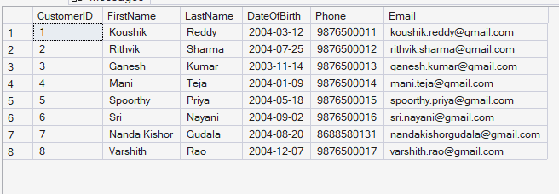

- View all records of PolicyAssignment table with CustomerId, PolicyId, StartDate and EndDate columns only.

Query:
SELECT CustomerID, PolicyID, StartDate, EndDate
FROM PolicyAssignments;

Output:
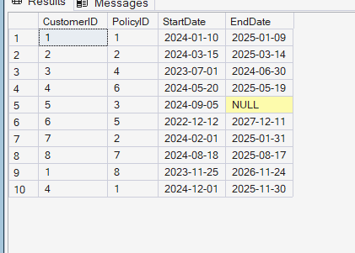

- Display all policies of Health type.
Query:
SELECT *
FROM Policies
WHERE PolicyType = 'Health';

Output:
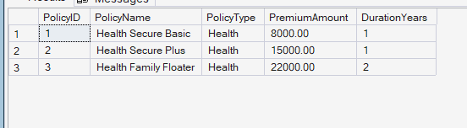

- Display policies having premium amount more than 10000 and DurationYears is 1.
Query:
SELECT * FROM Policies WHERE PremiumAmount > 10000 AND DurationYears = 1;
output:
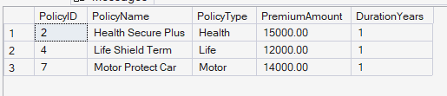

- Display unique city names from where agents belong to.
Query:
SELECT DISTINCT City FROM Agents;
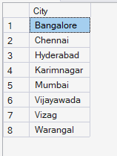

- List policies of type Life, Health, Motor use OR clause.
Query:
SELECT *
FROM Policies
WHERE PolicyType = 'Life'
OR PolicyType = 'Health'
OR PolicyType = 'Motor';Output:
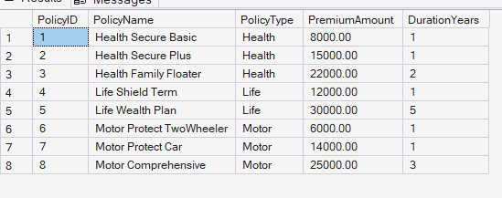

- List policies of type Life, Health, Motor use IN operator.
Query:
Query:
SELECT *
FROM Policies
WHERE PolicyType in ('Life','Health','Motor');

- Display list of customers born after January 1st, 2001 and before December 31st, 2020 using >= and <= operators.
Query:
SELECT *
FROM Customers
WHERE DateOfBirth >= '2001-01-01'
AND DateOfBirth <= '2020-12-31';

Output:
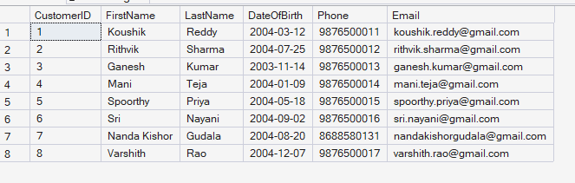

- Display list of customers born after January 1st, 2001 and before December 31st, 2020 using between operator.
Query:
SELECT *
FROM Customers
WHERE DateOfBirth BETWEEN '2001-01-01' AND '2020-12-31';

- Display claims data where claim status is Rejected.
Query:
SELECT *
FROM Claims
WHERE ClaimStatus = 'Rejected';
Output:
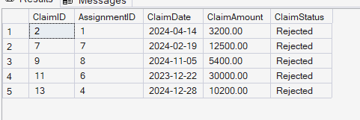
- Display records of Agents who stay in a city whose second letter is 'a'.
Query:
SELECT *
FROM Agents
WHERE City LIKE '_a%';
Output:
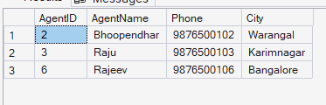

- Display highest and lowest claimAmount from Claims table.
Query:
SELECT
MAX(ClaimAmount) AS HighestClaimAmount,
MIN(ClaimAmount) AS LowestClaimAmount
FROM Claims;
Output:
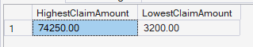

- Display latest claim record.
Query:
SELECT *
FROM Claims
ORDER BY ClaimDate DESC
OFFSET 0 ROWS FETCH NEXT 1 ROW ONLY;

Output:
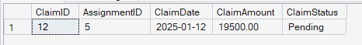

- Increase premium amount to 10% for all health insurance policies.
Query:

UPDATE Policies
SET PremiumAmount = PremiumAmount * 1.10
WHERE PolicyType = 'Health';
- Delete the record of PolicyAssignments whose EndDate is before today's date.
Query: DELETE FROM PolicyAssignments
WHERE EndDate < CAST(GETDATE() AS DATE);

Output:

- Display no of claims rejected.
Query:
SELECT COUNT(*) AS RejectedClaimsCount
FROM Claims
WHERE ClaimStatus = 'Rejected';

Output:
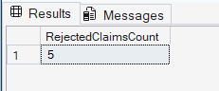

- Display PolicyId, PolicyName, PremiumAmount along with computed fields not in table à 6% LocalTaxes, PremiumAmountWithTax and MonthlyPremiumAmount considering PremiumAmount is Annual.
Query:
SELECT
PolicyID,
PolicyName,
PremiumAmount,
PremiumAmount * 0.06 AS LocalTaxes,
PremiumAmount + (PremiumAmount * 0.06) AS PremiumAmountWithTax,
(PremiumAmount + (PremiumAmount * 0.06)) / 12.0 AS MonthlyPremiumAmount
FROM Policies;
Output:
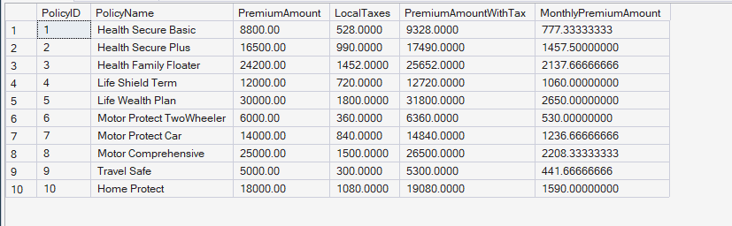

- Write a command to add Address and City Columns in the Customers table.
Query: ALTER TABLE Customers
ADD Address VARCHAR(100) NULL,
City VARCHAR(50) NULL;

- Write a command to add a new column named DevOfId (DevelopmentOfficerId) in an existing Agents table.
Query: ALTER TABLE Agents
ADD DevOfId INT NULL;

- Write command to make the above DevOfId as a recursive foreign key to AgentId as Parent.
Query:
ALTER TABLE Agents
ADD CONSTRAINT FK_Agents_DevOfId
FOREIGN KEY (DevOfId) REFERENCES Agents(AgentID);
5. Queries using Joins, Group By, Having etc.
- List all Policies for a CustomerId 5.
Query:
SELECT p.*
FROM PolicyAssignments pa
JOIN Policies p ON p.PolicyID = pa.PolicyID
WHERE pa.CustomerID = 5;

Output:
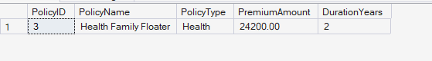

- View all customers with their policies.
Query:
SELECT
c.CustomerID, c.FirstName, c.LastName,
p.PolicyID,p.PolicyName,p.PolicyType, p.PremiumAmount,
pa.StartDate,pa.EndDate
FROM Customers c
JOIN PolicyAssignments pa ON pa.CustomerID = c.CustomerID
JOIN Policies p ON p.PolicyID = pa.PolicyID
ORDER BY c.CustomerID, p.PolicyID;

Output:
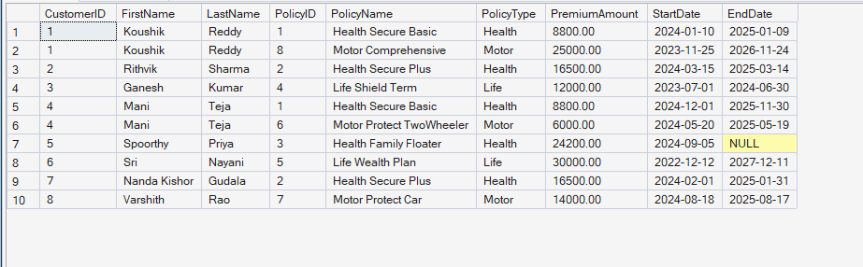

- View claims with customer name.
Query:
SELECT
c.CustomerID,
c.FirstName + ' ' + c.LastName AS CustomerName,
cl.ClaimID,
cl.ClaimDate,
cl.ClaimAmount,
cl.ClaimStatus
FROM Claims cl
JOIN PolicyAssignments pa ON pa.AssignmentID = cl.AssignmentID
JOIN Customers c ON c.CustomerID = pa.CustomerID
ORDER BY c.CustomerID, cl.ClaimDate DESC;

Ouput:
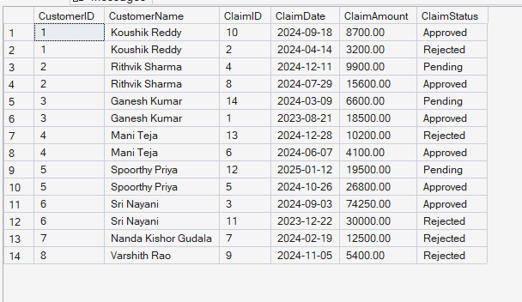

- Display FirstName, PolicyName, AgentName, StartDate and EndDate from their respective tables.
Query:
SELECT
c.FirstName,
p.PolicyName,
a.AgentName,
pa.StartDate,
pa.EndDate
FROM PolicyAssignments pa
JOIN Customers c ON c.CustomerID = pa.CustomerID
JOIN Policies p ON p.PolicyID = pa.PolicyID
JOIN Agents a ON a.AgentID = pa.AgentID;

Output:
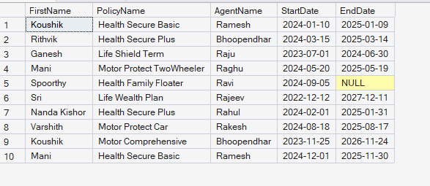

- Display claims report with FirstName, PolicyName, ClaimAmount, ClaimStatus, and ClaimDate from their respective tables.
Query:

SELECT
c.FirstName,
p.PolicyName,
cl.ClaimAmount,
cl.ClaimStatus,
cl.ClaimDate
FROM Claims cl
JOIN PolicyAssignments pa ON pa.AssignmentID = cl.AssignmentID
JOIN Customers c ON c.CustomerID = pa.CustomerID
JOIN Policies p ON p.PolicyID = pa.PolicyID
ORDER BY cl.ClaimDate DESC;

Output:
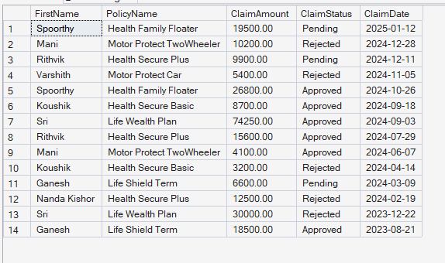

- Display records of Customers with or without Policies.
Query:
SELECT
c.CustomerID,
c.FirstName,
c.LastName,
p.PolicyID,
p.PolicyName,
pa.StartDate,
pa.EndDate
FROM Customers c
LEFT JOIN PolicyAssignments pa ON pa.CustomerID = c.CustomerID
LEFT JOIN Policies p ON p.PolicyID = pa.PolicyID

Output:
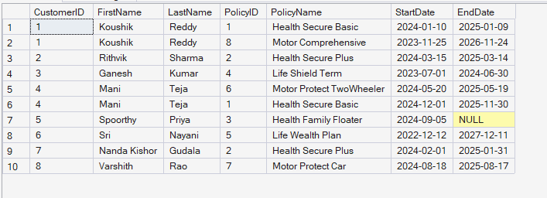

- Display all Customers with NO Claims.
Query:
SELECT c.CustomerID, c.FirstName, c.LastName
FROM Customers c
WHERE NOT EXISTS (
SELECT 1
FROM PolicyAssignments pa
JOIN Claims cl ON cl.AssignmentID = pa.AssignmentID
WHERE pa.CustomerID = c.CustomerID
);

Output:
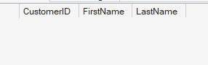
- Show CustomerName with Total Claim Amount per Customer.
Query:
SELECT
c.FirstName + ' ' + c.LastName AS CustomerName,
SUM(cl.ClaimAmount) AS TotalClaimAmount
FROM Customers c
JOIN PolicyAssignments pa ON pa.CustomerID = c.CustomerID
JOIN Claims cl ON cl.AssignmentID = pa.AssignmentID
GROUP BY c.FirstName, c.LastName
ORDER BY TotalClaimAmount DESC;

Output:
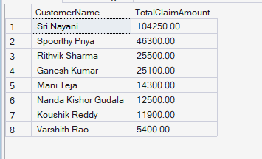

- Show names and total claim amount of Customers With Claim Amount > 50000 (Use HAVING Clause).
Query:
SELECT
c.FirstName + ' ' + c.LastName AS CustomerName,
SUM(cl.ClaimAmount) AS TotalClaimAmount
FROM Customers c
JOIN PolicyAssignments pa ON pa.CustomerID = c.CustomerID
JOIN Claims cl ON cl.AssignmentID = pa.AssignmentID
GROUP BY c.FirstName, c.LastName
HAVING SUM(cl.ClaimAmount) > 50000
ORDER BY TotalClaimAmount DESC;

Output:
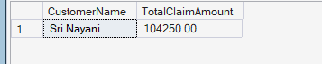

- Display list with Agent Wise Policy Count.
Query:
SELECT
a.AgentID,
a.AgentName,
COUNT(pa.AssignmentID) AS PolicyCount
FROM Agents a
LEFT JOIN PolicyAssignments pa ON pa.AgentID = a.AgentID
GROUP BY a.AgentID, a.AgentName
ORDER BY PolicyCount DESC;

Ouput:
