LockMe.com Project User Manual

v0

|  |  |  |  |
| --- | --- | --- | --- |
| Revision History | | | |
| Version no | Description | Author | Date of change |
| v0 | Initial version of LockMe.com project | Nandakumar R | 10 Aug 2021 |

# Introduction:

This user manual helps users to navigate through the application and check the functionalities available in it.

# Screen shots:

Main Menu:

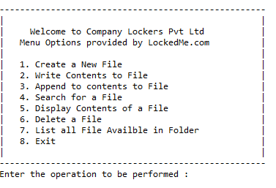

Users are prompted to enter the choice of option menu to perform the operations.

Create a New File Menu:

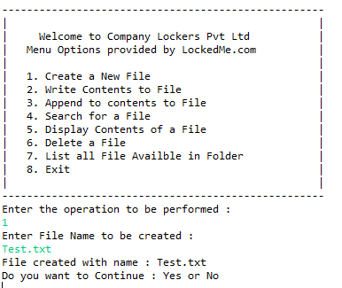

At end of each operation Users will be prompted to say whether to continue with application or not as in above image. If user inputs as “YES”, Main menu will continue and ask for users menu option as below

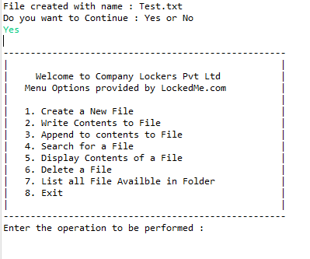

If user inputs “NO”, the application will exit the operation as shown below.

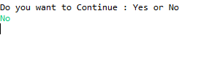

Write Contents to File:

When user input menu option “2”, application will delete the file entered.

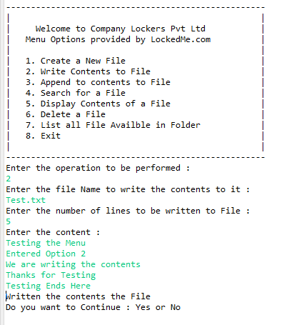



Append Contents to File:

When user input menu option “3”, application will delete the file entered.

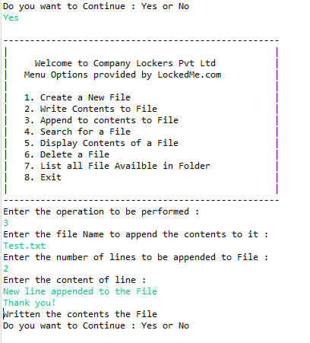



Search for a File:

User inputs the menu option “4” and application prompts user to input the file to be searched in the folder as shown below.

1. If file exists in the folder below result is shown.

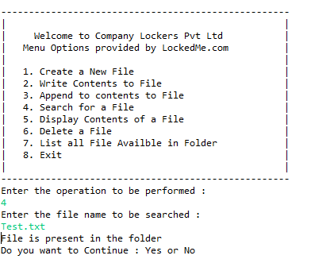



1. If file is not available in the folder below search result is shown to the user.

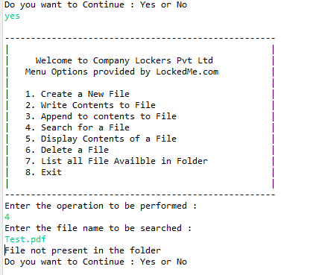



Display Contents of a File:

When user input menu option “5”, application will display the contents of the file entered.

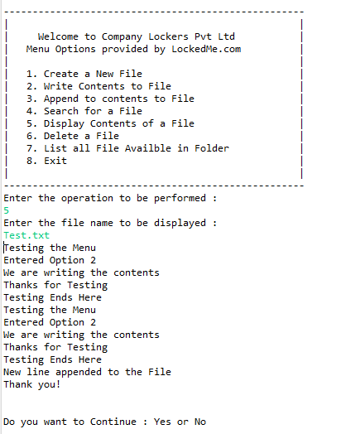

Delete a File:

When user input menu option “6”, application will delete the file entered.

1. Before deleting user can list the files available in folder to validate.

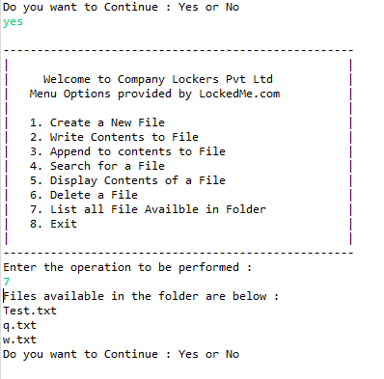



1. File is deleted as shown below

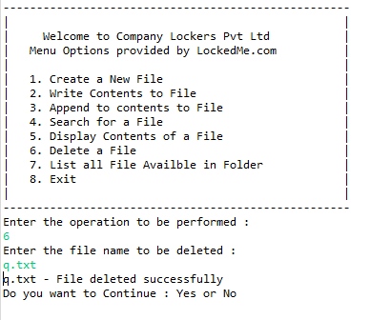



1. If user input an invalid file name t be deleted.

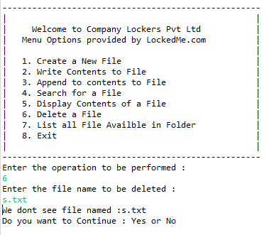



List all Files available in Folder:

If users select option “**7**”, this menu will display all the available files in folder in ascending order as shown below.

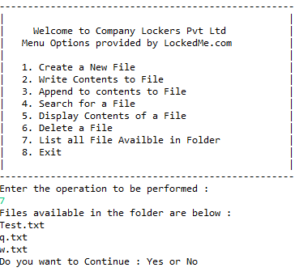

Exit:

When user input menu option “8”, application will exit the process of operations. This will not prompt user to continue the operations

