**Nandakumar R**

**727722EUEE067**

**727722EUEE067@skcet.ac.in**

**WEEK-1**

**DESIGN PATTERNS**

**Exercise 1: Implementing the Singleton Pattern**

**Scenario:**

You need to ensure that a logging utility class in your application has only one instance throughout the application lifecycle to ensure consistent logging.

**Steps:**

1. **Create a New Java Project:**
   * Create a new Java project named **SingletonPatternExample**.
2. **Define a Singleton Class:**
   * Create a class named Logger that has a private static instance of itself.
   * Ensure the constructor of Logger is private.
   * Provide a public static method to get the instance of the Logger class.
3. **Implement the Singleton Pattern:**
   * Write code to ensure that the Logger class follows the Singleton design pattern.
4. **Test the Singleton Implementation:**
   * Create a test class to verify that only one instance of Logger is created and used across the application.

**Solution:**

package singletonpatternexample;

/**

*

* @author nanda

*/

class ConfigurationManager {

private static ConfigurationManager instance;

private ConfigurationManager() {

System.out.println("ConfigurationManager instance created!");

}

public static ConfigurationManager getInstance() {

if (instance == null) {

instance = new ConfigurationManager();

}

return instance;

}

public void loadConfig(String configName) {

System.out.println("Loading configuration: " + configName);

}

}

public class SingletonPatternExample {

public static void main(String[] args) {

ConfigurationManager config1 = ConfigurationManager.getInstance();

config1.loadConfig("Database");

ConfigurationManager config2 = ConfigurationManager.getInstance();

config2.loadConfig("Authentication");

if (config1 == config2) {

System.out.println("config1 and config2 are the same instance");

} else {

System.out.println("config1 and config2 are NOT the same instance");

}

}

}

**Output:**

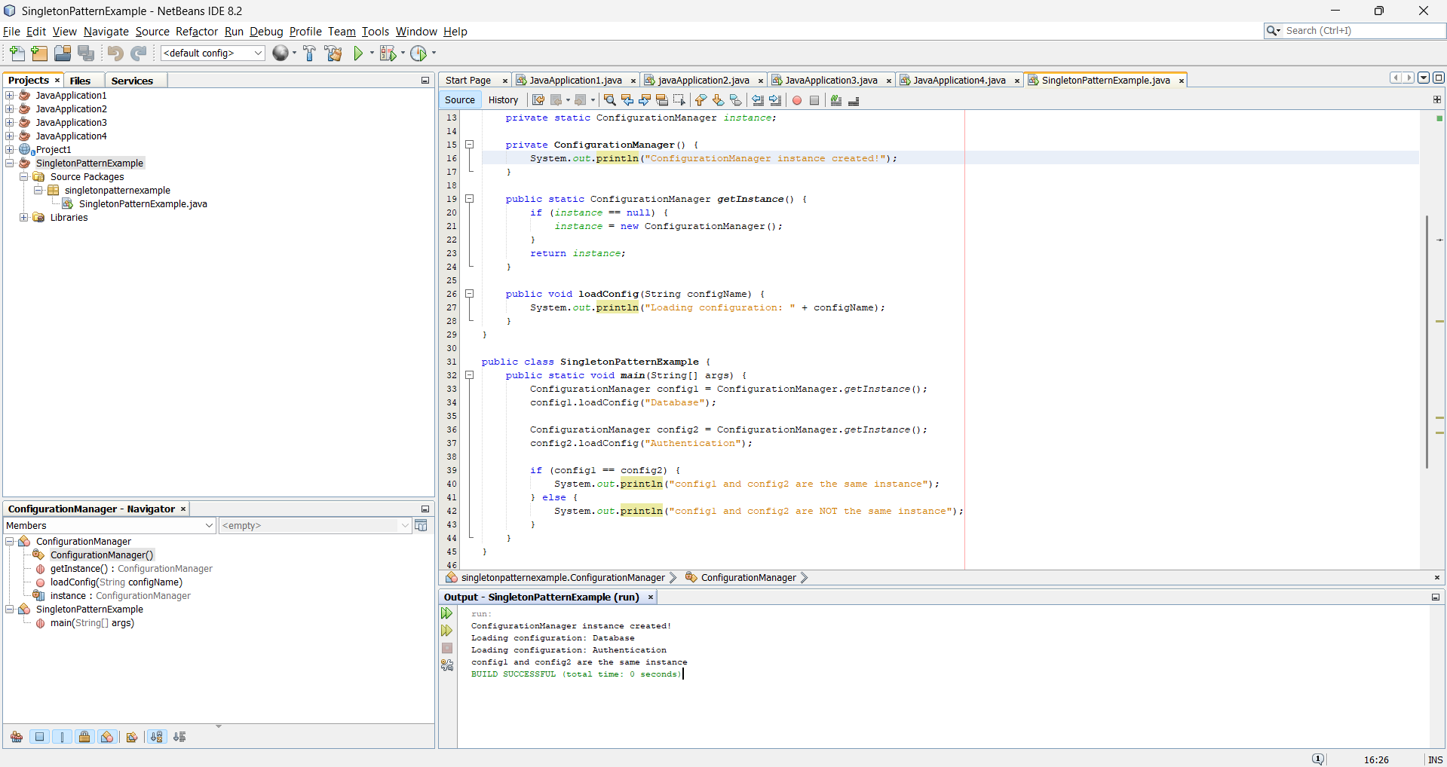

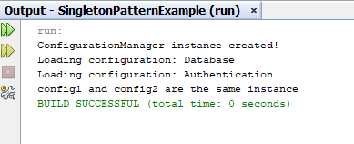

**Exercise 2: Implementing the Factory Method Pattern**

**Scenario:**

You are developing a document management system that needs to create different types of documents (e.g., Word, PDF, Excel). Use the Factory Method Pattern to achieve this.

**Steps:**

1. **Create a New Java Project:**
   * Create a new Java project named **FactoryMethodPatternExample**.
2. **Define Document Classes:**
   * Create interfaces or abstract classes for different document types such as **WordDocument**, **PdfDocument**, and **ExcelDocument**.
3. **Create Concrete Document Classes:**
   * Implement concrete classes for each document type that implements or extends the above interfaces or abstract classes.
4. **Implement the Factory Method:**
   * Create an abstract class **DocumentFactory** with a method **createDocument()**.
   * Create concrete factory classes for each document type that extends DocumentFactory and implements the **createDocument()** method.
5. **Test the Factory Method Implementation:**
   * Create a test class to demonstrate the creation of different document types using the factory method.

**Solution:**

package factorymethodpatternexample;

/**

** @author nanda

*/

interface Document {

void open();

}

class WordDocument implements Document {

public void open() {

System.out.println("Opening Word document...");

}

}

class PdfDocument implements Document {

public void open() {

System.out.println("Opening PDF document...");

}

}

class ExcelDocument implements Document {

public void open() {

System.out.println("Opening Excel document...");

}

}

abstract class DocumentFactory {

public abstract Document createDocument();

}

class WordDocumentFactory extends DocumentFactory {

public Document createDocument() {

return new WordDocument();

}

}

class PdfDocumentFactory extends DocumentFactory {

public Document createDocument() {

return new PdfDocument();

}

}

class ExcelDocumentFactory extends DocumentFactory {

public Document createDocument() {

return new ExcelDocument();

}

}

public class FactoryMethodPatternExample {

public static void main(String[] args) {

DocumentFactory wordFactory = new WordDocumentFactory();

Document wordDoc = wordFactory.createDocument();

wordDoc.open();

DocumentFactory pdfFactory = new PdfDocumentFactory();

Document pdfDoc = pdfFactory.createDocument();

pdfDoc.open();

DocumentFactory excelFactory = new ExcelDocumentFactory();

Document excelDoc = excelFactory.createDocument();

excelDoc.open();

}

}

**Output:**

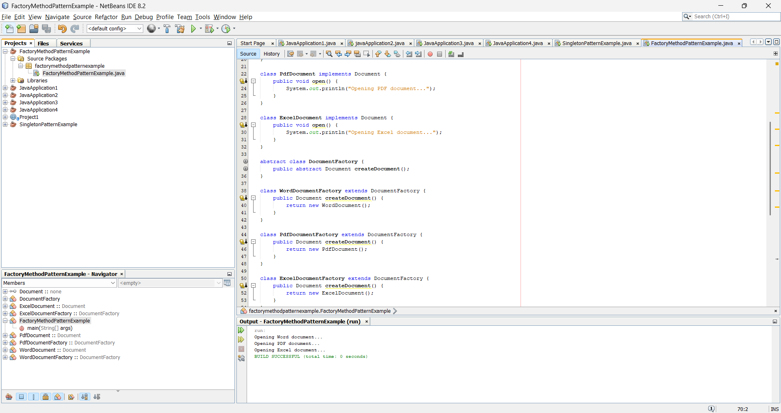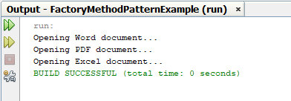

**DATA STRUCTURES AND ALGORITHMS**

**Exercise 2: E-commerce Platform Search Function**

**Scenario:**

You are working on the search functionality of an e-commerce platform. The search needs to be optimized for fast performance.

**Steps:**

1. **Understand Asymptotic Notation:**
   * Explain Big O notation and how it helps in analyzing algorithms.
   * Describe the best, average, and worst-case scenarios for search operations.
2. **Setup:**
   * Create a class **Product** with attributes for searching, such as **productId, productName**, and **category**.
3. **Implementation:**
   * Implement linear search and binary search algorithms.
   * Store products in an array for linear search and a sorted array for binary search.
4. **Analysis:**
   * Compare the time complexity of linear and binary search algorithms.
   * Discuss which algorithm is more suitable for your platform and why.

**Solution:**

package ecommercesearchexample;

/**

*

* @author nanda

*/

import java.util.Arrays;

import java.util.Comparator;

class Product {

int productId;

String productName;

String category;

Product(int productId, String productName, String category) {

this.productId = productId;

this.productName = productName;

this.category = category;

}

public String toString() {

return "Product ID: " + productId + ", Name: " + productName + ", Category: " + category;

}

}

public class EcommerceSearchExample {

public static Product linearSearch(Product[] products, String targetName) {

for (Product product : products) {

if (product.productName.equalsIgnoreCase(targetName)) {

return product;

}

}

return null;

}

public static Product binarySearch(Product[] products, String targetName) {

int low = 0;

int high = products.length - 1;

while (low <= high) {

int mid = (low + high) / 2;

int cmp = products[mid].productName.compareToIgnoreCase(targetName);

if (cmp == 0) return products[mid];

else if (cmp < 0) low = mid + 1;

else high = mid - 1;

}

return null;

}

public static void main(String[] args) {

Product[] products = {

new Product(101, "Laptop", "Electronics"),

new Product(102, "Shirt", "Clothing"),

new Product(103, "Mobile", "Electronics"),

new Product(104, "Shoes", "Footwear"),

new Product(105, "Watch", "Accessories")

};

System.out.println("🔍 Linear Search Result:");

Product result1 = linearSearch(products, "Mobile");

System.out.println(result1 != null ? result1 : "Product not found");

Arrays.sort(products, Comparator.comparing(p -> p.productName.toLowerCase()));

System.out.println("\n🔍 Binary Search Result:");

Product result2 = binarySearch(products, "Mobile");

System.out.println(result2 != null ? result2 : "Product not found");

}

}

**Output:**

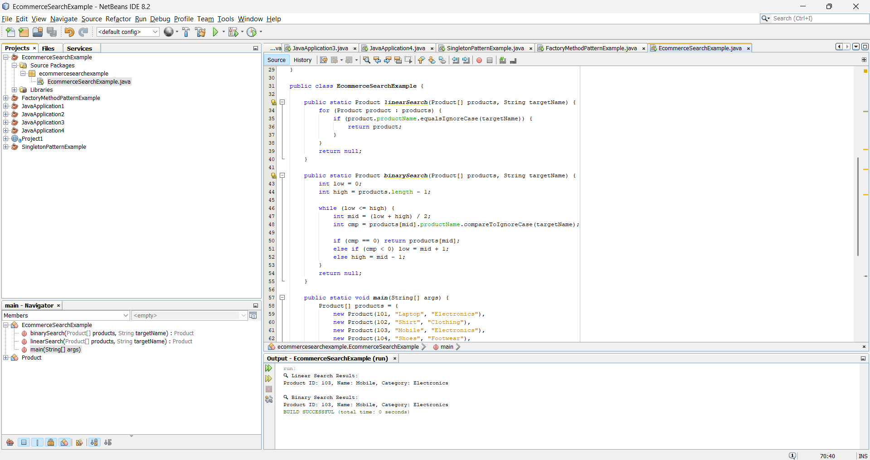

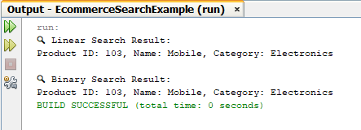

**Exercise 7: Financial Forecasting**

**Scenario:**

You are developing a financial forecasting tool that predicts future values based on past data.

**Steps:**

1. **Understand Recursive Algorithms:**
   * Explain the concept of recursion and how it can simplify certain problems.
2. **Setup:**
   * Create a method to calculate the future value using a recursive approach.
3. **Implementation:**
   * Implement a recursive algorithm to predict future values based on past growth rates.
4. **Analysis:**
   * Discuss the time complexity of your recursive algorithm.
   * Explain how to optimize the recursive solution to avoid excessive computation.

**Solution:**

package financialforecasting;

/**

*

* @author nanda

*/

public class FinancialForecasting {

// Step 2 & 3: Recursive function to calculate future value

public static double calculateFutureValue(double presentValue, double growthRate, int years) {

if (years == 0) {

return presentValue;

}

return calculateFutureValue(presentValue, growthRate, years - 1) * (1 + growthRate);

}

public static void main(String[] args) {

double presentValue = 10000; // Example: ₹10,000

double growthRate = 0.08; // 8% annual growth

int years = 5;

double futureValue = calculateFutureValue(presentValue, growthRate, years);

System.out.printf("Future value after %d years: Rs.%.2f\n", years, futureValue);

}

}

**Output:**

