Implementation Request for: | Payment Gateway Services (PGS)

Farm Name: | NGDC – PGS WS SSL Certificate Update  g4w1203.houston.hp.com  g4w1015.houston.hp.com  g4w1016.houston.hp.com

Type of Build: | MTT

Build date: | 01/06/2011 | Build Duration: | 1 hour
Environment: | ITG | DBA Required: | No

Functional Description

- This build document will provide instructions to renew SSL certificates for PGS WS.

Dependencies

- None.

Pre-Build Instructions (Required)

N/A

SSL – IIS

We start with IIS on g4w1203.houston.hp.com

Instructions

- Open server: g4w1203.houston.hp.com
- Open IIS Manager
- Stop the PGSWebSite only on g4w1203.houston.hp.com
- Open PGSWebSite Properties
- Change to Directory Security Tab

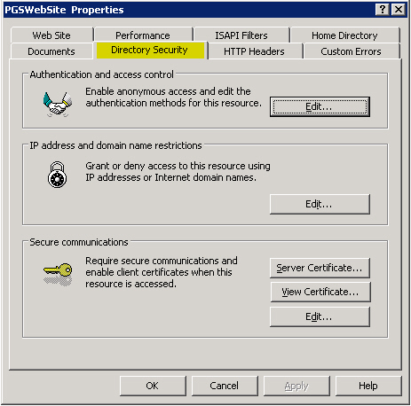

- Open Server Certificate

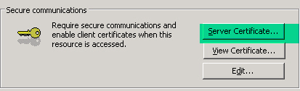
- On the Wizard. Click Next
- Select the option Remove the current certificate

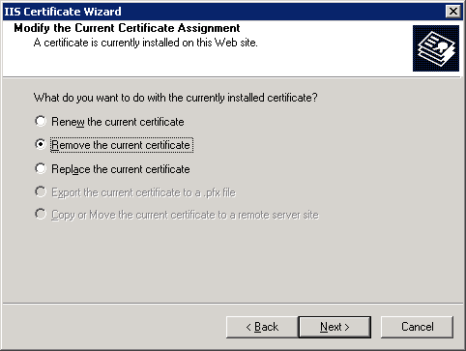
- Click through to remove the certificate
- Validate that the View Certificate Button is not available
- Select the option Create a new certificate

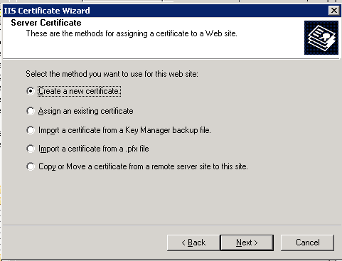
- Select the option Prepare the request now, but sent it later

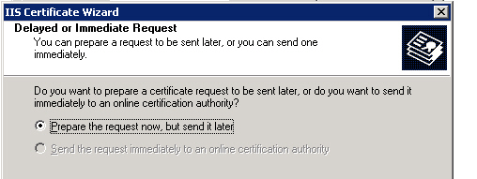
- Click Next
- Save the file as e:\vpgswsitgcert_2011.txt and click Next
- Information should be as below:

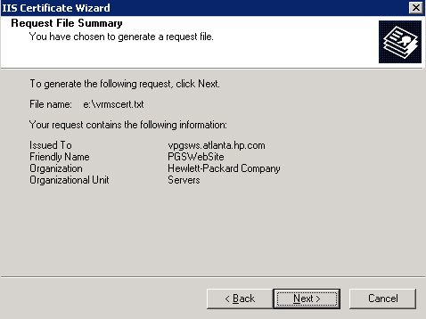
- Click next and Finish.

Now we go to Digitalbadge site.

- Browse to: https://g2t0066.austin.hp.com/hp/client/sslPrivateStart.php
- Accept agreement and begin enrollment
- On the following field, enter: team-pgs-rms-support@groups.hp.com
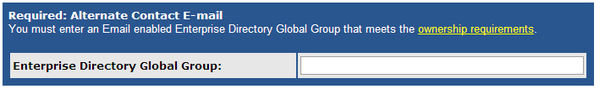
- Open the e:\vpgswsitgcert_2011.txt file created on previous step
- Paste the contents on the text area as shown:
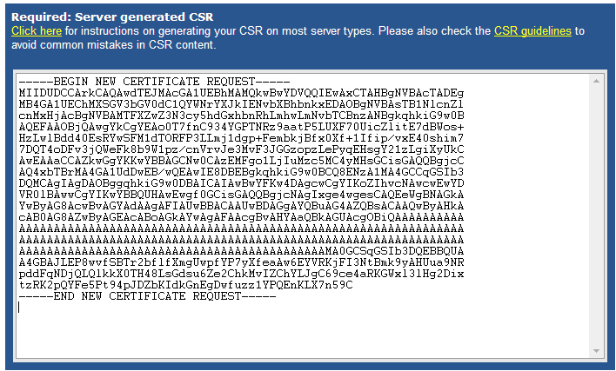
- Click to continue enrollment
- Continue with the creation of the certificate.
- You will receive an email from PKI with the new certificate.

Continue on IIS on g4w1203.houston.hp.com

- Copy/Paste the text from the digital badge renewal site into a Notepad file.
- Save the file to e:\vpgswsitgcert_2011.cer
- Open the saved file to ensure there are no issues with the certificate
- Go to Server Certificate
- Select as shown below and click next

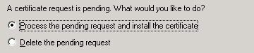
- Select the certificate file (e:\vpgswsitgcert_2011.cer)

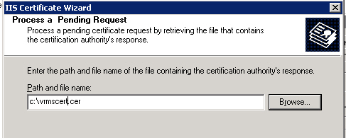
- Click Next and finish the process.
- Start the PGSWebSite

Now we move the new certificate to the other servers.

- Open again the Server Certificate
- Select Export the current certificate to a pfx file and click next
- Change to the E: Drive. Default Name is ok.
- On the password prompt, type: pgswsitgcert2011
- Confirm password
- Click next and finish the process

Now we import the certificate to the other servers in the farm.

- Log onto the web servers and perform the steps
  - g4w1015.houston.hp.com
  - g4w1016.houston.hp.com
- Copy the pfx file from g4w1203.houston.hp.com to the E: Drive
- Open up IIS admin console
- Select Properties of the PGSWebSite
- Click “Server Certificate” Button to open up the Web Server Certificate Wizard
- Select Remove the current certificate
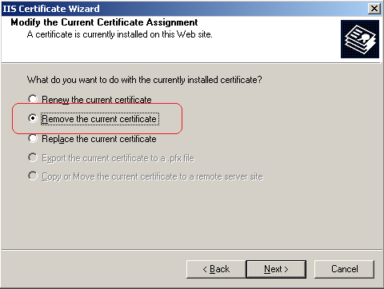
- Follow the instruction on the screen to remove the cert.
- Import the new .pfx file
  - Go back to step 1 to initial the Web Server Certificate Wizard
  - Select Import a certificate from .pfx file 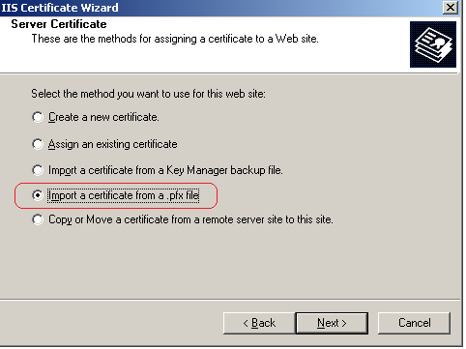
  - Browse to the right path for .pfx file 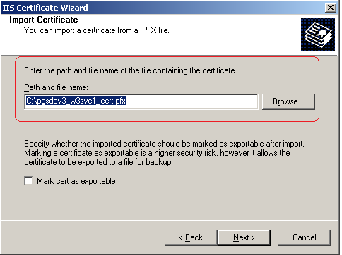
  - Follow the screen instruction
  - Input the password you used to export the cert to the .pfx file from the primary server - pgswsitgcert2011
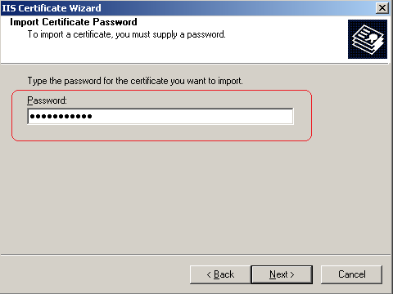
  - Select the port # for https 443. 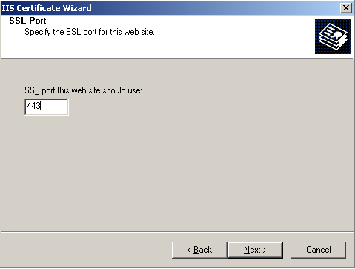
  - Follow the screen instruction to finish the import.
  - Repeat steps for additional servers.

Validation

To validate the new imported cert. Just follow the step 1, but click “View Certificate”

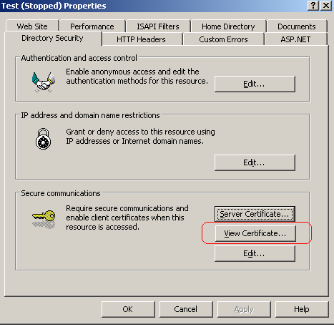

Rollback Instructions:

- No rollback is available as the previous license is expired.

