Software Requirements Specification

For

Student Management System

Version 1.0

Prepared by

Group Name: Enigma

|  |  |  |  |  |  |
| --- | --- | --- | --- | --- | --- |
| Nipuna Niranjana | 952441442V | Niranjana21283@gmail.com |  | 077541790 |  |
| Danushka Nandalochana | <student #> | <e-mail> |  | <TP> |  |
| <name> | <student #> | <e-mail> |  | <TP> |  |
| <name> | <student #> | <e-mail> |  | <TP> |  |
| <name> | <student #> | <e-mail> |  | <TP> |  |

|  |  |
| --- | --- |
| Instructor: | Mr. Lashan Chandika |
| Course: | Software Project |
| Batch: | 14 |
| Teaching Assistant: | Mr. Kasun Shamentha |
| Date: | 19th April 2017 |

Contents

1. Introduction 3

Document Purpose 3

Product Scope 3

Definitions, Acronyms and Abbreviations 3

References and Acknowledgments 3

2. Overall Description 4

Software Perspective 4

Users and Characteristics 4

Operating Environment <Optional> 4

Design and Implementation Constraints <Optional> 5

User Documentation <Optional> 6

Assumptions and Dependencies <Optional> 6

3. Specific Requirements 7

External Interface Requirements 7

Functional Requirements 23

Behaviour Requirements 24

4. Other Non-functional Requirements 25

Performance Requirements 25

Safety and Security Requirements 25

Appendix A - Group Log 25

# Introduction

The Student Managements System Designed by team Enigma can handle and compute all the details about a Student, the details which includes Institute details, Course details, Personal Details of the Student and Academic related details. The Student Management System is designed to automate the Manual Version of Student Management System which is generally used in Institute such as Mass Classes, Tuition Classes and other related institutes.

## Document Purpose

This Software Requirement Specification Document consist of Complete Information of the Offline (Localhost) Student Management System. This document provides the information needed for software support. New reliable, accurate and fast school management software with real time customer support. This software will help you with your daily struggle to maintain documents and processes of your institute. This is your solution to transfer from paperwork to electronic data.

## Product Scope

This Student Management System is developed for the basic and general purposes and to replace the manual paperwork done in Student Management. Student Management System can be updated with the existing paper database of students. Through this software, the user will be able to manage the institute broadcasting messages, Add new Branches, Manage the Events in a Real timed calendar, Schedule classes for individual students, Manage Examinations, Manage Couse content, Add/ Edit /Update / Delete Student Details, Add/ Edit /Update / Delete Users, Manage User access, Add/ Edit /Update / Delete Teacher Information, Check Attendance of Every user, student, teacher and Finally Manage the cash flow of the institute.

## Definitions, Acronyms and Abbreviations

S.M.S – Student Management System

S.I.M – Student Information System

J.D.K – Java Development Kit

## References and Acknowledgments

<Properly specify any other books, documents, or websites to which this SRS refers. These may include a vision document, scope document, standards, user interface style guides, contracts, system requirements specifications, or use case documents.

# Overall Description

## Software Perspective

The proposed Student Management System will be developed according to the basic requirements of a Student Managing Institute. This Software will be compatible with Microsoft Windows operating System. The Front end of the System will be developed using NetBeans 8.2 (JDK 1.8) and the backend database will be managed using MySQL server edition 5.0.6

Insert Windows 10, MySQL and NetBeans images here

## Users and Characteristics

**Student** – Student can view only limited sections of the Software such as Attendance, Profile and Reports

only. Student cannot make any changes to the system data at any circumstance.

**User**

**Admin** – Admin has all the privileges to access/ modify or remove data from the system

**Inputter** – Inputter can only input validated data through the system under the supervision of Admin.

All the changes made to the system data will be recorded with the relevant inputter ID

**Accountant** – Accountant can only manage the Financial Section of the system. Financial System of

the student management system is developed under the guidance of Financial Forensics.

**Teacher** – Teacher has access to students’ academic related processes within the system. This user can

amend the details regarding Reports and Marksheets of the relevant students.

**Characteristics**

Qualifications: Basic knowledge of English language.

Experience: Should be well educated about the Student management system and the processes of

the system

Technical Experience – Basic knowledge of computer handling.

## Operating Environment <Optional>

**Hardware Components**



**Software Components**

* Windows Operating System – Windows 7 or Later
* MySQL Server – MySQL Server Edition 5.0.6 or Higher
* J.D.K – Java Development Kit 1.8 or Higher
* Net Framework – Net Framework Version 3.0 or Higher

## 

## Design and Implementation Constraints <Optional>

No Hardware Limitations for this system.

(Required specifications of the Hardware mentioned in the Operating Environment 🡪 Hardware Components cannot be lowered).

Software Limitations

**Manage Institute** –

Broadcasting Messages – Messages can be broadcasted only after Login. All the messages

are visible to Admins and other related parties of the system.

Institute – Once new institute is introduced to the system, it will be replaced as the Default

institute of Institute of the system.

Calendar – Events are visible only for the current month.

Class Schedule – User must have a clear idea about class scheduling without any

contradictions. Inputter errors cannot be corrected using automated system

once updated.

Course content – Subjects can be defined once Streams are updated with the system.

**Students – No known limitations in Registering / Updating / Deleting / Searching Students.**

**Users - No known limitations in Registering / Updating / Deleting / Searching Users.**

**Attendance – Student / User / Teacher ID must be located before checking for attendance.**

**Settings – Only visible to Admins**

**Financial Tools – Only visible to Admins and Accountants. All the changes made to system in**

**This interfaces are recorded with IDs and can be viewed by both parties.**

**Constraints**

* + Only one administrator will be assigned to the system
  + Deleting system information can be carried out using Admin ID Only. Admin must be responsible for every action he performed in modifying the system info.

## User Documentation <Optional>

**Real-time customer support will be provided for this software.**

**Software Interface Guidance**

**Main Interfaces**

**Home –** Guide to Main Tabs

**Manage Institute -** Components of the Institute Managements tool

**Students –** Manage Student Details

**Users –** Manage User and Teacher Details

**Attendance –** Mark and view the Attendance of the Students, Users and Teachers

**Settings –** Visibility of the relevant user interfaces

**Financial Tools –** Manage the cash flow of the institute.

**Sub Interfaces**

**Manage Institute**

**Messages -**  Broadcasting messages will be visible in this interface.

**Institute –** Institutes can be added/deleted/searched in this interface

**Calendar –** Scheduled classes will be displayed in this interface.

**Class Schedule –** New Classes can be scheduled in this interface.

**Examinations -**  Examinations can be scheduled and viewed in this interface.

**Course Content –** New Streams and Subjects can be defined and added into system.

**Students**

**Student Information –** Students can be searched using IDs

**Student Registration –** New Students can be registered into system

**Student Re-Enroll –** Pre-registered student details can be modified

**Student Report –** Reports related to students are visible here

**Users**

**Staff Information –** Staff member details can be viewed using Staff ID

**Add New Staff –** New Staff members can be added to system

**Edit / Delete Staff -**Modify staff member details

**Add New Teacher –** Add new Teacher details to system.

**View Teachers –** List of institute teachers can be viewed.

**Attendance**

**Settings**

**Financial Tools**

**Student Payment –** Student Monthly payments are managed in this interface

**Student Due Payment –** Due-payments prior to the current month are added here

**Staff Payment –** Staff member payments are issued in this section.

## Assumptions and Dependencies <Optional>

<List any assumptions that could have an impact on the requirements specified in the SRS. These generally include third-party and commercial components as well as issues pertaining to the development or operating environment. In addition to this, identify any dependencies the project has on external factors, including software components that will be reused from another project.

Provide a brief list or outline of the key assumptions that would have an influential impact on the system design.>

# Specific Requirements

## External Interface Requirements

### **User Interfaces**

### 

### **Hardware Interfaces**

No hardware interfaces required for this system.

### **Software Interfaces**

All the interfaces come under this section

**Main Interface – Home Page**

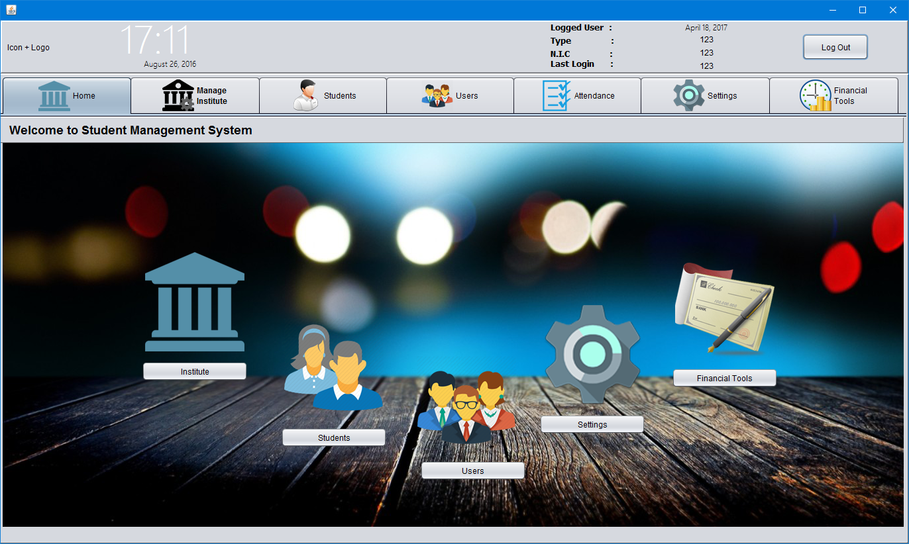

**Home Page 🡪 Manage Institute**

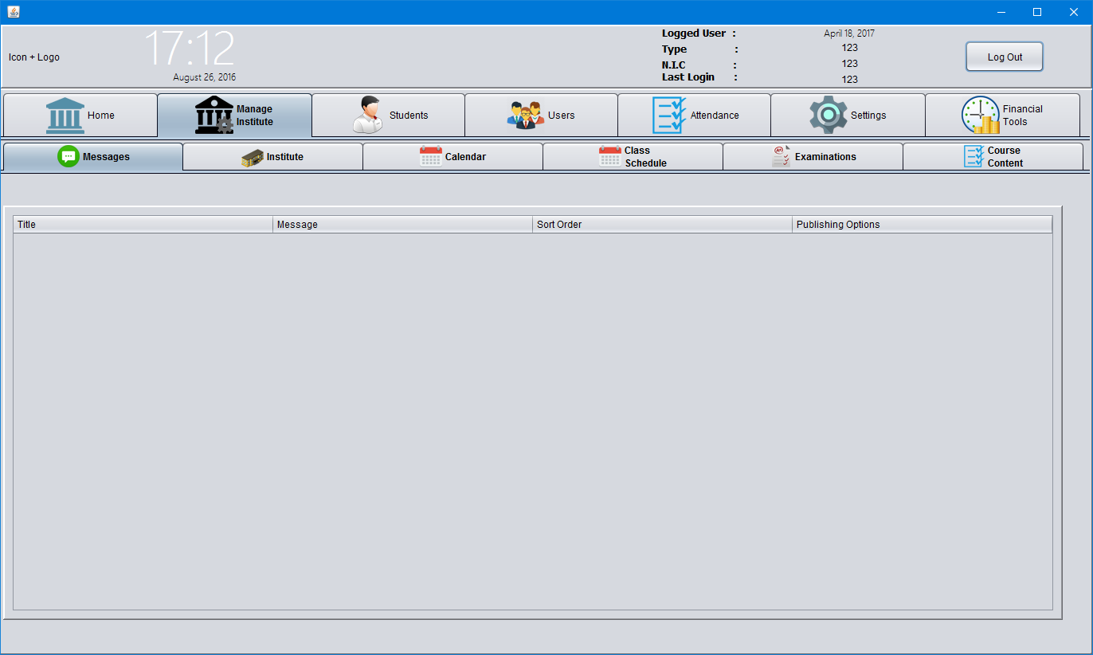

**Manage Institute 🡪 Institute 🡪 Institute Messages**

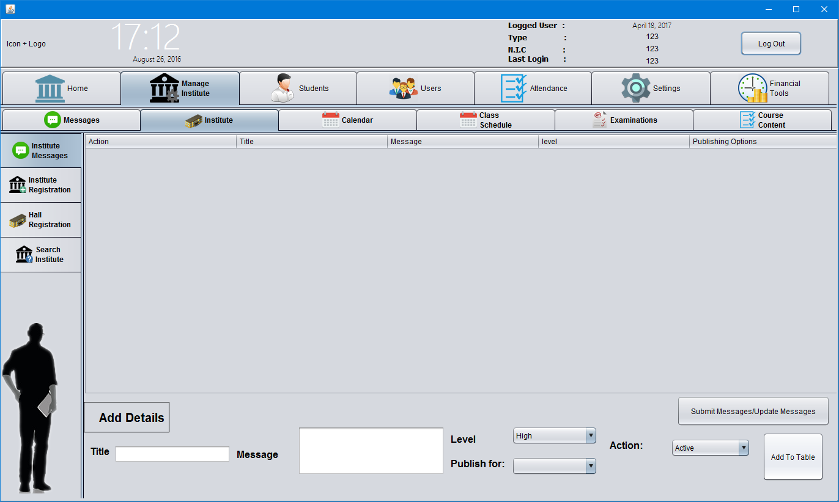

**Manage Institute 🡪 Institute 🡪 Institute Registration**

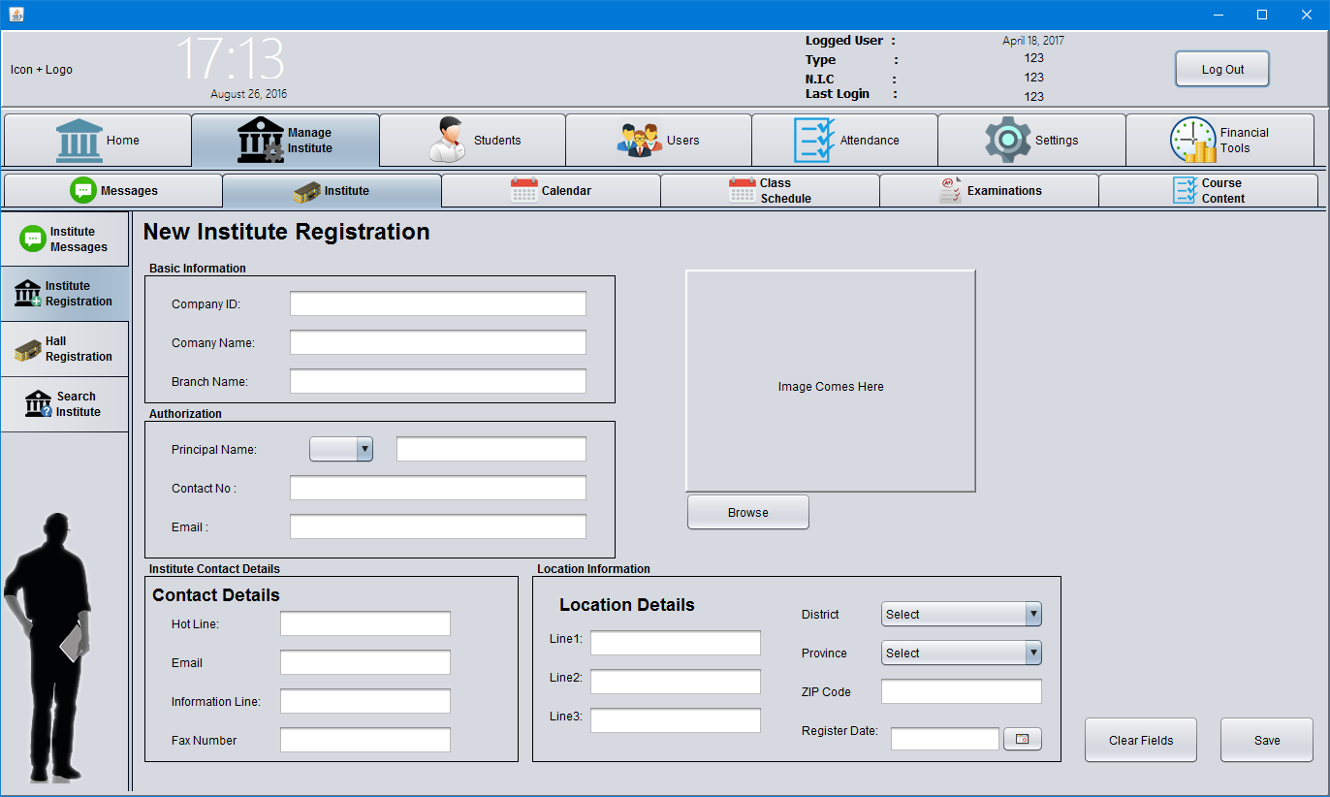

**Manage Institute 🡪 Institute 🡪 Hall Registration**

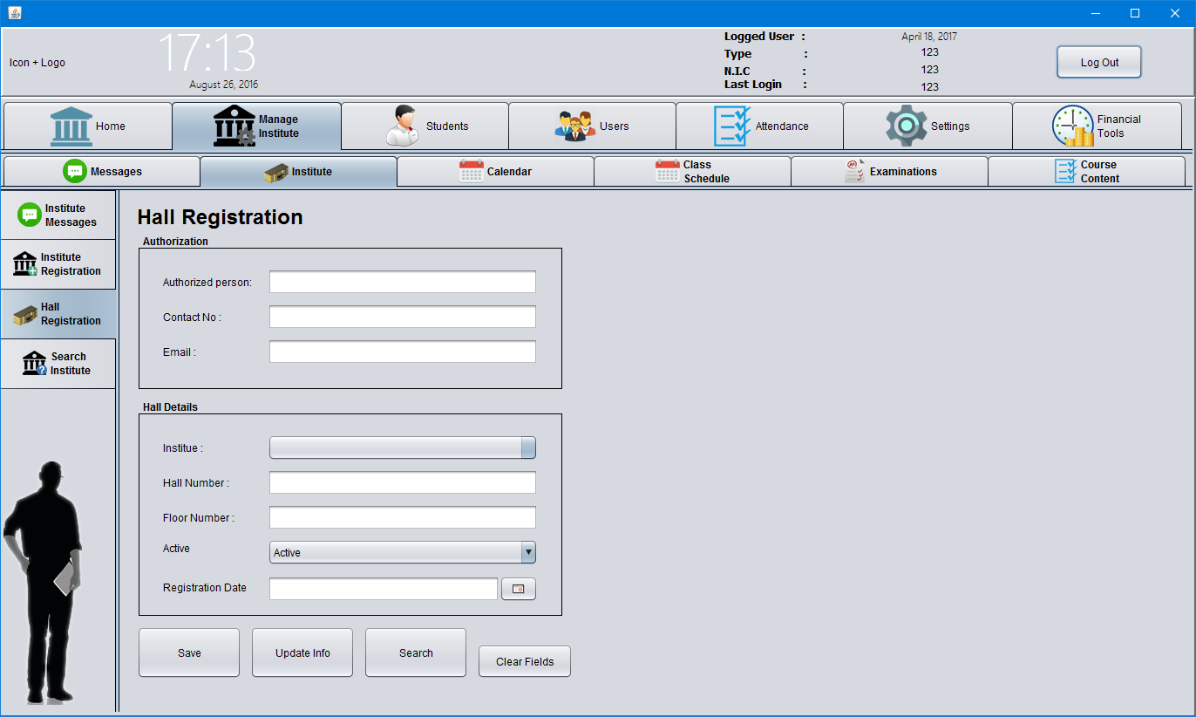

**Manage Institute 🡪 Institute 🡪 Search Institute**

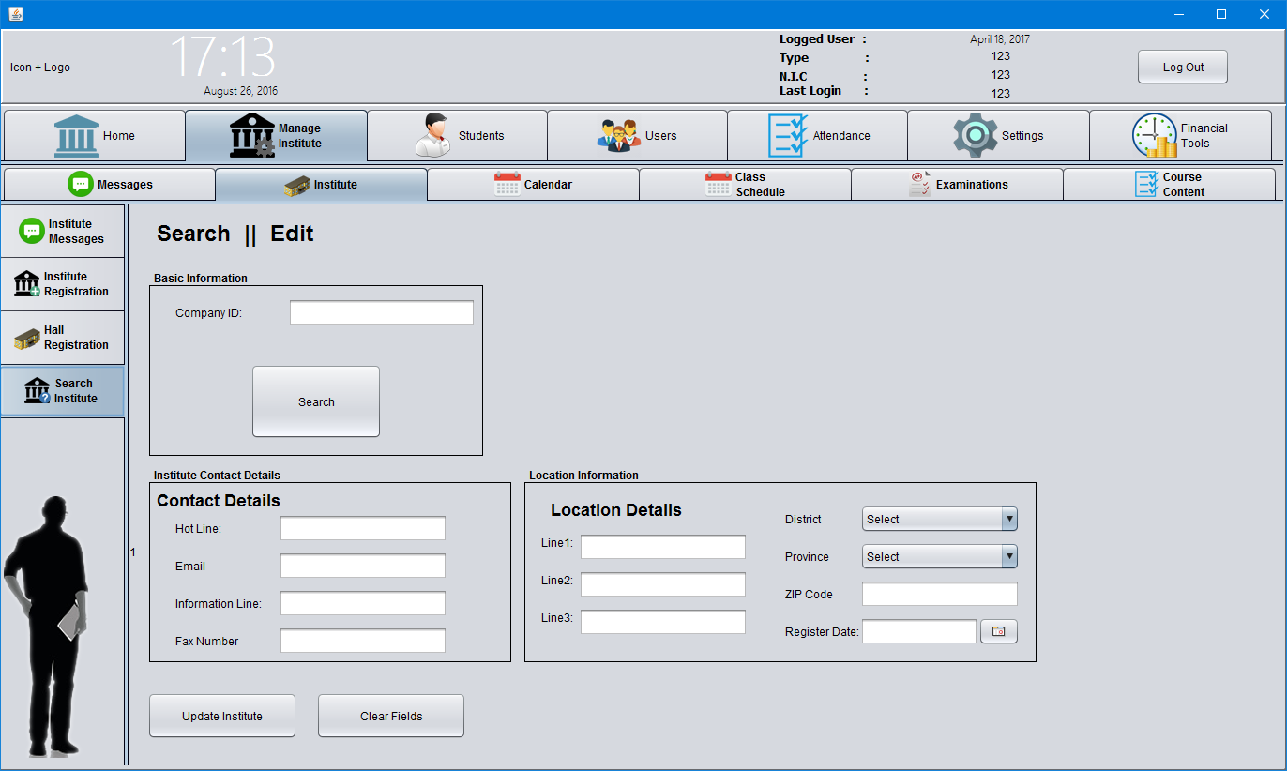

**Manage Institute 🡪 Calendar**

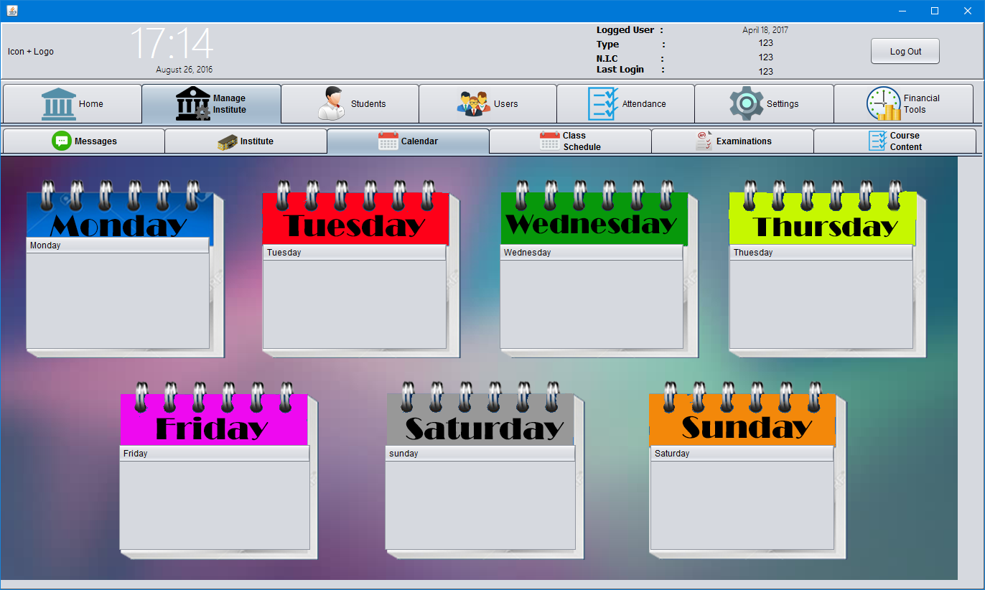

**Manage Institute 🡪 Class Schedule**

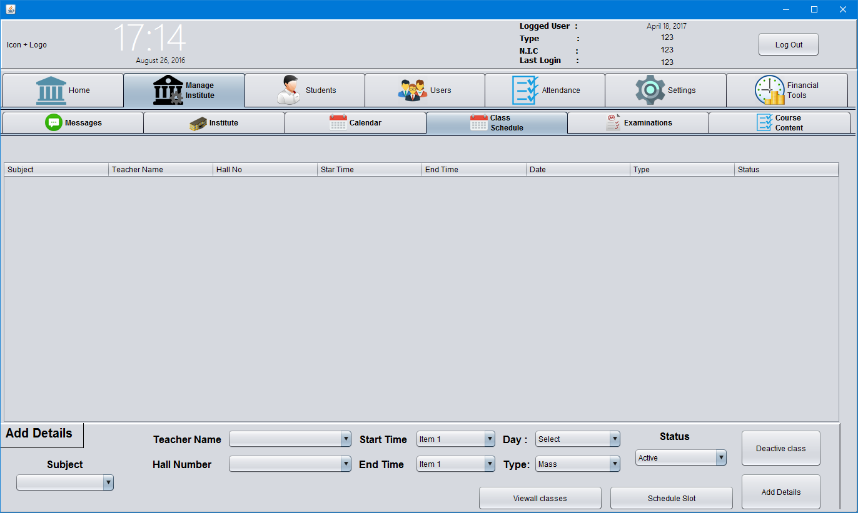

**Manage Institute 🡪 Examination 🡪 Add New Examination**

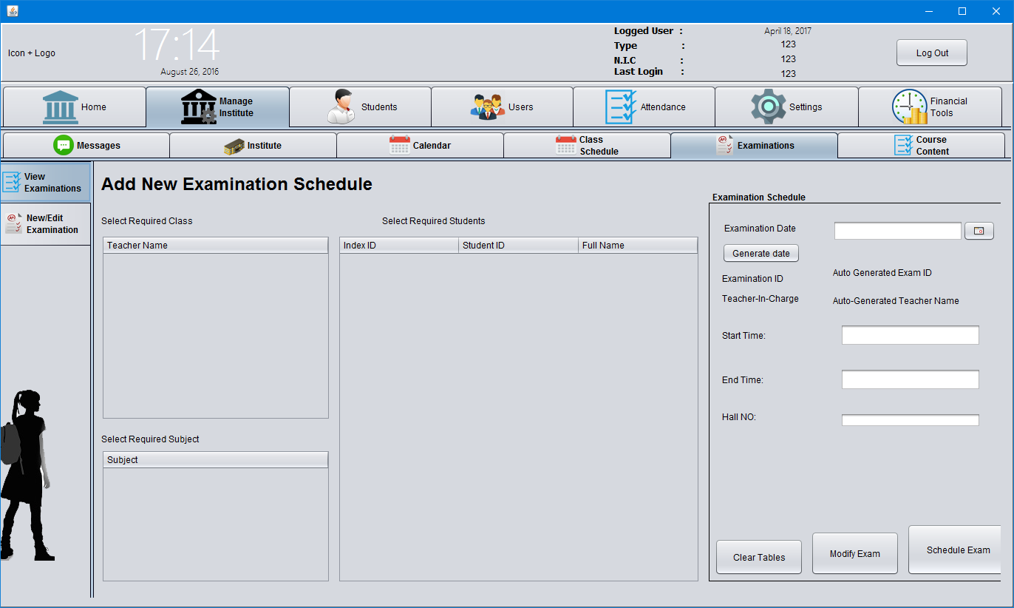

**Manage Institute 🡪 Examination 🡪 View Examination**

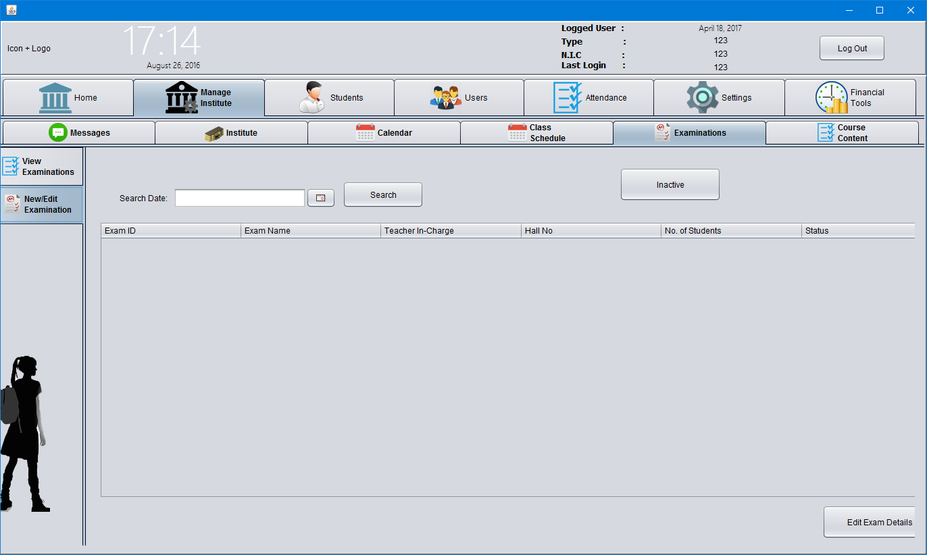

**Manage Institute 🡪 Course Content 🡪 Add New Stream**

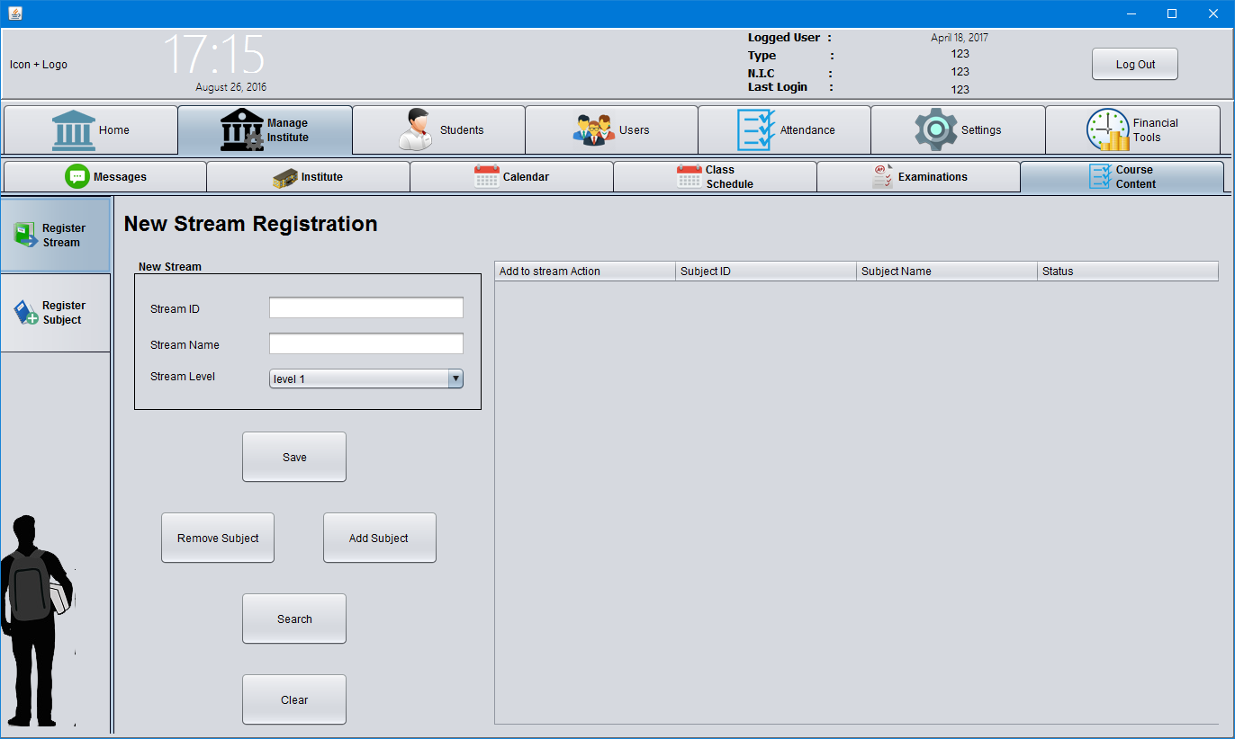

**Manage Institute 🡪 Course Content 🡪 Add New Subject**

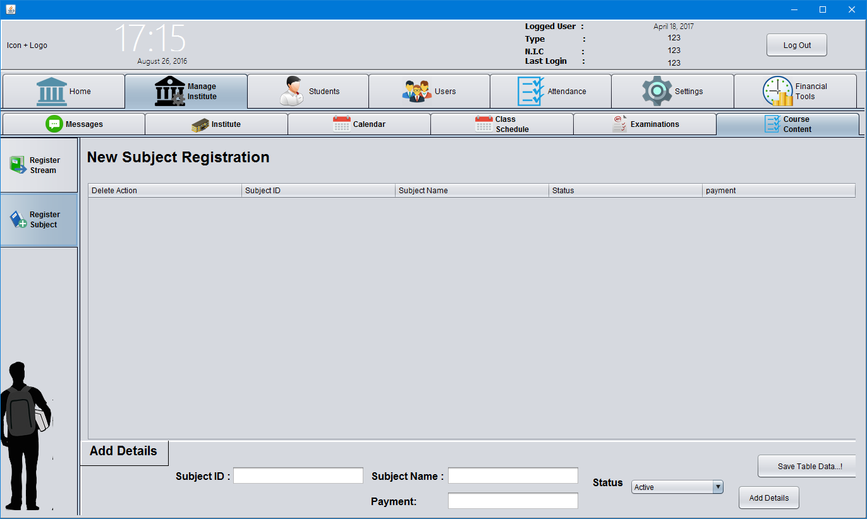

**Home Page 🡪 Students 🡪 Student Information**

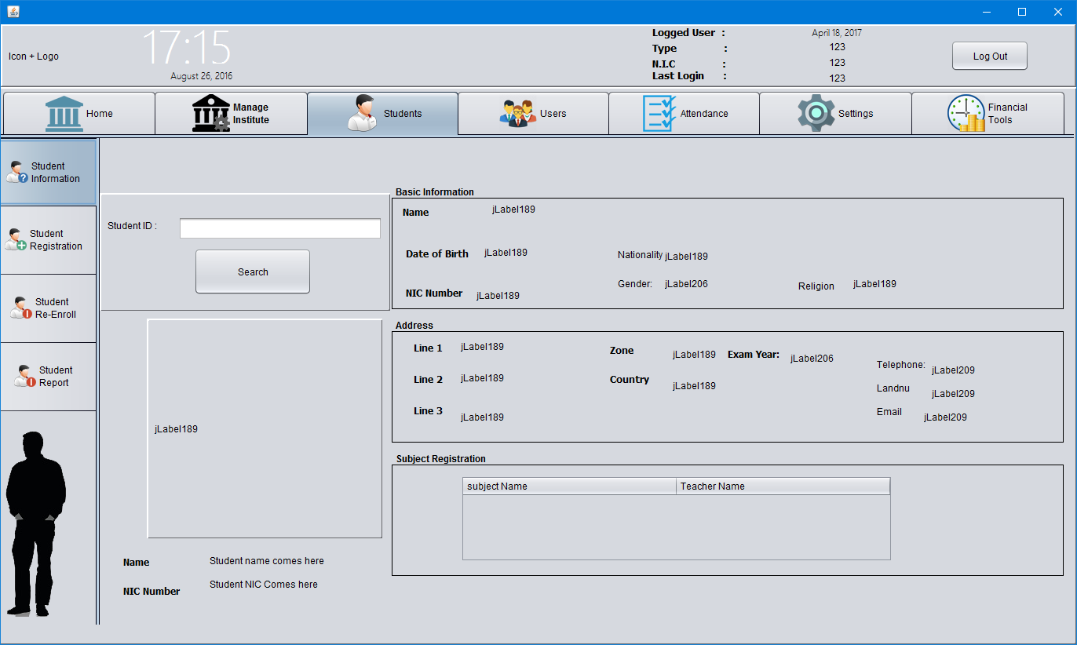

**Students 🡪 Student Registration**

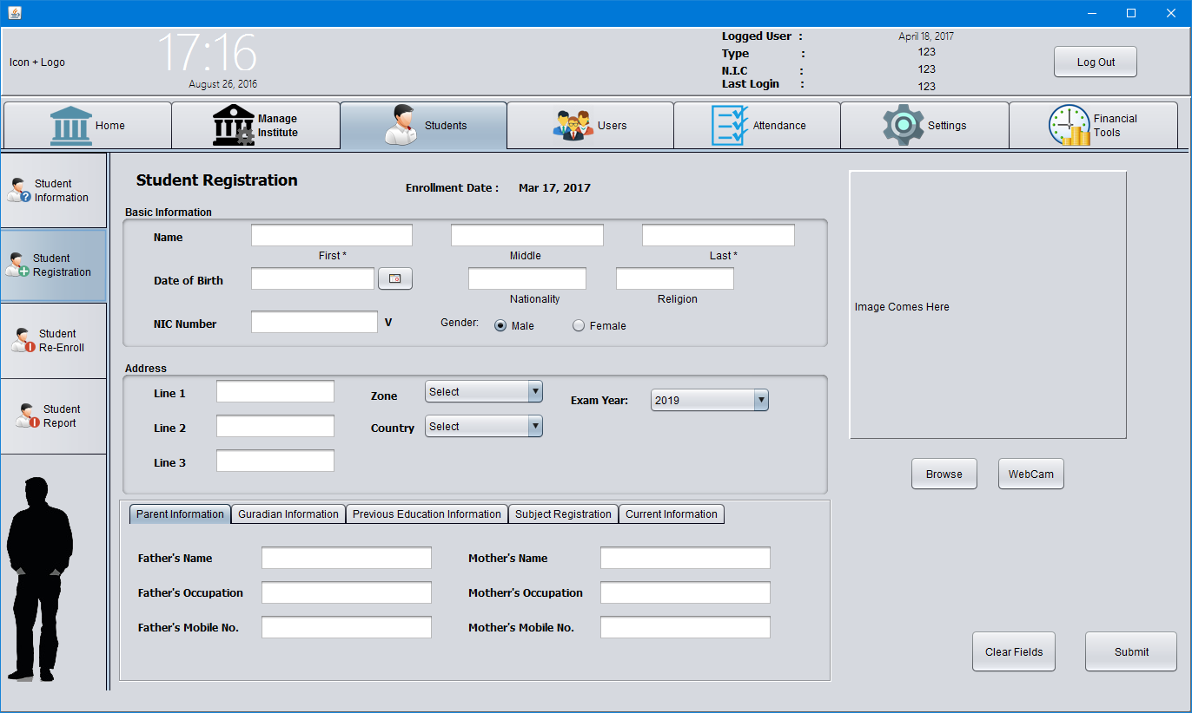

**Students 🡪 Student Re-Enroll**

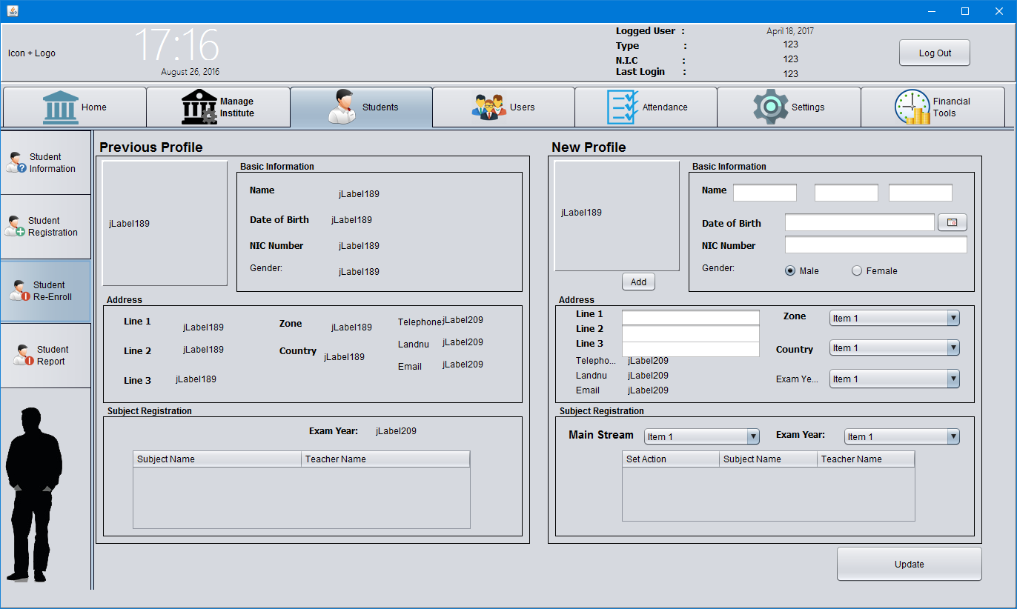

**Home Page 🡪 Users 🡪 Staff Information**

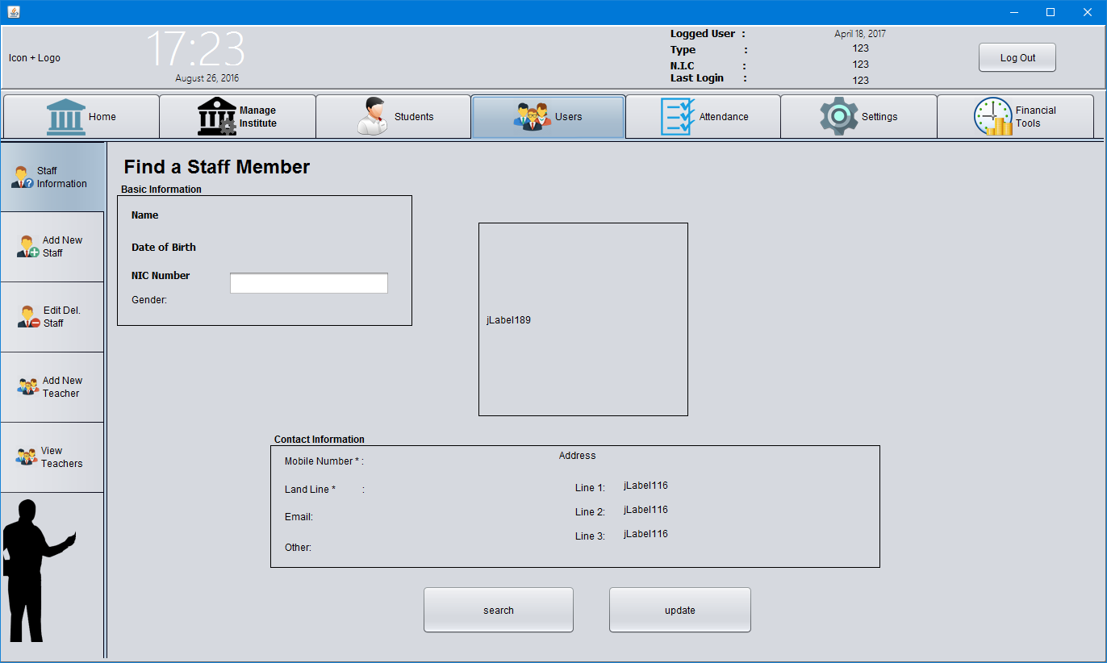

**Users 🡪 Add New Staff**

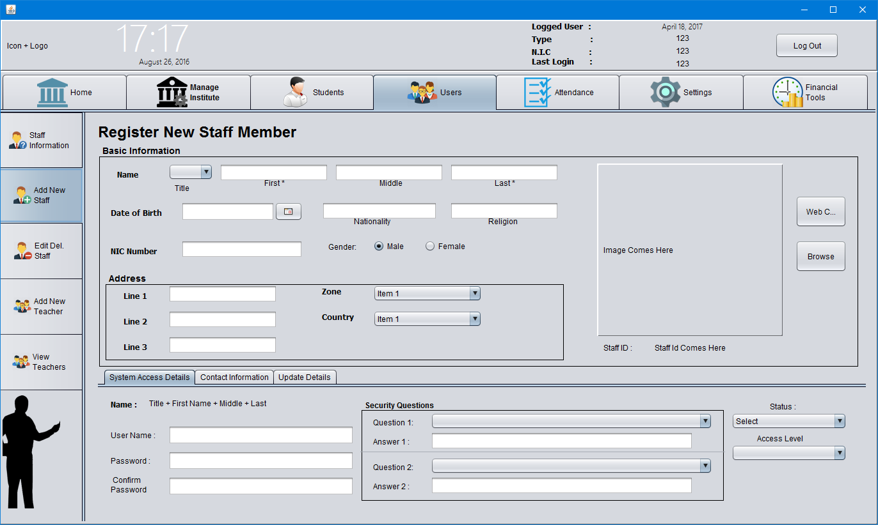

**Users 🡪 Edit / Delete Staff**

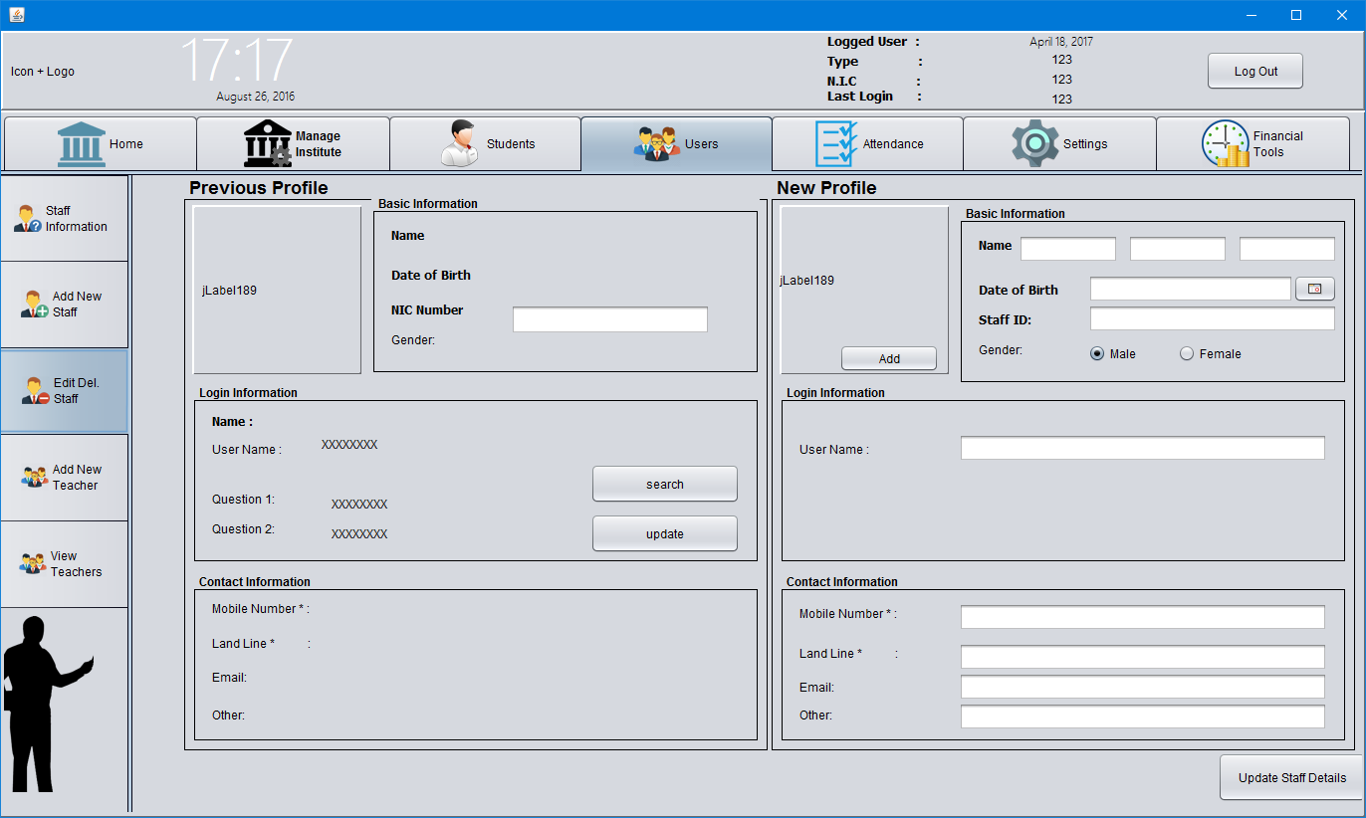

**Users 🡪 Add New Teacher**

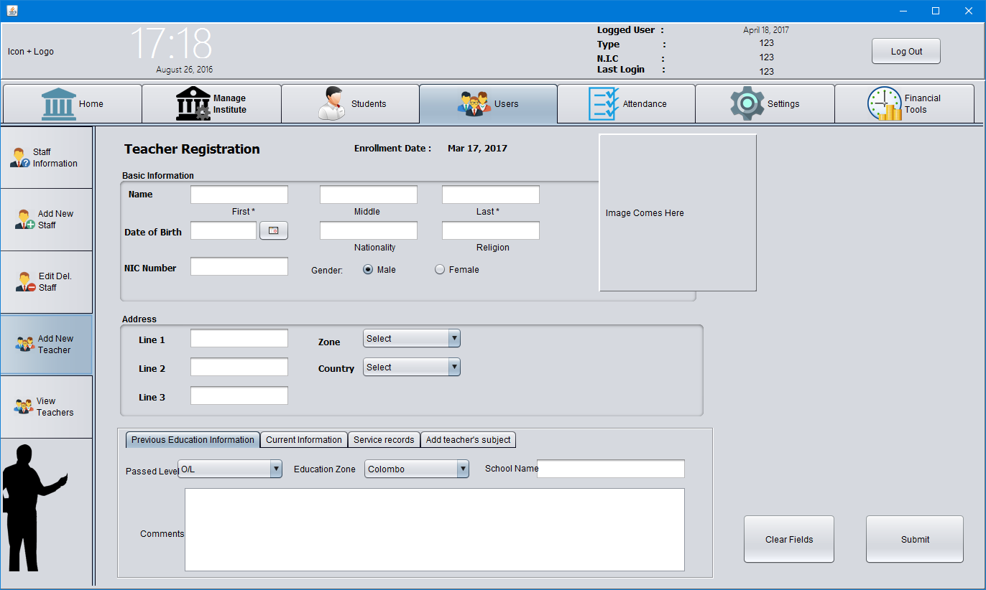

**Users 🡪 View Teacher**

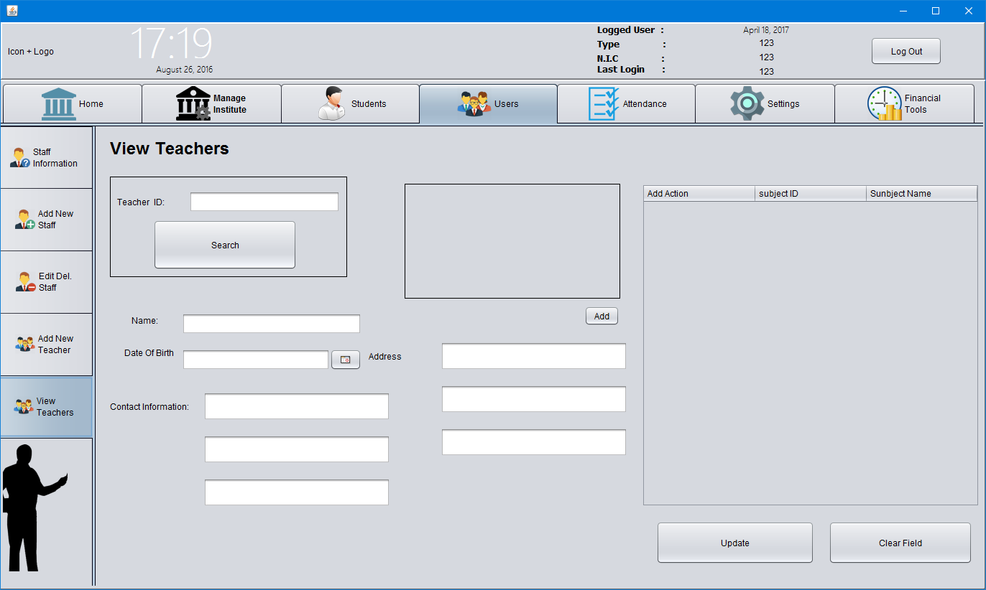

**Attendance**

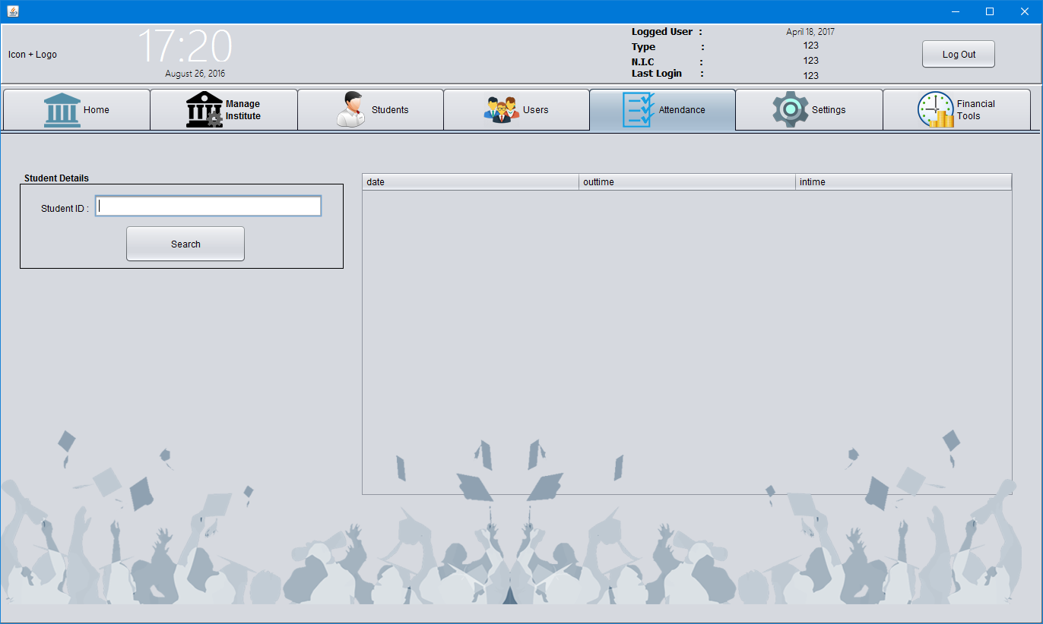

**Home Page 🡪 Settings**

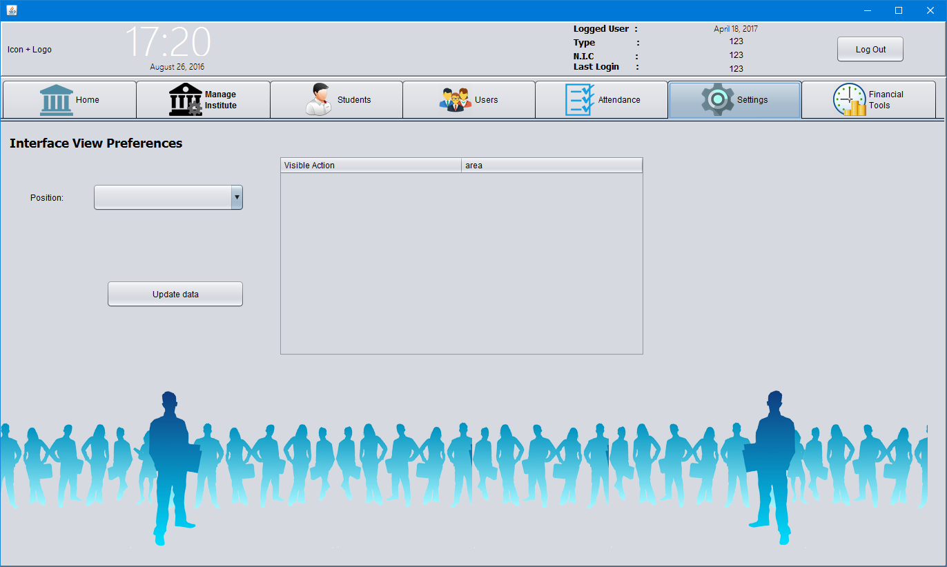

**Home Page 🡪 Financial Tools 🡪 Student Payment**

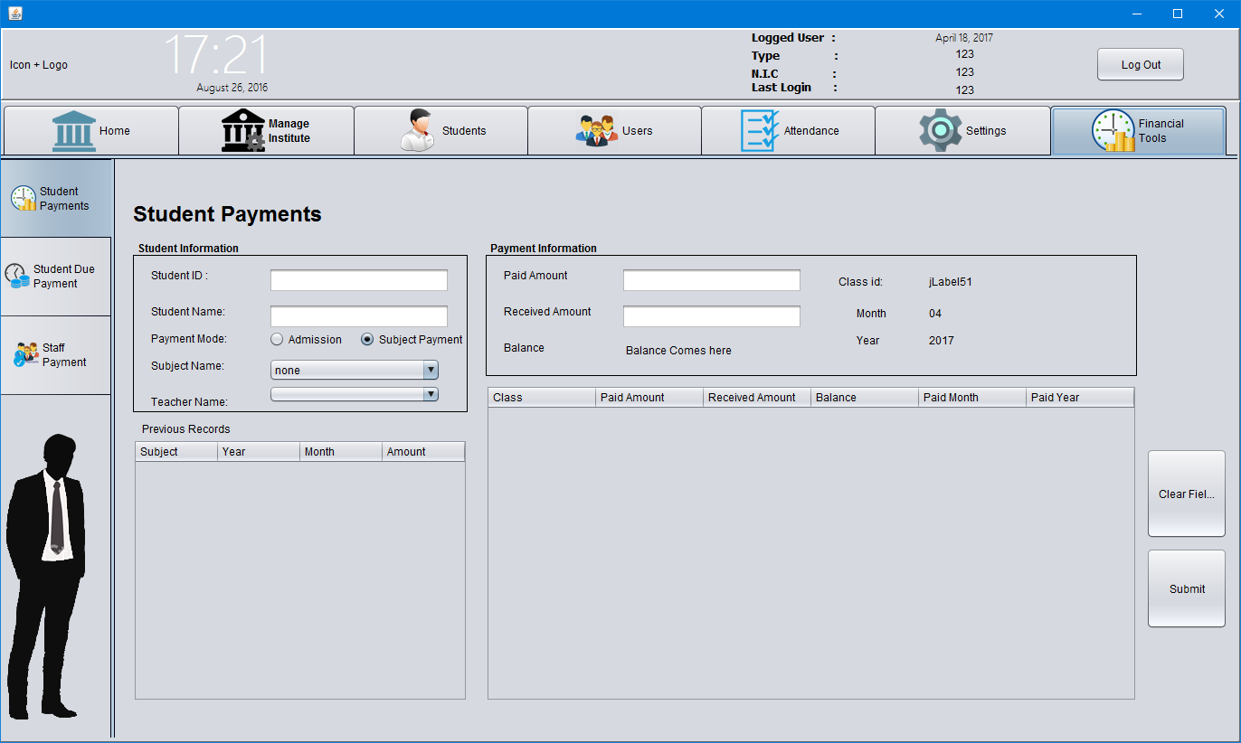

**Home Page 🡪 Financial Tools 🡪 Student Payment**

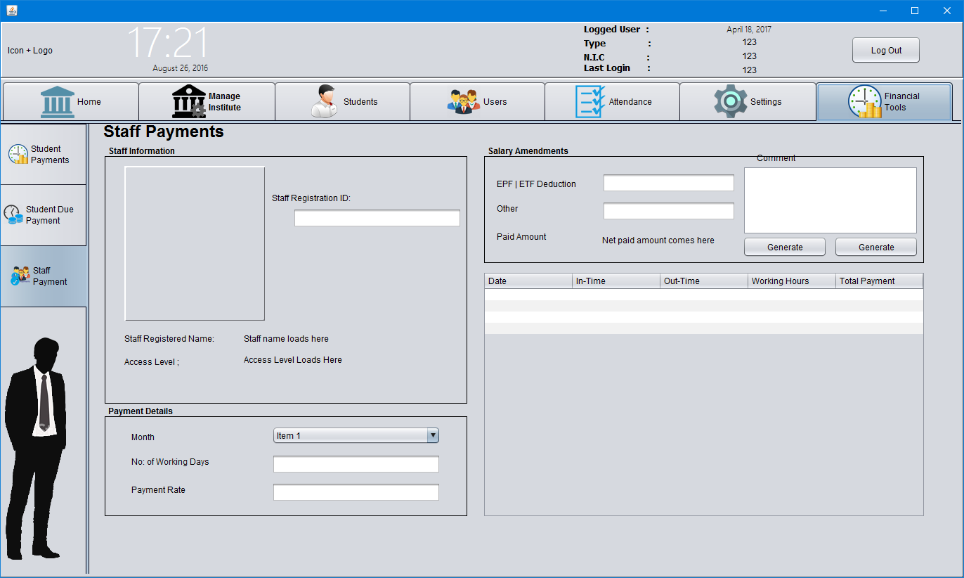

## Functional Requirements

**Main Interfaces**

**Home –** Guide to Main Tabs

**Manage Institute -** Components of the Institute Managements tool

**Students –** Manage Student Details

**Users –** Manage User and Teacher Details

**Attendance –** Mark and view the Attendance of the Students, Users and Teachers

**Settings –** Visibility of the relevant user interfaces

**Financial Tools –** Manage the cash flow of the institute.

**Manage Institute** –

Broadcasting Messages – Messages can be broadcasted only after Login. All the messages

are visible to Admins and other related parties of the system.

Institute – Once new institute is introduced to the system, it will be replaced as the Default

institute of Institute of the system.

Calendar – Events are visible only for the current month.

Class Schedule – User must have a clear idea about class scheduling without any

contradictions. Inputter errors cannot be corrected using automated system

once updated.

Course content – Subjects can be defined once Streams are updated with the system.

**Students –** No known limitations in Registering / Updating / Deleting / Searching Students.

**Users -** No known limitations in Registering / Updating / Deleting / Searching Users.

**Attendance –** Student / User / Teacher ID must be located before checking for attendance.

**Settings –** Only visible to Admins

**Financial Tools –** Only visible to Admins and Accountants. All the changes made to system in

This interfaces are recorded with IDs and can be viewed by both parties.

**Manage Institute**

**Messages -**  Broadcasting messages will be visible in this interface.

**Institute –** Institutes can be added/deleted/searched in this interface

**Calendar –** Scheduled classes will be displayed in this interface.

**Class Schedule –** New Classes can be scheduled in this interface.

**Examinations -**  Examinations can be scheduled and viewed in this interface.

**Course Content –** New Streams and Subjects can be defined and added into system.

**Students**

**Student Information –** Students can be searched using IDs

**Student Registration –** New Students can be registered into system

**Student Re-Enroll –** Pre-registered student details can be modified

**Student Report –** Reports related to students are visible here

**Users**

**Staff Information –** Staff member details can be viewed using Staff ID

**Add New Staff –** New Staff members can be added to system

**Edit / Delete Staff -**Modify staff member details

**Add New Teacher –** Add new Teacher details to system.

**View Teachers –** List of institute teachers can be viewed.

**Financial Tools**

**Student Payment –** Student Monthly payments are managed in this interface

**Student Due Payment –** Due-payments prior to the current month are added here

**Staff Payment –** Staff member payments are issued in this section.

## Behavior Requirements

### Use Case View

<A system use case illustrates a goal-oriented set of interactions between the external actors and the software.

Provide a clear use case diagram that will depict the entire system and all possible actors. Even though detailed use case descriptions are not recommended here, it is necessary to include a short description of every use-case and the actors identified in the diagram.>

# Other Non-functional Requirements

## Performance Requirements

<Specify clearly any performance requirements of the software and explain their rationale. Provide the timing relationships for real time systems. The state performance requirements for individual functional requirements or features can be provided here.

Provide the performance requirements for the software based on the information acquired from the client.>

## Safety and Security Requirements

<Specify the requirements concerned with possible loss, damage, or harm that could be a result from the use of the software and outline any safeguards or actions that should be taken as well as prevented. Refer to any compatible external safety policies or regulations and provide any related safety certifications. Provide any requirements regarding security or privacy issues pertaining to the use of the software or protection of the data used or generated by the software. User identity authentication requirements can also be described here.

* Describe several safety requirements based on interviews with the client or research.
* Specify the level of security expected from the software by the client, including the primary security requirements.>

Appendix A - Group Log

<Specify all the group meeting minutes, group activities, and other relevant information that will assist the supervisor to determine the effort put forth to produce this document.>