CHAROTAR UNIVERSITY OF SCIENCE & TECHNOLOGY

Faculty of Technology & Engineering
Devang Patel Institute of Advance Technology and Research (DEPSTAR)

Data Engineering (ITUC301)
Practical File – ODD Semester 2026–27

Student ID: 24DIT074

Student Name: NANDAN VAKANI

PRACTICAL 2
1. Problem Definition: Programmatically interface with diverse file-based, API-driven, and relational source database environments. Students will write generation engines to simulate transactional workloads, profile the incoming files to automatically discover schemas, isolate data quality violations (such as null entry leaks and format divergence), and establish appropriate operational ingestion criteria.
Dataset/Test Data: Programmatically simulated customer profile tables, semi-structured API transaction logs containing nested objects, and unstructured configuration text files.
Tools/Technology To Be Used: Python 3.x, Faker library, Pandas, Requests HTTP library, SQLite/PostgreSQL, and Git.
2. Solution :
The practical was implemented using Python 3.x with the following workflow:
➤ Step 1 – Generate Synthetic Data (generate_data.py)
➤ Step 2 – Store Data in SQLite Database (database.py)
➤ Step 3 – Read Data from SQLite (read_database.py)
➤ Step 4 – Fetch Data from Public REST API (api_data.py)
➤ Step 5 – Profile Dataset (profile.py)
➤ Step 6 – Validate Email Addresses (validate_email.py)
➤ Step 7 – Detect Duplicate Records (duplicate.py)
➤ Step 8 – Clean Dataset (clean_data.py)

2.1 generate_data.py – Synthetic Data Generation
The Faker library is used to produce 100 realistic customer records and export them to customers.csv. Each record contains a unique CustomerID, Name, Email, Age, and City.
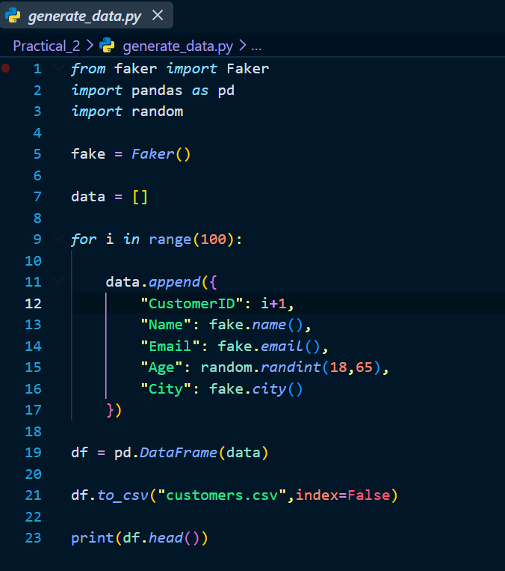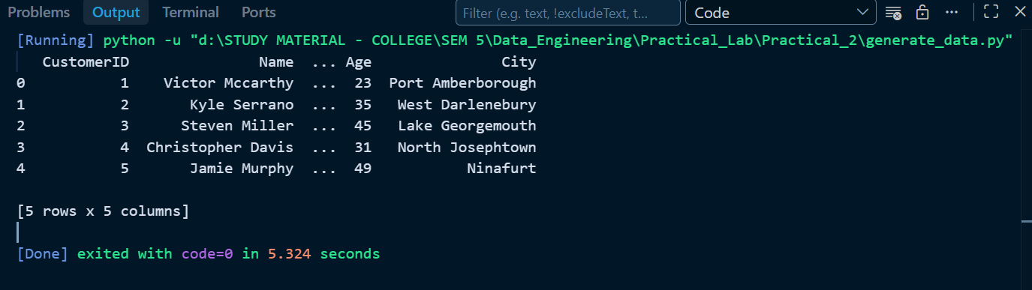
2.2 database.py – SQLite Storage
Loads the CSV data into an SQLite database (customers.db) using Pandas to_sql(), replacing the table if it already exists.
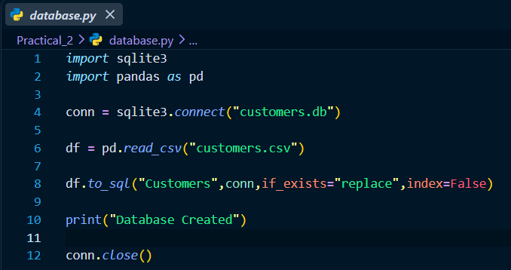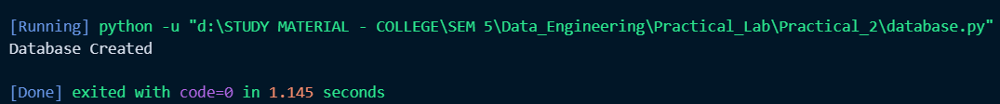
2.3 read_database.py – Reading from SQLite
Executes a SELECT * query against the Customers table and loads results into a Pandas DataFrame for display and downstream processing.
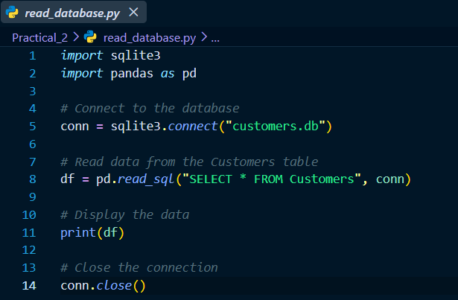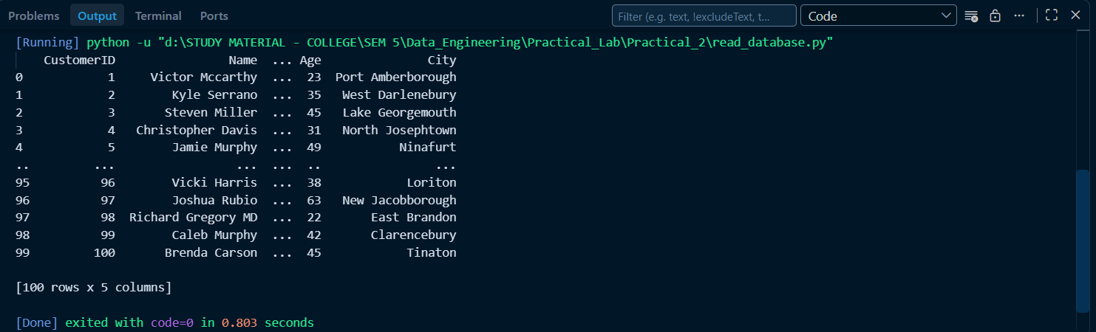
2.4 api_data.py – REST API Data Ingestion
Fetches a public JSON dataset from JSONPlaceholder to simulate third-party API data ingestion using the Requests library.
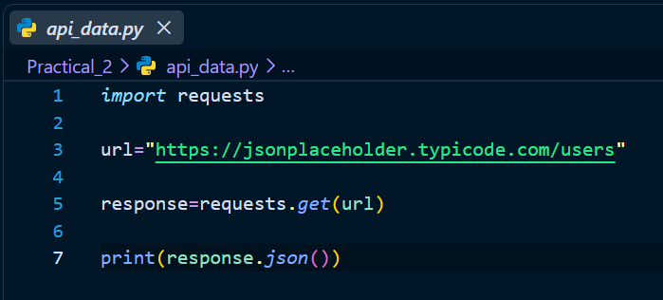
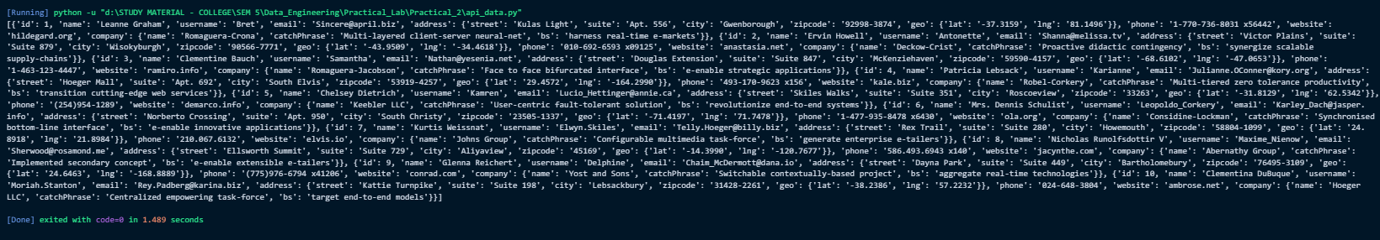
2.5 profile.py – Data Profiling
Produces a structural analysis of the dataset including column data types, descriptive statistics, and a null-value summary per column.
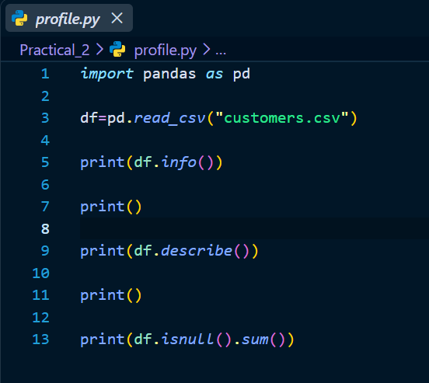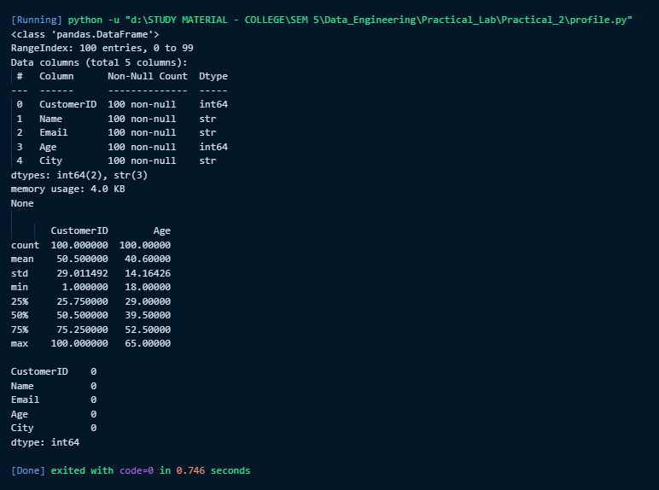

2.6 validate_email.py – Email Format Validation
Applies a regular-expression pattern to every Email field and flags records whose address does not conform to the standard user@domain.ext format.
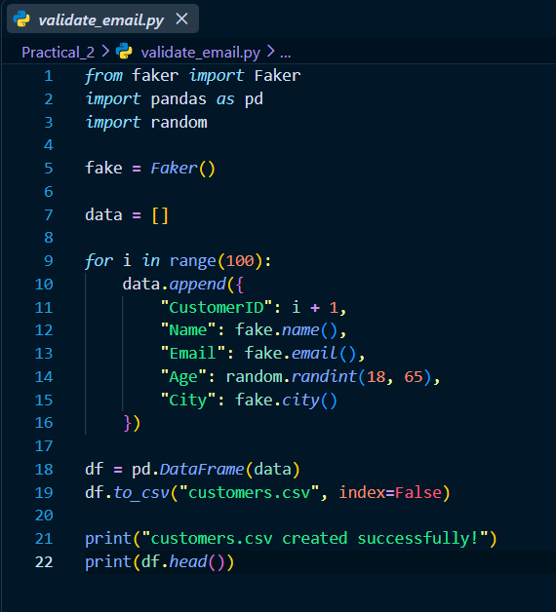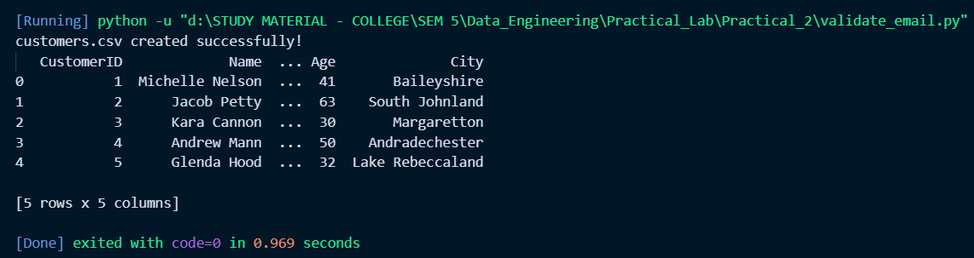
2.7 duplicate.py – Duplicate Record Detection
Scans the dataset for fully duplicate rows and reports the count. Since data is synthetically generated with unique CustomerIDs, no duplicates are expected.
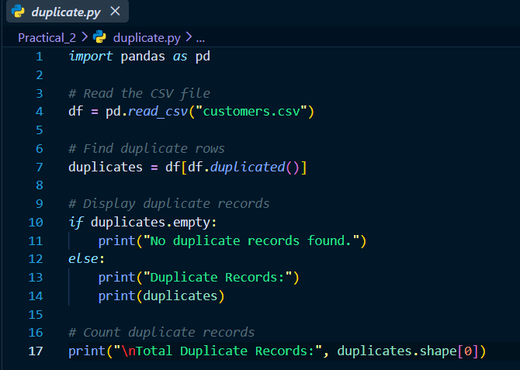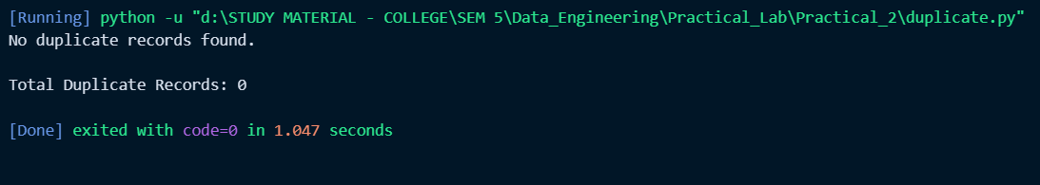

2.8 clean_data.py – Data Cleaning & Export
Removes all rows that contain at least one null value and exports the resulting clean dataset as clean_customers.csv, ready for ingestion into a downstream system.
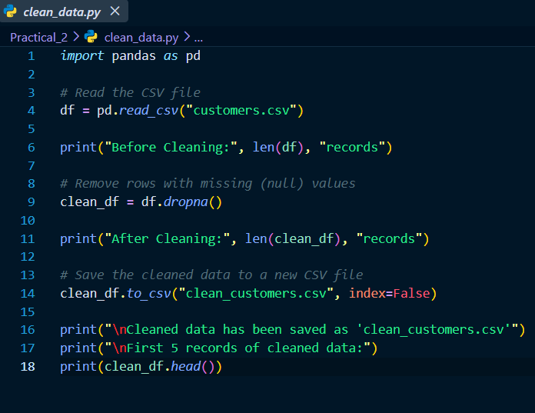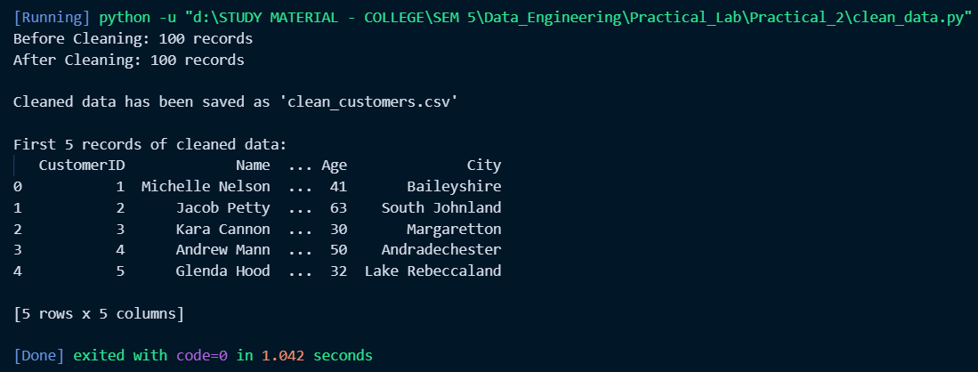
3. Output / Observed Results
generate_data.py → customers.csv created with 100 synthetic customer records.
database.py → customers.db SQLite database created; Customers table populated.
read_database.py → All 100 records retrieved and printed via SQL SELECT.
api_data.py → 10 user JSON objects returned from JSONPlaceholder API.
profile.py → Column dtypes confirmed; 0 null values detected across all fields.
validate_email.py → All generated email addresses passed regex validation.
duplicate.py → No duplicate records found (unique IDs ensure distinct rows).
clean_data.py → 100 clean records exported to clean_customers.csv.
4. Key Questions / Analysis
● Question / Key Point 1: Explain the architectural strategies used to manage severe structural schema drift when handling continuous external third-party API inputs.
Answer : Schema drift — where an upstream API changes its field names, data types, or nesting structure without notice — is one of the most disruptive failure modes in a data pipeline. Three architectural strategies defend against it. First, schema registry enforcement: every payload is validated against a versioned schema (using tools such as Apache Avro or JSON Schema) before it is allowed to land in the raw zone. When a mismatch is detected, the record is quarantined to a dead-letter queue rather than written to production storage. Second, schema-on-read storage: landing raw payloads in an immutable format such as JSON or Parquet in an object store (S3, GCS) means that structural changes do not corrupt previously ingested data — the schema is only interpreted at query time, allowing retroactive re-parsing when the consuming transformation logic is updated. Third, contract-based API design: producers and consumers agree on a published schema contract and versioning policy (for example, MAJOR version bumps for breaking changes, MINOR for additions). Combined with integration tests that run against a live sandbox environment, these strategies ensure that schema changes are detected during the CI/CD cycle, not during a production incident.
● Question / Key Point 2: What are the structural benefits and data storage trade-offs of using semi-structured nested JSON objects over heavily normalized SQL database records?
Answer : Nested JSON offers flexibility and co-location of related data: a single API response can carry an order, its line items, the shipping address, and payment metadata in one atomic document, eliminating the multi-table JOINs that a normalized SQL schema would require to reassemble the same entity. This co-location improves read performance for document-oriented access patterns and makes schema evolution easier — adding a new nested field does not require an ALTER TABLE migration across a large production database. However, the trade-offs are significant. JSON storage is verbose: repeated field names inflate disk usage, and columnar compression techniques work far less efficiently on deeply nested structures compared with flat tabular data stored in Parquet. Querying nested fields is computationally expensive in SQL-over-JSON engines, analytical aggregations (SUM, GROUP BY) are slower than on a properly indexed relational table, and enforcing referential integrity or uniqueness constraints is architecturally impossible without an external validation layer. In practice, the correct choice depends on the access pattern: JSON suits ingestion landing zones and event streaming; normalized SQL suits high-frequency transactional writes and complex relational analytics.
● Question / Key Point 3: How do you validate data quality at the point of ingestion without creating severe processing performance bottlenecks?
Answer : The key principle is to decouple validation from transformation. At the ingestion boundary, only lightweight structural checks should execute synchronously — confirming that required primary keys are present, that data types are parseable, and that the payload schema version is recognized. These checks operate at the message level and add sub-millisecond latency per record. Deeper semantic validations (referential integrity checks, cross-field business rule evaluation, statistical outlier detection) are dispatched asynchronously to a parallel validation worker pool, allowing the main ingestion pipeline to continue accepting new records without stalling. Records that fail synchronous checks are immediately routed to a quarantine store with a structured error envelope containing the original payload, the violation code, and the ingestion timestamp. Records that pass synchronous checks are written to the raw landing zone and flagged for asynchronous re-validation. Monitoring dashboards track the quarantine rate and alert operations teams when the proportion of rejected records exceeds a configured threshold. This approach — synchronous structural gating plus asynchronous semantic validation — provides data quality assurance without introducing latency spikes or throughput degradation in the ingestion tier.

6. Learning Outcomes
After completing this practical, the following skills were developed:
1. Programmatic synthetic data generation using the Faker library.
2. Reading and writing CSV files using Pandas.
3. Creating and querying SQLite databases from Python.
4. Integrating external REST APIs using the Requests library.
5. Profiling dataset structure, data types, and null-value distributions.
6. Applying regular-expression-based email format validation.
7. Detecting and reporting duplicate records in a dataset.
8. Removing null-containing rows and exporting a clean dataset.
9. Designing an automated file-scanning and quarantine routine.
10. Writing structured warning entries to application log files.

8. Conclusion
This practical demonstrated the complete data source profiling and ingestion preparation workflow. By generating synthetic data, storing it in a relational database, fetching external API data, profiling the dataset, validating field formats, detecting duplicates, and cleaning null entries, the core data engineering skills required before loading data into a production pipeline were exercised. The supplementary quarantine routine extended this into a realistic automated quality gate, and the post-laboratory log export reflects industry-standard observability practices applied to incoming data payloads.

