CONTINUOUS INTERNAL PRACTICAL EVALUATION – 1
SUBJECT : DATA ENGINEERING [ITUC301]
Problem Definition :
An e-commerce organization collects data from multiple sources, including:
• Customer and product information stored in a relational database.
• Transaction data received through an API in JSON format.
• Web application user activity logs generated continuously.

You are required to design and implement a simplified end-to-end data engineering pipeline.
TASK 1 : Data Engineering Lifecycle Design – DRAW.IO

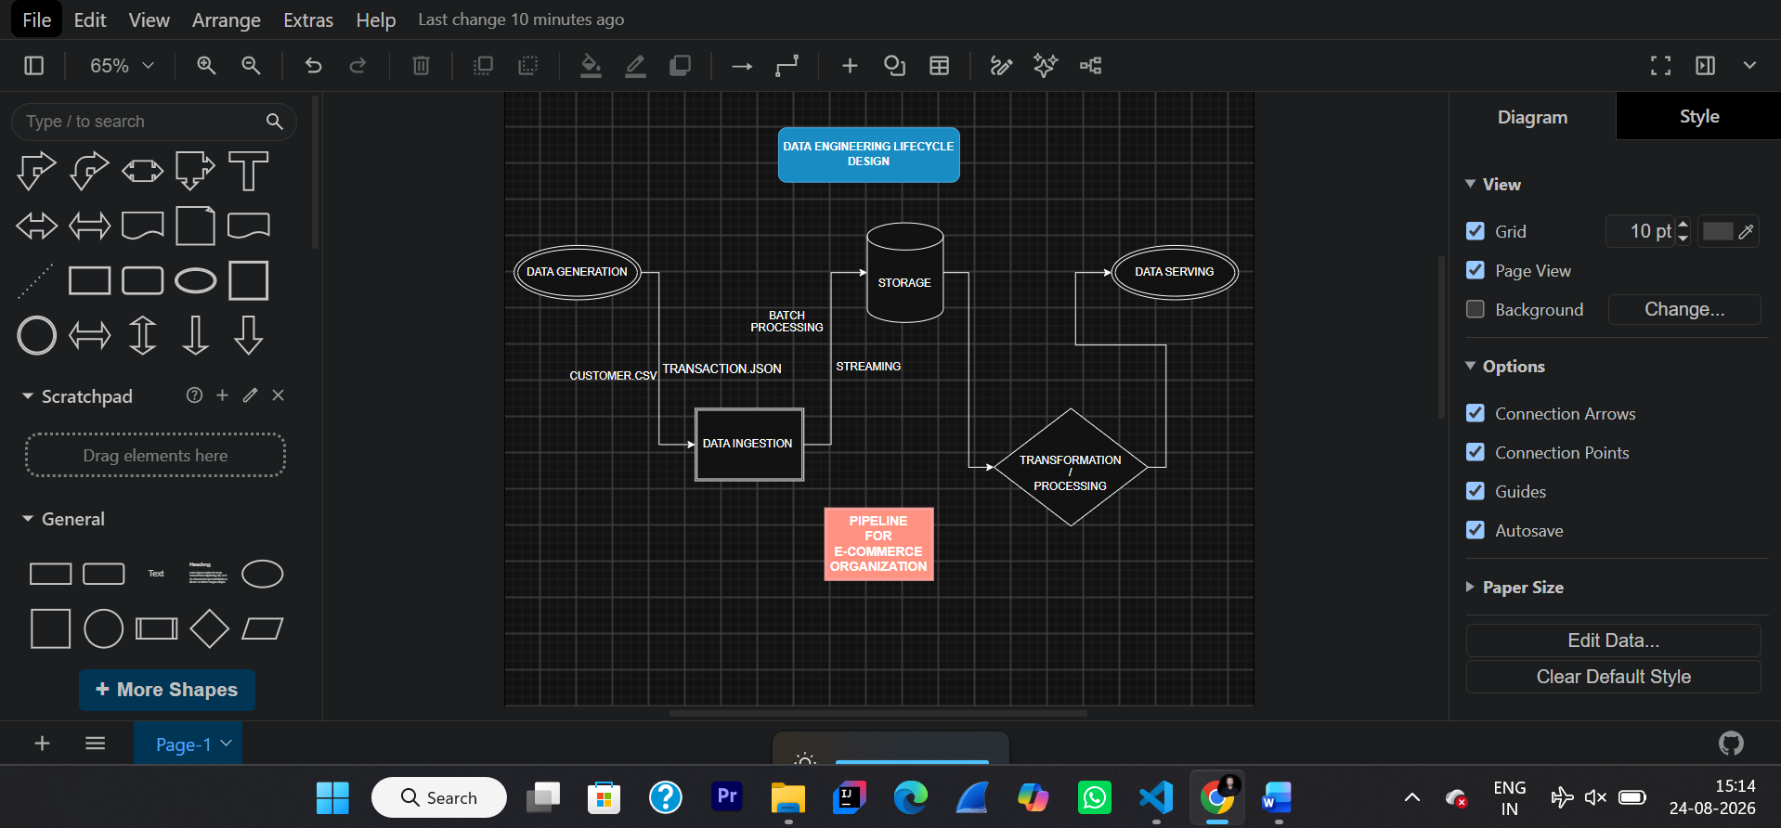
TASK 2 : Data Generation and Profiling

STEP 1 : Created Structure in the folder

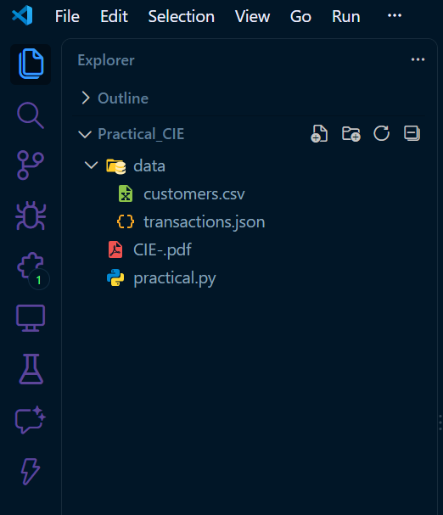
FOLDER_STRUCTURE
STEP 2 : Generated Customer.csv and
transaction.json

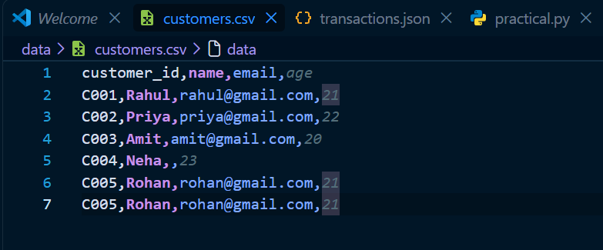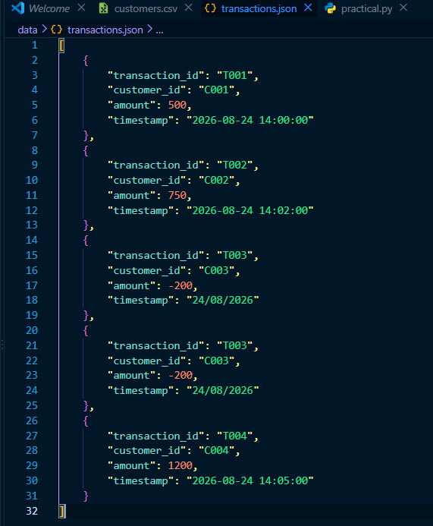
CUSTOMER.CSV TRANSACTION.JSON

STEP 3 : Created Practical.py
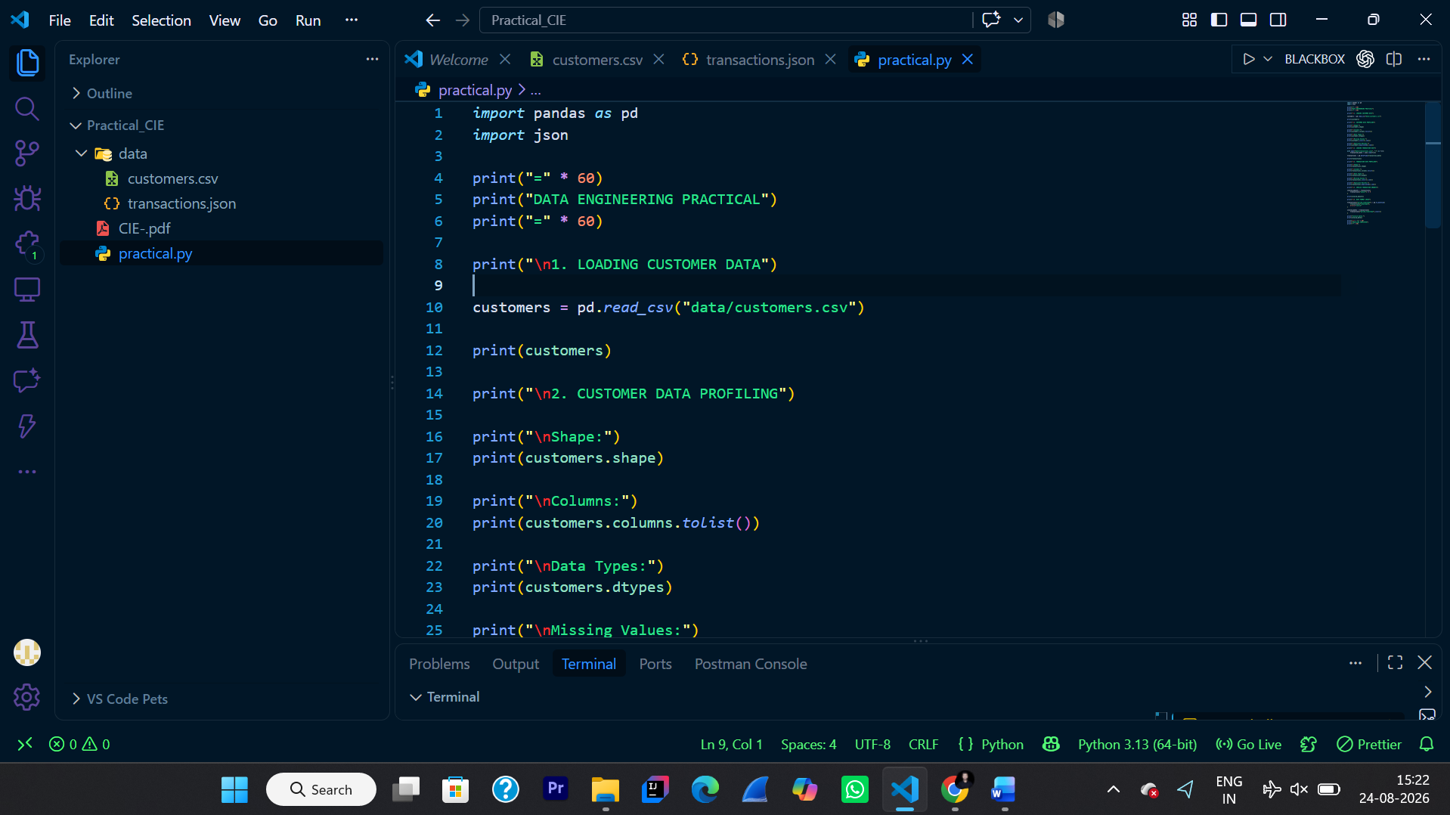
PRACTICAL.PY

STEP 4 : RUN practical.py
Command – python practical.py
OUTPUT :
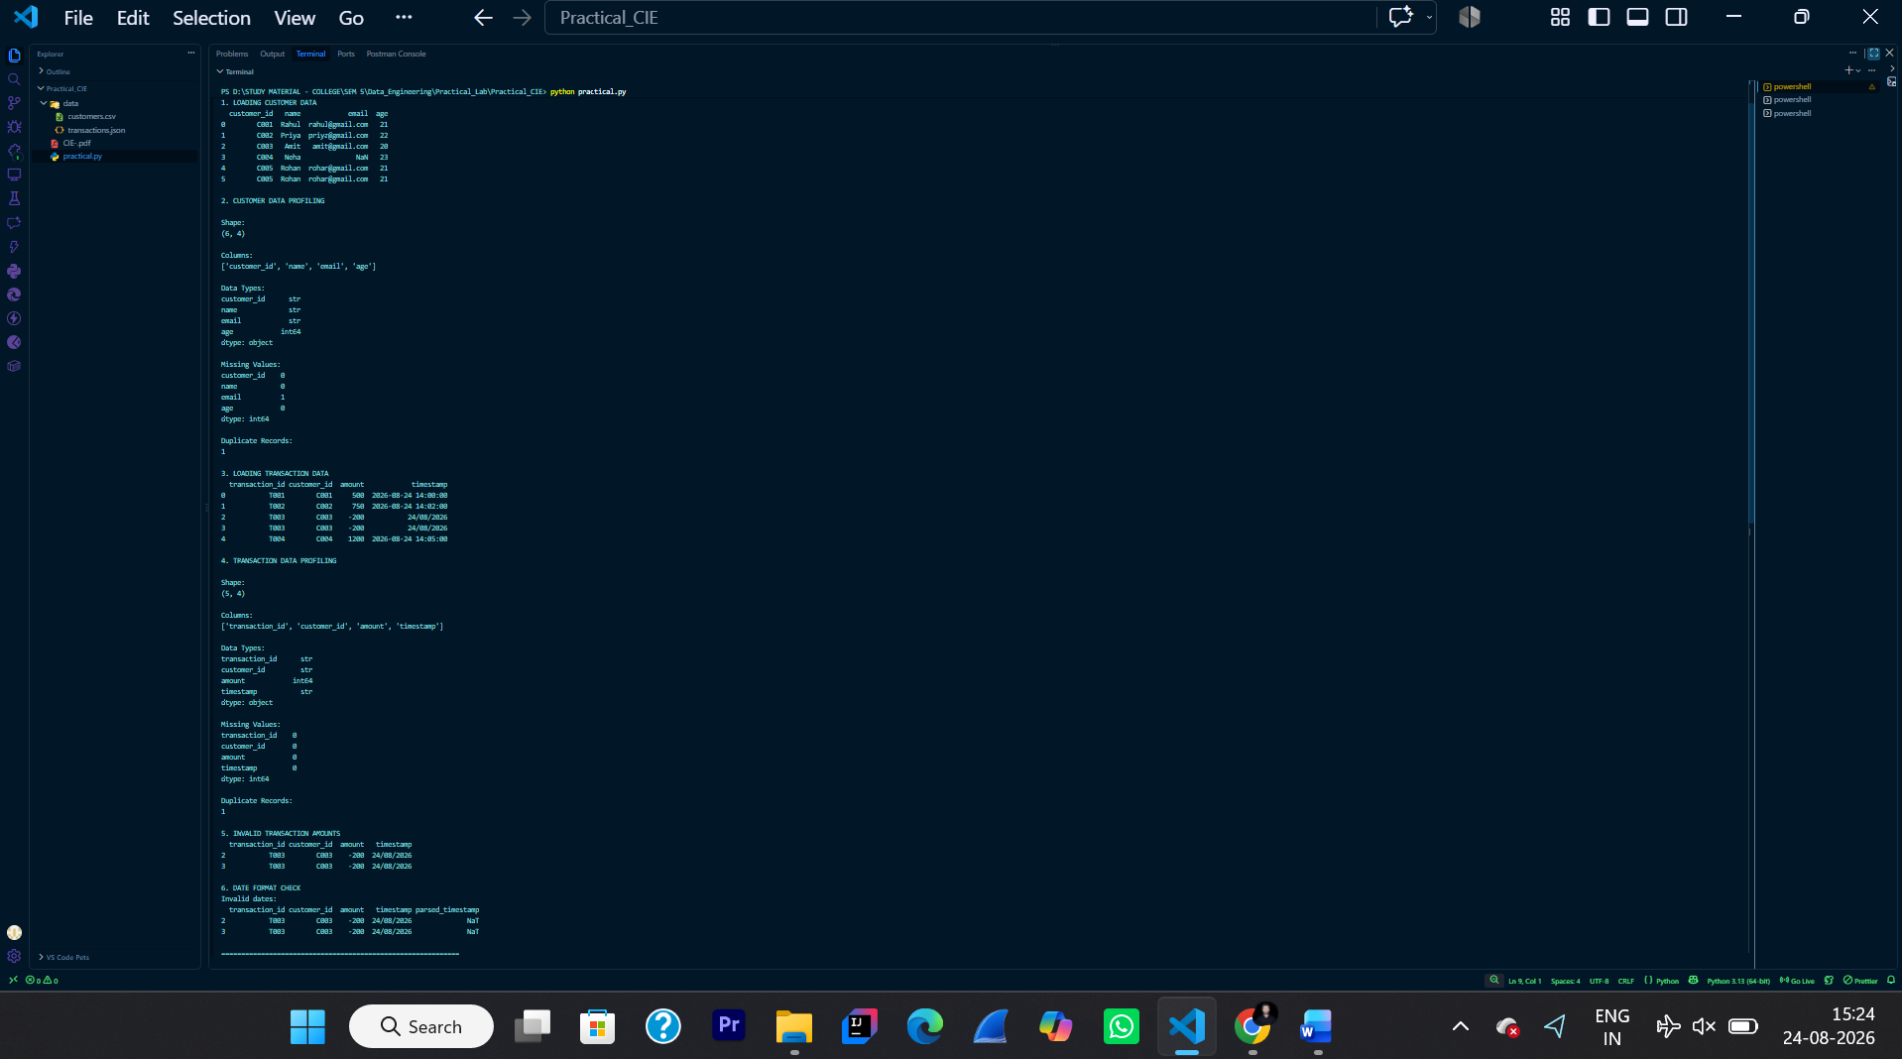
IDENTIFIED QUALITY ISSUES :
ISSUE 1 : CUSTOMER DATA ISSUE 2 : TRANSACTION DATA
Different types of data Different types of data
Missing Values Invalid Amount
Duplicate Records Invalid dates
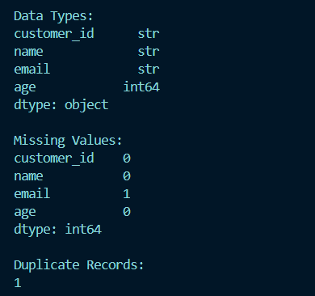 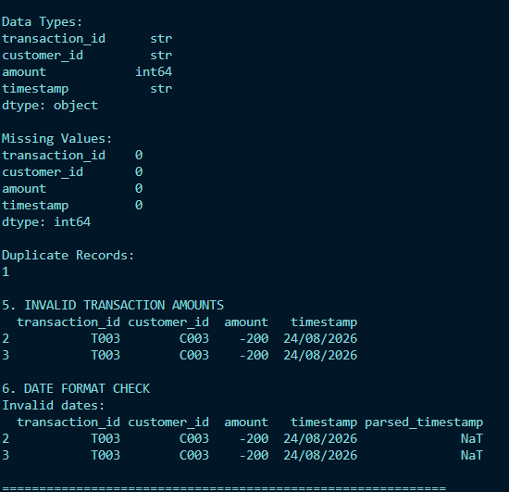

TASK 3 : Batch and Streaming Ingestion
STEP 1 : Created batch_ingestion.py

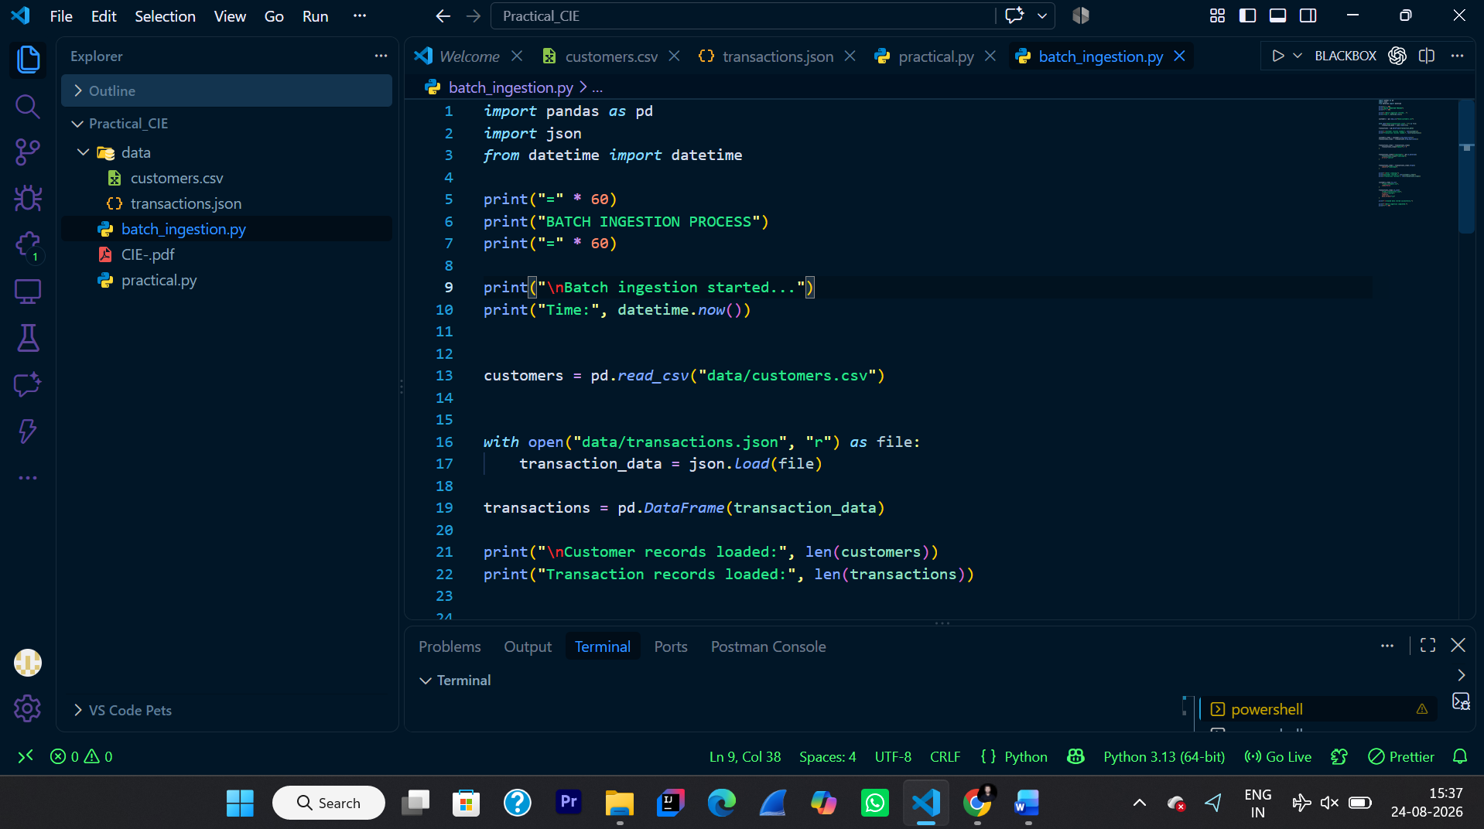

STEP 2 : RUN batch_ingestion.py
Command – python batch_ingestion.py
OUTPUT : clean_customers.csv and clean_transactions.json created
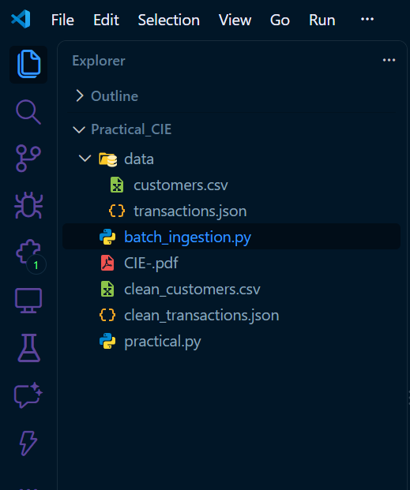 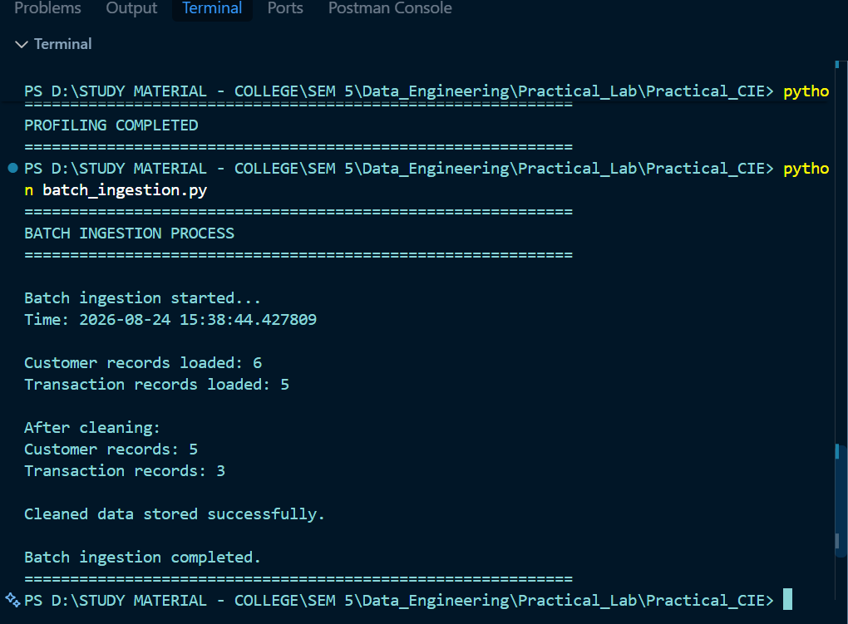 UPDATED FOLDER STRUCTURE BATCH_INGESTION RUN SUCCESSFULLY AND CLEANED DATA

STEP 3 : Created streaming_ingestion.py

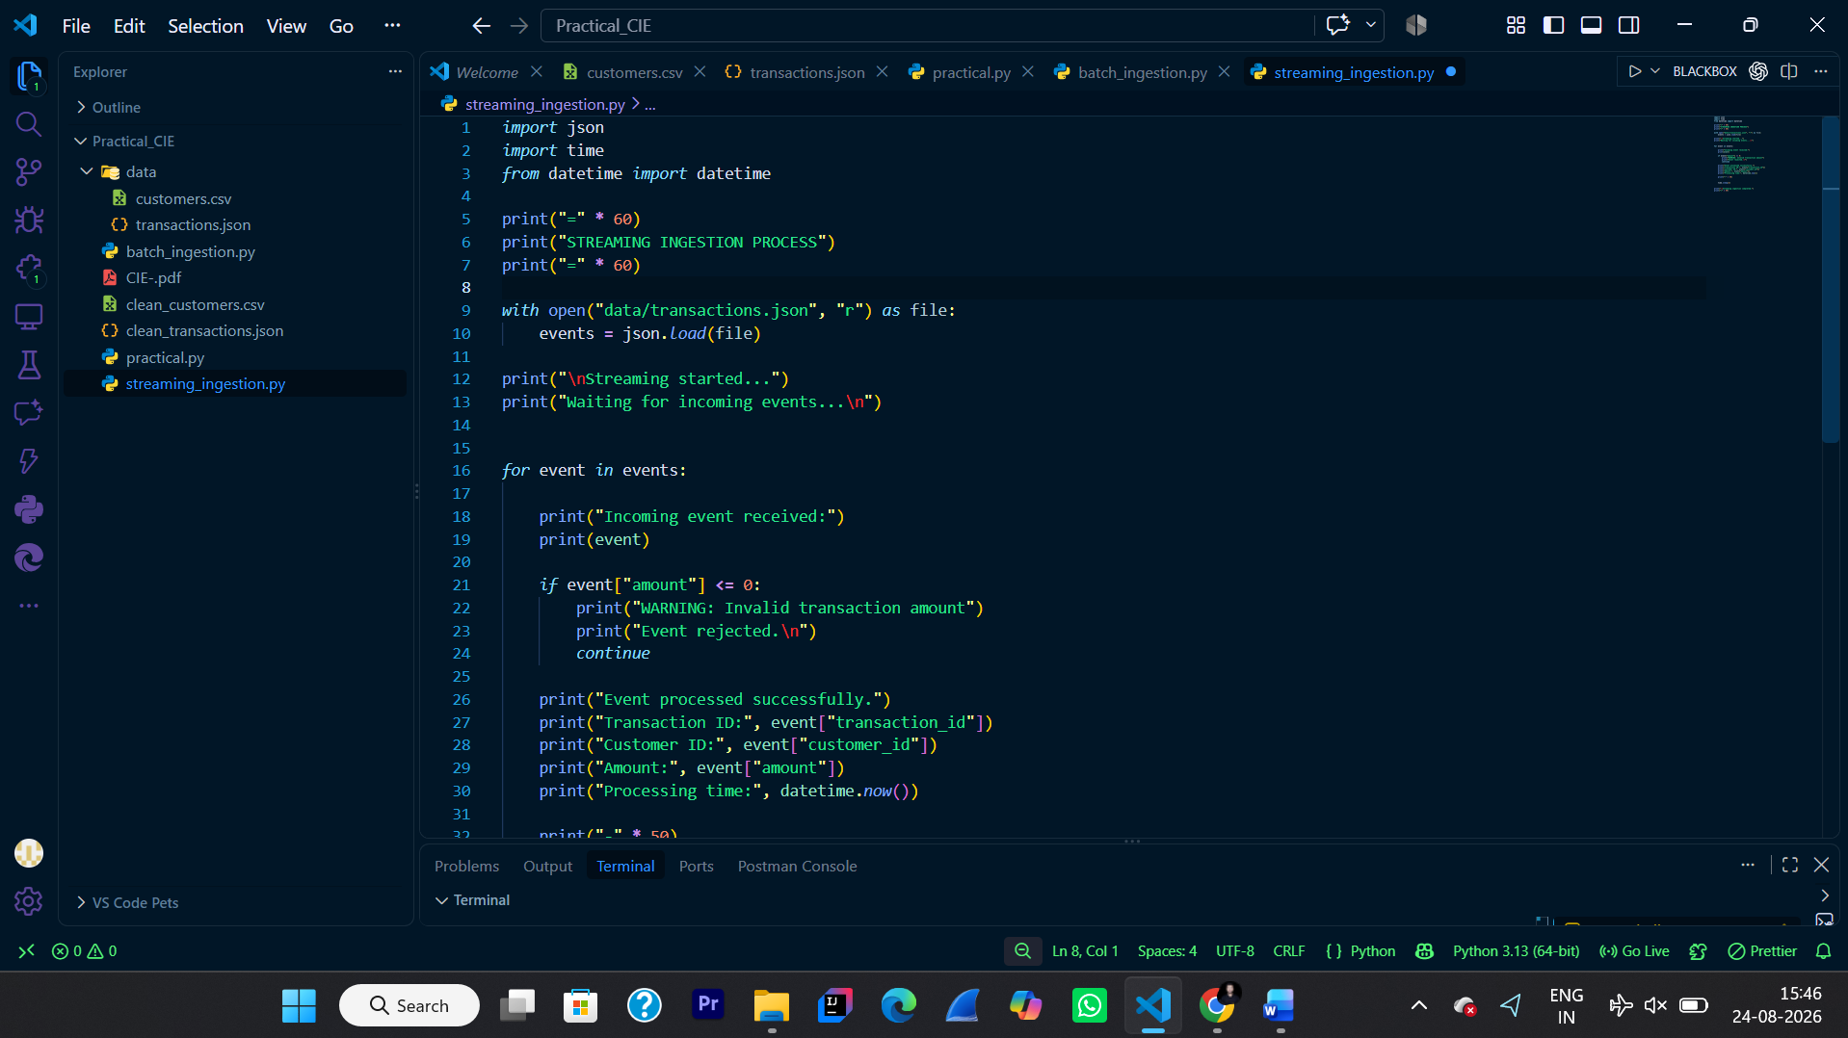

STEP 4 : RUN streaming_ingestion.py
Command – python streaming_ingestion.py

OUTPUT : Streaming ( one by one all event received and processed successfully )
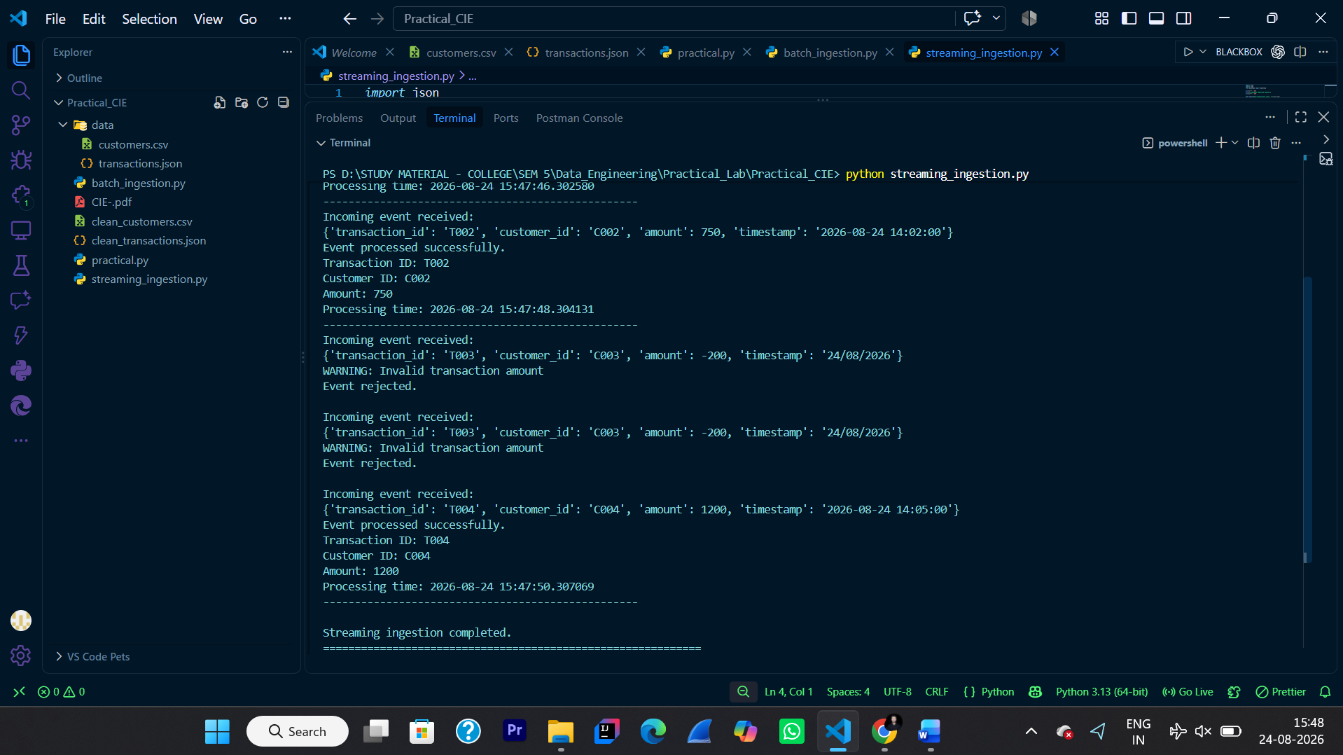

COMPARISION B/W 2 APPROACHES :

BATCH INGESTION :

- Data Processing Latency : Higher
- Throughput : Higher
- Use case : Suitable for large data

STREAMING INGESTION :

- Data Processing Latency : Very Low
- Throughput : Good for continuous incoming data
- Use case : Useful for real time application
TASK 4 : Result and Analysis

For historical transaction processing, batch ingestion is more suitable
For real-time user activity monitoring, streaming ingestion is more suitable.

Conclusion: Batch processing is better when we have a large amount of stored data, while streaming is better when data needs to be processed continuously and quickly.

