CHAROTAR UNIVERSITY OF SCIENCE & TECHNOLOGY

Faculty of Technology & Engineering
Devang Patel Institute of Advance Technology and Research (DEPSTAR)

Data Engineering (ITUC301)
Practical File – ODD Semester 2026–27

Student ID: 24DIT074

Student Name: NANDAN VAKANI

PRACTICAL 3
1. Problem Definition: Design, spin up, and evaluate two parallel data ingestion pipelines: a periodic time-triggered block batch pipeline and a continuous low-latency real-time event streaming processor. Students must capture telemetry statistics and benchmark performance parameters across both options, measuring data delivery latency, processing throughput spikes, and fault tolerance during simulated infrastructure drops.
Objectives :
The main objectives of this practical are:
1. To implement a periodic batch data ingestion pipeline.
2. To implement a real-time event streaming pipeline using Kafka/Redpanda.
3. To generate and process real-time web application activity and server telemetry data.
4. To measure data delivery latency for both pipelines.
5. To measure processing throughput under different workloads.
6. To simulate infrastructure/broker failures and evaluate fault tolerance.
7. To study the effect of traffic spikes on streaming performance.
8. To understand Kafka topic partitions and consumer groups.
9. To compare batch and streaming architectures.
10. To identify suitable real-world applications for each architecture.

Dataset/Test Data:
Real-time web application user activity logs, server performance metrics, and timestamps.

Tools/Technology To Be Used :
Tool / Technology | Purpose
Python | Pipeline implementation and data processing
Pandas | Data manipulation and analysis
Docker | Containerization and infrastructure setup
Apache Kafka / Redpanda | Distributed event streaming
Kafka-Python-NG | Python Kafka producer/consumer communication
VS code | Development and execution environment
Git | Version control and script management
CSV / Log Data | Input/test data

Batch Pipeline Architecture
Data Source → Batch File/Buffer → Scheduled Batch Processor → Pandas Processing → Output
The batch pipeline collects incoming records over a predefined time interval. Once the batch interval is reached, the collected records are processed together using Python and Pandas. This approach reduces the number of individual processing operations but introduces additional latency because records wait until the next batch execution.

Real-Time Streaming Architecture
Data Producer → Kafka Broker → student_latency Topic → Kafka Consumer → Latency Measurement → Output
The real-time streaming pipeline continuously generates and publishes events to the Kafka broker. The events are stored in the student_latency topic and consumed by the Kafka consumer. The consumer processes messages as they arrive and records the reception time to calculate message delivery latency. This approach provides low-latency processing and is suitable for applications requiring continuous event processing.

Docker / Kafka Setup
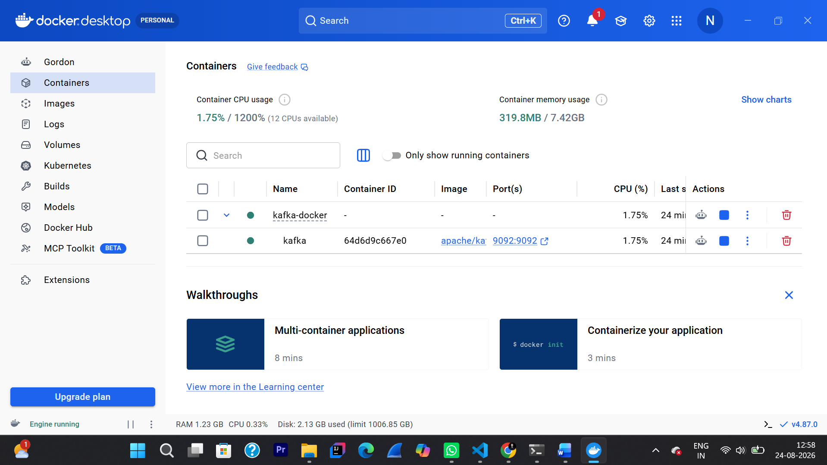

Project Structure
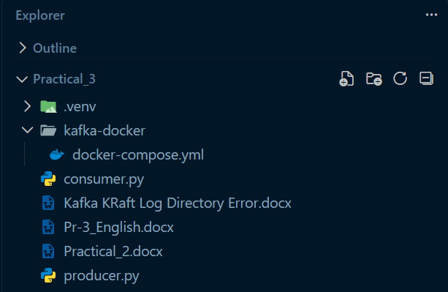

Dataset / Test Data
The test data consists of student records containing ID, name and department.
A timestamp is added to each record before it is sent to the Kafka topic student_latency.
ID Name Department
101 Maharsh IT
102 Dhairya CE
103 Milan CSE

Real-Time Producer Implementation
The Kafka producer sends timestamped student records to the student_latency topic using the Kafka broker at localhost:9092.
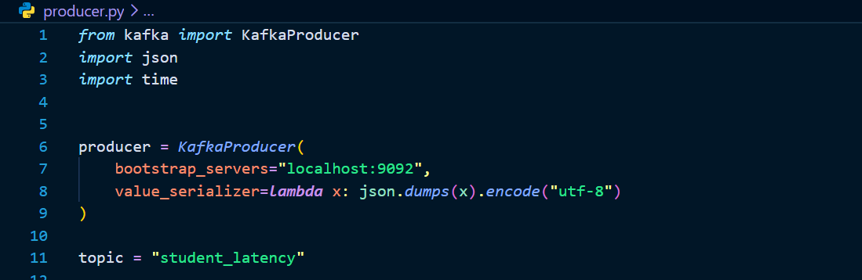

Real-Time Consumer Implementation
The Kafka consumer receives messages from the student_latency topic and processes them continuously.
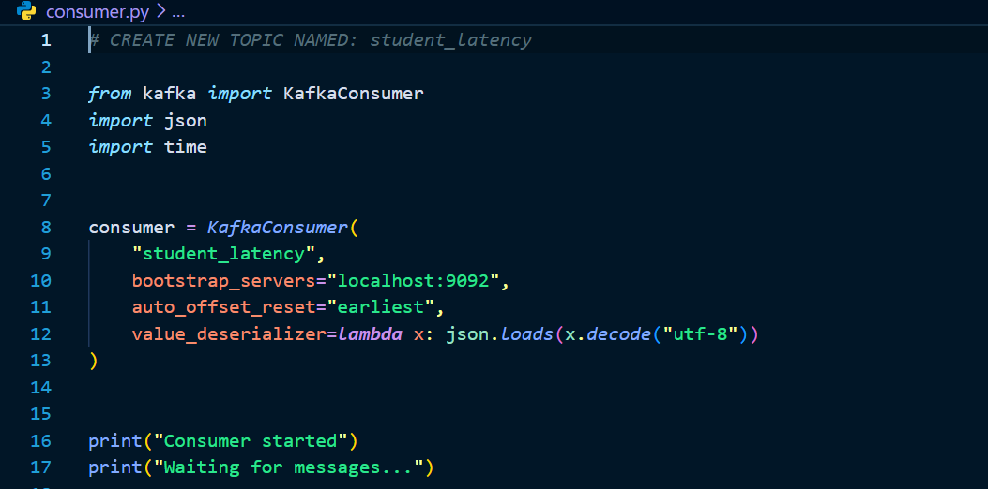

Docker / Kafka Execution
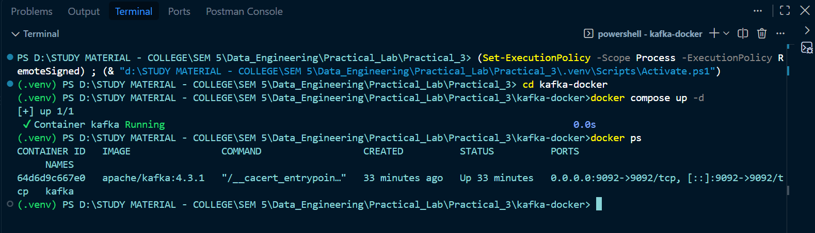
Producer Execution
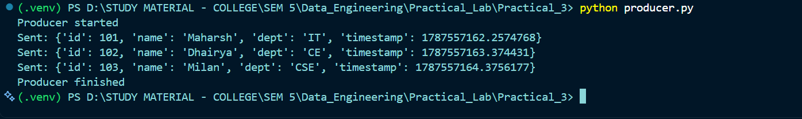
Consumer Execution
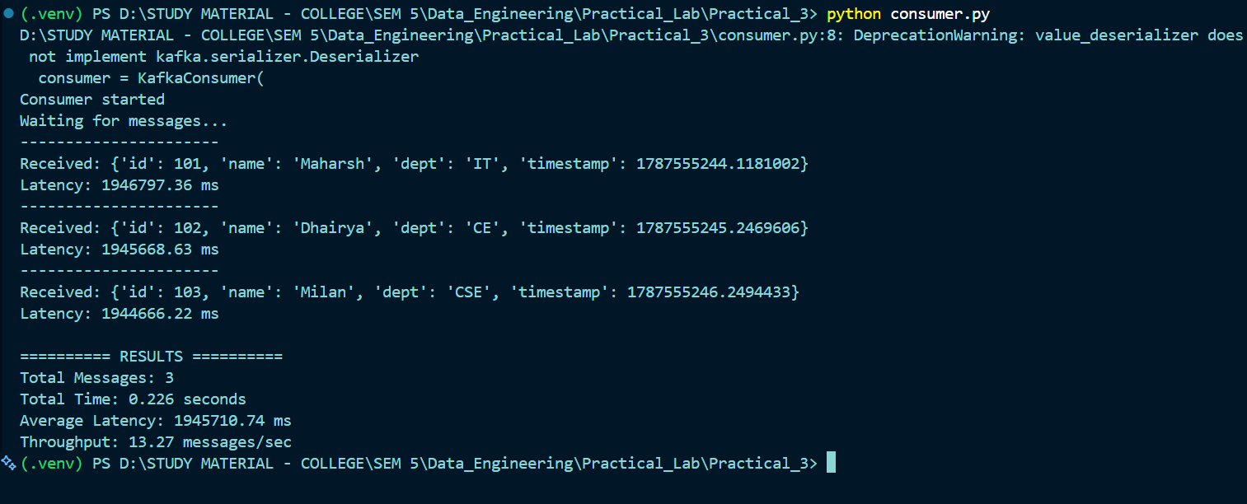
Send Messages
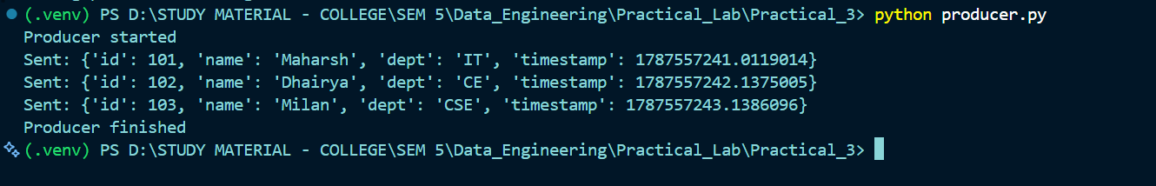
Performance Results
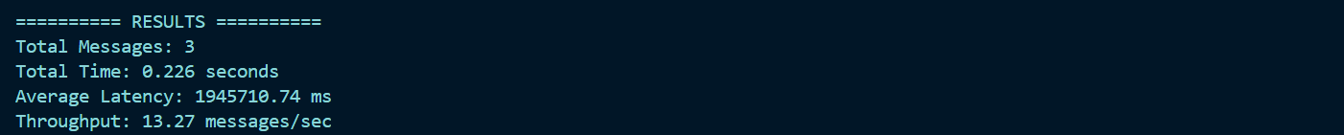

Key Question 1
Micro-batch processing is suitable when immediate processing is not required. It provides lower complexity while still allowing data to be processed at frequent intervals. It is useful for reports, ETL and periodic analytics.
Key Question 2
Kafka maintains reliability using partition replication, acknowledgements and consumer offsets. If a broker fails, another replica can take over depending on the configured replication and availability settings.
Key Question 3
Bulk compression reduces network bandwidth and storage requirements but requires CPU resources. Individual event serialization provides lower latency but introduces additional per-event CPU and network overhead.

Observations
1. Producer successfully sent three student events.
2. Consumer successfully received all three events.
3. Kafka topic student_latency was used for message transfer.
4. Message delivery latency was calculated in milliseconds.
5. Average latency and throughput were calculated successfully.
6. Streaming provides continuous event processing with low latency.

Conclusion
The practical successfully demonstrated a real-time Kafka data ingestion pipeline using Python and Docker. The producer generated timestamped student events and sent them to the student_latency topic. The consumer received the events and calculated latency and throughput. The experiment demonstrated the advantages of real-time streaming for lowlatency event processing.

