**Name – Nandan Shailesh Kasat**

**Kubernetes Task 2**

**Batch: Feb 2024**

Q1.Make a note on:

**a. Pod:** A Pod is the smallest deployable unit of computing that you can create and manage in Kubernetes. A Pod is a group of one or more containers, with shared storage and network resources, and a specification for how to run the containers. Pods are short by nature, if a pod fails, Kubernetes can automatically create a new replica of that pod to continue operations.**b. Replica:** A Kubernetes replica is regarded as an instance or a copy of a Kubernetes pod. It can only truly be considered a pod when it replaces a deleted or evicted pod.**c. ReplicaSet:** A ReplicaSet’s purpose is to maintain a stable set of replica Pods running at any given time. It is often used to guarantee the availability of a specified number of identical Pods. A ReplicaSet is defined with fields, including a selector that specifies how to identify Pods it can acquire, a number of replicas indicating how many Pods it should be maintaining, and a pod template specifying the data of new Pods it should create to meet the number of replicas criteria4.**d. Labels:** Labels are key/value pairs that are attached to objects such as Pods. Labels are intended to be used to specify identifying attributes of objects that are meaningful and relevant to users, but do not directly imply semantics to the core system. Labels can be used to organize and to select subsets of objects.**e. Namespace:** In Kubernetes, namespaces provide a mechanism for isolating groups of resources within a single cluster. Names of resources need to be unique within a namespace, but not across namespaces. Namespace-based scoping is applicable only for namespaced objects (e.g. Deployments, Services, etc.) and not for cluster-wide objects (e.g. Storage Class, Nodes, Persistent Volumes, etc.)

Q2. Show in practical of RC uses with all types of health probes and their file.

Example of a Kubernetes ReplicationController (RC) with liveness, readiness, and startup probes.

1] Liveness:

Replicationliveliness.yml

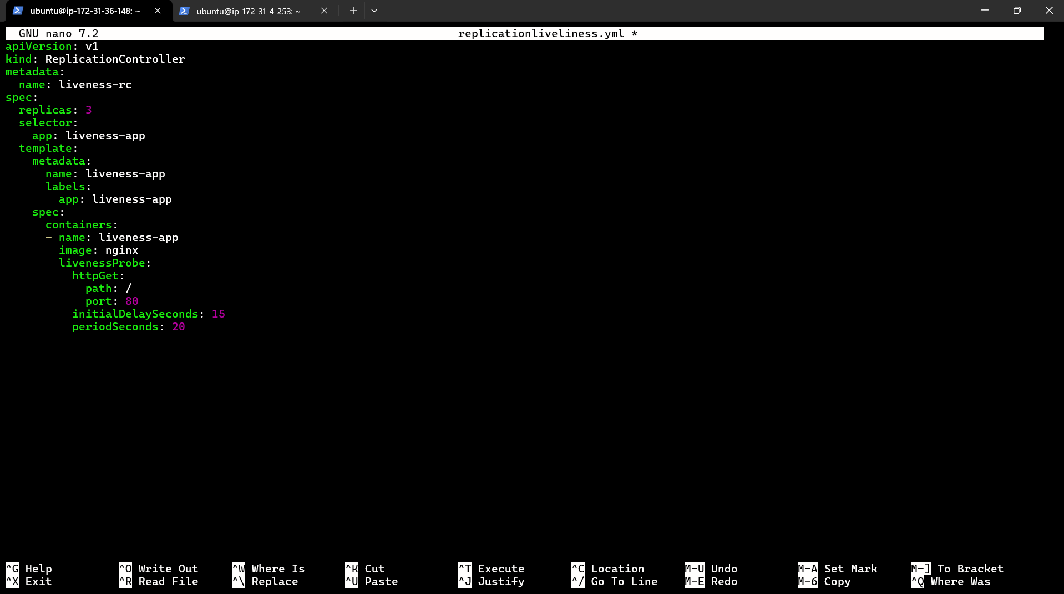

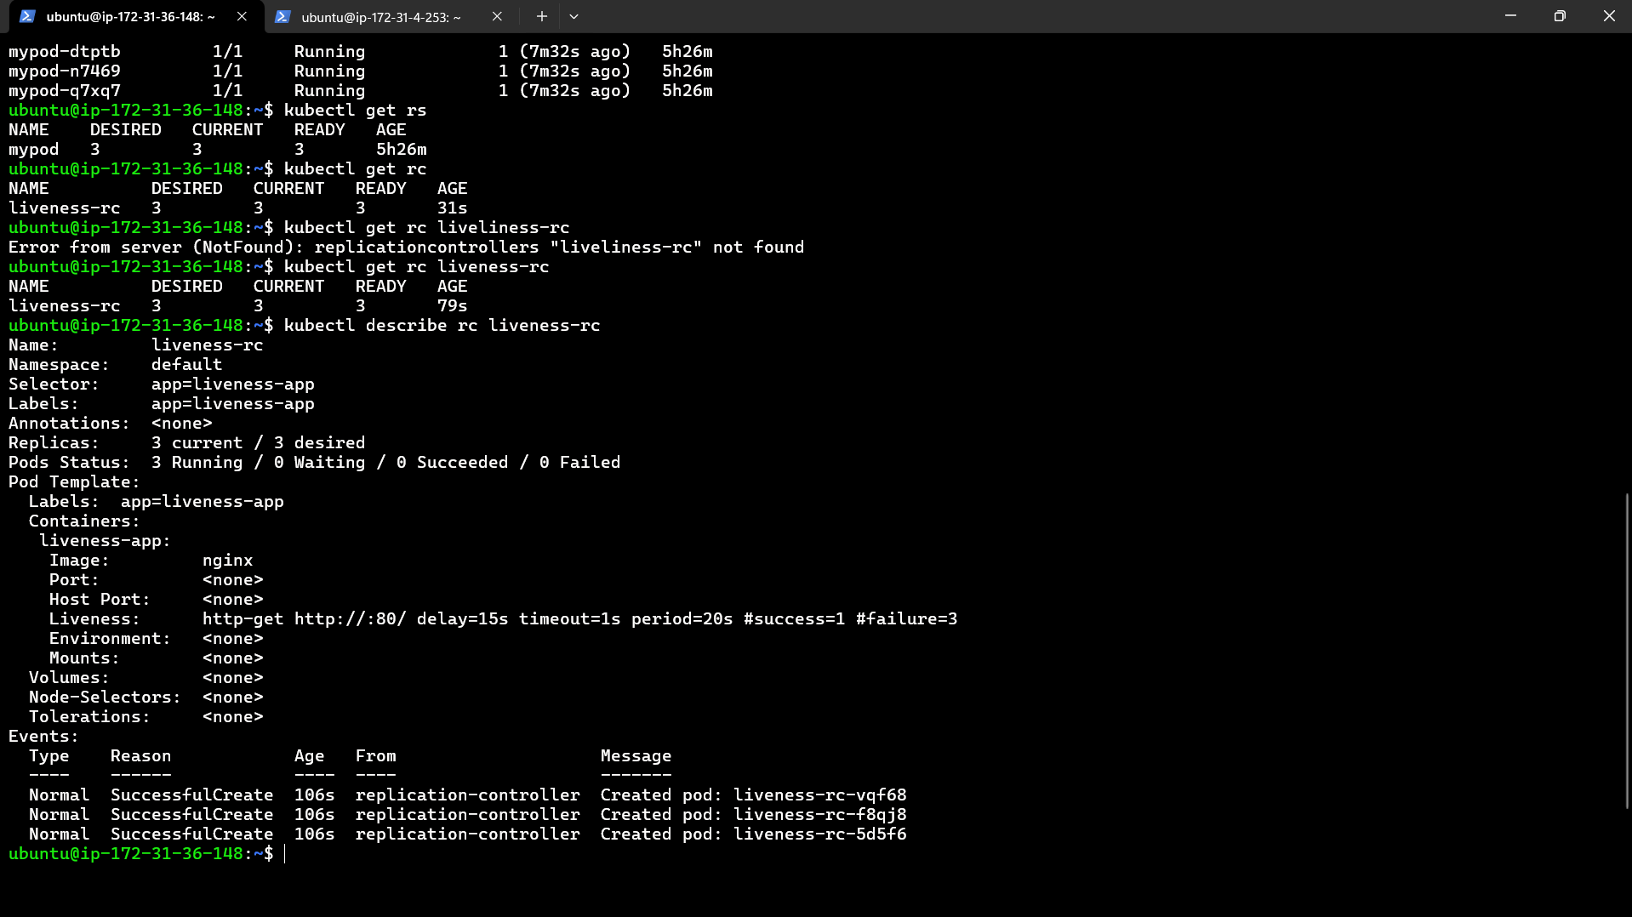

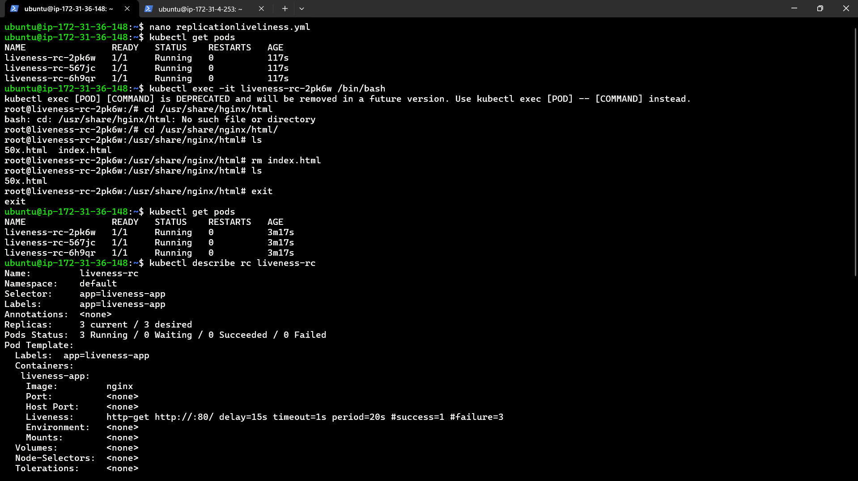

2] Readiness:

Replicationreadiness.yml



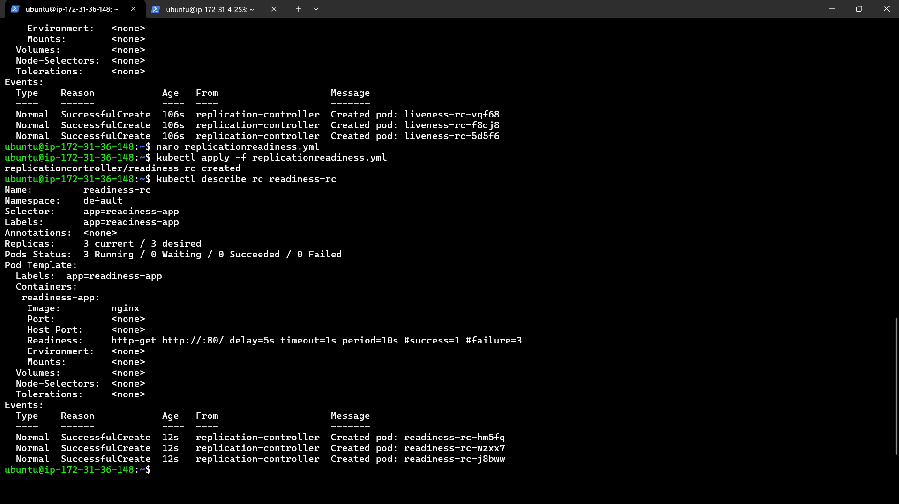

3] Startup:

