BOOTSTRAP ASSIGNMENT – WEB TECHNOLOGIES

NAME : NANDAN N

SRN : PES1UG21CS361

SECTION : F

ROLL NUMBER : 63

Initial Template(before)

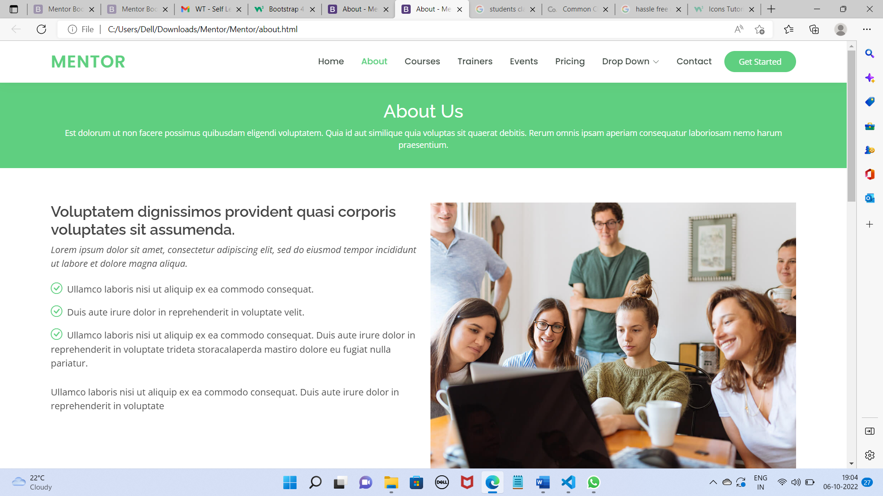

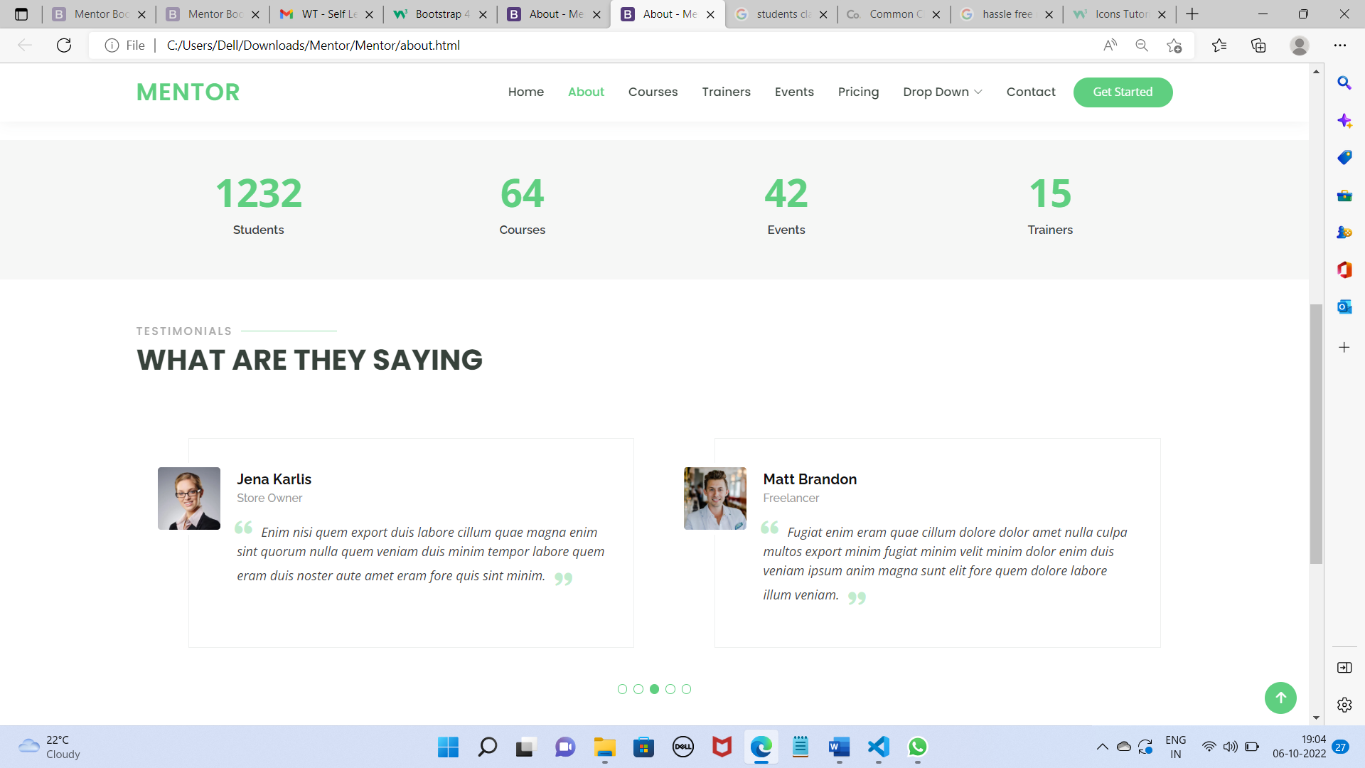

Final Template(After):

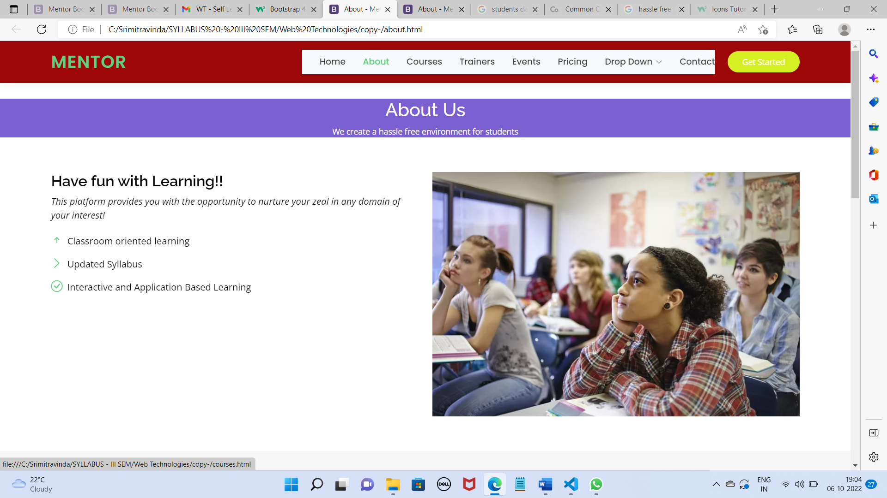

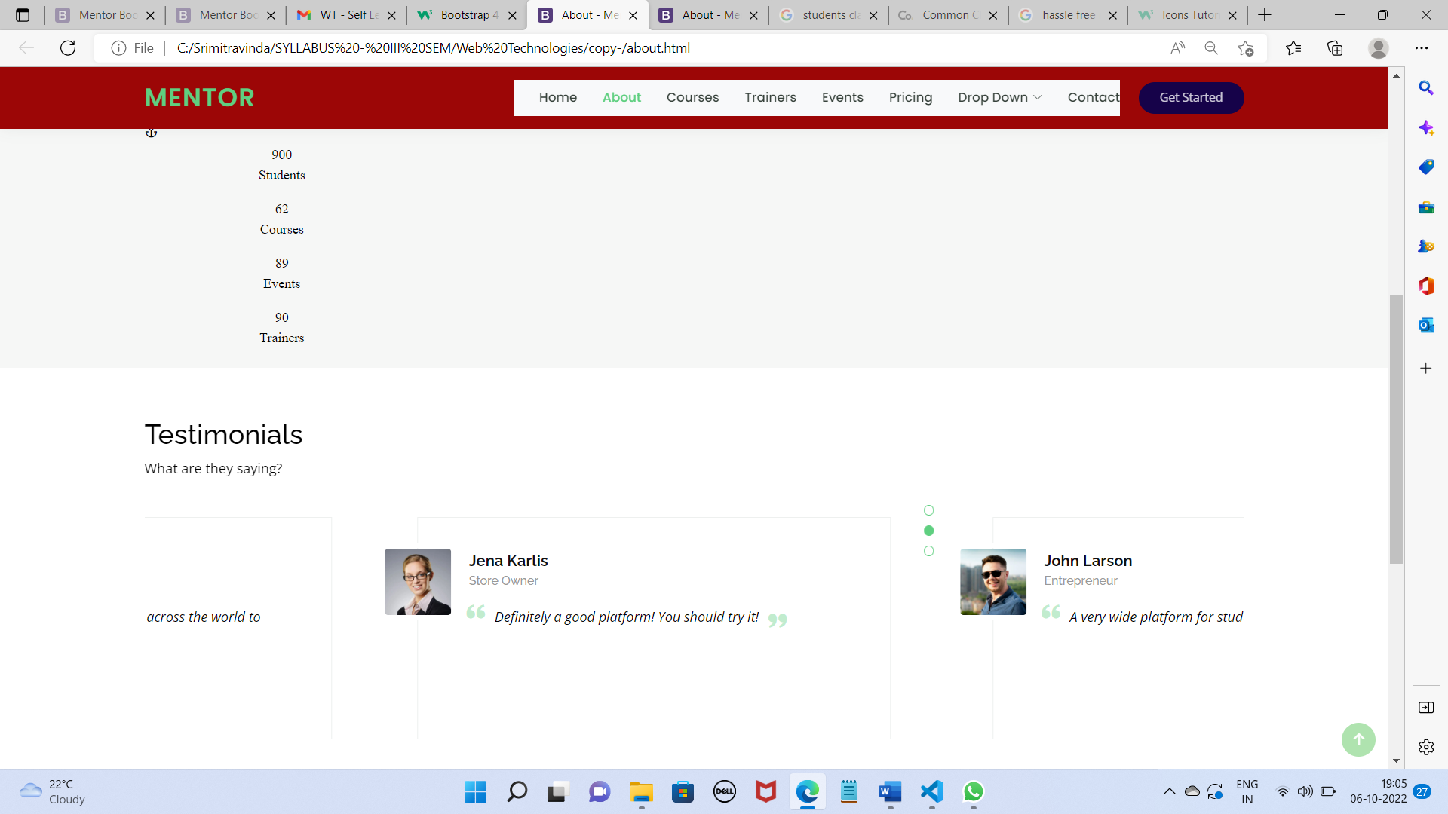

Modifications made:

1. Navbar property changed to navbar-expand-sm
2. -navbar colour properties changed to deep red .

Before:

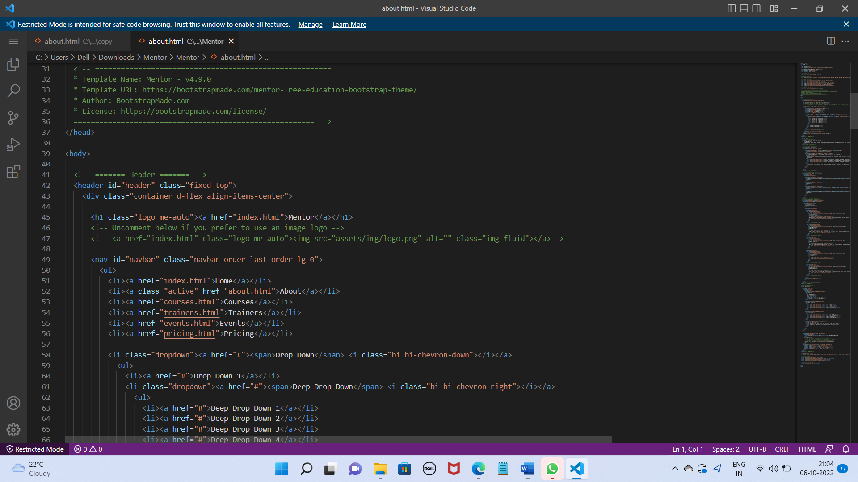

After:

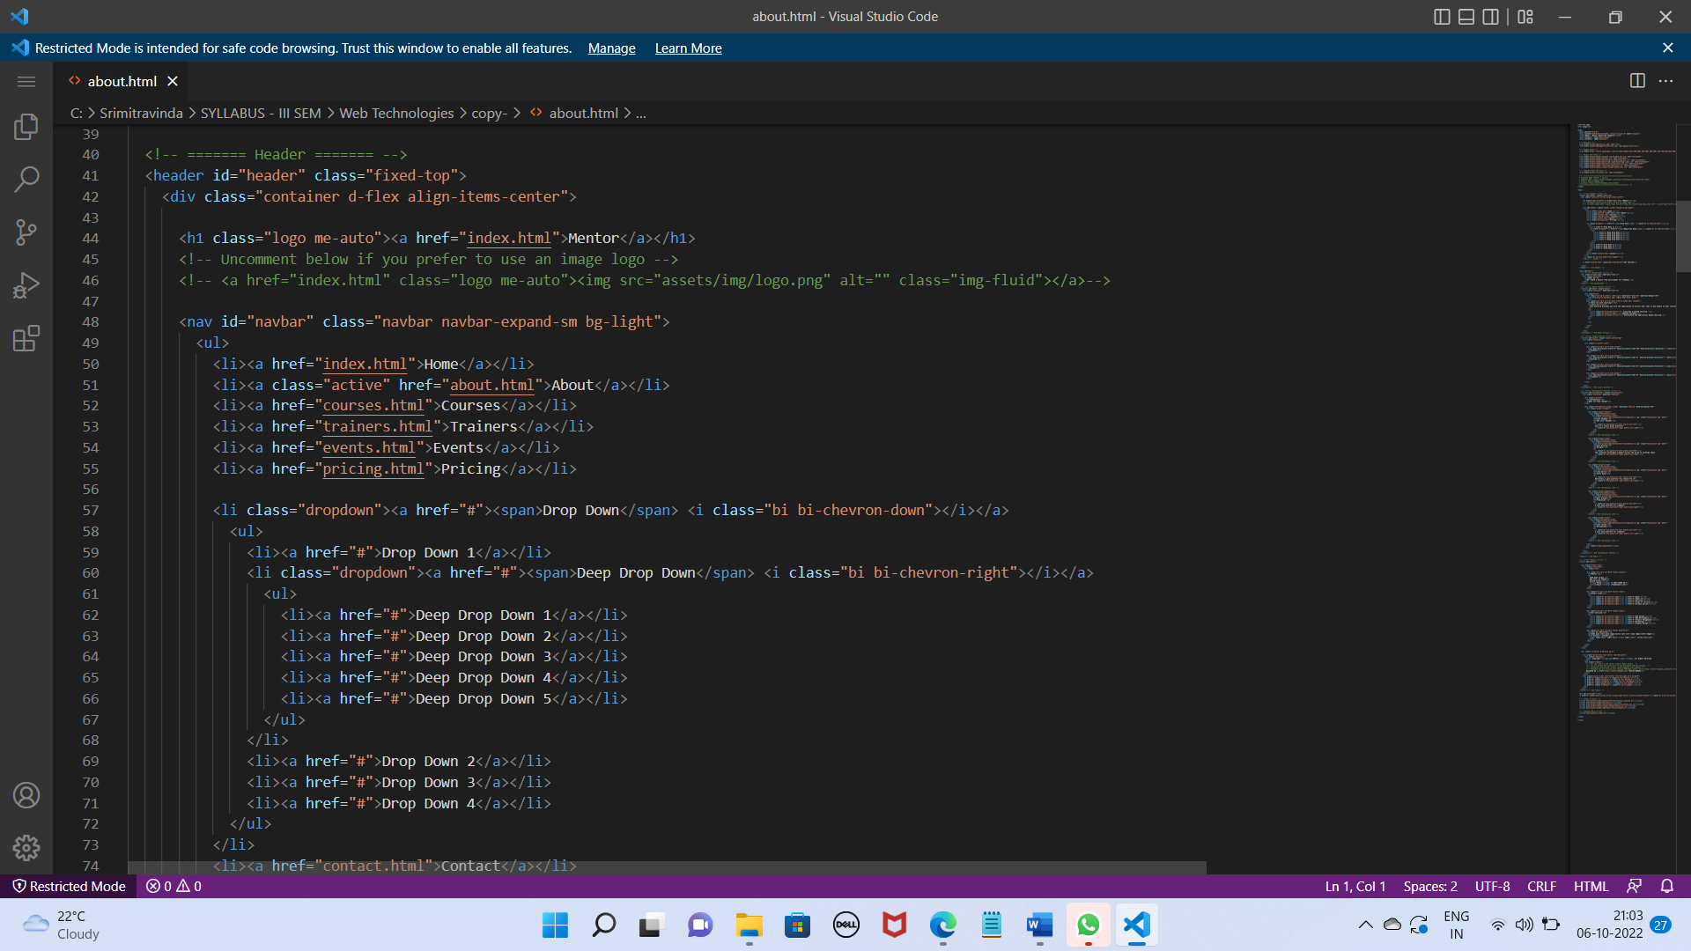

1. “About Us” bar margin properties , colour, padding properties modified.



1. The bulletins used to highlight the content have been changed to different types (bi-arrow-up-short,bi-chevron-right – bi bi check circle being the original

Before:

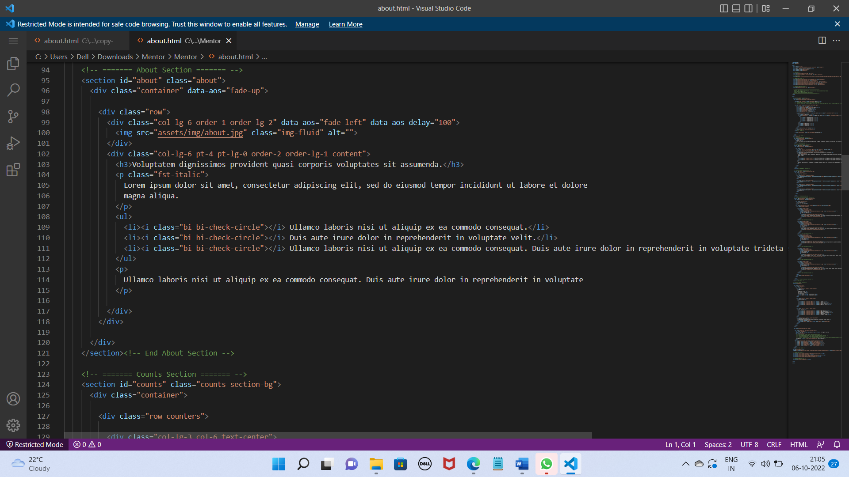

After:

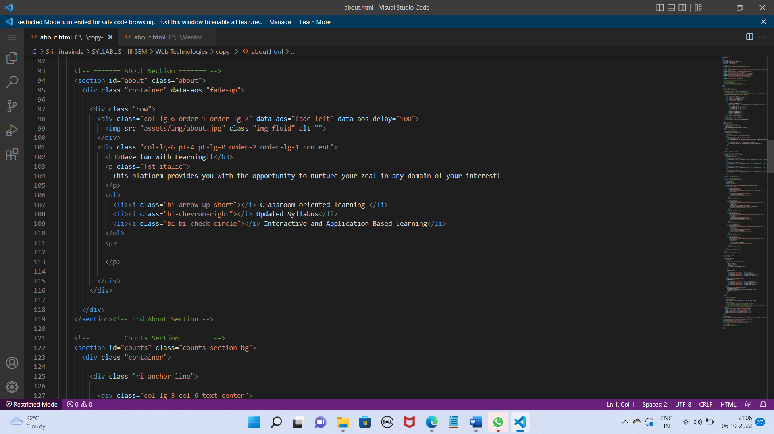

1. Changed the image uploaded in the right and dimensions modified



1. Modified the counts section – “row counters” class initially to “ri-anchor-line”; values also modifed.



Before: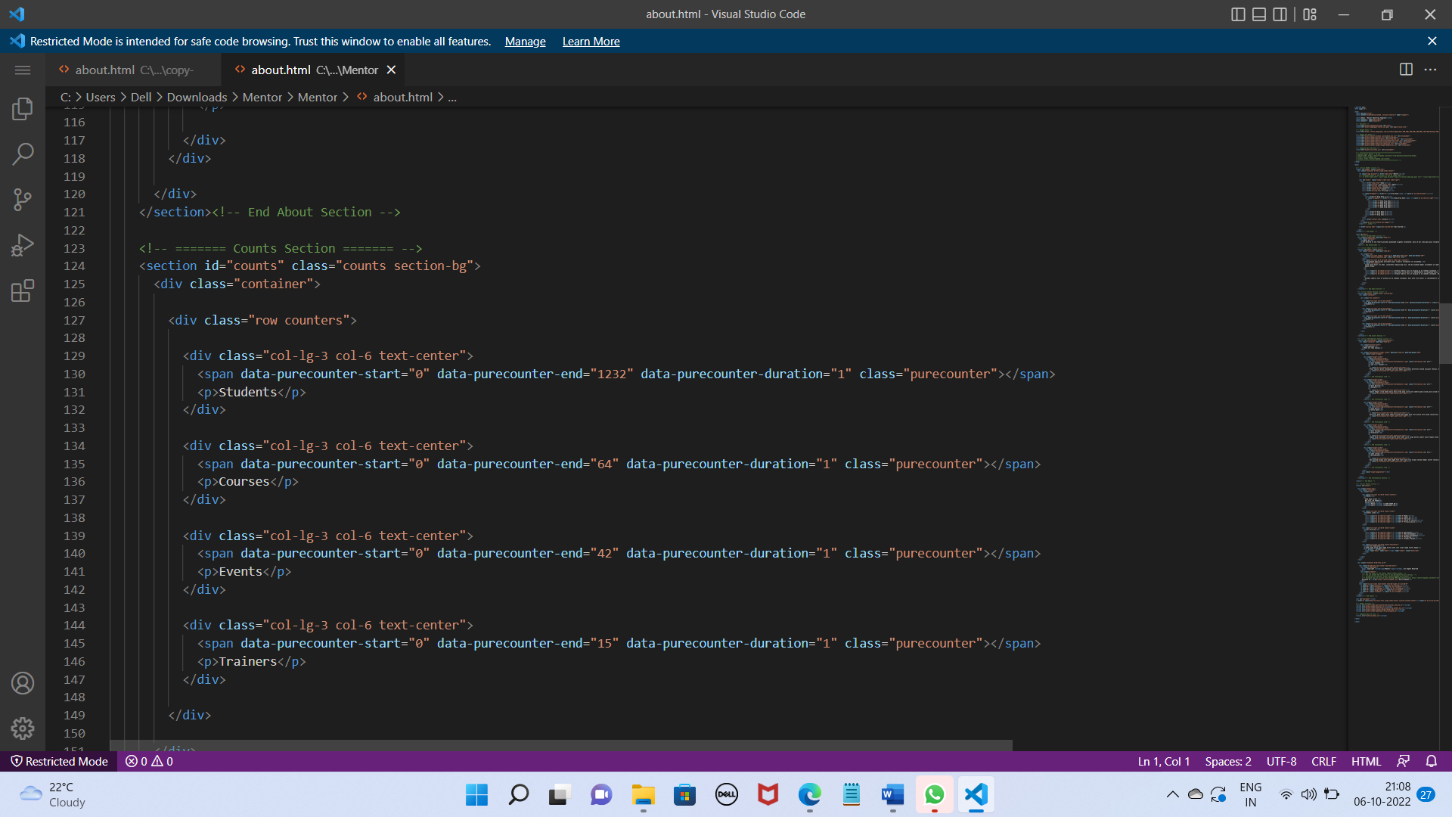

After:

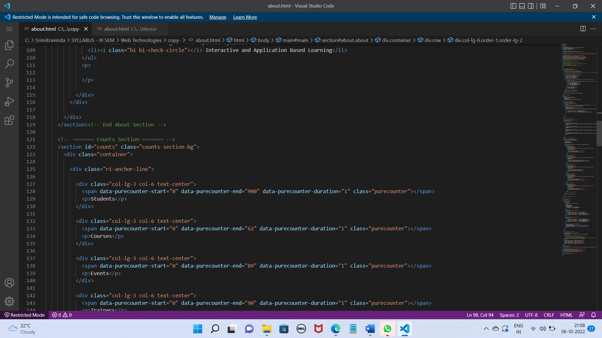

1. Testimonials section – div class changed to “section” from “section-titel

Before:

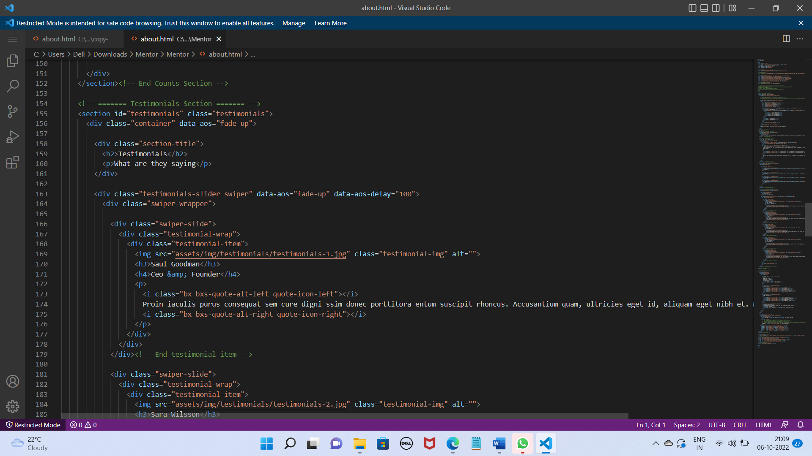

After:

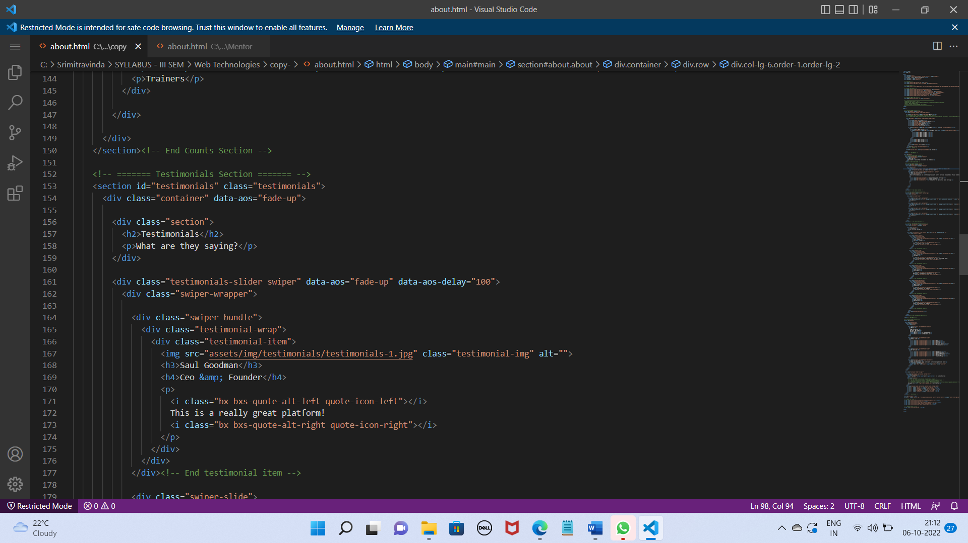

1. Swiper-slide changed to swiper-pagination and swiper-bundle



1. Modified content appropriately throughout the document.