AWS

- EC2
==================================================================================
create instance:

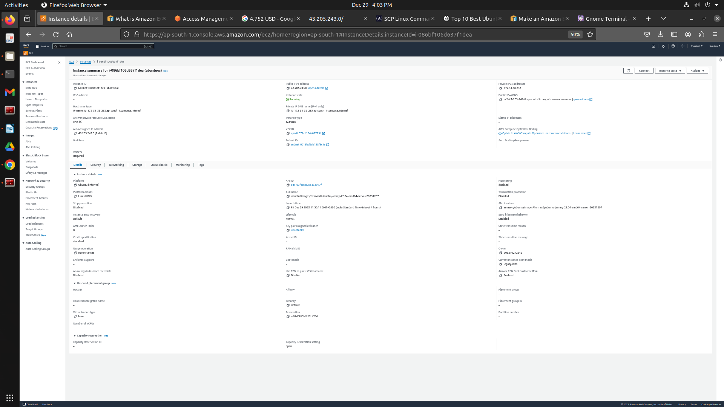
=======================================================================

#Change the permission to only read mode

nandan@cdac:~/CLOUD_COMPUTING/AWS$ chmod 400 "ubantudiot.pem"
nandan@cdac:~/CLOUD_COMPUTING/AWS$ ls -l ubantudiot.pem
-r-------- 1 nandan diot 1678 Dec 29 11:47 ubantudiot.pem

nandan@cdac:~/CLOUD_COMPUTING/AWS$ ssh -i "ubantudiot.pem" ubuntu@ec2-43-205-243-0.ap-south-1.compute.amazonaws.com

##################################################
Instance ID
i-086bf106d637f1dea (ubantuos)
- Open an SSH client.
- Locate your private key file. The key used to launch this instance is ubantudiot.pem
- Run this command, if necessary, to ensure your key is not publicly viewable.
chmod 400 "ubantudiot.pem"
- Connect to your instance using its Public DNS:
ec2-43-205-243-0.ap-south-1.compute.amazonaws.com
####################################################
ubuntu@ip-172-31-38-235:~$ sudo apt install

ubuntu@ip-172-31-38-235:~$ ifconfig
Command 'ifconfig' not found, but can be installed with:
sudo apt install net-tools
ubuntu@ip-172-31-38-235:~$ sudo apt install net-tools

ubuntu@ip-172-31-38-235:~$ ifconfig
eth0: flags=4163<UP,BROADCAST,RUNNING,MULTICAST> mtu 9001
inet 172.31.38.235 netmask 255.255.240.0 broadcast 172.31.47.255

lo: flags=73<UP,LOOPBACK,RUNNING> mtu 65536
inet 127.0.0.1 netmask 255.0.0.0

ubuntu@ip-172-31-38-235:~$ pwd
/home/ubuntu
ubuntu@ip-172-31-38-235:~$ whoami
ubuntu
ubuntu@ip-172-31-38-235:~$ ls
ubuntu@ip-172-31-38-235:~$ sudo apt update
ubuntu@ip-172-31-38-235:~$ sudo apt install mosquitto
ubuntu@ip-172-31-38-235:~$ mosquitto –version //mosquitto version 2.0.11
ubuntu@ip-172-31-38-235:~$ sudo netstat -neltp | grep 1883
tcp 0 0 127.0.0.1:1883 0.0.0.0:* LISTEN 115 27953 2373/mosquitto
tcp6 0 0 ::1:1883 :::* LISTEN 115 27954 2373/mosquitto

ubuntu@ip-172-31-38-235:~$ sudo apt install apache2
ubuntu@ip-172-31-38-235:~$ sudo service apache2 start
ubuntu@ip-172-31-38-235:~$ sudo service apache2 status

ubuntu@ip-172-31-38-235:/var/www/html$ sudo nano index.html
ubuntu@ip-172-31-38-235:/var/www/html$
ubuntu@ip-172-31-38-235:/var/www/html$ sudo nano index_bkp.html
ubuntu@ip-172-31-38-235:/var/www/html$ cat index_bkp.html
<!DOCTYPE html>
<html>
<body>

<h1>DIoT - Cloud</h1>

<p>CDAC PUNE</p>

</body>
</html>
ubuntu@ip-172-31-38-235:/var/www/html$ sudo rm index.html

ubuntu@ip-172-31-38-235:/var/www/html$ sudo cp index_bkp.html index.html
ubuntu@ip-172-31-38-235:/var/www/html$ sudo service apache2 restart

#########################################
nandan@cdac:~/.ssh$ ssh-keygen -t rsa -f ~/.ssh/id_rsa
nandan@cdac:~/.ssh$ cat id_rsa.pub //copy
ubuntu@ip-172-31-38-235:~/.ssh$ ssh-keygen -t rsa -f ~/.ssh/id_rsa
ubuntu@ip-172-31-38-235:~/.ssh$ sudo nano authorized_keys //paste here
nandan@cdac:~/.ssh$ ssh ubantu@43.205.243.0 //after run this
###########################################

to copy from local to Cloud in local terminal
nandan@cdac:~/Downloads$ scp -i ubantudiot.pem <file_name> ubuntu@43.205.243.0:/home/ubuntu //with key
nandan@cdac:~/Downloads$ scp <file_name> ubuntu@43.205.243.0:/home/ubuntu //without using key

to copy from Cloud to local in local terminal
nandan@cdac:~/Downloads$ scp ubuntu@43.205.243.0:/home/ubuntu/<file_name> . // to current directory (i.e Downloads)
nandan@cdac:~/Downloads$ scp ubuntu@43.205.243.0:/home/ubuntu/<file_name> /home/diot/Desktop/
=====================================================================================
create volume:
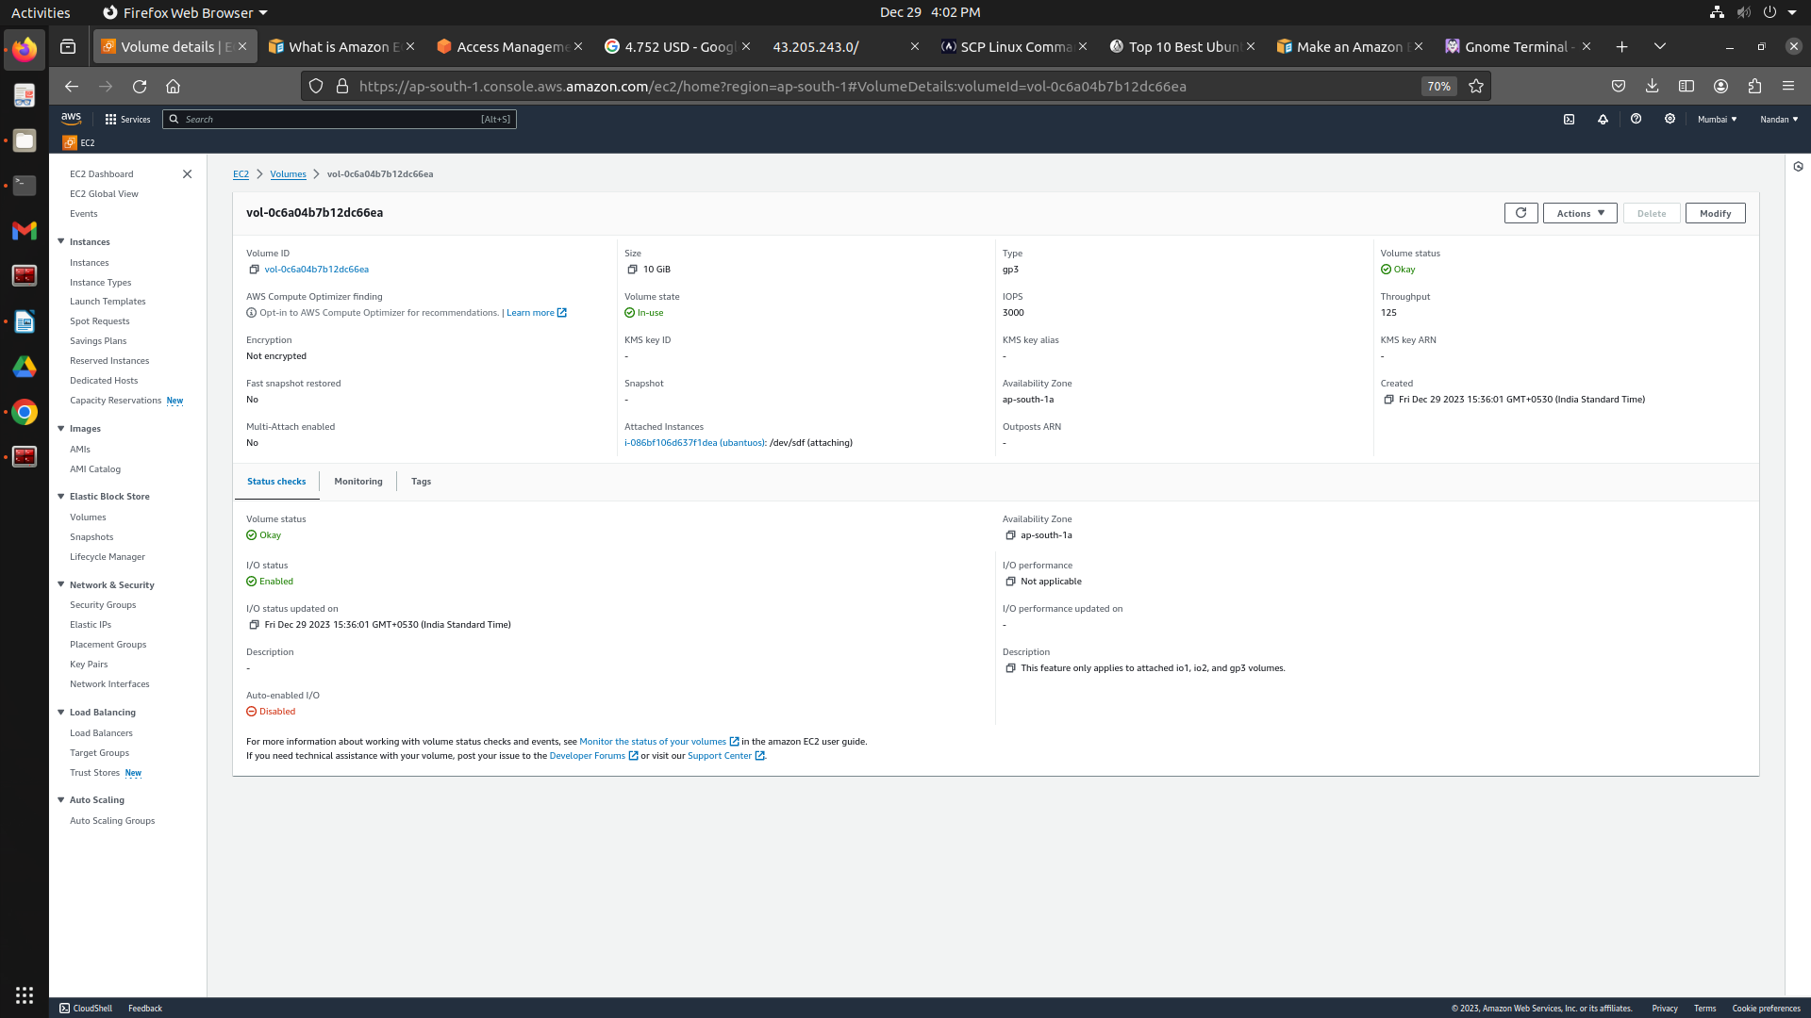

====================================================================================
ubuntu@ip-172-31-38-235:~$ sudo fdisk -l //to check file disk

ubuntu@ip-172-31-38-235:~$ lsblk //shows how much volume used for different

ubuntu@ip-172-31-38-235:~$ sudo file -s /dev/xvda1
/dev/xvda1: Linux rev 1.0 ext4 filesystem data, UUID=9e71e708-e903-4c26-8506-d85b84605ba0, volume name "cloudimg-rootfs" (needs journal recovery) (extents) (64bit) (large files) (huge files)

ubuntu@ip-172-31-38-235:~$ sudo file -s /dev/xvdf
/dev/xvdf: data //data means no file attached

ubuntu@ip-172-31-38-235:~$ sudo lsblk -f //command to get information about all of the devices attached to the instance.

ubuntu@ip-172-31-38-235:~$ sudo mkfs -t ext3 /dev/xvdf
mke2fs 1.46.5 (30-Dec-2021)
Creating filesystem with 2621440 4k blocks and 655360 inodes

ubuntu@ip-172-31-38-235:~$ sudo mkdir /data

ubuntu@ip-172-31-38-235:~$ sudo mount /dev/xvdf /data

ubuntu@ip-172-31-38-235:~$ sudo lsblk -f

ubuntu@ip-172-31-38-235:~$ sudo chmod 777 /data
//drwxrwxrwx 3 root root 4096 Dec 29 10:27 data check it using (ls -l)

