1. Create a new repository.

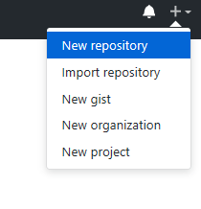

1. Enter repository name and create repository.

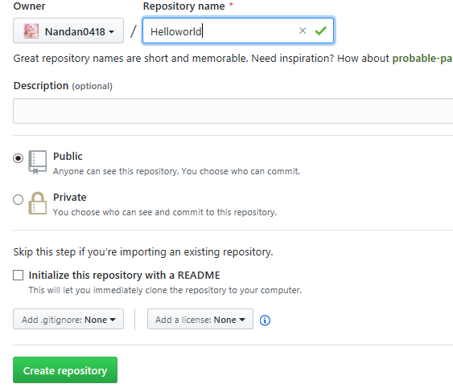

1. Create a new file in repository(Create new file).

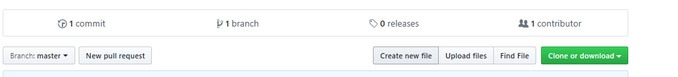

1. Enter file name, file content and commit.

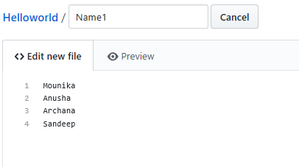

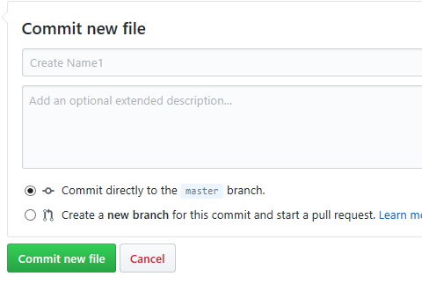

1. File <Name1> is created.

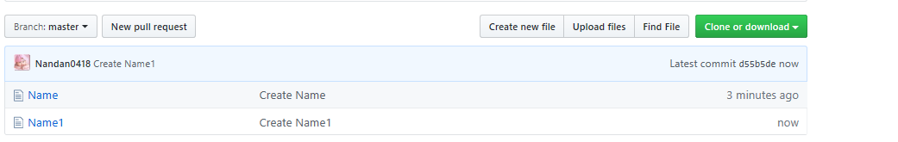

1. Add Branch. Enter Branch name and create Branch.

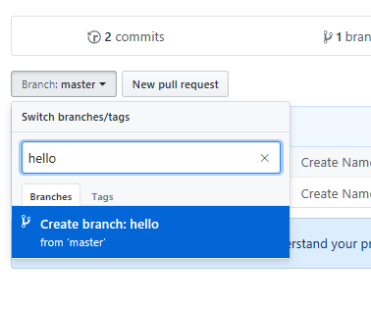

1. Branch <hello> is created with content same as master.

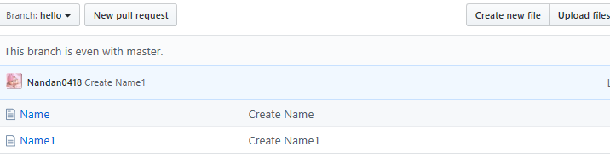

1. Create new file in branch and commit.



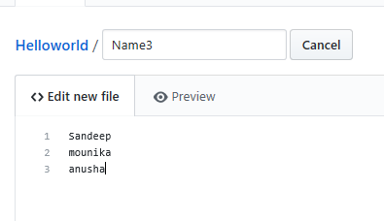

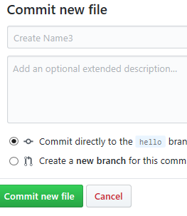

1. Branch <hello> contains <name>, <name1>, <name3>.

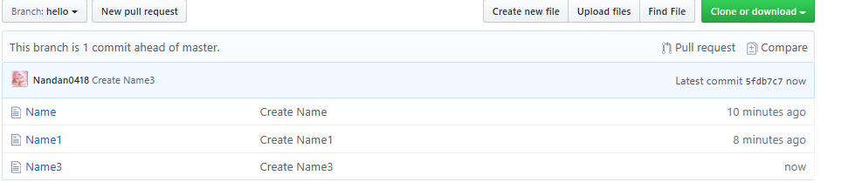

1. Master contains <name>, <name1>.

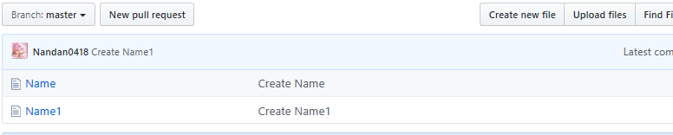

1. Pull request to compare and merge branch <hello> to master.



1. Select branch <hello> to compare.

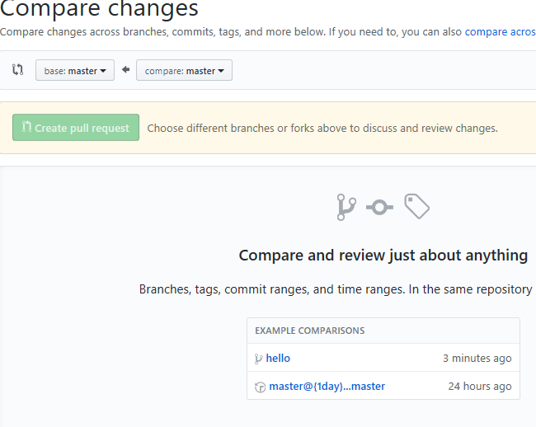

1. Displays the differences from master and create pull request.

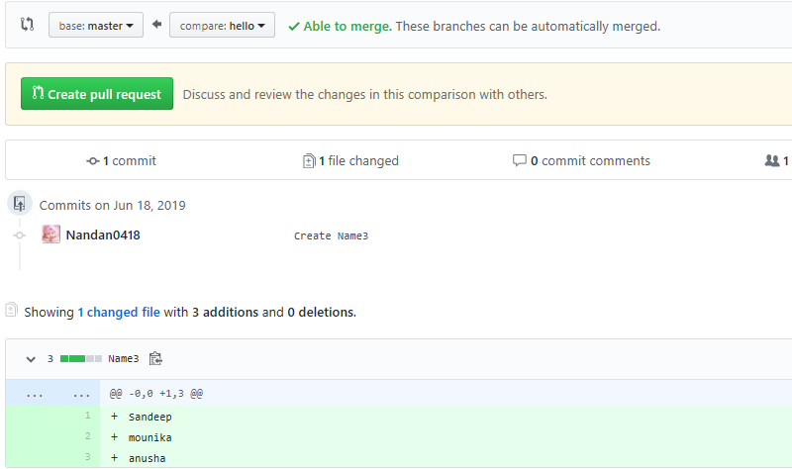

1. Write title, comment and Create Pull request.

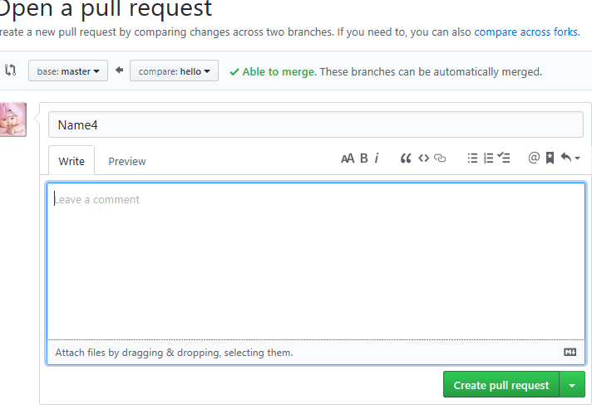

1. Merge Pull request and confirm merge.

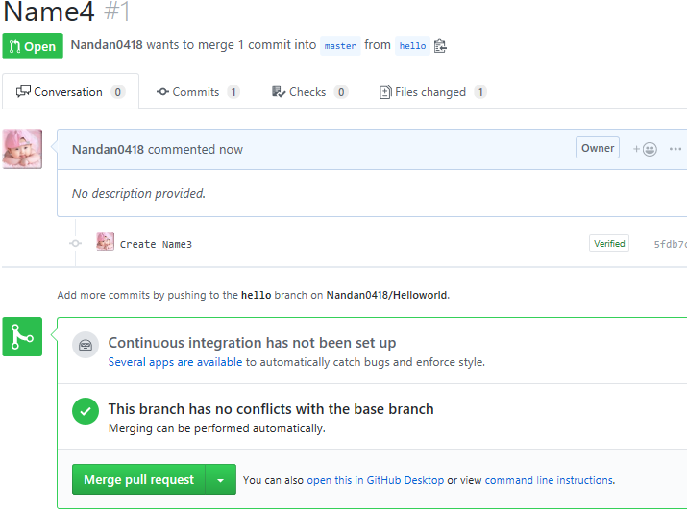

1. Once merged, delete the branch.

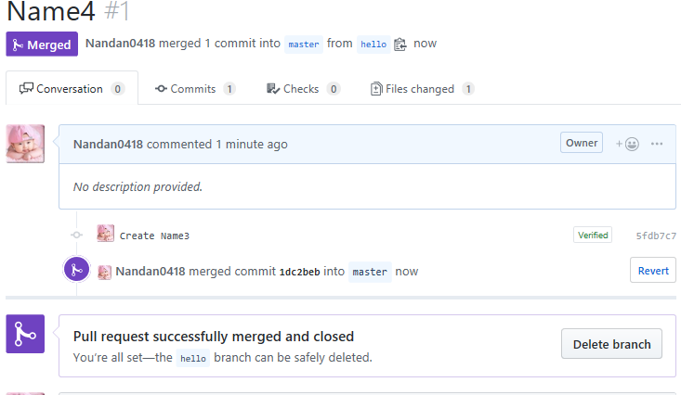

1. Branch <hello> is deleted(only master is rpesent) and <name3> is moved to master.

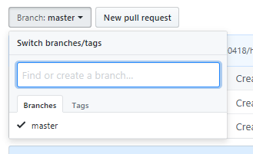

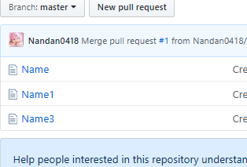

1. Add Folder in a repository- Create new file.

File name - <FolderName>\<file name>

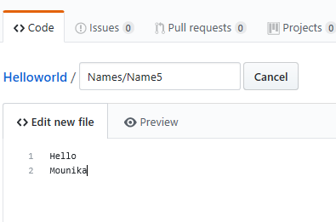

Commit

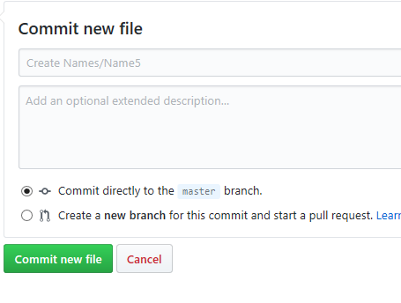

1. Folder <Names> is created in repository and <name5> inside the folder.

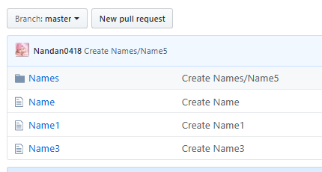

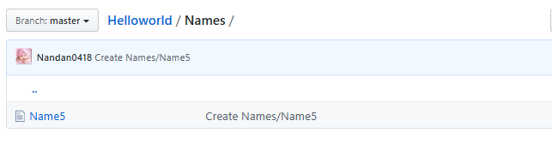

1. Fork – to copy from other repositories.

