EV Scooter Assembly Line Optimization
Lean Manufacturing + OEE + Bottleneck Analysis
Portfolio project based on synthetic manufacturing data
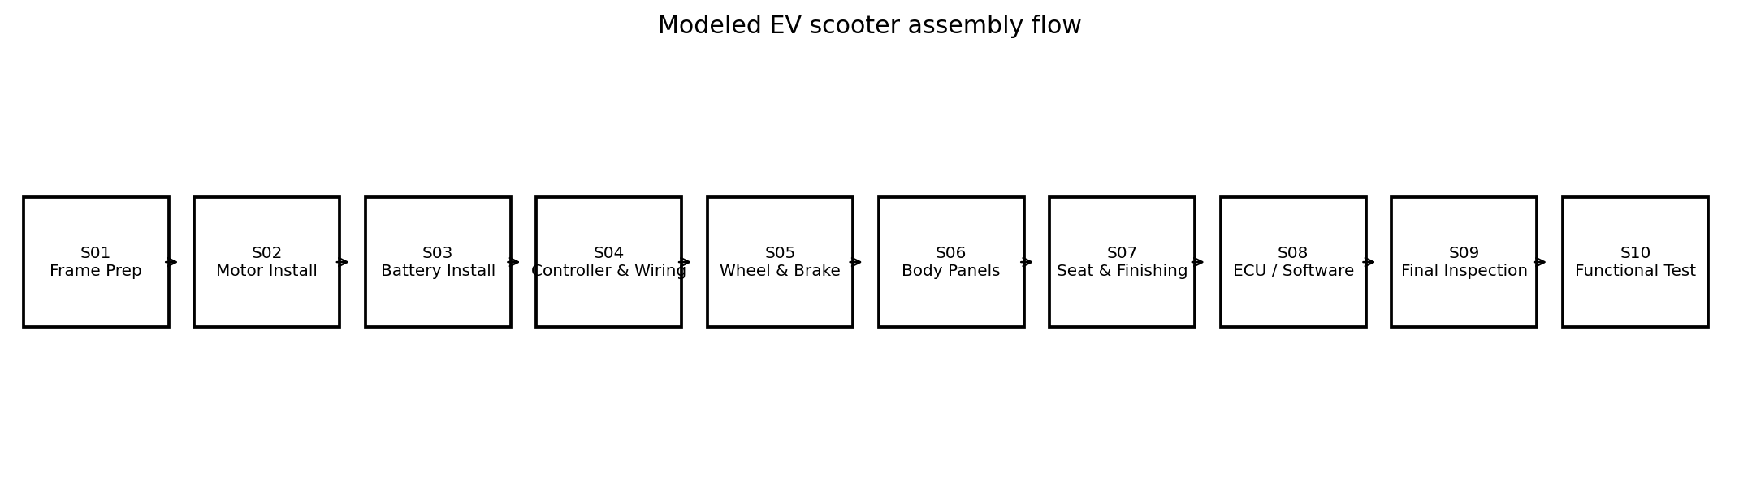
Figure 1. Modeled 10-station EV scooter assembly flow.

1. Executive Summary
Objective. Diagnose why a simulated EV scooter assembly line misses its production plan and define a Lean improvement roadmap that links cycle time, OEE, downtime, defects, and capacity.
Current state. Across 30 production days (600 station-shift records), the modeled final station processed 11,560 units against 15,502 planned units (74.6% plan attainment) and delivered 11,225 good units (97.1% good yield). The reference takt is 100.8 seconds; S05 Wheel & Brake averages 117.5 seconds, 16.7 seconds (16.6%) above takt.
Priority logic. S05 is treated as the primary cycle-time constraint. The largest loss buckets are material shortage and minor stops; the largest defect modes are fitment/alignment and wiring/connector. The improvement sequence therefore starts with S05 work-content/tooling, then S04 wiring/poka-yoke and material flow.

2. Project Scope and Dataset
Item | Value
Production horizon | 30 production days
Station-shift records | 600
Stations | 10
Shifts | 2 per day
Reference daily demand | 500 units/day
Reference takt | 100.8 sec/unit
Data status | Synthetic / simulated; not Ather factory data
Source alignment. The supplied Ather Operational Excellence JD emphasizes flow mapping, Muda/waste identification, ground-zero problem solving and visual tracking; the supplied Manufacturing Operations JD emphasizes process modification, PFMEA, poka-yoke, pilot production, plan-vs-actual, takt time and OEE. This project is intentionally structured around those capabilities.

3. Current-State Line Balance
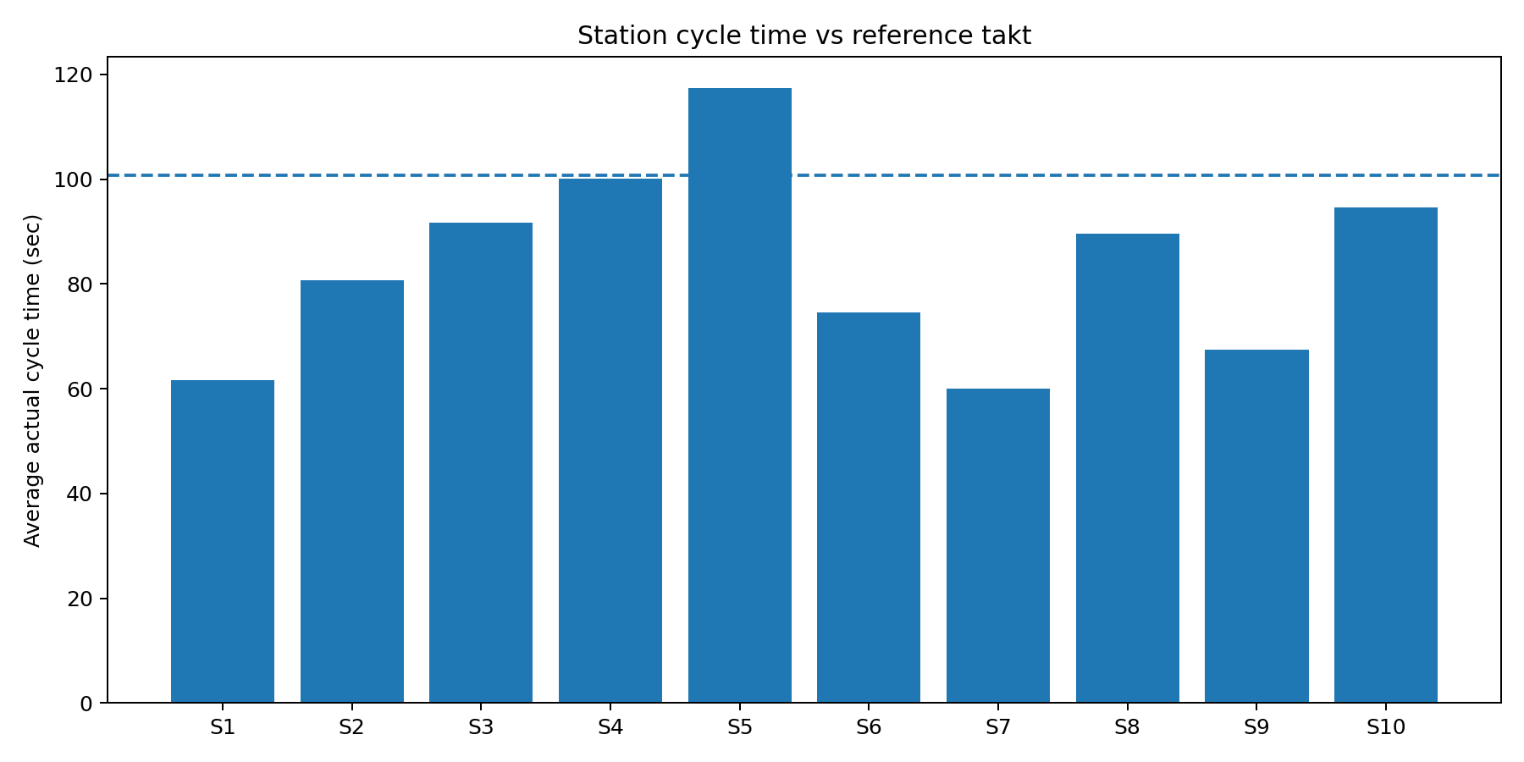
Figure 2. Average actual cycle time by station with a reference takt line at 100.8 seconds.
ID | Station | Ideal CT | Actual CT | Gap vs Takt | OEE | Plan Att.
S01 | Frame Prep | 60 | 61.6 | -39.2 | 48.2% | 76.9%
S02 | Motor Install | 78 | 80.8 | -20.0 | 62.6% | 76.8%
S03 | Battery Install | 88 | 91.7 | -9.1 | 69.9% | 77.0%
S04 | Controller & Wiring | 95 | 100.1 | -0.7 | 73.7% | 76.6%
S05 | Wheel & Brake | 110 | 117.5 | +16.7 | 83.7% | 73.9%
S06 | Body Panels | 72 | 74.6 | -26.2 | 55.8% | 75.0%
S07 | Seat & Finishing | 58 | 60.1 | -40.7 | 45.6% | 75.3%
S08 | ECU / Software | 85 | 89.6 | -11.2 | 64.7% | 74.6%
S09 | Final Inspection | 65 | 67.4 | -33.4 | 50.1% | 74.5%
S10 | Functional Test | 90 | 94.7 | -6.1 | 69.0% | 74.6%
Interpretation. S05 has the largest positive cycle-time gap (16.7 sec). Its OEE is not the lowest station OEE (83.7%), which illustrates why bottleneck identification should use both cycle-time and OEE/loss views rather than selecting the station with the lowest OEE automatically.

4. OEE Analysis
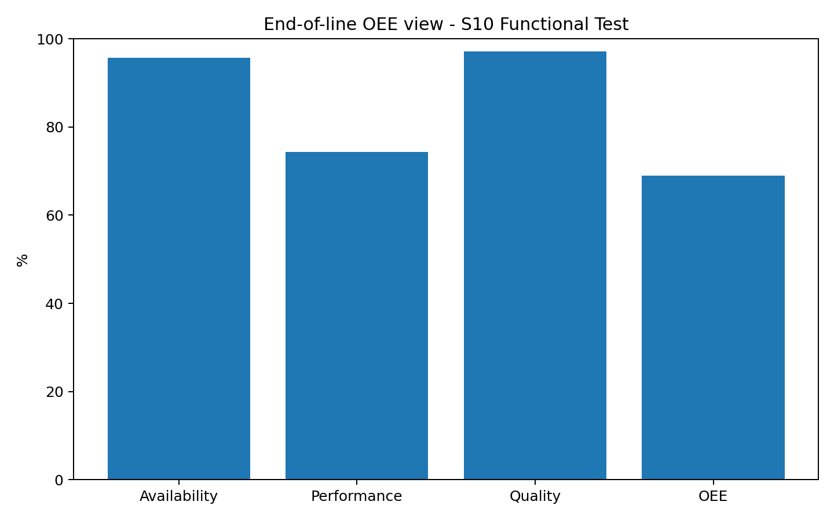
Figure 3. End-of-line OEE components for S10 Functional Test.
Metric | S10 / Line View
Availability | 95.7%
Performance | 74.3%
Quality | 97.1%
Weighted OEE | 69.0%
Reading the OEE. Availability is relatively high while performance is the largest component drag at the end-of-line station. This is consistent with a line that is not using the scheduled production window to its full theoretical rate; it should be read together with starvation, bottleneck and plan-attainment evidence.

5. Downtime and Quality Losses
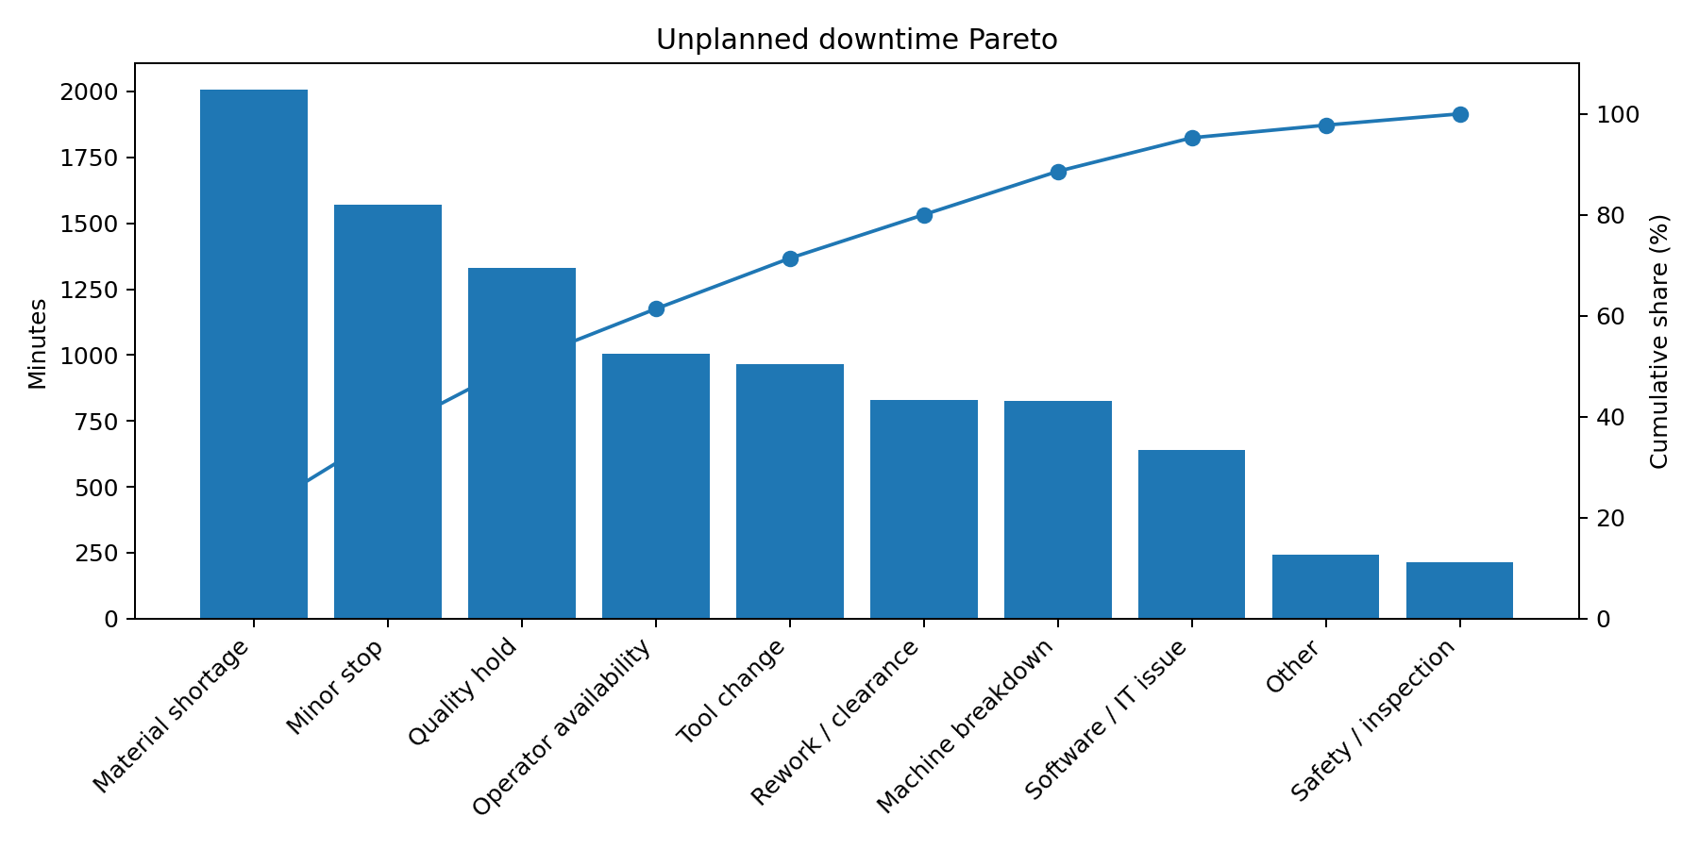
Figure 4. Unplanned downtime Pareto across all station-shift records.
Rank | Downtime reason | Minutes | Share
1 | Material shortage | 2,006 | 20.8%
2 | Minor stop | 1,572 | 16.3%
3 | Quality hold | 1,329 | 13.8%
4 | Operator availability | 1,006 | 10.4%
5 | Tool change | 965 | 10.0%
6 | Rework / clearance | 831 | 8.6%
Key signal. Material shortage is 20.8% of unplanned downtime and minor stops are 16.3%. This points to a combined material-availability and micro-stop problem rather than a single catastrophic machine failure.
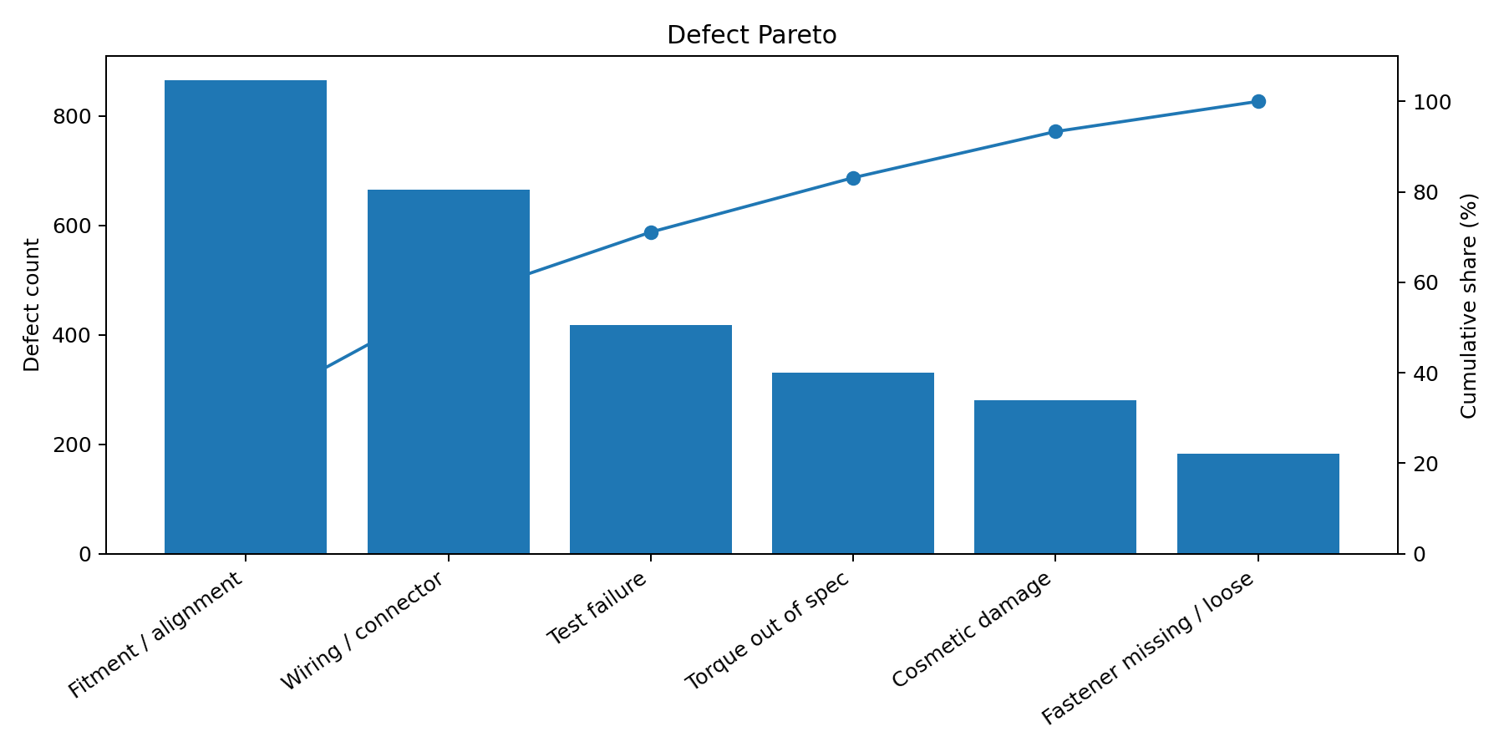
Figure 5. Defect Pareto across all station-shift records.
Rank | Defect mode | Count | Share
1 | Fitment / alignment | 866 | 31.6%
2 | Wiring / connector | 666 | 24.3%
3 | Test failure | 418 | 15.2%
4 | Torque out of spec | 330 | 12.0%
5 | Cosmetic damage | 280 | 10.2%
6 | Fastener missing / loose | 183 | 6.7%

6. Root Cause Analysis - S05
Problem statement. S05 Wheel & Brake averages 117.5 sec, exceeding the 100.8 sec reference takt by 16.7 sec.
Level | Logic | Evidence | Countermeasure
Why 1 | Why is S05 a constraint? | Cycle time is above takt. | Time-study work content and rebalance.
Why 2 | Why is cycle time high? | Dataset flags tooling variability and fitment/alignment as important loss signals. | Separate prep from critical-path work; improve fixture presentation.
Why 3 | Why does variation add delay? | S05 carries tool-change and rework/clearance downtime. | Quick-change tooling; standardize torque / alignment sequence.
Why 4 | Why do defects create extra work? | Fitment/alignment is the largest defect family. | Add poka-yoke, locators and first-piece checks.
Why 5 | Why does it recur? | The dataset represents recurring station-level loss patterns. | Daily visual CT/OEE review with escalation trigger.
Important limitation. The last two “whys” are hypotheses to verify at the shop floor; the synthetic dataset supports the loss pattern, not a claim about an actual Ather process.

7. Illustrative PFMEA and Control Plan
The workbook contains a six-row illustrative PFMEA for S05 covering wheel alignment, torque, caliper position, fastener presence, tool change and rework clearance. A separate control-plan CSV turns those risks into measurable controls and reactions. These are portfolio artifacts, not audited factory documents.
Process | Failure mode | Effect | S | O | D | RPN
Wheel fitment | Misalignment | Fitment / rework | 7 | 5 | 6 | 210
Brake torque | Out of spec | Safety / quality | 9 | 4 | 5 | 180
Brake caliper | Position error | Drag / test failure | 8 | 4 | 5 | 160
Fastener | Missing / loose | Rework / loose assembly | 8 | 3 | 6 | 144
Tool change | Setup delay | Cycle-time loss | 5 | 6 | 5 | 150
Rework clearance | Repeated adjustment | CT / WIP growth | 6 | 6 | 5 | 180

8. Improvement Model
Stage 1 assumption. Reduce S05 cycle time from 117.5 sec to 99.5 sec and reduce S05 unplanned downtime by 25%. The modeled S05 capacity proxy rises from 11,888 to 14,182 units over the 30-day window, a theoretical increase of 19.3%.
Next constraint. At the current-state numbers, S04 Controller & Wiring becomes the next tight constraint with a capacity proxy of about 13,980 units over the 30-day window. This is why the project is framed as a sequence of bottleneck releases rather than a one-time fix.
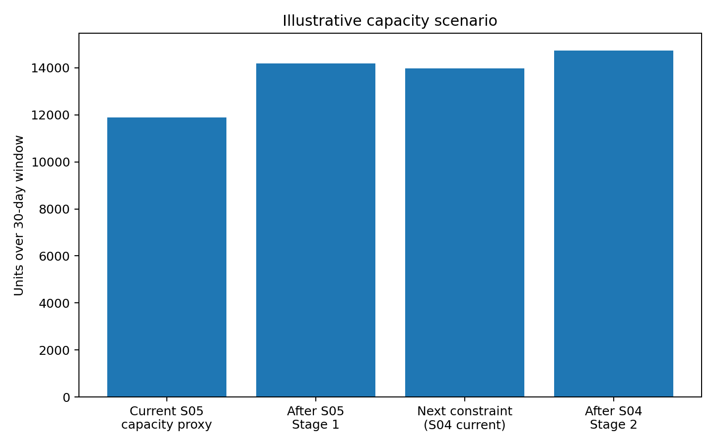
Figure 6. Illustrative capacity scenario; not a guaranteed production forecast.
Metric | Current | Illustrative target | Mechanism
S05 cycle time | 117.5 sec | 99.5 sec | Work balancing + fixture/tooling
S05 unplanned downtime | 961 min | 721 min | Quick change + preventive action
S03 material shortage DT | 517 min | 310 min | Kitting / supermarket / replenishment
S04 defects | 461 | 323 | Wiring standard work + poka-yoke

9. Daily Trend and Validation
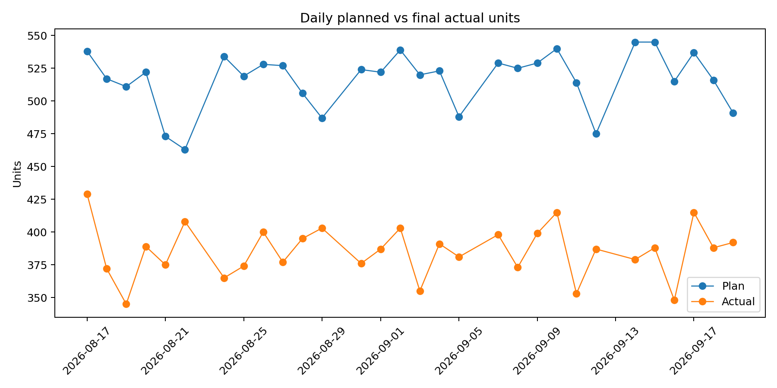
Figure 7. Daily plan vs final actual units.
Validation plan: run a pilot on S05, record a minimum two consecutive production shifts with a stable standard work method, verify the cycle-time distribution (not only the mean), monitor defects and rework, and then release the next improvement wave on S04. Use a visual daily management board for escalation and closure.
Date | Modeled condition
2026-08-24 | Supplier delay
2026-09-03 | Line trial / changeover-heavy day
2026-09-12 | Software release / test instability

10. 30-Day Implementation Roadmap
When | Workstream | Deliverable | Owner
Week 1 | Gemba + time study | S05 element breakdown, spaghetti diagram, CT distribution | IE / PM
Week 2 | Quick wins | Fixture locator, torque sequence, kitting, quick-change standard | ME + Quality
Week 3 | Pilot production | Run pilot, verify CT / OEE / defects, update PFMEA and control plan | Ops + Quality
Week 4 | Control + scale | Visual dashboard, escalation rule, next constraint review (S04) | PM / Site Ops

11. Resume and Interview Translation
- Built a 10-station EV assembly-line simulation with 600 station-shift records and analyzed takt time, cycle time, OEE, downtime, defects and plan-vs-actual performance.
- Identified S05 Wheel & Brake as the primary cycle-time constraint at 117.5s vs 100.8s takt; designed a Lean bottleneck-release roadmap using time study, fixture/poka-yoke and quick-change concepts.
- Used Pareto + 5-Why + illustrative PFMEA/control plan to prioritize material shortage, fitment/alignment and wiring losses, with a formula-driven future-state capacity scenario.

12. Files and Reproducibility
The accompanying ZIP contains the final Excel workbook, original synthetic dataset workbook, CSV extract, Python rerun script, Power BI build specification, report DOCX/PDF, presentation PPTX, control-plan CSV and supporting charts.
Source note. Ather job descriptions supplied by the user in this conversation: Graduate Trainee - Operational Excellence (2 pages) and Program Manager Manufacturing Operations (2 pages). The project content is aligned to those supplied requirements. All manufacturing data in this project are simulated.

