

Institute of Information Technology
University of Dhaka

Software Project Lab-3
Software Requirements Specification and Analysis Report
AIRiskWatch

Supervised by:
Dr. Ahmedul Kabir  Associate Professor  IIT,DU | Md Rayhanur Rahman  Assistant Professor  University of Alabama

Submitted by:
Nandan Bhowmick
Roll: 1436

Submission Date: 11/10/2026

Table of Contents
Table of Contents 1
1. Introduction 2
1.1 Motivation 2
1.2 Scope 3
1.3 Purpose of Document 3
2. Project Description 4
2.1 Quality Function Deployment 4
2.1.1 Normal Requirements 4
2.1.2 Expected Requirements 4
2.1.3 Exciting Requirements 5
2.2 User Stories 5
2.2.1 Browse and Explore AI Incidents 5
2.2.2 Search and Filter Incidents 6
2.2.3 View Source Reports 6
2.2.4 Explore the MIT AI Risk Taxonomy 6
2.2.5 Analytics Dashboard 6
2.2.6 Continuously Updated Knowledge Base 6
2.2.7 Search AI Incidents Using Natural Language 6
2.2.8 User Authentication & Preferences 6
3. Scenario-Based Modeling 7
3.1 Use Case Diagram 7
3.1.1 Level 0 7
3.1.2 Level 1 8
3.1.1 Level 1.1 10
3.1.2 Level 1.2 11
3.1.2 Level 1.3 13
3.1.2 Level 1.5 14
3.2 Activity Diagrams 16
3.2.1 Authentication 16
3.2.4 Incident Ingestion 17
3.2.5 Semantic Incident Searching 18
4. Database Modeling 19
4.1 ER Diagram 19
4.2 Schema 20
5. AI Engineering 22
5.1 Overview 22
5.2 LLM API Usage 22
5.3 Embedding Usage 24
Conclusion 25
References 26

1. Introduction

1.1 Motivation
Artificial intelligence (AI) systems are now used in many real-world applications such as healthcare, finance, education, transportation, recruitment, and customer service. As their adoption continues to grow, incidents caused by these systems are also becoming more common. Examples include biased hiring decisions, privacy leaks, misinformation, unsafe recommendations, and failures of autonomous systems. Studying these incidents is important because they help researchers, developers, and policymakers understand how AI systems fail and how similar failures can be prevented in the future.
Several organizations have already collected valuable information about these incidents. For example, the AI Incident Database (AIID) contains reports of real-world AI incidents from news articles and other sources, while the MIT AI Risk Repository classifies many of these incidents using a standardized AI risk taxonomy. However, these resources mainly exist as datasets intended for research. They are not designed as an interactive system that continuously collects new incidents, automatically classifies them, or allows users to easily search, explore, and analyze the information.
As a result, developers building new AI systems often have no easy way to discover similar past incidents that could help them identify potential risks. Researchers and policymakers also need to manually search through large collections of reports to analyze trends, compare different types of AI harms, or answer specific questions about previous incidents.
AIRiskWatch is motivated by the need to make AI incident knowledge more accessible and useful. The proposed system combines existing AI incident datasets with automated web scraping, AI-based incident classification, semantic vector search, and interactive dashboards to create a continuously growing AI incident intelligence platform. Users can ask questions in natural language, and the system retrieves the most relevant incidents before generating evidence-grounded summaries with citations to the supporting incidents.

1.2 Scope
AIRiskWatch is a web-based application consisting of a FastAPI backend with a PostgreSQL database (using the pgvector extension for vector search) and a React frontend. The frontend communicates with the backend through REST APIs.

The scope of this project includes:
- Initializing the knowledge base by importing the AI Incident Database (AIID), then continuously expanding it by automatically scraping trusted news sources, extracting structured information from relevant articles, matching reports to existing incidents or creating new incidents, and storing the resulting knowledge in the incident repository.
- The system automatically classifies AI incidents using an AI-based classification pipeline. The chosen classification model is evaluated against a human-labelled gold dataset before being used to classify previously unlabeled incidents.
- Providing an interactive incident explorer where users can search incidents, apply filters such as risk domain, risk subdomain, organization, stakeholder, and date range, and view detailed information about incidents and their supporting reports.
- Providing dashboards and visualizations that help users analyze AI incident trends, risk distributions, affected stakeholders, organizations, and other statistics derived from the incident data.
- Supporting natural language search over the incident knowledge base by embedding user queries, retrieving the most semantically relevant incidents using vector similarity search, and generating evidence-grounded summaries that cite the retrieved incidents.
- Allowing users to describe the AI system they are developing so that the platform can recommend previously reported AI incidents that are relevant to their system and potential risks.

1.3 Purpose of Document
This Software Requirements Specification defines what AIRiskWatch is expected to do, for whom, and how its behaviour is organised, so that design and implementation decisions can be traced back to an agreed set of requirements. Specifically, this document:
- Define functional requirements of the system as Normal, Expected, and Exciting.
- Describe the system's features from the users' perspective through user stories and use cases.
- Model the system's main workflows using activity diagrams.
- Present the database design and entity-relationship model used by the system.

2. Project Description

2.1 Quality Function Deployment
Requirements are prioritised using the Kano-style Normal / Expected / Exciting model. Normal requirements are basic capabilities users take for granted - their absence causes dissatisfaction, but their presence alone does not delight. Expected requirements are features users assume a system in this category will have, even if they do not explicitly ask for them; satisfaction scales with how well they are executed. Exciting requirements are differentiators - capabilities users did not expect, which is where a platform earns enthusiasm rather than mere acceptance.

2.1.1 Normal Requirements
- Browse AI incidents and view detailed incident information.
- Search incidents using keywords.
- Filter incidents by risk domain, subdomain, organization, stakeholder, date range, and other metadata.
- View the supporting source reports for each incident.
- Explore the MIT AI Risk Taxonomy and its domains/subdomains.
- View dashboards showing incident trends, distributions, and statistics.

2.1.2 Expected Requirements
- Secure authentication using Google OAuth.
- Responsive interface for desktop and mobile devices.
- Support for light and dark themes.
- Consistent search, filtering, pagination, and sorting across different pages.
- Automatically monitor trusted news sources, identify AI-related incidents, extract structured report information, match reports with existing incidents or create new incidents, classify newly discovered incidents, and continuously update the knowledge base.
- Users can search the knowledge base using natural language. The system retrieves the most semantically relevant incidents using vector similarity search and generates a concise summary grounded in those incidents. The retrieved incidents remain accessible for users to inspect individually.

2.1.3 Exciting Requirements
- Allow users to classify and explore incidents using additional AI governance and risk frameworks besides the MIT AI Risk Taxonomy.
- Recommend incidents based on a user's registered AI system and notify them when relevant new incidents are discovered.
- Analyze historical incidents to identify emerging AI risk trends and provide early warnings.
- Allow researchers and third-party applications to programmatically access incident data, analytics, and classifications.
- Introduce administrator and reviewer roles for managing data ingestion, reviewing automatically generated classifications, and maintaining the incident repository.
- Represent incidents, organizations, AI systems, stakeholders, technologies, and risk categories as a knowledge graph, allowing users to explore relationships that are difficult to discover through traditional search and filtering.

2.2 User Stories
AIRiskWatch is designed for individuals who want to explore, analyze, and understand AI incidents and their associated risks. Its users may include software developers seeking to learn from previous AI failures before deploying new systems, researchers studying trends and patterns in AI incidents, policymakers and governance professionals monitoring the societal impact of AI technologies, as well as students and practitioners interested in AI safety and risk management.

Although these users have different objectives, they all access the same information and perform the same set of operations within the platform. Therefore, AIRiskWatch models them as a single User actor rather than defining separate roles with different permissions or access levels. The following user stories are organized according to the platform's major feature areas.

2.2.1 Browse and Explore AI Incidents
Users can browse a paginated collection of AI incidents to explore previously reported AI failures. Each incident includes its title, description, occurrence date, MIT AI Risk Taxonomy classification, organizations involved, stakeholders affected, and links to supporting source reports.

2.2.2 Search and Filter Incidents
Users can quickly locate relevant incidents by searching with keywords or by applying filters such as risk domain, risk subdomain, organization, stakeholder, deployment stage, intent, and date range. Multiple filters can be combined to refine the search results.

2.2.3 View Source Reports
Users can access the original source reports associated with each incident to understand the evidence behind the recorded incident and verify the information presented by the platform.

2.2.4 Explore the MIT AI Risk Taxonomy
Users can browse the MIT AI Risk Taxonomy, including its risk domains and subdomains, together with the number of incidents associated with each category. This helps users better understand how AI incidents are classified.

2.2.5 Analytics Dashboard
Users can explore interactive dashboards that summarize the incident dataset through visualizations such as incident trends over time, risk-domain distributions, organization statistics, stakeholder distributions, and other analytical insights.

2.2.6 Continuously Updated Knowledge Base
The platform continuously monitors trusted news sources for newly reported AI incidents. Relevant news articles are automatically processed, linked to existing incidents where appropriate or stored as new incidents, classified using the AI classification pipeline, and added to the knowledge base.

2.2.7 Search AI Incidents Using Natural Language
Users can ask questions in natural language instead of manually browsing or filtering the dataset. The system retrieves the most relevant incidents using semantic search, generates a concise evidence-grounded summary, cites the incidents used to produce the answer, and allows users to open each retrieved incident for further exploration.

2.2.8 User Authentication & Preferences
Users can securely sign in using their Google account. Once authenticated, users can access all available platform features without maintaining a separate username and password. They will get incident reports of their preference, i.e. those that are relevant to them.

3. Scenario-Based Modeling

3.1 Use Case Diagram
A use case diagram is a graphical representation used in software engineering to illustrate how a system interacts with external actors in order to achieve specific goals. It identifies the system's functional requirements by showing the relationships between actors (such as users or external systems) and the use cases that represent the services or functionalities provided by the system. Use case diagrams are typically developed during the requirements analysis phase to capture user interactions and define the system's expected behavior.

3.1.1 Level 0
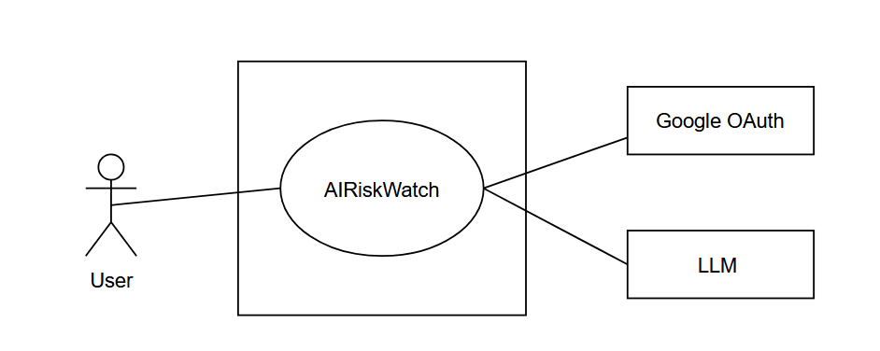
Fig 1: Level 0 (AIRiskWatch)

Use Case Name: AIRiskWatch System
Use Case ID: 0
Primary Actors: Users
Secondary Actors: Google OAuth, LLM
Goal in Context: The diagram above illustrates the complete system overview for AIRiskWatch, a platform designed for exploring, classifying, and understanding real-world AI incidents.
Description: This is the high-level view, or Level 0 view, of the AIRiskWatch system. It has one primary actor called User. The secondary actors are Google OAuth, used for authenticating the user, and LLM, used for automatically classifying incidents and generating summaries for the user.

3.1.2 Level 1

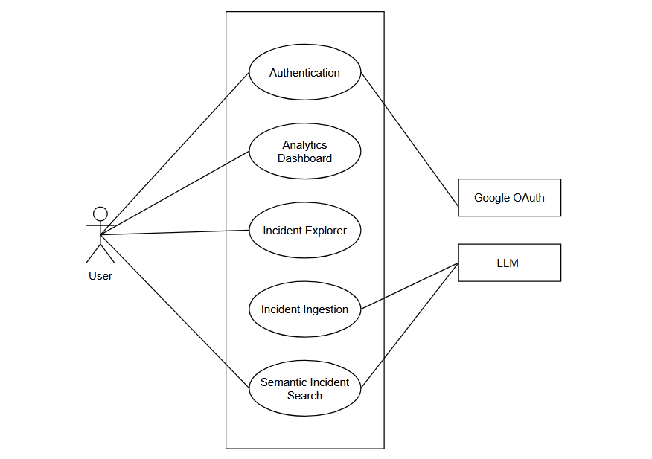
Fig 2: Level 1 (Modules of AIRiskWatch)

Use Case Name: Modules of AIRiskWatch
Use Case ID: 1
Primary Actors: User
Secondary Actors: Google OAuth, LLM
Goal in Context: The diagram above shows the modules of AIRiskWatch. It consists of 5 modules, which are further elaborated below.
Description:
- Authentication
- Functionality: this module manages the user's sign-in and sign-out. It delegates identity verification to Google OAuth rather than storing passwords itself.
- Purpose: authenticates the user and establishes their session with the platform.
- Key Dependencies: depends on Google OAuth.
- Incident Explorer
- Functionality: this module lets the user browse, search, and filter the incident corpus, and view a single incident's full detail, classification, and linked source reports.
- Purpose: gives the user a structured, exact way to find and inspect incidents.
- Key Role: acts as the primary window into the incident database for every other module's output.
- Analytics Dashboard
- Functionality: this module aggregates the incident corpus into trend, risk-distribution, organization, and stakeholder statistics.
- Purpose: helps the user understand patterns across the whole corpus rather than one incident at a time.
- Key Dependencies: depends on the incident data maintained by Incident Ingestion.
- Incident Ingestion
- Functionality: this module runs as a scheduled daily job that scrapes new AI-incident reports from trusted news sources, determines whether each report describes an incident already in the database or a new one, and classifies every new incident against the MIT AI Risk Taxonomy.
- Purpose: keeps the incident corpus current without manual data entry.
- Key Dependencies: depends on the LLM for relevance filtering, structured extraction, and classification.
- Output: new and updated incident records, ready for the user to explore through the Incident Explorer and Analytics Dashboard.
- Semantic Incident Search
- Functionality: this module lets the user describe an AI system in free text and retrieves the past incidents most relevant to that description, together with a short LLM-generated summary.
- Purpose: helps a user, particularly a developer, discover relevant precedents without needing to know the exact taxonomy terms to search for.
- Key Dependencies: depends on the LLM for summary generation and on the embeddings produced during Incident Ingestion.

3.1.1 Level 1.1

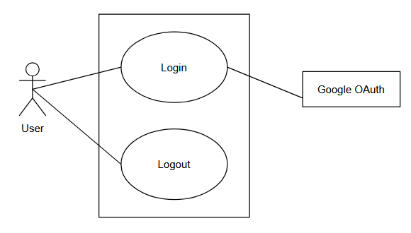
Fig 3: Level 1.1 (Authentication Module)

Use Case Name: Authentication
Use Case ID: 1.1
Primary Actors: User
Secondary Actors: Google OAuth
Goal in Context: The diagram above shows the Authentication module of AIRiskWatch, covering how a user establishes and ends a session with the platform. Authentication exists so that features requiring a persistent identity — most importantly Semantic Incident Search's stored system description — have a stable account to attach to, rather than the platform needing to manage its own credential storage.
Description:
Sign in with Google
- Functionality: the user selects "Sign in with Google" on the login screen; the system redirects them to Google OAuth, which handles the actual credential check and returns a verified identity token back to AIRiskWatch.
- Purpose: authenticates the user without AIRiskWatch ever storing or handling a password itself, reducing both security risk and implementation effort.
- Key Dependencies: depends entirely on Google OAuth for identity verification; AIRiskWatch only consumes the resulting token to establish a session.
Logout
- Functionality: the user selects "Logout" from anywhere in the signed-in interface; the system invalidates the current session.
- Purpose: lets the user end their session deliberately, e.g. on a shared or public computer.
- Key Dependencies: none — logout is handled entirely within AIRiskWatch and does not call Google OAuth again.

3.1.2 Level 1.2
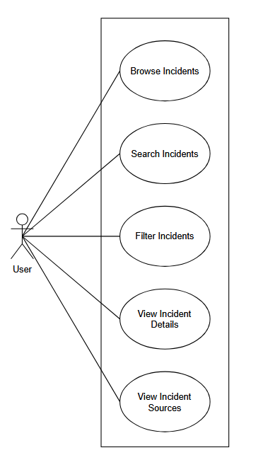
Fig 4: Level 1.2 (Incident Explorer Module)

Use Case Name: Incident Explorer
Use Case ID: 1.2
Primary Actors: User
Secondary Actors: None
Goal in Context: The diagram above shows the Incident Explorer module, the platform's primary and most frequently used surface — the structured, exact-match counterpart to Semantic Incident Search's fuzzy, descriptive matching. Every incident that Incident Ingestion adds to the database eventually becomes visible to the user through this module.
Description:
Browse Incidents
- Functionality: the user opens the explorer and the system returns a paginated list of catalogued incidents, newest first by default.
- Purpose: gives the user a starting point for exploration even before they know what they're looking for.
Search Incidents
- Functionality: the user types a keyword, and the system matches it against incident titles and descriptions.
- Purpose: lets the user quickly jump to incidents mentioning a specific system, technology, or organization by name.
Filter Incidents
- Functionality: the user selects one or more structured filters — risk domain, organization, date range, and similar fields — and the system narrows the list to incidents matching all active filters at once.
- Purpose: gives the user an exact, trustworthy way to answer precise questions (for example, "how many incidents happened last year"), in contrast to Semantic Incident Search's fuzzy, summary-based answers.
View Incident Details
- Functionality: the user selects an incident from the list, and the system displays its full description, date, classification, and involved organizations/stakeholders.
- Purpose: gives the user the complete picture behind a single incident once they've found it.
View Source Reports
- Functionality: the user opens the source-reports section of an incident's detail view, and the system lists every report linked to that incident.
- Purpose: lets the user verify a classification or description against the original news coverage rather than trusting the platform's summary alone.

3.1.2 Level 1.3
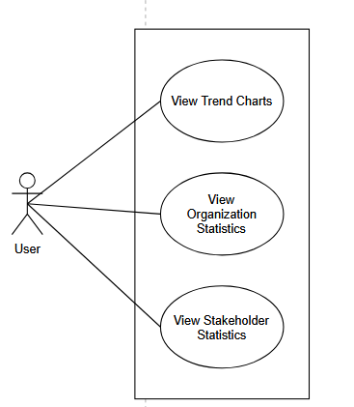
Fig 5: Level 1.3 (Analytics Dashboard Module)

Use Case Name: Analytics Dashboard
Use Case ID: 1.3
Primary Actors: User
Secondary Actors: None
Goal in Context: The diagram above shows the Analytics Dashboard module, which shifts the user's perspective from a single incident to patterns across the whole corpus. Where Incident Explorer answers "tell me about this incident," the Dashboard answers "what does the corpus look like as a whole."
Description:
View Trend Charts
- Functionality: the system aggregates incident counts by year and displays them as a chart, including year-over-year change.
- Purpose: lets the user see whether AI incidents are increasing, and how quickly.
View Organization Statistics
- Functionality: the system aggregates incidents by the organizations named as their developers or deployers and ranks them by incident count.
- Purpose: lets the user see which organizations appear most often across the corpus.

View Stakeholder Statistics
- Functionality: the system aggregates incidents by the stakeholder group they affected and displays the breakdown as a chart.
- Purpose: lets the user see which groups of people are most frequently harmed across the corpus.

3.1.2 Level 1.5
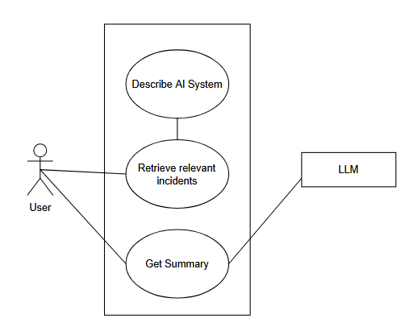
Fig 6: Level 1.5 (Semantic Incident Search Module)

Use Case Name: Semantic Incident Search
Use Case ID: 1.5
Primary Actors: User
Secondary Actors: LLM
Goal in Context: The diagram above shows the Semantic Incident Search module, aimed particularly at a developer who wants to know what has gone wrong with AI systems similar to the one they're building. It complements Incident Explorer's exact filtering with fuzzy, descriptive matching for questions the user can't easily express as structured filters, and it never claims to be exhaustive or to report exact counts — that remains Incident Explorer's job.

Description:
Write Query
- Functionality: the user writes a free-text description of an AI system or area of concern, rather than a structured filter.
- Purpose: lets the user ask for what they mean in their own words, without first learning the platform's taxonomy vocabulary.
Retrieve Relevant Incidents
- Functionality: the system embeds the query and retrieves a fixed number of the most similar incidents by cosine similarity against the incident corpus.
- Purpose: surfaces incidents that are conceptually related to the query even when they don't share any exact keywords with it.
- Key Dependencies: uses only vector similarity search (pgvector) — no LLM call is involved in retrieval itself.
Get Summary
- Functionality: the LLM is given the user's query together with the retrieved incidents and produces a short summary explaining, with citations, why those incidents are relevant.
- Purpose: saves the user from having to read every retrieved incident individually to understand the pattern connecting them.
- Key Dependencies: depends on the LLM; only summarizes the fixed set of incidents already retrieved, and is explicitly not asked to state exact counts or totals.

Note: Incident Ingestion appears as one of the five modules in the Level 1 diagram, but is not elaborated as its own numbered Level 1.x sub-diagram in this section, unlike Authentication, Incident Explorer, Analytics Dashboard, and Semantic Incident Search. This reflects a genuine difference in kind, not merely a gap in documentation: the Level 1.x sub-diagrams in this section exist specifically to show how a user's interaction with a module decomposes into individual use cases. Incident Ingestion has no user interaction to decompose — it is triggered by a daily schedule, not by any actor modeled in this document, and its internal steps (scraping, filtering, extraction, deduplication, classification) are a backend processing pipeline rather than a set of use cases an actor invokes. Its behavior is instead documented as an activity diagram later, which is the more appropriate model for a sequential, automated process with no actor-facing decision points of the kind a use-case diagram is meant to capture. Its presence in the Level 1 diagram is retained only to show that ingestion is a real module of the system whose output the other modules depend on, not to imply it has a use-case-level breakdown of its own.

3.2 Activity Diagrams
Activity diagrams are a UML behavioral modeling tool used to represent the flow of activities/actions within a system, process, or use case — essentially a flowchart-like notation showing the sequence of steps, decision points, and parallel or alternate paths a process can take. Pressman presents them as a complement to use-case diagrams: where a use-case diagram shows what a system does (from an actor's perspective) and who interacts with it, an activity diagram shows how a particular use case's internal logic actually flows — the step-by-step procedure, branching logic (decisions), and termination points.

3.2.1 Authentication
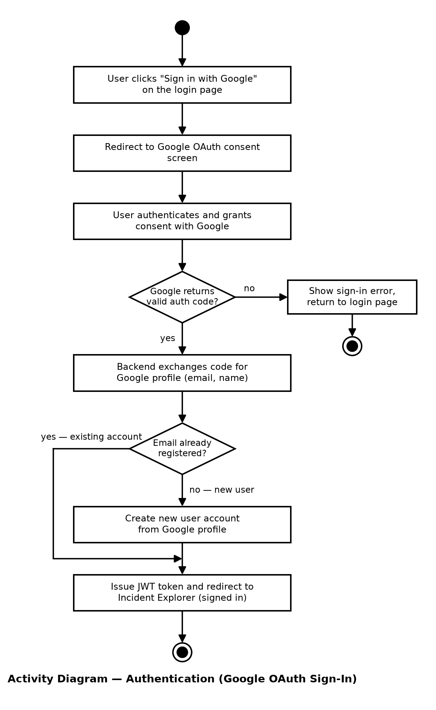
Fig 7: Activity diagram for Authentication module

3.2.4 Incident Ingestion
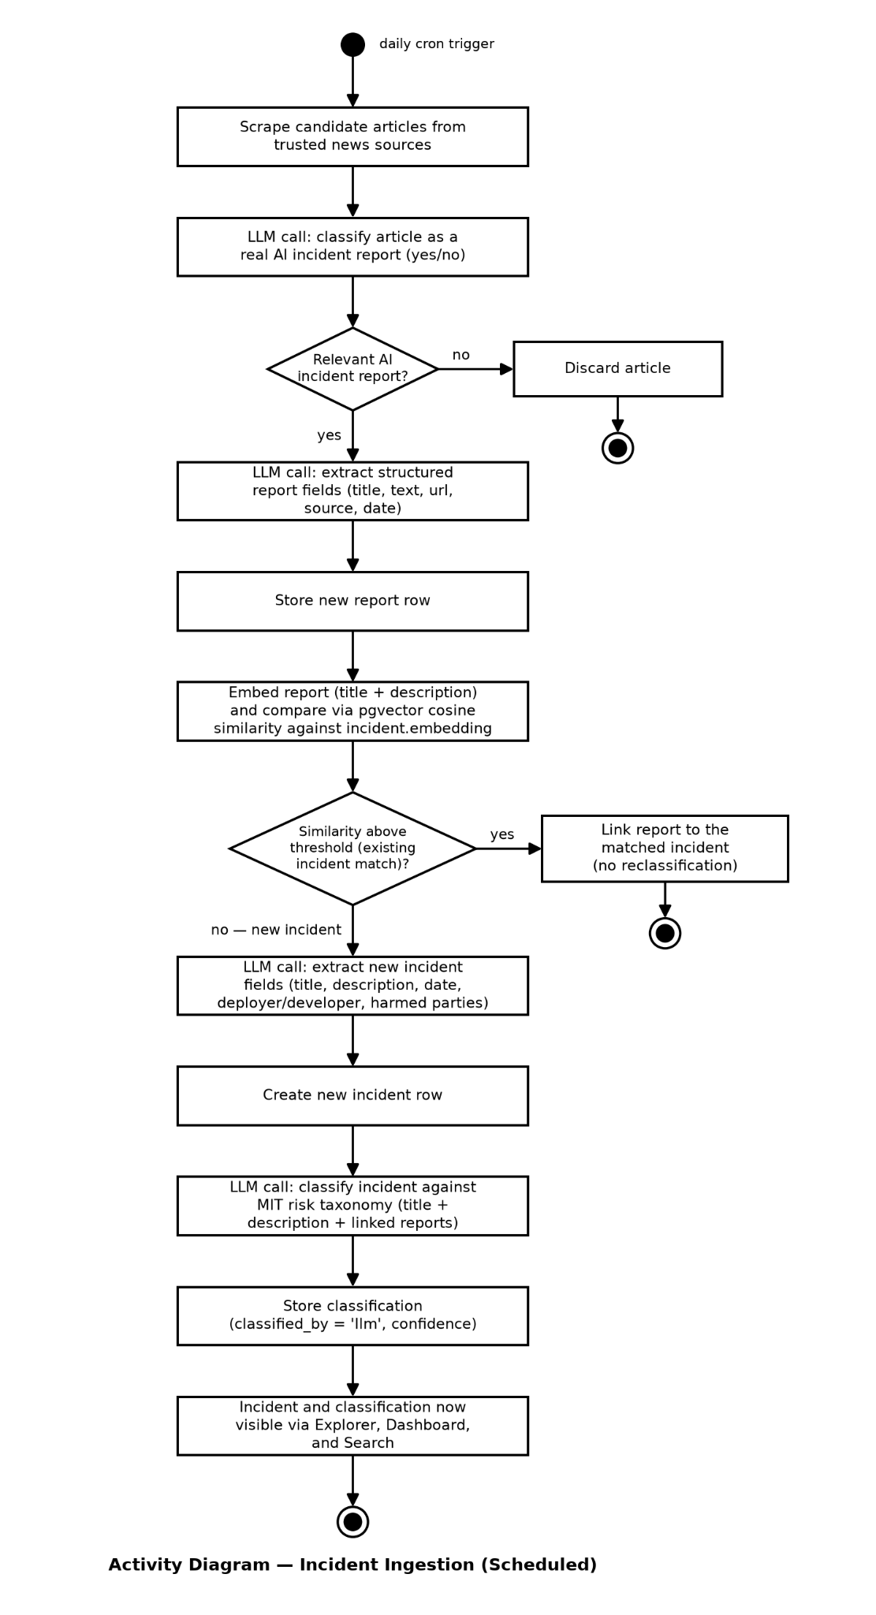
Fig 8: Activity diagram for Incident Ingestion module

3.2.5 Semantic Incident Searching
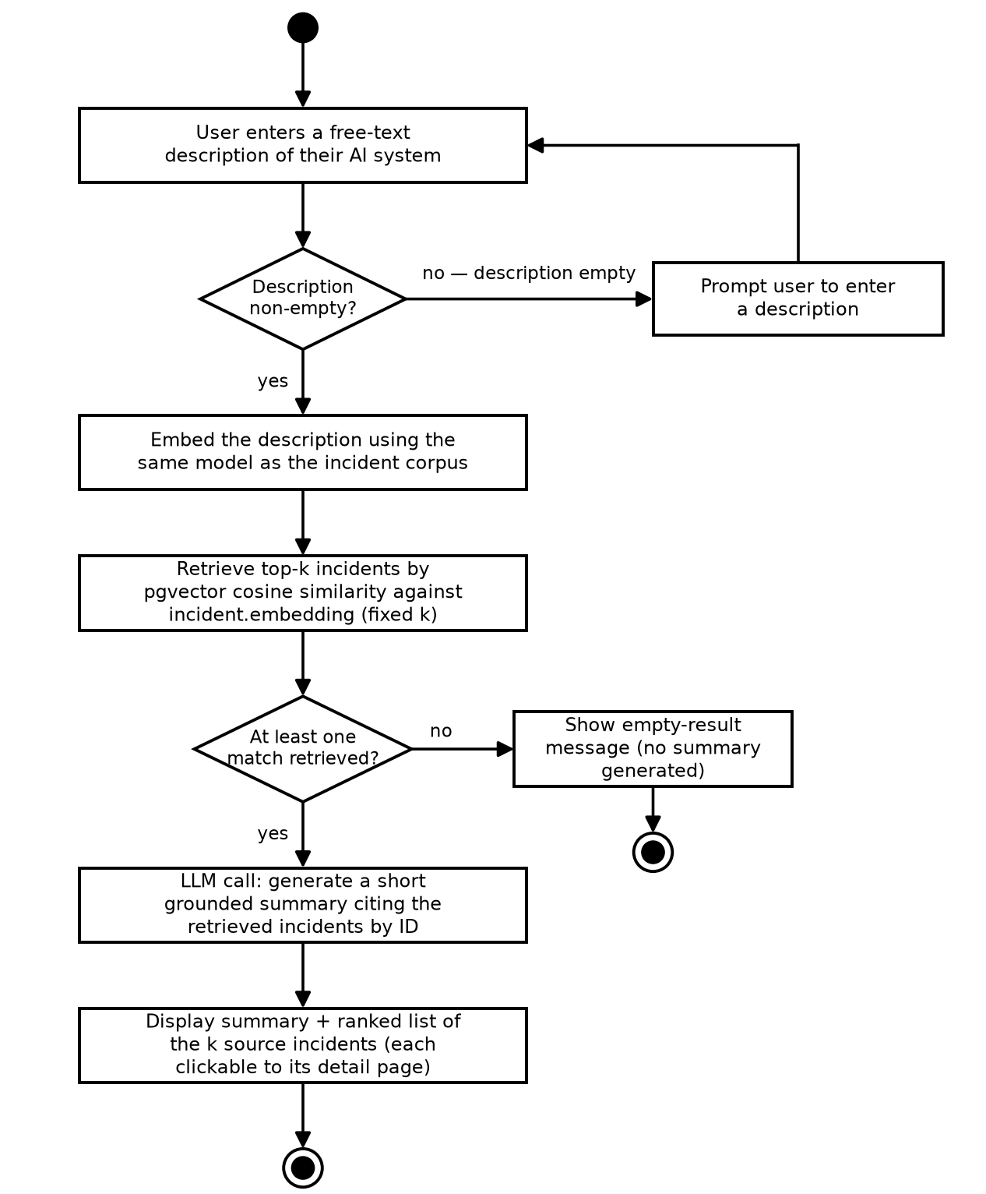
Fig 9: Activity diagram for Semantic Incident Searching module

4. Database Modeling
Database modeling is the process of designing the logical structure of a database by identifying the entities, their attributes, and the relationships between them. It provides a blueprint for how data is organized, stored, and managed within a system. Database models are typically developed during the system design phase to ensure data integrity, minimize redundancy, and support the functional requirements of the application.

4.1 ER Diagram
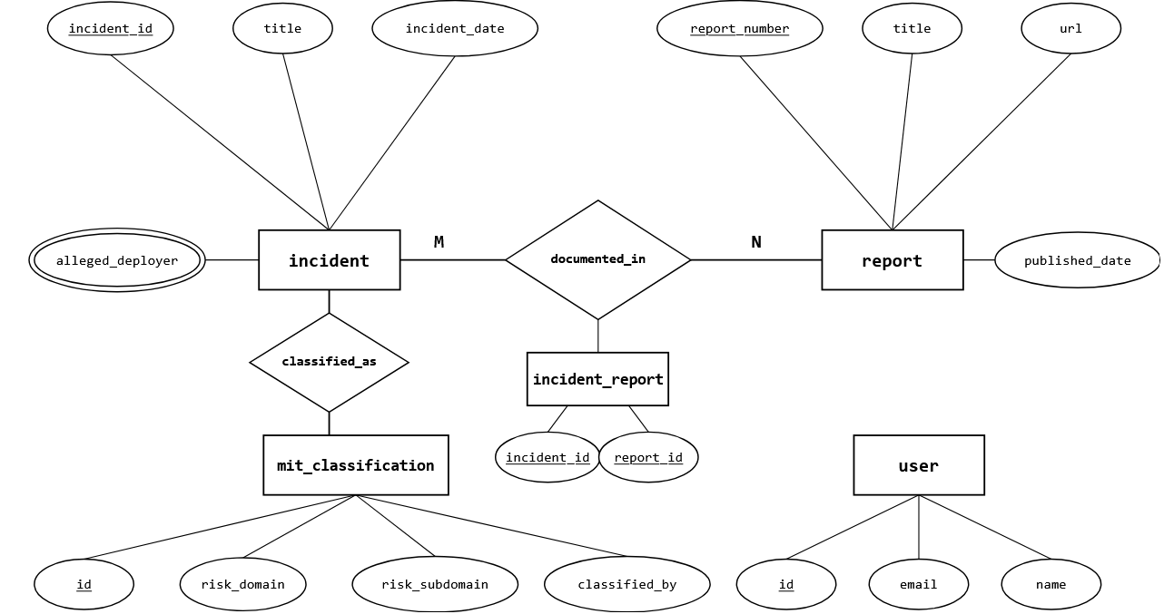

Fig 10: ER diagram of AIRiskWatch

4.2 Schema
Table | Column | Type | Constraints
user | id | SERIAL | PRIMARY KEY
user | google_sub | TEXT | NOT NULL, UNIQUE
user | email | TEXT | NOT NULL, UNIQUE
user | name | TEXT
user | created_at | TIMESTAMPTZ | NOT NULL DEFAULT now()
incident | id | SERIAL | PRIMARY KEY
incident | incident_id | INTEGER | NOT NULL, UNIQUE
incident | title | TEXT
incident | description | TEXT
incident | incident_date | DATE
incident | alleged_deployer | TEXT[]
incident | alleged_developer | TEXT[]
incident | harmed_parties | TEXT[]
incident | embedding | VECTOR(1536)
report | id | SERIAL | PRIMARY KEY
report | report_number | INTEGER | NOT NULL, UNIQUE
report | title | TEXT
report | text | TEXT
report | url | TEXT
report | source_domain | TEXT
report | authors | TEXT
report | published_date | DATE
report | language | TEXT
report | embedding | VECTOR(1536)
incident_report | incident_id | INTEGER | NOT NULL, PK (composite), REFERENCES incident(incident_id)
incident_report | report_id | INTEGER | NOT NULL, PK (composite), REFERENCES report(report_number)
mit_classification | id | SERIAL | PRIMARY KEY
mit_classification | incident_id | INTEGER | NOT NULL, UNIQUE REFERENCES incident(incident_id)
mit_classification | risk_domain | TEXT
mit_classification | risk_subdomain | TEXT
mit_classification | causal_entity | TEXT
mit_classification | timing | TEXT
mit_classification | intent | TEXT
mit_classification | published | BOOLEAN
mit_classification | confidence | REAL | LLM self-reported confidence (0–1); NULL for human gold rows
mit_classification | classified_by | TEXT | 'human' (seed gold) or 'llm' (backfill/ingestion)
mit_classification | classified_at | TIMESTAMPTZ | set for LLM classifications; NULL for gold rows

5. AI Engineering

5.1 Overview
AIRiskWatch incorporates two complementary AI techniques that serve distinct roles within the system: generative large language model (LLM) inference and embedding-based similarity search. LLMs are reserved for tasks requiring semantic reasoning or text generation, such as incident classification, incident relevance filtering, report structuring, and summary synthesis. In contrast, embedding-based similarity is used for retrieval and comparison tasks where decisions can be made by measuring semantic proximity between vector representations.
This design is shared across both the Incident Ingestion module, which performs automated incident resolution and deduplication, and the Semantic Incident Search module, which supports retrieval-augmented generation (RAG). Consequently, both mechanisms are described together in this section.

5.2 LLM API Usage
AIRiskWatch performs four primary LLM-assisted operations throughout the system:
- Relevance filtering: A binary check applied to each newly scraped article during ingestion, deciding whether it describes a genuine AI incident before any further processing is spent on it.
- Structured extraction (report structuring): Parses a relevant article into normalized fields (title, summary, date, candidate entities) for the report record, and, when the article turns out to describe a new incident rather than an existing one, into the corresponding incident fields as well.
- Taxonomy classification: Assigns an incident to its MIT AI Risk Repository risk domain/subdomain and causal-axis labels (causal entity, timing, intent).
- Answer/summary generation: Given a fixed, already-retrieved set of incidents (never the full corpus), produces a synthesised, cited answer for natural-language semantic search.
All LLM interactions are routed through a provider-independent LlmClient abstraction , allowing different providers, including Gemini, Mistral, Groq, and Ollama, to be used interchangeably through configuration. Every request specifies a structured JSON output schema, and responses are validated before use. If validation fails, the system performs a single repair attempt by resubmitting the original prompt together with the validation error. Should the repaired response still fail validation, the current item is skipped for that execution.
Below is a sample prompt for the classification task, divided into 2 parts:
- The system prompt gives the model the full MIT taxonomy and output contract:

You are an expert annotator applying the MIT AI Risk Repository taxonomy to
real-world AI incidents. Choose exactly one risk_domain, then a
risk_subdomain that BELONGS TO that domain, a second-best subdomain in the
same domain, then classify the three causal axes.

TAXONOMY:
DOMAIN: Discrimination and Toxicity
Harms from the AI system treating people unfairly or exposing them to
toxic, hateful, or otherwise harmful content.
Subdomains: Unfair discrimination and misrepresentation; Exposure to
toxic content; Unequal performance across groups.
[... 6 further domains, ~24 subdomains total, each with a description ...]

CAUSAL AXES:
causal_entity: AI | Human | Other
timing: Pre-deployment | Post-deployment | Other
intent: Intentional | Unintentional | Other

Output rules: subdomains must belong to the chosen domain and differ from
each other; confidence is 0-1; justification is at most 2 sentences; reply
with ONLY a JSON object with keys risk_domain, risk_subdomain,
risk_subdomain_second, causal_entity, timing, intent, confidence,

- The user prompt supplies one held-out few-shot example per domain, then the target incident:

EXAMPLE 1
Title: Google's YouTube Kids App Presents Inappropriate Content
Description: YouTube's content filtering and recommendation algorithms
exposed children to disturbing and inappropriate videos.
Answer: {"risk_domain": "Discrimination and Toxicity", "risk_subdomain":
"Exposure to toxic content", "causal_entity": "AI", "timing":
"Post-deployment", "intent": "Unintentional", "confidence": 0.9, ...}

[... 6 further examples ...]

Now classify this incident:
Title: Resume-Screening Tool Systematically Downranks Female Applicants
Description: An automated hiring platform was found to score resumes
containing terms associated with women's colleges lower than otherwise
identical resumes, reproducing bias in its historical training data.
Answer:

5.3 Embedding Usage
Semantic embeddings form the foundation of AIRiskWatch's retrieval and similarity-based functionality. The incident and report tables each contain a VECTOR(1536) embedding column stored directly in PostgreSQL using the pgvector extension. A single embedding model is used consistently across incidents, reports, and user queries, ensuring that cosine similarity remains meaningful throughout the system. The specific embedding model is intentionally left as an implementation choice, allowing either commercial APIs or open-weight sentence-transformer models to be adopted without requiring changes to the database schema.
Embedding comparison replaces repeated LLM inference in two principal workflows:
- Incident Deduplication: During ingestion, the title and description of each incoming report are converted into an embedding and compared against existing incident embeddings using cosine similarity. Candidate matches may be further narrowed using shared entities or temporal proximity. Reports whose similarity scores fall clearly above or below the configured threshold are resolved directly through vector comparison, while only ambiguous near-threshold cases are escalated to the optional LLM adjudication step. The similarity threshold is intentionally conservative to reduce the risk of incorrectly merging unrelated incidents.
- Semantic Search Retrieval: User queries are embedded using the same model and compared against stored incident and report embeddings to retrieve the most semantically relevant results. The retrieval stage itself relies entirely on vector similarity; the LLM is used only afterward to synthesize an answer from the retrieved documents.

Conclusion
This Software Requirements Specification presents the complete requirements and design models for AIRiskWatch, an AI incident intelligence platform that combines existing AI incident datasets with automated knowledge base maintenance, AI-assisted incident classification, semantic search, and interactive analytics. The document defines the system's functional requirements, user stories, use cases, activity diagrams, and database design, providing a clear blueprint for implementation.
The proposed architecture allows the platform to continuously expand its knowledge base by ingesting newly reported AI incidents while enabling users to efficiently explore, analyze, and learn from past AI failures. By integrating traditional information retrieval techniques with modern AI capabilities such as automated classification and retrieval-augmented generation, AIRiskWatch aims to make AI risk knowledge more accessible to developers, researchers, policymakers, and other stakeholders.
Although several advanced capabilities, such as support for additional AI risk frameworks, knowledge graph exploration, and administrative review workflows, are identified as future enhancements, the current specification defines a complete and extensible system that satisfies the project's objectives while providing a solid foundation for future development.

References
- Partnership on AI, "AI Incident Database." [Online]. Available: https://incidentdatabase.ai/
- P. Slattery, A. Zhang, J. Zhou, et al., "The AI Risk Repository: A Comprehensive Meta-Review, Database, and Taxonomy of Risks From Artificial Intelligence," arXiv preprint arXiv:2408.12622, 2024. [Online]. Available: https://arxiv.org/abs/2408.12622
- D. Russo, G. M. Orlando, V. La Gatta, and V. Moscato, "Automating AI Failure Tracking: Semantic Association of Reports in AI Incident Database," arXiv preprint arXiv:2507.23669, 2025. [Online]. Available: https://arxiv.org/abs/2507.23669
- R. S. Pressman and B. R. Maxim, *Software Engineering: A Practitioner's Approach*, 9th ed. New York, NY, USA: McGraw-Hill Education, 2019

