

Institute of Information Technology
University of Dhaka

Software Project Lab-3
Software Requirements Specification and Analysis Report
AIRiskWatch

Supervised by:
Dr. Ahmedul Kabir  Associate Professor  IIT,DU | Md Rayhanur Rahman  Assistant Professor  University of Alabama

Submitted by:
Nandan Bhowmick
Roll: 1436

Submission Date: 11/10/2026

Table of Contents
Table of Contents 1
1. Introduction 4
1.1 Motivation 4
1.2 Scope 4
1.3 Purpose of Document 5
2. Quality Function Deployment 6
2.1 Normal Requirements 6
2.2 Expected Requirements 6
2.3 Exciting Requirements 7
3. Database Modeling 8
3.1 ER Diagram 9
3.2 Schema 10
4. Component-Level Design 13
4.1 System Overview 13
4.2 Components 14
4.2.1 Incident Explorer and Analytics 14
4.2.2 Semantic Search and Risk Checklist 15
4.2.3 Incident Ingestion 15
4.2.4 Incident Classification 16
4.2.5 Accounts and Authentication 16
4.2.6 Monthly Digest 16
4.2.7 Administration 17
4.3 Component Interaction 17
4.3.1 Semantic Search and Risk Checklist 18
4.3.2 Automated Incident Ingestion 19
4.3.3 User Authentication 21
4.3.4 Monthly Digest Email 22
5. AI Engineering 23
5.1 Overview 23
5.2 Models Used 23
5.3 LLM Integration 23
5.4 Prompt Design 24
5.5 Embeddings and Retrieval 26
5.6 Evaluation 26
5.7 Limitations and Safeguards 27
6. Interface Design 28
6.1 Interface Objects and Actions 28
6.2 Events 29
6.3 Interface States and Transitions 29
6.3.1 Semantic Search 30
6.3.2 Risk Checklist 32
6.3.3 Incident List 34
6.3.4 Sign In 36
6.3.5 Admin Ingestion 39
7. Testing Components 41
7.1 Testing Approach and Strategy 41
7.2 Item Pass/Fail Criteria 41
7.3 Risks and Contingencies 42
7.4 Test Cases and Results 42
7.5 Summary 45
8. User Manual 46
8.1 Overview Dashboard 46
8.2 Browsing Incidents 46
8.3 Incident Details 47
8.4 Semantic Search 48
8.5 Risk Checklist 49
8.6 Exploring the MIT Taxonomy 50
8.7 Creating an Account and Signing In 52
8.8 Account Settings 53
8.9 Monthly Digest 54
8.10 Admin Console: Users 55
8.11 Admin Console: Ingestion 56
8.12 Admin Console: Incidents and Reports 57
8.13 Admin Console: Digest 58
References 60

1. Introduction

1.1 Motivation
Artificial intelligence (AI) systems are now used in many real-world applications such as healthcare, finance, education, transportation, recruitment, and customer service. As their adoption continues to grow, incidents caused by these systems are also becoming more common. Examples include biased hiring decisions, privacy leaks, misinformation, unsafe recommendations, and failures of autonomous systems. Studying these incidents is important because they help researchers, developers, and policymakers understand how AI systems fail and how similar failures can be prevented in the future.
Several organizations have already collected valuable information about these incidents. For example, the AI Incident Database (AIID) contains reports of real-world AI incidents from news articles and other sources, while the MIT AI Risk Repository classifies many of these incidents using a standardized AI risk taxonomy. However, these resources mainly exist as datasets intended for research. They are not designed as an interactive system that continuously collects new incidents, automatically classifies them, or allows users to easily search, explore, and analyze the information.
As a result, developers building new AI systems often have no easy way to discover similar past incidents that could help them identify potential risks. Researchers and policymakers also need to manually search through large collections of reports to analyze trends, compare different types of AI harms, or answer specific questions about previous incidents.
AIRiskWatch is motivated by the need to make AI incident knowledge more accessible and useful. The proposed system combines existing AI incident datasets with automated web scraping, AI-based incident classification, semantic vector search, and interactive dashboards to create a continuously growing AI incident intelligence platform. Users can ask questions in natural language, and the system retrieves the most relevant incidents before generating evidence-grounded summaries with citations to the supporting incidents.

1.2 Scope
AIRiskWatch is a web-based application consisting of a FastAPI backend with a PostgreSQL database (using the pgvector extension for vector search) and a React frontend. The frontend communicates with the backend through REST APIs.

The scope of this project includes:
- Initializing the knowledge base by importing the AI Incident Database (AIID), then continuously expanding it by automatically scraping trusted news sources, extracting structured information from relevant articles, matching reports to existing incidents or creating new incidents, and storing the resulting knowledge in the incident repository.
- The system automatically classifies AI incidents using an AI-based classification pipeline. The chosen classification model is evaluated against a human-labelled gold dataset before being used to classify previously unlabeled incidents.
- Providing an interactive incident explorer where users can search incidents, apply filters such as risk domain, risk subdomain, organization, stakeholder, and date range, and view detailed information about incidents and their supporting reports.
- Providing dashboards and visualizations that help users analyze AI incident trends, risk distributions, affected stakeholders, organizations, and other statistics derived from the incident data.
- Supporting natural language search over the incident knowledge base by embedding user queries, retrieving the most semantically relevant incidents using vector similarity search, and generating evidence-grounded summaries that cite the retrieved incidents.
- Allowing users to describe the AI system they are developing so that the platform can recommend previously reported AI incidents that are relevant to their system and potential risks.

1.3 Purpose of Document
This Software Requirements Specification defines what AIRiskWatch is expected to do, for whom, and how its behaviour is organised, so that design and implementation decisions can be traced back to an agreed set of requirements. Specifically, this document:
- Define the functional requirements of the system as Normal, Expected, and Exciting.
- Present the database design and entity-relationship model used by the system.
- Describe the component-level design of the system and how its components interact.
- Explain the AI engineering behind the system: the models, LLM integration, prompts and evaluation.
- Define the user interface design: interface objects, actions, events and state transitions.
- Describe the testing strategy, pass/fail criteria, risks, and the test cases with their results.
- Provide a user manual that walks through every screen of the application.

2. Quality Function Deployment
Requirements are prioritised using the Kano-style Normal / Expected / Exciting model. Normal requirements are basic capabilities users take for granted - their absence causes dissatisfaction, but their presence alone does not delight. Expected requirements are features users assume a system in this category will have, even if they do not explicitly ask for them; satisfaction scales with how well they are executed. Exciting requirements are differentiators - capabilities users did not expect, which is where a platform earns enthusiasm rather than mere acceptance.

2.1 Normal Requirements
- Browse AI incidents and view detailed incident information.
- Search incidents using keywords.
- Filter incidents by risk domain, subdomain, organization, stakeholder, date range, and other metadata.
- View the supporting source reports for each incident.
- Explore the MIT AI Risk Taxonomy and its domains/subdomains.
- View dashboards showing incident trends, distributions, and statistics.

2.2 Expected Requirements
- Secure authentication using Google OAuth.
- Responsive interface for desktop and mobile devices.
- Support for light and dark themes.
- Consistent search, filtering, pagination, and sorting across different pages.
- Automatically monitor trusted news sources, identify AI-related incidents, extract structured report information, match reports with existing incidents or create new incidents, classify newly discovered incidents, and continuously update the knowledge base.
- Users can search the knowledge base using natural language. The system retrieves the most semantically relevant incidents using vector similarity search and generates a concise summary grounded in those incidents. The retrieved incidents remain accessible for users to inspect individually.

2.3 Exciting Requirements
- Allow users to classify and explore incidents using additional AI governance and risk frameworks besides the MIT AI Risk Taxonomy.
- Recommend incidents based on a user's registered AI system and notify them when relevant new incidents are discovered.
- Analyze historical incidents to identify emerging AI risk trends and provide early warnings.
- Allow researchers and third-party applications to programmatically access incident data, analytics, and classifications.
- Introduce administrator and reviewer roles for managing data ingestion, reviewing automatically generated classifications, and maintaining the incident repository.
- Represent incidents, organizations, AI systems, stakeholders, technologies, and risk categories as a knowledge graph, allowing users to explore relationships that are difficult to discover through traditional search and filtering.

3. Database Modeling
Database modeling is the process of designing the logical structure of a database by identifying the entities, their attributes, and the relationships between them. AIRiskWatch stores its data in PostgreSQL hosted on Neon, with the pgvector extension providing a native vector column type for semantic search. Compared with the earlier design, the model now reflects the implemented system: embeddings use a 384-dimensional local model, users support both email/password and Google sign-in with a role, and a new digest_delivery entity records monthly email delivery.

3.1 ER Diagram
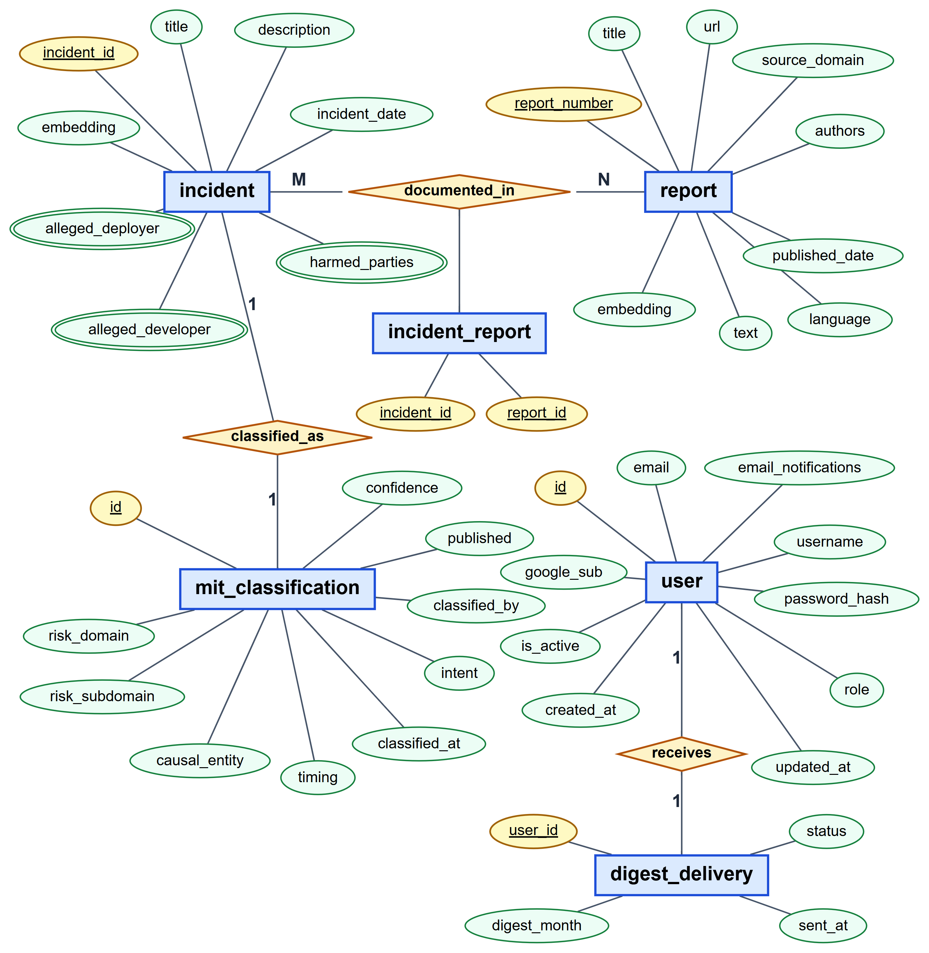
Fig 1: ER diagram of AIRiskWatch
The model contains five entities and one associative entity:
- incident: a real-world event in which an AI system caused or nearly caused harm. Deployer, developer and harmed parties are multi-valued attributes stored as PostgreSQL text arrays.
- report: a news article or document describing an incident. Its URL, source domain and publish date always come from the scraped page, never from the LLM.
- documented_in (incident_report): a many-to-many relationship. One incident is usually covered by several reports, and the seed corpus contains reports linked to more than one incident.
- mit_classification: the incident's position in the MIT AI Risk Taxonomy (domain, subdomain, causal entity, intent, timing). There is at most one row per incident; classified_by records whether it came from the human-labelled seed data or the LLM classifier.
- user: a registered account. A user may have a password hash, a Google subject identifier, or both, and a role of either user or admin.
- digest_delivery: one row per user recording the latest monthly digest delivery. Its atomic upsert guarantees that no user receives the same month's email twice.

3.2 Schema
Table | Column | Type | Constraints
incident | id | SERIAL | PRIMARY KEY
incident | incident_id | INTEGER | NOT NULL, UNIQUE
incident | title | TEXT
incident | description | TEXT
incident | incident_date | DATE | Indexed
incident | alleged_deployer | TEXT[]
incident | alleged_developer | TEXT[]
incident | harmed_parties | TEXT[]
incident | embedding | VECTOR(384) | multi-qa-MiniLM-L6-cos-v1 embedding of title and description
report | id | SERIAL | PRIMARY KEY
report | report_number | INTEGER | NOT NULL, UNIQUE
report | title | TEXT
report | text | TEXT
report | url | TEXT | Checked before ingestion to skip already-stored articles
report | source_domain | TEXT
report | authors | TEXT
report | published_date | DATE | Determines an incident's digest month
report | language | TEXT
report | embedding | VECTOR(384)
incident_report | incident_id | INTEGER | NOT NULL, PK (composite), REFERENCES incident(incident_id)
incident_report | report_id | INTEGER | NOT NULL, PK (composite), REFERENCES report(report_number)
mit_classification | id | SERIAL | PRIMARY KEY
mit_classification | incident_id | INTEGER | NOT NULL, UNIQUE, REFERENCES incident(incident_id), indexed
mit_classification | risk_domain | TEXT | Indexed
mit_classification | risk_subdomain | TEXT
mit_classification | causal_entity | TEXT
mit_classification | timing | TEXT
mit_classification | intent | TEXT
mit_classification | published | BOOLEAN
mit_classification | confidence | REAL | LLM self-reported confidence (0-1); NULL for human gold rows
mit_classification | classified_by | TEXT | 'human' (seed gold) or 'llm' (backfill/ingestion)
mit_classification | classified_at | TIMESTAMPTZ | Set for LLM classifications; NULL for gold rows
user | id | SERIAL | PRIMARY KEY
user | email | TEXT | NOT NULL, UNIQUE; stored lower-cased
user | username | TEXT | NOT NULL, UNIQUE
user | password_hash | TEXT | bcrypt hash; NULL for Google-only accounts
user | google_sub | TEXT | UNIQUE; NULL for password-only accounts
user | role | TEXT | NOT NULL DEFAULT 'user', CHECK (role IN ('user','admin'))
user | is_active | BOOLEAN | NOT NULL DEFAULT TRUE
user | email_notifications | BOOLEAN | NOT NULL DEFAULT TRUE; monthly digest opt-in
user | created_at | TIMESTAMPTZ | NOT NULL DEFAULT now()
user | updated_at | TIMESTAMPTZ | NOT NULL DEFAULT now()
digest_delivery | user_id | INTEGER | PRIMARY KEY, REFERENCES "user"(id) ON DELETE CASCADE
digest_delivery | digest_month | DATE | NOT NULL; first day of the month the digest covers
digest_delivery | status | TEXT | NOT NULL, CHECK (status IN ('pending','sent','failed'))
digest_delivery | sent_at | TIMESTAMPTZ | Set when the email is delivered
Schema changes are applied through numbered, idempotent SQL migration files (db/migrations/001-004), so the same script can be re-run safely against any environment. The users table is named "user", a reserved word in PostgreSQL, so raw SQL must always quote it.

4. Component-Level Design
This section describes how AIRiskWatch is divided into components, what each component is responsible for, and how the components work together. It stays at the level of responsibilities and design decisions rather than code.

4.1 System Overview
AIRiskWatch has three parts. A web application runs in the user's browser and provides every screen. A server application receives the browser's requests, holds all of the business logic and is the only part that talks to the database and to outside services. A PostgreSQL database stores incidents, reports, classifications and user accounts. The server also uses a hosted large language model (LLM), two small AI models that run on the server itself, a set of news websites, Google sign-in and an email server.
Inside the server, every feature is organised in the same layers. A route receives a request and checks that its input is valid, a service carries out the work, and models read and write the database. Anything that reaches outside the system, such as the LLM, the news sites or the email server, is wrapped in a separate client, so the rest of the code never depends on a particular provider. The whole server runs as one application rather than a set of separate services, which keeps development and operation simple at the scale of this project. Figure 2 shows these parts and how they connect.
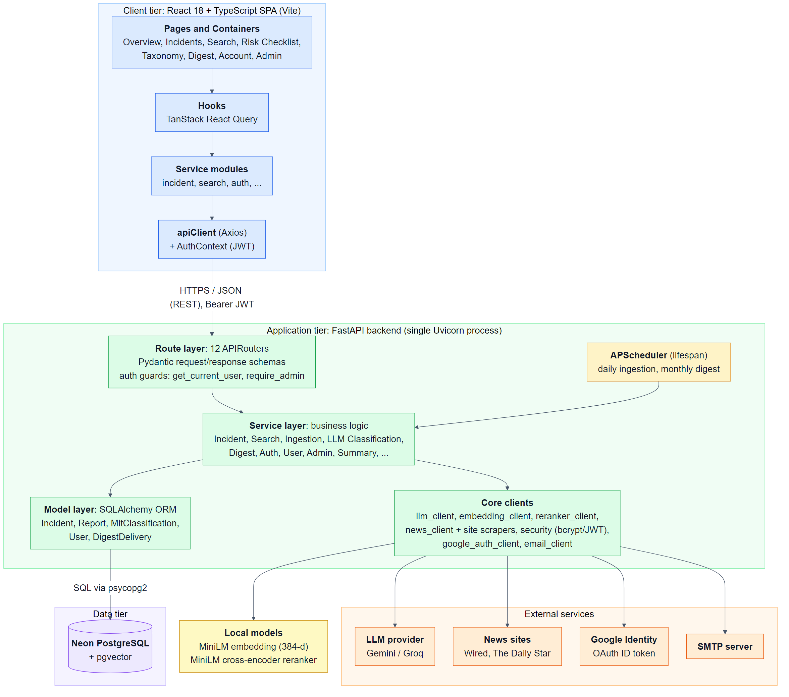
Fig 2: Overall structure of AIRiskWatch

4.2 Components
The system consists of seven functional components:

4.2.1 Incident Explorer and Analytics
Lets anyone browse, filter and inspect the incident database and see aggregate statistics.
- Responsibilities: paginated incident list with keyword, risk-domain, subdomain, cause and date filters; incident detail with source reports and classification; overview statistics, yearly trend and organisation leaderboard; taxonomy pages for every domain and subdomain.
- Works with: the database only.
- Design decisions: filters and page numbers are kept in the page address, so the back button and shared links restore the same view; lists are paginated on the server with at most 100 items per page.

4.2.2 Semantic Search and Risk Checklist
Finds past incidents that are similar in meaning to a user's description and turns them into a summary and a risk checklist.
- Responsibilities: convert the user's text into an embedding, retrieve similar incidents, reorder them by relevance, and generate a short summary that cites the incidents it is based on.
- Works with: the embedding model, the database's vector search, the reranker model and the LLM.
- Design decisions: 30 candidates are retrieved and then reranked before the best results are shown; the LLM only summarises that fixed set and is never asked to search on its own. The risk checklist is built in the browser from the same results, grouping them by MIT subdomain and marking each item High (5 or more similar incidents), Medium (2 to 4) or Low (1).

4.2.3 Incident Ingestion
Keeps the database current by reading trusted news sources and adding newly reported incidents.
- Responsibilities: discover articles published in the last 24 hours on Wired and The Daily Star, decide which describe real AI incidents, extract structured report and incident details, detect duplicates, and store new incidents or attach new reports to existing ones.
- Works with: the news sites, the LLM, the embedding model, the Incident Classification component and the database. It runs on a daily schedule or when an administrator starts it.
- Design decisions: the scraper obeys robots.txt and waits between requests; an article's URL, source and publish date always come from the page itself, never from the LLM; one failing article is recorded and skipped without stopping the run; a database lock prevents two runs at once.

4.2.4 Incident Classification
Places each incident in the MIT AI Risk Taxonomy.
- Responsibilities: assign a risk domain and subdomain, a second-best subdomain, and the three causal factors (entity, intent and timing), together with a confidence score.
- Works with: the LLM and the database; used by Incident Ingestion and by a batch script for existing incidents.
- Design decisions: the full taxonomy and one worked example per domain are given in every request; answers are checked against the taxonomy and corrected once if invalid; human-labelled classifications from the seed data are kept and only unclassified incidents are processed.

4.2.5 Accounts and Authentication
Manages user accounts and controls access to personal and administrative features.
- Responsibilities: registration, sign-in with email and password or with Google, account settings including the digest subscription, and user roles (user or admin).
- Works with: Google Identity and the database.
- Design decisions: passwords are stored only as bcrypt hashes; sign-in returns a signed token valid for 24 hours; the same error message is shown for an unknown email and a wrong password; the user is re-checked on every request so deactivation takes effect immediately; administrators can only be created from the command line.

4.2.6 Monthly Digest
Summarises each month's newly reported incidents on a page and by email.
- Responsibilities: build the monthly summary (counts, top domains, highlights and incident list), show it to signed-in users, and email it to subscribers on the first day of each month.
- Works with: the database and the email server.
- Design decisions: an incident belongs to the month of its earliest report; a per-user delivery record guarantees nobody receives the same month twice; administrators are left out of the bulk send and use a test send instead.

4.2.7 Administration
Gives administrators control over users, data and background jobs.
- Responsibilities: promote or deactivate users, run ingestion on demand, create, edit and delete incidents and reports, and preview or send the monthly digest.
- Works with: all other components.
- Design decisions: every administrative request is checked for the admin role on the server; an administrator cannot demote or deactivate their own account; records created by hand use the same identifier lock as ingestion so the two can never clash.

4.3 Component Interaction
The following sequence diagrams show how the components collaborate, step by step, in the four main scenarios of the system.

4.3.1 Semantic Search and Risk Checklist
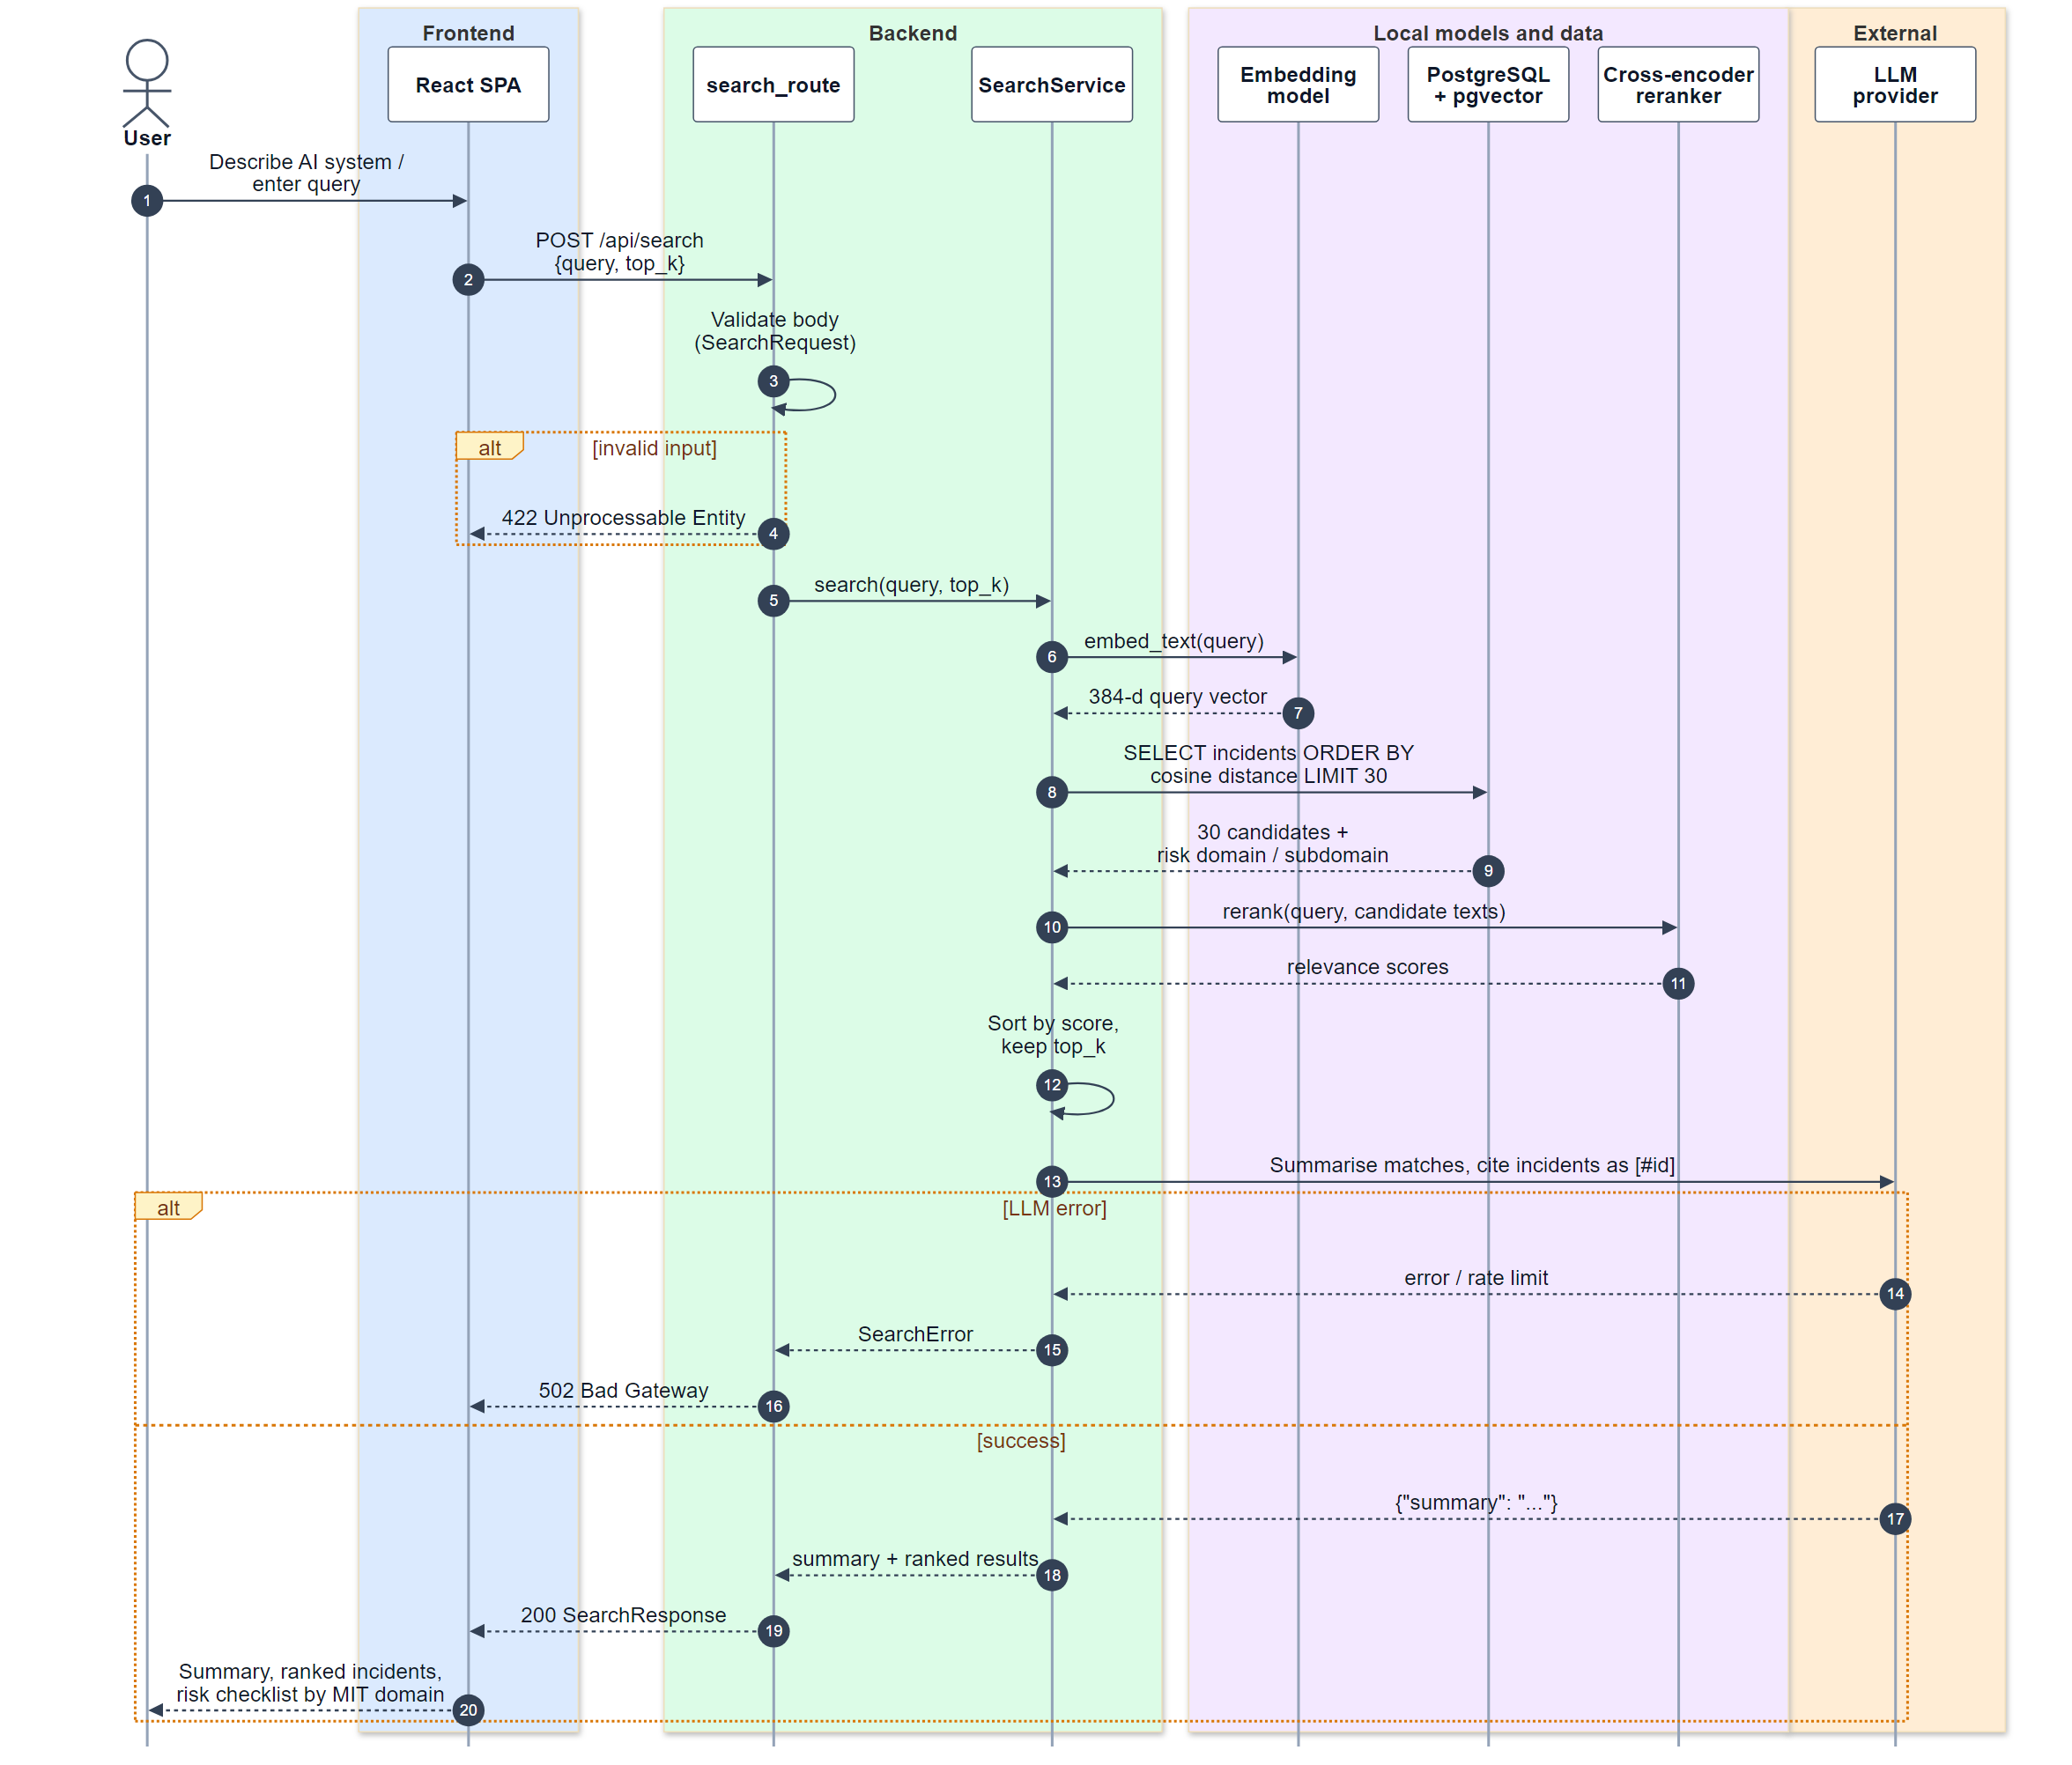
Fig 3: Sequence diagram for semantic search
The user's text is embedded with the same model used for stored incidents. PostgreSQL returns the 30 nearest incidents by cosine distance, a cross-encoder re-scores them against the query, and the best results (10 by default, at most 25) are sent to the LLM. The LLM writes a short summary that may only cite those incidents. The Risk Checklist page uses this same endpoint, then groups the matches by MIT domain and subdomain so the user can review each relevant risk.

4.3.2 Automated Incident Ingestion
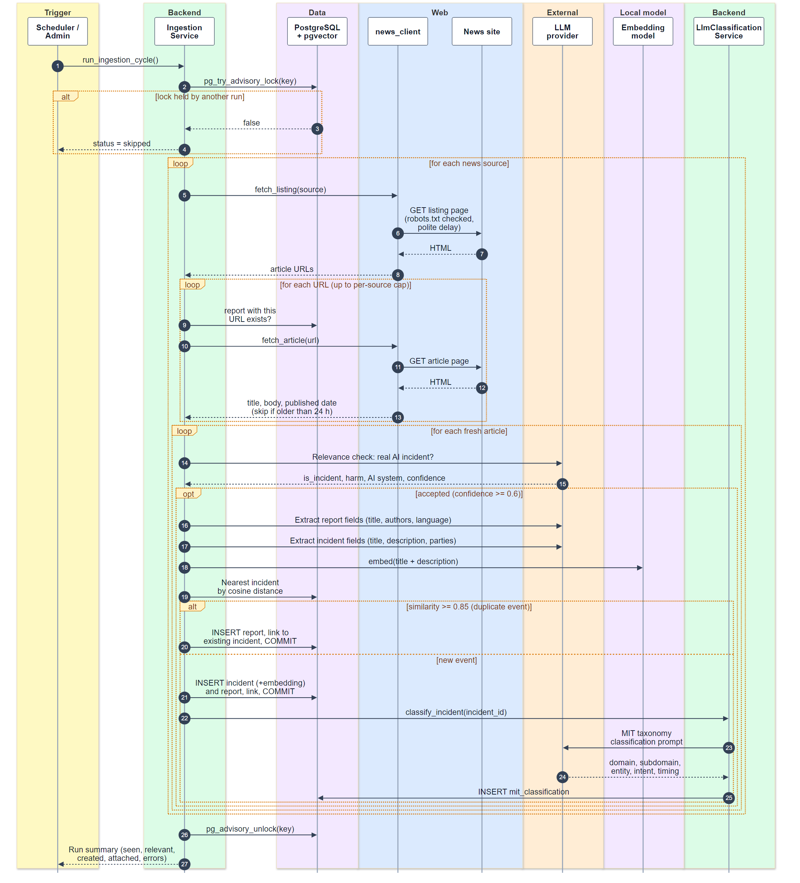
Fig 4: Sequence diagram for automated incident ingestion
Each run takes a database lock, then discovers articles published in the last 24 hours on each source's listing page. URLs already stored are skipped before any request or LLM call is made. For each new article the LLM first decides whether it describes a real AI incident; accepted articles are converted into structured report and incident fields. The incident is embedded and compared with existing incidents: at a cosine similarity of 0.85 or more the article is attached as a new report of that incident, otherwise a new incident is created and classified against the MIT taxonomy. Classification happens after the incident is saved, so a classification failure never loses it.

4.3.3 User Authentication
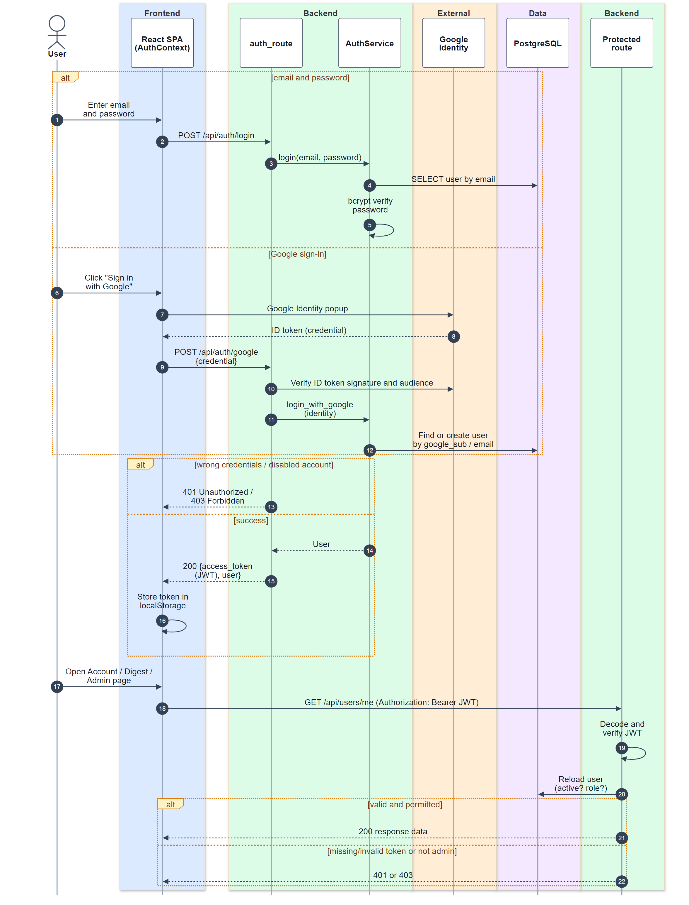
Fig 5: Sequence diagram for user authentication
Users sign in either with email and password (verified with bcrypt) or with Google, whose ID token is verified on the server. A Google account with a verified email is linked to an existing account with the same email or creates a new one. Both paths return a signed token that the browser stores and sends with every protected request; the server reloads the user each time, so role and deactivation changes apply immediately.

4.3.4 Monthly Digest Email
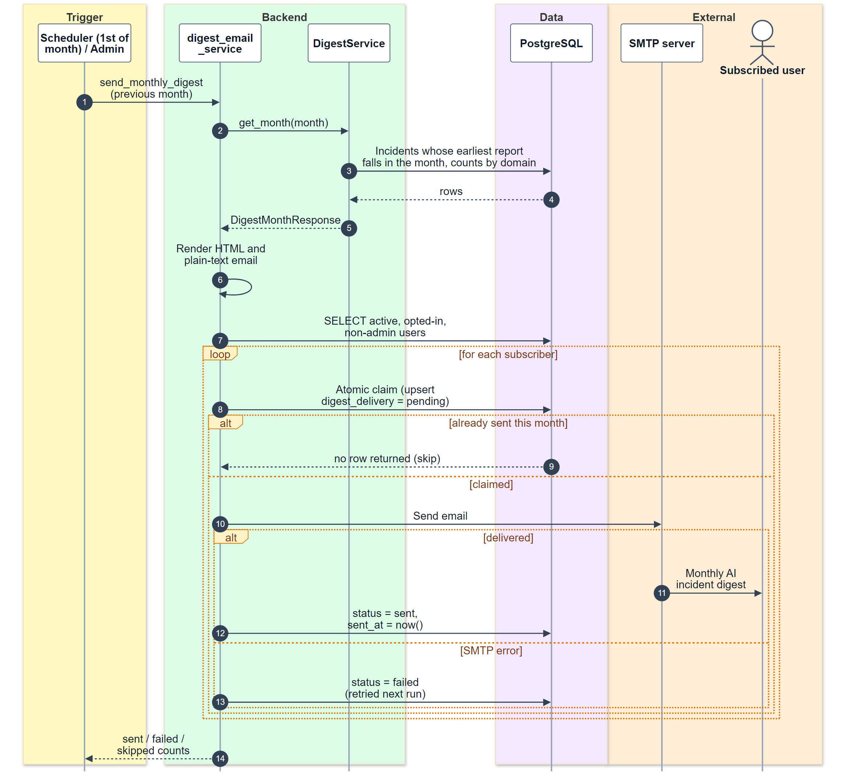
Fig 6: Sequence diagram for the monthly digest email
On the first day of each month the digest for the previous month is assembled and rendered once, then sent to every active user who has opted in. Before each email, an atomic update of the user's delivery record claims that user for the month; if the claim fails the user has already been served and is skipped. Failed deliveries are marked and retried on the next run.

5. AI Engineering

5.1 Overview
AIRiskWatch combines two complementary AI techniques. A generative large language model (LLM) is used where the system must read and reason about text: deciding whether a news article reports an AI incident, extracting structured fields from it, classifying incidents against the MIT taxonomy, and summarising search results. Embedding models are used where the task is to measure how similar two texts are: semantic search and duplicate detection. Keeping comparison tasks on embeddings means they are fast, free to run and repeatable, and the LLM is called only where reasoning is needed.

5.2 Models Used
Model | Type | Runs on | Used for
gemini-3.5-flash-lite (configurable: GPT-OSS-120B or Qwen3.8-27B via Groq) | Generative LLM | Google Gemini API | Relevance filtering, report and incident extraction, MIT classification, search summaries
multi-qa-MiniLM-L6-cos-v1 | Sentence embedding (384 dimensions) | Locally on the server | Incident and query embeddings for search and duplicate detection
cross-encoder/ms-marco-MiniLM-L6-v2 | Cross-encoder reranker | Locally on the server | Re-scoring the 30 search candidates against the query

5.3 LLM Integration
All LLM calls go through a single client interface, so the provider can be changed through configuration without touching the rest of the code. The integration applies the following rules:
- Structured output: every request includes a JSON schema describing the expected answer, and every response is validated with a Pydantic model before it is used.
- Repair on invalid output: if a classification answer fails validation, for example a subdomain that does not belong to the chosen domain, the request is sent once more together with the validation error. If it fails again, that incident is skipped.
- Rate limiting and retries: calls are spaced to stay within the provider's per-minute limit (10 requests per minute by default). Rate-limit and server errors are retried with exponential back-off, honouring the provider's Retry-After header.
- Grounding and provenance: prompts instruct the model to use only the text it is given. An article's URL, source and publish date are taken from the web page, never from the model.
- Failure isolation: an LLM failure on one article or incident is recorded and skipped; it never stops an ingestion run, and an incident is saved before it is classified.

5.4 Prompt Design
The system uses five prompts. Each has a fixed system instruction, a user message built from the data, and a JSON output schema.
Prompt | Purpose | Input | Output | Guardrails
Relevance check | Decide whether an article reports a real AI incident | Headline, standfirst and the first 2,000 characters of the article | is_incident, harm_type, ai_system, confidence, reason | Strict three-part definition and explicit exclusion list; the named system must appear in the text; accepted only at confidence 0.6 or above
Report extraction | Extract bibliographic details | Headline and up to 6,000 characters of article text | title, authors, language | Extract only what is stated; never guess an author; URL and date are not requested
Incident extraction | Write a neutral incident record in AIID style | Headline, publish date and article text | title, description, incident_date, deployer, developer, harmed parties | Facts from the article only; prefer an empty field to a guess
MIT classification | Assign taxonomy labels | Incident title, description and up to two linked reports, after seven worked examples | domain, subdomain, second subdomain, causal entity, intent, timing, confidence, justification | Full taxonomy in the prompt; values restricted to taxonomy names; one repair attempt
Search summary | Summarise the retrieved incidents for the user | The query and the top results (descriptions shortened to 600 characters) | summary | Use only the listed incidents; cite them as [#id]; never claim a total count; say so when nothing is related
Below is a sample prompt for the classification task, divided into 2 parts:
- The system prompt gives the model the full MIT taxonomy and output contract:

You are an expert annotator applying the MIT AI Risk Repository taxonomy to
real-world AI incidents. Choose exactly one risk_domain, then a
risk_subdomain that BELONGS TO that domain, a second-best subdomain in the
same domain, then classify the three causal axes.

TAXONOMY:
DOMAIN: Discrimination and Toxicity
Harms from the AI system treating people unfairly or exposing them to
toxic, hateful, or otherwise harmful content.
Subdomains: Unfair discrimination and misrepresentation; Exposure to
toxic content; Unequal performance across groups.
[... 6 further domains, ~24 subdomains total, each with a description ...]

CAUSAL AXES:
causal_entity: AI | Human | Other
timing: Pre-deployment | Post-deployment | Other
intent: Intentional | Unintentional | Other

Output rules: subdomains must belong to the chosen domain and differ from
each other; confidence is 0-1; justification is at most 2 sentences; reply
with ONLY a JSON object with keys risk_domain, risk_subdomain,
risk_subdomain_second, causal_entity, timing, intent, confidence,

- The user prompt supplies one held-out few-shot example per domain, then the target incident:

EXAMPLE 1
Title: Google's YouTube Kids App Presents Inappropriate Content
Description: YouTube's content filtering and recommendation algorithms
exposed children to disturbing and inappropriate videos.
Answer: {"risk_domain": "Discrimination and Toxicity", "risk_subdomain":
"Exposure to toxic content", "causal_entity": "AI", "timing":
"Post-deployment", "intent": "Unintentional", "confidence": 0.9, ...}

[... 6 further examples ...]

Now classify this incident:
Title: Resume-Screening Tool Systematically Downranks Female Applicants
Description: An automated hiring platform was found to score resumes
containing terms associated with women's colleges lower than otherwise
identical resumes, reproducing bias in its historical training data.
Answer:

5.5 Embeddings and Retrieval
A single embedding model is used for both stored incidents and user queries, so their similarity scores are directly comparable. Each incident is embedded from its title and description, and the 384-dimensional vector is stored in the incident table using pgvector. Embeddings serve two workflows:
- Semantic search: the query is embedded and PostgreSQL returns the 30 incidents with the smallest cosine distance. A cross-encoder then reads each query and incident pair together and reorders the candidates more precisely before the top results are returned.
- Duplicate detection: during ingestion, each new incident is compared with its nearest stored incident. At a cosine similarity of 0.85 or more the article is treated as another report of the same event; otherwise a new incident is created. The threshold is deliberately conservative so that unrelated incidents are not merged, and no LLM call is needed for this decision.

5.6 Evaluation
The classifier was evaluated offline against the human-labelled classifications that come with the MIT seed data. Each model classified randomly selected incidents, stratified so that all seven risk domains were covered; the incidents used as worked examples in the prompt were excluded. Three models were compared: Gemini 3.5 Flash-Lite, and GPT-OSS-120B and Qwen3.8-27B served through Groq. The Groq sample sizes were limited by the free tier's daily token quota, and those two models were run with an extended prompt of 39 worked examples.
Metric | Gemini 3.5 Flash-Lite | GPT-OSS-120B | Qwen3.8-27B
Incidents evaluated | 307 | 42 | 33
Risk domain accuracy | 82.4% | 69.0% | 75.8%
Risk domain macro-F1 | 0.754 | 0.670 | 0.693
Subdomain accuracy | 73.0% | 57.1% | 63.6%
Subdomain macro-F1 | 0.476 | 0.289 | 0.303
Gemini 3.5 Flash-Lite scored highest on both risk domain and subdomain, so it is the model used in production. Qwen3.8-27B came second and was the only model whose confidence dropped noticeably on wrong answers (77% against 87% on correct ones), which would make its confidence useful for flagging classifications for review. For all three models the weakest domains were Human-Computer Interaction and Socioeconomic and Environmental Harms, which have the fewest labelled incidents.

5.7 Limitations and Safeguards
- Hallucination: contained by grounding instructions, schema validation, taking provenance from the web page, and limiting the search summary to the retrieved incidents.
- Quota and availability: the free API tier limits requests per minute; the client rate-limits and retries, and the provider can be switched in configuration.
- Blocked responses: the provider occasionally refuses to answer (1 of 308 incidents in the evaluation); such items are skipped and recorded rather than guessed.
- Classification errors: LLM classifications are marked as such with their confidence, kept separate from human labels, and can be measured again with the evaluation harness after any prompt or model change.

6. Interface Design
The user interface was designed in three steps: identifying the interface objects on each screen and the actions a user can perform on them, defining the events that change what the screen shows, and describing every state a screen can be in together with the transitions between those states.

6.1 Interface Objects and Actions
Screen | Interface objects | Actions (operations)
Navigation bar (all pages) | Logo, section links, quick-search box (Ctrl+K), theme toggle, Sign in button or account avatar | Navigate, quick search, switch theme, open account or sign in
Overview | Statistic cards, yearly trend chart with range buttons, risk-domain bars, recent incidents | Change chart range, open a domain, open an incident
Incident list | Keyword box; Domain, Subdomain, Cause and Date filters; active-filter chips; incident rows; pagination | Search, filter, clear filters, change page, open an incident
Incident detail | Title and tags, description, MIT classification panel, source report list, related incidents | Open a source report, open a related incident, go back
Semantic search | Query box, Search button, facet panel (domain, year, minimum similarity), AI summary, result cards, pagination | Submit a query, toggle facets, change page, open an incident
Risk checklist | Description box, example button, Generate button, progress card with High, Medium and Low counts, grouped checklist items with tick boxes | Generate a checklist, tick or untick items, open matched incidents or taxonomy pages
Taxonomy | Taxonomy switch cards, domain map, domain and subdomain pages with statistics, trend and organisations | Open a domain, subdomain or causal category
Sign in and Sign up | Google button, email, username and password fields, submit button, error messages, link to the other page | Sign in, register, switch between the two pages
Account | Profile fields, sign-in methods, monthly digest switch, Sign out button | Rename, subscribe or unsubscribe, sign out
Monthly digest | Month strip, statistic cards, highlights, by-domain bars, incident list | Choose a month, open an incident
Admin console | Tabs; user table; Run ingestion button and run summary; incident and report tables with forms; digest month selector, preview and send buttons, delivery status | Manage users, run ingestion, create, edit and delete records, preview and send the digest

6.2 Events
Event (user action) | Screen | Resulting change of state
Submit a query (Search button or Enter) | Semantic search | Idle or Results to Searching; the button is disabled until the response arrives
Search response received | Semantic search | Searching to Results, or to Error if it failed
Toggle a facet | Semantic search | Results are filtered in place; if none remain, No filter match
Press Generate checklist | Risk checklist | Generating, then Checklist ready, Nothing to check or Error
Tick or untick a checklist item | Risk checklist | Progress counter updates
Type keywords or change a filter | Incident list | Updating (keywords wait until typing pauses), then Incidents listed or No matches; the address is updated
Change page | Lists and tables | The next page loads and the page number is kept in the address
Submit the sign-in form | Sign in | Field errors if input is invalid; otherwise Submitting, then Signed in or Authentication error
Google returns a credential | Sign in / Sign up | Submitting, then Signed in
Toggle the digest switch | Account | Setting saved and the switch shows the new value
Press Run ingestion | Admin console | Running (button disabled), then Run finished or Error
Press the theme toggle | All pages | Light and dark themes swap; the choice is remembered
Session expires (server answers 401) | Any page | The user is signed out automatically

6.3 Interface States and Transitions
For the five most interactive screens, the state transition diagram below shows every state the screen can be in and the event that moves it to the next state, followed by how each state looks to the user. Loading and error states were captured by holding or failing the network request in the browser.

6.3.1 Semantic Search
The search screen starts Idle with a hint. Typing enables the Search button; submitting shows a spinner, then either the results with their AI summary or an error message. Facets filter the results in place.
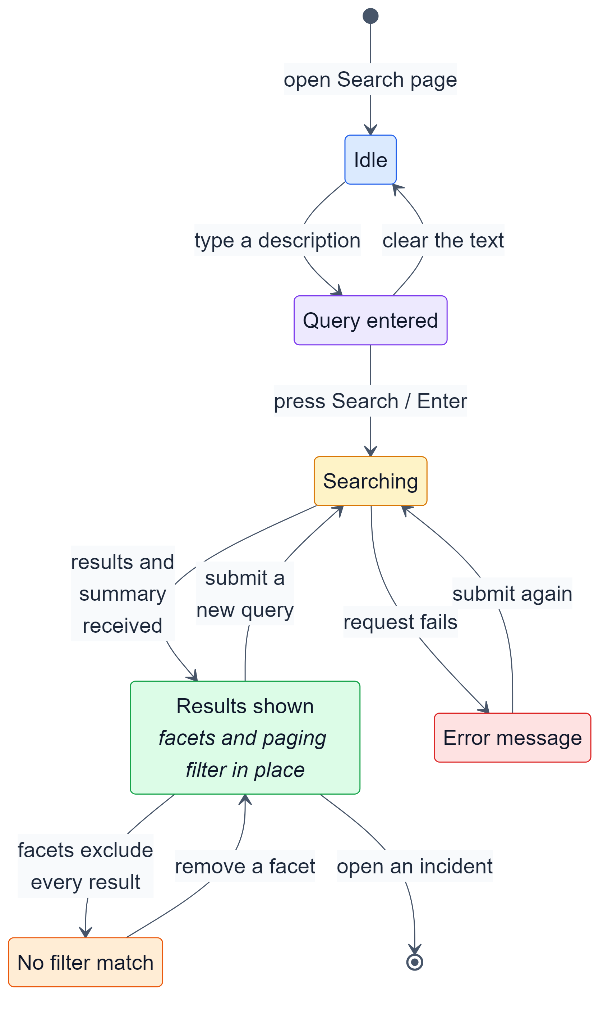
Fig 7: State transition diagram: semantic search
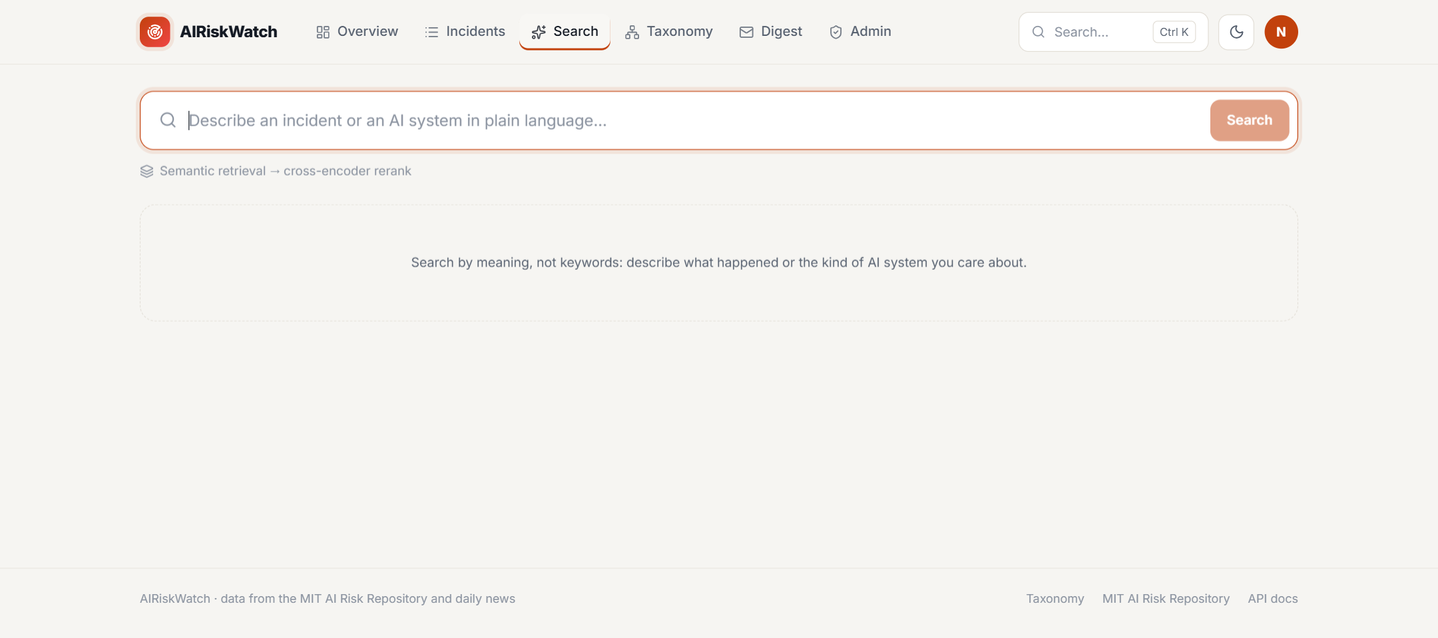
Fig 8: Search: Idle
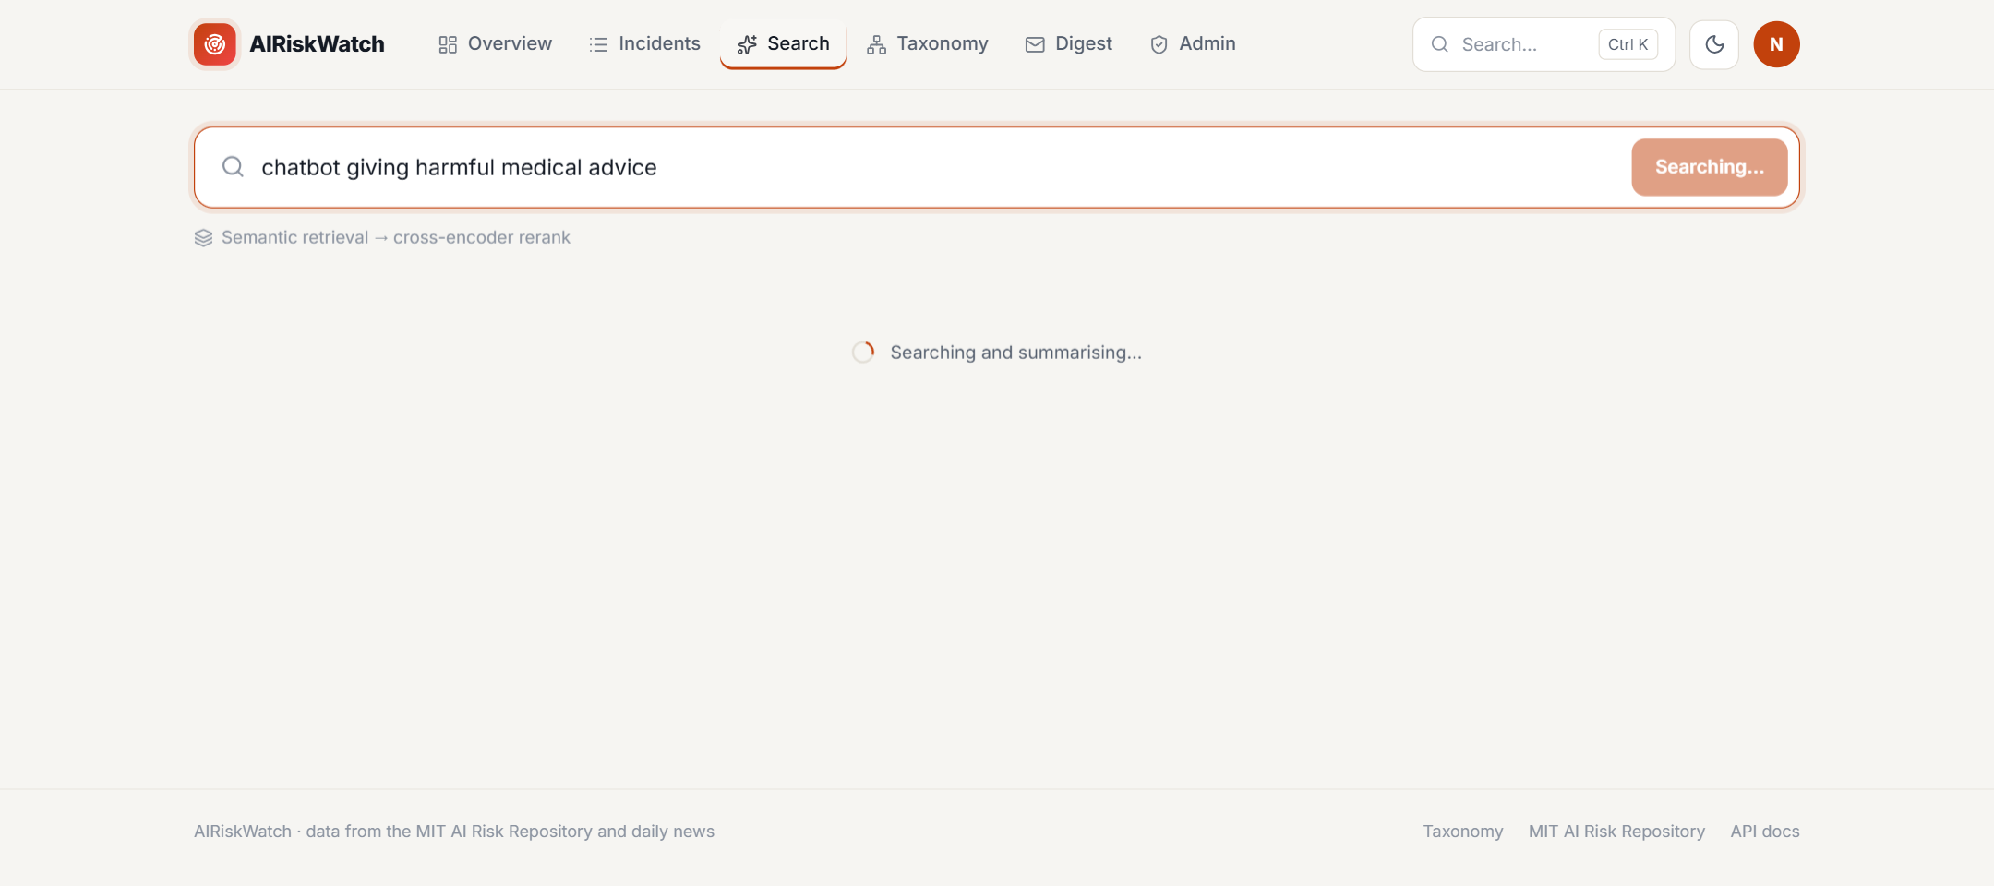
Fig 9: Search: Searching
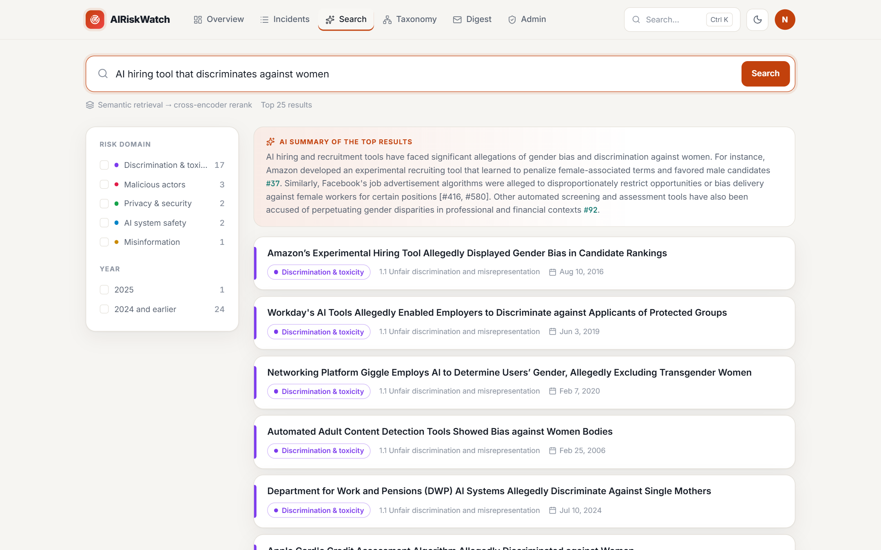
Fig 10: Search: Results shown
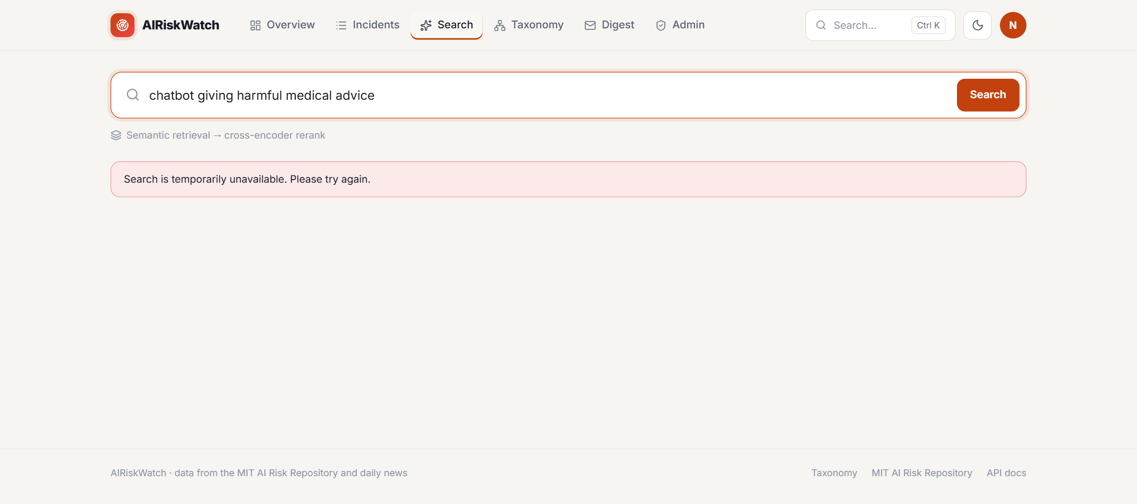
Fig 11: Search: Error message

6.3.2 Risk Checklist
The checklist screen waits for a system description. While the similar incidents are retrieved the checklist card shows a spinner; afterwards it shows the grouped checklist and a progress counter that changes as items are ticked.
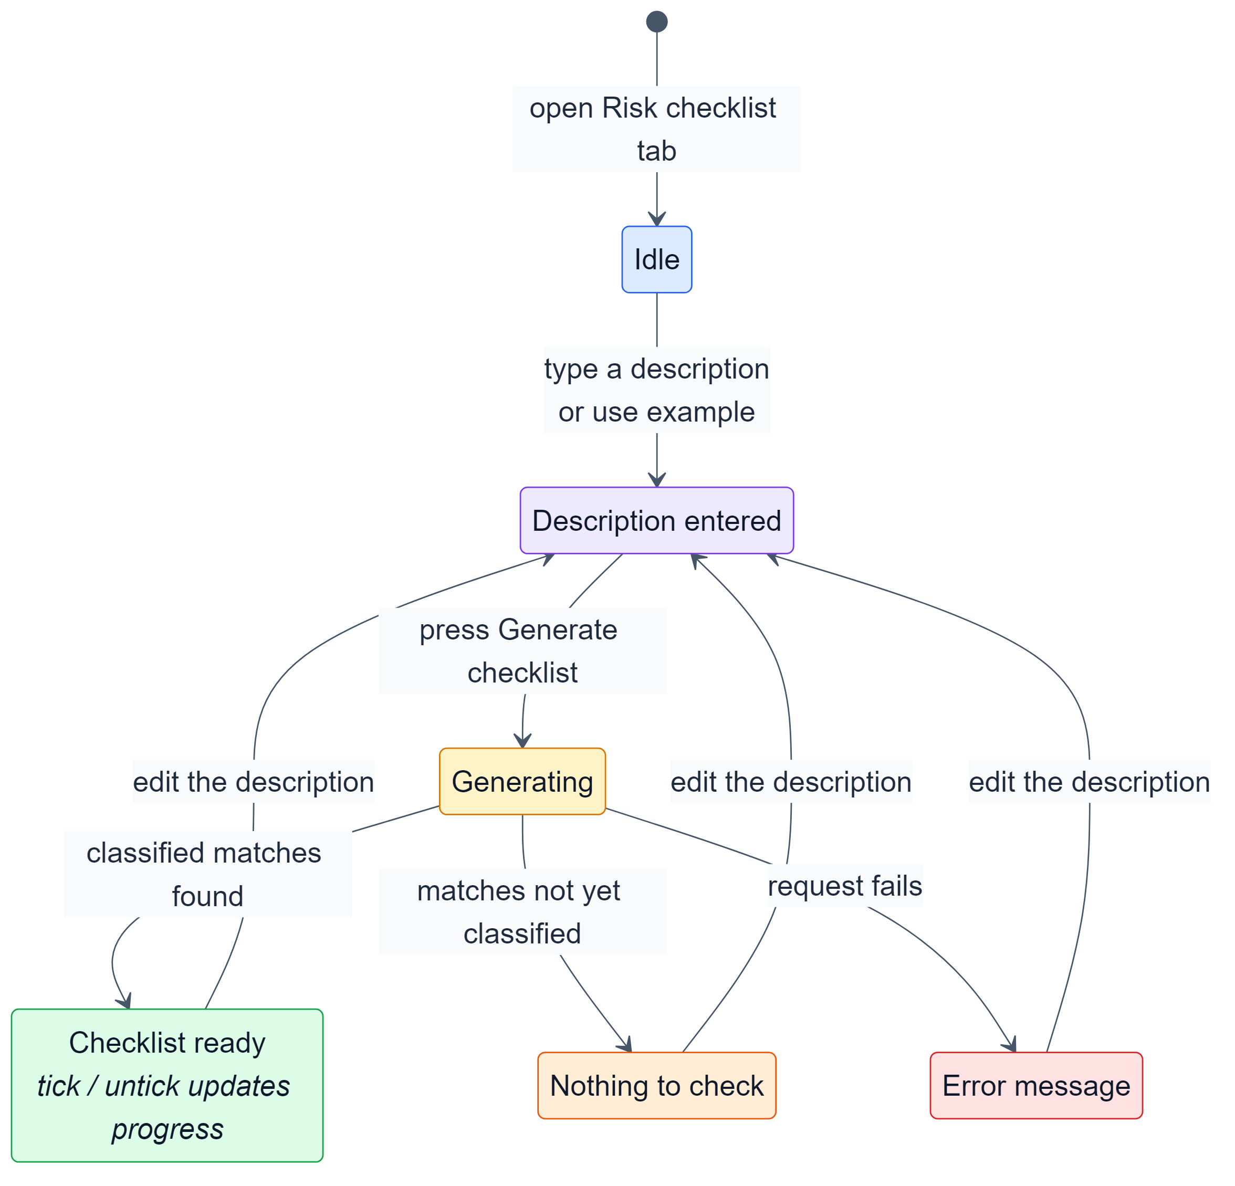
Fig 12: State transition diagram: risk checklist
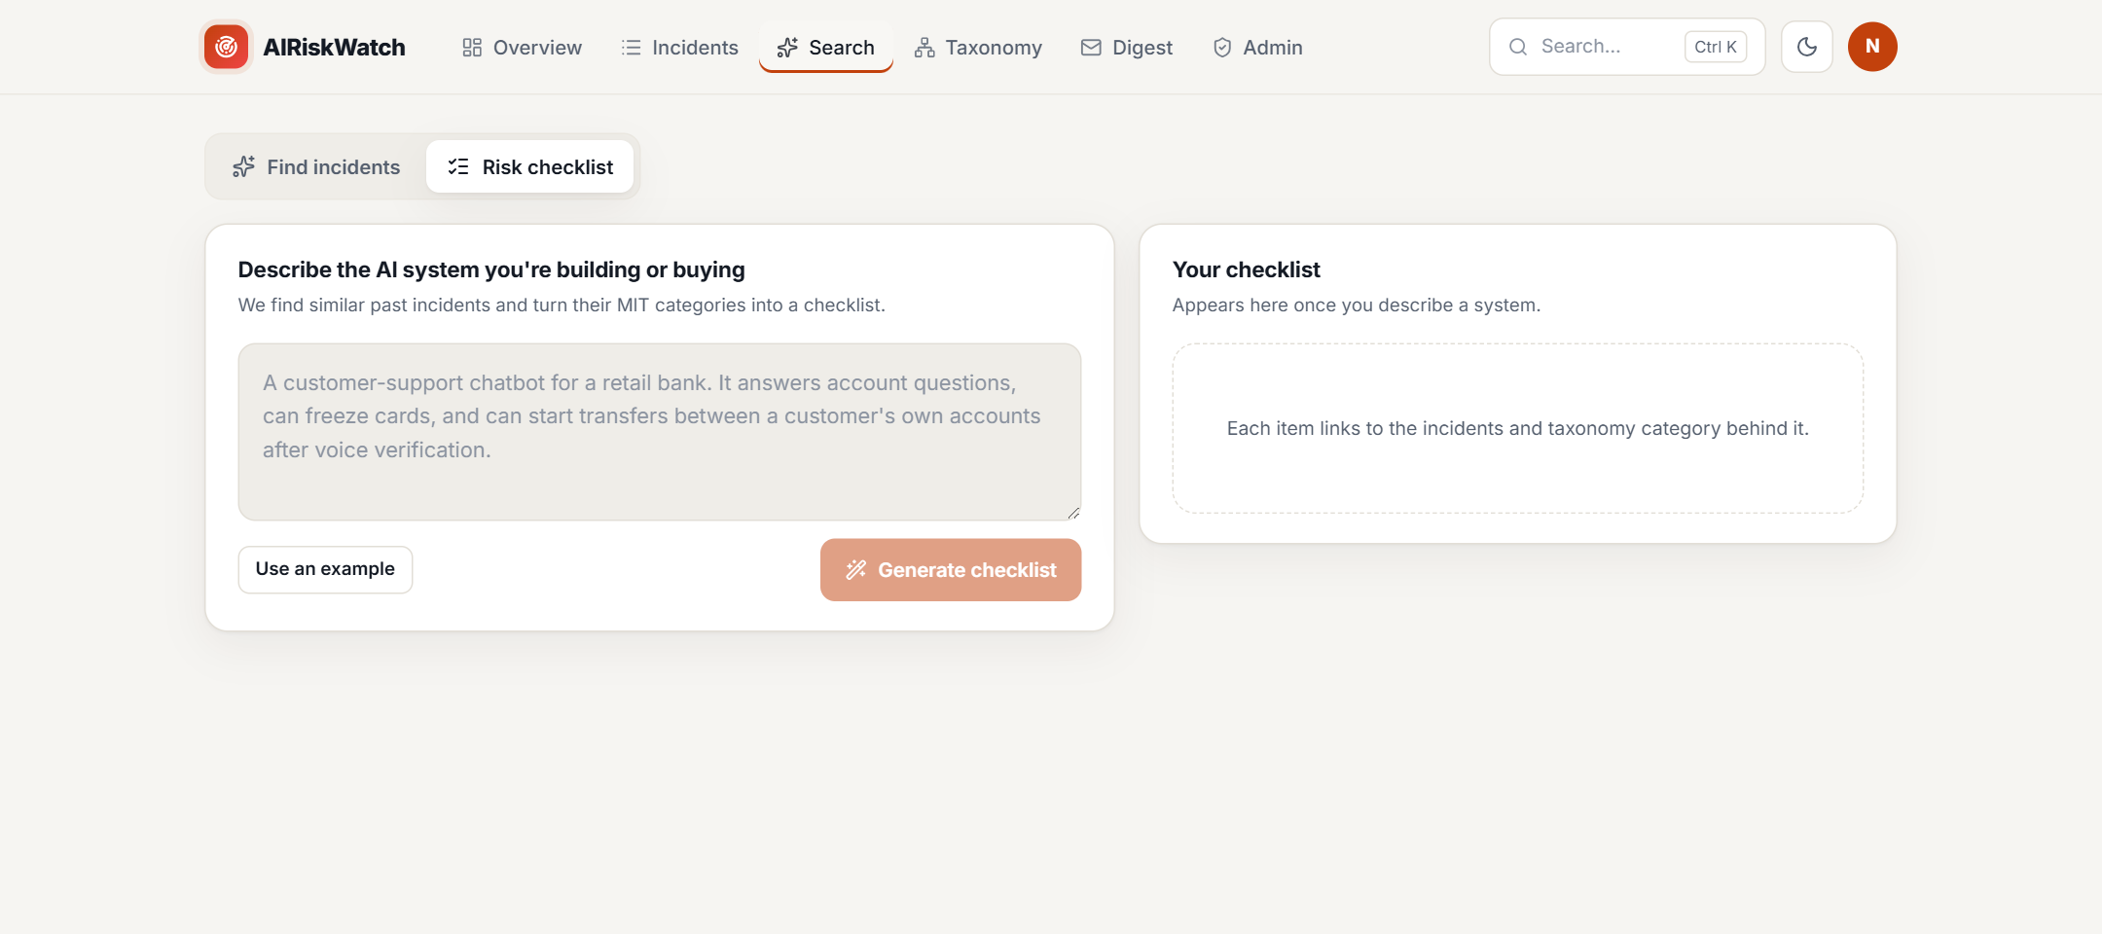
Fig 13: Risk checklist: Idle
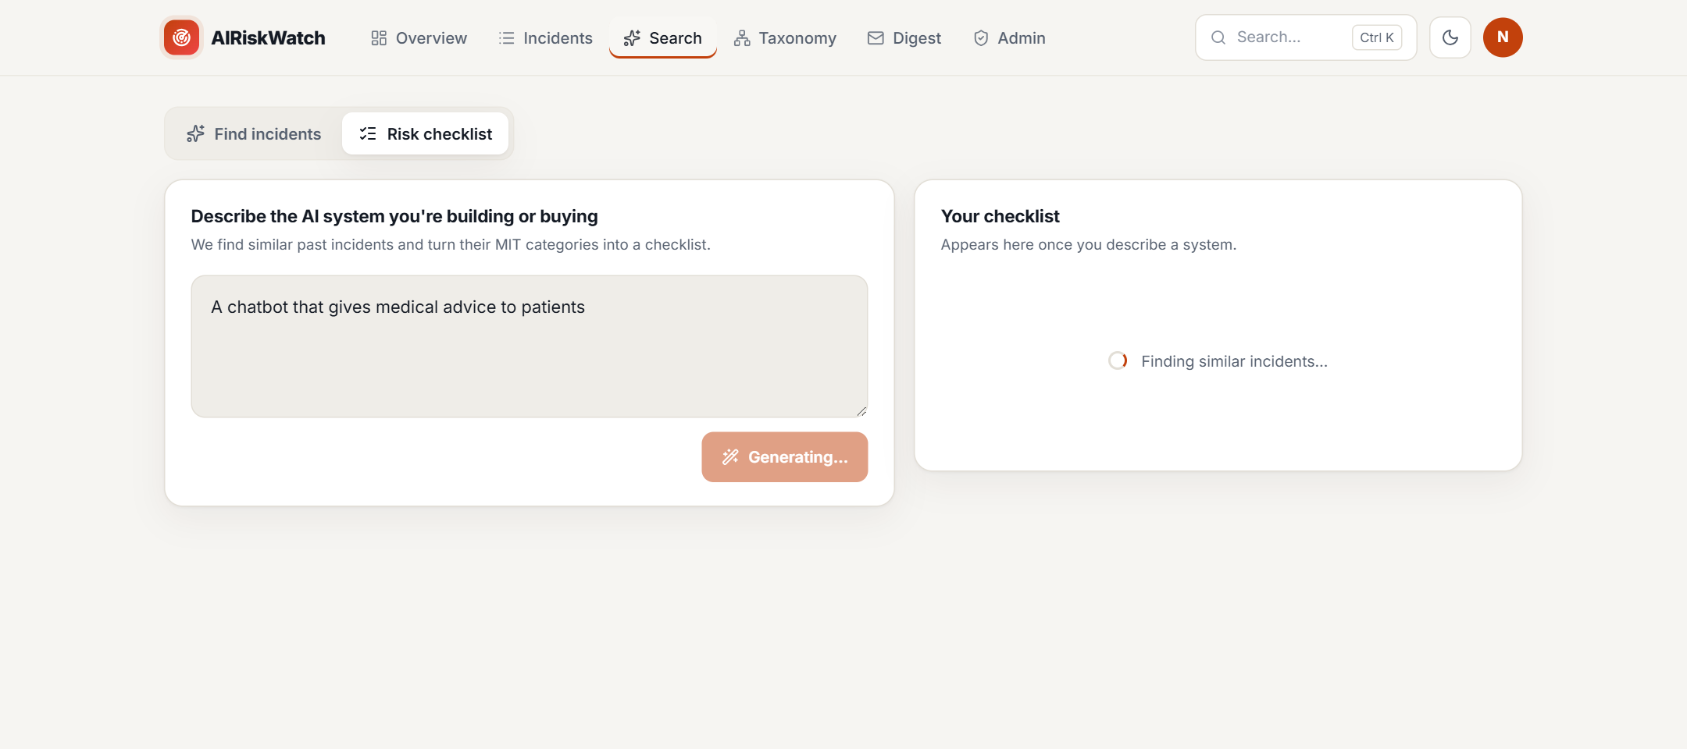
Fig 14: Risk checklist: Generating
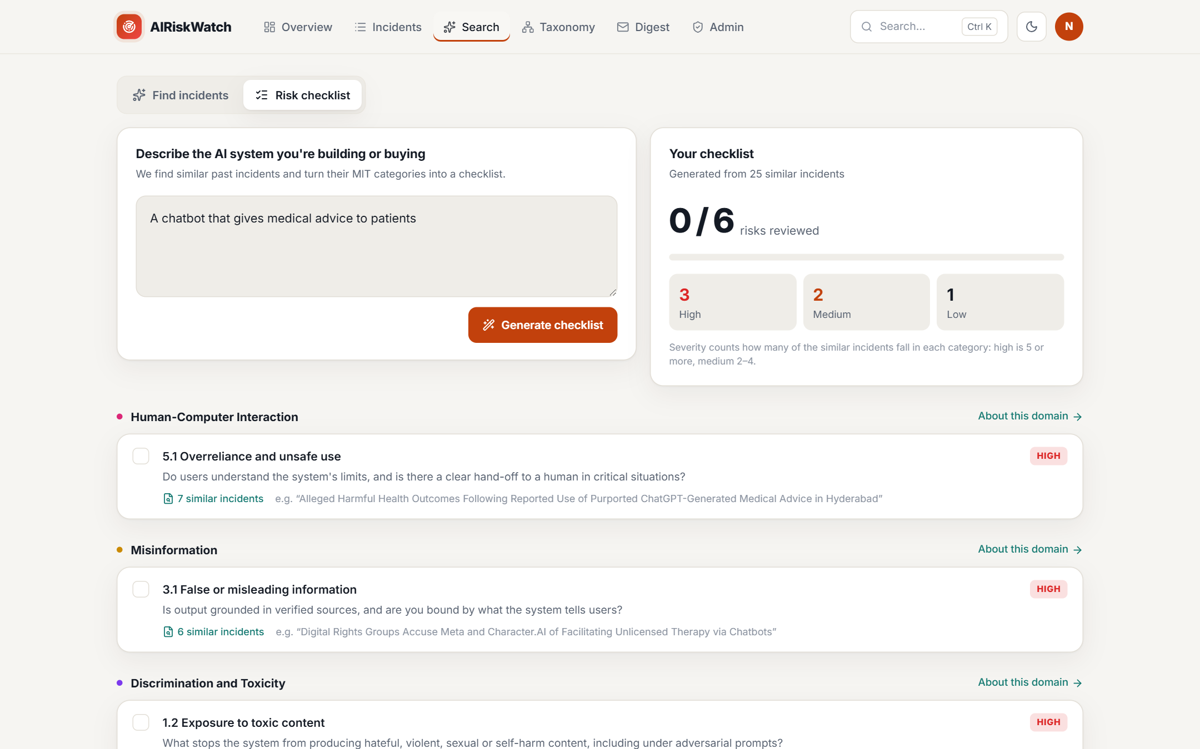
Fig 15: Risk checklist: Checklist ready

6.3.3 Incident List
The incident list loads with the newest incidents. Every filter change moves it to Updating and back to a list of incidents, or to an empty-result message when nothing matches.
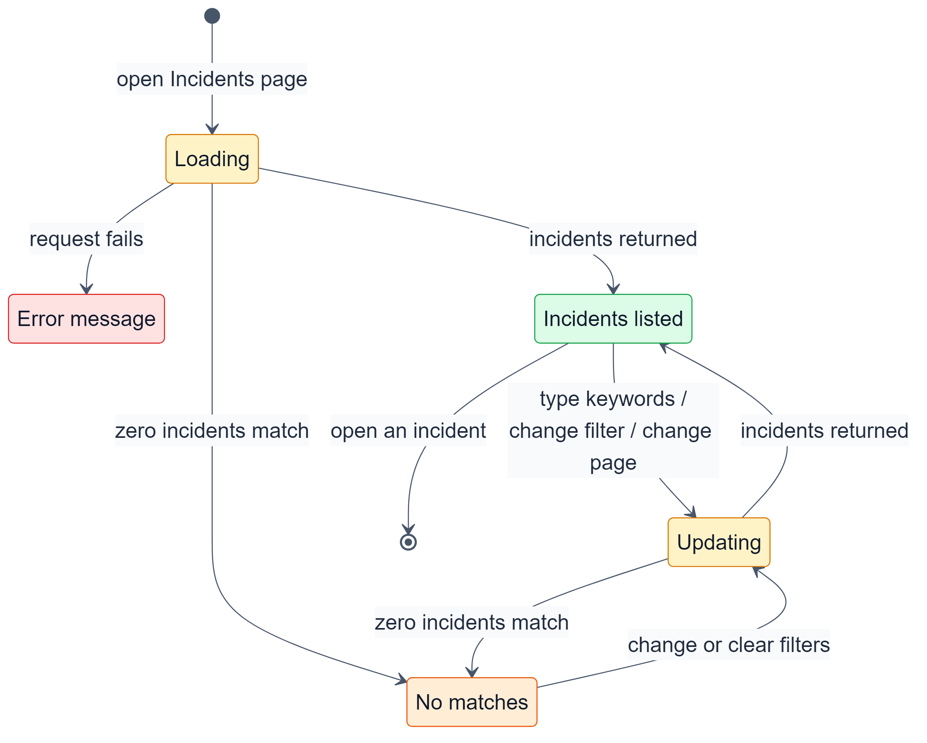
Fig 16: State transition diagram: incident list
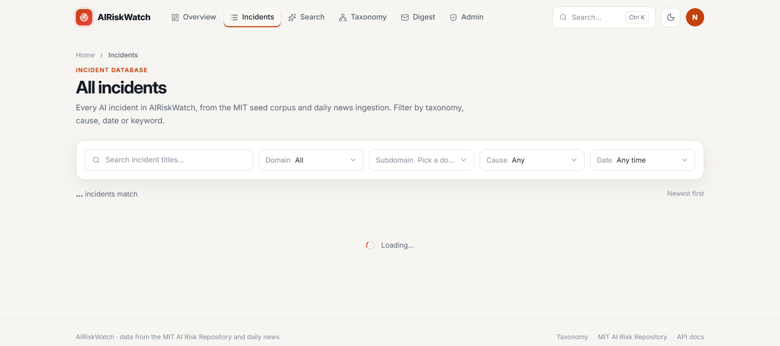
Fig 17: Incident list: Loading
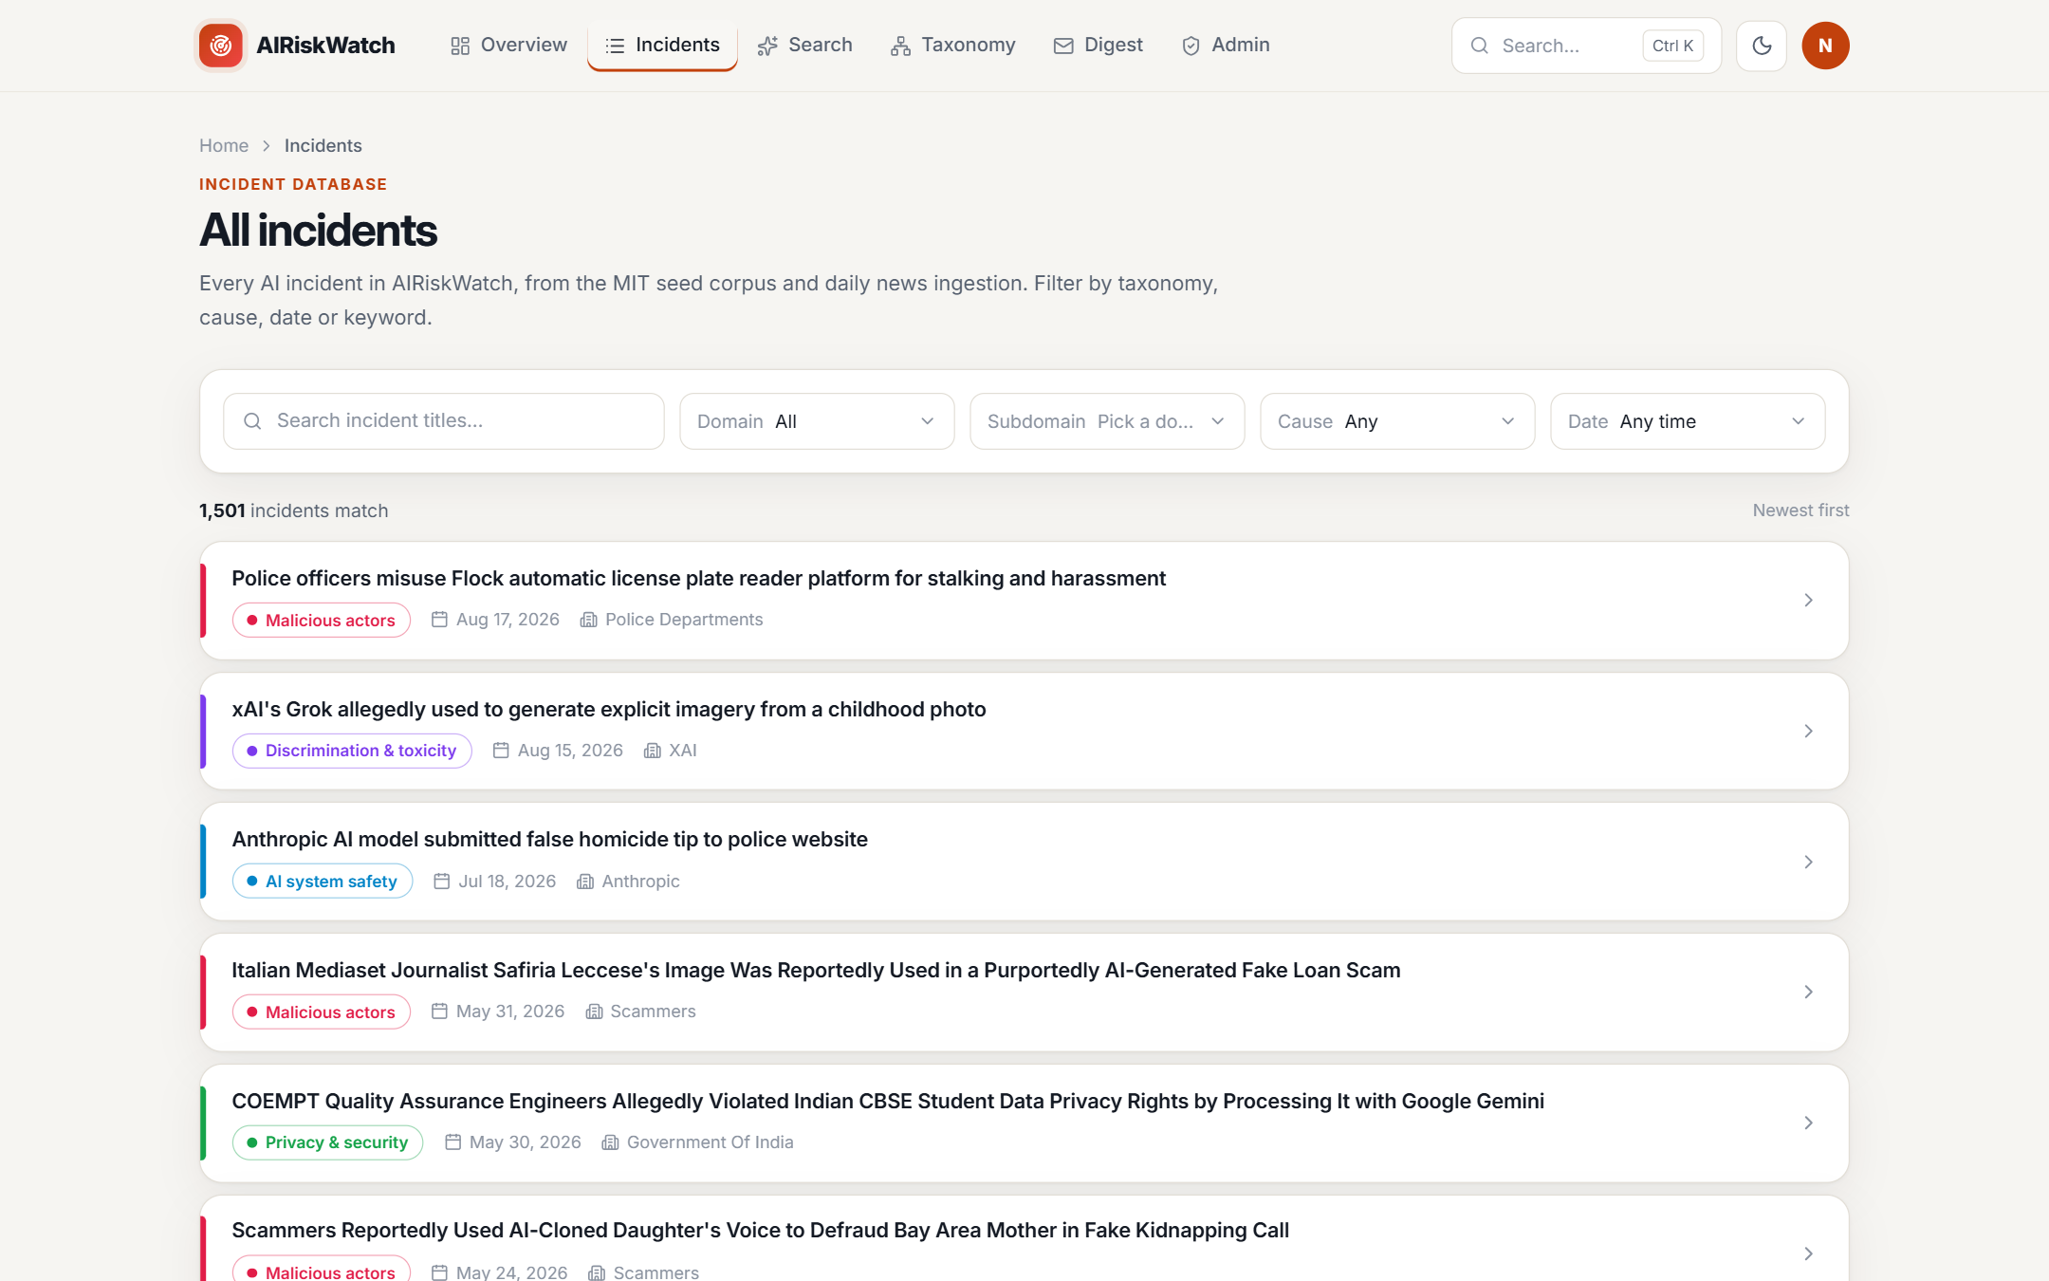
Fig 18: Incident list: Incidents listed
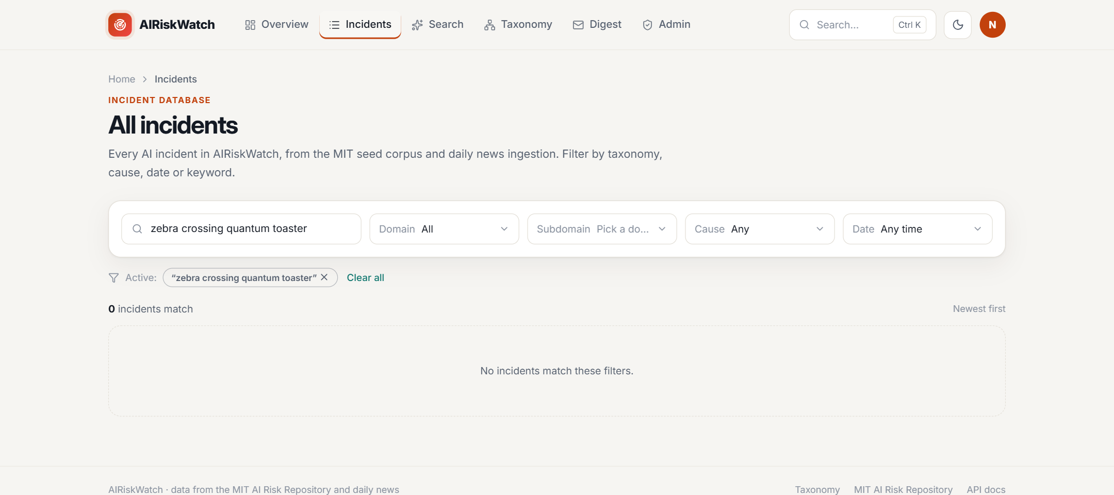
Fig 19: Incident list: No matches

6.3.4 Sign In
Invalid input is caught in the browser and shown under each field without contacting the server. Valid input is submitted; a rejected sign-in shows a single message that does not reveal whether the email exists.
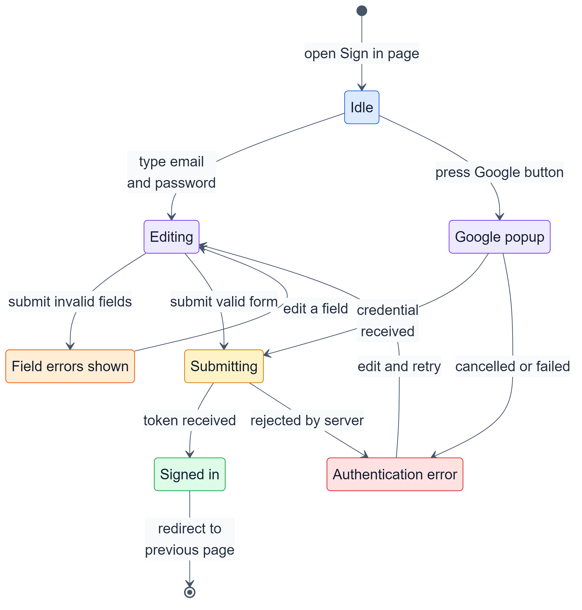
Fig 20: State transition diagram: sign in
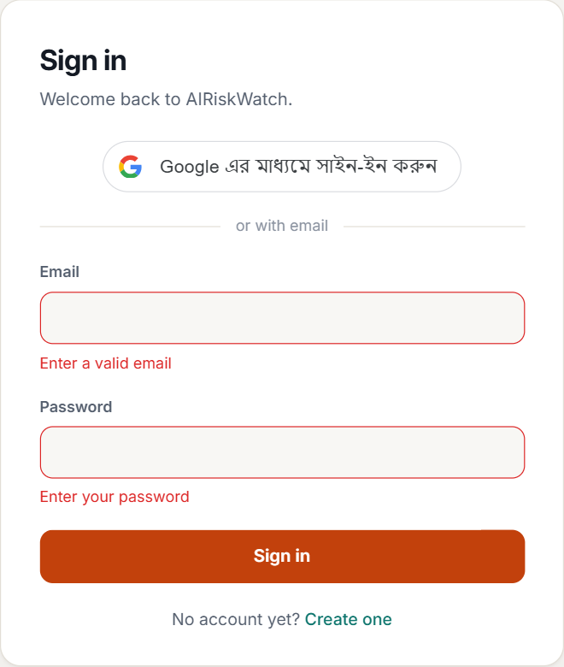
Fig 21: Sign in: Field errors shown
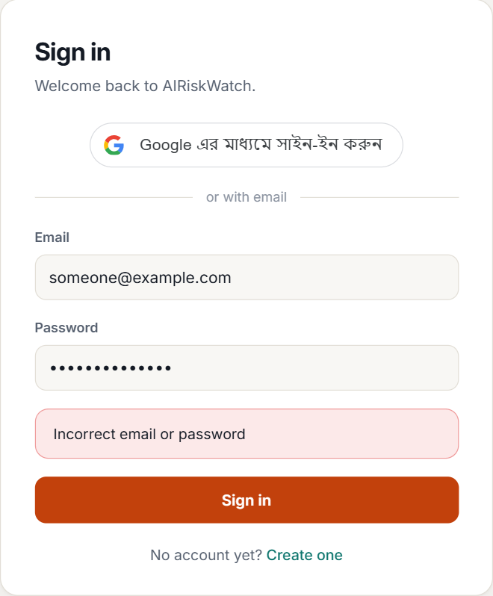
Fig 22: Sign in: Authentication error

6.3.5 Admin Ingestion
Starting a run disables the button and shows a spinner until the server returns the run summary, which reports whether the run completed, completed with errors, or was skipped because another run was in progress.
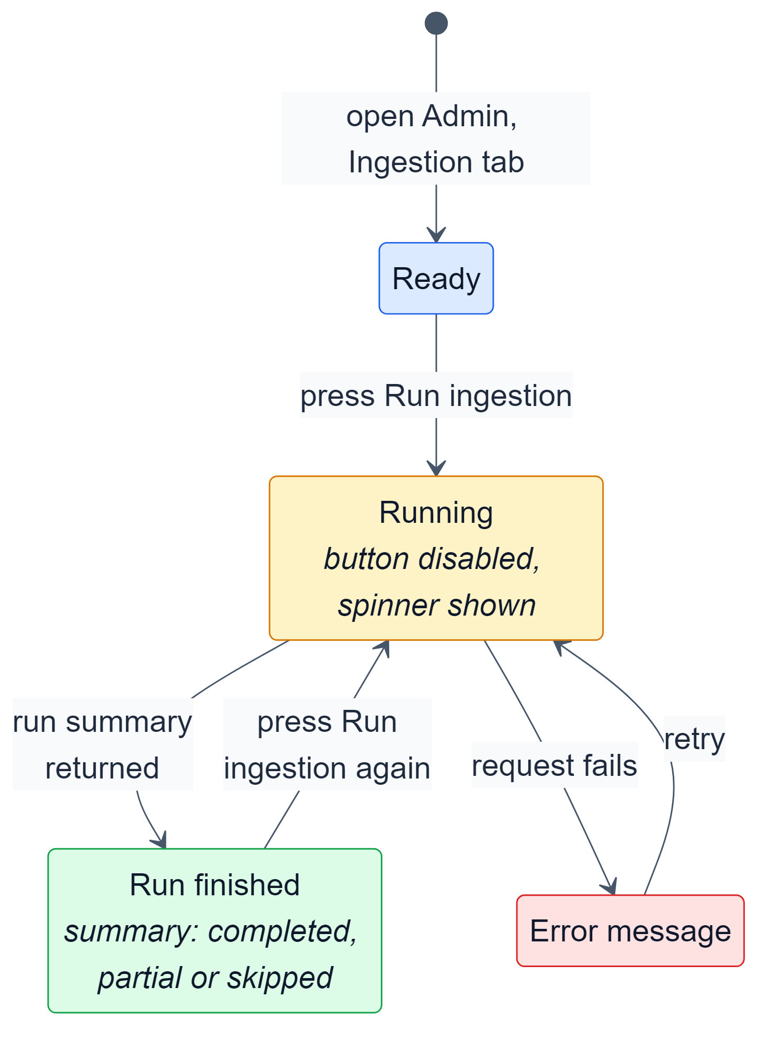
Fig 23: State transition diagram: admin ingestion
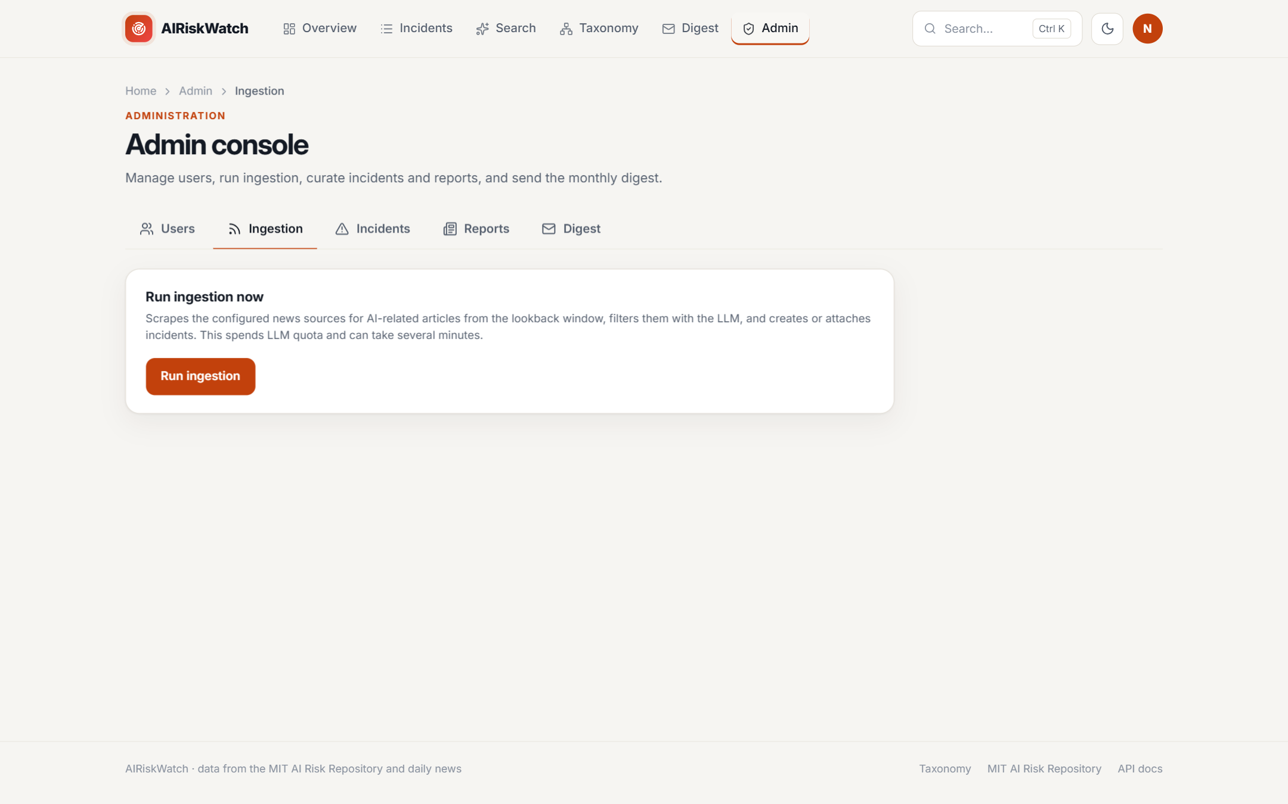
Fig 24: Admin ingestion: Ready
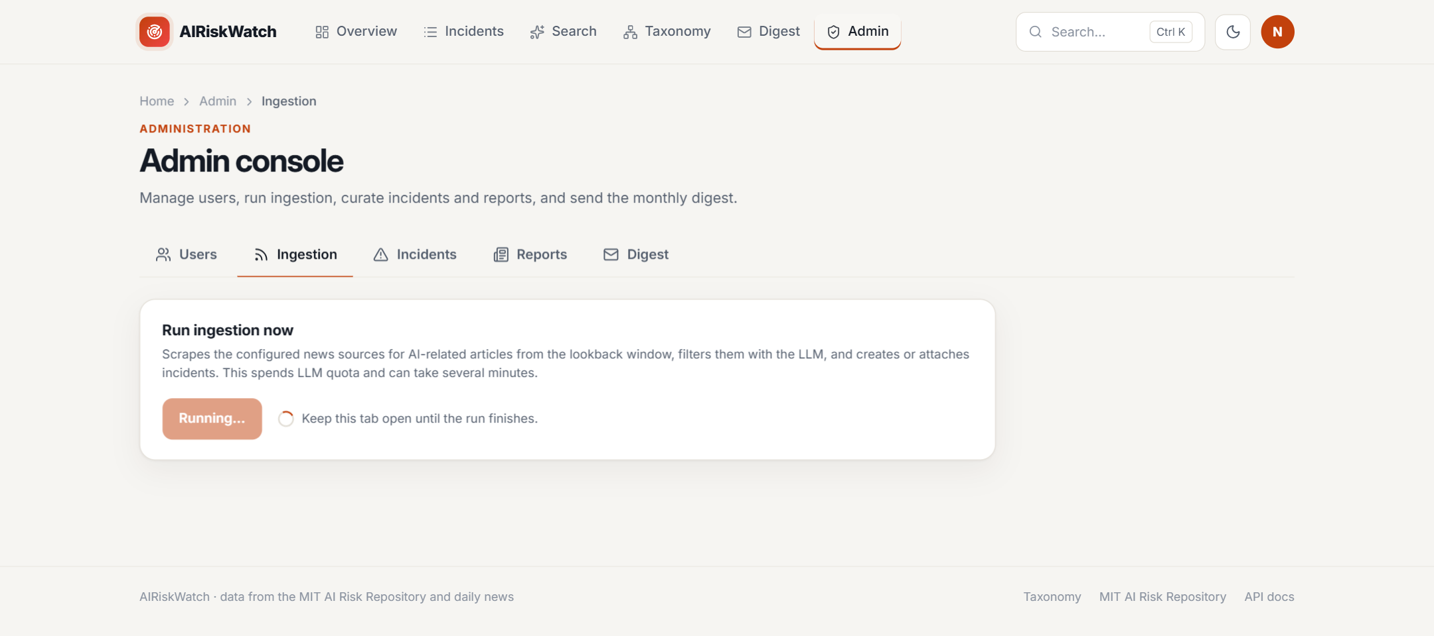
Fig 25: Admin ingestion: Running

7. Testing Components

7.1 Testing Approach and Strategy
Testing combined three activities:
- API testing: black-box tests of the REST API against the running system, the FastAPI backend connected to the Neon database with the scheduler disabled. A Python script built on the httpx client sent 43 requests covering every module and compared each response with the expected result.
- User interface testing: every screen and the interface states in Section 6.3 were opened in an automated Chromium browser (Playwright) with live data, which also produced the screenshots in this document.
- Model evaluation: the LLM classifier was measured against human labels, as reported in Section 5.6.
Each API module was tested for:
- Valid requests: correct data returned for listing, filtering, detail, analytics, search and digest endpoints.
- Input validation: malformed or out-of-range input rejected with 422 before reaching the service layer.
- Missing resources: unknown incident and report identifiers answered with 404.
- Authentication and authorisation: protected endpoints reject missing or invalid tokens with 401, and admin-only endpoints reject normal users with 403.

7.2 Item Pass/Fail Criteria
- A test case passes when the HTTP status code equals the expected code and, for successful responses, the body contains the required fields, for example items and total for lists, or summary and results for search.
- A test case fails on any other status code, a missing field, a connection error, or no response within 120 seconds.
- Read endpoints must respond within 2 seconds; semantic search must respond within 30 seconds, including model start-up.
- No server error (5xx) is acceptable from an endpoint that does not depend on an external service.
- A screen passes the interface test when it loads with live data and each state in Section 6.3 can be reached and displayed.
- The test run is accepted only if every test case passes.

7.3 Risks and Contingencies
Risk | Impact | Contingency
Tests run against the live database | Real data could be changed or deleted | Tests only read data; create, update and delete endpoints are tested only on paths that are rejected before any change; the scheduler is disabled during testing
LLM quota or rate limit reached | Search tests fail with 502 | One live LLM call per run; the client rate-limits and retries with back-off; the provider can be switched in configuration
Slow start of the local models | The first search may be slow or time out | 120-second client timeout; timing criteria allow for model start-up
Neon suspends idle compute | The first query may hit a closed connection | Connections are checked before use and reopened automatically
News-site layout changes | Ingestion finds no articles | Sources are checked with --check-sources and --dry-run before a full run; a failing source is recorded without stopping the others
LLM output is not deterministic | Exact wording cannot be asserted | Tests check structure and status, not wording; every LLM response is validated against its schema
Google sign-in cannot be automated | The successful Google path is not covered by the script | The invalid-token path is automated; the successful path is checked by signing in manually

7.4 Test Cases and Results
ID | Module | Endpoint | Test Case | Expected | Actual | Result
T01 | System | GET /health | Health check | 200 | 200 | Pass
T02 | Incidents | GET /api/incidents/?limit=20&offset=0 | List incidents (first page) | 200 | 200 | Pass
T03 | Incidents | GET /api/incidents/?search=deepfake&limit=5 | Keyword search filter | 200 | 200 | Pass
T04 | Incidents | GET /api/incidents/?risk_domain=Misinformation&limit=5 | Filter by risk domain | 200 | 200 | Pass
T05 | Incidents | GET /api/incidents/?date_from=2024-01-01&date_to=2024-12-31&limit=5 | Filter by date range | 200 | 200 | Pass
T06 | Incidents | GET /api/incidents/?limit=500 | Page size above maximum (100) | 422 | 422 | Pass
T07 | Incidents | GET /api/incidents/?date_from=not-a-date | Malformed date parameter | 422 | 422 | Pass
T08 | Incidents | GET /api/incidents/1511 | Incident detail with reports and classification | 200 | 200 | Pass
T09 | Incidents | GET /api/incidents/99999999 | Non-existent incident | 404 | 404 | Pass
T10 | Incidents | GET /api/incidents/trend | Yearly incident trend | 200 | 200 | Pass
T11 | Reports | GET /api/reports/7337 | Report detail | 200 | 200 | Pass
T12 | Reports | GET /api/reports/99999999 | Non-existent report | 404 | 404 | Pass
T13 | Taxonomy | GET /api/risk-domains/ | Risk domains with subdomain counts | 200 | 200 | Pass
T14 | Taxonomy | GET /api/classification-breakdowns/ | Causal-factor breakdowns | 200 | 200 | Pass
T15 | Analytics | GET /api/summary/ | Overview summary statistics | 200 | 200 | Pass
T16 | Analytics | GET /api/organizations/top?limit=10 | Top organisations leaderboard | 200 | 200 | Pass
T17 | Search | POST /api/search | Semantic search with LLM summary | 200 | 200 | Pass
T18 | Search | POST /api/search | Empty query rejected | 422 | 422 | Pass
T19 | Search | POST /api/search | top_k above maximum (25) | 422 | 422 | Pass
T20 | Auth | POST /api/auth/login | Login with wrong password | 401 | 401 | Pass
T21 | Auth | POST /api/auth/login | Login with malformed email | 422 | 422 | Pass
T22 | Auth | POST /api/auth/register | Register with already-used email | 409 | 409 | Pass
T23 | Auth | POST /api/auth/register | Register with short password | 422 | 422 | Pass
T24 | Auth | POST /api/auth/google | Google sign-in with invalid credential | 401 | 401 | Pass
T25 | Account | GET /api/users/me | Profile without token | 401 | 401 | Pass
T26 | Account | GET /api/users/me | Profile with invalid token | 401 | 401 | Pass
T27 | Account | GET /api/users/me | Profile with valid token | 200 | 200 | Pass
T28 | Account | PATCH /api/users/me | Username with invalid characters | 422 | 422 | Pass
T29 | Digest | GET /api/digest/months | Digest months without token | 401 | 401 | Pass
T30 | Digest | GET /api/digest/months | List available digest months | 200 | 200 | Pass
T31 | Digest | GET /api/digest/2026/9 | Monthly digest content | 200 | 200 | Pass
T32 | Digest | GET /api/digest/1999/1 | Year outside allowed range | 422 | 422 | Pass
T33 | Admin | GET /api/admin/users | Admin user list as normal user | 403 | 403 | Pass
T34 | Admin | GET /api/admin/users?limit=10 | Admin user list as admin | 200 | 200 | Pass
T35 | Admin | GET /api/admin/reports?limit=10 | Admin report list | 200 | 200 | Pass
T36 | Admin | POST /api/admin/incidents | Create incident with empty title | 422 | 422 | Pass
T37 | Admin | PATCH /api/admin/incidents/99999999 | Update non-existent incident | 404 | 404 | Pass
T38 | Admin | DELETE /api/admin/reports/99999999 | Delete non-existent report | 404 | 404 | Pass
T39 | Admin | GET /api/admin/digest/status | Digest delivery status | 200 | 200 | Pass
T40 | Admin | GET /api/admin/digest/preview | Digest email HTML preview | 200 | 200 | Pass
T41 | Admin | POST /api/admin/digest/send | Send digest as normal user | 403 | 403 | Pass
T42 | Ingestion | POST /api/ingestion/run | Trigger ingestion without token | 401 | 401 | Pass
T43 | Ingestion | POST /api/ingestion/run | Trigger ingestion as normal user | 403 | 403 | Pass

7.5 Summary
All 43 test cases passed (43/43). Read endpoints responded in 189-1559 ms, most of which is network latency to the hosted database. The semantic search request took about 24 seconds, because it was the first search after start-up and therefore also loaded the reranker model before calling the LLM; both are within the criteria in Section 7.2. The tests also confirmed that invalid input is rejected before any LLM quota is spent, and that admin and ingestion endpoints cannot be reached without an administrator token. All screens and interface states loaded correctly in the browser test.

8. User Manual
AIRiskWatch runs in any modern web browser. All incident data, search and taxonomy pages are open to everyone without an account. Signing in adds the monthly digest and account settings, and administrators additionally get the Admin console. The navigation bar at the top of every page links to each section; the moon icon switches between light and dark themes, and Ctrl+K opens a quick search.

8.1 Overview Dashboard
- Open the site, or click Overview, to see headline statistics: total incidents, incidents this year, the top risk domain and the share of incidents caused by AI.
- The Reported incidents over time chart shows yearly counts; switch the range with the buttons above it.
- Click a bar in By risk domain to open that domain's taxonomy page.
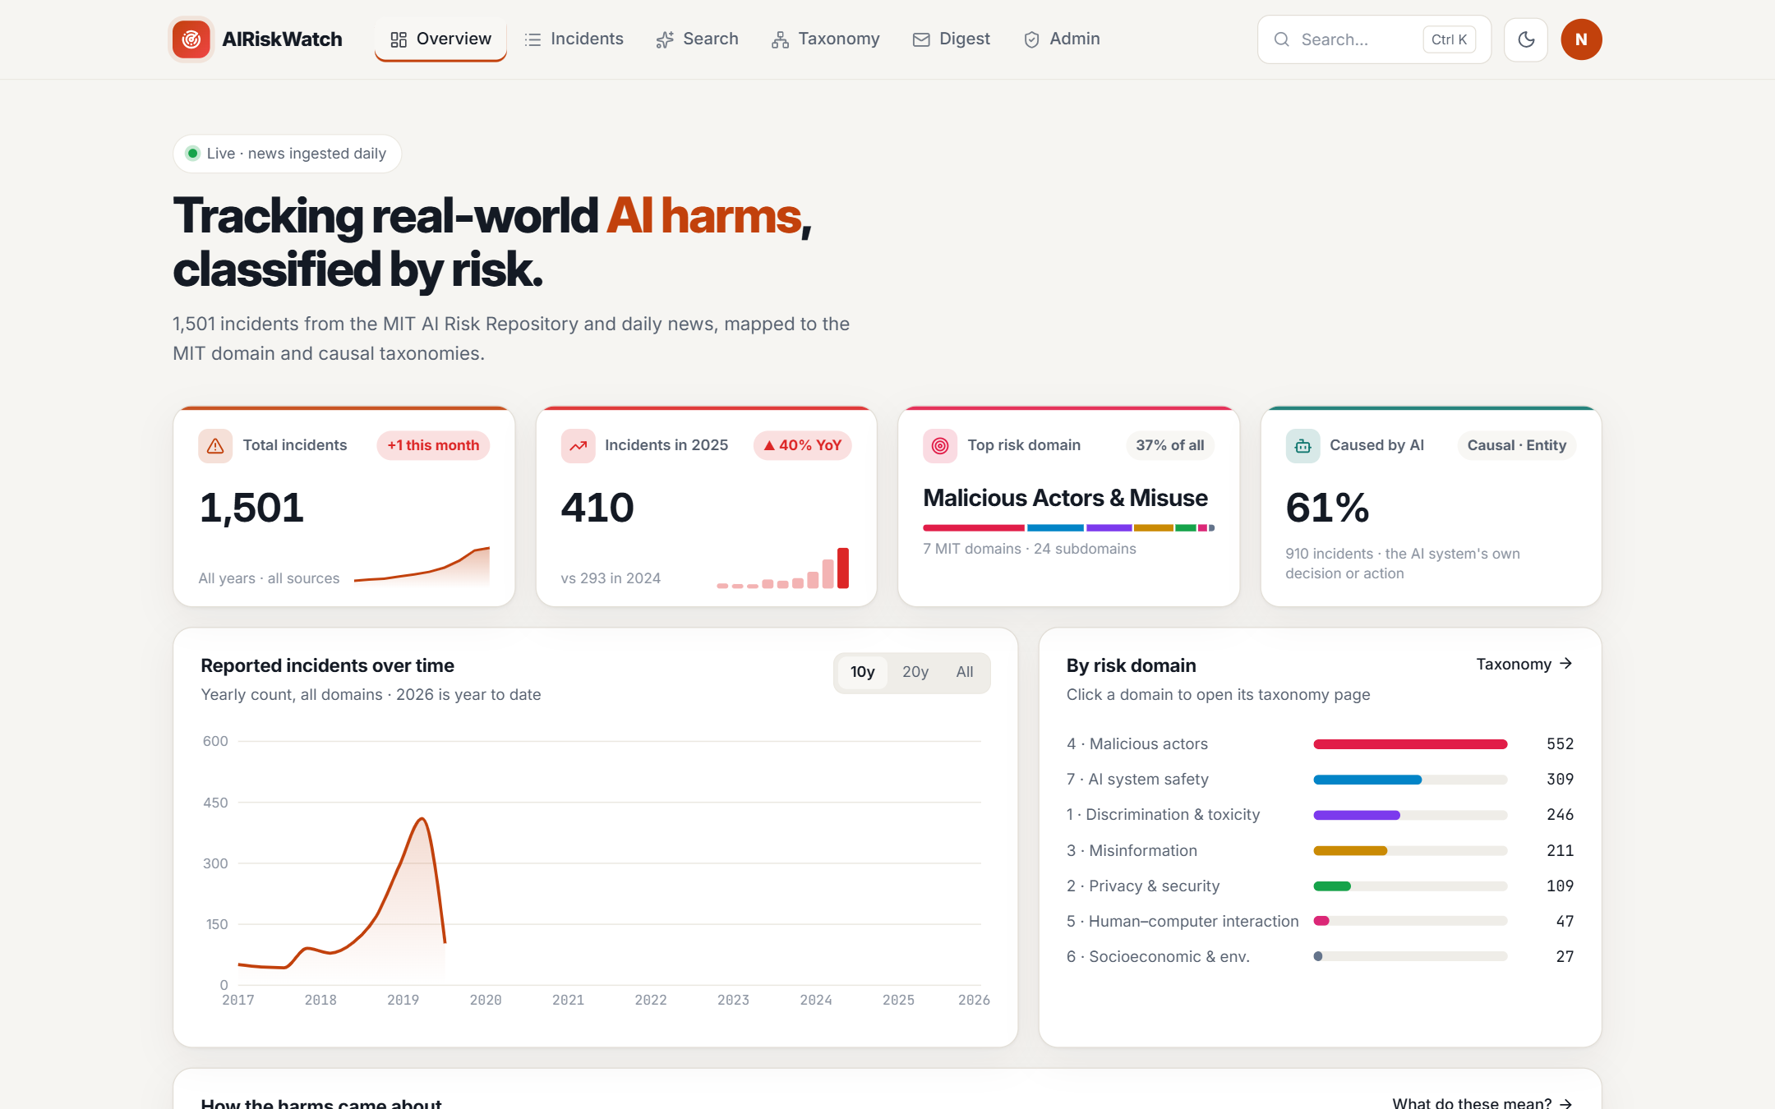
Fig 26: Overview dashboard

8.2 Browsing Incidents
- Click Incidents to open the full incident database, newest first.
- Type in the search box to filter by keywords in the title or description.
- Use the Domain, Subdomain, Cause and Date filters to narrow the list; the number of matching incidents updates instantly.
- Results are paginated; click any row to open the incident.
Fig 27: Incident list with filters

8.3 Incident Details
- The detail page shows the incident's title, date, deployer, developer and harmed parties, and a full description.
- The MIT Classification panel shows its risk domain, subdomain and causal factors.
- Source reports lists every article about the incident; click one to read the source.
- More in suggests other incidents in the same subdomain.
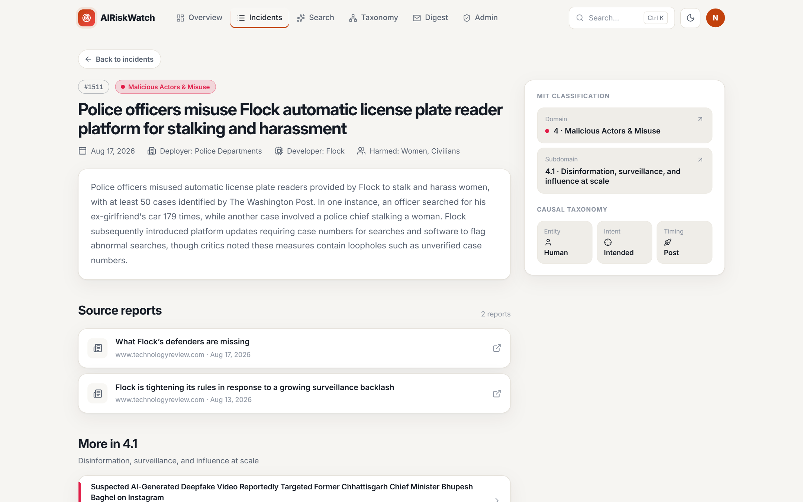
Fig 28: Incident detail page

8.4 Semantic Search
- Click Search, describe what you are looking for in plain language, for example "AI hiring tool that discriminates against women", and press Search.
- An AI summary explains how the top results relate to your query, citing incident numbers.
- Results are ranked by relevance and show their risk domain and similarity score; use the filters on the left to narrow them by domain, year or minimum similarity.
Fig 29: Semantic search results with AI summary

8.5 Risk Checklist
- Open Search and choose the Risk checklist tab.
- Describe the AI system you are building or buying and click Generate checklist.
- The checklist groups the risks found in similar past incidents by MIT domain. Each item has a review question, a High, Medium or Low level based on how many similar incidents fall under it, and links to those incidents.
- Tick items as you review them; the counter shows your progress.
Fig 30: Risk checklist generated from a system description

8.6 Exploring the MIT Taxonomy
- Click Taxonomy to see how incidents are classified. The coloured map shows all seven MIT risk domains and their subdomains, sized by number of incidents.
- The cards at the top switch between the domain taxonomy and the causal taxonomy (entity, intent and timing).
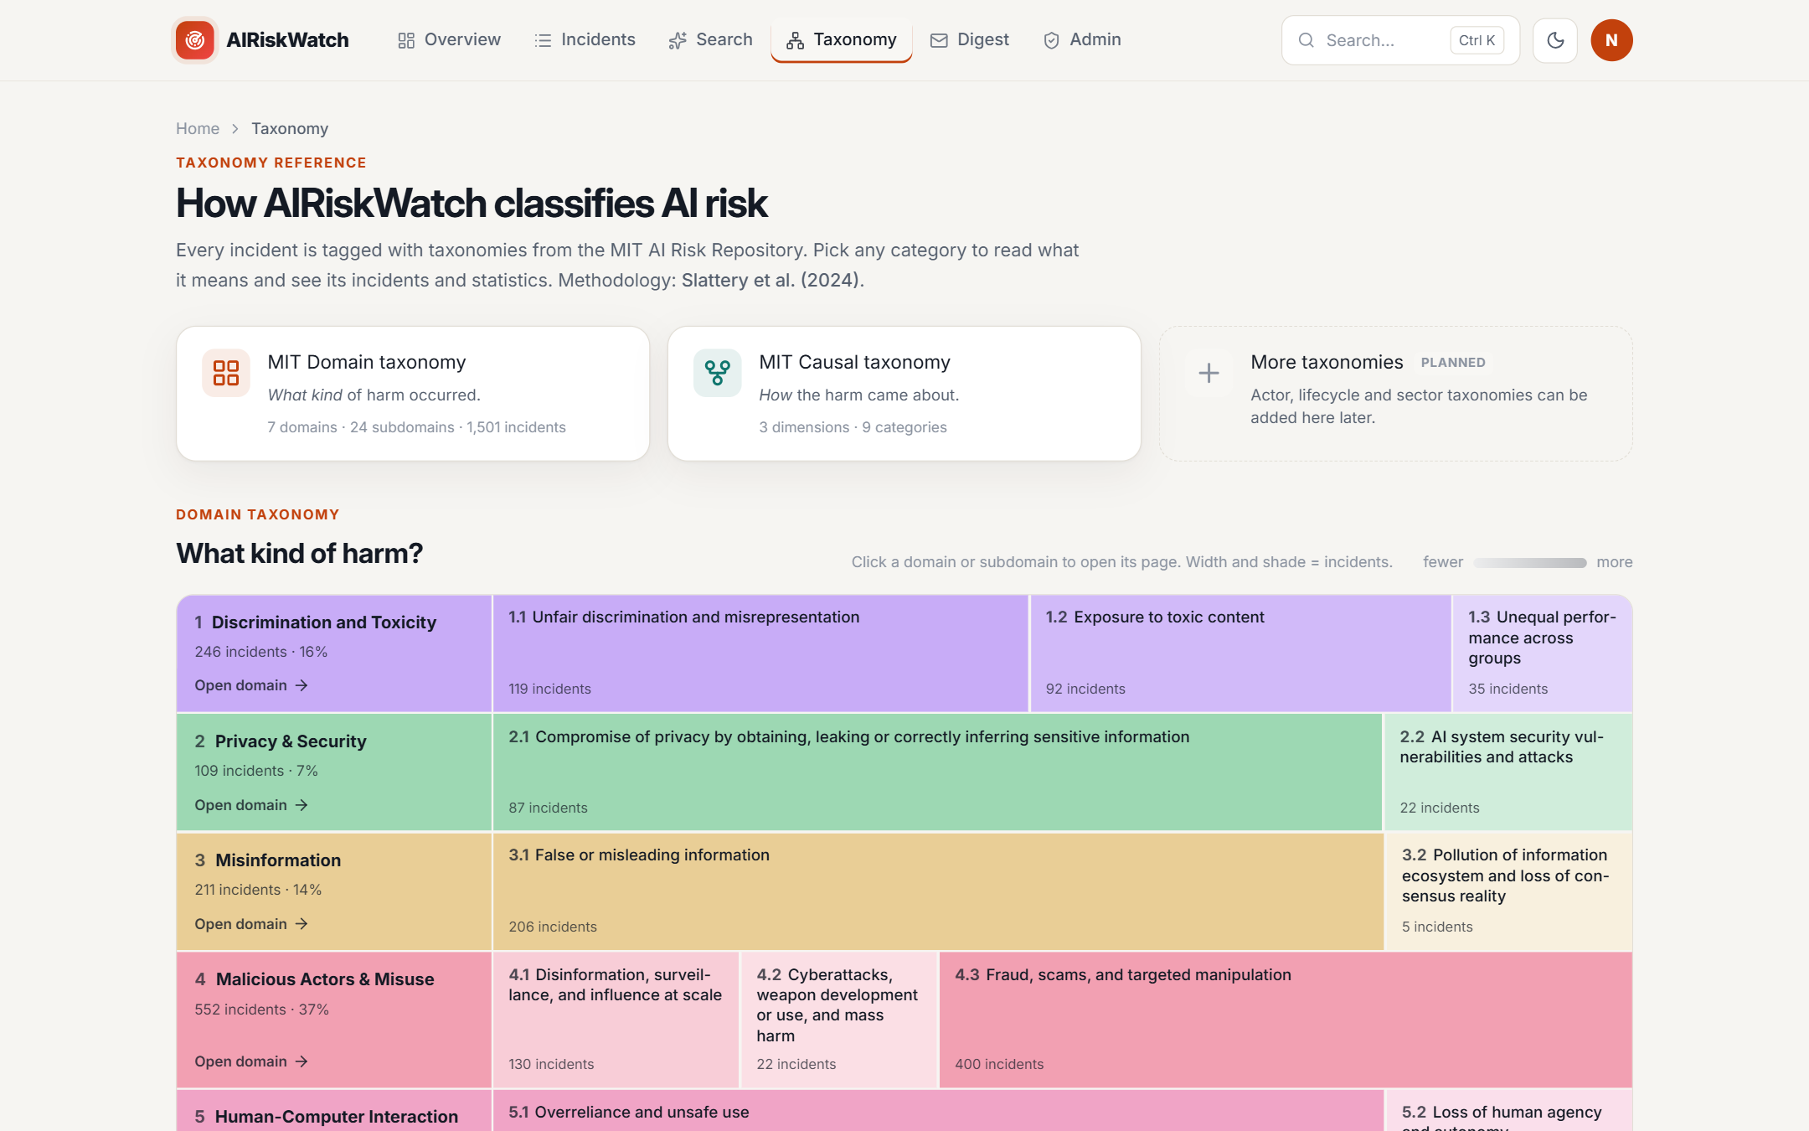
Fig 31: MIT AI Risk Taxonomy overview
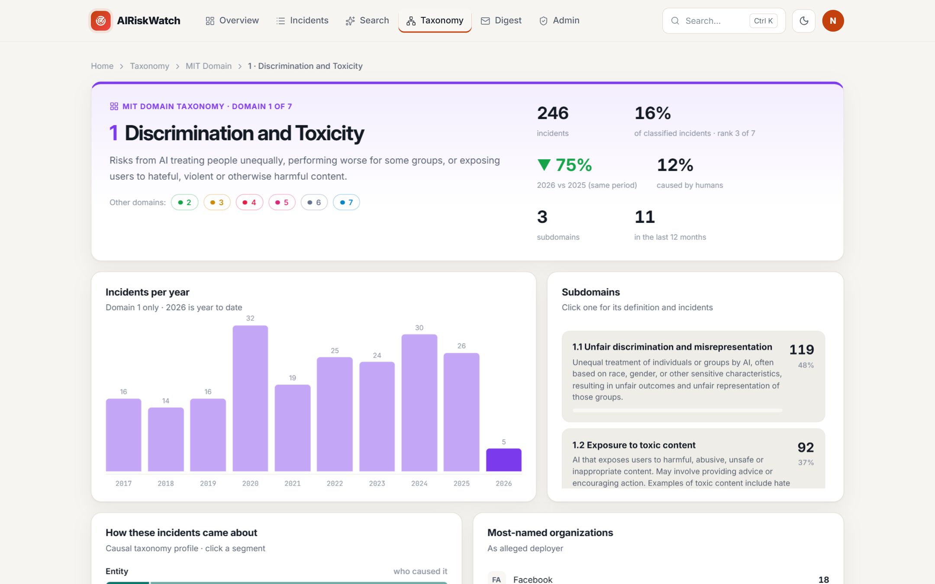
Fig 32: Risk domain page
- Click a domain to open its page with its definition, yearly trend, subdomains, most-named organisations and the incidents it contains.

8.7 Creating an Account and Signing In
- Click Sign in in the top-right corner, then Create one to register.
- Either click the Google button, or enter your email, a username and a password of at least 8 characters, then click Create account.
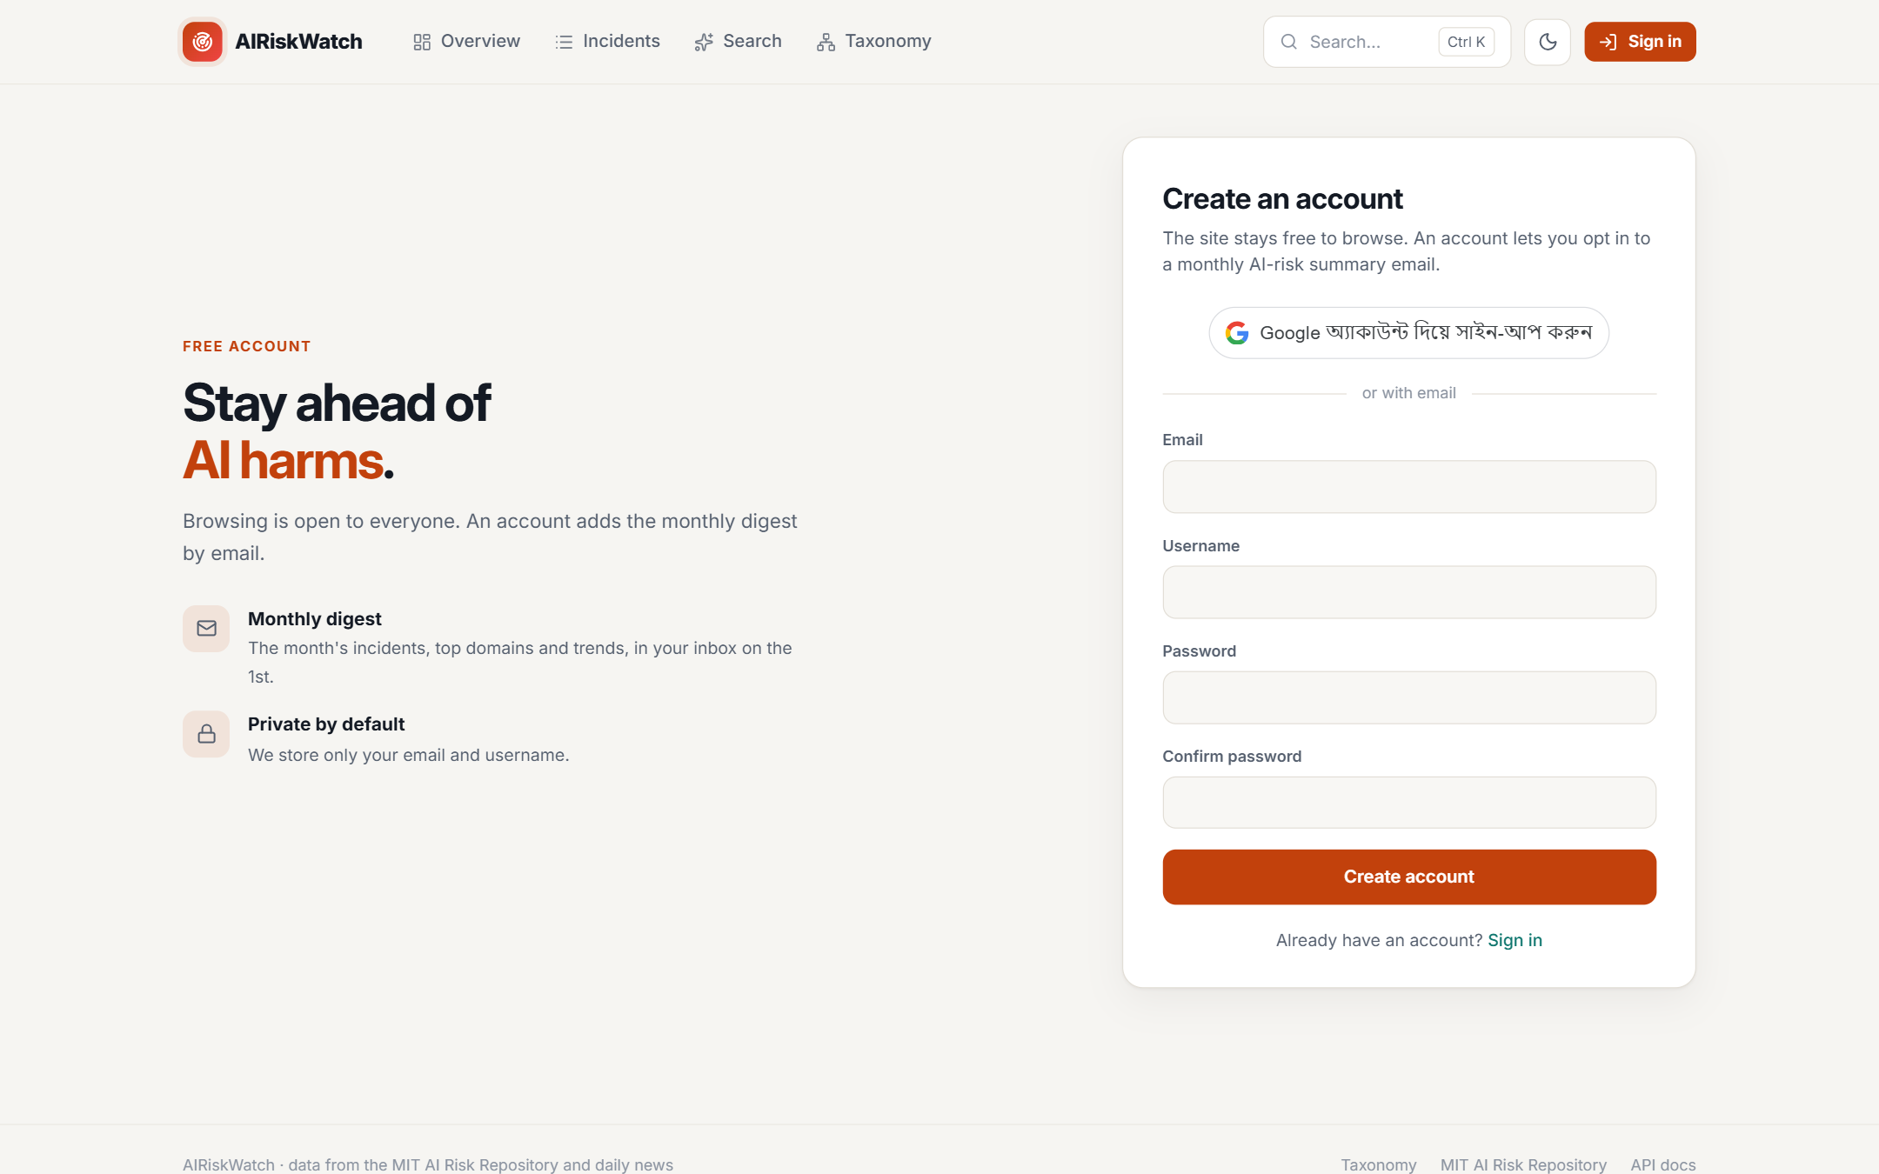
Fig 33: Sign-up page
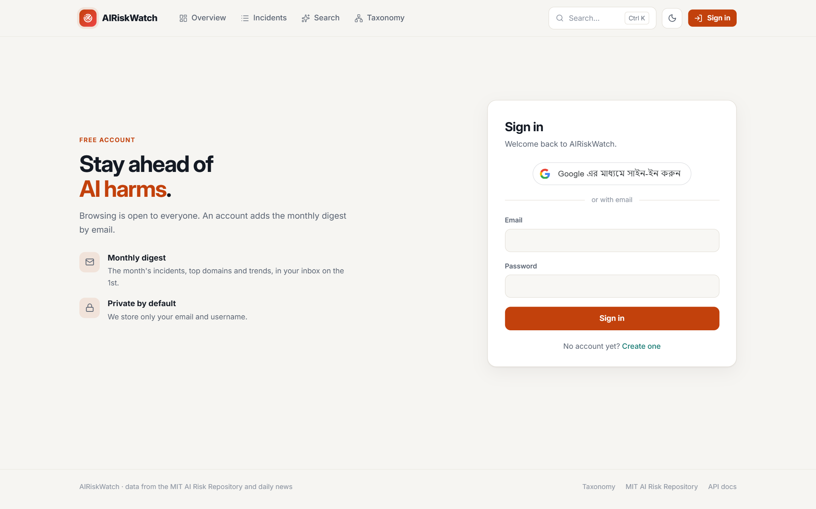
Fig 34: Sign-in page
- To sign in later, use the same Google account, or your email and password. You stay signed in on that browser until you sign out or the session expires after 24 hours.

8.8 Account Settings
- Click your avatar in the top-right corner to open Account settings.
- Change your username, and see your email, role, sign-in methods and join date.
- Use the Monthly digest email switch to subscribe to or unsubscribe from the monthly email.
- Click Sign out to end your session.
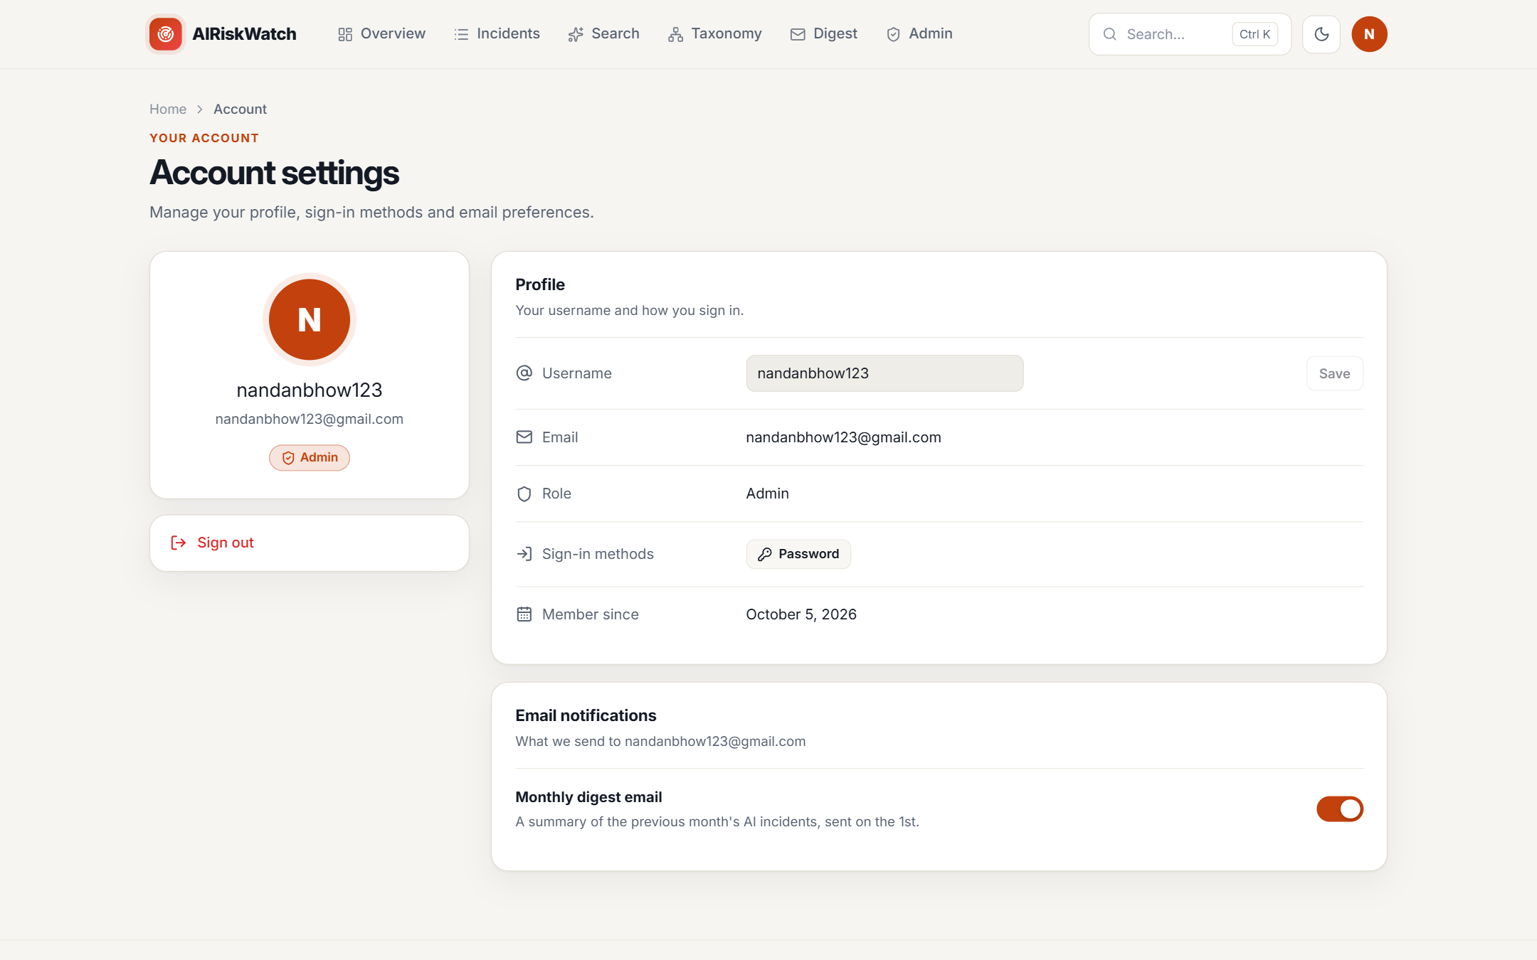
Fig 35: Account settings page

8.9 Monthly Digest
- Signed-in users can open Digest to review AI incidents month by month.
- Choose a month from the strip at the top to see the number of incidents reported, the top risk domain, the domains touched and the share caused by AI, followed by the month's highlights, a breakdown by risk domain and the full list of incidents.
- Subscribed users receive the same digest by email on the first day of each month.
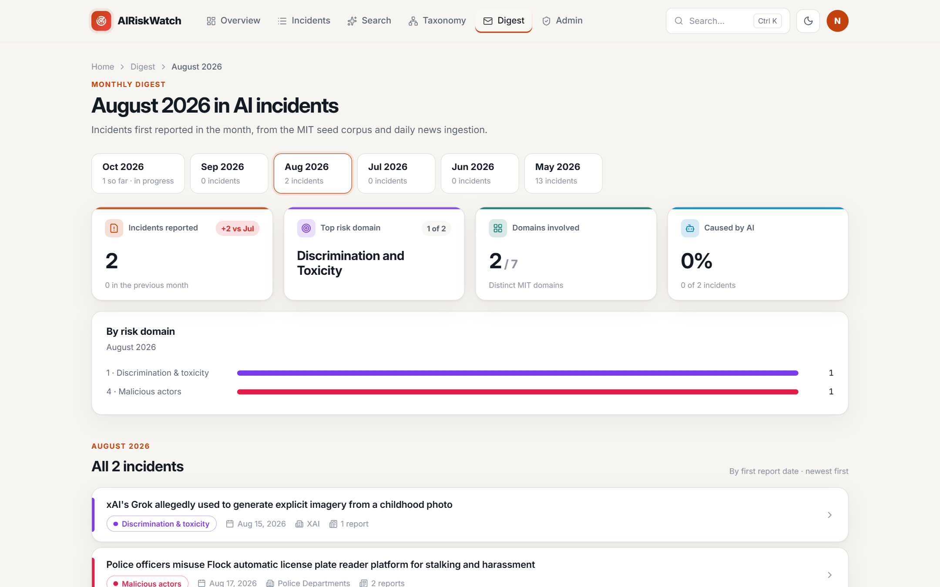
Fig 36: Monthly digest page

8.10 Admin Console: Users
- Administrators see an Admin link in the navigation bar. The console has five tabs: Users, Ingestion, Incidents, Reports and Digest.
- On Users, search for an account, promote a user to admin with Make admin, or block access with Deactivate. An administrator cannot demote or deactivate their own account.
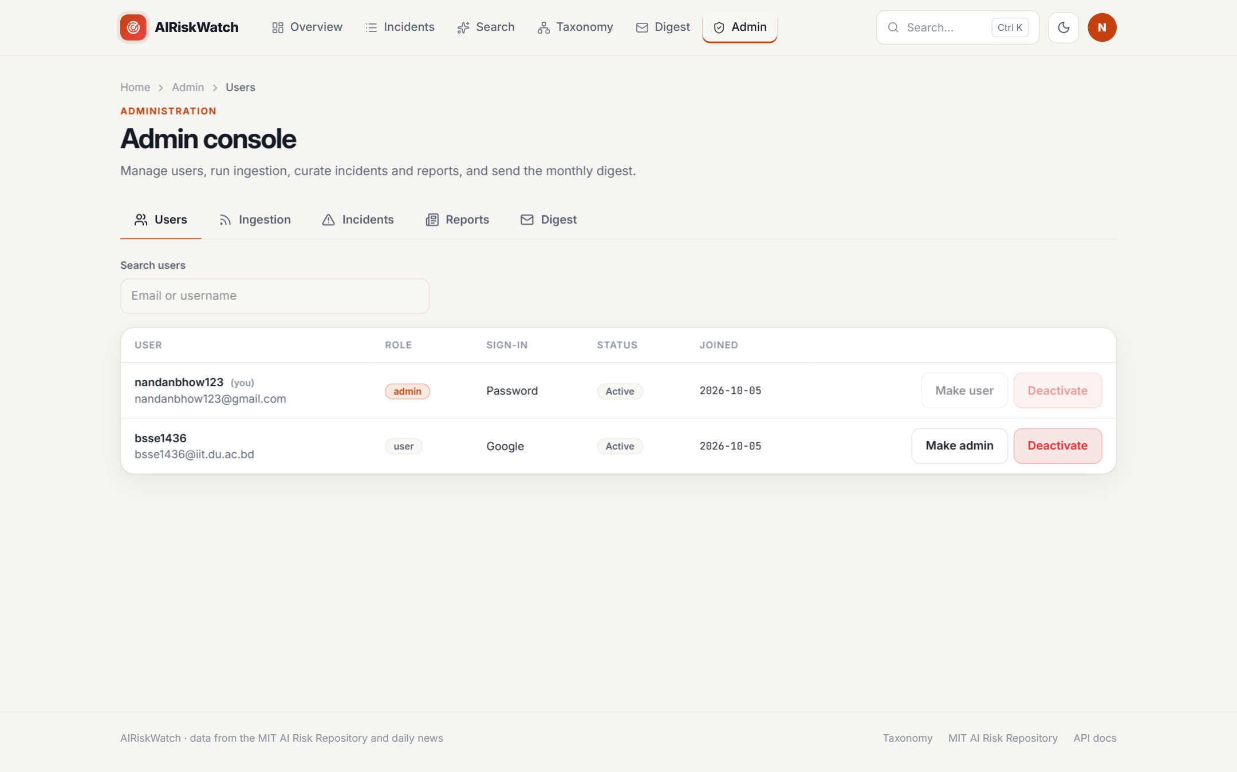
Fig 37: Admin console: user management

8.11 Admin Console: Ingestion
- Click Run ingestion to scrape the configured news sources immediately rather than waiting for the daily schedule.
- When the run finishes, a summary shows how many articles were seen, judged relevant, created as new incidents or attached to existing ones, and any errors.
Fig 38: Admin console: running ingestion

8.12 Admin Console: Incidents and Reports
- On Incidents, search the database, create a new incident with New incident, or use Edit and Delete to correct or remove one.
- The Reports tab works the same way for source reports, including linking a report to incidents.
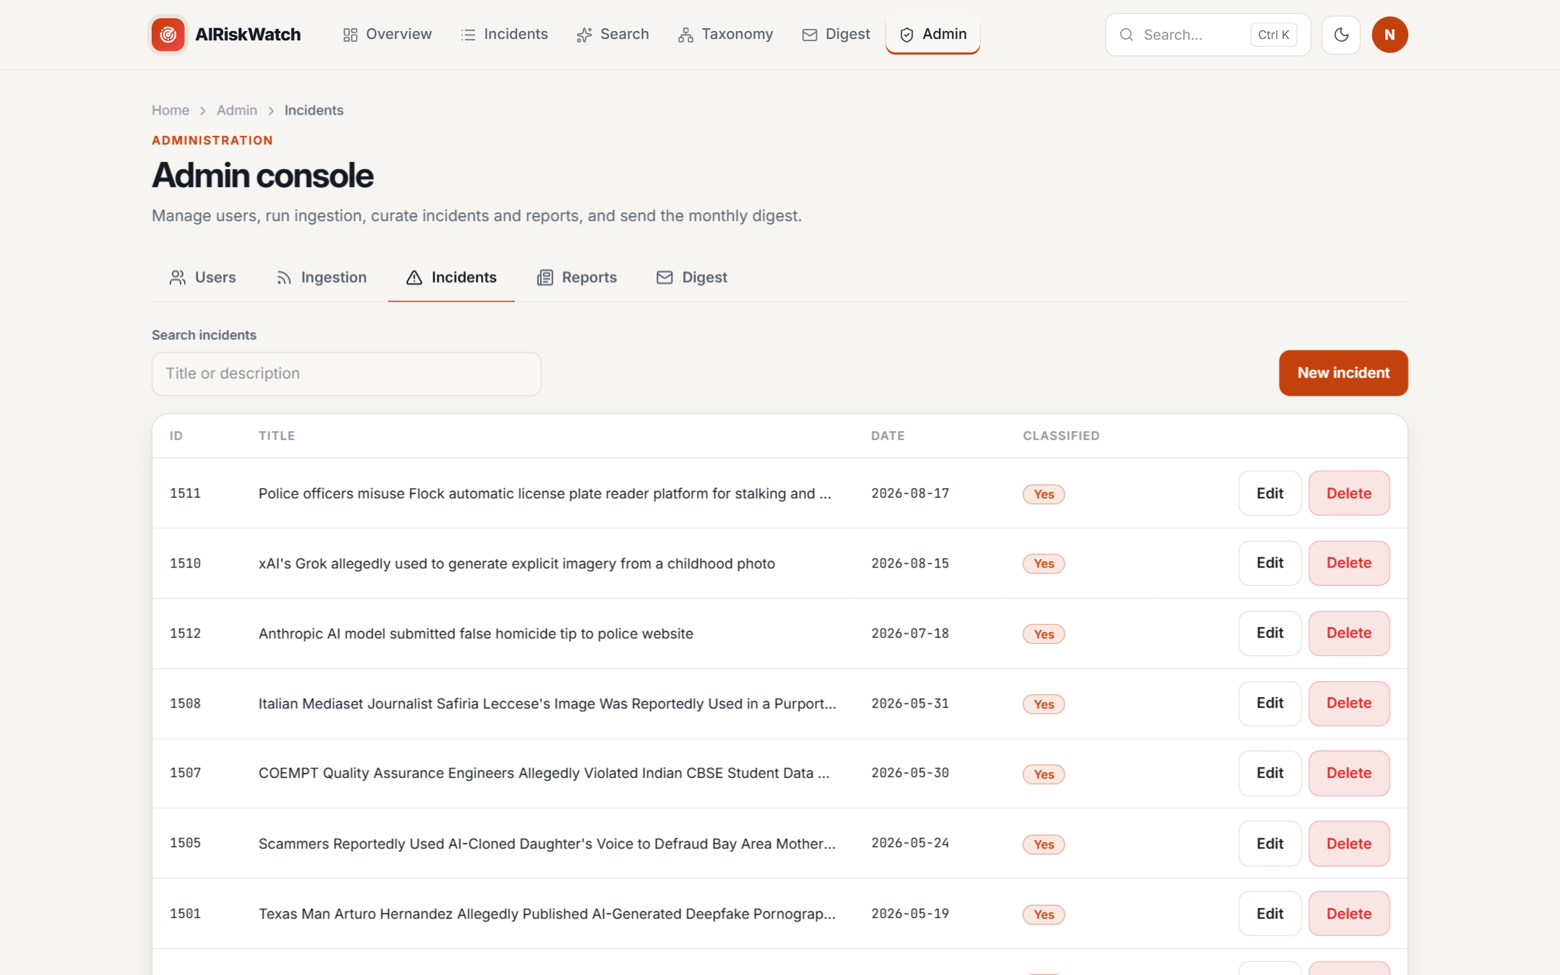
Fig 39: Admin console: incident management

8.13 Admin Console: Digest
- Choose a month, then click Preview email to see the exact email users will receive.
- Send test to me sends one copy to the administrator's own address.
- Send to all subscribers sends the digest now; users who already received that month's digest are skipped automatically. The delivery status panel shows how many emails were sent, failed or are pending.
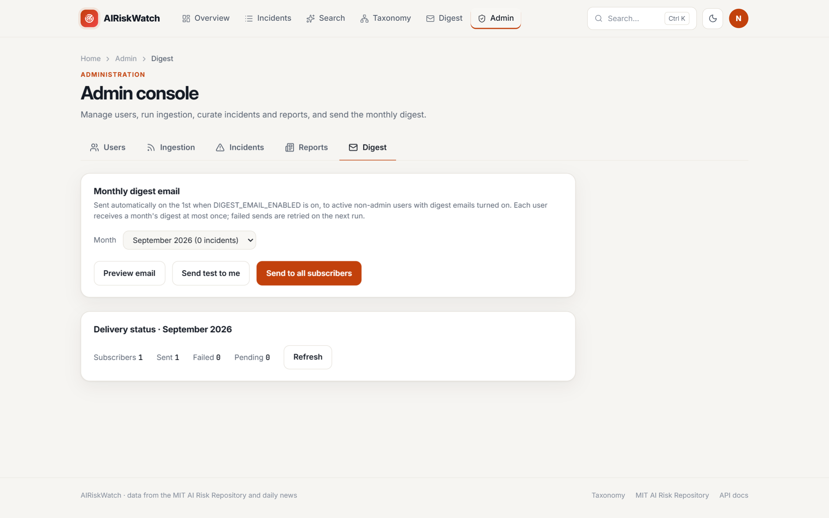
Fig 40: Admin console: monthly digest

References
- Partnership on AI, "AI Incident Database." [Online]. Available: https://incidentdatabase.ai/
- P. Slattery, A. Zhang, J. Zhou, et al., "The AI Risk Repository: A Comprehensive Meta-Review, Database, and Taxonomy of Risks From Artificial Intelligence," arXiv preprint arXiv:2408.12622, 2024. [Online]. Available: https://arxiv.org/abs/2408.12622
- D. Russo, G. M. Orlando, V. La Gatta, and V. Moscato, "Automating AI Failure Tracking: Semantic Association of Reports in AI Incident Database," arXiv preprint arXiv:2507.23669, 2025. [Online]. Available: https://arxiv.org/abs/2507.23669
- R. S. Pressman and B. R. Maxim, *Software Engineering: A Practitioner's Approach*, 9th ed. New York, NY, USA: McGraw-Hill Education, 2019

