Software Requirements Specification

AIRiskWatch
An AI Incident Intelligence Platform for Multi-Taxonomy
Risk Classification, Semantic Search, and Personalized Monitoring

Supervisors
Ahmedul Kabir
Md. Rayhanur Rahman

2026

Table of Contents
(Right-click and choose "Update Field", or press Ctrl+A then F9 in Microsoft Word, to populate this table of contents after opening the document.)

1. Introduction

1.1 Motivation
Every year, systems built on artificial intelligence are deployed into contexts where their failures are no longer abstract engineering defects but concrete, documented harms: wrongful arrests from face-recognition mismatches, discriminatory hiring filters, medical triage systems that fail silently for underrepresented patients, and chatbots that provide dangerous advice. The Partnership on AI's AI Incident Database (AIID) and the MIT AI Risk Repository have independently catalogued more than a thousand such events, each tagged against a published taxonomy of risk domains and causal factors. Yet this evidence base exists almost entirely as static, siloed exports - spreadsheets and dataset dumps intended for researchers already fluent in the taxonomy, not as a live system a developer, policy analyst, or researcher can query, filter, or reason over.
We call this gap Incident Opacity: the knowledge that an AI system similar to the one you are about to build has already caused harm exists somewhere in the corpus, but no tool surfaces it at the moment the decision is being made. A developer building an obstacle-detection aid for visually impaired users has no easy way to ask "what has gone wrong with systems like mine before?" A policy maker cannot ask, in plain language, which harms are trending fastest without first learning a seven-domain, twenty-one-subdomain classification scheme by hand.
AIRiskWatch is motivated by closing this gap: taking the AI Incident Database's corpus and the MIT AI Risk Taxonomy's classification scheme, and building an intelligence platform on top of them - one that classifies incidents automatically, makes them explorable through faceted browsing and dashboards, answerable through natural-language search, and, for a developer who registers the system they are building, personally relevant without having to re-search the corpus every time. The underlying data already exists; what is missing is the system that makes it usable.

1.2 Scope
AIRiskWatch is a two-tier web application: a PostgreSQL + pgvector-backed FastAPI service, and a React single-page frontend that consumes it over a read-oriented REST API. The scope of this specification covers:
- The system imports and normalises the AI Incident Database corpus scoped to the MIT AI Risk Taxonomy (incidents, their source reports, and MIT Risk-Domain / Causal-axis classifications).
- The system classifies incidents against the MIT taxonomy using a large language model, with a held-out, human-labelled gold set used to measure classification accuracy before any automatically generated label is treated as authoritative.
- The system exposes incidents, reports, and classifications through a faceted explorer (search, filter by risk domain/causal axis/date range) and a persona-oriented analytics dashboard (trend, breakdown, and leaderboard charts).
- The system supports natural-language querying over the incident corpus (retrieval-augmented search) and personalized relevance - a registered user describes the AI system they are building once, and the platform surfaces incidents relevant to that description.
- The system does not, in this scope, build a live web scraper that continuously discovers new incidents from news sources; ingestion is from the AI Incident Database's published corpus. A scraper/ingestion pipeline is documented as future scope (Section 2.1.3) but is not part of the requirement set implemented for the final submission.
- The system does not implement CSET or GMF taxonomy classification, an entity-relationship knowledge graph, or GraphRAG multi-hop querying; these are documented only where they shape the data model (Section 4) for forward compatibility.
- Administrative/operator tooling (source management, scrape scheduling, human review queues) is documented as an Exciting requirement (Section 2.1.3) that motivates the data model but is explicitly out of scope for the final project deliverable - the author will not be implementing an admin role or admin-facing UI.

1.3 Purpose of Document
This Software Requirements Specification defines what AIRiskWatch is expected to do, for whom, and how its behaviour is organised, so that design and implementation decisions can be traced back to an agreed set of requirements. Specifically, this document:
- Classifies the platform's requirements by priority using the Kano-style Normal / Expected / Exciting model (Section 2), so that the minimum viable system is distinguished from its differentiators.
- Describes, from the perspective of a single unified user role, the concrete stories that motivate each feature area (Section 2.2).
- Models user-system interaction through use case and activity diagrams (Section 3), making explicit the control flow, decision points, and exception paths of the platform's core workflows.
- Specifies the persistent data model through an entity-relationship diagram and schema tables (Section 4), distinguishing what is implemented today from what the target system still requires.
- Closes with a summary of the project's contribution and a reference list of the sources, libraries, and standards the system builds on (Sections 5 and 6).

2. Project Description

2.1 Quality Function Deployment
Requirements are prioritised using the Kano-style Normal / Expected / Exciting model. Normal requirements are basic capabilities users take for granted - their absence causes dissatisfaction, but their presence alone does not delight. Expected requirements are features users assume a system in this category will have, even if they do not explicitly ask for them; satisfaction scales with how well they are executed. Exciting requirements are differentiators - capabilities users did not expect, which is where a platform earns enthusiasm rather than mere acceptance.

2.1.1 Normal Requirements
- The system loads the AI Incident Database corpus scoped to the MIT AI Risk Taxonomy - incidents, their linked source reports, and human-labelled MIT Risk-Domain / Causal-axis classifications - into a queryable relational store.Incident Corpus Import:
- Users can browse a paginated list of incidents and open a detail view showing its title, description, date, classifications, and every linked source report.Incident List & Detail View:
- Users can filter the incident list by a free-text keyword matched against incident titles and descriptions.Keyword Search:
- Users can narrow the incident list by MIT risk domain, risk subdomain, causal entity (AI/Human/Other), timing (pre-/post-deployment), intent (intentional/unintentional), and incident date range, in any combination.Faceted Filtering:
- Every classification shown to a user is traceable back to the specific news report(s) that describe the incident, so no classification is presented without its evidentiary source.Source Report Traceability:
- Users can view the full MIT taxonomy - seven risk domains and their subdomains - annotated with how many catalogued incidents fall under each, giving a mental map of the classification scheme itself.Risk-Domain Reference View:

2.1.2 Expected Requirements
- Users expect a dashboard summarising the corpus, not just a list - incident counts over time, year-over-year change, breakdowns by causal axis, and a leaderboard of the organisations named most often as alleged deployers or developers.Trend & Breakdown Dashboards:
- Where an incident lacks a human label, the system is expected to classify it automatically using a large language model - but only after that model's accuracy has been measured against the human-labelled gold set and shown to be trustworthy, with the resulting confidence score and provenance (human vs. LLM) visible wherever the classification is shown.LLM-Assisted Classification with Measured Accuracy:
- Filters applied on the explorer are expected to compose predictably with pagination, sorting, and the trend chart, rather than resetting unexpectedly when a user navigates between views.Consistent Filter State Across Views:
- The dashboard and explorer are expected to render cleanly on both desktop and constrained viewport widths, and to respect a light/dark theme preference consistently across every chart and card.Responsive, Theme-Aware Interface:

2.1.3 Exciting Requirements
- A user can ask a question in plain language - "what kinds of AI systems are causing the most harm to women and children?" - and receive a synthesised, cited answer grounded in the actual incident corpus via retrieval-augmented generation, rather than having to construct a taxonomy-aware filter query by hand.Natural-Language Semantic Search (RAG):
- A user can register an account and describe, in free text, the AI system they are building; the platform embeds that description once and uses it to rank and filter the incident feed so the user sees what is relevant to their own project without re-searching every visit.Personalized Relevance Profile:
- Building on the personalization profile, the platform can proactively notify a user when a newly classified incident closely matches their registered system description, turning the platform from a pull-based tool into a push-based early-warning signal.Match Notifications:
- A researcher can traverse a graph view connecting organisations (as developers, deployers, or entities that caused harm) to the incidents that link them, surfacing patterns that a flat incident list would not reveal.Entity Relationship Exploration:
- A user can save a named filter/search configuration and export the matching incident set with its linked source reports for offline analysis.Saved Searches & Export:
- A live scraper with a source-management admin panel, scheduled and on-demand ingestion runs, and a human review queue for low-confidence relevance, deduplication, or classification decisions. This capability motivates the data model's SCRAPE_SOURCE / SCRAPE_RUN / REVIEW_ITEM entities (Section 4) but is explicitly excluded from the author's final project scope - the platform is scoped to a single User role throughout this document, with no administrator-facing surface.Administrative Ingestion & Review Console (not implemented in this project):

2.2 User Stories
The platform is used by three overlapping kinds of people - a policy or governance analyst monitoring risk trends, a developer checking a system they are building against prior failures, and a researcher tracing relationships across the corpus. Rather than modelling these as separate accounts or roles, AIRiskWatch treats them as one User actor whose stories vary by intent, grouped below by feature area.

2.2.1 Exploring and Filtering Incidents
- As a user, I want to browse a list of catalogued AI incidents, so that I can get an overview of the kinds of harm AI systems have caused without needing to know the taxonomy in advance.
- As a user, I want to filter incidents by risk domain, causal axis, and date range, so that I can narrow the corpus down to the slice relevant to my question.
- As a user, I want to search incidents by keyword, so that I can quickly find incidents mentioning a specific system, technology, or organisation.
- As a user, I want to open an incident and see every source report that describes it, so that I can verify a classification against the original evidence rather than trusting a label blindly.

2.2.2 Understanding Risk Trends
- As a user, I want to see how many incidents fall under each MIT risk domain and how that has changed year over year, so that I can identify which risks are growing fastest.
- As a user, I want to see a breakdown of incidents by causal entity, timing, and intent, so that I can understand whether harms are mostly caused by the AI system itself, by human misuse, before deployment, or after.
- As a user, I want to see which organisations are named most often as alleged developers or deployers, so that I can gauge where accountability concentrates in the corpus.

2.2.3 Searching in Natural Language
- As a user, I want to ask a plain-language question about the incident corpus and receive a cited answer, so that I do not have to translate my question into the taxonomy's filter vocabulary before I can get an answer.
- As a developer about to build a new AI-powered feature, I want to describe what I am building and see what incidents similar systems have caused, so that I can design around those failure modes before I ship.

2.2.4 Personalization and Ongoing Monitoring
- As a user, I want to register an account and describe the AI system I am building once, so that afterwards my dashboard surfaces relevant incidents automatically instead of requiring me to re-search every time I visit.
- As a user, I want to be notified when a newly classified incident closely matches the system I registered, so that I do not have to keep manually checking the dashboard for new relevant incidents.

2.2.5 Exploring Relationships and Saving Work
- As a researcher, I want to explore the relationships between the organisations that develop, deploy, and are implicated in harming parties across incidents, so that I can trace accountability patterns that a flat list would hide.
- As a user, I want to save a search or filter configuration and export the matching incidents with their source reports, so that I can continue my analysis outside the platform.

3. Scenario-Based Modeling

3.1 Use Case Diagram
AIRiskWatch is modelled with a single actor, User, representing any visitor of the platform - whether their intent is that of a policy analyst, a developer, or a researcher (Section 2.2). The diagrams below are presented at two levels of detail: a system-boundary view listing every use case the platform supports, and a module-level decomposition grouping those use cases into six functional areas.

3.1.1 Level 0 - System Boundary
At the system boundary, the User interacts with nine use cases spanning incident exploration, analytics, semantic search, personalization, relationship exploration, and saved work. Two include-style relationships are shown: browsing incidents includes viewing incident detail, and viewing risk-domain analytics includes running a semantic search over the same underlying corpus.
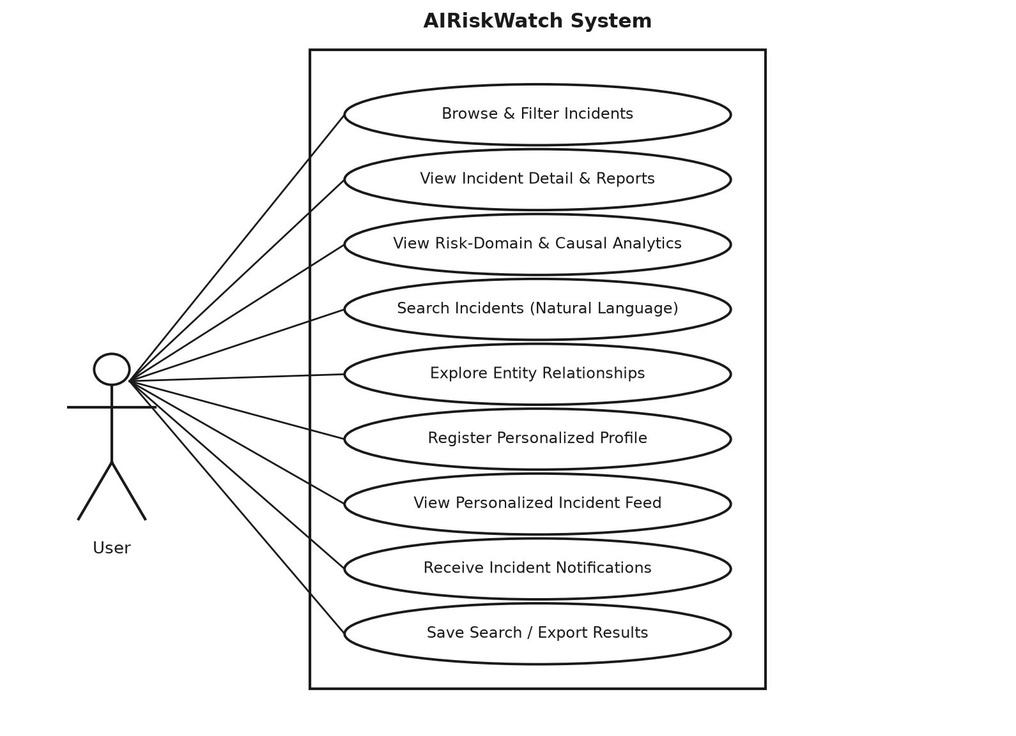
Figure 3.1 - Use Case Diagram - System Boundary (Level 0)

3.1.2 Level 1 - Module Decomposition
Decomposing the system boundary into modules groups the nine use cases into six functional areas: Explore Incidents and Analyse Trends (Normal/Expected requirements, implemented today), Semantic Search and Personalization (Exciting requirements, target-system scope), and Relationship Exploration and Saved Work (Exciting requirements, target-system scope).
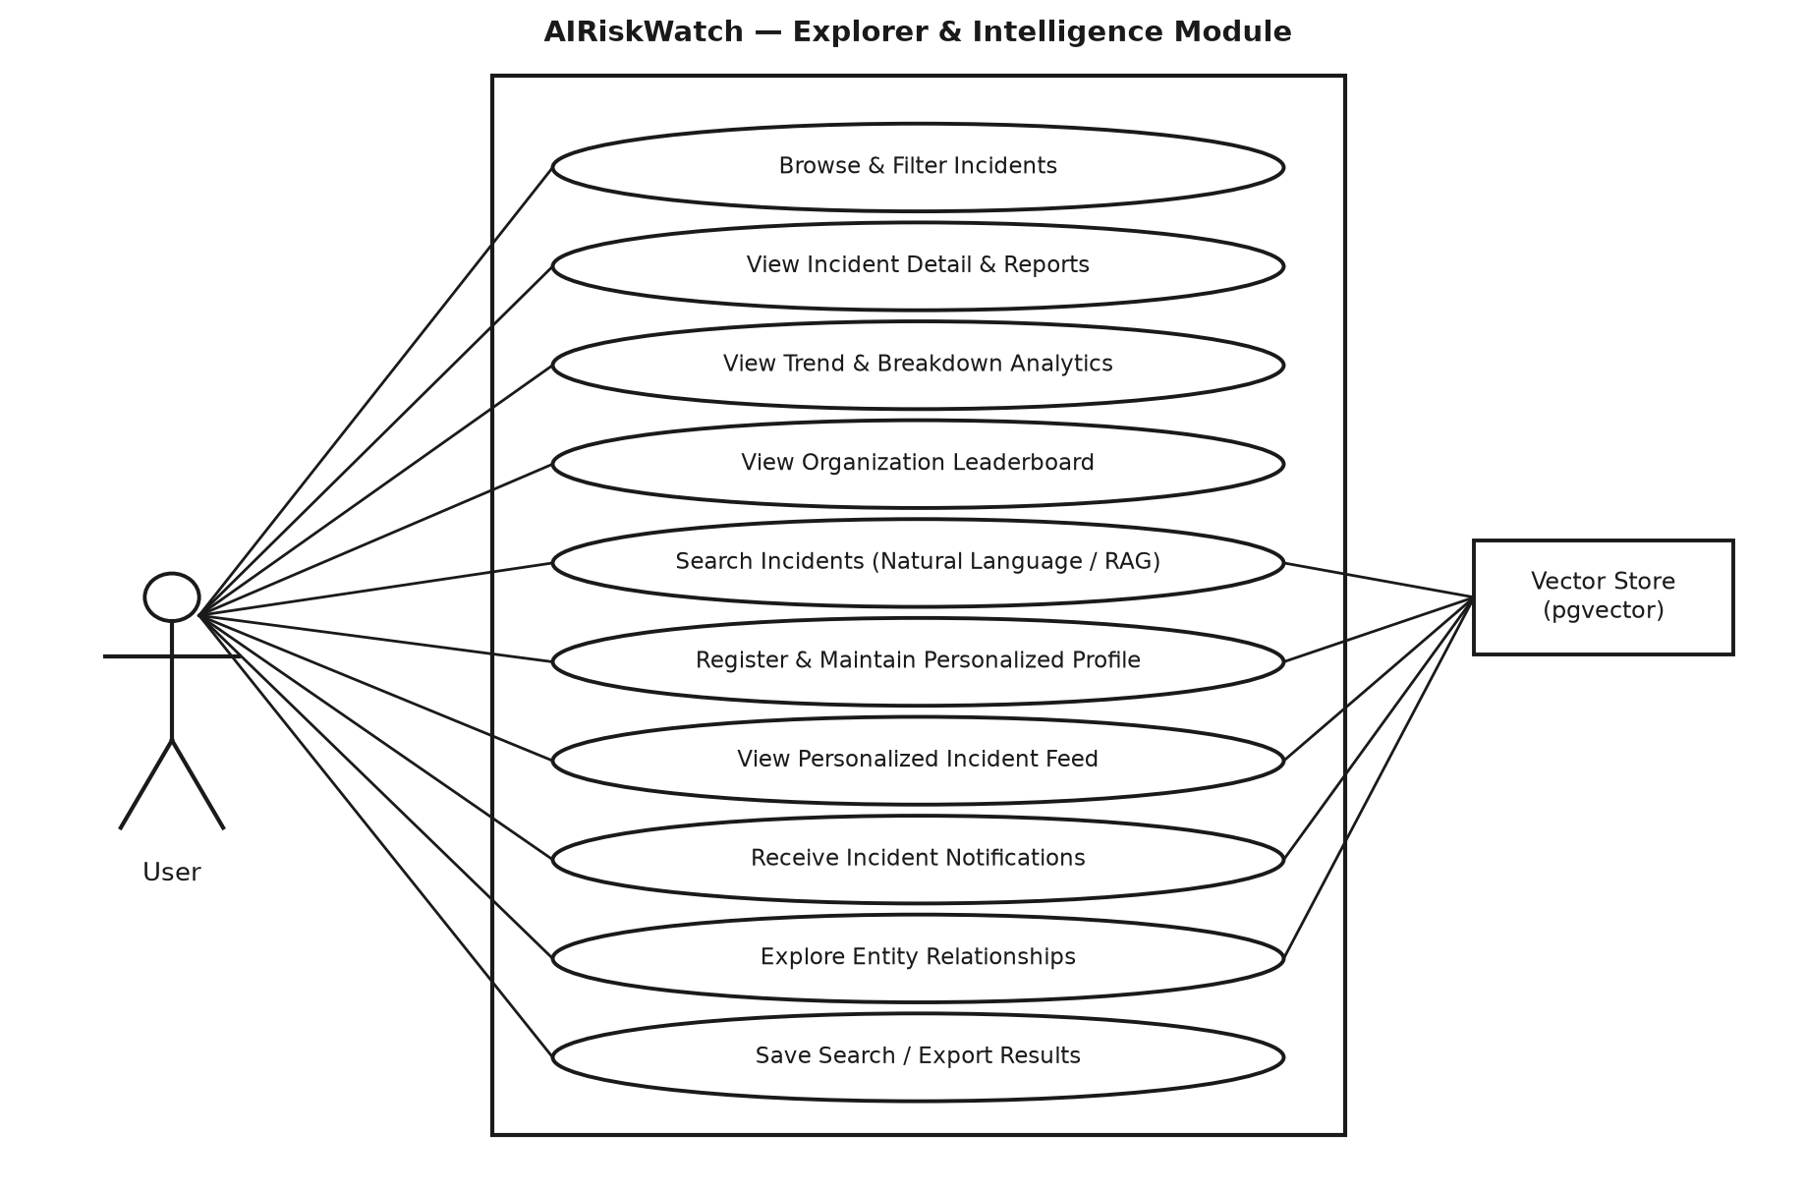
Figure 3.2 - Use Case Diagram - Module Decomposition (Level 1)

3.1.3 Use Case Descriptions
The table below elaborates each Level 0 use case with its actor, goal, and basic flow.
Table 3.1 - Use Case Descriptions
Use Case | Actor | Goal | Basic Flow
Browse & Filter Incidents | User | Narrow the corpus to a relevant slice | User opens the explorer -> system loads default list -> user applies keyword/facet filters -> system returns matching, paginated incidents.
View Incident Detail & Reports | User | Verify a classification against its evidence | User selects an incident -> system displays description, classifications, and every linked source report.
View Risk-Domain & Causal Analytics | User | Understand corpus-wide trends | User opens the dashboard -> system renders trend, breakdown, and leaderboard charts from current filter state.
Search Incidents (Natural Language / RAG) | User | Get a cited answer without learning the taxonomy | User submits a free-text question -> system retrieves semantically similar incidents -> an LLM synthesises a cited answer.
Explore Entity Relationships | User | Trace accountability across organisations | User opens the relationship view -> system renders a graph of organisations linked through shared incidents -> user traverses connected nodes.
Register & Maintain Personalized Profile | User | Get incidents ranked by relevance to a project | User registers an account -> describes the AI system being built -> system embeds the description as the user's profile vector.
View Personalized Incident Feed | User | See only what matters to their project | User opens the dashboard while signed in -> system ranks/filters incidents against the user's stored profile vector.
Receive Incident Notifications | User | Learn about new matches without polling | A newly classified incident is embedded -> system compares it to every stored profile vector -> above-threshold matches queue a notification.
Save Search / Export Results | User | Continue analysis outside the platform | User configures a filter/search -> saves it under a name -> later re-runs it or exports the matching incidents and their source reports.

3.2 Activity Diagrams
Three representative workflows are modelled below as activity diagrams: browsing and filtering the incident corpus (the platform's Normal-requirement core), natural-language semantic search (the platform's flagship Exciting requirement), and the offline LLM-assisted classification and evaluation pipeline that keeps the corpus labelled. The third diagram models an operator-triggered batch process rather than an end-user action; it is included because it directly produces the classification data every other workflow depends on, even though no admin-facing UI is implemented for it.

3.2.1 Browse & Filter Incidents
This is the platform's most frequently exercised workflow. Filters are validated client-side before a query is issued; an incident selection opens the detail page, while declining to select one returns the user to a refined search.
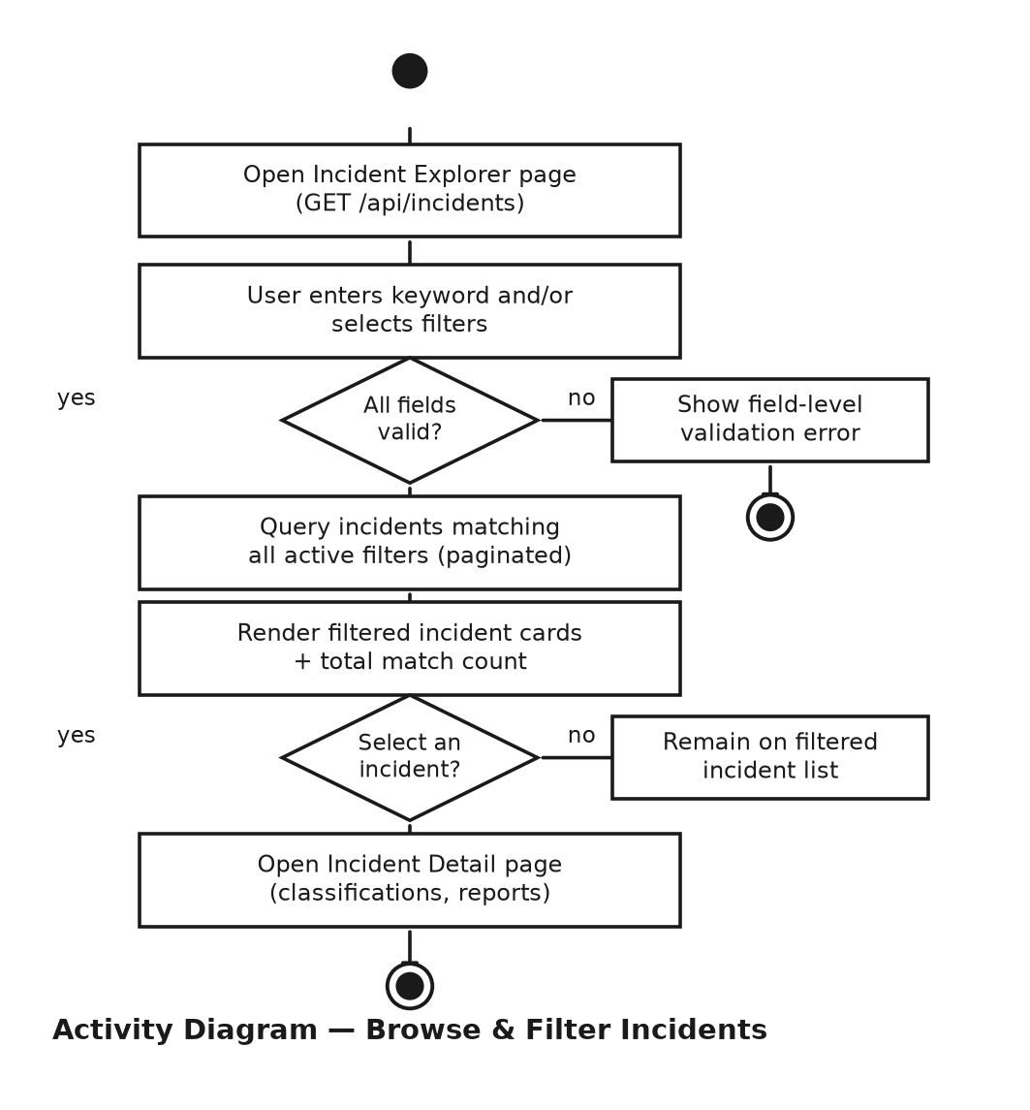
Figure 3.3 - Activity Diagram - Browse & Filter Incidents

3.2.2 Natural-Language (RAG) Search
A user's question is embedded with the same model used to embed the incident corpus, so that similarity search can retrieve the nearest incidents and reports; those excerpts ground the language model's answer, and every claim in the response is traceable to a cited incident. An empty retrieval result short-circuits to a clear empty-result message rather than asking the language model to answer ungrounded.
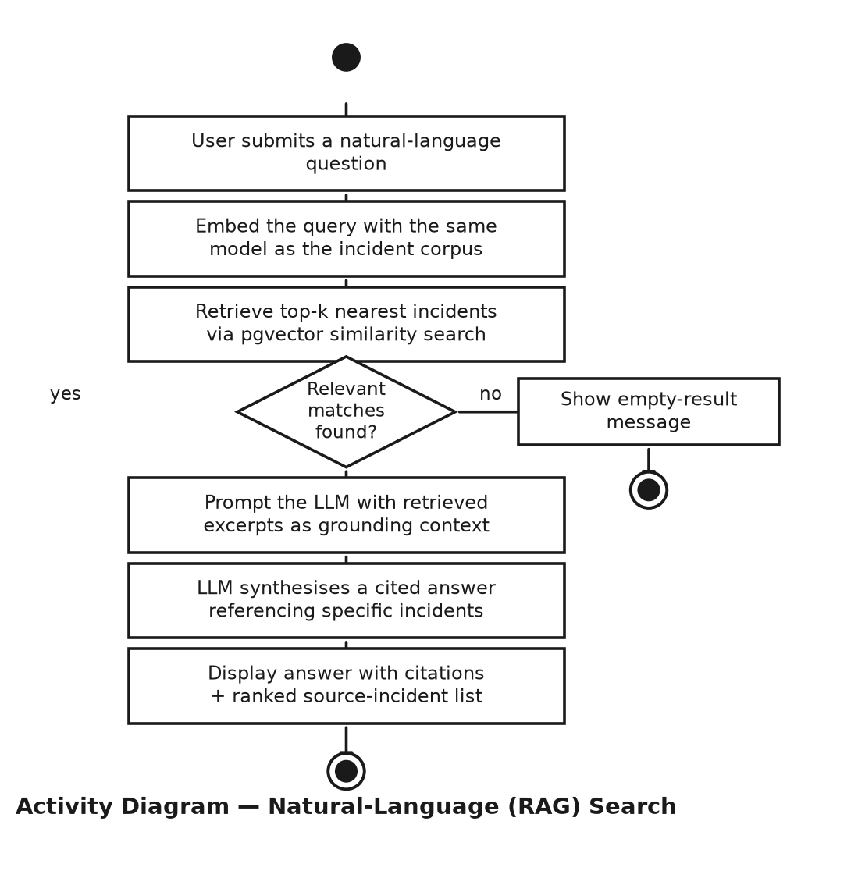
Figure 3.4 - Activity Diagram - Natural-Language (RAG) Search

3.2.3 LLM-Assisted Classification & Evaluation
Classification runs in one of two modes. In evaluation mode, predictions are scored against the human-labelled gold set and never written to the database, so prompt iteration can happen freely without risking the corpus. Only in backfill mode - and only once evaluation has shown the classifier is trustworthy - is a prediction persisted, tagged with its provenance (classified_by = 'llm') and confidence score. An invalid LLM response triggers exactly one repair retry before the incident is skipped for that run.
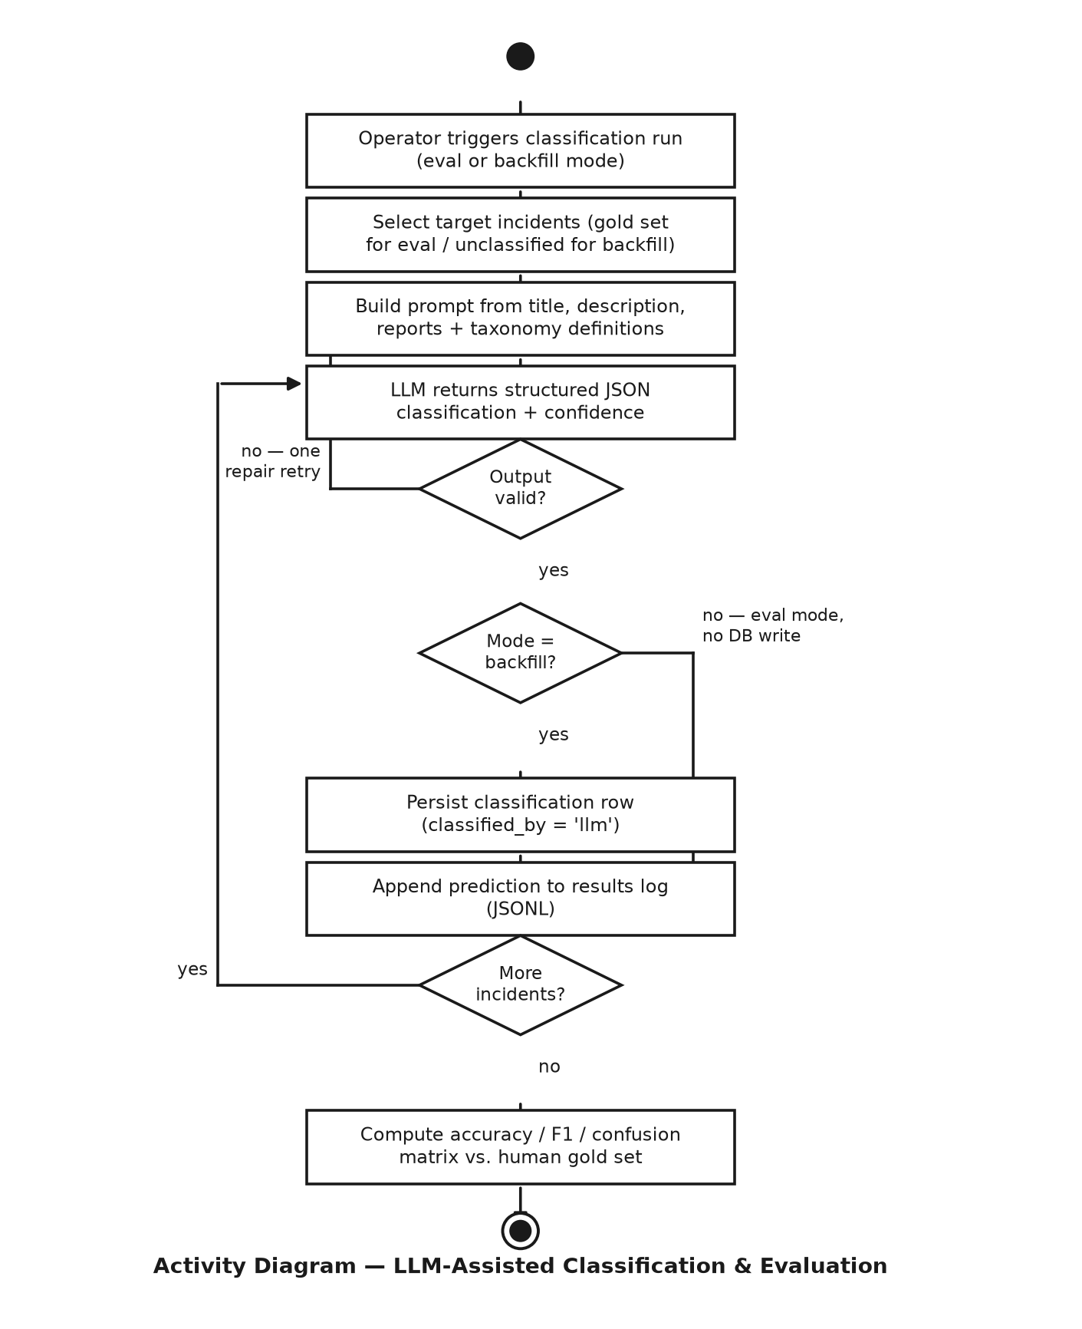
Figure 3.5 - Activity Diagram - LLM-Assisted Classification & Evaluation

4. Database Modeling
AIRiskWatch persists to PostgreSQL with the pgvector extension enabled, so that relational data (incidents, reports, classifications) and vector embeddings (for semantic search and personalization matching) live side by side without a separate vector database. The schema below distinguishes entities that are implemented and seeded today from entities that belong to the target system's Exciting-requirement scope (Section 2.1.3) but do not yet exist in the database - the latter are drawn with dashed borders throughout this section.

4.1 ER Diagram
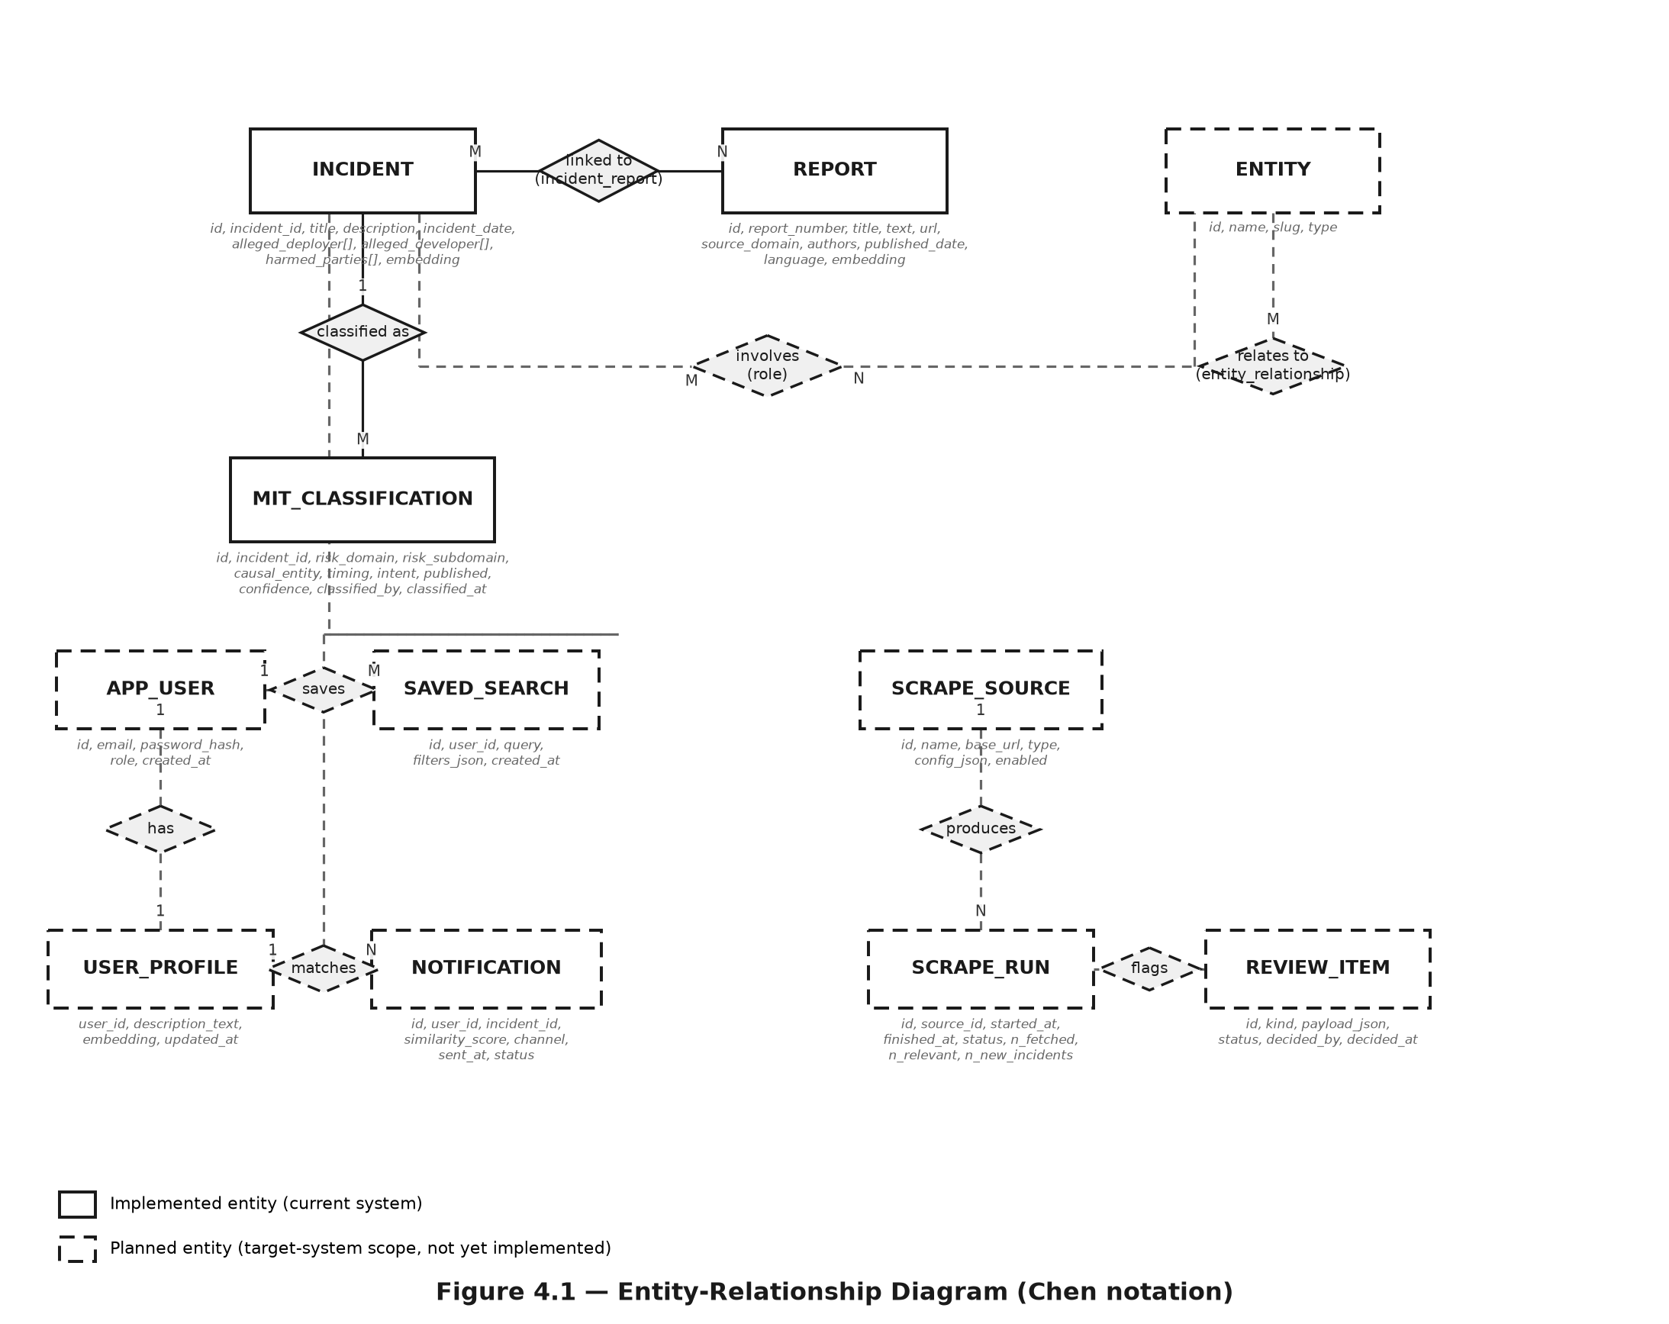
Figure 4.1 - Entity-Relationship Diagram (Chen notation)

4.2 Schema
Implemented tables (solid border in Figure 4.1) are described first, followed by the planned tables that extend the schema for personalization, entity relationships, and ingestion.

4.2.1 Implemented Tables
Table 4.1 - Schema - incident
Attribute | Type | Notes
id | SERIAL | Primary key (surrogate)
incident_id | INTEGER | Unique, not null - public AIID number; the business key every foreign key references
title | TEXT
description | TEXT
incident_date | DATE | Indexed
alleged_deployer | TEXT[] | Organisation names; unnested at query time for leaderboards
alleged_developer | TEXT[]
harmed_parties | TEXT[]
embedding | VECTOR(1536) | Reserved for semantic search / personalization matching (Section 2.1.3); not yet populated or indexed

Table 4.2 - Schema - report
Attribute | Type | Notes
id | SERIAL | Primary key (surrogate)
report_number | INTEGER | Unique, not null - public AIID number; used as the FK target from incident_report
title | TEXT
text | TEXT | Full article body
url | TEXT
source_domain | TEXT
authors | TEXT
published_date | DATE
language | TEXT
embedding | VECTOR(1536) | Reserved for semantic search; not yet populated or indexed

Table 4.3 - Schema - incident_report (join table)
Attribute | Type | Notes
incident_id | INTEGER | FK -> incident(incident_id)
report_id | INTEGER | FK -> report(report_number)
(composite) | PRIMARY KEY | (incident_id, report_id)

Table 4.4 - Schema - mit_classification
Attribute | Type | Notes
id | SERIAL | Primary key
incident_id | INTEGER | FK -> incident(incident_id); indexed. One incident may have multiple rows (human gold label plus a later LLM label)
risk_domain | TEXT | Indexed; one of the 7 MIT risk domains
risk_subdomain | TEXT
causal_entity | TEXT | AI / Human / Other
timing | TEXT | Pre-deployment / Post-deployment / Other
intent | TEXT | Intentional / Unintentional / Other
published | BOOLEAN
confidence | REAL | LLM self-reported confidence (0-1); null for human gold rows
classified_by | TEXT | 'human' or 'llm'
classified_at | TIMESTAMPTZ | Null for human gold rows

4.2.2 Planned Tables (Target-System Scope)
The following tables extend the schema to support the Exciting requirements of Section 2.1.3 - entity relationships, personalization, and, for completeness of the data model, an administrative ingestion pipeline that is not part of the author's implementation scope but is documented here because it shapes the schema shown in Figure 4.1.
Table 4.5 - Schema - entity, incident_entity, entity_relationship
Table | Attribute | Type
entity | id, name, slug, type | SERIAL / TEXT / TEXT UNIQUE / TEXT (org, product, person, group)
incident_entity | incident_id, entity_id, role | FK, FK, TEXT - composite PK (incident_id, entity_id, role); role = developer|deployer|harmed
entity_relationship | from_entity, to_entity, rel_type | FK, FK, TEXT

Table 4.6 - Schema - app_user, user_profile, notification, saved_search
Table | Attribute | Type
app_user | id, email, password_hash, role, created_at | SERIAL / TEXT UNIQUE / TEXT / TEXT ('admin'|'user') / TIMESTAMPTZ
user_profile | user_id, description_text, embedding, updated_at | FK UNIQUE -> app_user / TEXT / VECTOR(1536) / TIMESTAMPTZ
notification | id, user_id, incident_id, similarity_score, channel, sent_at, status | SERIAL / FK / FK / REAL / TEXT / TIMESTAMPTZ / TEXT
saved_search | id, user_id, query, filters_json, created_at | SERIAL / FK / TEXT / JSONB / TIMESTAMPTZ

Table 4.7 - Schema - scrape_source, scrape_run, review_item
Table | Attribute | Type
scrape_source | id, name, base_url, type, config_json, enabled | SERIAL / TEXT / TEXT / TEXT / JSONB / BOOLEAN
scrape_run | id, source_id, started_at, finished_at, status, n_fetched, n_relevant, n_new_incidents, n_new_reports, error | SERIAL / FK / TIMESTAMPTZ / TIMESTAMPTZ / TEXT / INT / INT / INT / INT / TEXT
review_item | id, kind, payload_json, status, decided_by, decided_at | SERIAL / TEXT / JSONB / TEXT / TEXT / TIMESTAMPTZ

Indexing notes: report(url) carries a unique constraint to perform exact deduplication at source; incident(incident_date) and mit_classification(incident_id, risk_domain) carry b-tree indexes for filter and aggregation performance. incident.embedding and report.embedding are declared but not yet indexed (no HNSW/IVFFlat index) or populated - semantic search (Section 2.1.3) will require both a population step and a vector index before it can serve queries at corpus scale. user_profile.embedding does not need an approximate-nearest-neighbour index at expected scale, since personalization matching compares one new incident against N stored user profiles - a plain linear scan.

Conclusion
AIRiskWatch responds to a specific gap: the AI Incident Database and the MIT AI Risk Repository already contain a rich, multi-taxonomy record of real-world AI harms, but that record is distributed as static exports rather than as a system a developer, policy analyst, or researcher can actually query at the moment they need it. This specification has defined that system across four layers - a prioritised requirement set separating what the platform must do from what makes it distinctive (Section 2), the concrete user stories that motivate each feature area, the use case and activity models that pin down how a single User actor moves through the platform's core workflows (Section 3), and the entity-relationship schema that grounds every feature in a concrete data model (Section 4).
The requirement set is deliberately layered: the Normal and Expected tiers - incident import, faceted exploration, source-report traceability, and trend/breakdown dashboards - describe a system that is fully specified and buildable on PostgreSQL and pgvector alone, with LLM-assisted classification validated against a held-out, human-labelled gold set before any automatically generated label is trusted. The Exciting tier - natural-language semantic search, personalized relevance profiles, match notifications, and entity-relationship exploration - defines the platform's differentiators, each scoped so that its underlying data model (Figure 4.1) is fully specified even where the corresponding workflow has not yet been implemented. The administrative ingestion pipeline is documented for the same reason: it shapes the schema without being part of what this project delivers.
Read together, Sections 2 through 4 give an implementer everything needed to build incrementally without redesigning the data model at each step: every table a future feature will need already has a place in the schema, every workflow's decision points and exception paths are pinned down before code is written, and every requirement is traceable to the concrete user story that motivated it. That is the standard this specification is written to meet.

References
[1] Partnership on AI, "AI Incident Database," 2024. [Online]. Available: https://incidentdatabase.ai/. [Accessed: 2026].
[2] N. Slattery, A. Zhang, J. Zhou, et al., "The AI Risk Repository: A Comprehensive Meta-Review, Database, and Taxonomy of Risks From Artificial Intelligence," MIT FutureTech, 2024. [Online]. Available: arXiv:2408.12622.
[3] A. Bommasani, D. A. Hudson, E. Adeli, et al., "On the Opportunities and Risks of Foundation Models," arXiv preprint arXiv:2108.07258, 2021.
[4] N. Reimers and I. Gurevych, "Sentence-BERT: Sentence Embeddings using Siamese BERT-Networks," in Proc. 2019 Conf. Empirical Methods in Natural Language Processing (EMNLP-IJCNLP), 2019, pp. 3982-3992.
[5] P. Lewis, E. Perez, A. Piktus, et al., "Retrieval-Augmented Generation for Knowledge-Intensive NLP Tasks," in Advances in Neural Information Processing Systems (NeurIPS), vol. 33, 2020.
[6] PostgreSQL Global Development Group, "PostgreSQL 16 Documentation." [Online]. Available: https://www.postgresql.org/docs/16/.
[7] pgvector Contributors, "pgvector: Open-source vector similarity search for Postgres." [Online]. Available: https://github.com/pgvector/pgvector.
[8] FastAPI, "FastAPI Documentation." [Online]. Available: https://fastapi.tiangolo.com/.
[9] SQLAlchemy Project, "SQLAlchemy 2.0 Documentation." [Online]. Available: https://docs.sqlalchemy.org/en/20/.
[10] React, "React Documentation." [Online]. Available: https://react.dev/.
[11] Google, "Gemini API Rate Limits and Model Documentation." [Online]. Available: https://ai.google.dev/gemini-api/docs/rate-limits.
[12] R. S. Pressman and B. R. Maxim, Software Engineering: A Practitioner's Approach, 9th ed. New York, NY, USA: McGraw-Hill Education, 2019.
[13] I. Sommerville, Software Engineering, 10th ed. Boston, MA, USA: Pearson, 2015.

