SPL-3 Software Requirement Specification and Analysis Report
CodeSight: An Autonomous Architectural Intelligence Engine
SE 801: Software Project Lab III

Supervised by:
Md. Saeed Siddik
Assistant Professor
Institute of Information Technology
University of Dhaka

Submitted by:
Md. Mahfuz Ibne Ali Ayon
Roll: BSSE-1421
Institute of Information Technology
University of Dhaka

Submitted to:
SPL-3 Program Committee

Submission Date: 02-07-26

Table of Contents
1. Introduction3
1.1 Motivation3
1.2 Scope3
1.3 Project Timeline4
1.4 Purpose of Document4
2. Project Description4
2.1 Quality Function Deployment4
2.1.1 Normal Requirements5
2.1.2 Expected Requirements5
2.1.3 Exciting Requirements6
2.2 Usage Scenarios7
3. Scenario-Based Modeling11
3.1 Use Case Diagram11
3.1.1 Level 0 — System Boundary11
3.1.2 Level 1 — Expanded Modules13
3.1.3 Level 2 — Per-Module Use Case Diagrams14
3.2 Activity Diagrams22
4. Database Modeling31
4.1 ER Diagram and Schemas32
5. Class-Based Modeling35
5.1 Analysis Classes35
5.2 Class Cards (CRC)35
5.3 CRC Diagram38
Conclusion39
References40

1. Introduction
This chapter introduces the CodeSight software, establishing its motivation, scope, timeline, and the purpose of this document. It provides a foundation for understanding why the system was built and what boundaries it operates within.

1.1 Motivation
In the modern software industry, JavaScript and TypeScript have become the dominant languages for both frontend and backend development. Large-scale applications built with frameworks such as Next.js, React, and Node.js often contain hundreds or thousands of source files organized by physical directory conventions — components here, services there, utilities elsewhere. While this mechanical organization aids file navigation, it fundamentally obscures how the system behaves at runtime.
The real structure of a codebase is not its directory tree — it is the network of import relationships, shared dependencies, data flow boundaries, and execution pathways that connect source files to each other. This network determines which files must be understood together, which modules are tightly coupled, and where a single change may cascade across unrelated subsystems. When this network is invisible, developers suffer from what we call Architectural Blindness.
The consequences of Architectural Blindness are well-documented in practice: junior developers take weeks to become productive on large codebases because no document explains which files form a domain; senior architects spend significant time in code review correcting misplaced logic because contributors do not see module boundaries; and god-files — central hubs that accumulate responsibility over time — grow unchecked because no visualization surfaces them. Dead imports that were never cleaned up inflate bundle sizes and add cognitive clutter.
CodeSight was conceived to dissolve Architectural Blindness by transforming any JS/TS codebase into an interactive architectural map — one that reveals genuine functional modules derived from the codebase itself, not from manually maintained diagrams that become stale the moment code changes.

1.2 Scope
- The system accepts JavaScript and TypeScript source files (.js, .jsx, .ts, .tsx, .mjs) as input. Non-source files, build artifacts, and dependency directories are filtered automatically.
- The system parses all accepted files using Tree-sitter, a deterministic AST framework, to extract import/export relationships, callsite bindings, and reference usages.
- The system constructs a weighted directed dependency graph and applies two-pass hierarchical clustering (structural graph communities + semantic embedding similarity) to produce functional module boundaries.
- The system optionally labels each cluster using an LLM (OpenAI or Ollama). If no LLM is configured, deterministic heuristic labeling is used and analysis succeeds unconditionally.
- The system persists results in a relational database (PostgreSQL/MySQL) and serves them as a flat-relational blueprint schema to a Next.js frontend.
- The frontend renders the blueprint as an interactive React Flow canvas. Developers can drill into clusters, toggle between structure and flow layouts, prune edges, and navigate commit history diffs.
- The system supports multi-tenant organizations with per-project role-based access control (OWNER, ADMIN, MEMBER, VIEWER).
- The system does not support non-JS/TS languages. Python, Java, Go, and other languages are outside the current scope.
- Monorepo sub-workspace isolation is a planned feature (roadmap) but is not yet implemented.

1.3 Purpose of Document
The purposes of this document are as follows:
- Analyze and specify the functional and non-functional requirements of CodeSight using the Quality Function Deployment model.
- Define elaborated usage scenarios that describe how each system feature serves its target users in real-world workflows.
- Present scenario-based modeling through use case diagrams (Level 0 and Level 1), each supported by a detailed textual specification of actors, triggers, flows, and exceptions.
- Document the database schema and entity relationship model underlying the system.
- Define the object-oriented design of the system through analysis classes and CRC (Class-Responsibility-Collaborator) cards.
- Describe the architectural design patterns — Pipe-and-Filter for the analysis pipeline and Layered Architecture for the full stack.
- Provide a component-level design mapping requirements to architectural building blocks.
- Present the deployment architecture for all three runtime processes (Spring Boot, Next.js, FastAPI).
- Document the applied methodology: inputs, processing steps, and outputs of the analysis pipeline.
- Provide a user interface walkthrough of every page and feature.
- Present a structured test plan with concrete test cases and expected outcomes.

2. Project Description
CodeSight functions as an Autonomous Architectural Intelligence Engine. It ingests a target JavaScript or TypeScript codebase and transforms it into an interactive architectural blueprint — a navigable graph of functional modules derived entirely from the codebase's structural and semantic properties.

2.1 Quality Function Deployment
The KANO model is used to categorize requirements into three tiers: Normal Requirements that define the baseline product, Expected Requirements that users assume will be present, and Exciting Requirements that provide unexpected value and differentiation.

2.1.1 Normal Requirements
The following are the core requirements that define CodeSight's baseline functionality. The absence of any of these would make the system unusable:
- The system must enable users to upload a JavaScript/TypeScript project via ZIP file, local folder, or GitHub repository URL, and store it securely on the server.
- The system must parse all JS/TS source files using Tree-sitter AST analysis to build an explicit import/export dependency graph.
- The system must group files into functional clusters using graph community detection algorithms (Leiden or Louvain), producing a flat-relational blueprint schema (clusters, nodes, edges).
- The system must display the clustered graph as an interactive React Flow canvas with file card nodes and cluster group nodes.
- Users must be able to register an account with email verification and log in securely using JWT-based authentication.
- The system must support multi-tenant organizations, where each organization contains multiple projects and users may belong to several organizations simultaneously.
- The system must enforce role-based access control per project (OWNER, ADMIN, MEMBER, VIEWER) with all permission checks enforced server-side.
- Users must be able to trigger analysis with a single action and monitor its progress in real time.
- Analysis failures must transition the project to a FAILED state with an error message surfaced to the user; no silent failures are permitted.
- Users must be able to reset a project's codebase (deleting the uploaded files and blueprint) and re-upload a new version.

2.1.2 Expected Requirements
These requirements represent performance, usability, and security properties that users reasonably assume will be present. While not always stated explicitly, their absence causes dissatisfaction:
- Full analysis of a 150-file codebase must complete in 60 seconds or less on standard developer hardware (8 GB RAM, modern CPU).
- The canvas must remain interactive (pan, zoom, drag) at 300 or more nodes without frame drops, using React Flow's built-in virtualization.
- Phase-1 commit diff overlay must apply to the canvas in 100 milliseconds or less, with no graph re-layout triggered.
- All error states — upload failures, analysis errors, authentication rejections — must surface as user-readable toast notifications with clear, actionable messages.
- The system must automatically detect architectural god-files (files whose in-degree centrality exceeds 15% of total nodes) and highlight them visually on the canvas.
- Dead imports (import bindings declared but never used in any callsite or reference) must be detected per file and visually marked on edges.
- LLM-generated cluster names must be provided when an API key is configured. A deterministic heuristic fallback (directory-stem naming) must always run as a default so analysis never fails due to LLM unavailability.
- File card nodes must display rich metadata: centrality score as a percentage, execution role badge (ENTRY_POINT, TERMINAL_SINK, SHARED_DEPENDENCY, or INTERNAL), and a god-file crown indicator.
- The canvas must include pan-and-zoom controls, drag-to-reposition nodes, and a minimap showing the current viewport position.
- Passwords must be stored as BCrypt hashes (strength 10); JWT tokens must use HS256 signing and be stored in httpOnly cookies to prevent XSS-based token theft.
- Project status transitions (PENDING_UPLOAD → READY_FOR_ANALYSIS → IN_PROGRESS → COMPLETED/FAILED) must be persisted to the database and recoverable after a browser refresh or session expiry.

2.1.3 Exciting Requirements
These requirements are not expected by users and are not obvious from the problem statement. Their presence significantly elevates the perceived value of the product:
- Two-Phase Commit History Diff: The system implements a two-phase commit diff visualization. Phase 1 (instant, ~50 ms) maps JGit file-level diffs onto the existing graph — adding color-coded borders to affected nodes without re-running analysis or re-computing layout. Phase 2 (async, background) re-analyzes the file tree at each historical commit SHA and computes structural deltas (cluster migrations, new and deleted modules), enabling architects to compare cluster evolution across the project's history.
- Structure vs. Flow Canvas Toggle: Users can switch the canvas between two fundamentally different layout modes. Structure mode applies a D3 force simulation that groups files within their cluster boundaries, optimizing for module cohesion visibility. Flow mode applies topological sorting that layers files from entry points (in-degree = 0) at the top to terminal sinks (out-degree = 0) at the bottom, making execution pathways immediately visible.
- Collaborative Edge Pruning with Persistence: Users can select and delete any edge on the canvas (dead imports, noisy cross-cluster connections) by pressing the Delete key. Pruned edges are persisted per project in localStorage, surviving page reloads. Crucially, pruning never modifies the canonical blueprint stored in the database — it is a personal visual refinement layer, and a “Reset View” action restores all edges instantly.
- Semantic + Structural Hybrid Clustering: Rather than clustering purely on import graph structure (which causes utility files to dominate cluster membership), the system blends 384-dimensional semantic embeddings (sentence-transformers all-MiniLM-L6-v2, weight 0.70) with structural edge weights (weight 0.30). This produces clusters that reflect behavioral intent rather than just import density.
- Per-Cluster Domain Annotation: Team leads and architects can override the LLM-generated cluster name and functional summary directly on the canvas. Overrides are persisted to the database and immediately visible to all project members.
- Multi-Paradigm Auto-Detection: The analysis engine reads package.json dependency arrays and structural signals to automatically classify the project's paradigm before clustering begins (NEXTJS, REACT, NODEJS_ESM, NODEJS_CJS, NODEJS_MIXED, REACT_NATIVE, PURE_LIBRARY).
- Chunked ZIP Upload for Large Codebases: ZIP archives are uploaded in 3 MB chunks through Next.js API routes, which reassemble them on the Spring Boot server before extraction, eliminating browser timeout failures on large repositories.
- Collaborative Cluster Notes: any project member holding at least the MEMBER role can attach a free-form note to any cluster directly on the canvas — independent of the ADMIN/OWNER-only name and summary override — letting less-privileged contributors record onboarding tips, gotchas, or historical context without needing elevated permissions. Notes are visible to the whole team and persist alongside the cluster's other metadata.
- Automatic Cluster Ownership Attribution: CodeSight computes and displays a “cluster owner” badge on every cluster — the team member with the largest share of commits and changed lines across the cluster's files, derived from git blame and commit-authorship data via JGit. This gives the team an immediate, always-up-to-date answer to “who do I ask about this part of the codebase,” without anyone having to maintain a CODEOWNERS file by hand.

2.2 Usage Scenarios
The following scenarios describe how CodeSight's target users interact with each major feature area. Each scenario covers the primary workflow, the system's response, and notable edge cases or failure paths.

2.2.1 Authentication and Account Management
A developer new to CodeSight begins by visiting the platform's URL and navigating to the registration page. The sign-up form requests their first name, last name, email address, and a password. Upon submission, the system validates that all fields are filled, that the email conforms to a valid format, and that the email has not been previously registered. If validation passes, the account is created in an unverified state — the user is not immediately able to log in — and a verification email is dispatched via SMTP within 60 seconds. The user is redirected to a confirmation screen instructing them to check their inbox.
When the user clicks the verification link in their email, the system validates the token (checking that it has not expired and has not already been used), marks the account as verified, and redirects the user to the login page with a success notification. On the login page, the user enters their email and password. If credentials are correct and the account is verified, a JWT signed with HS256 is issued and stored in an httpOnly cookie — inaccessible to browser JavaScript, protecting against XSS-based session theft. The user is then redirected to the dashboard.
If a user enters a wrong password, a generic “Invalid credentials” error is returned. This message deliberately does not distinguish between “wrong password” and “account not found,” preventing account enumeration attacks. If a verified user tries to log in while their account is flagged as inactive, a separate message is shown. If an unverified user attempts to log in, they receive a message instructing them to complete email verification first, and a “Resend Verification Email” option is available.
Password recovery begins on the forgot-password page, where the user submits their email address. The system always returns HTTP 200 regardless of whether the email belongs to a registered account — again preventing enumeration. If the email is registered, a password-reset link with a unique, time-limited token is sent. The reset page requires the user to enter and confirm a new password. On success, the old reset token is invalidated, and the user is redirected to login. For account security, the logout action clears the httpOnly JWT cookie, immediately terminating the session on the client side.

2.2.2 Organization and Team Workspace Management
CodeSight follows a multi-tenant hierarchy: Users belong to Organizations, and Organizations contain Projects. After a first-time user logs in, they are presented with an onboarding flow if they do not yet belong to any organization. This flow guides them through a named step-indicator (Step 1: Name Your Organization) and creates their first organization, automatically assigning them as its OWNER member.
Once inside an organization, the user sees their org's project list in the main dashboard. A top navigation bar contains an organization switcher — a dropdown that lists every organization the current user belongs to. Selecting a different organization instantly updates the dashboard and sidebar to show that organization's projects and settings. Users who join multiple teams (as a contractor, for example) can switch context without logging out or opening a second browser tab.
If a user is removed from an organization by an administrator, that organization no longer appears in their switcher on their next page load. Because organization membership is checked server-side on every request, a removed member cannot access any project belonging to that organization, even if they retain a valid JWT cookie. An attempt to directly access a project URL from a former organization returns HTTP 403.

2.2.3 Project Creation and Management
Within an organization, a team lead creates a new project by clicking “New Project” and providing a name and an optional description. On creation, the project is assigned the PENDING_UPLOAD status and the creator is automatically set as the project's OWNER member. The project appears in the organization's project list immediately, showing its name, description, and current status as a color-coded badge.
The project detail page is the central workspace for a single project. It shows the project's current state — whether it is waiting for an upload, ready to analyze, currently analyzing, or has a completed or failed analysis — and presents the appropriate action to the user for each state. A PENDING_UPLOAD project shows the upload interface. A READY_FOR_ANALYSIS project shows an “Analyze” button. An IN_PROGRESS project shows a real-time status panel. A COMPLETED project shows the interactive canvas. A FAILED project shows the error message and a “Retry” option.
Deleting a project is available to OWNER and ADMIN members. A confirmation dialog is shown before the deletion proceeds. Deletion removes the project record, all stored codebase files from the filesystem, the analysis blueprint from the database, all member records associated with the project, and all graph snapshots. If analysis is currently IN_PROGRESS when deletion is requested, the running analysis job is terminated first to prevent orphaned processes.

2.2.4 Codebase Ingestion (Upload)
CodeSight offers four upload channels, accessible from a tabbed interface on the project detail page.
ZIP File Upload: The user selects or drags a ZIP archive onto the upload zone. Because ZIP files from large codebases can exceed typical browser upload limits, the file is split into 3 MB chunks by the Next.js API route and sent sequentially to the Spring Boot backend. Each chunk is identified by its index and the total chunk count, allowing the backend to validate completeness before reassembling the archive. A progress bar reflects chunk-by-chunk completion. If any chunk fails, the upload can be retried without re-sending successfully uploaded chunks. Once all chunks arrive, the ZIP is extracted and validated; files are stored under the namespace storage/codebases/{orgId}/{projectId}/. The project status transitions to READY_FOR_ANALYSIS on success.
Folder Upload: The user clicks “Upload Folder” and selects a local directory using the browser's webkitdirectory file picker. All files within the selected directory are collected by the browser and sent as a single multipart upload. This method is simpler than chunked ZIP and works well for medium-sized codebases. The Python engine filters noise directories (node_modules, .next, dist) during analysis regardless of what the browser sends.
GitHub Clone — Public Repository: The user pastes a GitHub HTTPS URL into the GitHub tab. The Spring Boot backend invokes git clone as a shell command, pointing it at the project's storage directory. The operation is synchronous; the user sees a “Cloning…” spinner. On success, the project status transitions to READY_FOR_ANALYSIS. Invalid or unreachable URLs cause the clone to fail, returning a user-readable error message.
GitHub Clone — Private Repository: For private repositories, the GitHub tab also accepts a Personal Access Token (PAT). The PAT is incorporated into the clone URL at runtime and is never stored in the database or logged. If the PAT is invalid or lacks the repo scope, the clone fails with a 401-equivalent error. On success, the flow is identical to a public clone.
Reset and Re-Upload: A “Reset Codebase” button on the project detail page (available to ADMIN and OWNER) allows the team to discard the current upload and start fresh. After a confirmation dialog, the stored codebase files and the analysis blueprint are deleted, and the project reverts to PENDING_UPLOAD status. Historical graph snapshots from the commit history feature are preserved during reset, so architectural history is not lost when the codebase is refreshed.

2.2.5 Automated Architectural Analysis
Once a project has a codebase uploaded (status READY_FOR_ANALYSIS), an “Analyze” button appears on the project detail page, accessible to ADMIN and OWNER members. Clicking the button sends an asynchronous POST request to the Spring Boot backend, which immediately returns HTTP 202 (Accepted) and transitions the project to IN_PROGRESS. The actual analysis is dispatched to a Spring virtual thread, which calls the Python FastAPI microservice on port 8000.
During analysis, the frontend polls the project status endpoint every 3 seconds. The status panel displays the current phase of analysis as reported by the FastAPI status endpoint (e.g., “Parsing imports…”, “Generating embeddings…”, “Clustering…”). This polling continues until the project reaches COMPLETED or FAILED status.
When the Python engine completes successfully, it writes graph_blueprint.json to a shared filesystem path. Spring reads this file, validates its schema, and persists the blueprint to the CodebaseGraph entity. The project status transitions to COMPLETED, polling stops, and the React Flow canvas is rendered automatically — no page reload required.
If the Python engine reports an error (malformed codebase, parsing failure, out-of-memory), the Spring backend sets the project to FAILED and records the error message. The frontend displays the error in a notification and provides a “Retry Analysis” option. The blueprint is not updated; the previous valid blueprint (if any) is preserved.
After analysis completes, a metadata panel appears above the canvas showing: the detected project paradigm, the total number of files indexed, the number of clusters discovered, and the total number of import edges mapped.

2.2.6 Graph Visualization and Interactive Canvas
The React Flow canvas is the centrepiece of CodeSight. After analysis completes, the canvas renders the blueprint as a two-level hierarchy: cluster group nodes (pill-shaped boundaries containing related files) at the top level, and file card nodes (individual source files) nested within them.
At the root level, each cluster pill displays the cluster's name and the number of files it contains. Files are positioned within their cluster boundaries using a D3 force simulation that maximizes visual separation while respecting cluster membership. The minimap in the lower-right corner shows the full graph extent and a highlighted rectangle indicating the current viewport position.
Clicking on a cluster pill drills down into that cluster, revealing its individual file card nodes in detail. Each file card displays: the file's short name, its execution role badge (color-coded), its centrality percentage, and a crown icon if the file exceeds the god-file threshold. Import edges between files are drawn as directed arrows. A breadcrumb bar at the top of the canvas shows the current navigation path.
The Structure vs. Flow toggle on the canvas toolbar switches between two rendering modes. Structure mode (default) positions files within cluster boundaries and optimizes for cluster cohesion. Flow mode applies topological sorting, layering files from entry points at the top to terminal sinks at the bottom.
Users can prune edges by selecting them and pressing the Delete key. This removes the edge from the canvas without modifying the canonical blueprint. Pruned edges are stored in localStorage per project. The List View toggle replaces the canvas with a collapsible tree structure for users who prefer text-based exploration.

2.2.7 Collaboration and Role-Based Access Control
CodeSight's RBAC model recognizes four project roles. OWNER is the highest role, assigned automatically to the project creator; the OWNER cannot be demoted or removed by any member, including other ADMINs. ADMIN members have full control over the project including member management and deletion, but cannot modify the OWNER. MEMBER roles can upload and re-upload the codebase but cannot manage other members. VIEWER roles can explore the canvas and read all analysis results but cannot upload, analyze, or change any project data.
A team lead (ADMIN or OWNER) invites colleagues by entering their email address and selecting a role from the Members panel on the project detail page. If the email belongs to a registered CodeSight user, they are added to the project immediately. If not, a pending invitation record is stored, and the user is added to the project when they later register with that email address.
Changing a member's role is available for all members below the requesting user's own role. An ADMIN can change MEMBERs and VIEWERs, but not other ADMINs or the OWNER. All role checks are enforced on the Spring Boot backend — the frontend hides irrelevant controls as a convenience, but every protected operation returns HTTP 403 if the requesting user's role is insufficient.
Removing a member requires the same role hierarchy: an ADMIN can remove MEMBERs and VIEWERs but not other ADMINs. Removal requires a confirmation dialog. After removal, the former member's next request to access the project returns HTTP 403, even if they still hold a valid JWT cookie.

2.2.8 Commit History and Diff Visualization
For projects whose codebase is a git repository, a CommitTimeline strip appears at the bottom of the canvas page after analysis. The strip shows the last 10 git commits, each represented as a chip displaying the short commit hash, a truncated commit message, the author name, and the relative date. The most recent commit (HEAD) is highlighted with a distinct border.
Clicking a commit chip triggers Phase-1 diff visualization. The Spring Boot backend uses JGit to compute the file-level diff between the selected commit and its parent, identifying added, modified, deleted, and renamed files. This diff is mapped onto the current graph's node IDs and applied as a color-coded border overlay. The overlay is applied without re-running analysis or re-computing layout positions, making it near-instant. Clicking the chip again or pressing a “Clear Diff” button removes the overlay.
For deeper analysis, an ADMIN or OWNER can trigger Phase-2 deep re-analysis by clicking “Deep Analyze” on a commit chip. This sends the file tree at that specific commit SHA to the Python engine asynchronously. The engine runs the full analysis pipeline on the historical snapshot and stores the result as a GraphSnapshot with a pre-computed deltaJson describing structural changes.

2.2.9 Cluster Customization, Notes, and Search
The LLM-generated cluster names and functional summaries that CodeSight produces are starting points, not final answers. CodeSight allows any ADMIN or OWNER to override these labels directly on the canvas. Double-clicking a cluster's title label transitions it into an editable text field; the override is persisted to the database and immediately visible to all project members.
Beyond the ADMIN/OWNER-only name and summary override, any team member holding at least the MEMBER role can attach a free-form note to a cluster — a lighter-weight, lower-privilege annotation distinct from renaming. Clicking the “Add Note” control in a cluster's detail panel opens a text field; on save, the note is persisted per project and per cluster and immediately visible to every team member who opens that cluster's panel, including VIEWER-role members who can read but not add or edit notes. Notes are intended for onboarding tips, known caveats, or context that doesn't belong in the cluster's formal name or summary — for example, “This cluster still uses the old auth middleware, don't copy this pattern into new code.” Multiple notes can accumulate on the same cluster over time, each stamped with its author and timestamp, giving the panel a lightweight running history rather than a single overwritable field.
A global search feature (accessible from the topbar search bar) allows developers to find a specific file or cluster by typing its name, drawing from the in-memory blueprint without requiring a network round-trip. Selecting a result centers and highlights the corresponding node on the canvas.

2.2.10 Cluster Ownership Attribution
Every cluster on the canvas displays an owner badge naming the team member CodeSight considers most responsible for that part of the codebase. Ownership is not manually assigned; it is computed automatically from git history. When analysis completes (or when a commit-history-aware project's blueprint is refreshed), CodeSight walks the commit log for every file in a cluster using JGit, attributing each changed line to its author, and aggregates these counts per cluster. The contributor with the highest share of commits and changed lines across the cluster's files is shown as that cluster's owner, alongside a small contribution percentage (e.g., “Maria Chen — 62% of changes”).
Clicking the owner badge opens a short breakdown panel listing the next few highest contributors and their respective shares, so the feature degrades gracefully into a general “who works on this” view rather than a single point of contact that may be wrong or outdated. For projects without git history (a ZIP or folder upload with no .git directory), the owner badge is omitted entirely rather than showing misleading or default data. Ownership recalculates automatically the next time the project is analyzed or a Phase-2 deep re-analysis is triggered on a later commit, so the badge reflects the current state of the repository rather than a one-time snapshot.

3. Scenario-Based Modeling
Scenario-based modeling describes how the system behaves in response to user actions and external events. Use case diagrams provide a visual and textual summary of these interactions, showing the system's main actors and their relationships to each functional use case. This chapter presents the use case diagrams at two levels of granularity — a system-level Level 0 view and a module-expanded Level 1 view — followed by a fully elaborated textual specification for every module and its constituent use cases.

3.1 Use Case Diagram

3.1.1 Level 0 — System Boundary
Name: CodeSight
Primary Actor: Developer / Architect — the end user who registers an account, uploads or connects a codebase, triggers analysis, and explores the resulting architectural blueprint. This actor represents the full spectrum of CodeSight's human users: individual contributors verifying their own module boundaries, senior architects auditing a legacy system before a refactor, and technical leads onboarding new hires onto an unfamiliar repository.
Secondary Actors:
- Python Analysis Engine (FastAPI microservice) — performs AST parsing, semantic embedding, graph clustering, and cluster labeling on behalf of the primary actor's analysis request.
- Email Service (SMTP) — sends account verification and password-reset emails triggered by the Authentication module.
- Database (PostgreSQL) — the system of record for users, organizations, projects, blueprints, and historical snapshots.
- GitHub — an external git remote that is cloned when the Developer chooses the repository-upload channel.
- LLM Service (OpenAI API or Ollama) — an optional dependency that supplies natural-language cluster names; the system degrades gracefully to heuristic labeling when this actor is unavailable or unconfigured.
Trigger: The Developer/Architect opens the CodeSight web application in a browser and begins any authenticated workflow.
Preconditions: None for first-time visitors (registration is open); an existing account and a verified email address are required before any project-level use case (upload, analyze, or collaborate) can be exercised.
Goal: The diagram represents the whole CodeSight system as a single boundary with its primary user and all supporting external systems. The Developer/Architect actor drives all interactions through the web interface — there is no batch, CLI, or unattended entry point at this level of abstraction. All other actors are subordinate systems that CodeSight depends on to fulfill specific capabilities, and each is optional in isolation except the Database, which is required for every stateful operation. This Level 0 view intentionally hides the internal module boundaries (Authentication, Project Management, Ingestion, Analysis, Visualization, Collaboration, and Commit History) so that the reader first sees CodeSight as a coherent single product before Section 3.1.2 expands it into its constituent parts.
Basic Flow: (1) The Developer/Architect requests the CodeSight platform. (2) The system authenticates the request, involving the Database and, for first-time registration, the Email Service. (3) Once authenticated, the Developer/Architect issues a feature-level request — upload, analyze, visualize, or collaborate. (4) CodeSight dispatches the request to the appropriate secondary actor (Python Analysis Engine for analysis, GitHub for repository cloning, LLM Service for cluster labeling) and persists the result to the Database. (5) The system returns a rendered response to the Developer/Architect.
Postcondition: The Developer/Architect's action has been durably recorded (in the Database) and any externally-dependent step (email delivery, git clone, LLM labeling, AST analysis) has either completed or failed with a surfaced, user-readable error.
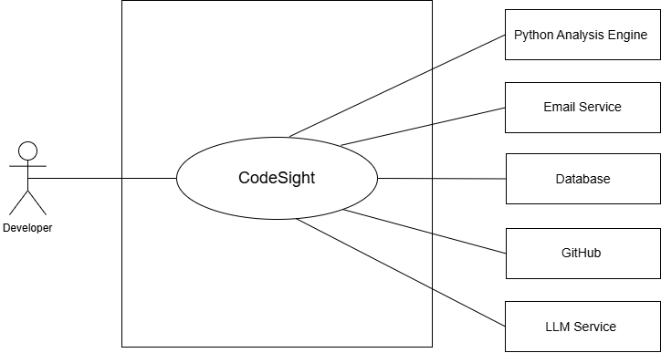
Figure 3.1 — Use Case Diagram, Level 0
3.1.2 Level 1 — Expanded Modules
Name: CodeSight — Expanded Modules
Primary Actor: Developer / Architect. A second, more specialized primary actor, Team Lead (a Developer holding the ADMIN or OWNER project role), is introduced at this level because several use cases — inviting members, changing roles, and triggering Phase-2 deep re-analysis — are only reachable by a user with elevated permissions. Team Lead is a specialization of Developer / Architect, not a separate account type: any Developer becomes a Team Lead the moment they are assigned OWNER or ADMIN on a given project.
Secondary Actors: Python Analysis Engine, Email Service, Database, GitHub, LLM Service (as in Level 0). At this level of detail their involvement is scoped to specific modules rather than the system as a whole: the Email Service is exercised only by Authentication; GitHub only by Codebase Ingestion; and the LLM Service only indirectly, invoked by the Python Analysis Engine during the labeling phase of Analysis & Blueprint and Commit History re-analysis.
Goal: This diagram expands the single CodeSight boundary into its seven major functional modules — Authentication, Organization & Project Management, Codebase Ingestion, Analysis & Blueprint, Graph Visualization, Collaboration, and Commit History — each shown as its own use-case oval with its own associated secondary-actor dependencies. Decomposing the system this way makes the boundaries between modules explicit: a reader can see at a glance that Graph Visualization has no secondary-actor dependency beyond the Database (because it renders a blueprint that was already computed), while Analysis & Blueprint is the only module that talks directly to the Python Analysis Engine, and by extension, indirectly to the LLM Service.
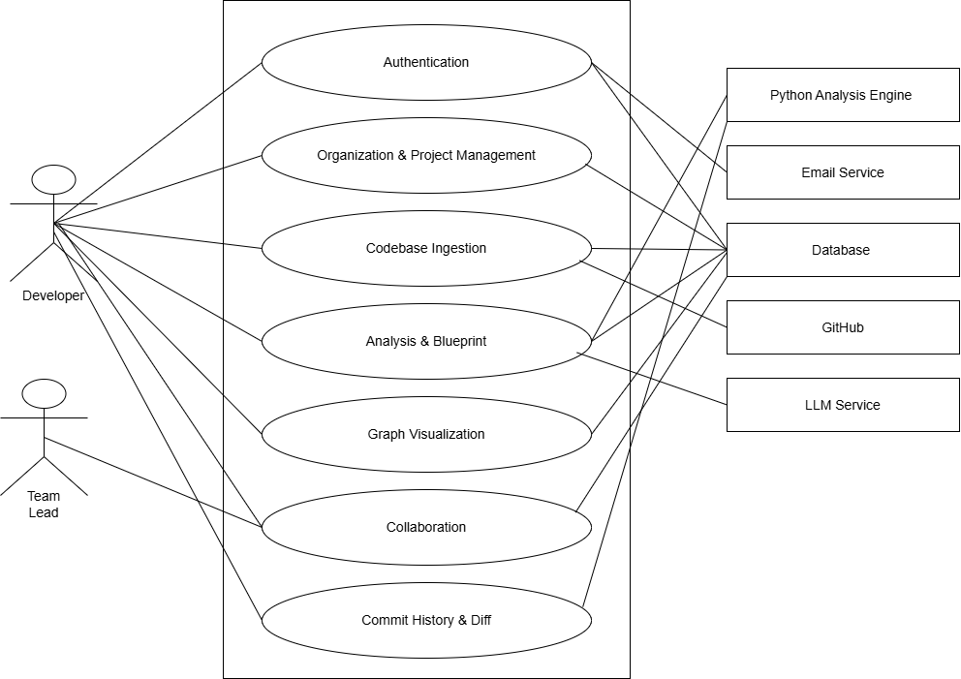
Figure 3.2 — Use Case Diagram, Level 1 .
Each module oval in Figure 3.2 is itself a bundle of several individual use cases. The remainder of this section expands every module into its own Level 2 use case diagram — showing each constituent use case as its own oval, together with the specific secondary actors it touches — followed by the corresponding textual specification table.

3.1.3 Level 2 — Per-Module Use Case Diagrams
The seven diagrams below are the Level 2 decomposition of Figure 3.2: each module oval is expanded into the individual use cases it contains, drawn in the same notation as Level 0 and Level 1 so the three levels read as one consistent family of diagrams rather than three different styles.

Authentication Module
This module handles all account lifecycle operations. Trigger: a Developer submits the registration form, or an existing Developer submits login credentials, or a Developer requests a password reset. Precondition for Login: the account must exist and be email-verified. The Developer actor can register a new account (triggering an email verification to the Email Service), verify their email using the link received, log in with credentials to receive a JWT token, use the forgot-password flow (which sends a reset email regardless of whether the address is registered, to prevent enumeration), reset their password using the received token, and log out to clear their session. Exception flow: if the submitted email is already registered, registration is rejected with a field-level validation error before any email is sent; if a login is attempted against an unverified account, the system responds with an instruction to complete verification rather than a generic authentication failure.
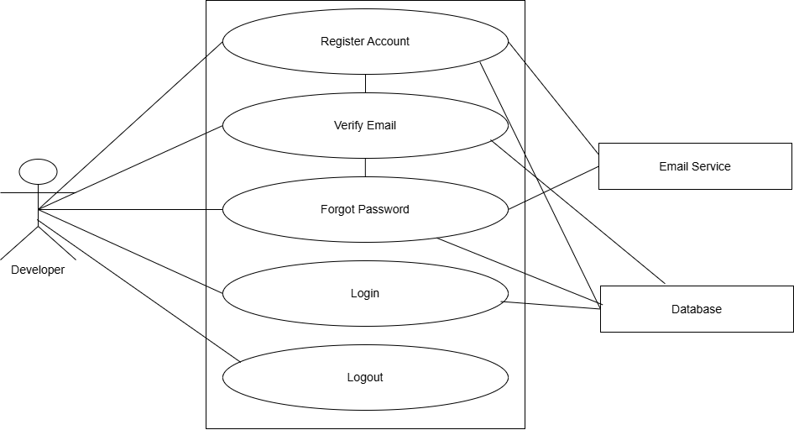
Figure 3.3 — Use Case Diagram, Level 2 — Authentication Module
Use Case | Primary Actor | Secondary Actor | Description
Register Account | Developer | Email Service, Database | Create new user account; send verification email
Verify Email | Developer | Database | Consume verification token; activate account
Login | Developer | Database | Authenticate with email/password; issue JWT cookie
Forgot Password | Developer | Email Service, Database | Issue password-reset email (anti-enumeration)
Reset Password | Developer | Database | Consume reset token; update password
Logout | Developer | — | Clear JWT cookie; terminate session

Organization & Project Management Module
This module manages the workspace hierarchy. Trigger: a Developer completes onboarding (first login with no existing organization) or explicitly opens the project list. Precondition: the Developer must be authenticated; project-scoped use cases additionally require organization membership. The Developer can create an organization, view their organizations, switch between organizations, create projects within an organization, list and view projects, and delete a project. Exception flow: attempting to open a project belonging to an organization the Developer does not (or no longer) belong to returns HTTP 403 rather than exposing project metadata.
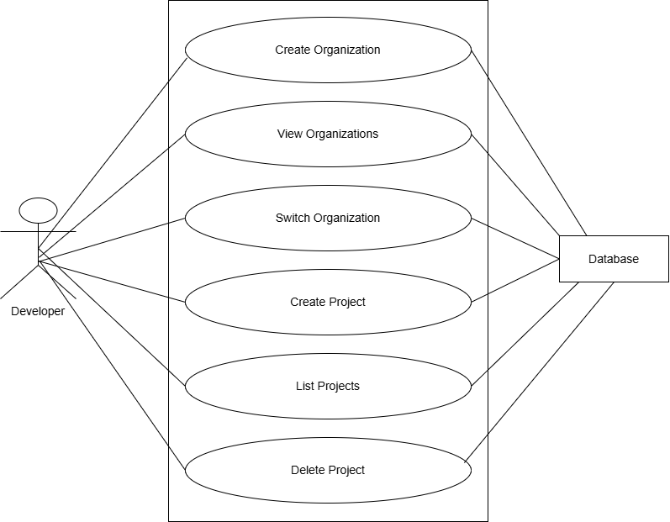
Figure 3.4 — Use Case Diagram, Level 2 — Organization & Project Management Module

Use Case | Primary Actor | Secondary Actor | Description
Create Organization | Developer | Database | Create org; set creator as OWNER
View Organizations | Developer | Database | List all orgs the user belongs to
Switch Organization | Developer | Database | Change active org context in the UI
Create Project | Developer | Database | Create project in org; set status to PENDING_UPLOAD
List Projects | Developer | Database | Show all accessible projects in active org
Delete Project | Developer | Database | Remove project, codebase, blueprint, members

Codebase Ingestion Module
This module handles codebase upload and storage. Trigger: a Developer selects an upload channel on a PENDING_UPLOAD project. Precondition: the project must exist and be in the PENDING_UPLOAD or, for reset, any post-upload state. The Developer can upload a ZIP file (chunked), upload a local folder, clone a public GitHub repository, or clone a private GitHub repository using a PAT. They can also reset the codebase to start over. Postcondition: on success the project transitions to READY_FOR_ANALYSIS; on failure (corrupt archive, unreachable git URL, invalid PAT) the project remains in its prior state and a specific, user-readable error is returned.
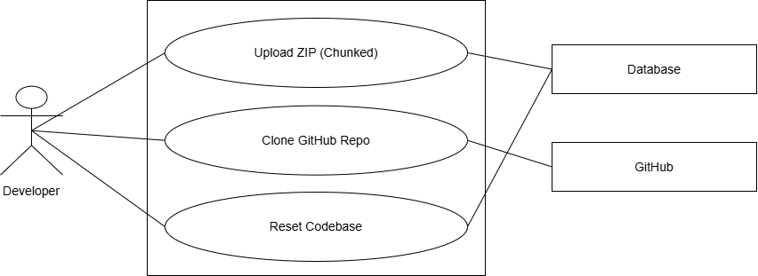
Figure 3.5 — Use Case Diagram, Level 2 — Codebase Ingestion Module
Use Case | Primary Actor | Secondary Actor | Description
Upload ZIP (Chunked) | Developer | Database, Filesystem | Stream 3 MB chunks; reassemble; extract to storage
Clone Public GitHub Repo | Developer | GitHub, Filesystem | Server-side git clone via HTTPS
Clone Private GitHub Repo | Developer | GitHub, Filesystem | Server-side git clone with PAT
Reset Codebase | Developer | Database, Filesystem | Delete files + blueprint; revert to PENDING_UPLOAD

Analysis & Blueprint Module
This module orchestrates the analysis pipeline. Trigger: the Developer clicks “Analyze” on a READY_FOR_ANALYSIS project. Precondition: a codebase has already been ingested. The Developer triggers analysis; the Spring backend dispatches to Python; the Python engine runs the six-phase pipeline and writes the blueprint; Spring persists it and updates status. While analysis is IN_PROGRESS, the Developer can monitor progress through 3-second status polling, and once COMPLETED, view the detected paradigm and summary metadata. Exception flow: a parsing failure or out-of-memory condition in the Python engine surfaces as a FAILED status with the underlying error message preserved for the Developer to read, rather than a silent timeout.
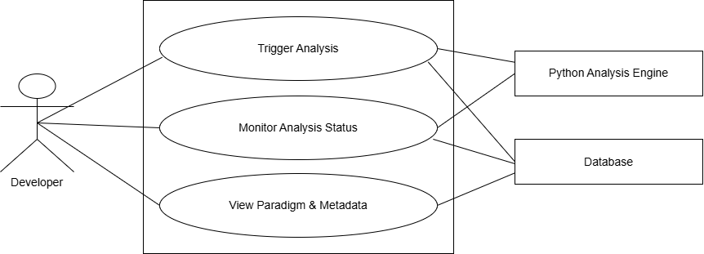
Figure 3.6 — Use Case Diagram, Level 2 — Analysis & Blueprint Module.
Use Case | Primary Actor | Secondary Actor | Description
Trigger Analysis | Developer | Python Engine, Database | POST /analyze; async dispatch; transition to IN_PROGRESS
Monitor Analysis Status | Developer | Python Engine, Database | 3-second polling; display phase; stop on COMPLETED/FAILED
View Paradigm & Metadata | Developer | Database | Show detected paradigm, file count, cluster count

Graph Visualization Module
This module powers the interactive canvas. Trigger: a Developer opens a COMPLETED project. Precondition: the project has a persisted CodebaseGraph blueprint. The Developer can view the cluster graph, drill into a cluster, navigate via breadcrumb, toggle layout modes, pan/zoom/drag, view file metadata, prune edges, and switch to List View. Beyond pure navigation, any ADMIN or OWNER can override a cluster's generated name or summary, any team member with at least the MEMBER role can add or edit a free-form note on a cluster, and every team member — including VIEWER — can see the automatically computed cluster owner badge. This module has no secondary-actor dependency beyond the Database for most navigation use cases, since the blueprint it renders was already computed by the Analysis & Blueprint module; the two exceptions are cluster notes/overrides, which write back to the Database, and the cluster owner badge, which is derived from git history the same way Commit History's diff data is.
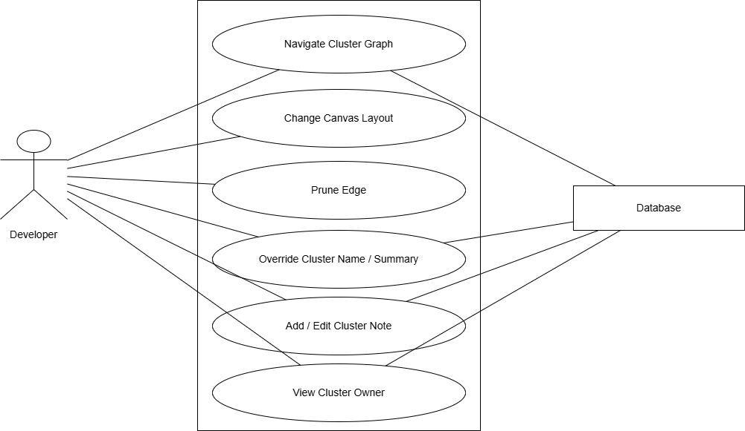
Figure 3.7 — Use Case Diagram, Level 2 — Graph Visualization Module.
Use Case | Primary Actor | Secondary Actor | Description
View Cluster Graph | Developer | Database | Render React Flow canvas from blueprint
Drill Into Cluster | Developer | — | Navigate from cluster pill to file card view
Navigate via Breadcrumb | Developer | — | Return to parent level or root
Toggle Structure/Flow Layout | Developer | — | Switch D3 force vs. topological sort
Prune Edge | Developer | localStorage | Delete edge; persist to localStorage
View File Metadata | Developer | — | See centrality, role, god-file flag, dead-import count
Switch to List View | Developer | — | Text-based cluster/file tree alternative
Override Cluster Name/Summary | Developer (ADMIN/OWNER) | Database | Replace LLM-suggested cluster label or summary
Add/Edit Cluster Note | Developer (MEMBER+) | Database | Attach a timestamped, authored note to a cluster
View Cluster Owner | Developer | Database (JGit) | Show top contributor and share of changes per cluster

Collaboration Module
This module manages project membership and RBAC. Trigger: a Team Lead opens the Members panel on a project they own or administer. Precondition: the requesting actor must hold ADMIN or OWNER role on the target project; every operation in this module is additionally re-validated server-side regardless of what the frontend displays. A Team Lead (ADMIN/OWNER) can invite members, change roles, and remove members. All role checks are enforced server-side, so a request forged outside the UI (e.g., a MEMBER attempting to call the remove-member endpoint directly) is rejected with HTTP 403 in the same way an unauthorized UI action would be.
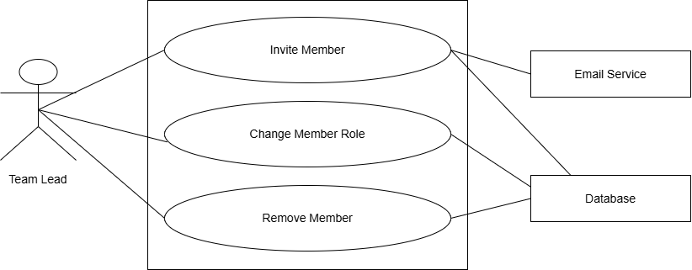
Figure 3.8 — Use Case Diagram, Level 2 — Collaboration Module
Use Case | Primary Actor | Secondary Actor | Description
Invite Member | Team Lead | Database | Add user to project by email; assign role
Change Member Role | Team Lead | Database | Update role for MEMBER or VIEWER
Remove Member | Team Lead | Database | Remove user; revoke project access
Enforce Role Permissions | System | Database | HTTP 403 on any unauthorized action

Commit History Module
This module provides temporal diff visualization. Trigger: a Developer opens the canvas of a COMPLETED project whose codebase is a git repository. Precondition: the project's stored codebase contains a .git directory with at least one commit; if it does not, the module degrades to a “No git history available” message rather than an error. The Developer can view the commit timeline, select a commit to see a color-coded diff overlay, clear the overlay, and (if a Team Lead) trigger deep re-analysis of a historical commit. The deep re-analysis path is the only use case in this module that re-invokes the Python Analysis Engine, since Phase-1 overlay reuses the existing blueprint while Phase-2 re-analysis computes a brand-new one for the historical snapshot.
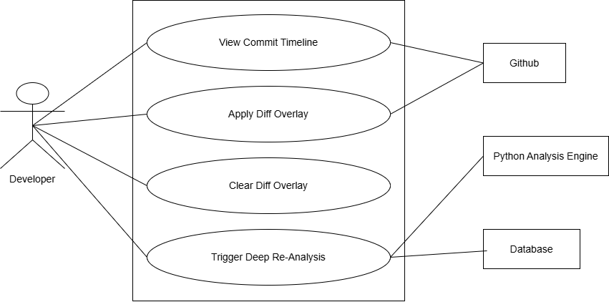
Figure 3.9 — Use Case Diagram, Level 2 — Commit History Module.
Use Case | Primary Actor | Secondary Actor | Description
View Commit Timeline | Developer | Database (JGit) | Show last 10 commits in a strip
Apply Diff Overlay | Developer | Database (JGit) | Color-code changed nodes on current graph
Clear Diff Overlay | Developer | — | Remove overlay; restore default node styles
Trigger Deep Re-Analysis | Team Lead | Python Engine, Database | Async analysis of historical commit; store GraphSnapshot

3.2 Activity Diagrams
Where the use case diagrams in Section 3.1 show what the system can do and who triggers it, the activity diagrams below show how each flow actually plays out step by step — including validation branches, permission checks, and failure paths. Each diagram corresponds to one or more use cases from the module of the same name. Swimlanes are intentionally omitted; the actor for every step is the Developer/Architect (or the more specific Team Lead) already identified in Section 3.1, so a single flow per diagram keeps the notation to start/action/decision/end nodes only.

3.2.1 Authentication — Registration & Email Verification
Covers the Register Account and Verify Email use cases, including the field-validation and duplicate-email exception paths described in Section 2.2.1.
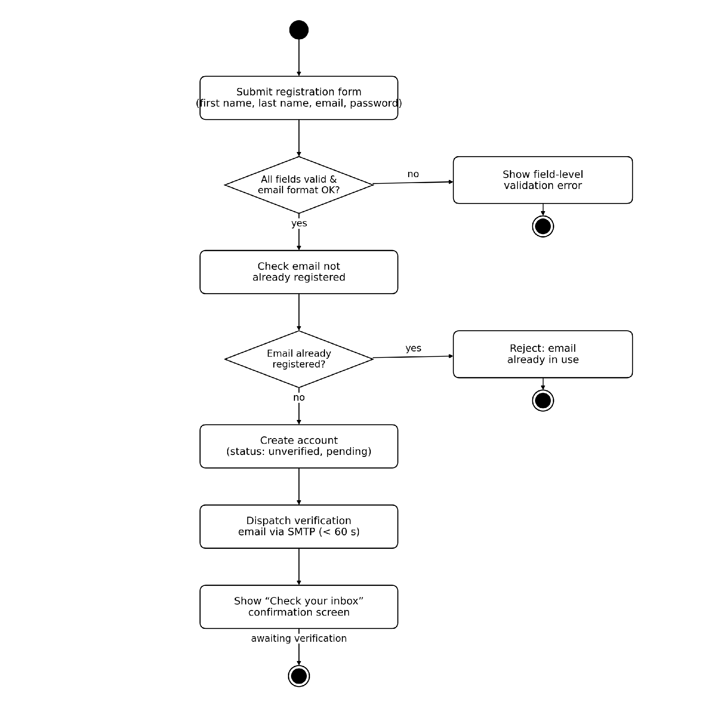
Figure 3.10 — Activity Diagram — Registration. An editable version of this diagram is provided as activity_auth_register_p1.drawio.
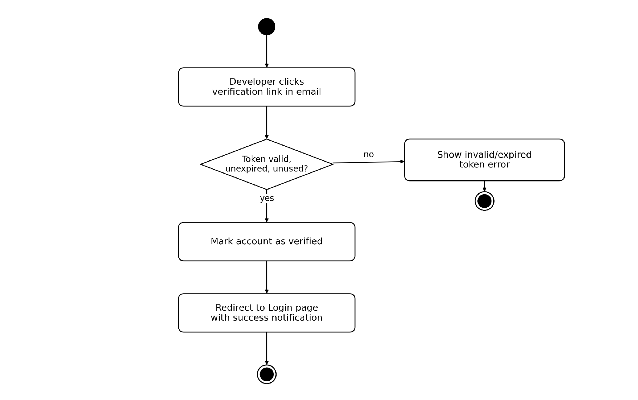
Figure 3.11 — Activity Diagram — Email Verification. An editable version of this diagram is provided as activity_auth_register_p2.drawio.

3.2.2 Authentication — Login, Forgot & Reset Password
Covers the Login, Forgot Password, and Reset Password use cases, including the invalid-credentials, unverified-account, and inactive-account branches, plus the anti-enumeration behavior of the password-reset request.
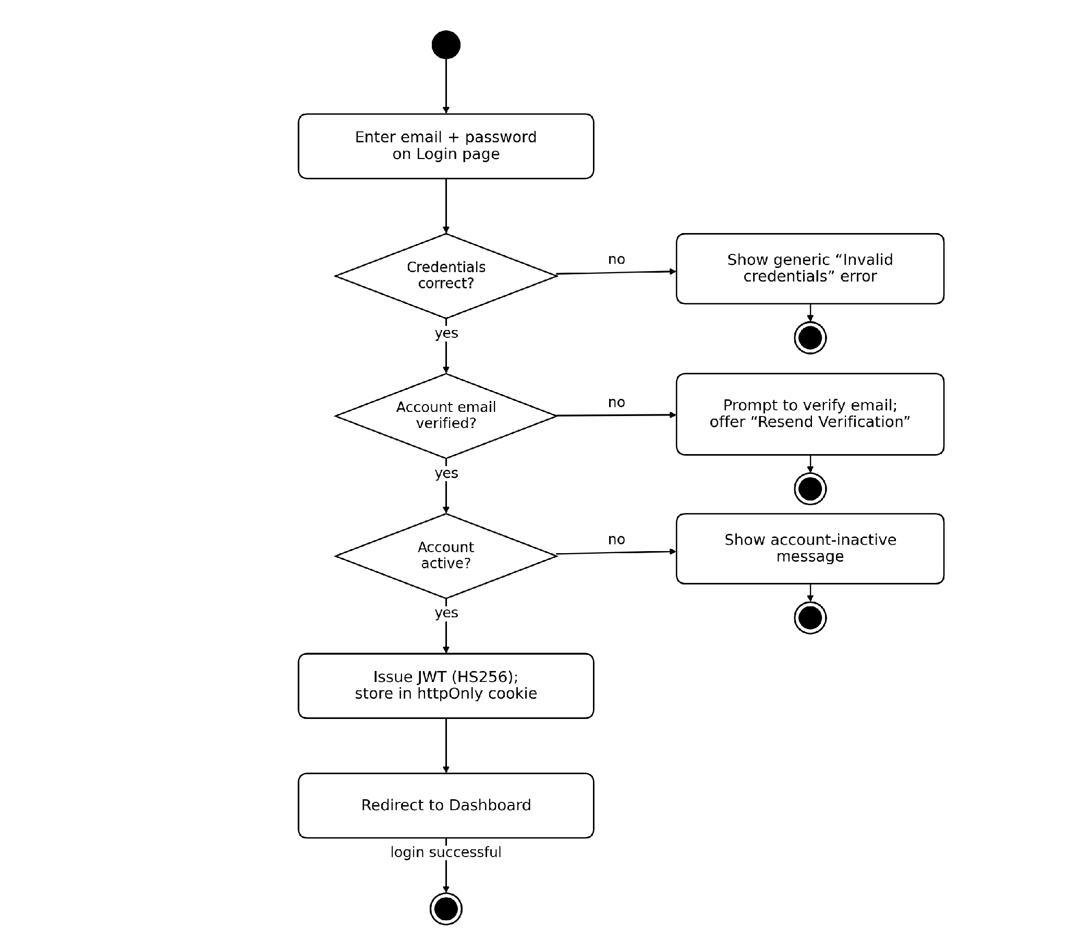
Figure 3.12 — Activity Diagram — Login. An editable version of this diagram is provided as activity_auth_login_p1.drawio.
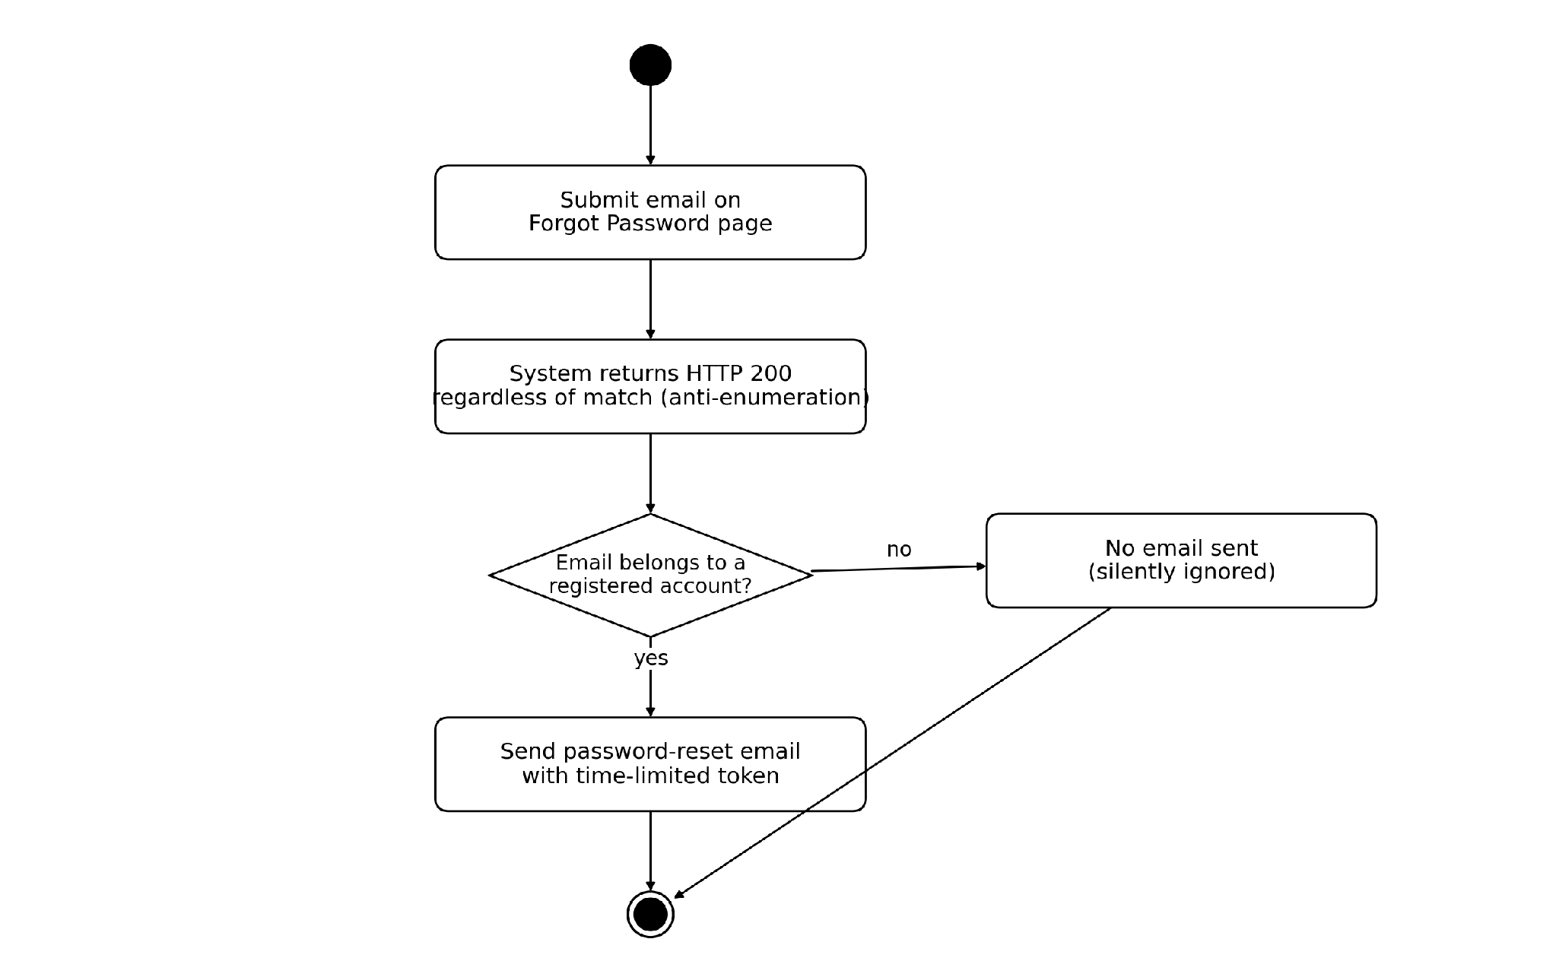
Figure 3.13 — Activity Diagram — Forgot Password. An editable version of this diagram is provided as activity_auth_login_p2.drawio.
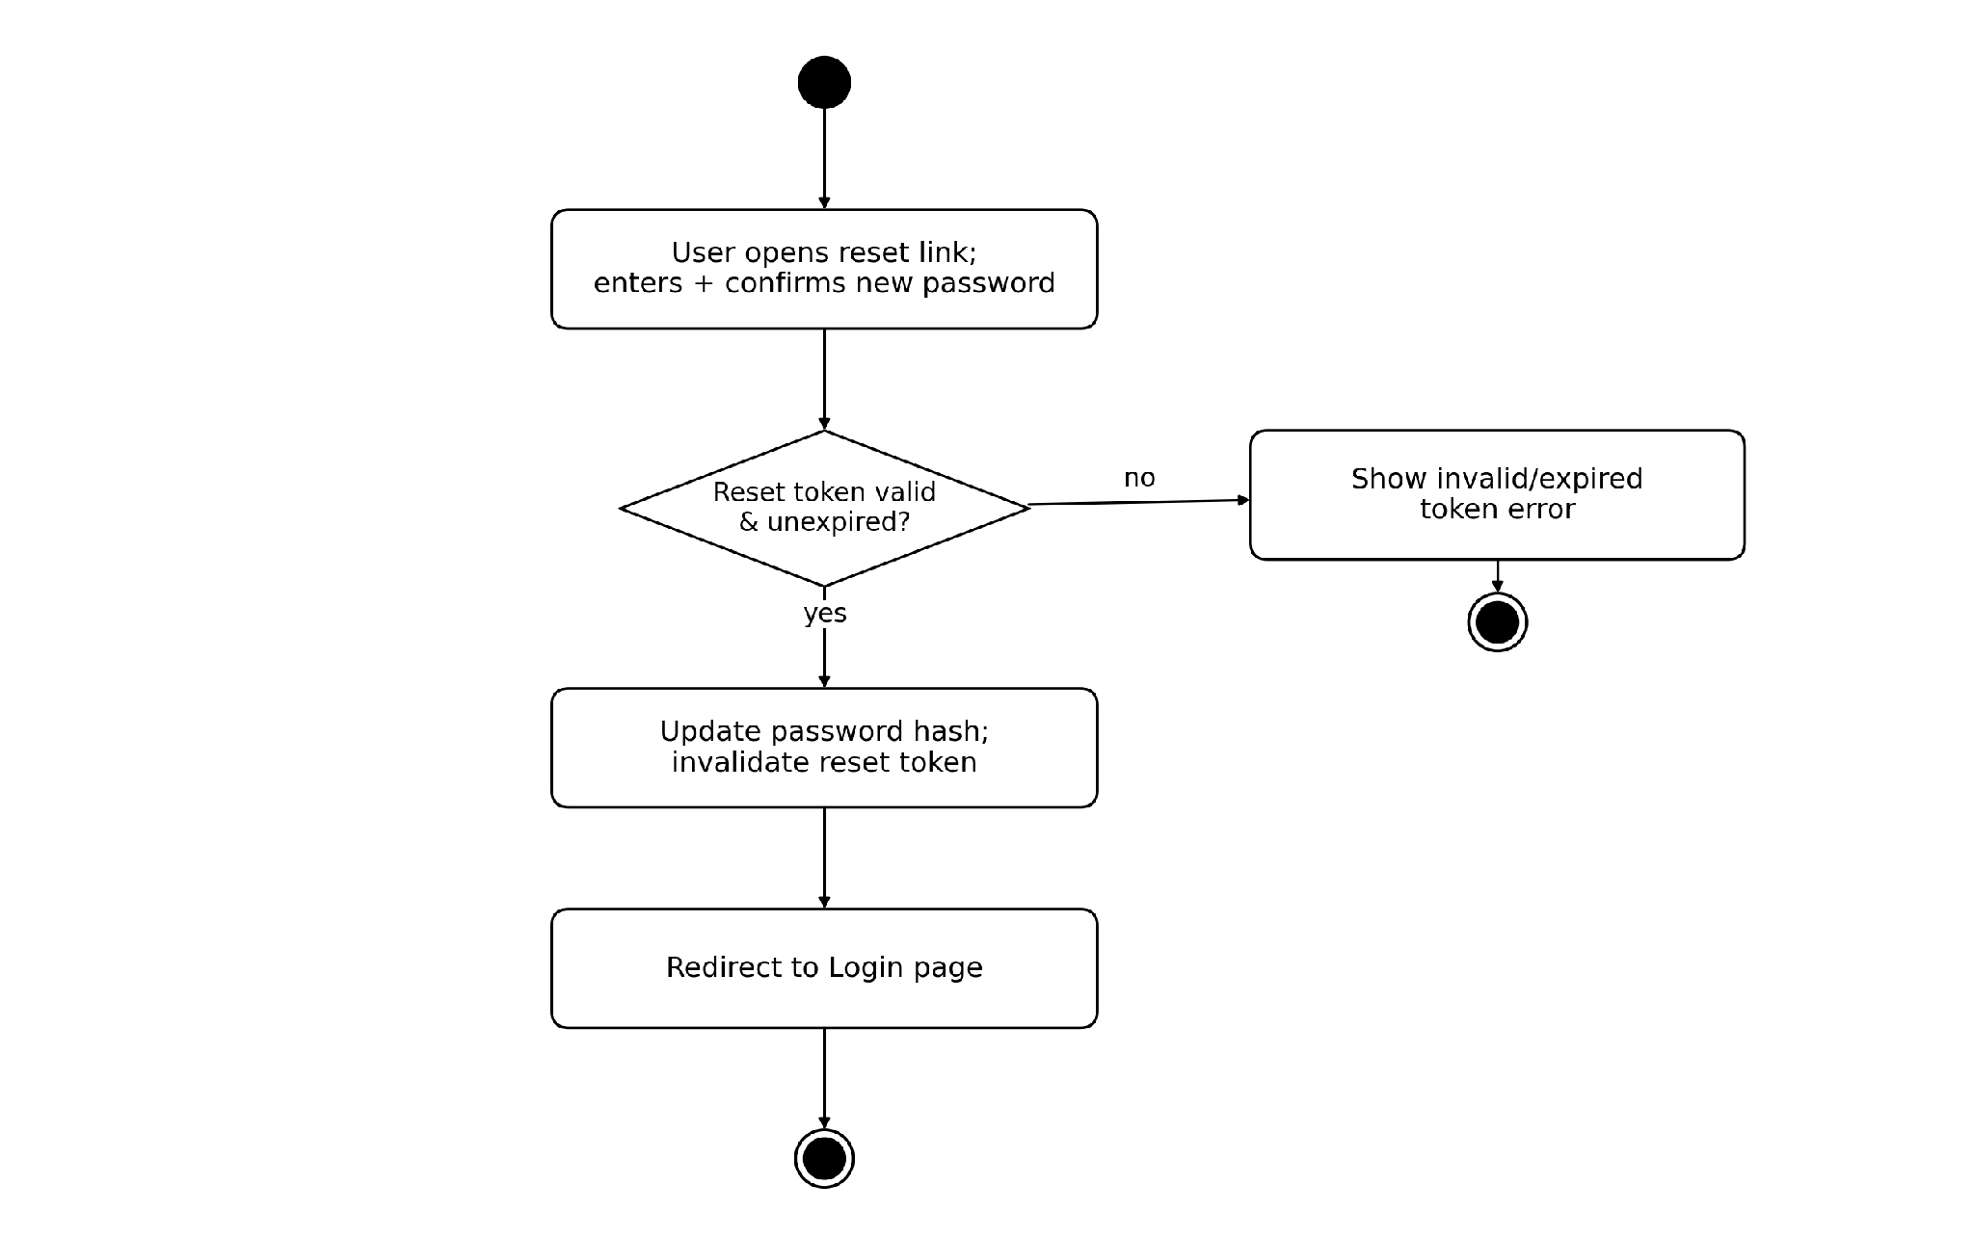
Figure 3.14 — Activity Diagram — Reset Password. An editable version of this diagram is provided as activity_auth_login_p3.drawio.

3.2.3 Organization & Project Management — Project Lifecycle
Covers onboarding into a first organization, Create Project, and Delete Project, including the confirmation dialog and the safeguard that terminates an IN_PROGRESS analysis job before deletion proceeds.
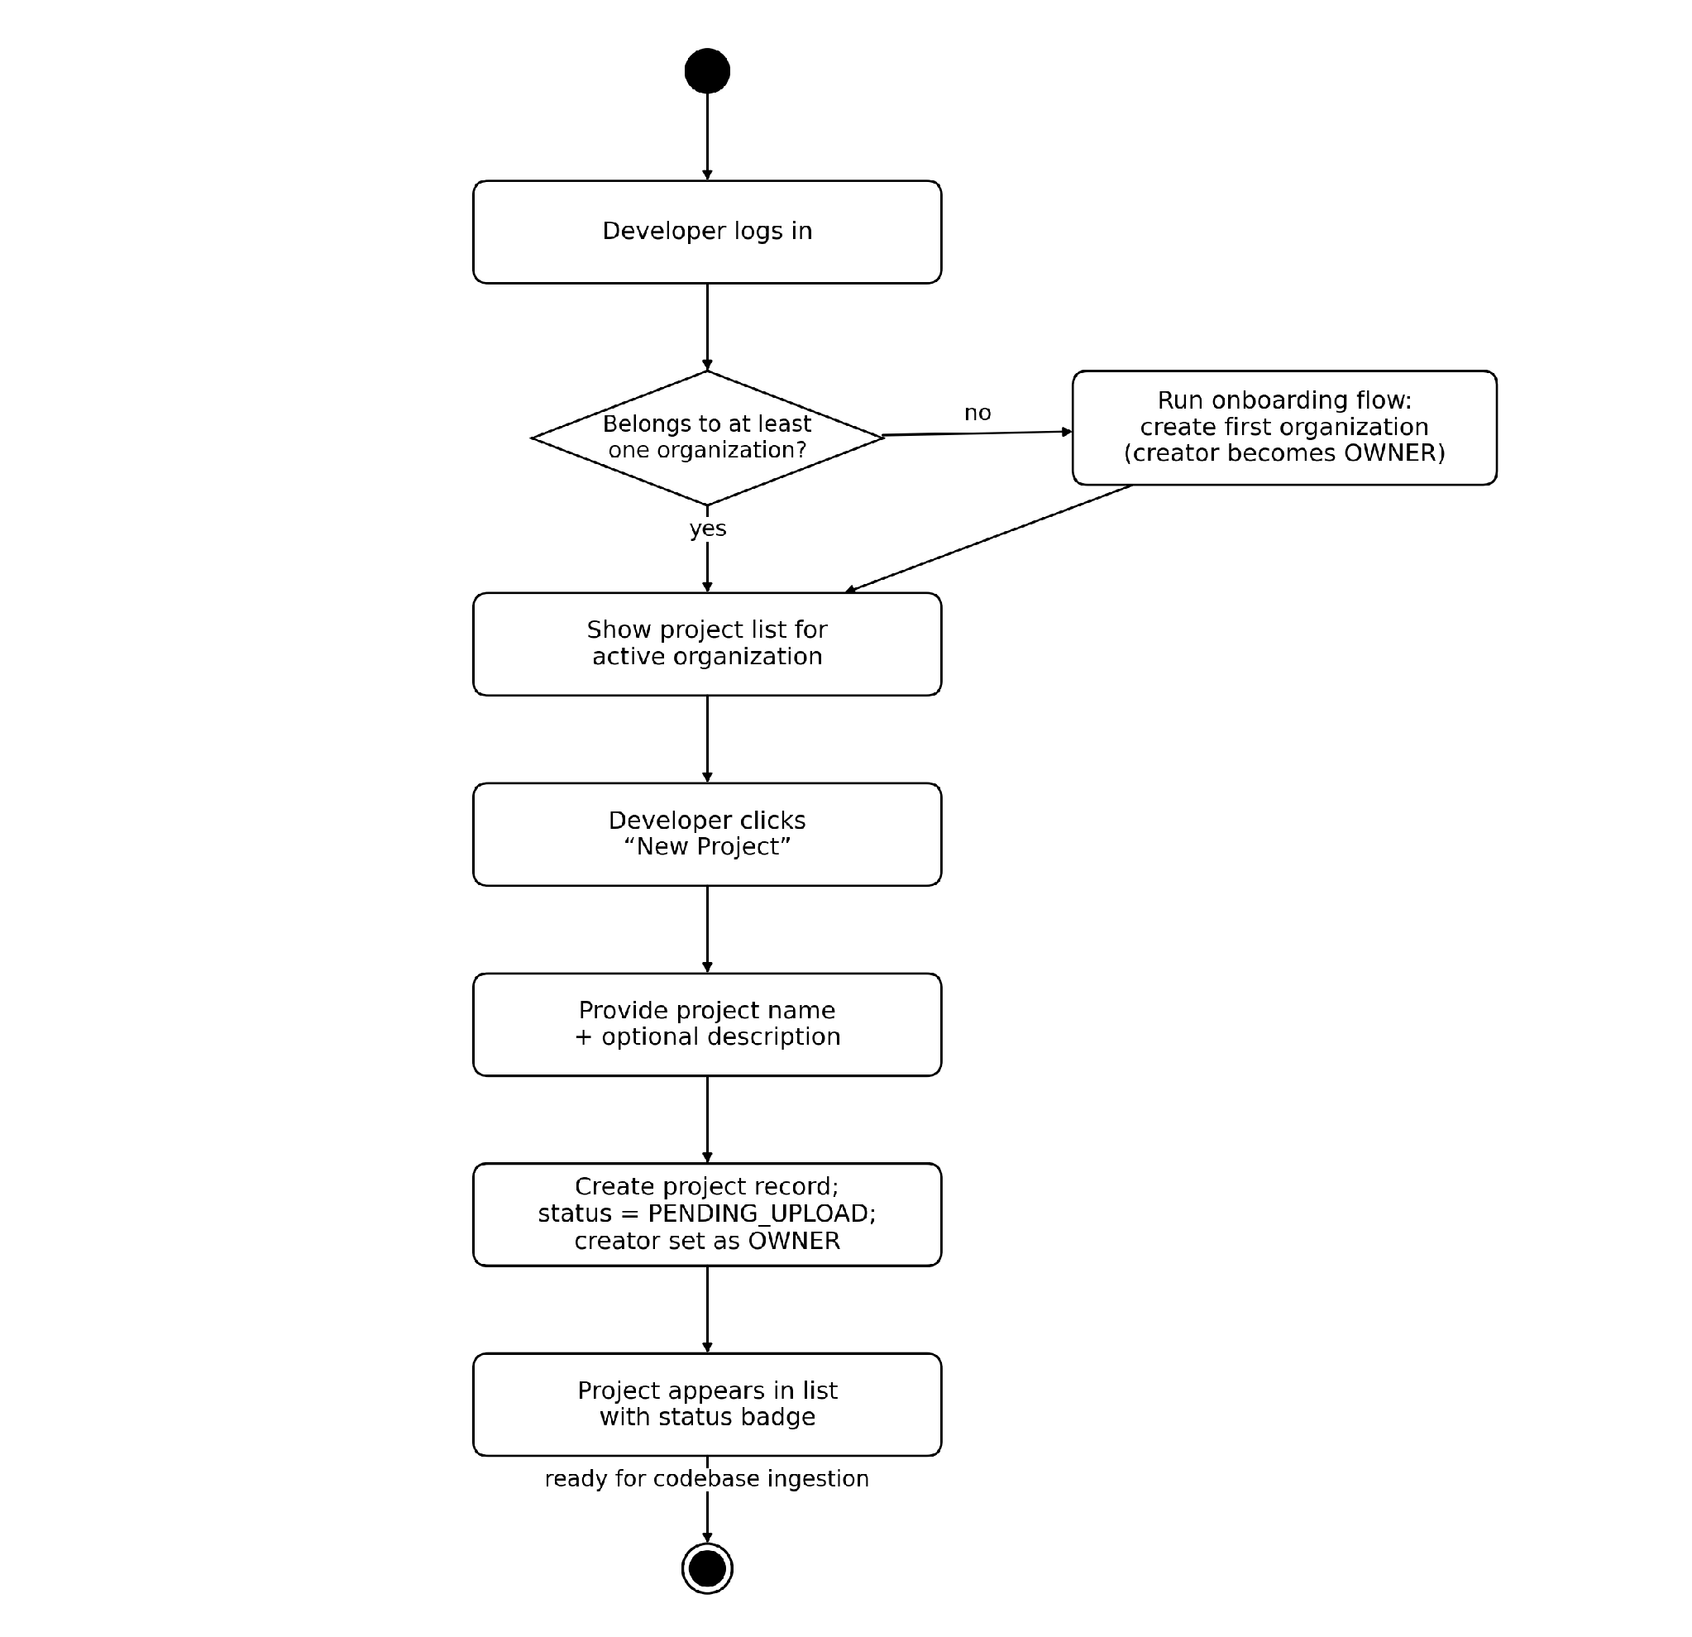
Figure 3.15 — Activity Diagram — Onboarding & Create Project. An editable version of this diagram is provided as activity_orgproj_p1.drawio.
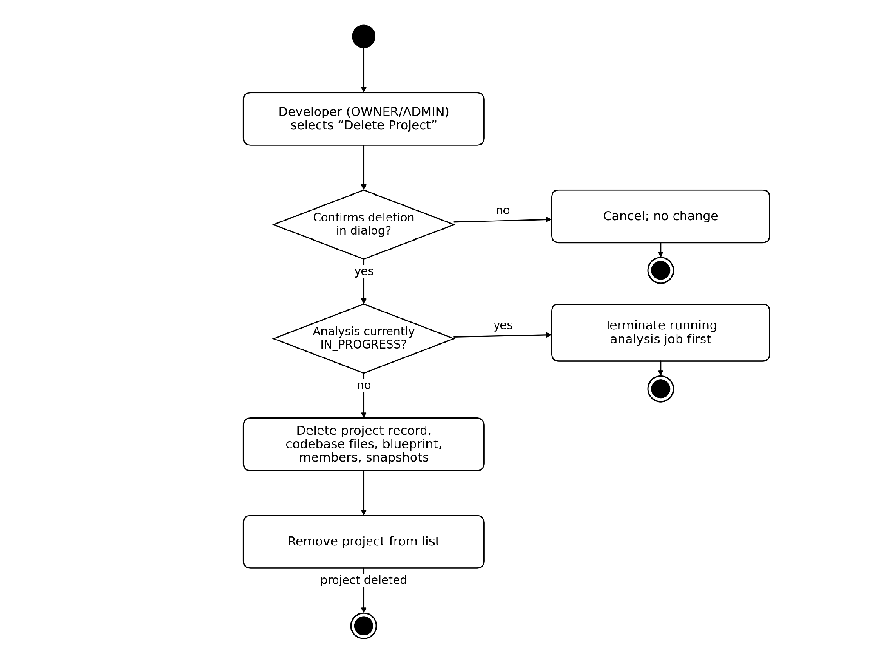
Figure 3.16 — Activity Diagram — Delete Project. An editable version of this diagram is provided as activity_orgproj_p2.drawio.

3.2.4 Codebase Ingestion — Upload / Clone & Reset
Covers all four ingestion use cases (chunked ZIP, folder, public GitHub clone, private GitHub clone) converging on a common validation and status-transition path, plus the separate Reset Codebase flow.
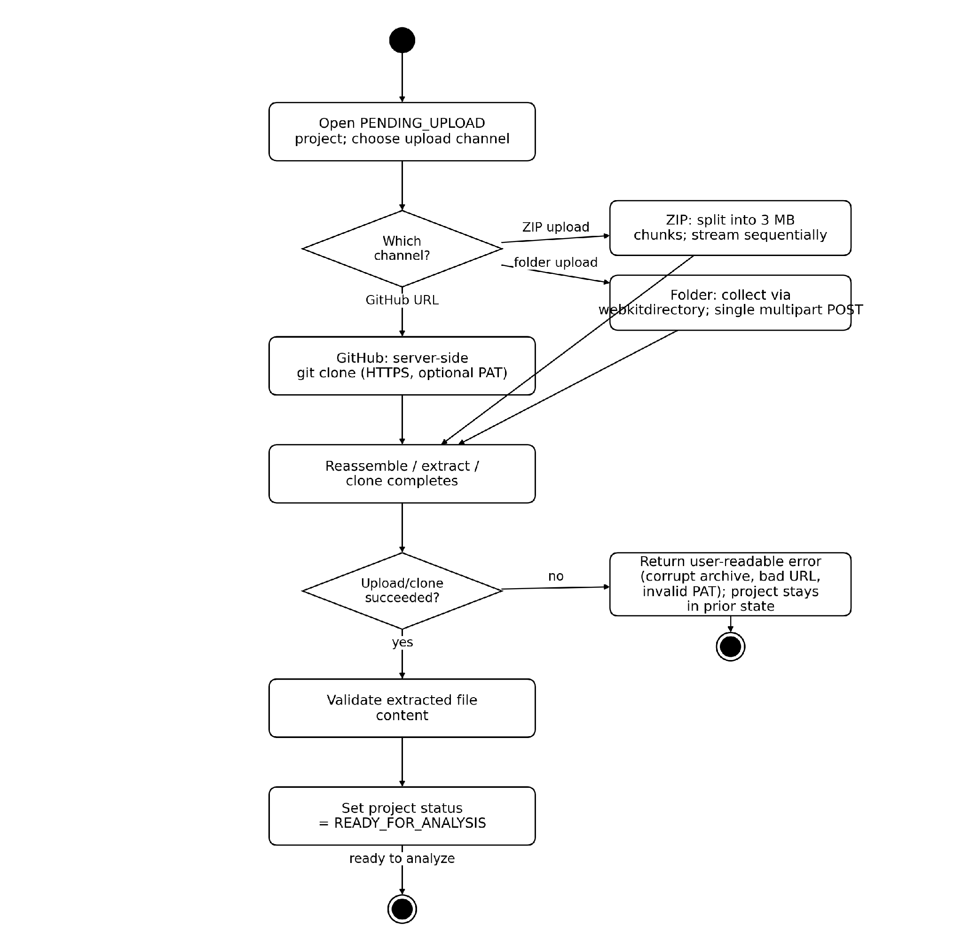
Figure 3.17 — Activity Diagram — Upload / Clone. An editable version of this diagram is provided as activity_ingest_p1.drawio.
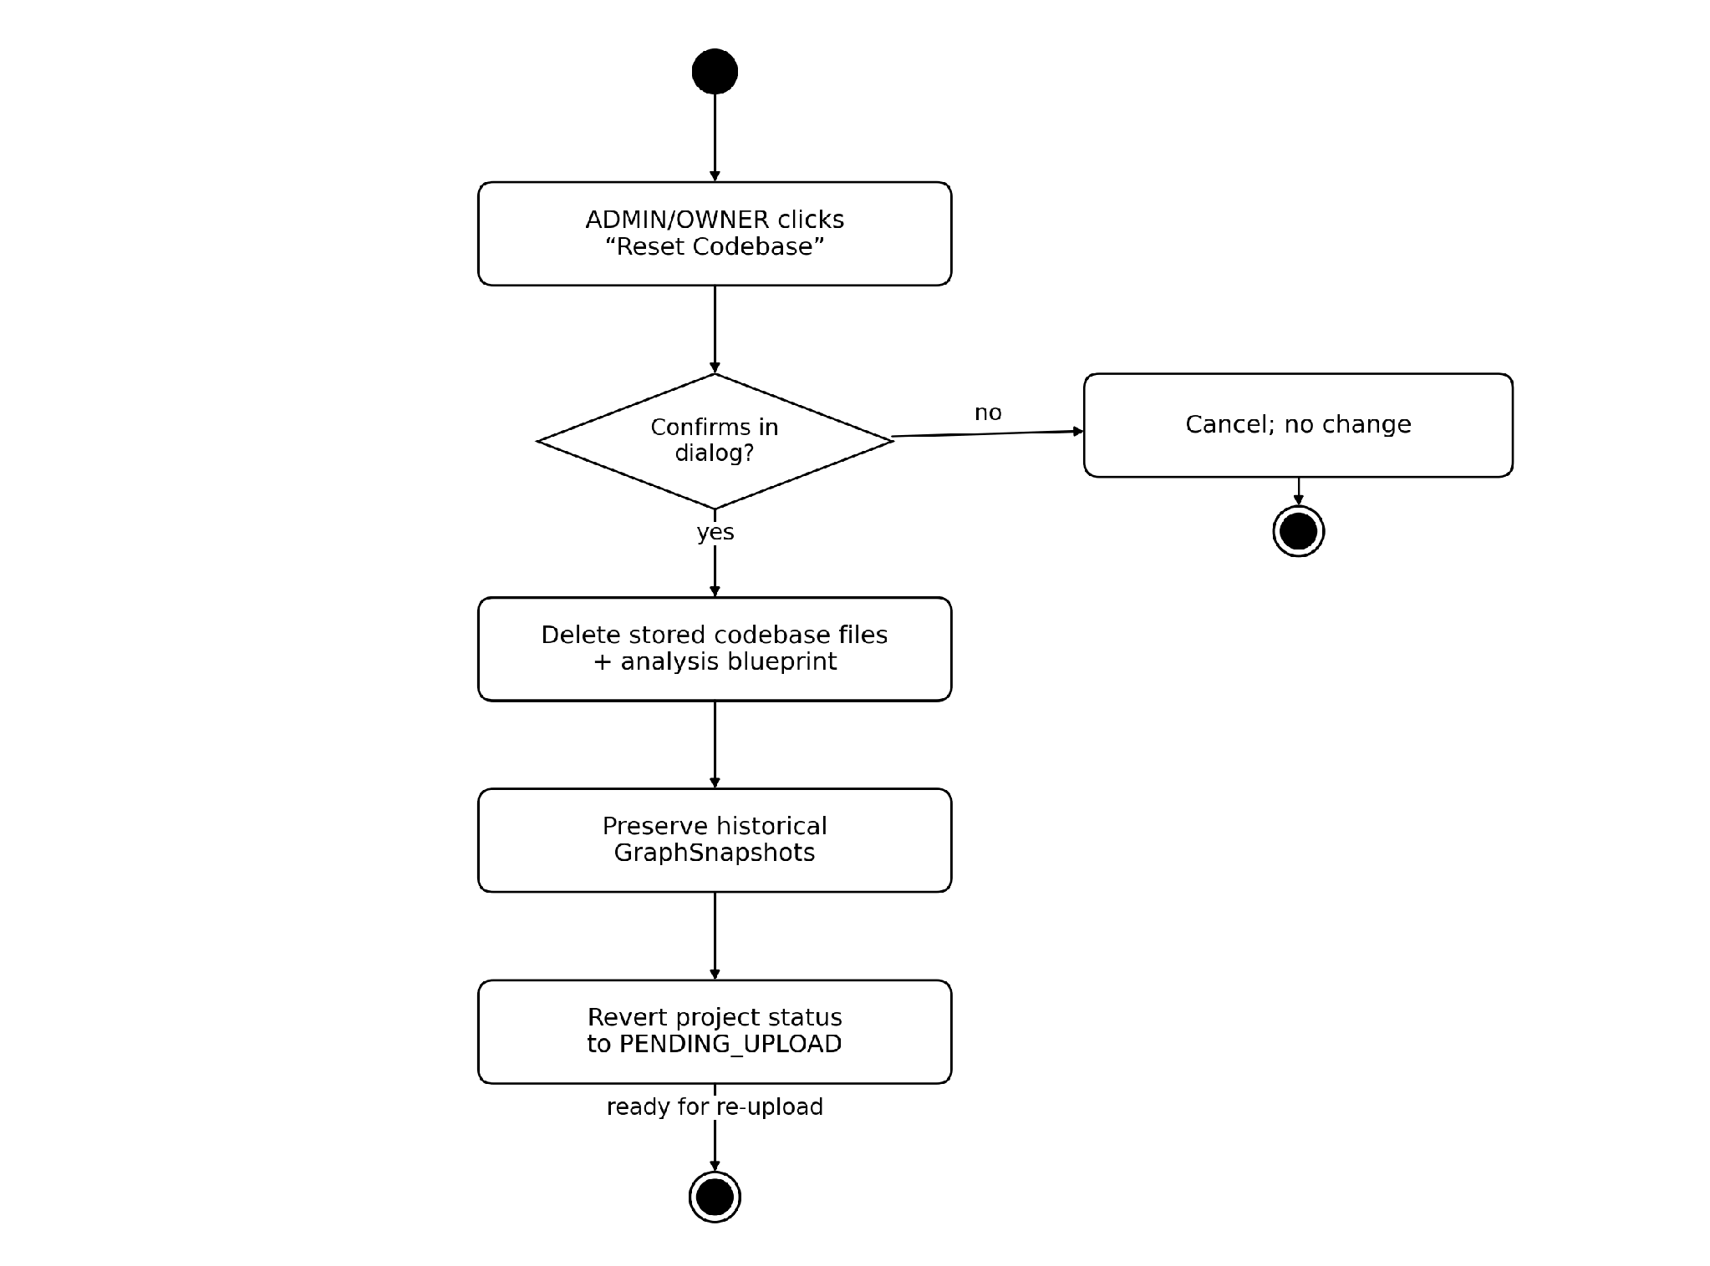
Figure 3.18 — Activity Diagram — Reset Codebase. An editable version of this diagram is provided as activity_ingest_p2.drawio.

3.2.5 Analysis & Blueprint — Trigger, Poll & Persist
Covers Trigger Analysis and Monitor Analysis Status, including the 3-second polling loop and the success/failure branch that determines whether the blueprint is persisted or the project is marked FAILED with a preserved error message.
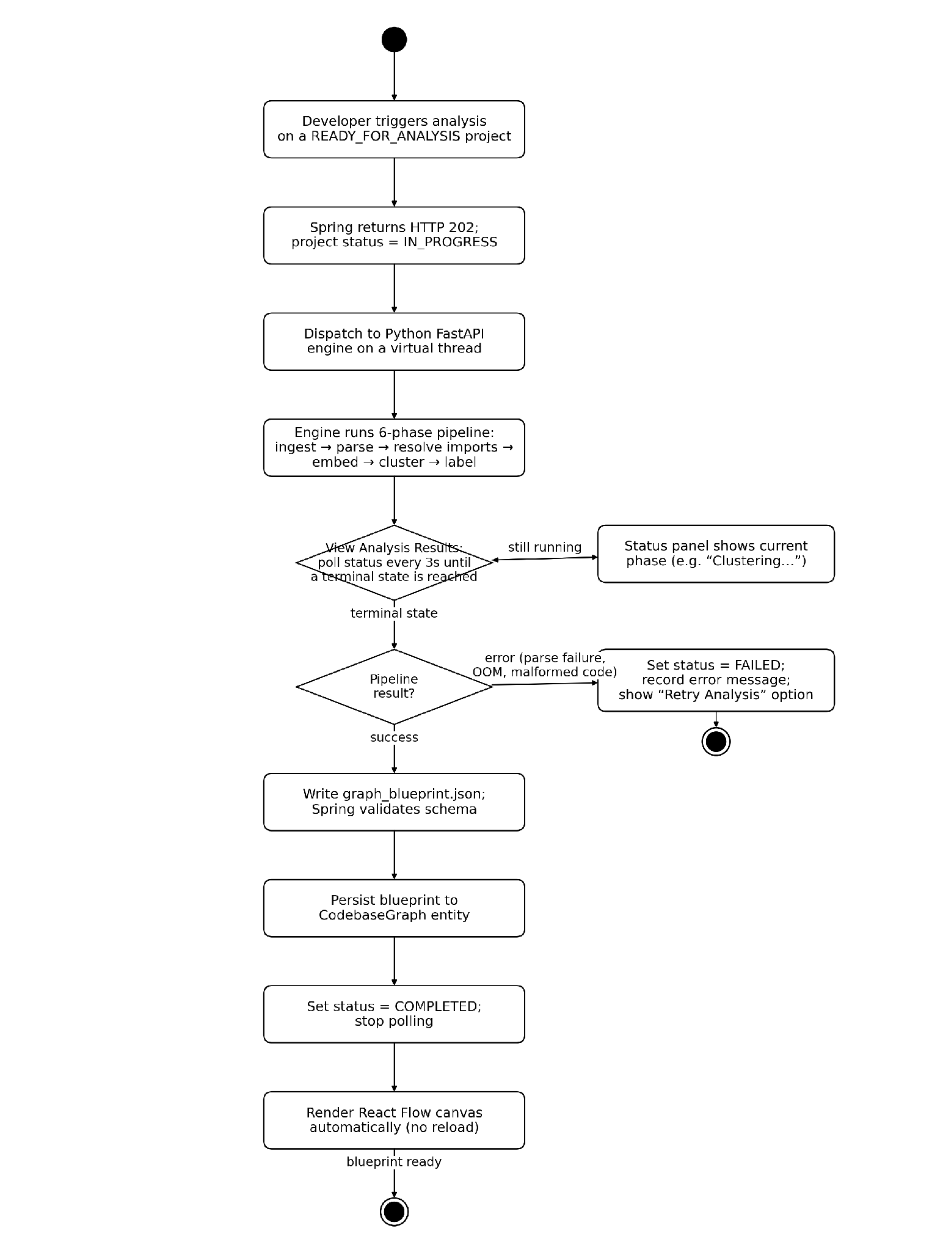
Figure 3.19 — Activity Diagram — Analysis & Blueprint. An editable version of this diagram is provided as activity_analysis.drawio.

3.2.6 Graph Visualization — Cluster Interaction, Notes & Ownership
Covers ordinary canvas navigation alongside the three cluster-metadata use cases added in Section 2.2.9/2.2.10: overriding a cluster's name or summary (ADMIN/OWNER only), adding a cluster note (MEMBER role or above), and viewing the automatically computed cluster owner badge (any role, read-only). The permission-check decision applies only to the two write actions; navigation and owner viewing are always permitted.
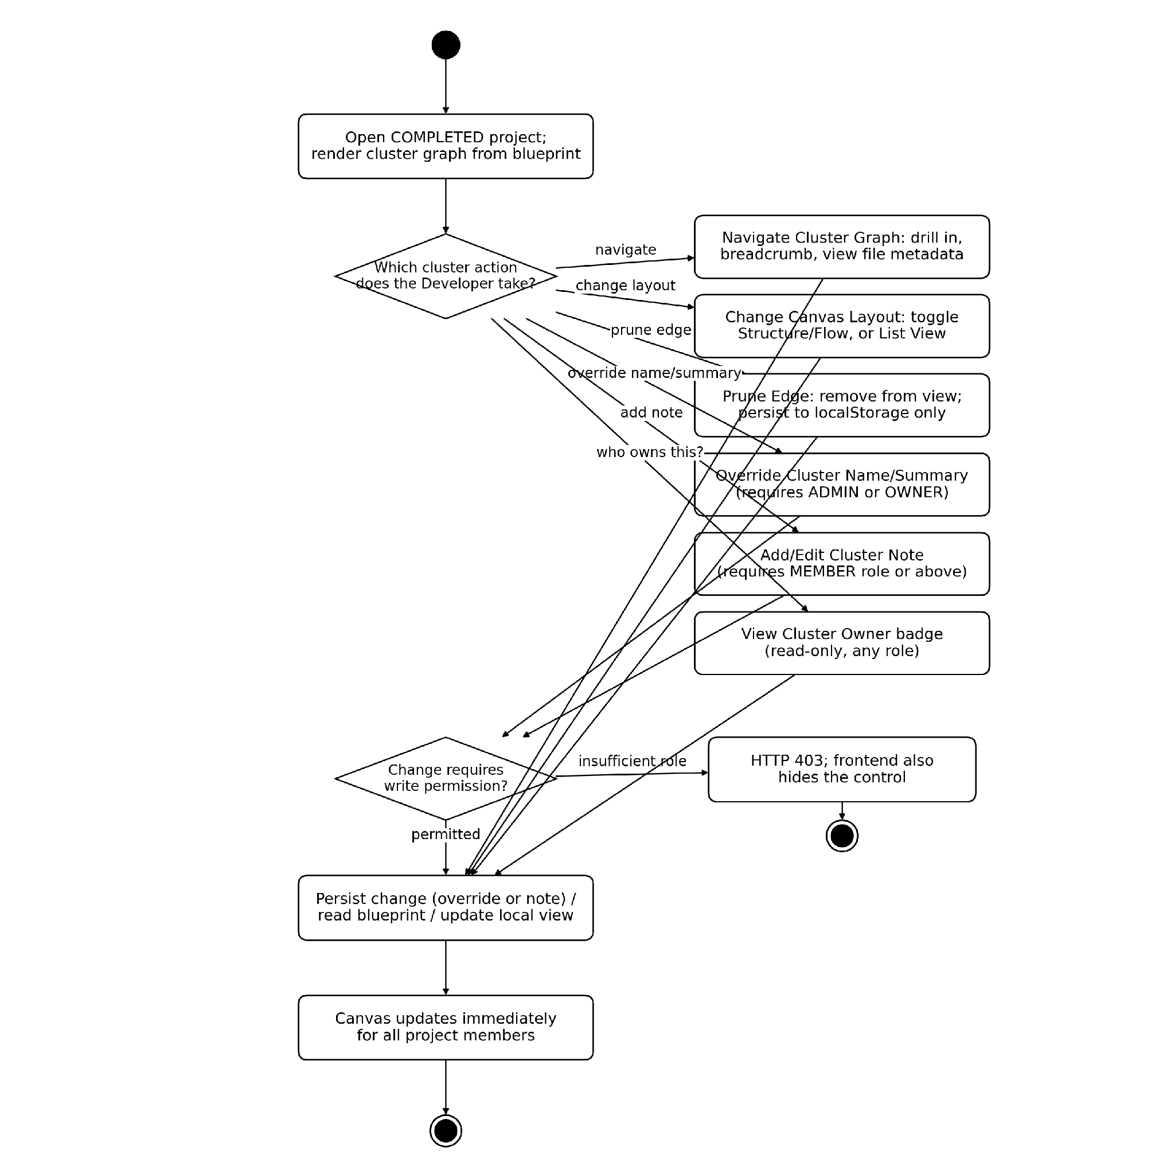
Figure 3.20 — Activity Diagram — Graph Visualization & Cluster Actions. An editable version of this diagram is provided as activity_viz.drawio.

3.2.7 Collaboration — Invite & Role Enforcement
Covers Invite Member, Change Member Role, and Remove Member, including the pending-invitation path for emails that are not yet registered CodeSight users and the server-side role-hierarchy check that returns HTTP 403 for any insufficiently-privileged request.
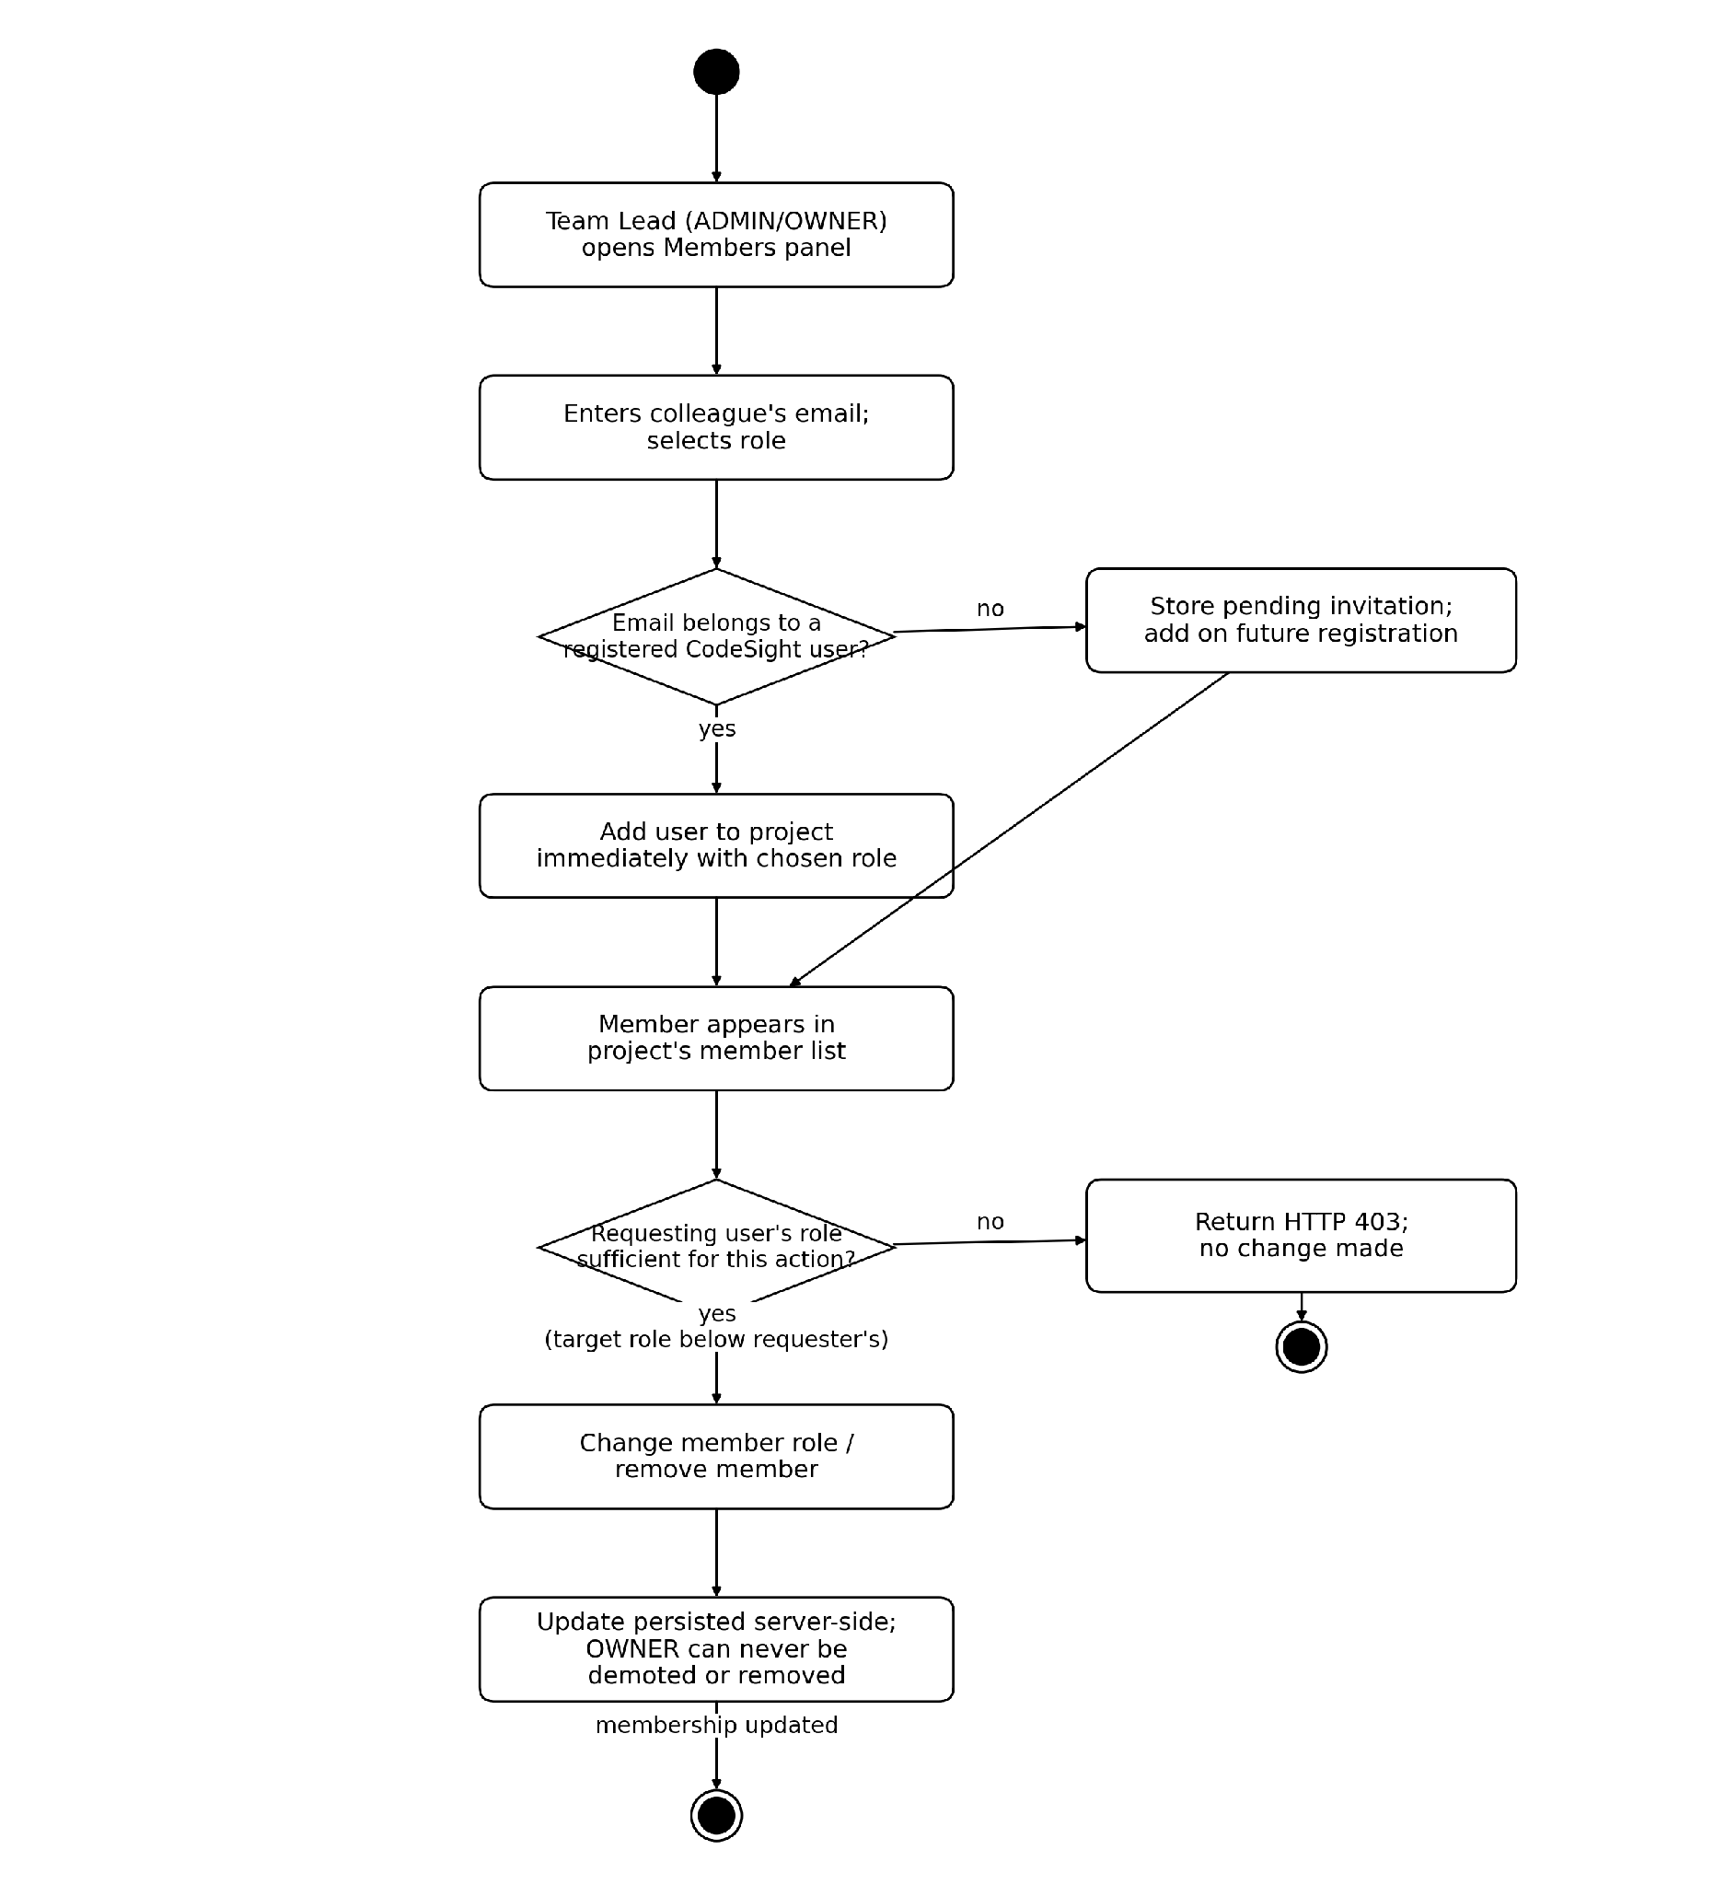
Figure 3.21 — Activity Diagram — Collaboration & RBAC Enforcement. An editable version of this diagram is provided as activity_collab.drawio.

3.2.8 Commit History — Timeline, Diff Overlay & Deep Re-Analysis
Covers View Commit Timeline, Apply/Clear Diff Overlay, and Trigger Deep Re-Analysis, including the graceful degradation for projects without a git repository and the asynchronous Phase-2 path that computes a GraphSnapshot for a historical commit.
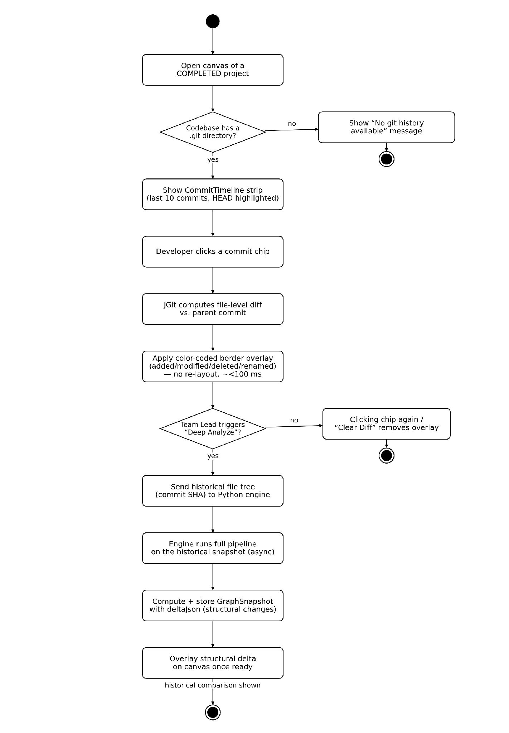
Figure 3.22 — Activity Diagram — Commit History & Diff Visualization. An editable version of this diagram is provided as activity_commit.drawio.

4. Database Modeling
Database modeling describes how persistent data is structured and related within the system. CodeSight uses a relational schema (PostgreSQL or MySQL) managed by Spring Data JPA with Hibernate as the ORM.

4.1 ER Diagram and Schemas
Entity Relationships:
- A User can belong to many Organizations through OrganizationMember.
- An Organization contains many Projects.
- A Project has many ProjectMembers and at most one CodebaseGraph.
- A Project can have many GraphSnapshots (one per analyzed commit).
- A User can have many VerificationTokens (email verification, password reset).
- A Project can have many ClusterAnnotations (one per annotated cluster in its blueprint).
- A User can own many ClusterAnnotations (as the computed cluster owner) and can also author many ClusterAnnotations (as the member who last updated the note or override).
ER Relationship Summary:
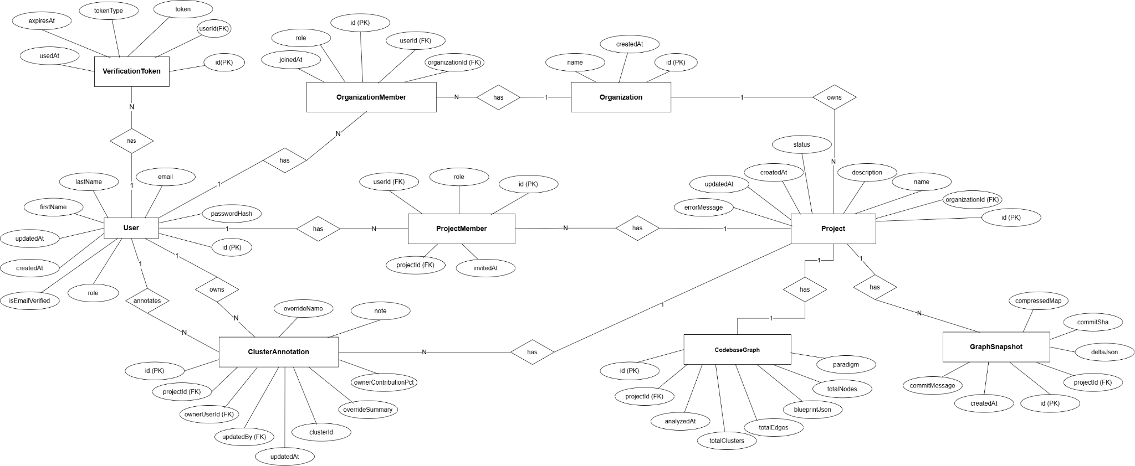
Figure 4.1 — Entity Relationship Diagram.
Table 4.1 — Schemas
Schema | Attribute | Type
User | id (PK) | BIGINT (auto)
User | firstName | VARCHAR(100)
User | lastName | VARCHAR(100)
User | email | VARCHAR(255) UNIQUE
User | passwordHash | VARCHAR(255)
User | role | ENUM(USER, ADMIN)
User | isEmailVerified | BOOLEAN
User | createdAt | DATETIME
User | updatedAt | DATETIME
Organization | id (PK) | BIGINT (auto)
Organization | name | VARCHAR(255)
Organization | createdAt | DATETIME
OrganizationMember | id (PK) | BIGINT (auto)
OrganizationMember | organizationId (FK) | BIGINT → Organization
OrganizationMember | userId (FK) | BIGINT → User
OrganizationMember | role | ENUM(OWNER, ADMIN, MEMBER, VIEWER)
OrganizationMember | joinedAt | DATETIME
Project | id (PK) | BIGINT (auto)
Project | organizationId (FK) | BIGINT → Organization
Project | name | VARCHAR(255)
Project | description | TEXT
Project | status | ENUM(PENDING_UPLOAD, READY_FOR_ANALYSIS, IN_PROGRESS, COMPLETED, FAILED)
Project | errorMessage | TEXT (nullable)
Project | createdAt | DATETIME
Project | updatedAt | DATETIME
ProjectMember | id (PK) | BIGINT (auto)
ProjectMember | projectId (FK) | BIGINT → Project
ProjectMember | userId (FK) | BIGINT → User
ProjectMember | role | ENUM(OWNER, ADMIN, MEMBER, VIEWER)
ProjectMember | invitedAt | DATETIME
CodebaseGraph | id (PK) | BIGINT (auto)
CodebaseGraph | projectId (FK) | BIGINT → Project
CodebaseGraph | blueprintJson | LONGTEXT
CodebaseGraph | paradigm | VARCHAR(50)
CodebaseGraph | totalNodes | INT
CodebaseGraph | totalEdges | INT
CodebaseGraph | totalClusters | INT
CodebaseGraph | analyzedAt | DATETIME
GraphSnapshot | id (PK) | BIGINT (auto)
GraphSnapshot | projectId (FK) | BIGINT → Project
GraphSnapshot | commitSha | VARCHAR(40)
GraphSnapshot | commitMessage | VARCHAR(500)
GraphSnapshot | compressedMap | LONGBLOB (gzip blueprint)
GraphSnapshot | deltaJson | LONGTEXT (structural delta)
GraphSnapshot | createdAt | DATETIME
VerificationToken | id (PK) | BIGINT (auto)
VerificationToken | userId (FK) | BIGINT → User
VerificationToken | token | VARCHAR(255) UNIQUE
VerificationToken | tokenType | ENUM(EMAIL_VERIFY, PASSWORD_RESET)
VerificationToken | expiresAt | DATETIME
VerificationToken | usedAt | DATETIME (nullable)
ClusterAnnotation | id (PK) | BIGINT (auto)
ClusterAnnotation | projectId (FK) | BIGINT → Project
ClusterAnnotation | clusterId | VARCHAR(100) (id within blueprintJson)
ClusterAnnotation | overrideName | VARCHAR(255) (nullable)
ClusterAnnotation | overrideSummary | TEXT (nullable)
ClusterAnnotation | note | TEXT (nullable)
ClusterAnnotation | ownerUserId (FK) | BIGINT → User (nullable, computed)
ClusterAnnotation | ownerContributionPct | DECIMAL(5,2) (nullable, computed)
ClusterAnnotation | updatedBy (FK) | BIGINT → User
ClusterAnnotation | updatedAt | DATETIME

5. Class-Based Modeling
Class-based modeling captures the object-oriented structure of the system — the major classes, their attributes, methods, responsibilities, and how they collaborate with each other. This provides a developer-level understanding of CodeSight's internal design.

5.1 Analysis Classes
Analyzing the system's domain vocabulary and responsibilities, the following 8 analysis classes were identified:
1. AuthManager — Handles user authentication lifecycle: registration, email verification, login, JWT issuance, password reset, and logout.
2. OrganizationManager — Manages organization creation, listing, and member management including role assignments.
3. ProjectManager — Manages project lifecycle: CRUD operations, state machine transitions (PENDING → READY → IN_PROGRESS → COMPLETED/FAILED), and codebase reset.
4. CodebaseIngestionManager — Handles all four upload channels (chunked ZIP, folder, GitHub public, GitHub private), storage namespace management, and upload validation.
5. AnalysisOrchestrator — Dispatches analysis jobs to the Python engine, polls for completion, validates the returned blueprint, persists it to the database, and updates project status.
6. GraphWorkspaceManager — Serves the BlueprintDto to the frontend, handles cluster name/summary overrides and free-form cluster notes, and provides diff data for the commit timeline.
7. CommitHistoryManager — Uses JGit to read commit logs and file-level diffs, computes Phase-1 diff payloads, aggregates per-author commit and line-change counts into a cluster ownership attribution, and orchestrates Phase-2 per-commit re-analysis via HistoricalAnalysisService.
8. PythonAnalysisEngine — The FastAPI microservice. Orchestrates the six-phase analysis pipeline: ingestion, AST parsing, import resolution, embedding, clustering, and LLM labeling. Outputs the flat-relational blueprint.

5.2 Class Cards (CRC)
Table 5.1 — CRC Card: AuthManager
AuthManager
Attributes | Methods
- jwtService: JWTService  - passwordEncoder: BCryptPasswordEncoder  - verificationService: VerificationService  - mailService: VerificationEmailService | + register(dto): UserDto  + verifyEmail(token): void  + login(dto): AuthResponse  + forgotPassword(email): void  + resetPassword(token, newPassword): void  + logout(response): void
Responsibilities | Collaborators
Validates registration inputs and ensures email uniqueness.  Issues and validates JWT tokens.  Sends verification and reset emails.  Enforces anti-enumeration on forgot-password. | JWTService  VerificationService  VerificationEmailService  UserRepository
Table 5.2 — CRC Card: OrganizationManager
OrganizationManager
Attributes | Methods
- organizationRepository: OrganizationRepository  - memberRepository: OrganizationMemberRepository | + createOrganization(name, userId): OrgDto  + listUserOrganizations(userId): List<OrgDto>  + getOrganization(orgId, userId): OrgDto  + addMember(orgId, userId, role): void  + removeMember(orgId, userId): void
Responsibilities | Collaborators
Creates organizations and assigns creator as OWNER.  Lists orgs for a given user.  Manages organization membership and roles.  Enforces org-scoped access checks. | OrganizationRepository  OrganizationMemberRepository  ProjectAccessService
Table 5.3 — CRC Card: ProjectManager
ProjectManager
Attributes | Methods
- projectRepository: ProjectRepository  - projectAccessService: ProjectAccessService  - memberRepository: ProjectMemberRepository | + createProject(orgId, dto, userId): ProjectDto  + listProjects(orgId, userId): List<ProjectDto>  + getProject(projectId, userId): ProjectDto  + deleteProject(projectId, userId): void  + transitionStatus(projectId, status): void  + resetCodebase(projectId, userId): void
Responsibilities | Collaborators
Manages project CRUD.  Enforces OWNER assignment on creation.  Drives status machine transitions.  Cleans up filesystem and blueprint on delete or reset. | ProjectRepository  ProjectMemberRepository  ProjectAccessService  CodebaseStorageService
Table 5.4 — CRC Card: CodebaseIngestionManager
CodebaseIngestionManager
Attributes | Methods
- storageService: CodebaseStorageService  - chunkStore: ChunkedUploadService  - githubCloneService: GithubCloneService | + uploadZipChunk(projectId, chunk, index, total): void  + finalizeZipUpload(projectId): void  + uploadFolder(projectId, files): void  + cloneGitHub(projectId, url, pat): void  + validateAndStore(projectId): void
Responsibilities | Collaborators
Receives and reassembles chunked ZIP uploads.  Handles folder multipart uploads.  Invokes git clone for GitHub channel.  Validates file content post-upload.  Manages storage namespace per project. | CodebaseStorageService  ChunkedUploadService  GithubCloneService  ProjectManager
Table 5.5 — CRC Card: AnalysisOrchestrator
AnalysisOrchestrator
Attributes | Methods
- pythonClient: RestTemplate  - blueprintService: ProjectAnalysisBlueprintService  - snapshotService: SnapshotPersistenceService | + triggerAnalysis(projectId): void (async)  + pollStatus(projectId, taskId): AnalysisStatus  + persistBlueprint(projectId, blueprintJson): void  + handleAnalysisResult(projectId, result): void
Responsibilities | Collaborators
Dispatches analysis to FastAPI microservice on a virtual thread.  Polls FastAPI task status.  Validates returned blueprint JSON.  Persists blueprint to CodebaseGraph entity.  Updates project status on success or failure. | PythonAnalysisService  ProjectAnalysisBlueprintService  ProjectManager  SnapshotPersistenceService
Table 5.6 — CRC Card: GraphWorkspaceManager
GraphWorkspaceManager
Attributes | Methods
- graphRepository: CodebaseGraphRepository  - overrideService: ClusterMetadataOverrideService  - annotationRepository: ClusterAnnotationRepository | + getBlueprint(projectId, userId): BlueprintDto  + overrideClusterName(clusterId, name): void  + overrideClusterSummary(clusterId, summary): void  + addClusterNote(clusterId, userId, text): NoteDto  + getDiffPayload(projectId, commitSha): CommitDiffDto
Responsibilities | Collaborators
Fetches and hydrates the blueprint from the database.  Serves the BlueprintDto to the frontend.  Persists cluster name and summary overrides per cluster.  Persists team member notes on a cluster, each stamped with author and timestamp.  Provides commit diff payloads for Phase-1 overlay. | CodebaseGraphRepository  ClusterMetadataOverrideService  ClusterAnnotationRepository  CommitHistoryManager
Table 5.7 — CRC Card: CommitHistoryManager
CommitHistoryManager
Attributes | Methods
- commitHistoryService: CommitHistoryService  - historicalAnalysisService: HistoricalAnalysisService  - deltaService: GraphDeltaService  - snapshotRepository: GraphSnapshotRepository | + getCommitHistory(projectId): CommitHistoryResponse  + getDiffForCommit(projectId, sha): CommitDiffDto  + triggerDeepAnalysis(projectId, sha): void (async)  + computeClusterOwners(projectId): Map<clusterId, OwnerDto>  + getSnapshot(projectId, sha): SnapshotSummaryDto
Responsibilities | Collaborators
Reads last 10 commits from the project's git log via JGit.  Computes file-level diffs using JGit DiffFormatter.  Aggregates per-author commit and changed-line counts per cluster to derive the cluster owner and contribution percentage.  Orchestrates Phase-2 per-commit re-analysis asynchronously.  Computes and stores deltaJson between snapshots. | CommitHistoryService  HistoricalAnalysisService  GraphDeltaService  GraphSnapshotRepository  GraphWorkspaceManager
Table 5.8 — CRC Card: PythonAnalysisEngine (FastAPI)
PythonAnalysisEngine (FastAPI)
Attributes | Methods
- taskStore: Dict[str, TaskStatus]  - analyzer: Orchestrator  - embedder: EmbeddingModule  - clusterer: ClusteringModule  - summarizer: LLMSummarizer | + analyze(projectPath): AnalysisResponse (async)  + analyzeSync(projectPath): BlueprintJson  + getStatus(projectId): StatusResponse  + health(): HealthResponse
Responsibilities | Collaborators
Executes the 6-phase analysis pipeline.  Manages in-memory task state for async jobs.  Returns blueprint JSON on success.  Reports per-phase status during execution.  Fails gracefully when LLM is unavailable. | modules/ingestion  modules/parser  modules/import_resolver  modules/embeddings  modules/clustering  modules/summarizer

5.3 CRC Diagram
The CRC diagram below illustrates the primary collaborator relationships between the eight analysis classes — tracing the path from account authentication, through organization and project ownership, into codebase ingestion and analysis, and finally into blueprint publication and commit-history comparison.
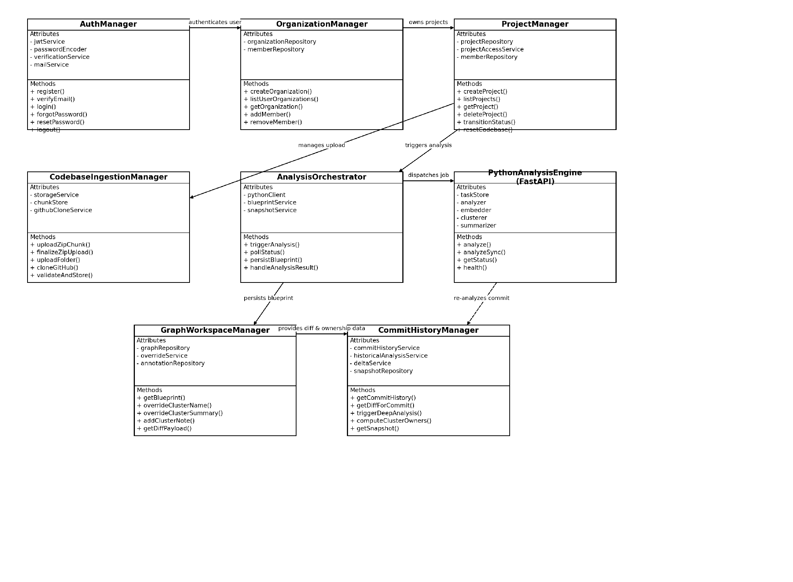
Figure 5.1 — CRC Collaboration Diagram. An editable version of this diagram is provided as crc_class_diagram.drawio.

Conclusion
CodeSight addresses a well-defined and practically significant problem in modern software development: the inability of development teams to perceive the true behavioral architecture of a JavaScript/TypeScript codebase from its physical file structure alone. By combining deterministic Tree-sitter AST analysis with sentence-transformer semantic embeddings, two-pass hierarchical clustering (directory-seeded grouping followed by Leiden/Louvain community detection), and optional LLM labeling, CodeSight transforms raw source files into a coherent, human-readable architectural blueprint.
The system's polyglot architecture — Python for analysis intelligence, Spring Boot for identity and persistence, and Next.js for interactive visualization — reflects a deliberate separation of concerns: each layer does what it is best suited for, and the boundaries between them are clean and minimal. The flat-relational blueprint schema is a key design decision that makes the data forward-compatible with future analytics and avoids the nested-tree migration problems of the legacy format.
The multi-tenant RBAC model, collaborative cluster annotation, and commit history diff visualization collectively transform CodeSight from a one-time analysis tool into a living architectural reference for the entire development team. The two-phase commit diff feature — instant Phase-1 color overlay without re-layout, and async Phase-2 structural re-analysis — demonstrates that architectural intelligence and developer experience are not in conflict.
The test plan validates the system's functional correctness across eight modules and 22 test cases, confirming that role-based permissions are enforced server-side, the analysis pipeline produces the expected schema, and user-facing features behave correctly end-to-end.
CodeSight is a practical, production-ready tool that measurably reduces the cognitive cost of understanding, maintaining, and evolving large JavaScript and TypeScript codebases.

References
[1] N. Ousterhout, “A Philosophy of Software Design,” Yaknyam Press, 2018.
[2] M. Fowler, “Refactoring: Improving the Design of Existing Code,” 2nd ed., Addison-Wesley, 2018.
[3] Leidenalg Python library — Leiden algorithm for community detection: https://leidenalg.readthedocs.io/
[4] tree-sitter: An incremental parsing library for programming tools — https://tree-sitter.github.io/tree-sitter/
[5] Reimers, N., & Gurevych, I. (2019). Sentence-BERT: Sentence Embeddings using Siamese BERT-Networks. EMNLP 2019. Available: https://arxiv.org/abs/1908.10084
[6] XY Flow (React Flow) Documentation — https://reactflow.dev/
[7] Spring Boot Reference Documentation — https://docs.spring.io/spring-boot/docs/current/reference/html/
[8] FastAPI Documentation — https://fastapi.tiangolo.com/
[9] JGit Documentation — https://eclipse.dev/jgit/
[10] GitHub Repository: [Your Repository URL]

