Department of Computer Engineering
Faculty of Technology
Dharmsinh Desai University, Nadiad
B. Tech. CE Semester – V
Subject: (23CE520) Advanced Technologies
Project Title
SMART SOCIETY OS
A Multi-Tenant SaaS Platform for Residential Community Management
By
Name | Roll No. | Student ID
Darsh Parekh | 116 | 24ceuoz084
Nandan Vadi | 111 | 24ceuoz078

Guided by
Prof. Ankit P. Vaishnav
TABLE OF CONTENTS
1. Abstract 3
2. Introduction 4
3. Functional and Non-functional Requirements 5
4. UML Diagrams and Database Design 6
5. Implementation Detail 10
6. Testing 11
7. Screen-shots 12
8. Conclusion 13
9. Limitation and Future Extension 14
10. Bibliography 15

1. Abstract
Residential societies still depend on WhatsApp groups, paper registers and spreadsheets for daily operations, which leads to poor visitor security, untracked complaints and unclear billing. Smart Society OS is a web-based, multi-tenant SaaS platform that digitizes these operations in a single system. It provides QR-based visitor pre-approval and gate verification, complaint registration and tracking, facility booking, parking allocation, a digital notice board, a community marketplace, simulated maintenance billing and analytics dashboards.
The system is built on the MERN stack (MongoDB, Express.js, React.js, Node.js) with JWT-based authentication and role-based access control for six user roles. Each society works inside its own isolated tenant workspace, so data never crosses society boundaries.

2. Introduction

2.1 Brief Introduction
Smart Society OS aims to replace manual and informal coordination in housing societies with one secure platform. Residents, security guards, maintenance staff, committee members, society admins and super admins each get a role-specific dashboard showing only the functions relevant to them. The project goals are to reduce the administrative burden on committees, improve security at the gate, and make society services transparent and fast for residents.

2.2 Technology / Platform / Tools Used
Layer | Technologies
Frontend | React.js with TypeScript, Tailwind CSS, React Router, Axios, React Query, React Hook Form, Redux Toolkit, Recharts
Backend | Node.js, Express.js, JWT authentication, bcrypt, Multer (file uploads)
Database | MongoDB Atlas with Mongoose ODM
Real-time and QR | Socket.IO (notifications and alerts), qrcode and html5-qrcode libraries
Cloud and Storage | Cloudinary (images), Vercel (frontend hosting), Render (backend hosting)
Security | Helmet, CORS, Express Rate Limiter, HTTPS/TLS
Dev Tools | Postman, Swagger / OpenAPI, Git and GitHub

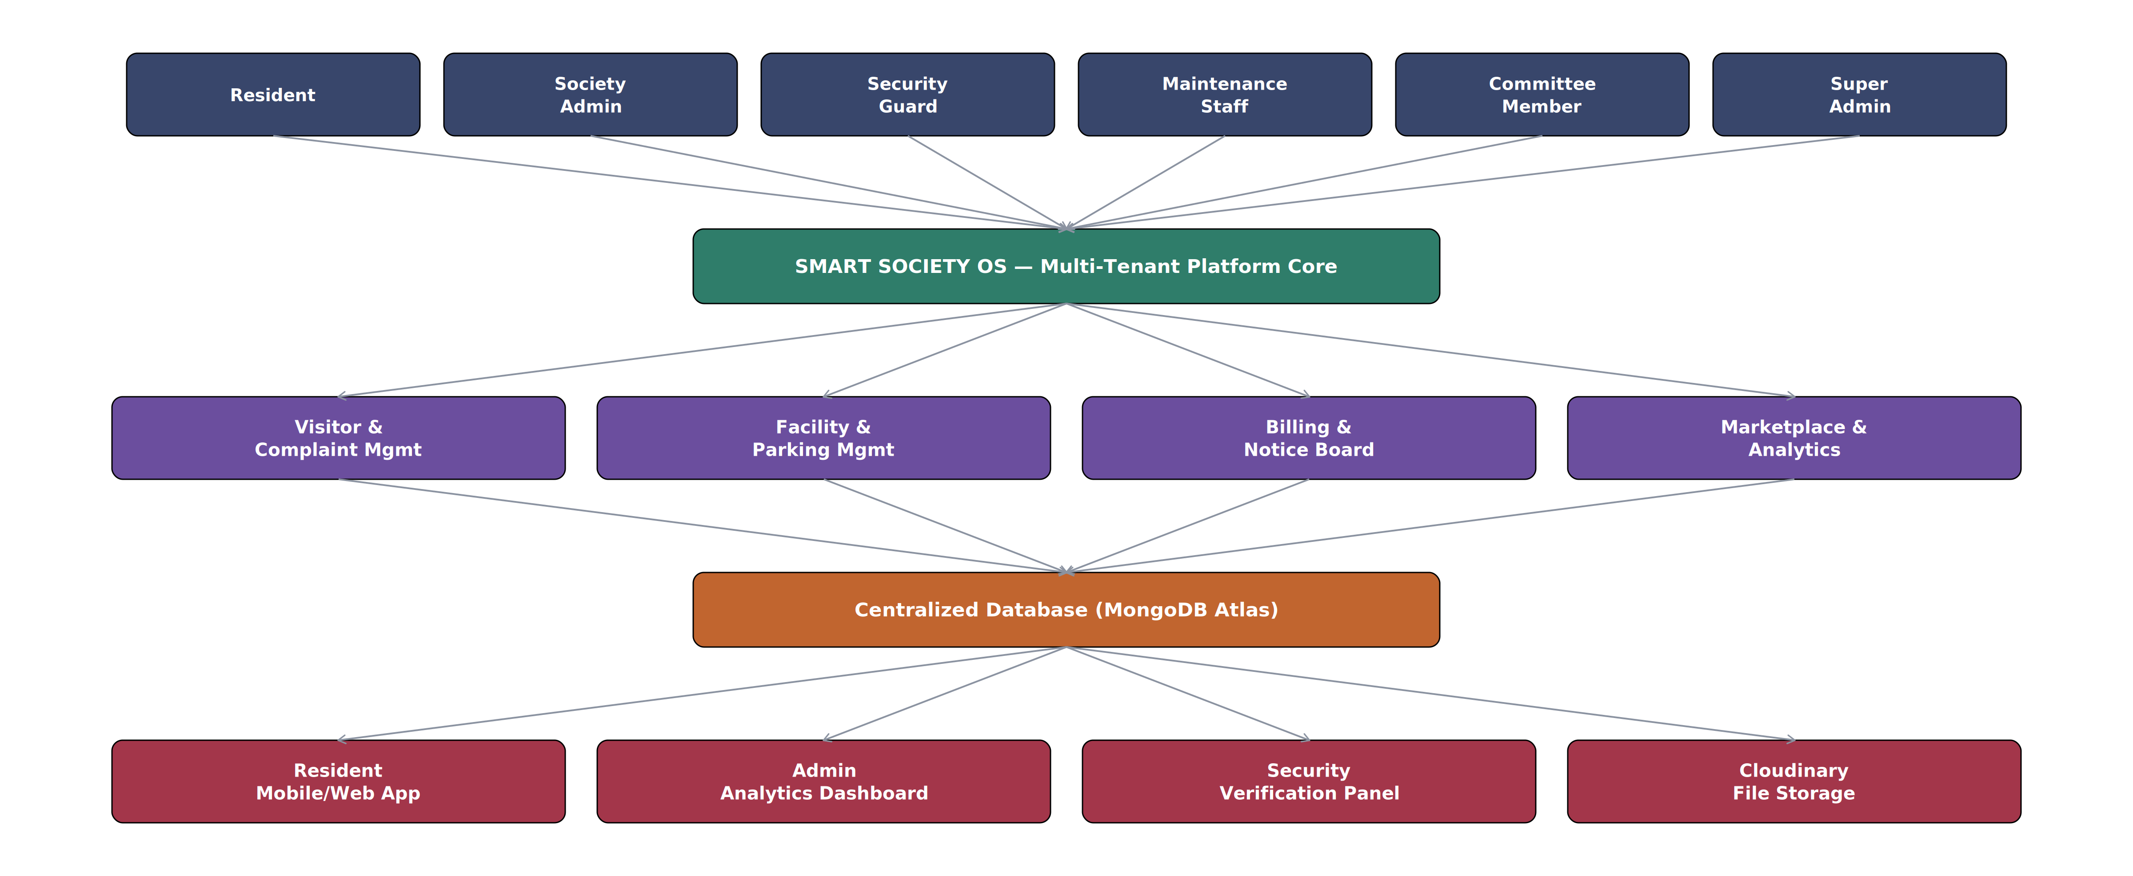
Figure 2.1 – High-level system architecture

3. Functional and Non-functional Requirements

3.1 Functional Requirements
No. | Module | Key Requirements
1 | Authentication and Access Control | Secure login (R.1.1), role-based access control (R.1.2), forgot password / email verification (R.1.3)
2 | Visitor Management | Pre-approve visitor with QR pass (R.2.1), register walk-in visitor (R.2.2), verify QR at gate (R.2.3), view visitor history (R.2.4)
3 | Complaint Management | Raise complaint with image (R.3.1), assign to staff (R.3.2), update status (R.3.3), track timeline (R.3.4)
4 | Facility Booking | View availability (R.4.1), book facility (R.4.2), approve or reject booking (R.4.3)
5 | Parking Management | Allocate resident parking (R.5.1), visitor QR parking pass (R.5.2), view slot status (R.5.3)
6 | Notice Board | Publish notice or alert (R.6.1), view notices (R.6.2)
7 | Community Marketplace | Create listing (R.7.1), approve listing (R.7.2), browse and message (R.7.3)
8 | Maintenance Billing | Generate monthly bill (R.8.1), view bills and status (R.8.2), mark paid – simulated (R.8.3)
9 | Reports and Analytics | Analytics dashboard (R.9.1), export reports (R.9.2)
10 | Profile Management | Update profile (R.10.1), manage family members (R.10.2)

3.2 Non-functional Requirements
- Performance: real-time notifications within 2 seconds; API responses within 1–2 seconds; QR generation and verification within 1 second; supports societies of up to 500 units.
- Security: bcrypt-hashed passwords, signed JWT with expiry, RBAC on every endpoint, Helmet and CORS, rate limiting, HTTPS/TLS and strict tenant isolation.
- Usability: responsive mobile-first interface, role-specific dashboards, inline form validation and clear error messages.
- Reliability: data consistency for concurrent operations such as simultaneous facility bookings.
- Maintainability and Scalability: modular MERN code documented with Swagger; new societies can be onboarded without structural changes.
- Portability: works on current Chrome, Edge, Firefox and Safari on desktop and mobile.

4. UML Diagrams and Database Design

4.1 Actors
The system has six actors: Resident, Society Admin, Committee Member, Security Guard, Maintenance Staff and Super Admin. All of them inherit common attributes (name, email, password hash, phone, role) from an abstract User class, which is stored in a single users collection distinguished by a role field.

4.2 Activity Diagrams
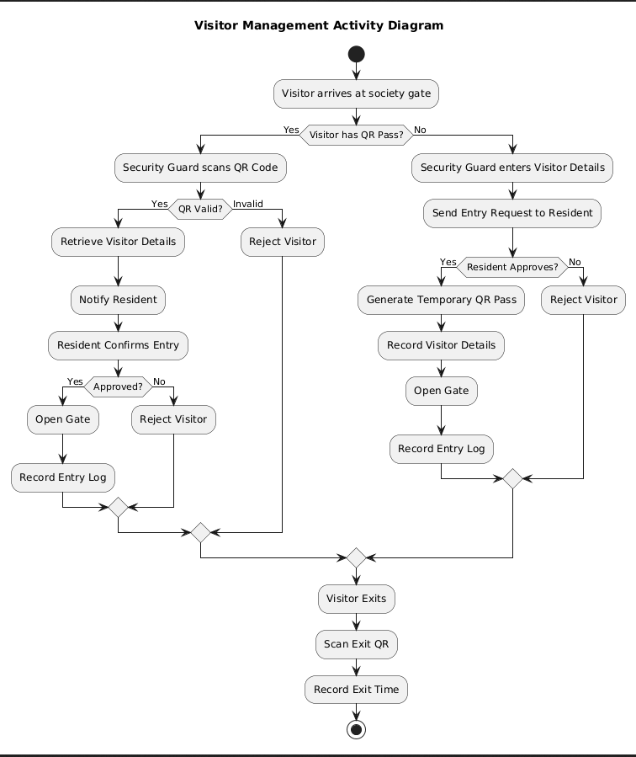
Figure 4.1 – Visitor Management activity diagram
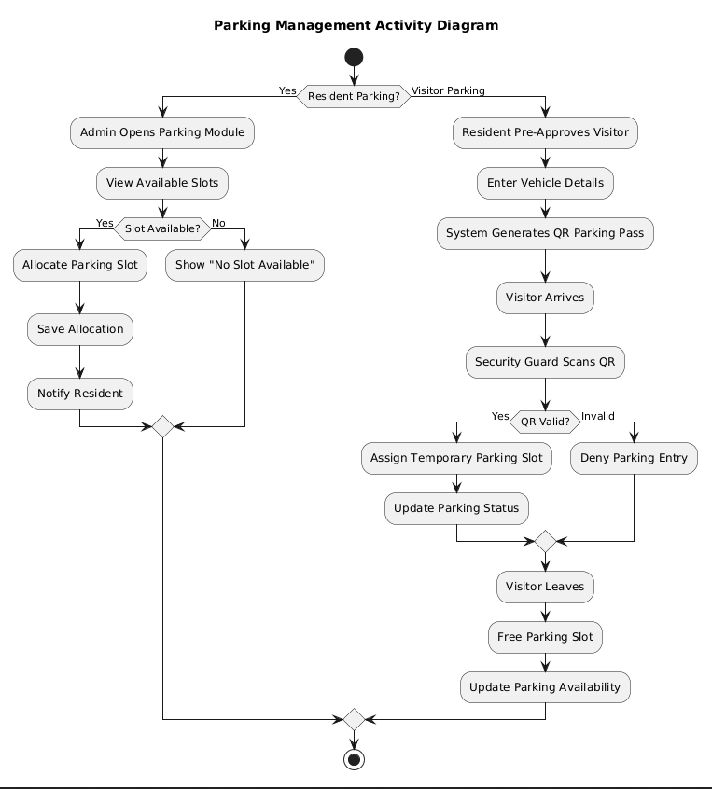
Figure 4.2 – Parking Management activity diagram

4.3 Sequence Diagrams
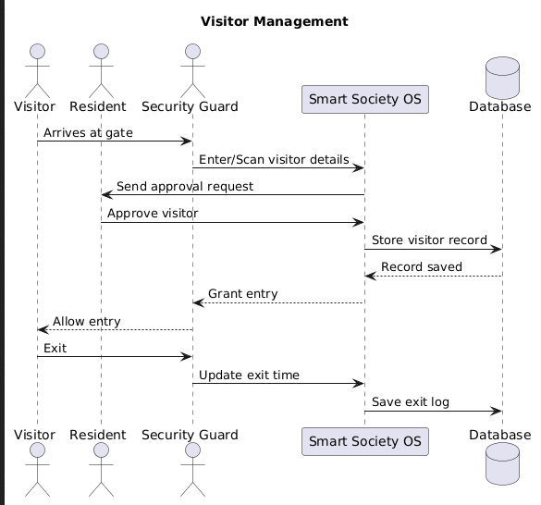
Figure 4.3 – Visitor Management sequence diagram
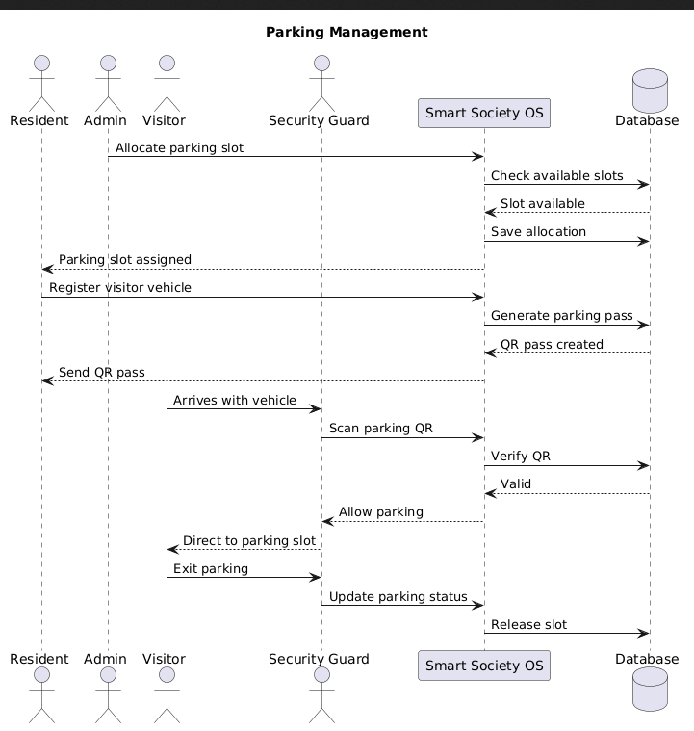
Figure 4.4 – Parking Management sequence diagram

4.4 Entity-Relationship Diagram
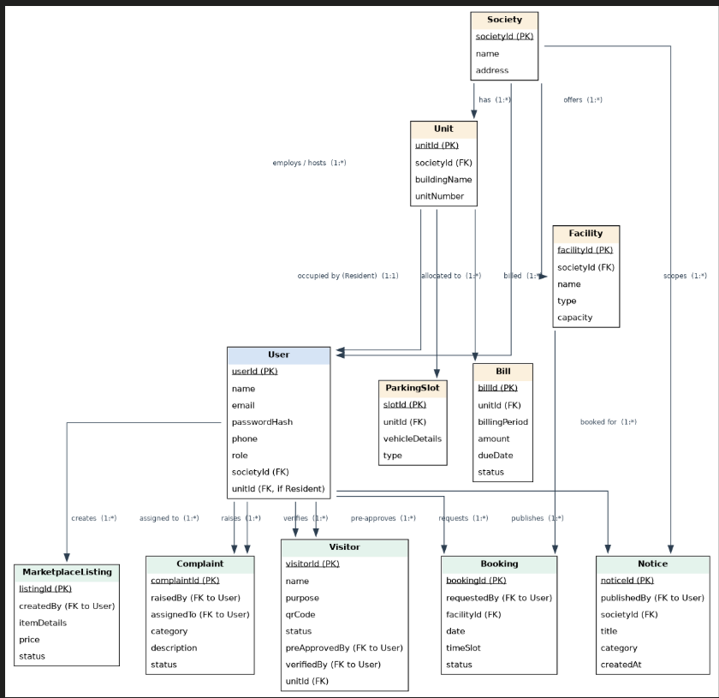
Figure 4.5 – ER diagram of Smart Society OS

4.5 Database Design (MongoDB)
The ER model is mapped to 11 MongoDB collections using references (ObjectId) for independently queried data and embedding for small owned data such as a resident's familyMembers.
Collection | Purpose | Key References
societies | One document per tenant workspace | –
units | Flats within a society | societyId
users | All six roles (role field) | societyId, unitId
visitors | Visitor entry/exit and QR pass records | unitId, preApprovedBy, verifiedBy
complaints | Complaints and resolution status | raisedBy, assignedTo
facilities | Bookable shared amenities | societyId
bookings | Facility booking requests | requestedBy, facilityId
notices | Notice board entries | societyId, publishedBy
marketplacelistings | Buy / sell / rent / exchange listings | createdBy
parkingslots | Resident and visitor parking | unitId
bills | Simulated monthly maintenance bills | unitId

5. Implementation Detail

5.1 Modules Created
Module | Brief Description
Authentication and RBAC | Registration, login with bcrypt and JWT, password reset, and role-based route protection for all six portals.
Visitor Management | Residents pre-approve visitors and receive a QR pass; guards scan QR or register walk-ins; entry/exit is logged and the resident is notified in real time.
Complaint Management | Residents raise complaints with category and image; admin assigns staff; staff update status; residents track the timeline.
Facility Booking | Availability calendar for amenities; residents request slots and admin approves or rejects.
Parking Management | Admin allocates resident slots; QR parking pass is generated for visitor vehicles and the slot is freed on exit.
Notice Board | Admin and committee publish notices and alerts with priority (Low / Medium / High); residents view them on the dashboard.
Marketplace | Residents list items; admin approves; other residents browse and message the owner.
Billing | Monthly maintenance bills per unit with due date; paid/due/overdue status; admin marks bills paid (simulated).
Analytics and Reports | Dashboards for visitors, complaints, facility use, occupancy and billing; report export.
Profile and SOS | Profile, emergency contacts, family members; one-touch SOS that raises a siren alert at the gate.

5.2 Algorithm / Flowchart
Visitor QR verification (see Figure 4.1):
- Visitor arrives at the gate; the guard checks whether the visitor has a QR pass.
- If yes, the guard scans the QR code. The system validates it; an invalid code is rejected.
- For a valid code the visitor details are fetched and the resident is notified to confirm entry.
- If the resident approves, the gate is opened and the entry log is recorded; otherwise the visitor is rejected.
- If there is no pass, the guard enters visitor details and sends a request to the resident; on approval a temporary QR pass is generated and entry is logged.
- On leaving, the exit QR is scanned and the exit time is recorded.
Example: Resident pre-approves guest Kunal Joshi and gets pass QR-VIS-98231; the guard scans it, the system confirms it is valid, logs the entry, and later logs the exit time.
Login and RBAC: the user submits email and password; the server checks the bcrypt hash and issues a JWT (user id, role, society id); middleware verifies the token and role on every request and filters queries by society id.

6. Testing

6.1 Testing Framework and Method
Black-box functional testing was performed manually through the web interface, using the demo accounts of all six roles. REST API endpoints were tested with Postman and documented through Swagger / OpenAPI. Each test case below was checked for expected output, including role-based access and tenant isolation.

6.2 Test Cases
ID | Test Case | Input | Expected Result
TC1 | Login with valid credentials | Valid email and password | JWT issued; role dashboard opens
TC2 | Login with wrong password | Valid email, wrong password | Error message; access denied
TC3 | Access admin page as resident | Resident token on admin route | Access denied (RBAC)
TC4 | Pre-approve visitor | Name, purpose, time | QR visitor pass generated
TC5 | Verify valid QR at gate | Scan valid QR | Entry logged; resident notified
TC6 | Verify invalid QR | Scan unknown QR | Visitor rejected
TC7 | Raise complaint | Category, description, image | Ticket created with unique ID
TC8 | Assign complaint | Complaint ID, staff | Staff notified; status Assigned
TC9 | Book facility | Facility, date, slot | Request pending; admin approves or rejects
TC10 | Publish notice | Title, description, priority | Notice visible to residents
TC11 | Generate / view bill | Unit, billing period | Bill with due date and status shown
TC12 | Cross-society data access | Society A user requests Society B data | No data returned (tenant isolation)

7. Screen-shots
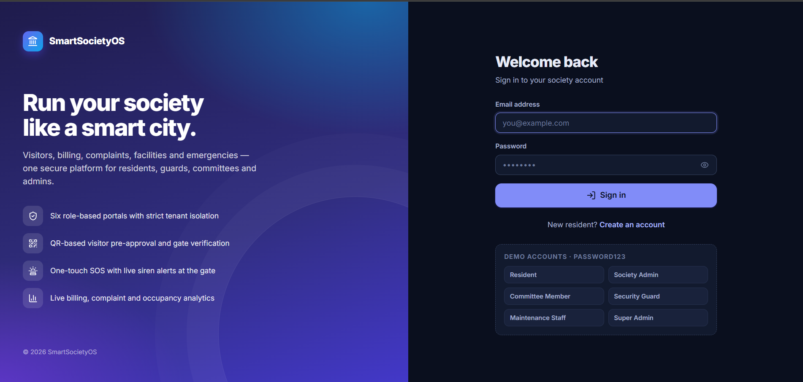
Figure 7.1 – Login page with demo accounts for six roles
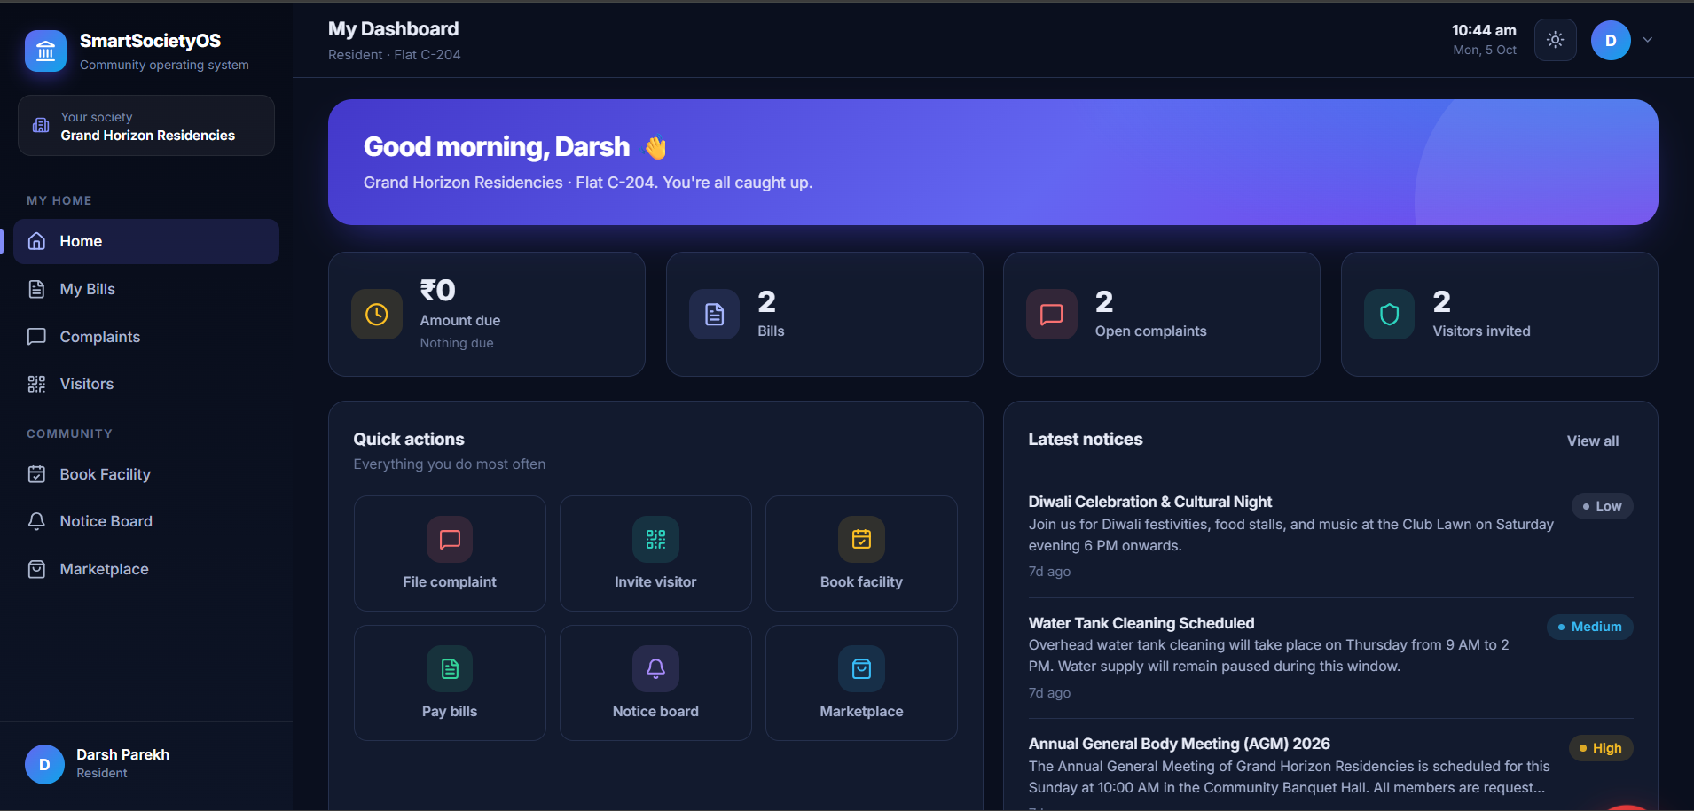
Figure 7.2 – Resident dashboard (bills, complaints, visitors, quick actions, notices)

8. Conclusion
Smart Society OS was implemented as a working multi-tenant web platform with six role-based portals. The implemented functionality includes secure JWT login with RBAC, QR-based visitor pre-approval and gate verification, complaint registration and tracking, facility booking, parking allocation, notice board, community marketplace, simulated maintenance billing, SOS alert and analytics dashboards, all backed by a MongoDB database with isolated society data.

9. Limitation and Future Extension

9.1 Limitations
- Billing is simulated only; no real payment gateway is integrated.
- Requires stable internet connectivity, especially at the security gate, for real-time features and QR verification.
- Only a web application is provided; there is no native mobile app.
- Vendor role and service orders in the marketplace are not implemented.

9.2 Future Extensions
- AI-based complaint categorization and a resident chatbot.
- Razorpay / Stripe integration for real payments and recurring charges.
- Resident messaging, polls, surveys and e-voting.
- React Native mobile app for iOS and Android.
- Smart gate, IoT parking sensors, smart meters, face recognition, delivery and domestic staff management.
- Predictive maintenance and resource-utilization forecasting.

10. Bibliography
- IEEE Std 830-1998, IEEE Recommended Practice for Software Requirements Specifications – https://ieeexplore.ieee.org/document/720574
- MongoDB Atlas Documentation – https://www.mongodb.com/docs/atlas/
- Express.js Documentation – https://expressjs.com/
- React Documentation – https://react.dev/
- Node.js Documentation – https://nodejs.org/en/docs
- Socket.IO Documentation – https://socket.io/docs/v4/
- JSON Web Tokens Introduction – https://jwt.io/introduction
- Cloudinary Documentation – https://cloudinary.com/documentation
- OWASP Top Ten – https://owasp.org/www-project-top-ten/
- Vercel Documentation – https://vercel.com/docs
- Render Documentation – https://render.com/docs

