**Experiment No.: 1**

**Aim:**

Familiarization of linux commands.

**CO2:**

Perform system administration task.

**Procedure:**

1. **pwd** - Print the working directory find the path of the current working directory

$pwd

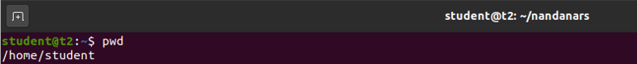

2.**ls** – To view the content of the directory

$ls



2.1 **ls -R** – To list the contents of sub directory

$ls -R

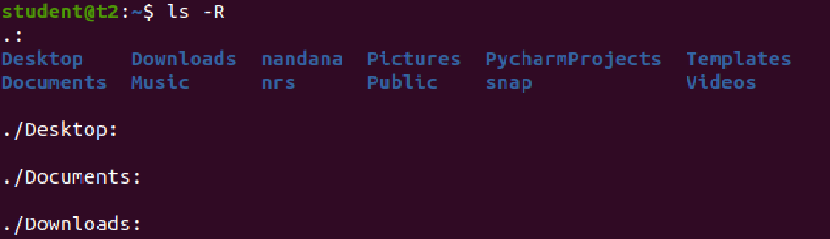

2.2. **ls -l** – Long listing of the contents

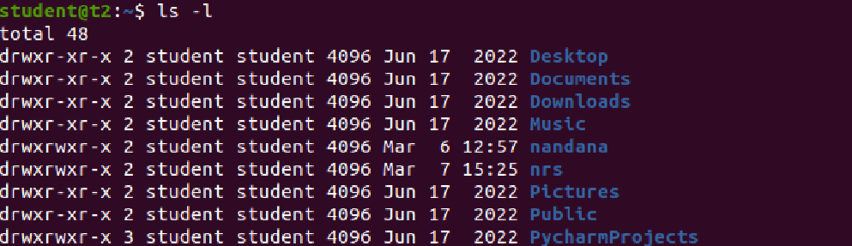

2.3 **ls -a** – To list the all hidden files

$ls -a

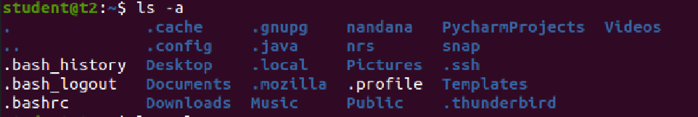

2.4 **ls -al** – List the files and directorys with detaild information.

$ls -al

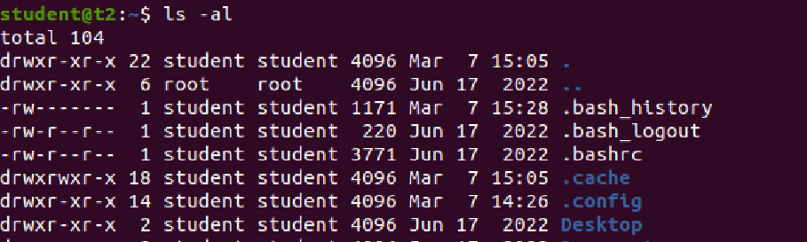

2.5 **ls -t** – List the files sorted in the order of last modified.

$ls -t



2.6 **ls -r** – To reverse the natural sorting order

$ls -r



3. **history** – To review the command that have been previously executed for a certain period of time.

$history

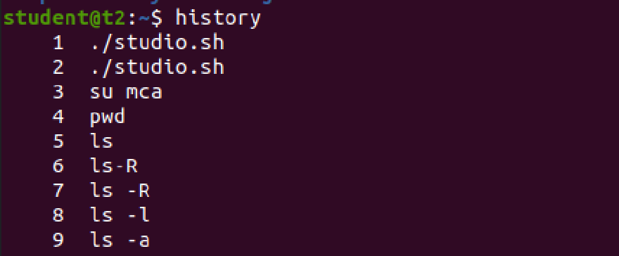

4.**man** – learn and understand about different command right from the shell using man command

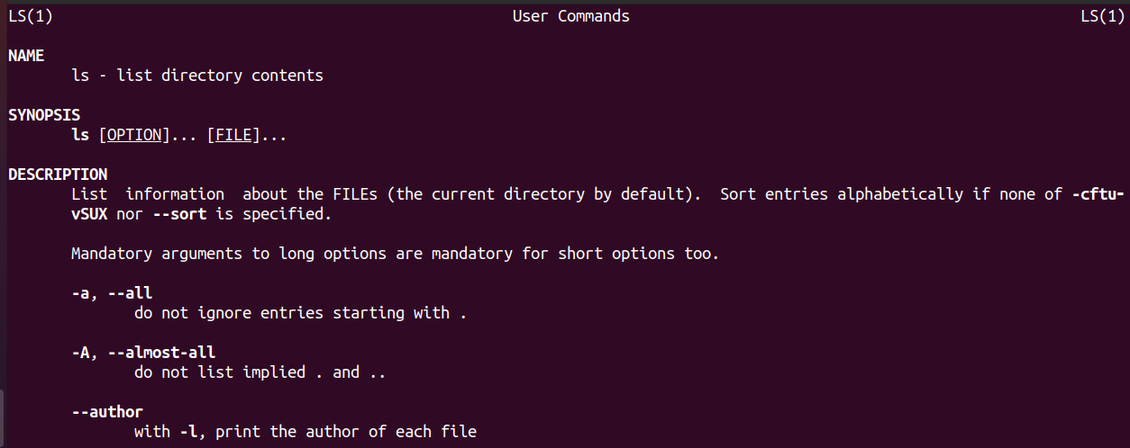$man

5. **mkdir** – To create a new directory

$mkdir

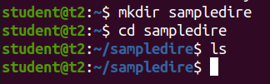

6. **rmdir** – To remove a directory

$rmdir

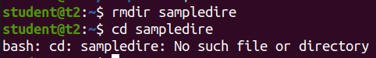

7. **touch** – To create new empty file

$touch file1.txt



8. **cat** – Concatenate the files and print on the standard output

$cat

(a). **cat > filename.txt** – To create a file with inserting contents

$cat > file1.txt

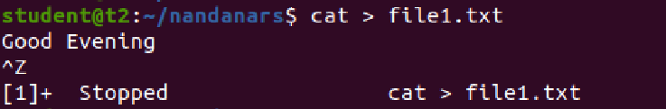

(b). **cat filename.txt** – To view the content of the file

$cat file1.txt



(c ). **cat >> filename.txt** – To append new contents to an existing file

$cat >> file1.txt

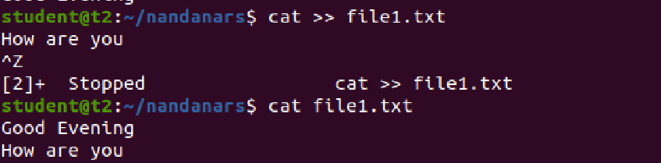

(d). **cat -n filename.txt** – Number all output lines

$cat -n name3.txt

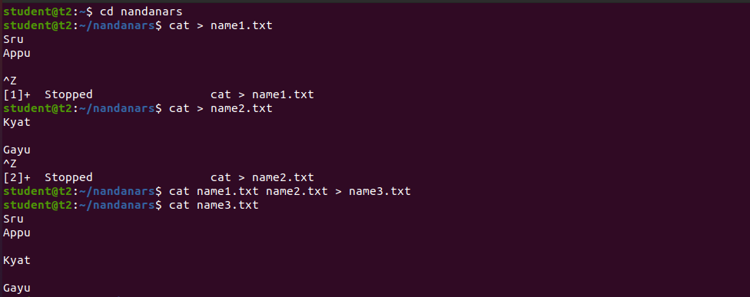

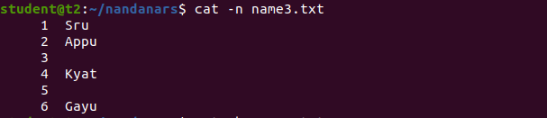

(e). **cat -b filename.txt** – To remove the empty lines

$cat -b name3.txt

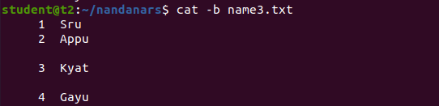

(f). **cat -E filename.txt** – Display $ at end of each line

$cat -E name3.txt

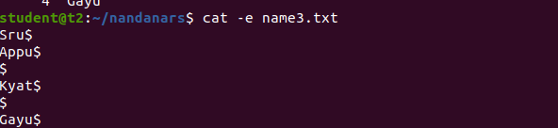

(g). **cat filename.txt | tr a-z A-Z > output.txt** – To convert characters from lower case to uppercase, you can either specify a range of characters or use the predefined character classes.

$cat name3.txt | tr a-z A-Z > output.txt

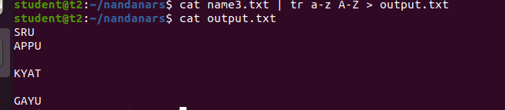

**Result**

The program was executed and the result was successfully obtained. Thus CO1 was obtained.