**1**

drop procedure if exists greatest;

DELIMITER $$

create procedure greatest(in a int,in b int,in c int,out g int)

BEGIN

if a>=b and a>=c then

set g=a;

elseif b>=a and b>=c then

set g=b;

else

set g=c;

end if;

END $$

DELIMITER ;

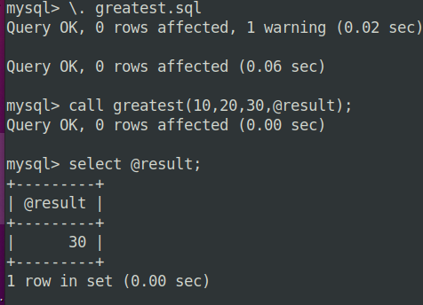

**1.1**

DELIMITER $$

create procedure greatest1(in a int,in b int, in c int)

BEGIN

declare r varchar(100);

if (a>b) then

if (a>c) then

set r=concat(a," is greatest");

else

set r=concat(c," is greatest");

end if;

else if (b>c) then

set r=concat(b," is greatest");

else

set r=concat(c," is greatest");

end if;

end if;

select r as output_message;

END $$

DELIMITER ;

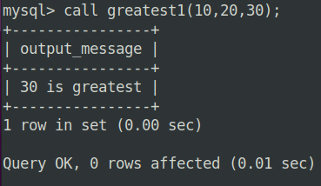

**2**

DELIMITER $$

create procedure nosbtw(in a int,in b int)

BEGIN

DECLARE counter INT;

DECLARE RESULT VARCHAR(100);

SET counter = LEAST(a,b);

SET RESULT = " ";

num: LOOP

SET RESULT = CONCAT(RESULT,counter,' ');

SET counter=counter+1;

IF counter >= GREATEST (a,b) THEN

LEAVE num;

END IF;

END LOOP;

SELECT RESULT AS numbers;

END $$

DELIMITER ;

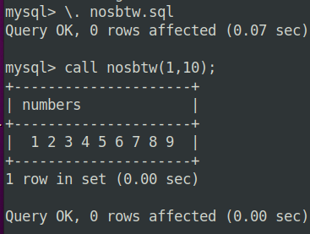

**3**

DELIMITER $$

DROP PROCEDURE IF EXISTS series;

CREATE PROCEDURE series(IN a INT, OUT sum INT)

BEGIN

DECLARE counter INT DEFAULT 1;

DECLARE total INT DEFAULT 0;

WHILE counter <= a DO

SET total = total + counter;

SET counter = counter + 1;

END WHILE;

SET sum = total;

END$$

DELIMITER ;

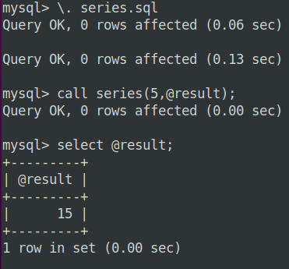

**7**

DELIMITER $$

DROP PROCEDURE IF EXISTS customer;

CREATE PROCEDURE customer(

IN cname VARCHAR(15),

OUT cid INT,

OUT ccity VARCHAR(15),

OUT ccredits VARCHAR(10)

)

BEGIN

SELECT id, city, credits

INTO cid, ccity, ccredits

FROM customer

WHERE name=cname;

END $$

DELIMITER ;

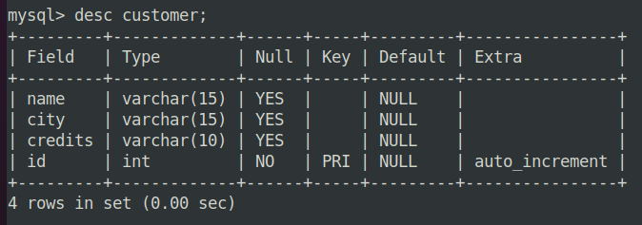

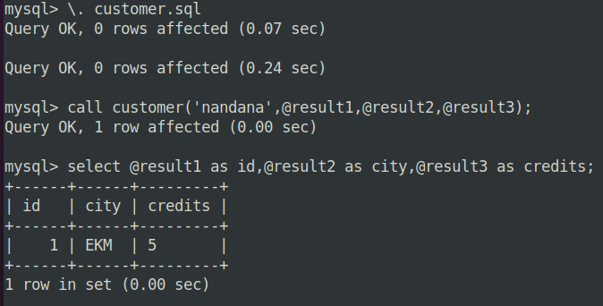

**8**

drop procedure if exists membership;

DELIMITER $$

CREATE PROCEDURE membership(

IN cname VARCHAR(15),

OUT cid INT,

OUT ccity VARCHAR(15),

OUT ccredits VARCHAR(10),

out mem varchar(50)

)

BEGIN

SELECT id, city, credits

INTO cid, ccity, ccredits

FROM customer

WHERE name=cname;

if ccredits>5000 then

set mem="Platinum";

elseif ccredits>=1000 and ccredits<=5000 then

set mem="Gold";

else

set mem="Silver";

end if;

END $$

DELIMITER ;

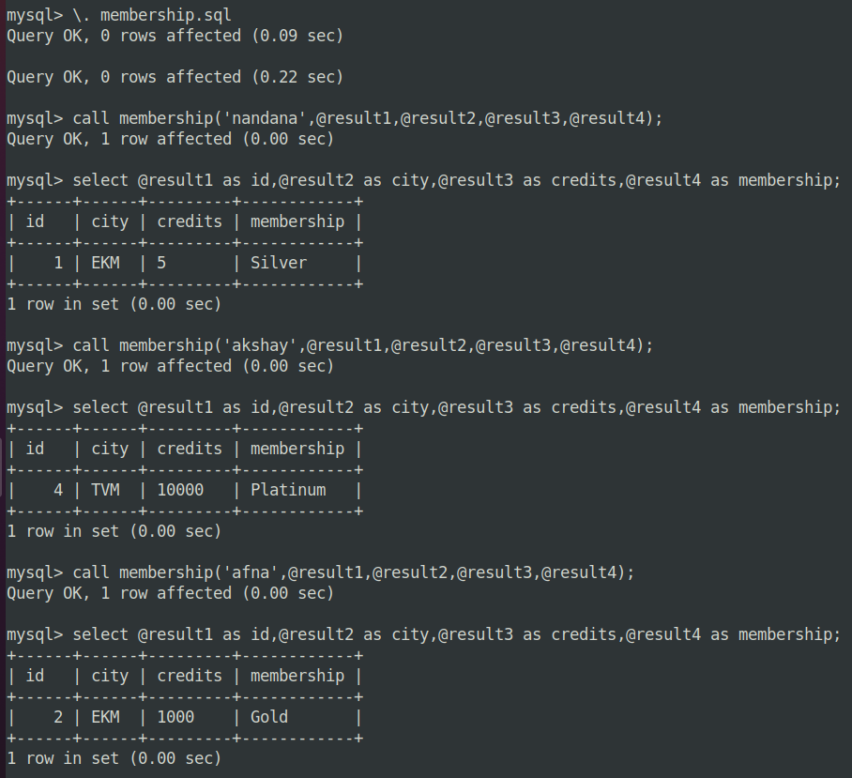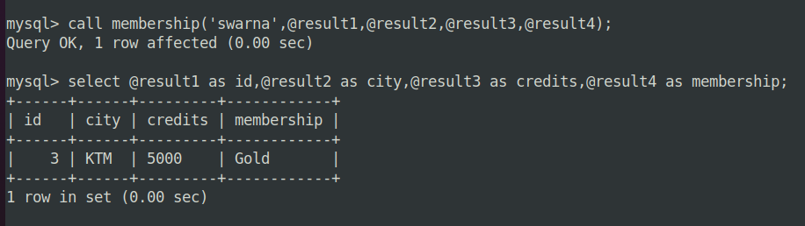

**11**

DELIMITER $$

create procedure emp_salary()

BEGIN

declare finished integer default 0;

declare id varchar(10);

declare desig varchar(50);

declare days int;

declare sal int;

declare curSal CURSOR FOR SELECT emp_id,designation,no_of_working_days FROM emp_salary;

declare CONTINUE HANDLER FOR NOT FOUND SET finished=1;

OPEN curSal;

L1: LOOP

Fetch curSal INTO id,desig,days;

if finished=1 then

LEAVE L1;

END IF;

if(desig='Assistant Professor') then

set sal = days*1750;

elseif (desig='Programmer') then

set sal = days*1250;

elseif (desig='Clerk') then

set sal = days*750;

end if;

UPDATE emp_salary set salary=sal where emp_id=id;

end LOOP L1;

CLOSE curSal;

end $$

DELIMITER ;

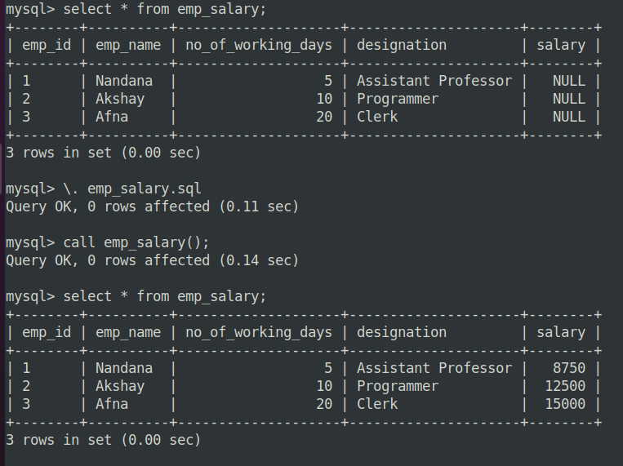

DELIMITER $$

drop procedure if exists email_list;

create procedure email_list(INOUT list varchar(4000))

BEGIN

declare finished integer default 0;

declare email_id varchar(50);

declare curEmail CURSOR FOR SELECT email FROM emp_salary;

declare CONTINUE HANDLER FOR NOT FOUND SET finished=1;

OPEN curEmail;

Fetch curEmail INTO list;

L1: LOOP

if finished=1 then

LEAVE L1;

END IF;

fetch curEmail into email_id;

set list=concat(list,';',email_id);

end LOOP L1;

CLOSE curEmail;

end $$

DELIMITER ;

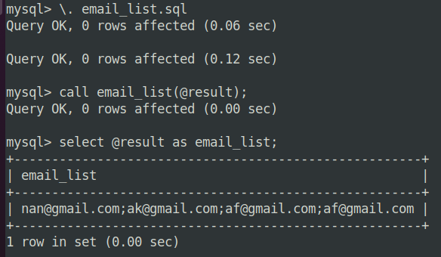

**12**

DELIMITER $$

drop procedure if exists bill;

CREATE PROCEDURE bill()

BEGIN

DECLARE finished INT DEFAULT 0;

DECLARE v_customer_id INT;

DECLARE v_name VARCHAR(50);

DECLARE v_pre_reading varchar(50);

DECLARE v_cur_reading varchar(50);

DECLARE v_units DECIMAL(10,2);

DECLARE v_amount DECIMAL(10,2);

DECLARE curBill CURSOR FOR SELECT customer_id, name, pre_reading, cur_reading FROM bill;

DECLARE CONTINUE HANDLER FOR NOT FOUND SET finished = 1;

OPEN curBill;

L1: LOOP

FETCH curBill INTO v_customer_id, v_name, v_pre_reading, v_cur_reading;

IF finished=1 THEN

LEAVE L1;

END IF;

SET v_units = v_cur_reading - v_pre_reading;

IF v_units <= 100 THEN

SET v_amount = v_units * 2;

ELSEIF v_units <= 200 THEN

SET v_amount = 100 * 2 + (v_units - 100) * 2.5;

ELSEIF v_units <= 300 THEN

SET v_amount = 100 * 2 + 100 * 2.5 + (v_units - 200) * 3;

ELSE

SET v_amount = 100 * 2 + 100 * 2.5 + 100 * 3 + (v_units - 300) * 4;

END IF;

UPDATE bill SET unit = v_units, amount = v_amount WHERE customer_id = v_customer_id;

END LOOP;

CLOSE curBill;

END $$

DELIMITER ;

