mysql> create table jobs(job_id int primary key auto_increment not null,job_title text not null,min_salary double not null,max_salary double not null);

mysql> create table regions(region_id int primary key auto_increment not null,region_name text not null);
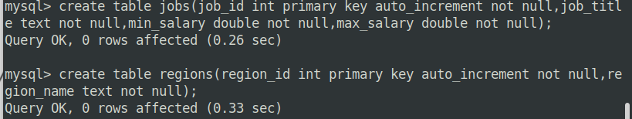
mysql> create table countries(country_id int not null,country_name text not null,region_id int not null,primary key(country_id ASC),foreign key(region_id)references regions(region_id) on delete cascade on update cascade);
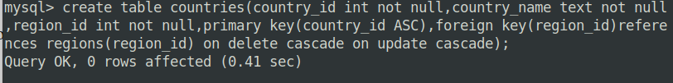
mysql> create table locations(location_id int primary key auto_increment not null,street_address text,postal_code text,city text not null,state_province text,country_id int not null,foreign key(country_id)references countries(country_id) on delete cascade on update cascade);
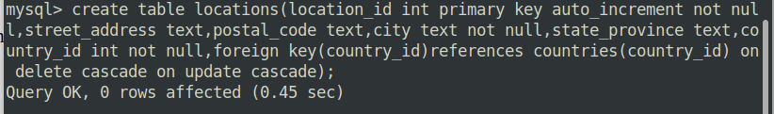
mysql> create table departments(department_id int primary key auto_increment not null,department_name text not null,location_id int not null,foreign key(location_id)references locations(location_id) on delete cascade on update cascade);
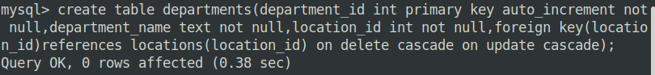
mysql> create table employees(employee_id int primary key auto_increment not null,first_name text not null,last_name text not null,email text not null,phone_num
ber text not null,hire_date date not null,job_id int not null,salary double not null,manager_id int,department_id int not null,foreign key(job_id) references jobs(job_id) on delete cascade on update cascade,foreign key(department_id)references departments(department_id) on delete cascade on update cascade,foreign key(manager_id)references employees(employee_id) on delete cascade on update cascade);

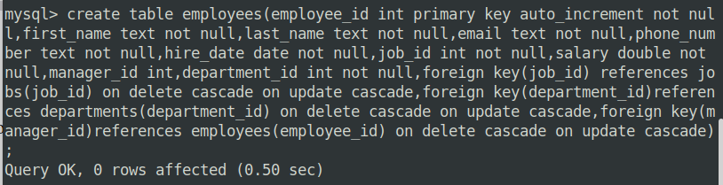
mysql> create table dependents(dependent_id int primary key auto_increment not null,first_name text not null,last_name text not null,relationship text not null,employee_id int not null,foreign key(employee_id) references employees(employee_id) on delete cascade on update cascade);
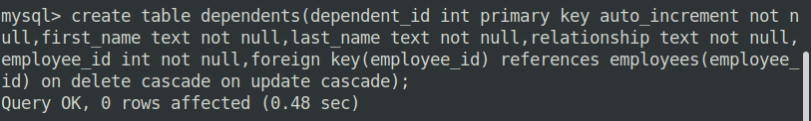

mysql> insert into regions values(1,'Europe'),(2,'America'),(3,'Asia'),(4,'Middle East and Africa');
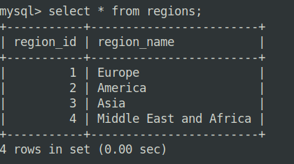

insert into countries values(1,'Aegentina',2),(2,'Canada',2),(3,'Germany',1),(4,'France',1),(5,'India',3),(6,'Italy',1),(7,'Japan',3),(8,'Nigeria',4),(9,'Egypt',4),(10,'Israel',4);
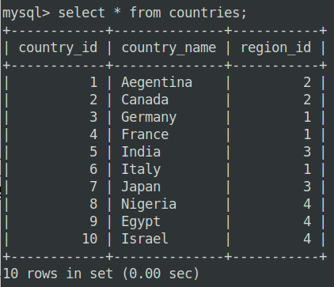

insert into locations(street_address,postal_code,city,state_province,country_id)
values('abc1','pc001','Kottayam','Kerala',5),('abc2','pc002','Delhi','UP',5),('abc3','pc003','Toronto','Ontario',2),('abc4','pc004','Paris','Paris',4),('abc5','pc005','Tokyo','Kanto',7);

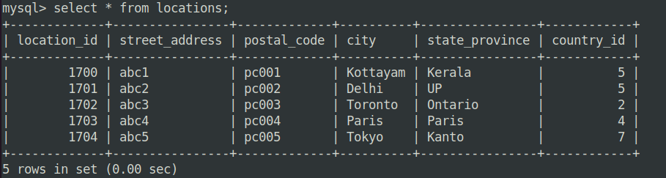

1. SELECT * FROM employees WHERE location_id = 1700;
2. SELECT * FROM employees WHERE location_id <> 1700;
3. SELECT * FROM employees ORDER BY salary DESC LIMIT 1;
4. SELECT * FROM employees WHERE salary > (SELECT AVG(salary) FROM employees);
5. SELECT department_id, department_name FROM departments WHERE department_id IN (SELECT department_id FROM employees WHERE salary > 10000);
6. SELECT department_id, department_name FROM departments WHERE department_id NOT IN (SELECT department_id FROM employees WHERE salary > 10000);
7. SELECT * FROM employees WHERE salary > (SELECT MIN(salary) FROM employees);
8. SELECT * FROM employees WHERE salary >= (SELECT MAX(salary) FROM employees);
9. SELECT AVG(avg_salary) FROM (SELECT AVG(salary) AS avg_salary FROM employees GROUP BY department_id) AS department_avg_salaries;
10. SELECT employee_id, salary, (SELECT AVG(salary) FROM employees) AS avg_salary, salary - (SELECT AVG(salary) FROM employees) AS salary_difference FROM employees;
11. SELECT * FROM employees e1 WHERE salary > (SELECT AVG(salary) FROM employees e2 WHERE e1.department_id = e2.department_id);
12. SELECT * FROM employees WHERE employee_id NOT IN (SELECT employee_id FROM dependents);
13. SELECT e.first_name, e.last_name, d.department_name FROM employees e JOIN departments d ON e.department_id = d.department_id WHERE d.department_id IN (1, 2, 3);
14. SELECT e.first_name, e.last_name, j.job_title, d.department_name FROM employees e JOIN departments d ON e.department_id = d.department_id JOIN jobs j ON e.job_id = j.job_id WHERE d.department_id IN (1, 2, 3) AND e.salary > 10000;
15. SELECT department_name, street_address, postal_code, country_name, region_name FROM departments;
16. SELECT e.first_name, e.last_name, e.department_id, d.department_name FROM employees e LEFT JOIN departments d ON e.department_id = d.department_id;
17. SELECT first_name, last_name, department, city, state_province FROM employees WHERE first_name LIKE '%Z%';
18. SELECT d.department_name, e.first_name, e.last_name, e.department_id FROM departments d LEFT JOIN employees e ON d.department_id = e.department_id;
19. SELECT e1.first_name AS employee_name, e2.first_name AS manager_name FROM employees e1 LEFT JOIN employees e2 ON e1.manager_id = e2.employee_id;
20. SELECT e.first_name, e.last_name, e.department_id FROM employees e JOIN employees t ON e.department_id = t.department_id WHERE t.last_name = 'Taylor';
21. SELECT j.job_title, e.first_name || ' ' || e.last_name AS employee_name, (j.max_salary - e.salary) AS salary_difference FROM employees e JOIN jobs j ON e.job_id = j.job_id;
22. SELECT d.department_name, AVG(e.salary) AS average_salary, COUNT(e.commission_pct) AS employees_with_commission FROM departments d LEFT JOIN employees e ON d.department_id = e.department_id GROUP BY d.department_name;
23. CREATE VIEW department_employees_delhi AS
SELECT
e.first_name || ' ' || e.last_name AS employee_name,
e.employee_id,
e.phone_number,
j.job_title,
d.department_name,
m.first_name || ' ' || m.last_name AS manager_name
FROM
employees e
JOIN
departments d ON e.department_id = d.department_id
JOIN
jobs j ON e.job_id = j.job_id
LEFT JOIN
employees m ON e.manager_id = m.employee_id
WHERE
d.location_id IN (SELECT location_id FROM locations WHERE city = 'Delhi');

SELECT * FROM department_employees_delhi;
24 .SELECT
employee_name
FROM
department_employees_delhi
WHERE
job_title = 'Manager' AND department_name = 'Finance';
25. Updating the phone number of an employee in the view is possible if the view is created without aggregations, group by or distinct clauses and if it includes the necessary columns from the underlying table.
26. SELECT * FROM employees WHERE employee_id NOT IN (SELECT employee_id FROM dependents);
27. SELECT * FROM employees WHERE manager_id = 101 UNION SELECT * FROM employees WHERE manager_id = 201;
28. SELECT * FROM employees WHERE employee_id IN (SELECT employee_id FROM dependents);

