LAB CYCLE 2

Experiment no.4

Date:3/3/2025

**Familiarization of Subquery,Joins,Views and Set operations.**

Consider the following database schema

Employee (ID character 5, DeptID numeric 2 , Name character 15,

Designation character 15, Basic numeric 10,2 , Gender character 1)

**>>create table employee(ID varchar(5),DeptID int(2),Name varchar(15),Designation varchar(15),Basic float(10,2),Gender varchar(1));**



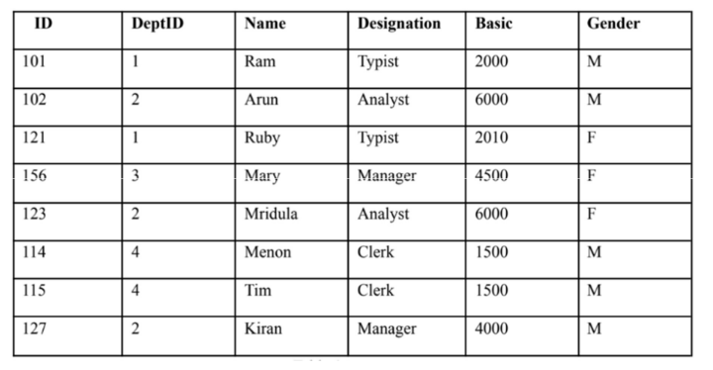

**>>insert into employee values('101',1,'Ram','Typist',2000,'M');**

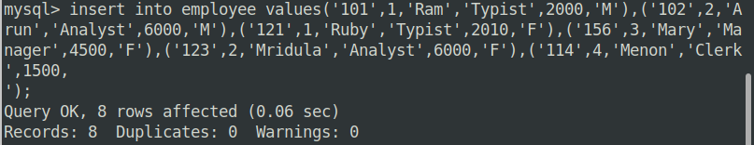

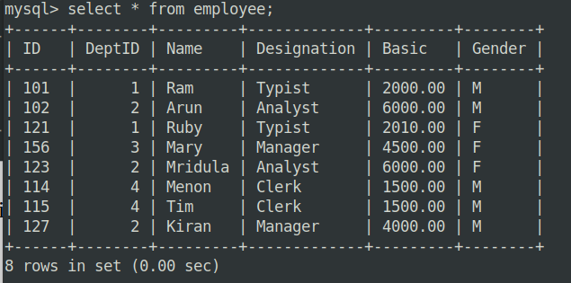

1. Display the different designations existing in the organisation.

**>>select distinct Designation from employee;**

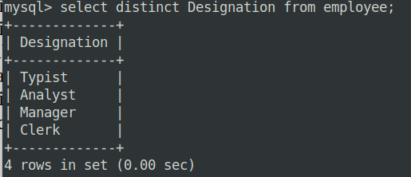

2. Display the number of different designations existing in the organisation.

**>>select count(distinct Designation) from employee;**

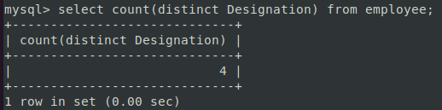

3. Display ID, name, desig,deptID and basic, DA, HRA and net salary of all employees with

suitable headings as DA, HRA and NET_SAL respectively.(DA is 7.5% of basic, and NET_SAL

is Basic + DA+ HRA)

**>>select ID,Name,Designation,DeptID,Basic,(Basic*0.075) as DA,(Basic*0.10) as HRA,(Basic+(Basic*0.075)+(Basic*0.10)) as NET_SAL from employee;**

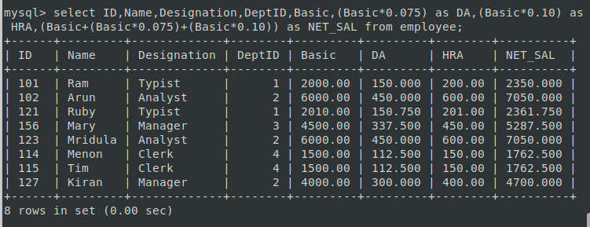

4. Display the maximum salary given for female employees.

**>>select max(Basic) from employee where Gender='F';**

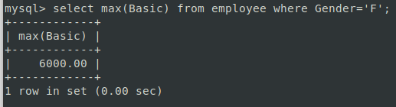

5. Add a column manager-id into the above table.

**>>alter table employee add column manager_id varchar(5);**



6. Update values of manager id of employees as null for 101, 101 for 102, 121, 156. 102 for

123,114,115.121 for 127.

**>> update employee set manager_id=Null where ID='101';**

**>> update employee set manager_id='101' where ID in('102','121','156');**

**>> update employee set manager_id='102' where ID in('123','114','115');**

**>> update employee set manager_id='121' where ID='127';**

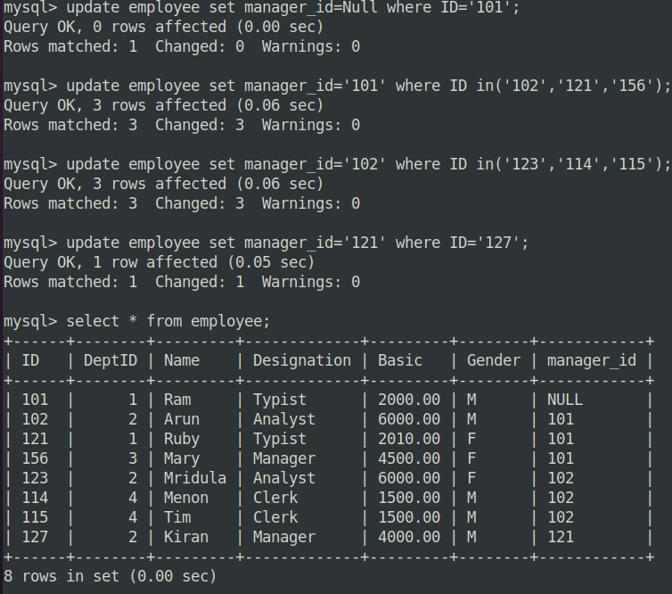

7. Add a column joining date to the above table and update appropriate values for the

joining date field.

**>> alter table employee add column joining_date date;**

**>> update employee set joining_date='2024-01-01' where ID in('123','114');**

**>> update employee set joining_date='2020-10-12' where ID='127';**

**>> update employee set joining_date='2020-09-08' where ID='115';**

**>> update employee set joining_date='2023-12-12' where ID='101';**

**>> update employee set joining_date='2019-11-05' where ID='102';**

**>> update employee set joining_date='2025-02-08' where ID in('121','156');**

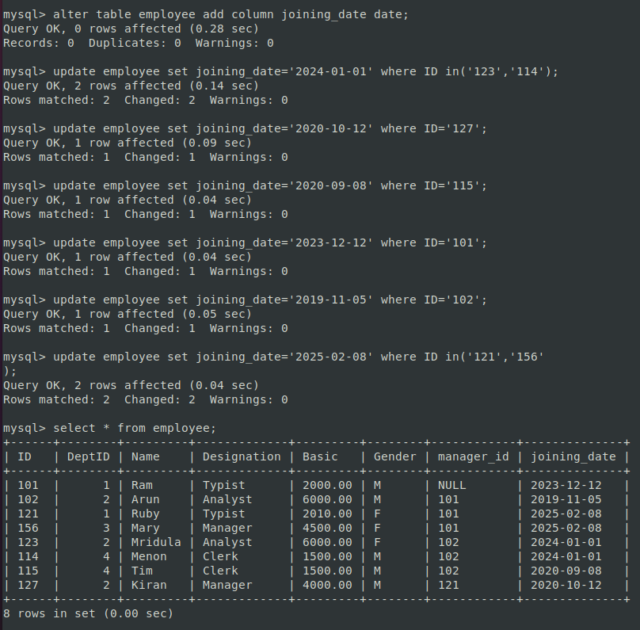

8. Display the details of employees according to their seniority.

**>>select * from employee order by joining_date;**

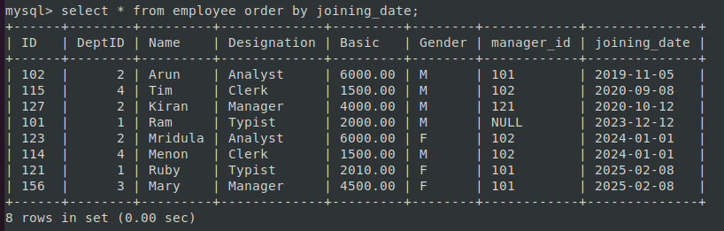

9. Create a new table DEPARTMENT with fields DEPTID and DNAME. Make DEPTID as the primary key and make DEPTID in employee table to refer to the DEPARTMENT table.

**>>create table department(DeptID int(2) primary key,Dname varchar(20));**

**>>alter table employee add constraint fk_dept foreign key(DeptID) references department(DeptID) on delete cascade;**



10. Insert values into the DEPARTMENT table. Make sure that all the existing values for

DEPTID in emp is inserted into this table. Sample values are DESIGN, CODING,

TESTING, RESEARCH.

**>>insert into department values(1,'Design'),(2,'Testing'),(3,'Coding'),(4,'Research');**

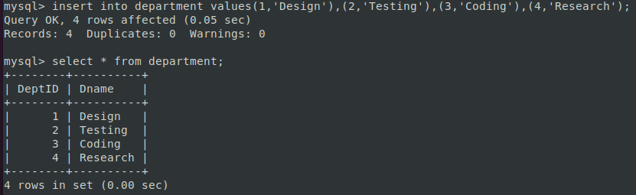

11. Display the employee name and department name.

**>>select employee.Name,department.Dname from employee join department on employee.DeptID=department.DeptID;**

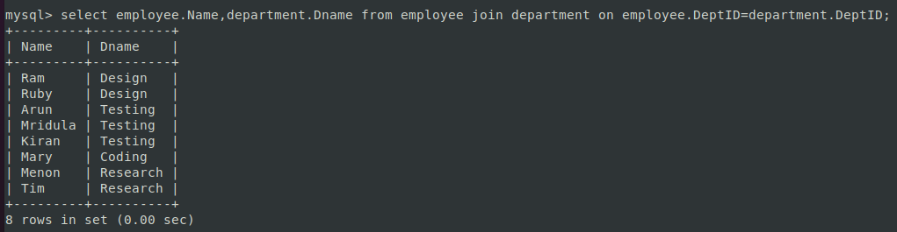

12. Display the department name of employee Arun.

**>>select employee.Name,department.Dname from employee join department on employee.DeptID=department.DeptID where employee.Name='Arun';**

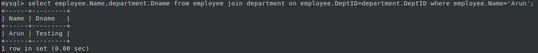

13. Display the salary given by DESIGN department.

**>>select employee.Name,employee.Basic from employee join department on employee.DeptID=department.DeptID where department.Dname='Design';**

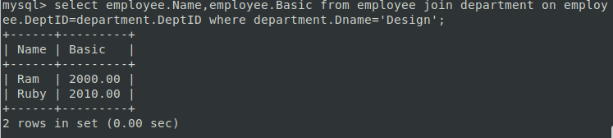

14. Display the details of typist working in DESIGN department.

**>>select employee.ID,employee.Name,employee.Basic,employee.Gender from employee join department on employee.DeptID=department.DeptID where employee.Designation='Typist' and department.Dname='Design';**



15. Display the salary of employees working in RESEARCH department.

**>>select employee.Name,employee.Basic from employee join department on employee.DeptID=department.DeptID where department.Dname='Research';**

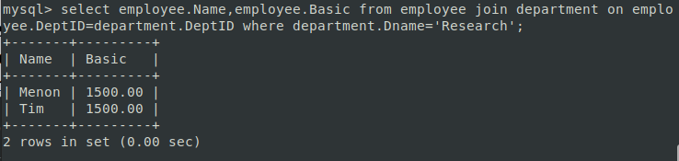

16. List the female employees working in TESTING department.

**>>select employee.ID,employee.Name from employee join department on employee.DeptID=department.DeptID where employee.Gender='F' and department.Dname='Testing';**

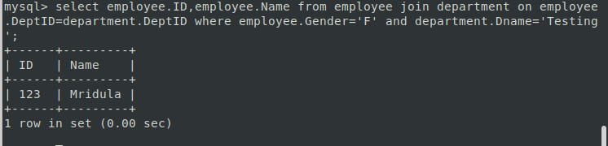

17. Display the details of employees not working in CODING or TESTING department.

18. Display the names of department giving maximum salary.

19. Display the names of departments with minimum number of employees.

20. Display the second maximum salary.

21. Display the second minimum salary.

22. Display the names of employees getting salary greater than the average salary of their

department.

23. Display the names of employees working under the manager Ram.