Experiment No: 1

Date : 13/02/2025

Familiarization of DDL Commands

Data Definition Language (DDL) - These SQL commands are used for creating,

modifying, and dropping the structure of database objects. The commands are

CREATE, ALTER, DROP, RENAME, and TRUNCATE.

A. Consider the database for a college. Write SQL commands to implement the

following:

1. Create a database

>> create database college;

2. Select the current database

>> use college;

3. Create the following tables:

a) Student (roll_no integer, name varchar, dob date, address text, phone_no varchar,

blood_grp varchar)

>> create table student(roll_no int,name varchar(10),dob date,address

varchar(10),phone_no varchar(10),blood_grp varchar(10));

b) Course (Course_id integer, Course_name varchar, course_duration integer)

>> create table course(course_id int,course_name varchar(10),course_duration int);

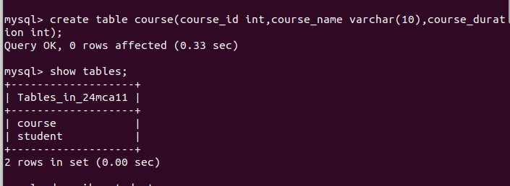

4. List all tables in the current database.

>> show tables;

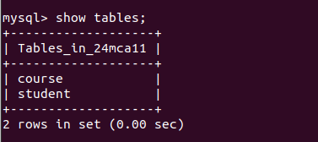

5. Display the structure of the Student table.

>> describe student;6. Drop the column blood_grp from Student table.

>> alter table student drop column blood_grp;

7. Add a new column Adar_no with domain number to the table Student.

>> alter table student add column adar_no int;8. Change the datatype of phone_no from varchar to int

>> alter table student modify phone_no int;

9. Drop the tables.

>> drop table student;B. Consider the database for an organization. Write SQL commands to implement the

following:

1. Create a database

>> create database company;

2. Select the current database

>> use company;

3. Create the following tables:

a) Employee (emp_no varchar, emp_name varchar, dob date, address text, mobile_no

integer, dept_no varchar, salary integer)

>> create table employee(emp_no varchar(10),emp_name varchar(10),dob

date,address varchar(10),mobile_no int,dept_no varchar(10),salary int);

b) Department (dept_no varchar, dept_name varchar, location varchar)

>> create table department(dept_no varchar(10),dept_name varchar(10),location

varchar(10));4. List all tables in the current database.

>> show tables;

5. Display the structure of the Employee table and Department table.

>> describe department;

>> describe employee;6. Add a new column ‘Designation’ to the table Employee.

>> alter table employee add column designation varchar(10);

7. Drop the column ‘location’ from Department table.

>> alter table department frop column location;Experiment No: 2

Date : 13/02/2025

Familiarization of SQL Constraints.

1. Create new table Persons with attributes PersonID (integer, PRIMARY KEY),

Name (varchar , NOT NULL), Aadhar (Number, NOT NULL, UNIQUE), Age

(integer , CHECK>18).

>> create table persons(person_id int primary key,name varchar(10) not null,aadhar

int not null unique,age int,check(age>=18));

2. CREATE TABLE Orders with attributes OrderID (PRIMARY KEY),

OrderNumber(NOT NULL) and PersonID( set FOREIGN KEY on attribute PersonID

referencing the column PersonId of Person table)

>> create table orders(order_id int primary key,order_no int not null,person_id

int,foreign key(person_id)references persons(person_id));

3. Display the structure of Persons tables.

>> describe persons;4. Display the structure of Orders tables.

>> describe orders;

5. Add emp_no as the primary key of the table Employee.

>> alter table employee add primary key(emp_no);6. Add dept_no as the primary key of the table Department.

>> alter table department add primary key(dept_no);

7. Add dept_no in Employee table as the foreign key reference to the table

Department with on delete cascade.

>> alter table employee add constraint fk foreign key(dept_no)rferences

department(dept_no)on delete cascade;8. Drop the primary key of the table Orders.

>> alter table orders drop primary key;Experiment No: 3

Date : 20/02/2025

Familiarization of DML Commands

1. Add at least 10 rows into the table Employee and Department.

>> insert into department

values('D01','sales'),('D02','finance'),('D03','HR'),('D04','marketing'),('D05','security),

('D06','IT’),('D07','delivary'),('D08','export’),('D09','service'),('D10','purchase');

>> insert into employee values('emp1','john','1989-

14','london','8763926489','D01','4000','staff');

2. Display all the records from the above tables.

>> select * from department;>> select * from employee;

3. Display the emp_no and name of employees from department no ‘D02’.

>> select emp_no,emp_name from employee where dept_no='D02';4. Display emp_no, emp_name , designation, deptno and salary of employees in the

descending order of salary.

>> select emp_no,emp_name,designation,dept_no,salary from employee order by

salary desc;

5. Display the emp_no , name of employees whose salary is between 2000 and 5000

>> select emp_no,emp_name from employee where salary between 2000 and 5000;

6. Display the designations without duplicate values

>> select distinct designation from employee;7. Change the salary of employees to 45000 whose designation is 'Manager'

>> update employee set salary='45000' where designation='manager';

>> describe employee;

8. Change the mobile number of employees named John

>> update employee set mobile_no='7834563489' where emp_name='john';9. Delete all employees whose salary is equal to Rs.7000

>> delete from employee where salary='7000';

10. Retrieve the name, mobile number of all employees whose name start with “A”.

>> select emp_name,mobile_no from employee where emp_name like'a%';

11. Display the details of the employee whose name has at least three characters and

salary greater than 20000.

>> select emp_name,mobile_no from employee where emp_name like'a%';12. Display the details of employees with empid ‘emp1’, ‘emp2’ and ‘emp6’.

>> select * from employee where emp_no in('emp1', 'emp2', 'emp6');

13. Display employee name and employee id of those who have salary between

120000 and 300000.

>> select emp_name,emp_no from employee where salary between 120000 and

300000;

14. Display the details of employees whose designation is ‘Manager’ or ‘Computer

Assistant’.

>> select * from employee where designation in('manager', 'computer assistant');15. Displays how many employees work for each department.

>> select dept_no,count(dept_no) from employee group by dept_no;

16. Displays average salary of employees in each department.

>> select dept_no,avg(salary) from employee group by dept_no;

17. Displays total salary of employees in each department.

>> select dept_no,sum(salary) from employee group by dept_no;18. Displays top and lower salary of employees in each department.

>> select dept_no,max(salary),min(salary) from employee group by dept_no;

19. Displays average salary of employees in all departments except department with

department number ‘D05’.

>> select dept_no,avg(salary) from employee where dept_no!= 'D05' group by

dept_no;20. Displays average salary of employees in all departments except department with

department number ‘D01’ and average salary greater than 20000 in the ascending

order of average salary.

>> select dept_no,avg(salary) from employee where dept_no!= 'D01' group by

dept_no having avg(salary)> '20000' order by avg(salary) asc;