**LAB CYCLE 4**

**Submitted By,**

**NANDANA ANIL**

**S1 MCA**

**Roll No: 107**

**Program No:1**

**AIM: Outline a registration form using php and do necessary validations.**

**Program code:**

|  |  |
| --- | --- |
| **registrationform.html** | <html>  <head>  <title>Registration Form</title>  </head>  <body>  <br><br>  <center>  <form name="frmRegistration" method="post" action="action.php">  <table border="0" width="800" align="center">  <tr><th colspan=2>Registration Form</th></tr>  <tr><td>Username</td>  <td><input type="text" name="userName" value"></td>  </tr>  <tr><td>First Name</td>  <td><input type="text" name="firstName" value"></td>  </tr>  <tr><td>Last Name</td>  <td><input type="text" name="lastName" value"></td>  </tr>  <tr><td>Password</td>  <td><input type="password" name="password" value=""></td>  </tr>  <tr><td>Confirm Password</td>  <td><input type="password" name="confirm_password" value=""></td>  </tr>  <tr><td>Email</td>  <td><input type="text" name="userEmail" ></td>  </tr>  <tr><td>Gender</td>  <td><input type="radio" name="gender" id="gender" value="Male" > Male  <input type="radio" name="gender" id="gender" value="Female"> Female  </td>  </tr>  <tr>  <td></td>  <td><input type="checkbox" name="terms"> I accept Terms and  Conditions</td>  </tr>  <tr><th colspan=2>  <div><input type="submit" name="submit" value="Register" ></div>  </th></tr>  </table>  </form>  </body>  </html> |
| action.php | <html>  <head>  <title>Registration Form</title>  </head>  <body>  <center>  <br><br>  <?php  foreach($_POST as $key=>$value) {  if(empty($_POST[$key])) {  $message = ucwords($key) . " field is required";  break;  }  }  /* Password Matching Validation */  if($_POST['password'] != $_POST['confirm_password']){  $message = 'Passwords should be same<br>';  }  /* Email Validation */  if(!isset($message)) {  if (!filter_var($_POST["userEmail"], FILTER_VALIDATE_EMAIL)) {  $message = "Invalid UserEmail";  }  }  /* Validation to check if gender is selected */  if(!isset($message)) {  if(!isset($_POST["gender"])) {  $message = " Gender field is required";  }  }  /* Validation to check if Terms and Conditions are accepted */  if(!isset($message)) {  if(!isset($_POST["terms"])) {  $message = "Accept Terms and conditions before submit";  }  }  print("<table width='700'><tr><th colspan=2>Registration Details</th></tr>");  print("<tr><td align='right'>User Name : </td><td>". $_POST["userName"]."</td></tr>");  print("<tr><td align='right'>First Name : </td><td>". $_POST["firstName"]."</td></tr>");  print("<tr><td align='right'>Last Name : </td><td>". $_POST["lastName"]."</td></tr>");  print("<tr><td align='right'>Email : </td><td>". $_POST["userEmail"]."</td></tr>");  print("<tr><td align='right'>Gender : </td><td>". $_POST["gender"]."</td></tr>");  print("<tr><th colspan=2> </th></tr></table></body></html>");  ?> |

**OUTPUT:**

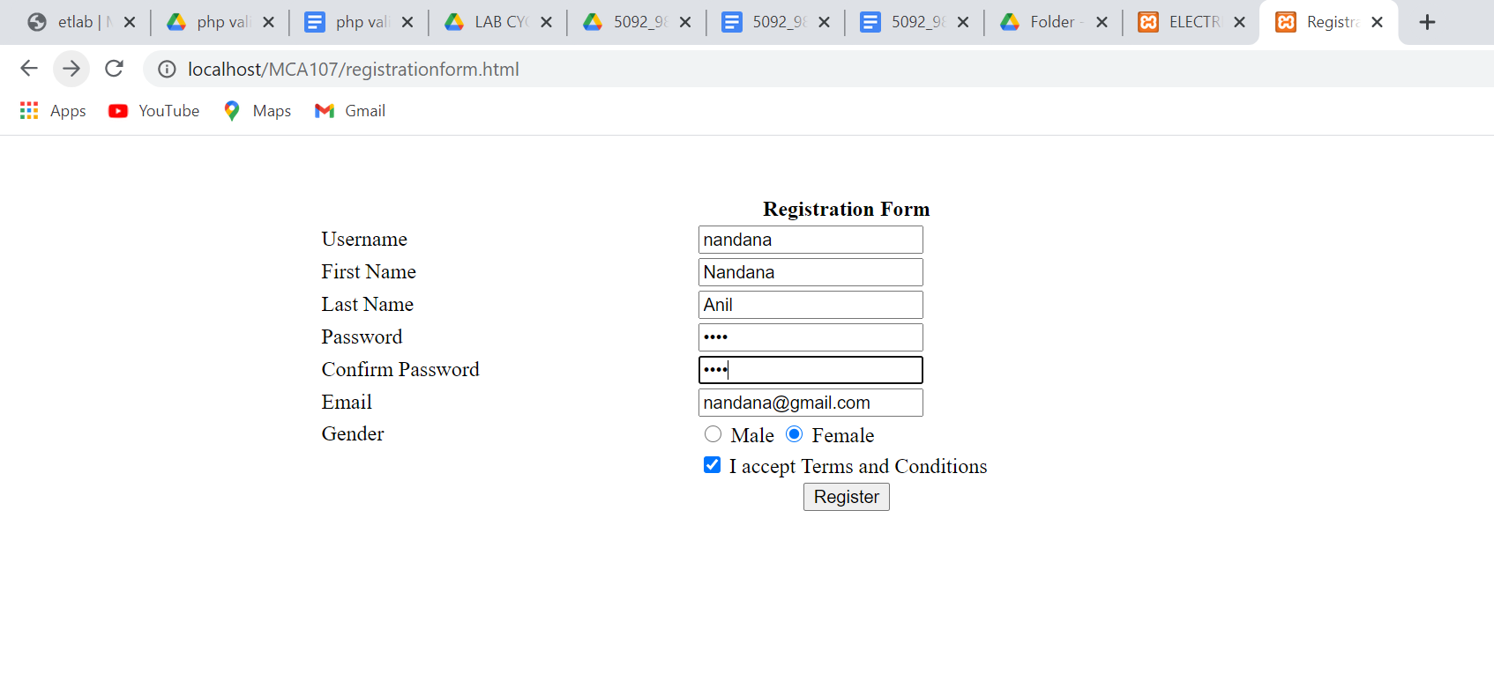

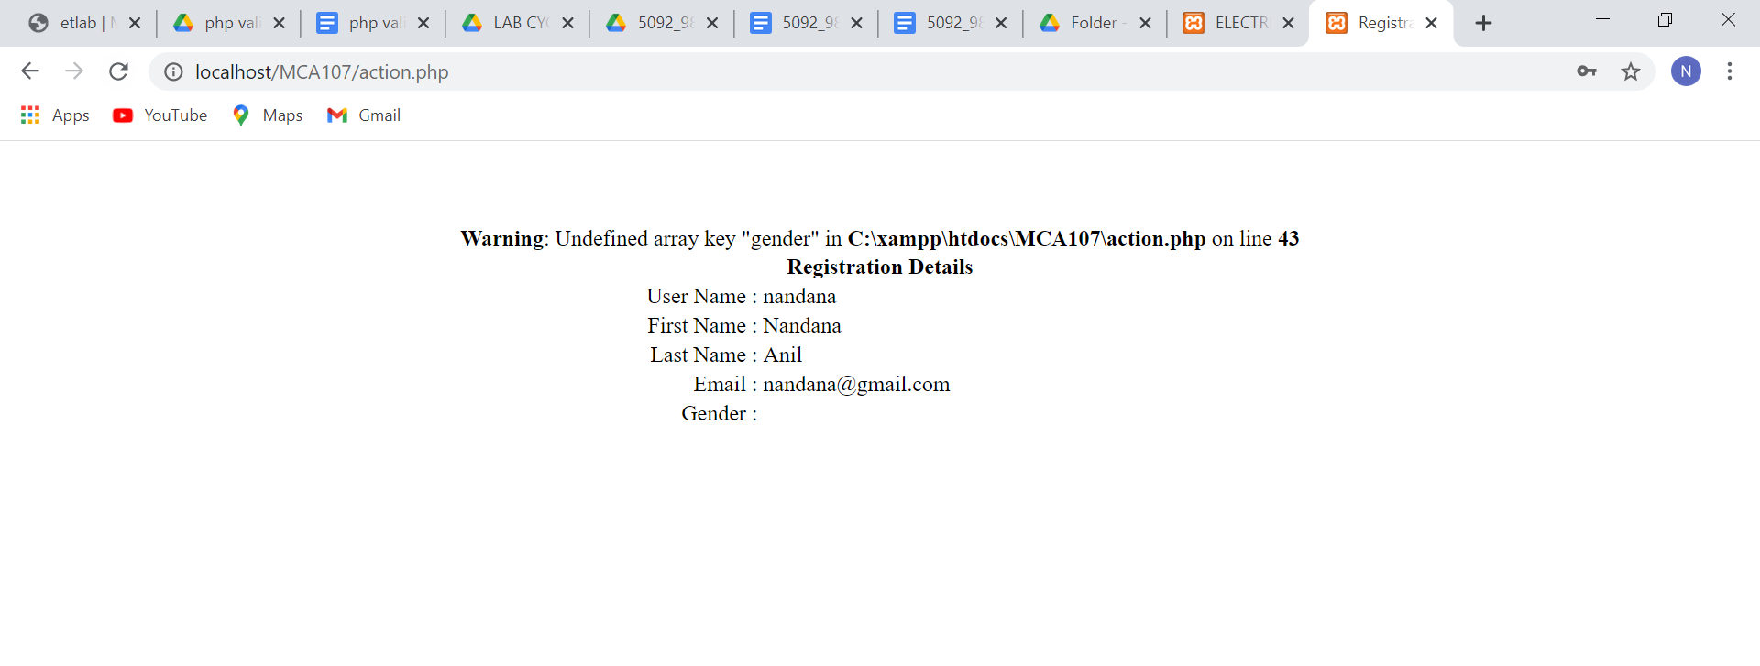

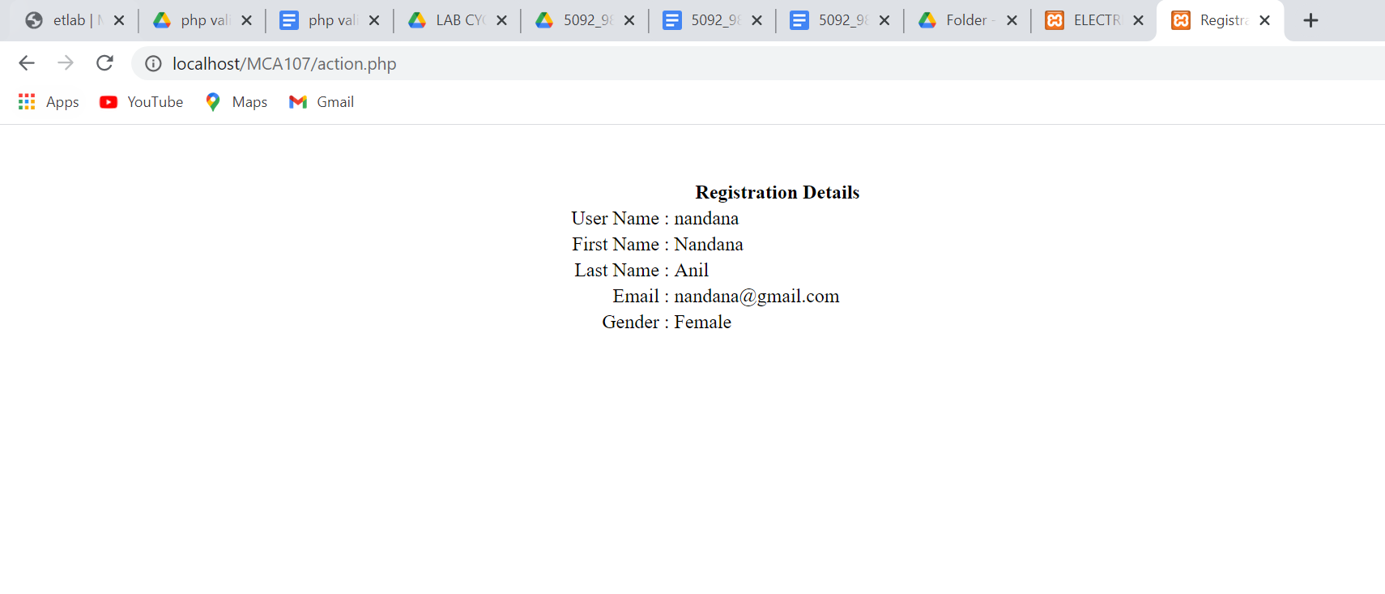

**Program No:2**

**AIM: Compose Electricity bill from user input based on a given tariff using PHP.**

**PROGRAM CODE:**

|  |  |
| --- | --- |
| **ebill.html** | <html>  <head>  <title>ELECTRICITY BILL</title>  </head>  <body>  <br><br>  <form action="ebill.php" method="get">  <center>  <table width="50%" border="0" cellspacing="0" cellpadding="10">  <tr><th colspan="2"><h2>ELECTRICITY BILL</h2></th></tr>  <tr>  <td>Enter the consumer number</td>  <td><input type="text" name="consumer_number"></td>  </tr>  <tr>  <td>Enter the customer name</td>  <td><input type="text" name="consumer_name"></td>  </tr>  <tr>  <td>Enter the previous readingA</td>  <td><input type="text" name="previous_reading"></td>  </tr>  <tr>  <td>Enter the present reading</td>  <td><input type="text" name="present_reading"></td>  </tr>  <tr>  <th colspan="2"><input type="submit" value="SUBMIT"></th>  </tr>  </table>  </center>  </form>  </body>  </html> |
| **ebill.php** | <?php  $servername = "localhost";  $username = "root";  $password = "";  $dbname = "demo";  $consumer_number = $_GET["consumer_number"];  $consumer_name = $_GET["consumer_name"];  $previous_reading = $_GET["previous_reading"];  $present_reading = $_GET["present_reading"];  $conn=mysqli_connect($servername,$username,$password);  if(!$conn){  die('Could not connect: '.mysqli_connect_error());  }  echo 'Connected successfully<br/>';  $sql = "create table electricitybill (consumer_number INT AUTO_INCREMENT,consumer_name VARCHAR(20) NOT NULL,  previous_reading INT NOT NULL,present_reading INT NOT NULL,primary key (consumer_number))";  mysqli_select_db($conn,$dbname);  mysqli_query($conn, $sql);  $sql1 = "INSERT INTO electricitybill values('$consumer_number','$consumer_name','$previous_reading','$present_reading')";  mysqli_query($conn, $sql1);  mysqli_close($conn);  $unit = $present_reading - $previous_reading;  if ($unit < 100) {  $amt = $unit * 3;  } else if (100 <= $unit && $unit <= 200) {  $amt = $unit * 4;  } else if (200 <= $unit && $unit <= 300) {  $amt = $unit * 5;  } else {  $amt = $unit * 6;  }  echo '<table width="40%" border="0" cellspacing="0" cellpadding="10">  <tr><th colspan="2"><h2>ELECTRICITY BILL</h2></th></tr>';  echo "<tr>  <td>Consumer Number</td>  <td>$consumer_number</td>  </tr>";  echo "<tr><td>Customer Name</td>  <td>$consumer_name</td>  </tr>";  echo "<tr><td>Previous Reading</td>  <td>$previous_reading</td>  </tr>";  echo "<tr><td>Present Reading</td>  <td>$present_reading</td>  </tr>";  echo "<tr><td>Unit consumed</td>  <td>$unit</td>  </tr>";  echo "<tr><td>Amount</td>  <td>$amt</td>  </tr>";  echo '<tr><th colspan="2"> </th></tr></table></body></html>';  ?> |

**OUTPUT:**

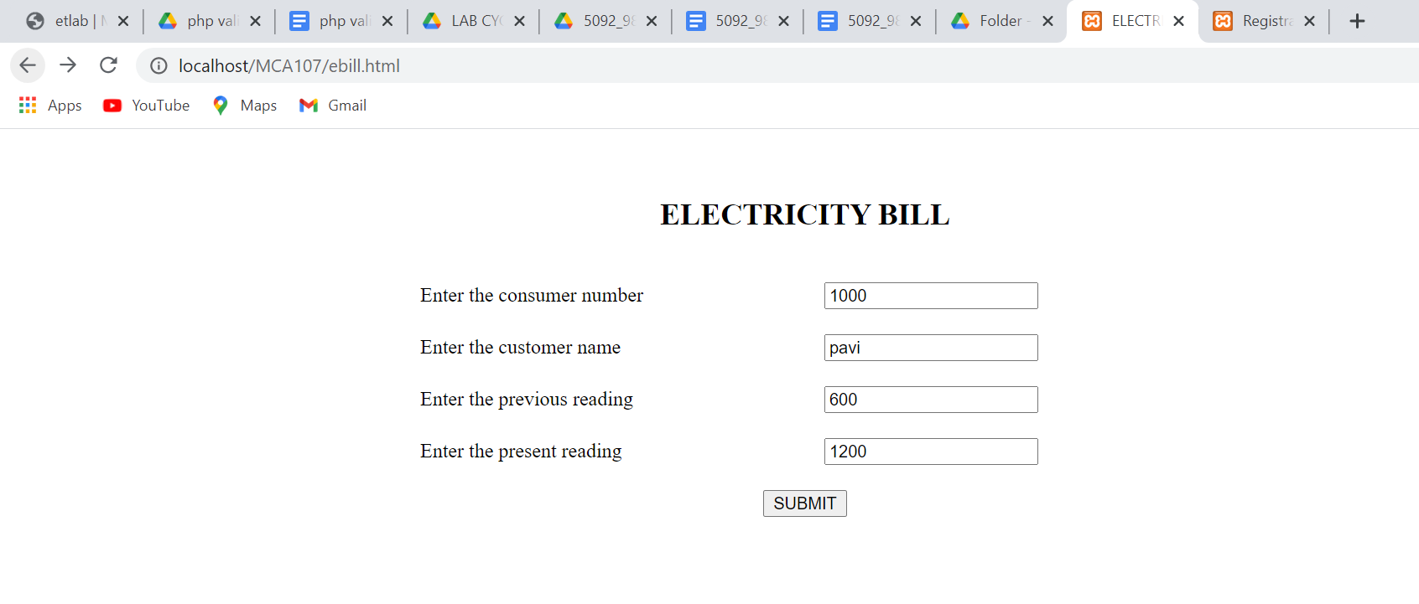

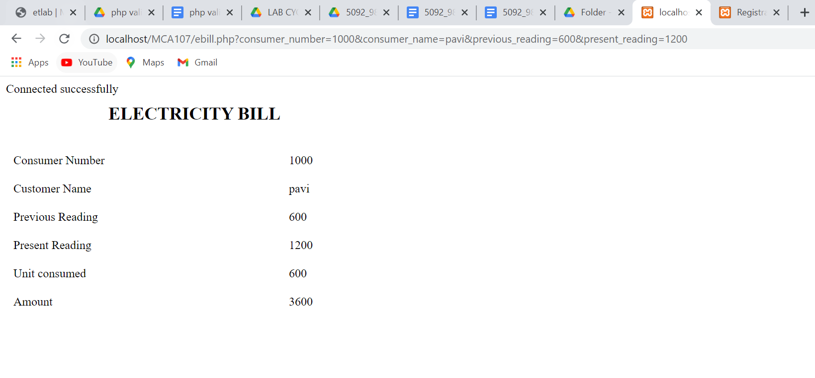

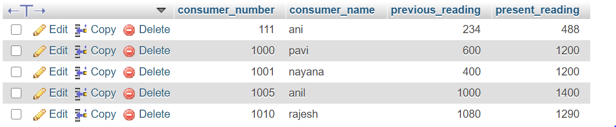

**Program No:3**

**AIM: Build a php code to store name of students in an array and display it using print_r function. Sort and display the same using asort and arsort functions.**

**PROGRAM CODE:**

|  |  |
| --- | --- |
| **sort.php** | <!DOCTYPE html>  <html>  <body>  <?php  $names = array("jasmin", "reshma", "nithya","nandana","amala","aarav");  sort($names);  $clength = count($names);  for($x = 0; $x < $clength; $x++) {  echo $names[$x];  echo "<br>";  }  echo "sorted using values";  echo "<br>";  $age = array("jasmin"=>"35", "reshma"=>"37", "nithya"=>"43","nandana"=>"20","amala"=>"60","aarav"=>"45");  asort($age);  foreach($age as $x => $x_value) {  echo "Key=" . $x ;  echo "<br>";  }  echo "<br>";  echo "sorted using values and in descending order";  echo "<br>";  $age = array("jasmin"=>"35", "reshma"=>"37", "nithya"=>"43","nandana"=>"20","amala"=>"60","aarav"=>"45");  arsort($age);  foreach($age as $x => $x_value) {  echo "Key=" . $x . ", Value=" . $x_value;  echo "<br>";  }  ?>  </body>  </html> |

**OUTPUT:**  
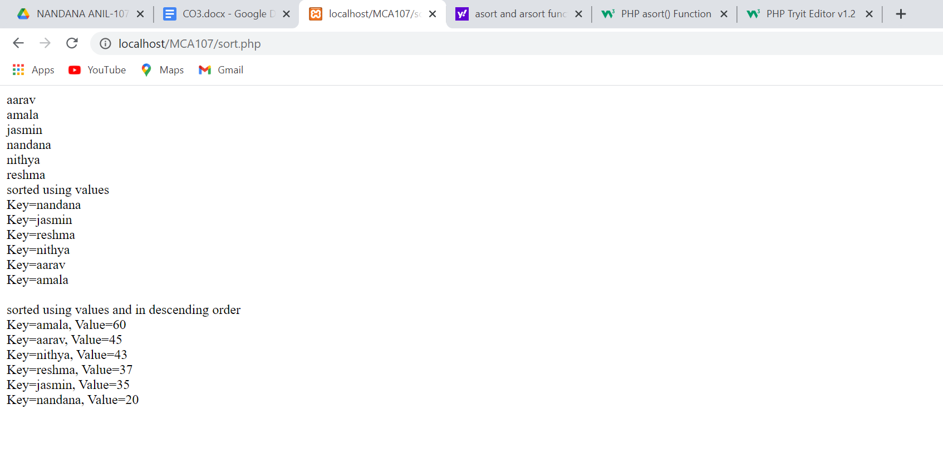

**Program No:4**

**AIM: Build a php code to store name of Indian Cricket Players in an array and display the same in HTML table.**

**PROGRAM CODE:**

|  |  |
| --- | --- |
| players.php | <!DOCTYPE html>  <html>  <body>  <?php  $players = array("Sachin", "Dhoni", "Kohli","Jadeja", "Rohit Sharma", "Raina","Dravid", "Munaf", "Sehwag","Zaheer");  echo "<table border='1'>";  echo "<tr><th>NAME OF INDIAN CRICKET PLAYERS</th></tr>";  for($i=0;$i<count($players);$i++)  {  echo "<tr><td>".$players[$i]."</td></tr>";  }  echo "</table>";  ?>  </body>  </html> |

**OUTPUT:**

