1. INTRODUCTION
1.1 Purpose
This Software Requirements Specification (SRS) document provides a detailed description of the WeatherGuard system, including its functionalities, system architecture, constraints, and design considerations. It serves as a reference for developers, project supervisors, and stakeholders to ensure proper understanding and implementation of the system.
1.2 Scope
The WeatherGuard system is an intelligent weather monitoring and disaster alert platform that provides real-time weather updates, predictive risk analysis, and location-based alerts. The system enables users to monitor environmental conditions, assess potential risks, and access emergency preparedness guidelines.
The system includes features such as user management, weather data retrieval, risk assessment using predefined models, alert generation, and emergency guidance. It is designed as a scalable web-based application.
However, the system is limited to software-based predictions and depends on external APIs for weather data. Future enhancements may include AI-based forecasting and IoT integration.
1.3 Definitions, Acronyms, Abbreviations
- SRS – Software Requirements Specification
- API – Application Programming Interface
- UI – User Interface
- DBMS – Database Management System
- GPS – Global Positioning System
1.4 Overview
This document outlines the functional and non-functional requirements of the WeatherGuard system. It also describes system constraints, assumptions, and dependencies to ensure a structured development approach.

2. PROBLEM STATEMENT
Existing weather applications mainly provide general weather forecasts but lack integrated disaster alerts, risk assessment, and emergency guidance. Users rely on multiple sources, causing delays and confusion during emergencies. A unified system is required to provide real-time information and safety support.

3. OBJECTIVES
- To develop a system that provides real-time weather updates
- To integrate disaster alert mechanisms
- To implement a Smart Risk Indicator
- To provide location-based personalized services
- To include an Emergency Preparedness module

4. LITERATURE REVIEW
4.1 Existing System
Current systems include weather apps and government platforms.
Features:
- Display weather conditions (temperature, humidity, forecasts)
- Provide limited notifications
Limitations:
- No integration of disaster alerts
- Lack of risk prediction mechanisms
- No emergency guidance
- Fragmented information sources
- Poor decision-making support
4.2 Proposed System
The proposed system (WeatherGuard) overcomes these limitations.
Features:
- Real-time weather data via APIs
- Integrated disaster alerts
- Smart Risk Indicator (Low, Medium, High)
- Emergency preparedness guidance
- User-friendly dashboard
Advantages:
- Centralized platform
- Faster response during emergencies
- Improved safety awareness
- Better user experience
System Features (Functional Requirements)
- 3.1 User Management
- The system shall allow users to register and log in securely.
- The system shall allow users to update profile and location preferences.

- 3.2 Weather Data Retrieval
- The system shall fetch real-time weather data using external APIs.
- The system shall display temperature, humidity, rainfall, and wind speed.

3.3 Risk Analysis
- The system shall utilize an existing RiskAnalysisService to compute risk levels.
- The system shall analyze multiple parameters such as temperature, rainfall, humidity, and wind speed.
- The system shall classify risk levels as Low, Medium, or High.

- 3.4 Alerts System
- The system shall generate alerts for severe weather conditions.
- The system shall support a hybrid alert mechanism (API + simulated alerts).
- The system shall categorize alerts based on severity.
3.5 Emergency Preparedness
- The system shall provide disaster-specific safety guidelines.
- The system shall display recommendations based on risk levels.
3.6 Data Visualization
- The system shall present weather trends using charts and graphs.
3.7 Admin Functions
- The admin shall manage alerts and monitor system activity.

4. External Interface Requirements
4.1 User Interface
- Responsive web interface
- Simple navigation and dashboard view

4.2 Hardware Interface
- Standard computing devices (PC, mobile)
4.3 Software Interface
- Weather APIs
- Database system
4.4 Communication Interface
- HTTP/HTTPS protocols
5. Non-Functional Requirements
5.1 Performance
- The system shall provide fast response times for real-time data.
5.2 Reliability
- The system shall ensure high availability and fault tolerance.
5.3 Security
- The system shall implement secure authentication and data protection.
5.4 Usability
- The system shall provide an intuitive user interface.
5.5 Scalability
- The system shall support increasing users and data load.
  - Maintainability
- The system shall be modular and easy to update.
6. Database Design (Aligned with System)
Entities:
- User
- Location
- WeatherData
- RiskData
- Alert
- EmergencyGuidelines
- Key Tables:
WeatherData
- weather_id, location_id, temperature, humidity, rainfall, wind_speed, timestamp
RiskData
- risk_id, weather_id, risk_level, temperature, rainfall, wind_speed, humidity, description, timestamp
Alert
- alert_id, location_id, alert_type, severity, message, source, timestamp
- EmergencyGuidelines
- guideline_id, risk_level, disaster_type, description
7. System Workflow
- Weather data is fetched from external APIs
- Data is stored in the database
- RiskAnalysisService evaluates risk
- Risk level is stored and displayed
- Alerts are generated
- Emergency guidelines are provided
- shall be encrypted and protected against unauthorized access.
6.5 Scalability
- The system shall support future expansion with increased users and data load.
6.6 Maintainability
- The system shall be modular and easy to update or modify.
- Proper documentation shall be maintained for future enhancements.

7. SOFTWARE AND HARDWARE REQUIREMENTS
Software
- Frontend: React
- Backend: Spring Boot
- Database: MySQL
- Tools: Postman, VS Code
Hardware
- Minimum 4GB RAM
- Internet connection

8. USER ROLES
Admin
- Manage system data
- Monitor alerts
User
- View weather updates
- Check alerts and risk levels
- Access emergency information

9. ASSUMPTIONS AND CONSTRAINTS
Assumptions
- Users have internet access
- APIs are available
Constraints
- Dependence on third-party APIs
- Limited real-time government data access

10. SYSTEM DESIGN DOCUMENT (SDD)
10.1 Use Case Diagram (Description)
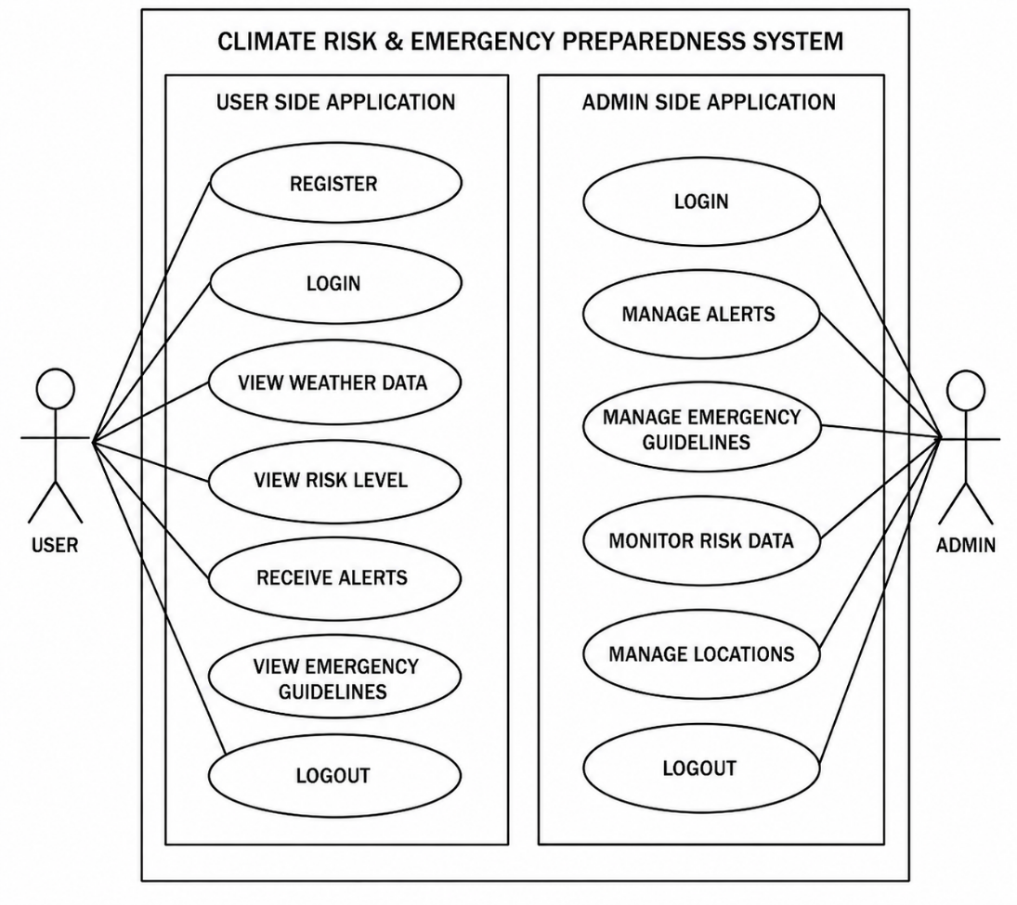
Actors:
- User
- Admin
User Side Use Cases
- Register
- Login
- View Weather Data
- View Risk Level
- Receive Alerts
- View Emergency Guidelines
- Logout
Admin Side Use Case
- Login
- Manage Alerts
- Manage Emergency Guidelines
- Monitor Risk Data
- Logout

10.2 DATABASE DESIGN

10.2.1 ER Diagram
Entities:
- Users
- WeatherData
- Alerts
- RiskData
Relationships:
- Users access weather data
- Alerts linked to location
- Risk derived from weather data

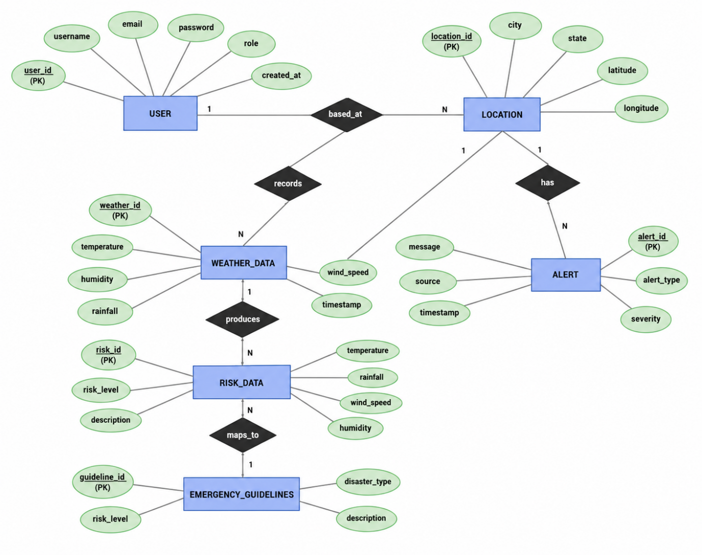

10.2.2 TABLES
Table 1: Users
Field Name | Data Type / Constraint | Description
user_id | INT, Primary Key, Auto Increment | Unique identifier for each user
username | VARCHAR, UNIQUE, NOT NULL | Username of the user
email | VARCHAR, UNIQUE, NOT NULL | Email address of the user
password_hash | VARCHAR, NOT NULL | Encrypted password for authentication
role | ENUM ('user', 'admin') | Defines user role (normal user or admin)
location_id | INT, Foreign Key | References Location(location_id)
created_at | TIMESTAMP | Timestamp of account creation

Table 2: Location
Field Name | Data Type / Constraint | Description
location_id | INT, Primary Key, Auto Increment | Unique identifier for location
city | VARCHAR | Name of the city
state | VARCHAR | Name of the state
latitude | DECIMAL | Latitude coordinate
longitude | DECIMAL | Longitude coordinate

Table 3: Weather Data
Field Name | Data Type / Constraint | Description
weather_id | INT, Primary Key, Auto Increment | Unique identifier for weather record
location_id | INT, Foreign Key | References Location(location_id)
temperature | DECIMAL | Temperature value
humidity | DECIMAL | Humidity level
rainfall | DECIMAL | Rainfall measurement
wind_speed | DECIMAL | Wind speed value
timestamp | TIMESTAMP | Time of data recording

Table 4: RiskData
Field Name | Data Type / Constraint | Description
risk_id | INT, Primary Key, Auto Increment | Unique identifier for risk record
weather_id | INT, Foreign Key | References WeatherData(weather_id)
risk_level | ENUM ('Low', 'Medium', 'High') | Classified risk level
temperature | DECIMAL | Temperature used for risk calculation
rainfall | DECIMAL | Rainfall used for risk calculation
wind_speed | DECIMAL | Wind speed used for risk calculation
humidity | DECIMAL | Humidity used for risk calculation
description | VARCHAR | Explanation of risk level
timestamp | TIMESTAMP | Time of risk evaluation

Table 5: Emergency Guidelines

Field Name | Data Type / Constraint | Description
guideline_id | INT, Primary Key, Auto Increment | Unique identifier for each guideline
risk_level | ENUM ('Low', 'Medium', 'High') | Associated risk level
disaster_type | VARCHAR | Type of disaster (e.g., Flood, Heatwave, Storm)
description | TEXT | Detailed emergency instructions
timestamp | TIMESTAMP | Time of guideline creation/update

