Exchange rates: 2024-08-19 to 2026-08-17
Daily rates for USD/INR, INR/GBP, INR/EUR, with a least-squares trend for each pair. Generated 17 August 2026 at 10:31.

What the trend shows
USD/INR. Moved from 83.014 to 88.11, a change of 6.14%. The fitted line slopes +2.5567 per year with an R-squared of 1.0, so USD is weakening over this window. Range 83.014 on 2024-08-19 to 88.11 on 2026-08-17.
INR/GBP. Moved from 0.009499 to 0.009208, a change of -3.07%. The fitted line slopes -0.0001 per year with an R-squared of 1.0, so INR is strengthening over this window. Range 0.009208 on 2026-08-17 to 0.009499 on 2024-08-19.
INR/EUR. Moved from 0.0111 to 0.011246, a change of 1.31%. The fitted line slopes +0.0001 per year with an R-squared of 1.0, so INR is weakening over this window. Range 0.0111 on 2024-08-19 to 0.011246 on 2026-08-17.
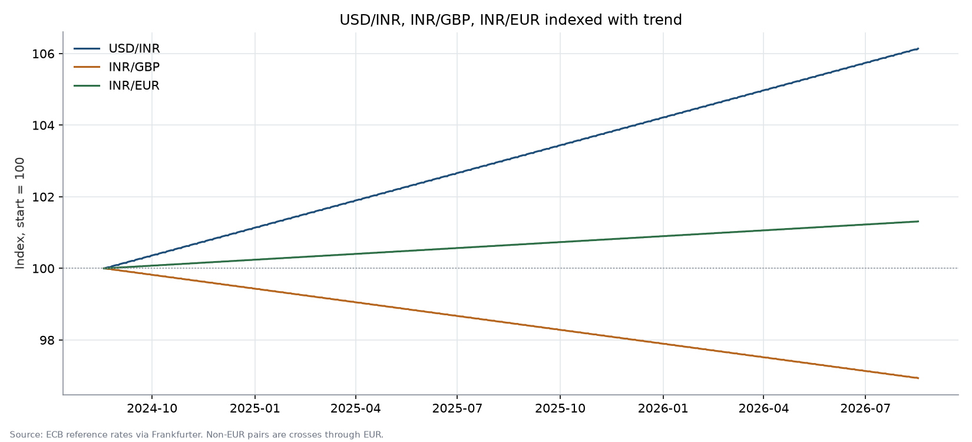
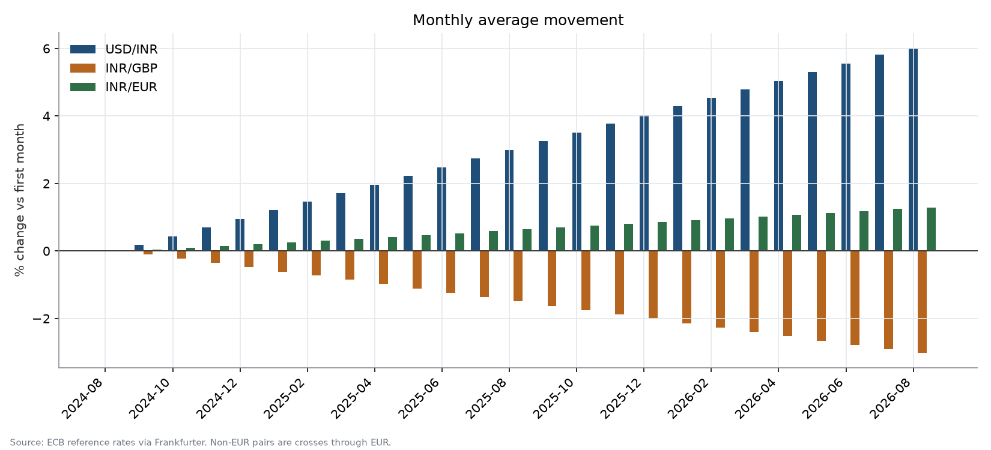

Monthly averages
Month | USD/INR | INR/GBP | INR/EUR
2024-08 | 83.053846 | 0.009497 | 0.011102
2024-09 | 83.203233 | 0.009488 | 0.011106
2024-10 | 83.41729 | 0.009476 | 0.011112
2024-11 | 83.630467 | 0.009464 | 0.011118
2024-12 | 83.843839 | 0.009452 | 0.011124
2025-01 | 84.06129 | 0.009439 | 0.01113
2025-02 | 84.2675 | 0.009428 | 0.011136
2025-03 | 84.473613 | 0.009416 | 0.011142
2025-04 | 84.6877 | 0.009404 | 0.011148
2025-05 | 84.901065 | 0.009391 | 0.011154
2025-06 | 85.114233 | 0.009379 | 0.01116
2025-07 | 85.32829 | 0.009367 | 0.011167
2025-08 | 85.544613 | 0.009355 | 0.011173
2025-09 | 85.7587 | 0.009342 | 0.011179
2025-10 | 85.97229 | 0.00933 | 0.011185
2025-11 | 86.185 | 0.009318 | 0.011191
2025-12 | 86.39929 | 0.009306 | 0.011197
2026-01 | 86.616065 | 0.009293 | 0.011203
2026-02 | 86.8225 | 0.009282 | 0.011209
2026-03 | 87.028839 | 0.00927 | 0.011215
2026-04 | 87.2427 | 0.009258 | 0.011221
2026-05 | 87.455613 | 0.009245 | 0.011227
2026-06 | 87.6697 | 0.009233 | 0.011233
2026-07 | 87.88329 | 0.009221 | 0.01124
2026-08 | 88.050294 | 0.009211 | 0.011244

Method and limits
- Source: European Central Bank via Frankfurter (api.frankfurter.dev).
- ECB reference rates via Frankfurter. Non-EUR pairs are crosses computed through EUR, suitable for trend analysis, not for pricing a transaction.
- The window holds 521 published business days across 729 calendar days. The 208 non-publishing days carry the previous rate forward so the horizontal axis stays a real calendar.
- The trend is ordinary least squares on rate against date. It describes the window it was fitted to and is not a forecast.
- Where pairs are compared, charts plot an index set to 100 at the series start, because the underlying rates differ by orders of magnitude and would not share an axis.

