 | 
Faculty of Technology and Engineering
Chandubhai S. Patel Institute of Technology (CSPIT)
Department of Computer Science & Engineering
Date:
Laboratory Manul
Academic Year | : | 2026-27 | Semester | : | 3rd
Course code | : | ITUE203 | Course name | : | WEB DEVELOPMENT FRAMEWORKS

Practical – 3:-
Responsive UI Design using CSS2.0/CSS3.0, CSS Grid and flexbox
Problem Statement:-
Design responsive layouts for Home, About, Registration, Dashboard, and Events pages using CSS Grid and Flexbox. Optional to use CSS framework such as Bootstrap or Tailwind. Ensure mobile-first
responsiveness.
Objective:-
To design and develop responsive layouts for Home, About, Registration, Dashboard, and Events pages using modern CSS layout techniques such as CSS Grid and Flexbox. The aim is to create a mobile-first responsive web interface that adapts smoothly to different screen sizes and provides a better user experience. The implementation focuses on organizing web content efficiently, improving page structure, and ensuring accessibility across various devices.
Github Repository link: https://github.com/Nandani-1809/StudentPortal

Bootstrap:
Home:
<!DOCTYPE html>
<html lang="en">
<head>
<meta charset="UTF-8">
<meta name="viewport" content="width=device-width, initial-scale=1.0">
<title>Student Hub Portal | Home</title>

<!-- Bootstrap CSS -->
<link href="https://cdn.jsdelivr.net/npm/bootstrap@5.3.3/dist/css/bootstrap.min.css" rel="stylesheet">
</head>

<body>

<!-- Header -->
<header class="bg-primary text-white text-center py-4">

<img src="studenthublogo.png"
alt="Student Hub Logo"
width="110"
height="110"
class="img-fluid mb-3">

<h1 class="mb-2">STUDENT HUB PORTAL</h1>

<p class="lead">Connecting Students Through Technology</p>

<!-- Navigation -->
<nav class="navbar navbar-expand-lg navbar-dark mt-3">

<div class="container justify-content-center">

<button class="navbar-toggler"
type="button"
data-bs-toggle="collapse"
data-bs-target="#navbarNav">

<span class="navbar-toggler-icon"></span>

</button>

<div class="collapse navbar-collapse justify-content-center"
id="navbarNav">

<ul class="navbar-nav">

<li class="nav-item">
<a class="nav-link text-white" href="Home.html">Home</a>
</li>

<li class="nav-item">
<a class="nav-link text-white" href="AboutUs.html">About Us</a>
</li>

<li class="nav-item">
<a class="nav-link text-white" href="Dashboard.html">Dashboard</a>
</li>

<li class="nav-item">
<a class="nav-link text-white" href="Events.html">Events</a>
</li>

<li class="nav-item">
<a class="nav-link text-white" href="FAQ.html">FAQ</a>
</li>

<li class="nav-item">
<a class="nav-link text-white" href="Contact.html">Contact</a>
</li>

<li class="nav-item">
<a class="nav-link text-white" href="Login.html">Login</a>
</li>

<li class="nav-item">
<a class="nav-link text-white" href="Register.html">Register</a>
</li>

<li class="nav-item">
<a class="nav-link text-white" href="Profile.html">Profile</a>
</li>

</ul>

</div>

</div>

</nav>

</header>

<!-- Banner -->
<section>

<img src="banner.png"
alt="Student Hub Banner"
class="img-fluid w-100">

</section>

<!-- Welcome Section -->
<section class="container text-center my-5">

<h2 class="text-primary mb-4">
Welcome to Student Hub Portal
</h2>

<p class="fs-5 mx-auto" style="max-width:900px; line-height:1.8;">

Student Hub Portal is a modern platform designed for students to access
academic information, register for events, receive announcements,
manage profiles and stay connected with their institution anytime,
anywhere.

</p>

<div class="mt-4">

<a href="Register.html" class="btn btn-primary btn-lg me-3">
Register Now
</a>

<a href="Login.html" class="btn btn-success btn-lg">
Login
</a>

</div>

</section>

<!-- Information Section -->
<section class="container my-5">

<div class="row text-center g-4">

<div class="col-md-3">
<div class="card h-100 shadow-sm">
<div class="card-body">
<h4>Why Choose Student Hub?</h4>
</div>
</div>
</div>

<div class="col-md-3">
<div class="card h-100 shadow-sm">
<div class="card-body">
<h4>Upcoming Events</h4>
</div>
</div>
</div>

<div class="col-md-3">
<div class="card h-100 shadow-sm">
<div class="card-body">
<h4>Latest Notices</h4>
</div>
</div>
</div>

<div class="col-md-3">
<div class="card h-100 shadow-sm">
<div class="card-body">
<h4>Announcements</h4>
</div>
</div>
</div>

</div>

</section>

<!-- Announcements -->
<section class="container mb-5">

<div class="alert alert-info text-center fs-5">

🎉 Coding Competition Registration Open |
📢 Workshop on Artificial Intelligence |
🏆 Annual Sports Day Coming Soon

</div>

</section>

<!-- Footer -->
<footer class="bg-dark text-white text-center py-4">

<div class="mb-3">

<a href="Home.html" class="text-white text-decoration-none mx-2">Home</a> |

<a href="AboutUs.html" class="text-white text-decoration-none mx-2">About Us</a> |

<a href="Events.html" class="text-white text-decoration-none mx-2">Events</a> |

<a href="FAQ.html" class="text-white text-decoration-none mx-2">FAQ</a> |

<a href="Contact.html" class="text-white text-decoration-none mx-2">Contact</a>

</div>

<p class="mb-0">
© 2026 Student Hub Portal | All Rights Reserved
</p>

</footer>

<!-- Bootstrap JS -->
<script src="https://cdn.jsdelivr.net/npm/bootstrap@5.3.3/dist/js/bootstrap.bundle.min.js"></script>

</body>
</html>
Output: 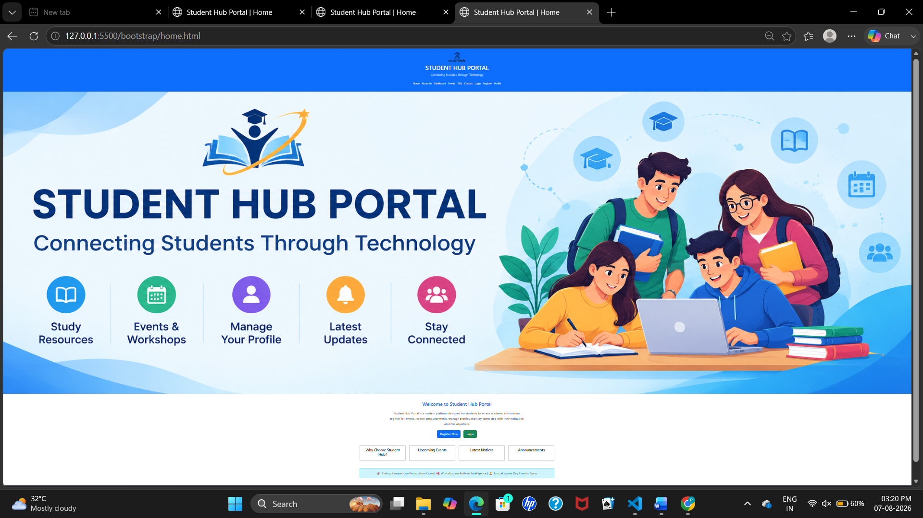

Flexbox:
Home.html:
<!DOCTYPE html>
<html lang="en">

<head>

<meta charset="UTF-8">

<meta name="viewport" content="width=device-width, initial-scale=1.0">

<title>Student Hub Portal | Home</title>

<link rel="stylesheet" href="style.css">

</head>

<body>

<!-- Header -->

<header>

<img src="studenthublogo.png"
alt="Student Hub Logo"
width="110"
height="110">

<h1>STUDENT HUB PORTAL</h1>

<p>Connecting Students Through Technology</p>

<nav>

<a href="Home.html">Home</a>

<a href="AboutUs.html">About Us</a>

<a href="Dashboard.html">Dashboard</a>

<a href="Events.html">Events</a>

<a href="FAQ.html">FAQ</a>

<a href="Contact.html">Contact</a>

<a href="Login.html">Login</a>

<a href="Register.html">Register</a>

<a href="Profile.html">Profile</a>

</nav>

</header>

<!-- Banner -->

<section class="banner">

<img src="banner.png"
alt="Student Hub Banner">

</section>

<!-- Welcome Section -->

<section class="welcome">

<h2>

Welcome to Student Hub Portal

</h2>

<p>

Student Hub Portal is a modern platform designed for students to access
academic information, register for events, receive announcements,
manage profiles and stay connected with their institution anytime,
anywhere.

</p>

<div class="button-container">

<a href="Register.html">

<button class="register-btn">

Register Now

</button>

</a>

<a href="Login.html">

<button class="login-btn">

Login

</button>

</a>

</div>

</section>

<!-- Information Section -->

<section class="info-section">

<div class="info-box">

<h3>Why Choose Student Hub?</h3>

</div>

<div class="info-box">

<h3>Upcoming Events</h3>

</div>

<div class="info-box">

<h3>Latest Notices</h3>

</div>

<div class="info-box">

<h3>Announcements</h3>

</div>

</section>

<!-- Announcements -->

<section class="announcement">

🎉 Coding Competition Registration Open |
📢 Workshop on Artificial Intelligence |
🏆 Annual Sports Day Coming Soon

</section>

<!-- Footer -->

<footer>

<div class="footer-links">

<a href="Home.html">Home</a>

<a href="AboutUs.html">About Us</a>

<a href="Events.html">Events</a>

<a href="FAQ.html">FAQ</a>

<a href="Contact.html">Contact</a>

</div>

<p>

© 2026 Student Hub Portal | All Rights Reserved

</p>

</footer>

</body>

</html>

Style.css:

*{
margin:0;
padding:0;
box-sizing:border-box;
}

/* Body */

body{
font-family:Arial, Helvetica, sans-serif;
background:#f5f5f5;
color:#333;
}

/* Header */

header{
background:#0d6efd;
color:white;
text-align:center;
padding:20px;
}

header img{
margin-bottom:10px;
}

header h1{
margin:10px 0;
}

header p{
margin-bottom:20px;
}

/* Navigation - Flexbox */

nav{
display:flex;
justify-content:center;
align-items:center;
flex-wrap:wrap;
gap:15px;
}

nav a{
color:white;
text-decoration:none;
padding:10px 15px;
border-radius:5px;
transition:0.3s;
}

nav a:hover{
background:rgba(255,255,255,0.2);
}

/* Banner */

.banner img{
width:100%;
height:auto;
display:block;
}

/* Welcome Section */

.welcome{
text-align:center;
padding:40px 20px;
}

.welcome h2{
color:#1E3A8A;
margin-bottom:20px;
}

.welcome p{
width:80%;
margin:auto;
font-size:18px;
line-height:30px;
}

/* Buttons - Flexbox */

.button-container{
display:flex;
justify-content:center;
align-items:center;
gap:20px;
flex-wrap:wrap;
margin-top:30px;
}

.button-container a{
text-decoration:none;
}

.button-container button{
color:white;
border:none;
padding:12px 30px;
font-size:18px;
cursor:pointer;
border-radius:5px;
}

.register-btn{
background:#2563EB;
}

.login-btn{
background:#16A34A;
}

/* Information Section - Flexbox */

.info-section{
display:flex;
justify-content:center;
align-items:center;
flex-wrap:wrap;
gap:20px;
padding:40px 20px;
}

.info-box{
background:white;
width:250px;
padding:25px;
text-align:center;
border-radius:8px;
box-shadow:0 2px 8px rgba(0,0,0,0.2);
}

.info-box h3{
color:#1E3A8A;
}

/* Announcement */

.announcement{
background:#d9edf7;
margin:20px;
padding:20px;
text-align:center;
font-size:18px;
border-radius:8px;
}

/* Footer */

footer{
background:#222;
color:white;
text-align:center;
padding:20px;
}

.footer-links{
display:flex;
justify-content:center;
align-items:center;
flex-wrap:wrap;
gap:15px;
margin-bottom:15px;
}

.footer-links a{
color:white;
text-decoration:none;
}

.footer-links a:hover{
text-decoration:underline;
}

/* Responsive Design */

@media (max-width:768px){

nav{
flex-direction:column;
}

.button-container{
flex-direction:column;
}

.info-section{
flex-direction:column;
}

.footer-links{
flex-direction:column;
}

.welcome p{
width:95%;
}

}
Output:

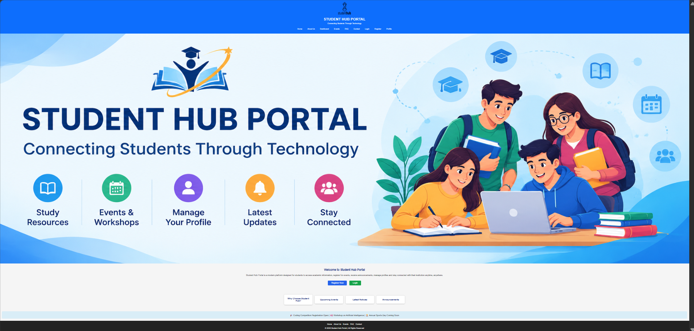

Grid:
Home.html:
<!DOCTYPE html>
<html lang="en">

<head>

<meta charset="UTF-8">

<meta name="viewport" content="width=device-width, initial-scale=1.0">

<title>Student Hub Portal | Home</title>

<link rel="stylesheet" href="style.css">

</head>

<body>

<!-- Header -->

<header>

<img src="studenthublogo.png"
alt="Student Hub Logo"
width="110"
height="110">

<h1>STUDENT HUB PORTAL</h1>

<p>Connecting Students Through Technology</p>

<nav>

<a href="HomeGrid.html">Home</a>

<a href="AboutUs.html">About Us</a>

<a href="Dashboard.html">Dashboard</a>

<a href="Events.html">Events</a>

<a href="FAQ.html">FAQ</a>

<a href="Contact.html">Contact</a>

<a href="Login.html">Login</a>

<a href="Register.html">Register</a>

<a href="Profile.html">Profile</a>

</nav>

</header>

<!-- Banner -->

<section class="banner">

<img src="banner.png"
alt="Student Hub Banner">

</section>

<!-- Welcome Section -->

<section class="welcome">

<h2>

Welcome to Student Hub Portal

</h2>

<p>

Student Hub Portal is a modern platform designed for students to access
academic information, register for events, receive announcements,
manage profiles and stay connected with their institution anytime,
anywhere.

</p>

<div class="button-container">

<a href="Register.html">

<button class="register-btn">

Register Now

</button>

</a>

<a href="Login.html">

<button class="login-btn">

Login

</button>

</a>

</div>

</section>

<!-- Information Section -->

<section class="info-section">

<div class="info-box">

<h3>Why Choose Student Hub?</h3>

</div>

<div class="info-box">

<h3>Upcoming Events</h3>

</div>

<div class="info-box">

<h3>Latest Notices</h3>

</div>

<div class="info-box">

<h3>Announcements</h3>

</div>

</section>

<!-- Announcements -->

<section class="announcement">

🎉 Coding Competition Registration Open |
📢 Workshop on Artificial Intelligence |
🏆 Annual Sports Day Coming Soon

</section>

<!-- Footer -->

<footer>

<div class="footer-links">

<a href="HomeGrid.html">Home</a>

<a href="AboutUs.html">About Us</a>

<a href="Events.html">Events</a>

<a href="FAQ.html">FAQ</a>

<a href="Contact.html">Contact</a>

</div>

<p>

© 2026 Student Hub Portal | All Rights Reserved

</p>

</footer>

</body>

</html>

Style.css:
/* Reset */

*{
margin:0;
padding:0;
box-sizing:border-box;
}

/* Body */

body{

font-family:Arial, Helvetica, sans-serif;
background:#f5f5f5;

}

/* Header */

header{

background:#0d6efd;
color:white;
text-align:center;
padding:20px;

}

/* Navigation using Grid */

nav{

display:grid;
grid-template-columns:repeat(auto-fit,minmax(100px,auto));
justify-content:center;
gap:15px;
margin-top:20px;

}

nav a{

color:white;
text-decoration:none;
padding:10px;

}

nav a:hover{

background:rgba(255,255,255,0.2);
border-radius:5px;

}

/* Banner */

.banner img{

width:100%;
display:block;

}

/* Welcome Section */

.welcome{

text-align:center;
padding:40px 20px;

}

.welcome h2{

color:#1E3A8A;
margin-bottom:20px;

}

.welcome p{

width:80%;
margin:auto;
font-size:18px;
line-height:30px;

}

/* Buttons using Grid */

.button-container{

display:grid;
grid-template-columns:auto auto;
justify-content:center;
gap:20px;
margin-top:30px;

}

.button-container button{

color:white;
border:none;
padding:12px 30px;
font-size:18px;
cursor:pointer;
border-radius:5px;

}

.register-btn{

background:#2563EB;

}

.login-btn{

background:#16A34A;

}

/* Information Section using Grid */

.info-section{

display:grid;
grid-template-columns:repeat(4,1fr);
gap:20px;
padding:40px;

}

.info-box{

background:white;
padding:25px;
text-align:center;
border-radius:8px;
box-shadow:0 2px 8px rgba(0,0,0,0.2);

}

.info-box h3{

color:#1E3A8A;

}

/* Announcement */

.announcement{

background:#d9edf7;
margin:20px;
padding:20px;
text-align:center;
font-size:18px;
border-radius:8px;

}

/* Footer */

footer{

background:#222;
color:white;
text-align:center;
padding:20px;

}

.footer-links{

display:grid;
grid-template-columns:repeat(5,auto);
justify-content:center;
gap:15px;
margin-bottom:15px;

}

.footer-links a{

color:white;
text-decoration:none;

}

.footer-links a:hover{

text-decoration:underline;

}

/* Responsive Grid */

@media(max-width:768px){

nav{

grid-template-columns:1fr;

}

.button-container{

grid-template-columns:1fr;

}

.info-section{

grid-template-columns:1fr;

}

.footer-links{

grid-template-columns:1fr;

}

.welcome p{

width:95%;

}

}

Output: 