 | 
Faculty of Technology and Engineering
Chandubhai S. Patel Institute of Technology (CSPIT)
Department of Computer Science & Engineering
Date: 22/07/2026
Laboratory Manul
Academic Year | : | 2026-27 | Semester | : | 3rd
Course code | : | ITUE203 | Course name | : | WEB DEVELOPMENT FRAMEWORKS

Practical 2:-
Semantic HTML5 Pages with Accessibility -Rady struture
Problem Statement:- Develop static HTML5 skeletons for at least 10 StudentHub pages such as Home, About, Register, Login, Dashboard, Events, Profile, Contact, Admin, FAQ, and Feedback. Use semantic tags and accessibility-friendly
structure.

Objective:- To create the basic structure of at least 10 StudentHub web pages using HTML5. The aim is to use semantic HTML tags to make the website well-organized, easy to understand, and accessible for all users. This helps in building a strong foundation for the website before adding design and functionality.

Github Repository link: https://github.com/Nandani-1809/StudentPortal

Screenshots:
1.Home:-
Code:
<!DOCTYPE html>
<html lang="en">

<head>
<meta charset="UTF-8">
<meta name="viewport" content="width=device-width, initial-scale=1.0">
<title>Student Hub Portal | Home</title>
</head>

<body style="margin:0; background-color:#F0F8FF; font-family:Arial, sans-serif;">

<!-- ================= HEADER ================= -->

<header style="background-color:#2563EB; color:white; text-align:center; padding:20px;">

<img src="studenthublogo.png" alt="Student Hub Logo"
width="110" height="110">

<h1 style="margin:10px;">STUDENT HUB PORTAL</h1>

<p>Connecting Students Through Technology</p>

<nav style="margin-top:20px;">

<a href="Home.html" style="color:white;text-decoration:none;padding:12px;">Home</a>

<a href="AboutUs.html" style="color:white;text-decoration:none;padding:12px;">About Us</a>

<a href="Dashboard.html" style="color:white;text-decoration:none;padding:12px;">Dashboard</a>

<a href="Events.html" style="color:white;text-decoration:none;padding:12px;">Events</a>

<a href="FAQ.html" style="color:white;text-decoration:none;padding:12px;">FAQ</a>

<a href="Contact.html" style="color:white;text-decoration:none;padding:12px;">Contact</a>

<a href="Login.html" style="color:white;text-decoration:none;padding:12px;">Login</a>

<a href="Register.html" style="color:white;text-decoration:none;padding:12px;">Register</a>

<a href="Profile.html" style="color:white;text-decoration:none;padding:12px;">Profile</a>

</nav>

</header>

<!-- ================= HERO ================= -->

<section style="width:100%; margin:0; padding:0;">

<img src="banner.png"
alt="Student Hub Banner"
style="width:100%;
height:auto;
display:block;">

</section>

<section style="text-align:center; padding:40px;">

<h2 style="color:#1E3A8A;">
Welcome to Student Hub Portal
</h2>

<p style="font-size:18px; width:80%; margin:auto; line-height:30px;">

Student Hub Portal is a modern platform designed for students to access
academic information, register for events, receive announcements,
manage profiles and stay connected with their institution anytime,
anywhere.

</p>

<br>

<a href="Register.html">

<button style="background:#2563EB;
color:white;
border:none;
padding:12px 30px;
font-size:18px;
cursor:pointer;
border-radius:5px;">

Register Now

</button>

</a>

&nbsp;&nbsp;

<a href="Login.html">

<button style="background:#16A34A;
color:white;
border:none;
padding:12px 30px;
font-size:18px;
cursor:pointer;
border-radius:5px;">

Login

</button>

</a>

</section>

<!-- ================= FEATURES ================= -->

<section style="background:white;padding:30px;">

<h2 style="text-align:center;color:#1E3A8A;">
Why Choose Student Hub?
</h2>

<table width="100%" cellpadding="20">

<tr align="center">

<td>

<h3>📚 Learning</h3>

<p>Access study resources and important academic information.</p>

</td>

<td>

<h3>📅 Events</h3>

<p>Register and participate in college activities easily.</p>

</td>

<td>

<h3>👤 Profile</h3>

<p>Manage your personal and academic profile securely.</p>

</td>

<td>

<h3>📢 Notices</h3>

<p>Stay updated with the latest college announcements.</p>

</td>

</tr>

</table>

</section>

<!-- ================= EVENTS ================= -->

<section style="padding:30px;">

<h2 align="center" style="color:#1E3A8A;">
Upcoming Events
</h2>

<table border="1"
width="80%"
align="center"
cellpadding="12"
style="background:white;border-collapse:collapse;">

<tr bgcolor="#2563EB" style="color:white;">

<th>Event</th>

<th>Date</th>

<th>Venue</th>

</tr>

<tr>

<td>Hackathon 2026</td>

<td>25 July</td>

<td>Seminar Hall</td>

</tr>

<tr>

<td>Web Development Workshop</td>

<td>30 July</td>

<td>Computer Lab</td>

</tr>

<tr>

<td>Sports Meet</td>

<td>12 August</td>

<td>College Ground</td>

</tr>

</table>

</section>

<!-- ================= NOTICES ================= -->

<section style="background:white;padding:30px;">

<h2 align="center" style="color:#1E3A8A;">
Latest Notices
</h2>

<ul style="font-size:18px;line-height:35px;">

<li>Semester classes begin from 6 July.</li>

<li>Assignment submission closes this Friday.</li>

<li>Library timing has been extended till 8 PM.</li>

<li>Scholarship applications are now open.</li>

</ul>

</section>

<!-- ================= ANNOUNCEMENTS ================= -->

<section style="padding:30px;">

<h2 align="center" style="color:#1E3A8A;">
Announcements
</h2>

<marquee>

🎉 Coding Competition Registration Open |
📢 Workshop on Artificial Intelligence |
🏆 Annual Sports Day Coming Soon

</marquee>

</section>

<!-- ================= FOOTER ================= -->

<footer style="background:#1E3A8A;
color:white;
text-align:center;
padding:20px;">

<h3>Student Hub Portal</h3>

<p>
Home |
About Us |
Events |
FAQ |
Contact
</p>

<p>
&copy; 2026 Student Hub Portal | All Rights Reserved
</p>

</footer>

</body>
</html>
Output:
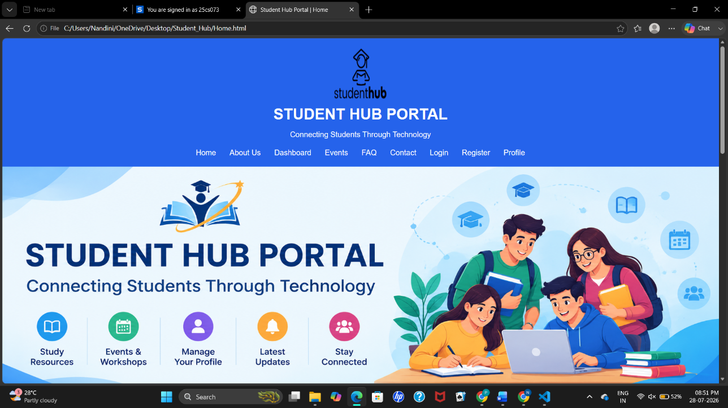
2.Dashboard:-
Code:
<!DOCTYPE html>
<html lang="en">

<head>
<meta charset="UTF-8">
<meta name="viewport" content="width=device-width, initial-scale=1.0">
<title>Student Hub Portal | Dashboard</title>
</head>

<body style="margin:0; background-color:#F0F8FF; font-family:Arial, sans-serif;">

<!-- ================= HEADER ================= -->

<header style="background-color:#2563EB; color:white; text-align:center; padding:20px;">

<img src="studenthublogo.png"
alt="Student Hub Logo"
width="110"
height="110">

<h1 style="margin:10px;">STUDENT HUB PORTAL</h1>

<p>Connecting Students Through Technology</p>

<nav style="margin-top:20px;">

<a href="Home.html" style="color:white;text-decoration:none;padding:12px;">Home</a>

<a href="AboutUs.html" style="color:white;text-decoration:none;padding:12px;">About Us</a>

<a href="Dashboard.html" style="color:white;text-decoration:none;padding:12px;"><b>Dashboard</b></a>

<a href="Events.html" style="color:white;text-decoration:none;padding:12px;">Events</a>

<a href="FAQ.html" style="color:white;text-decoration:none;padding:12px;">FAQ</a>

<a href="Contact.html" style="color:white;text-decoration:none;padding:12px;">Contact</a>

<a href="Login.html" style="color:white;text-decoration:none;padding:12px;">Login</a>

<a href="Register.html" style="color:white;text-decoration:none;padding:12px;">Register</a>

<a href="Profile.html" style="color:white;text-decoration:none;padding:12px;">Profile</a>

</nav>

</header>

<!-- ================= WELCOME ================= -->

<section style="text-align:center; padding:40px;">

<h2 style="color:#1E3A8A;">
Welcome to Your Dashboard
</h2>

<p style="font-size:18px; width:80%; margin:auto; line-height:30px;">

Access your academic information, manage your profile,
check assignments, attendance, results and stay updated
with college activities.

</p>

</section>

<!-- ================= DASHBOARD CARDS ================= -->

<section style="padding:30px;">

<table width="100%" cellpadding="20">

<tr align="center">

<td style="background:#DBEAFE; border-radius:10px;">

<h3>👤 Profile</h3>

<p>View and update your personal information.</p>

</td>

<td style="background:#DCFCE7; border-radius:10px;">

<h3>📚 Courses</h3>

<p>View enrolled subjects and study materials.</p>

</td>

<td style="background:#FEF3C7; border-radius:10px;">

<h3>📝 Assignments</h3>

<p>Check assignment deadlines and submissions.</p>

</td>

</tr>

<tr align="center">

<td style="background:#FCE7F3; border-radius:10px;">

<h3>📅 Attendance</h3>

<p>Monitor your attendance percentage.</p>

</td>

<td style="background:#E0F2FE; border-radius:10px;">

<h3>🏆 Results</h3>

<p>View examination marks and grades.</p>

</td>

<td style="background:#F3E8FF; border-radius:10px;">

<h3>📢 Notices</h3>

<p>Read the latest college announcements.</p>

</td>

</tr>

</table>

</section>

<!-- ================= ACADEMIC STATUS ================= -->

<section style="background:white; padding:30px;">

<h2 align="center" style="color:#1E3A8A;">
Academic Status
</h2>

<table border="1"
width="80%"
align="center"
cellpadding="12"
style="border-collapse:collapse; background:white;">

<tr bgcolor="#2563EB" style="color:white;">

<th>Subject</th>

<th>Attendance</th>

<th>Assignment</th>

<th>Status</th>

</tr>

<tr>

<td>Web Technology</td>

<td>92%</td>

<td>Completed</td>

<td>Excellent</td>

</tr>

<tr>

<td>Data Structures</td>

<td>88%</td>

<td>Pending</td>

<td>Good</td>

</tr>

<tr>

<td>Digital Electronics</td>

<td>95%</td>

<td>Completed</td>

<td>Excellent</td>

</tr>

<tr>

<td>Mathematics</td>

<td>90%</td>

<td>Completed</td>

<td>Very Good</td>

</tr>

</table>

</section>

<!-- ================= UPCOMING TASKS ================= -->

<section style="padding:30px;">

<h2 align="center" style="color:#1E3A8A;">
Upcoming Tasks
</h2>

<ul style="font-size:18px; line-height:35px; width:70%; margin:auto;">

<li>📌 Submit Web Technology Assignment</li>

<li>📌 Attend AI Workshop</li>

<li>📌 Complete Data Structures Lab</li>

<li>📌 Register for Coding Competition</li>

<li>📌 Prepare for Internal Examination</li>

</ul>

</section>

<!-- ================= QUICK LINKS ================= -->

<section style="background:white; padding:30px;">

<h2 align="center" style="color:#1E3A8A;">
Quick Links
</h2>

<table width="70%" align="center" cellpadding="15">

<tr align="center">

<td>

<a href="Profile.html">

<button style="background:#2563EB;color:white;border:none;padding:12px 25px;cursor:pointer;">
My Profile
</button>

</a>

</td>

<td>

<a href="Events.html">

<button style="background:#16A34A;color:white;border:none;padding:12px 25px;cursor:pointer;">
Events
</button>

</a>

</td>

<td>

<a href="FAQ.html">

<button style="background:#F59E0B;color:white;border:none;padding:12px 25px;cursor:pointer;">
FAQ
</button>

</a>

</td>

</tr>

</table>

</section>

<!-- ================= FOOTER ================= -->

<footer style="background:#1E3A8A;
color:white;
text-align:center;
padding:20px;">

<h3>Student Hub Portal</h3>

<p>

<a href="Home.html" style="color:white;text-decoration:none;">Home</a> |

<a href="AboutUs.html" style="color:white;text-decoration:none;">About Us</a> |

<a href="Events.html" style="color:white;text-decoration:none;">Events</a> |

<a href="FAQ.html" style="color:white;text-decoration:none;">FAQ</a> |

<a href="Contact.html" style="color:white;text-decoration:none;">Contact</a>

</p>

<p>

&copy; 2026 Student Hub Portal | All Rights Reserved

</p>

</footer>

</body>

</html>

Output:
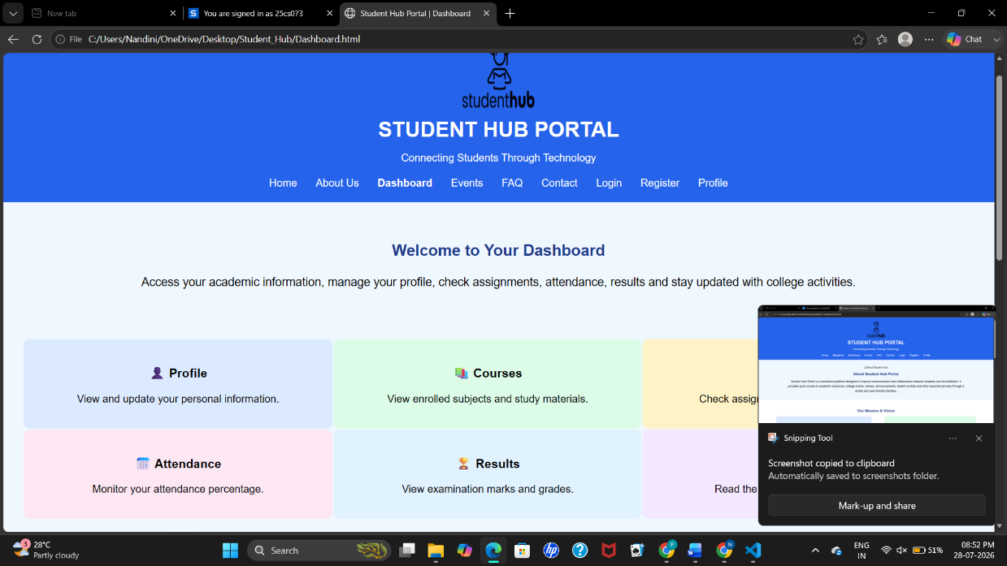

3.About Us
Code:
<!DOCTYPE html>
<html lang="en">

<head>
<meta charset="UTF-8">
<meta name="viewport" content="width=device-width, initial-scale=1.0">
<title>Student Hub Portal | About Us</title>
</head>

<body style="margin:0; background-color:#F0F8FF; font-family:Arial, sans-serif;">

<!-- ================= HEADER ================= -->

<header style="background-color:#2563EB; color:white; text-align:center; padding:20px;">

<img src="studenthublogo.png"
alt="Student Hub Logo"
width="110"
height="110">

<h1 style="margin:10px;">
STUDENT HUB PORTAL
</h1>

<p>
Connecting Students Through Technology
</p>

<nav style="margin-top:20px;">

<a href="Home.html" style="color:white;text-decoration:none;padding:12px;">Home</a>

<a href="AboutUs.html" style="color:white;text-decoration:none;padding:12px;"><b>About Us</b></a>

<a href="Dashboard.html" style="color:white;text-decoration:none;padding:12px;">Dashboard</a>

<a href="Events.html" style="color:white;text-decoration:none;padding:12px;">Events</a>

<a href="FAQ.html" style="color:white;text-decoration:none;padding:12px;">FAQ</a>

<a href="Contact.html" style="color:white;text-decoration:none;padding:12px;">Contact</a>

<a href="Login.html" style="color:white;text-decoration:none;padding:12px;">Login</a>

<a href="Register.html" style="color:white;text-decoration:none;padding:12px;">Register</a>

<a href="Profile.html" style="color:white;text-decoration:none;padding:12px;">Profile</a>

</nav>

</header>

<!-- ================= ABOUT US ================= -->

<section style="padding:40px; text-align:center;">

<img src="images/about.jpg"
alt="About Student Hub"
width="600"
height="300">

<h2 style="color:#1E3A8A;">
About Student Hub Portal
</h2>

<p style="font-size:18px; width:80%; margin:auto; line-height:30px;">

Student Hub Portal is a centralized platform designed to improve communication
and collaboration between students and the institution. It provides quick
access to academic resources, college events, notices, announcements,
student profiles and other essential services through a simple and
user-friendly interface.

</p>

</section>

<!-- ================= MISSION & VISION ================= -->

<section style="background:white; padding:40px;">

<h2 align="center" style="color:#1E3A8A;">
Our Mission & Vision
</h2>

<table width="90%" align="center" cellpadding="20">

<tr align="center">

<td style="background:#DBEAFE; border-radius:10px;">

<h3 style="color:#2563EB;">
🎯 Our Mission
</h3>

<p style="line-height:28px;">

To provide students with a secure, reliable and easy-to-use digital platform
that simplifies access to academic information and campus activities.

</p>

</td>

<td width="40"></td>

<td style="background:#DCFCE7; border-radius:10px;">

<h3 style="color:#16A34A;">
🌍 Our Vision
</h3>

<p style="line-height:28px;">

To become an innovative student portal that enhances learning, communication
and overall campus engagement through technology.

</p>

</td>

</tr>

</table>

</section>

<!-- ================= OUR SERVICES ================= -->

<section style="padding:40px;">

<h2 align="center" style="color:#1E3A8A;">
What We Provide
</h2>

<table width="100%" cellpadding="20">

<tr align="center">

<td>

<h3>📚 Academic Resources</h3>

<p>Access notes, assignments and study materials.</p>

</td>

<td>

<h3>📅 Event Registration</h3>

<p>Register for workshops, seminars and competitions.</p>

</td>

<td>

<h3>📢 Notices</h3>

<p>Receive important announcements from the college.</p>

</td>

</tr>

<tr align="center">

<td>

<h3>👤 Student Profile</h3>

<p>Manage your profile and academic details.</p>

</td>

<td>

<h3>💬 Feedback</h3>

<p>Share your suggestions to improve the portal.</p>

</td>

<td>

<h3>❓ Support</h3>

<p>Find answers through our FAQ and Contact pages.</p>

</td>

</tr>

</table>

</section>

<!-- ================= OUR VALUES ================= -->

<section style="background:white; padding:40px;">

<h2 align="center" style="color:#1E3A8A;">
Our Core Values
</h2>

<ul style="font-size:18px; line-height:35px; width:70%; margin:auto;">

<li>✔ Student-Centered Approach</li>

<li>✔ Innovation Through Technology</li>

<li>✔ Accessibility for Everyone</li>

<li>✔ Secure Information Management</li>

<li>✔ Continuous Learning & Growth</li>

<li>✔ Teamwork and Collaboration</li>

</ul>

</section>

<!-- ================= WHY CHOOSE US ================= -->

<section style="padding:40px;">

<h2 align="center" style="color:#1E3A8A;">
Why Choose Student Hub?
</h2>

<table width="90%" align="center" cellpadding="20">

<tr align="center">

<td style="background:#E0F2FE;">

<h3>🚀 Easy to Use</h3>

<p>Simple navigation with a clean and attractive interface.</p>

</td>

<td style="background:#FEF3C7;">

<h3>🔒 Secure</h3>

<p>Your personal and academic information remains protected.</p>

</td>

<td style="background:#DCFCE7;">

<h3>🌐 Accessible</h3>

<p>Access the portal anytime and anywhere.</p>

</td>

</tr>

</table>

</section>

<!-- ================= FOOTER ================= -->

<footer style="background:#1E3A8A;
color:white;
text-align:center;
padding:20px;">

<h3>
Student Hub Portal
</h3>

<p>

<a href="Home.html" style="color:white;text-decoration:none;">Home</a> |

<a href="AboutUs.html" style="color:white;text-decoration:none;">About Us</a> |

<a href="Events.html" style="color:white;text-decoration:none;">Events</a> |

<a href="FAQ.html" style="color:white;text-decoration:none;">FAQ</a> |

<a href="Contact.html" style="color:white;text-decoration:none;">Contact</a>

</p>

<p>

&copy; 2026 Student Hub Portal | All Rights Reserved

</p>

</footer>

</body>
</html>
Output:
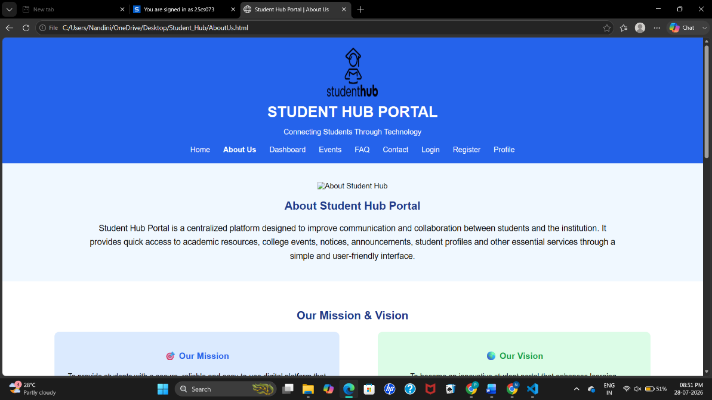
4.Login:-
Code:
<!DOCTYPE html>
<html lang="en">

<head>

<meta charset="UTF-8">

<meta name="viewport" content="width=device-width, initial-scale=1.0">

<title>Student Hub Portal | Login</title>

</head>

<body style="margin:0; background-color:#F0F8FF; font-family:Arial, sans-serif;">

<!-- ================= HEADER ================= -->

<header style="background-color:#2563EB; color:white; text-align:center; padding:20px;">

<img src="studenthublogo.png"
alt="Student Hub Logo"
width="110"
height="110">

<h1 style="margin:10px;">STUDENT HUB PORTAL</h1>

<p>Connecting Students Through Technology</p>

<nav style="margin-top:20px;">

<a href="Home.html" style="color:white;text-decoration:none;padding:12px;">Home</a>

<a href="AboutUs.html" style="color:white;text-decoration:none;padding:12px;">About Us</a>

<a href="Dashboard.html" style="color:white;text-decoration:none;padding:12px;">Dashboard</a>

<a href="Events.html" style="color:white;text-decoration:none;padding:12px;">Events</a>

<a href="FAQ.html" style="color:white;text-decoration:none;padding:12px;">FAQ</a>

<a href="Contact.html" style="color:white;text-decoration:none;padding:12px;">Contact</a>

<a href="Login.html" style="color:white;text-decoration:none;padding:12px;"><b>Login</b></a>

<a href="Register.html" style="color:white;text-decoration:none;padding:12px;">Register</a>

<a href="Profile.html" style="color:white;text-decoration:none;padding:12px;">Profile</a>

</nav>

</header>

<!-- ================= LOGIN ================= -->

<section style="text-align:center; padding:40px;">

<h2 style="color:#1E3A8A;">
Student Login
</h2>

<p style="font-size:18px; width:70%; margin:auto; line-height:30px;">

Login to access your dashboard, profile, assignments,
results and latest college updates.

</p>

</section>

<!-- ================= LOGIN FORM ================= -->

<section style="padding:30px;">

<form>

<table align="center"
cellpadding="15"
style="background:white;
width:45%;
border-radius:10px;">

<tr>

<td colspan="2" align="center">

<img src="images/login.png"
alt="Login"
width="120"
height="120">

</td>

</tr>

<tr>

<td><b>Email ID</b></td>

<td>

<input type="email"
placeholder="Enter Email Address"
style="width:100%; padding:8px;">

</td>

</tr>

<tr>

<td><b>Password</b></td>

<td>

<input type="password"
placeholder="Enter Password"
style="width:100%; padding:8px;">

</td>

</tr>

<tr>

<td colspan="2">

<input type="checkbox">

Remember Me

</td>

</tr>

<tr align="center">

<td colspan="2">

<input type="submit"
value="Login"
style="background:#2563EB;
color:white;
border:none;
padding:12px 30px;
cursor:pointer;
font-size:16px;">

&nbsp;&nbsp;

<input type="reset"
value="Clear"
style="background:#16A34A;
color:white;
border:none;
padding:12px 30px;
cursor:pointer;
font-size:16px;">

</td>

</tr>

</table>

</form>

</section>

<!-- ================= QUICK LINKS ================= -->

<section style="background:white;padding:30px;">

<h2 align="center" style="color:#1E3A8A;">
Need Help?
</h2>

<table width="80%" cellpadding="20">

<tr align="center">

<td style="background:#DBEAFE;">

<h3>🔑 Forgot Password?</h3>

<p>Contact the administrator to reset your password.</p>

</td>

<td style="background:#DCFCE7;">

<h3>📝 New Student?</h3>

<p>Create your account by visiting the Register page.</p>

<br>

<a href="Register.html">

<button style="background:#16A34A;
color:white;
border:none;
padding:10px 20px;
cursor:pointer;">

Register Now

</button>

</a>

</td>

<td style="background:#FEF3C7;">

<h3>📞 Support</h3>

<p>Email: support@studenthub.com</p>

<p>Phone: +91 98765 43210</p>

</td>

</tr>

</table>

</section>

<!-- ================= LOGIN BENEFITS ================= -->

<section style="padding:30px;">

<h2 align="center" style="color:#1E3A8A;">
Benefits of Logging In
</h2>

<ul style="font-size:18px; line-height:35px; width:70%; margin:auto;">

<li>✔ Access your personal dashboard.</li>

<li>✔ View assignments and attendance.</li>

<li>✔ Check examination results.</li>

<li>✔ Register for college events.</li>

<li>✔ Receive important announcements.</li>

<li>✔ Update your student profile.</li>

</ul>

</section>

<!-- ================= FOOTER ================= -->

<footer style="background:#1E3A8A;
color:white;
text-align:center;
padding:20px;">

<h3>Student Hub Portal</h3>

<p>

<a href="Home.html" style="color:white;text-decoration:none;">Home</a> |

<a href="AboutUs.html" style="color:white;text-decoration:none;">About Us</a> |

<a href="Events.html" style="color:white;text-decoration:none;">Events</a> |

<a href="FAQ.html" style="color:white;text-decoration:none;">FAQ</a> |

<a href="Contact.html" style="color:white;text-decoration:none;">Contact</a>

</p>

<p>

&copy; 2026 Student Hub Portal | All Rights Reserved

</p>

</footer>

</body>

</html>
Output:
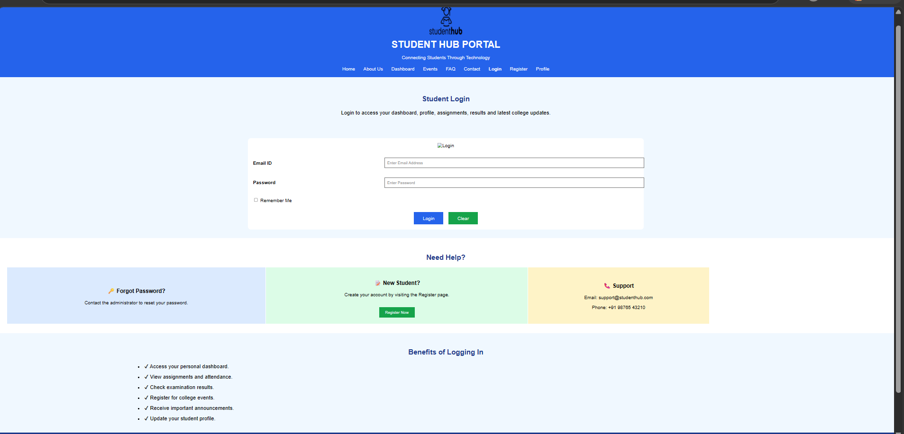
5.Register:-
Code:
<!DOCTYPE html>
<html lang="en">

<head>

<meta charset="UTF-8">

<meta name="viewport" content="width=device-width, initial-scale=1.0">

<title>Student Hub Portal | Register</title>

</head>

<body style="margin:0; background-color:#F0F8FF; font-family:Arial, sans-serif;">

<!-- ================= HEADER ================= -->

<header style="background-color:#2563EB; color:white; text-align:center; padding:20px;">

<img src="studenthublogo.png"
alt="Student Hub Logo"
width="110"
height="110">

<h1 style="margin:10px;">STUDENT HUB PORTAL</h1>

<p>Connecting Students Through Technology</p>

<nav style="margin-top:20px;">

<a href="Home.html" style="color:white;text-decoration:none;padding:12px;">Home</a>

<a href="AboutUs.html" style="color:white;text-decoration:none;padding:12px;">About Us</a>

<a href="Dashboard.html" style="color:white;text-decoration:none;padding:12px;">Dashboard</a>

<a href="Events.html" style="color:white;text-decoration:none;padding:12px;">Events</a>

<a href="FAQ.html" style="color:white;text-decoration:none;padding:12px;">FAQ</a>

<a href="Contact.html" style="color:white;text-decoration:none;padding:12px;">Contact</a>

<a href="Login.html" style="color:white;text-decoration:none;padding:12px;">Login</a>

<a href="Register.html" style="color:white;text-decoration:none;padding:12px;"><b>Register</b></a>

<a href="Profile.html" style="color:white;text-decoration:none;padding:12px;">Profile</a>

</nav>

</header>

<!-- ================= PAGE TITLE ================= -->

<section style="text-align:center;padding:40px;">

<img src="images/register.png"
alt="Register"
width="140"
height="140">

<h2 style="color:#1E3A8A;">
Student Registration
</h2>

<p style="font-size:18px; width:80%; margin:auto; line-height:30px;">

Complete the registration form below to create your Student Hub account.

</p>

</section>

<!-- ================= REGISTRATION FORM ================= -->

<section style="padding:30px;">

<form>

<table align="center"
cellpadding="12"
width="70%"
style="background:white;">

<tr bgcolor="#2563EB">

<th colspan="2" style="color:white;">

Registration Form

</th>

</tr>

<tr>

<td><b>First Name</b></td>

<td><input type="text" style="width:100%; padding:8px;"></td>

</tr>

<tr>

<td><b>Last Name</b></td>

<td><input type="text" style="width:100%; padding:8px;"></td>

</tr>

<tr>

<td><b>Enrollment Number</b></td>

<td><input type="text" style="width:100%; padding:8px;"></td>

</tr>

<tr>

<td><b>Email Address</b></td>

<td><input type="email" style="width:100%; padding:8px;"></td>

</tr>

<tr>

<td><b>Mobile Number</b></td>

<td><input type="tel" style="width:100%; padding:8px;"></td>

</tr>

<tr>

<td><b>Date of Birth</b></td>

<td><input type="date" style="width:100%; padding:8px;"></td>

</tr>

<tr>

<td><b>Gender</b></td>

<td>

<input type="radio" name="gender"> Male

<input type="radio" name="gender"> Female

<input type="radio" name="gender"> Other

</td>

</tr>

<tr>

<td><b>Department</b></td>

<td>

<select style="width:100%; padding:8px;">

<option>Computer Engineering</option>

<option>Information Technology</option>

<option>Mechanical Engineering</option>

<option>Civil Engineering</option>

<option>Electrical Engineering</option>

</select>

</td>

</tr>

<tr>

<td><b>Semester</b></td>

<td>

<select style="width:100%; padding:8px;">

<option>Semester 1</option>

<option>Semester 2</option>

<option>Semester 3</option>

<option>Semester 4</option>

<option>Semester 5</option>

<option>Semester 6</option>

<option>Semester 7</option>

<option>Semester 8</option>

</select>

</td>

</tr>

<tr>

<td><b>Address</b></td>

<td>

<textarea rows="4"
style="width:100%;"></textarea>

</td>

</tr>

<tr>

<td><b>Password</b></td>

<td>

<input type="password"
style="width:100%; padding:8px;">

</td>

</tr>

<tr>

<td><b>Confirm Password</b></td>

<td>

<input type="password"
style="width:100%; padding:8px;">

</td>

</tr>

<tr>

<td><b>Interests</b></td>

<td>

<input type="checkbox"> Coding

<input type="checkbox"> Sports

<input type="checkbox"> Music

<input type="checkbox"> Reading

</td>

</tr>

<tr>

<td colspan="2">

<input type="checkbox">

I agree to the Terms and Conditions.

</td>

</tr>

<tr align="center">

<td colspan="2">

<input type="submit"
value="Register"
style="background:#2563EB;
color:white;
border:none;
padding:12px 30px;
font-size:16px;
cursor:pointer;">

&nbsp;&nbsp;

<input type="reset"
value="Clear"
style="background:#16A34A;
color:white;
border:none;
padding:12px 30px;
font-size:16px;
cursor:pointer;">

</td>

</tr>

</table>

</form>

</section>

<!-- ================= BENEFITS ================= -->

<section style="background:white;padding:30px;">

<h2 align="center" style="color:#1E3A8A;">

Why Register?

</h2>

<table width="100%" cellpadding="20">

<tr align="center">

<td style="background:#DBEAFE;">

<h3>📚 Study Resources</h3>

<p>Access notes, assignments and course material.</p>

</td>

<td style="background:#DCFCE7;">

<h3>📅 Event Registration</h3>

<p>Participate in workshops and competitions.</p>

</td>

<td style="background:#FEF3C7;">

<h3>👤 Student Profile</h3>

<p>Manage all your academic information online.</p>

</td>

</tr>

</table>

</section>

<!-- ================= FOOTER ================= -->

<footer style="background:#1E3A8A;
color:white;
text-align:center;
padding:20px;">

<h3>Student Hub Portal</h3>

<p>

<a href="Home.html" style="color:white;text-decoration:none;">Home</a> |

<a href="AboutUs.html" style="color:white;text-decoration:none;">About Us</a> |

<a href="Events.html" style="color:white;text-decoration:none;">Events</a> |

<a href="FAQ.html" style="color:white;text-decoration:none;">FAQ</a> |

<a href="Contact.html" style="color:white;text-decoration:none;">Contact</a>

</p>

<p>

&copy; 2026 Student Hub Portal | All Rights Reserved

</p>

</footer>

</body>

</html>

Output:
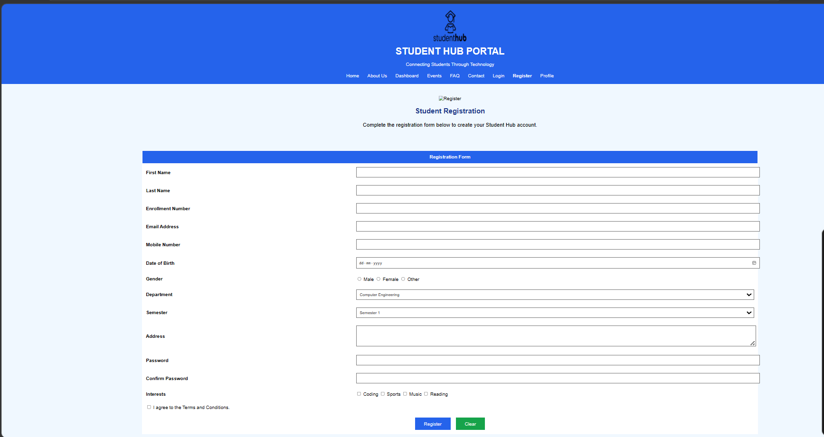
6.Contact Us:-
Code:
<!DOCTYPE html>
<html lang="en">

<head>

<meta charset="UTF-8">

<meta name="viewport" content="width=device-width, initial-scale=1.0">

<title>Student Hub Portal | Contact</title>

</head>

<body style="margin:0; background-color:#F0F8FF; font-family:Arial, sans-serif;">

<!-- ================= HEADER ================= -->

<header style="background-color:#2563EB; color:white; text-align:center; padding:20px;">

<img src="studenthublogo.png"
alt="Student Hub Logo"
width="110"
height="110">

<h1 style="margin:10px;">STUDENT HUB PORTAL</h1>

<p>Connecting Students Through Technology</p>

<nav style="margin-top:20px;">

<a href="Home.html" style="color:white;text-decoration:none;padding:12px;">Home</a>

<a href="AboutUs.html" style="color:white;text-decoration:none;padding:12px;">About Us</a>

<a href="Dashboard.html" style="color:white;text-decoration:none;padding:12px;">Dashboard</a>

<a href="Events.html" style="color:white;text-decoration:none;padding:12px;">Events</a>

<a href="FAQ.html" style="color:white;text-decoration:none;padding:12px;">FAQ</a>

<a href="Contact.html" style="color:white;text-decoration:none;padding:12px;"><b>Contact</b></a>

<a href="Login.html" style="color:white;text-decoration:none;padding:12px;">Login</a>

<a href="Register.html" style="color:white;text-decoration:none;padding:12px;">Register</a>

<a href="Profile.html" style="color:white;text-decoration:none;padding:12px;">Profile</a>

</nav>

</header>

<!-- ================= PAGE TITLE ================= -->

<section style="text-align:center;padding:40px;">

<h2 style="color:#1E3A8A;">
Contact Us
</h2>

<p style="font-size:18px; width:80%; margin:auto; line-height:30px;">

Have questions or need assistance? We'd love to hear from you.
Contact us using the information below or send us a message through the contact form.

</p>

</section>

<!-- ================= CONTACT DETAILS ================= -->

<section style="background:white;padding:30px;">

<h2 align="center" style="color:#1E3A8A;">
Our Contact Information
</h2>

<table width="100%" cellpadding="20">

<tr align="center">

<td style="background:#DBEAFE;">

<h3>📍 Address</h3>

<p>

ABC College of Engineering<br>

Anand, Gujarat<br>

India

</p>

</td>

<td style="background:#DCFCE7;">

<h3>📞 Phone</h3>

<p>

+91 98765 43210<br>

+91 91234 56789

</p>

</td>

<td style="background:#FEF3C7;">

<h3>📧 Email</h3>

<p>

info@studenthub.com<br>

support@studenthub.com

</p>

</td>

</tr>

</table>

</section>

<!-- ================= CONTACT FORM ================= -->

<section style="padding:30px;">

<h2 align="center" style="color:#1E3A8A;">
Send Us a Message
</h2>

<form>

<table align="center"
cellpadding="15"
style="background:white; width:60%;">

<tr>

<td><b>Full Name</b></td>

<td>

<input type="text"
placeholder="Enter your name"
style="width:100%; padding:8px;">

</td>

</tr>

<tr>

<td><b>Email Address</b></td>

<td>

<input type="email"
placeholder="Enter your email"
style="width:100%; padding:8px;">

</td>

</tr>

<tr>

<td><b>Subject</b></td>

<td>

<input type="text"
placeholder="Enter subject"
style="width:100%; padding:8px;">

</td>

</tr>

<tr>

<td><b>Message</b></td>

<td>

<textarea rows="6"
style="width:100%;"
placeholder="Write your message here..."></textarea>

</td>

</tr>

<tr align="center">

<td colspan="2">

<input type="submit"
value="Send Message"
style="background:#2563EB;
color:white;
border:none;
padding:12px 25px;
cursor:pointer;
font-size:16px;">

&nbsp;&nbsp;

<input type="reset"
value="Clear"
style="background:#16A34A;
color:white;
border:none;
padding:12px 25px;
cursor:pointer;
font-size:16px;">

</td>

</tr>

</table>

</form>

</section>

<!-- ================= OFFICE HOURS ================= -->

<section style="background:white;padding:30px;">

<h2 align="center" style="color:#1E3A8A;">
Office Hours
</h2>

<table border="1"
width="60%"
align="center"
cellpadding="12"
style="border-collapse:collapse;">

<tr bgcolor="#2563EB" style="color:white;">

<th>Day</th>

<th>Timing</th>

</tr>

<tr>

<td>Monday - Friday</td>

<td>9:00 AM - 5:00 PM</td>

</tr>

<tr>

<td>Saturday</td>

<td>9:00 AM - 1:00 PM</td>

</tr>

<tr>

<td>Sunday</td>

<td>Closed</td>

</tr>

</table>

</section>

<!-- ================= MAP ================= -->

<section style="padding:30px; text-align:center;">

<h2 style="color:#1E3A8A;">
College Location
</h2>

<img src="images/map.jpg"
alt="College Location Map"
width="700"
height="300">

<p>

Map location of the Student Hub Campus.

</p>

</section>

<!-- ================= FOOTER ================= -->

<footer style="background:#1E3A8A;
color:white;
text-align:center;
padding:20px;">

<h3>Student Hub Portal</h3>

<p>

<a href="Home.html" style="color:white;text-decoration:none;">Home</a> |

<a href="AboutUs.html" style="color:white;text-decoration:none;">About Us</a> |

<a href="Events.html" style="color:white;text-decoration:none;">Events</a> |

<a href="FAQ.html" style="color:white;text-decoration:none;">FAQ</a> |

<a href="Contact.html" style="color:white;text-decoration:none;">Contact</a>

</p>

<p>

&copy; 2026 Student Hub Portal | All Rights Reserved

</p>

</footer>

</body>
</html>

Output:
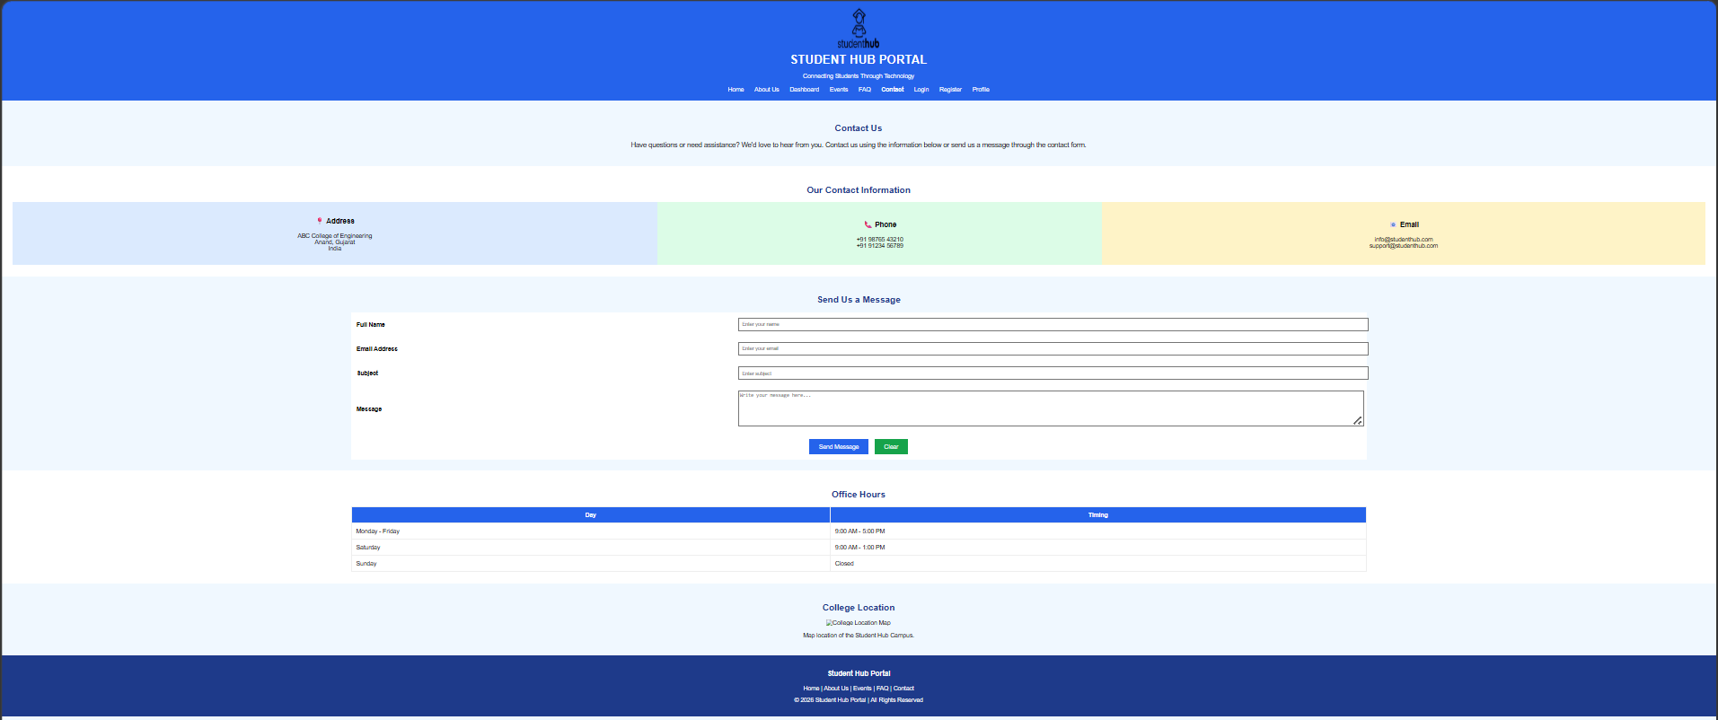
7.Profile:-
Code:
<!DOCTYPE html>
<html lang="en">

<head>

<meta charset="UTF-8">

<meta name="viewport" content="width=device-width, initial-scale=1.0">

<title>Student Hub Portal | Profile</title>

</head>

<body style="margin:0; background-color:#F0F8FF; font-family:Arial, sans-serif;">

<!-- ================= HEADER ================= -->

<header style="background-color:#2563EB; color:white; text-align:center; padding:20px;">

<img src="studenthublogo.png"
alt="Student Hub Logo"
width="110"
height="110">

<h1 style="margin:10px;">STUDENT HUB PORTAL</h1>

<p>Connecting Students Through Technology</p>

<nav style="margin-top:20px;">

<a href="Home.html" style="color:white;text-decoration:none;padding:12px;">Home</a>

<a href="AboutUs.html" style="color:white;text-decoration:none;padding:12px;">About Us</a>

<a href="Dashboard.html" style="color:white;text-decoration:none;padding:12px;">Dashboard</a>

<a href="Events.html" style="color:white;text-decoration:none;padding:12px;">Events</a>

<a href="FAQ.html" style="color:white;text-decoration:none;padding:12px;">FAQ</a>

<a href="Contact.html" style="color:white;text-decoration:none;padding:12px;">Contact</a>

<a href="Login.html" style="color:white;text-decoration:none;padding:12px;">Login</a>

<a href="Register.html" style="color:white;text-decoration:none;padding:12px;">Register</a>

<a href="Profile.html" style="color:white;text-decoration:none;padding:12px;"><b>Profile</b></a>

</nav>

</header>

<!-- ================= PROFILE ================= -->

<section style="text-align:center;padding:40px;">

<img src="images/profile.png"
alt="Student Profile"
width="150"
height="150"
style="border-radius:50%;">

<h2 style="color:#1E3A8A;">

Student Profile

</h2>

<p style="font-size:18px;">

View your personal and academic information.

</p>

</section>

<!-- ================= PERSONAL DETAILS ================= -->

<section style="background:white;padding:30px;">

<h2 align="center" style="color:#1E3A8A;">

Personal Information

</h2>

<table border="1"
width="80%"
align="center"
cellpadding="12"
style="border-collapse:collapse;">

<tr bgcolor="#2563EB" style="color:white;">

<th>Field</th>

<th>Information</th>

</tr>

<tr>

<td>Full Name</td>

<td>Nandani Patel</td>

</tr>

<tr>

<td>Enrollment Number</td>

<td>25CS073</td>

</tr>

<tr>

<td>Email</td>

<td>student@example.com</td>

</tr>

<tr>

<td>Mobile</td>

<td>+91 98765 43210</td>

</tr>

<tr>

<td>Department</td>

<td>Computer Engineering</td>

</tr>

<tr>

<td>Semester</td>

<td>Semester 2</td>

</tr>

</table>

</section>

<!-- ================= ACADEMIC DETAILS ================= -->

<section style="padding:30px;">

<h2 align="center" style="color:#1E3A8A;">

Academic Performance

</h2>

<table width="100%" cellpadding="20">

<tr align="center">

<td style="background:#DBEAFE;">

<h3>📚 Attendance</h3>

<h2>92%</h2>

</td>

<td style="background:#DCFCE7;">

<h3>📝 Assignments</h3>

<h2>8 / 10</h2>

</td>

<td style="background:#FEF3C7;">

<h3>🏆 CGPA</h3>

<h2>8.9</h2>

</td>

<td style="background:#FCE7F3;">

<h3>🎯 Projects</h3>

<h2>5</h2>

</td>

</tr>

</table>

</section>

<!-- ================= SKILLS ================= -->

<section style="background:white;padding:30px;">

<h2 align="center" style="color:#1E3A8A;">

Skills

</h2>

<ul style="font-size:18px; line-height:35px; width:70%; margin:auto;">

<li>✔ HTML5</li>

<li>✔ CSS3</li>

<li>✔ JavaScript</li>

<li>✔ C Programming</li>

<li>✔ C++ Programming</li>

<li>✔ Web Development</li>

</ul>

</section>

<!-- ================= ACHIEVEMENTS ================= -->

<section style="padding:30px;">

<h2 align="center" style="color:#1E3A8A;">

Achievements

</h2>

<table width="90%" cellpadding="20">

<tr align="center">

<td style="background:#DBEAFE;">

🏅 Participated in Hackathon 2026

</td>

<td style="background:#DCFCE7;">

🥇 Web Development Workshop Completed

</td>

<td style="background:#FEF3C7;">

🎖 Active Student Club Member

</td>

</tr>

</table>

</section>

<!-- ================= ACTION BUTTONS ================= -->

<section style="text-align:center;padding:30px;">

<a href="Dashboard.html">

<button style="background:#2563EB;
color:white;
border:none;
padding:12px 30px;
font-size:16px;
cursor:pointer;">

Dashboard

</button>

</a>

&nbsp;&nbsp;

<a href="Contact.html">

<button style="background:#16A34A;
color:white;
border:none;
padding:12px 30px;
font-size:16px;
cursor:pointer;">

Contact Support

</button>

</a>

</section>

<!-- ================= FOOTER ================= -->

<footer style="background:#1E3A8A;
color:white;
text-align:center;
padding:20px;">

<h3>Student Hub Portal</h3>

<p>

<a href="Home.html" style="color:white;text-decoration:none;">Home</a> |

<a href="AboutUs.html" style="color:white;text-decoration:none;">About Us</a> |

<a href="Events.html" style="color:white;text-decoration:none;">Events</a> |

<a href="FAQ.html" style="color:white;text-decoration:none;">FAQ</a> |

<a href="Contact.html" style="color:white;text-decoration:none;">Contact</a>

</p>

<p>

&copy; 2026 Student Hub Portal | All Rights Reserved

</p>

</footer>

</body>

</html>

Output:
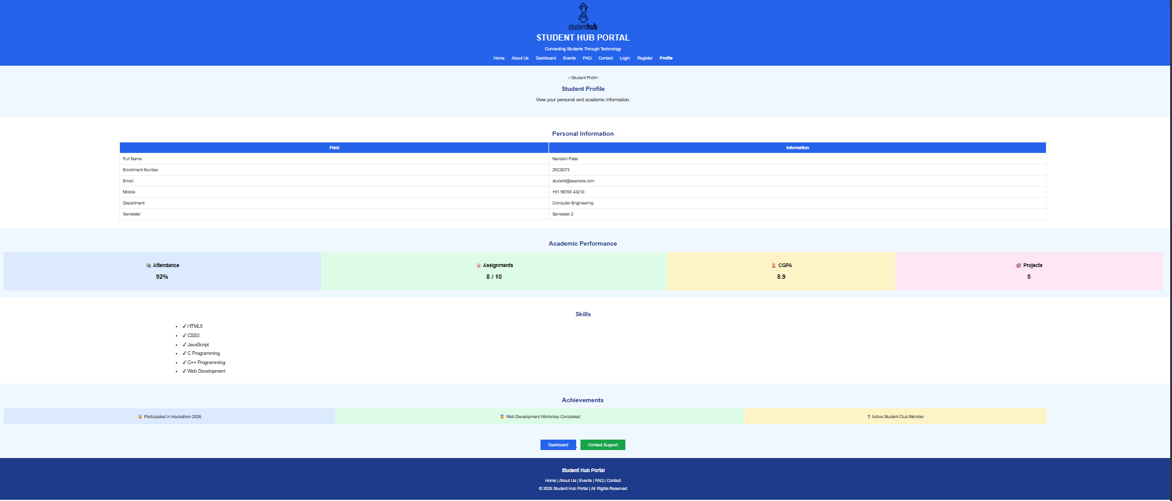
8.Events:-
Code:
<!DOCTYPE html>
<html lang="en">

<head>
<meta charset="UTF-8">
<meta name="viewport" content="width=device-width, initial-scale=1.0">
<title>Student Hub Portal | Events</title>
</head>

<body style="margin:0; background-color:#F0F8FF; font-family:Arial, sans-serif;">

<!-- ================= HEADER ================= -->

<header style="background-color:#2563EB; color:white; text-align:center; padding:20px;">

<img src="studenthublogo.png"
alt="Student Hub Logo"
width="110"
height="110">

<h1 style="margin:10px;">STUDENT HUB PORTAL</h1>

<p>Connecting Students Through Technology</p>

<nav style="margin-top:20px;">

<a href="Home.html" style="color:white;text-decoration:none;padding:12px;">Home</a>

<a href="AboutUs.html" style="color:white;text-decoration:none;padding:12px;">About Us</a>

<a href="Dashboard.html" style="color:white;text-decoration:none;padding:12px;">Dashboard</a>

<a href="Events.html" style="color:white;text-decoration:none;padding:12px;"><b>Events</b></a>

<a href="FAQ.html" style="color:white;text-decoration:none;padding:12px;">FAQ</a>

<a href="Contact.html" style="color:white;text-decoration:none;padding:12px;">Contact</a>

<a href="Login.html" style="color:white;text-decoration:none;padding:12px;">Login</a>

<a href="Register.html" style="color:white;text-decoration:none;padding:12px;">Register</a>

<a href="Profile.html" style="color:white;text-decoration:none;padding:12px;">Profile</a>

</nav>

</header>

<!-- ================= PAGE TITLE ================= -->

<section style="text-align:center;padding:40px;">

<h2 style="color:#1E3A8A;">
College Events
</h2>

<p style="font-size:18px; width:80%; margin:auto; line-height:30px;">

Stay informed about workshops, competitions,
seminars, cultural programmes and sports activities
happening in our college.

</p>

</section>

<!-- ================= UPCOMING EVENTS ================= -->

<section style="background:white;padding:30px;">

<h2 align="center" style="color:#1E3A8A;">
Upcoming Events
</h2>

<table border="1"
width="90%"
align="center"
cellpadding="12"
style="border-collapse:collapse; background:white;">

<tr bgcolor="#2563EB" style="color:white;">

<th>Event</th>
<th>Date</th>
<th>Time</th>
<th>Venue</th>

</tr>

<tr>

<td>Hackathon 2026</td>
<td>25 July</td>
<td>9:00 AM</td>
<td>Seminar Hall</td>

</tr>

<tr>

<td>Web Development Workshop</td>
<td>30 July</td>
<td>11:00 AM</td>
<td>Computer Lab</td>

</tr>

<tr>

<td>Coding Competition</td>
<td>5 August</td>
<td>10:00 AM</td>
<td>Auditorium</td>

</tr>

<tr>

<td>Sports Meet</td>
<td>12 August</td>
<td>8:00 AM</td>
<td>College Ground</td>

</tr>

<tr>

<td>Cultural Fest</td>
<td>20 August</td>
<td>5:00 PM</td>
<td>Main Campus</td>

</tr>

</table>

</section>

<!-- ================= EVENT HIGHLIGHTS ================= -->

<section style="padding:30px;">

<h2 align="center" style="color:#1E3A8A;">
Event Highlights
</h2>

<table width="100%" cellpadding="20">

<tr align="center">

<td style="background:#DBEAFE;">

<h3>💻 Technical Events</h3>

<p>

Coding contests, hackathons,
robotics and AI workshops.

</p>

</td>

<td style="background:#DCFCE7;">

<h3>🎭 Cultural Events</h3>

<p>

Dance, music,
drama and talent shows.

</p>

</td>

<td style="background:#FEF3C7;">

<h3>🏆 Sports</h3>

<p>

Indoor and outdoor
sports competitions.

</p>

</td>

</tr>

</table>

</section>

<!-- ================= EVENT GALLERY ================= -->

<section style="background:white;padding:30px;">

<h2 align="center" style="color:#1E3A8A;">
Event Gallery
</h2>

<table width="100%" cellpadding="20">

<tr align="center">

<td>

<img src="images/event1.jpg"
alt="Hackathon"
width="250"
height="170">

<p>Hackathon</p>

</td>

<td>

<img src="images/event2.jpg"
alt="Workshop"
width="250"
height="170">

<p>Workshop</p>

</td>

<td>

<img src="images/event3.jpg"
alt="Sports"
width="250"
height="170">

<p>Sports Meet</p>

</td>

</tr>

</table>

</section>

<!-- ================= REGISTER ================= -->

<section style="padding:40px; text-align:center;">

<h2 style="color:#1E3A8A;">
Participate in Upcoming Events
</h2>

<p style="font-size:18px;">

Register now and showcase your talent.

</p>

<a href="Register.html">

<button style="background:#2563EB;
color:white;
border:none;
padding:12px 30px;
font-size:18px;
cursor:pointer;">

Register Now

</button>

</a>

&nbsp;&nbsp;

<a href="Contact.html">

<button style="background:#16A34A;
color:white;
border:none;
padding:12px 30px;
font-size:18px;
cursor:pointer;">

Contact Coordinator

</button>

</a>

</section>

<!-- ================= ANNOUNCEMENTS ================= -->

<section style="background:white;padding:30px;">

<h2 align="center" style="color:#1E3A8A;">
Latest Event Announcements
</h2>

<marquee>

🎉 Hackathon Registration Open |
🏆 Sports Meet Begins Soon |
💻 Web Development Workshop Seats Filling Fast |
🎭 Cultural Fest Auditions This Week

</marquee>

</section>

<!-- ================= FOOTER ================= -->

<footer style="background:#1E3A8A;
color:white;
text-align:center;
padding:20px;">

<h3>Student Hub Portal</h3>

<p>

<a href="Home.html" style="color:white;text-decoration:none;">Home</a> |

<a href="AboutUs.html" style="color:white;text-decoration:none;">About Us</a> |

<a href="Events.html" style="color:white;text-decoration:none;">Events</a> |

<a href="FAQ.html" style="color:white;text-decoration:none;">FAQ</a> |

<a href="Contact.html" style="color:white;text-decoration:none;">Contact</a>

</p>

<p>

&copy; 2026 Student Hub Portal | All Rights Reserved

</p>

</footer>

</body>
</html>

Output:
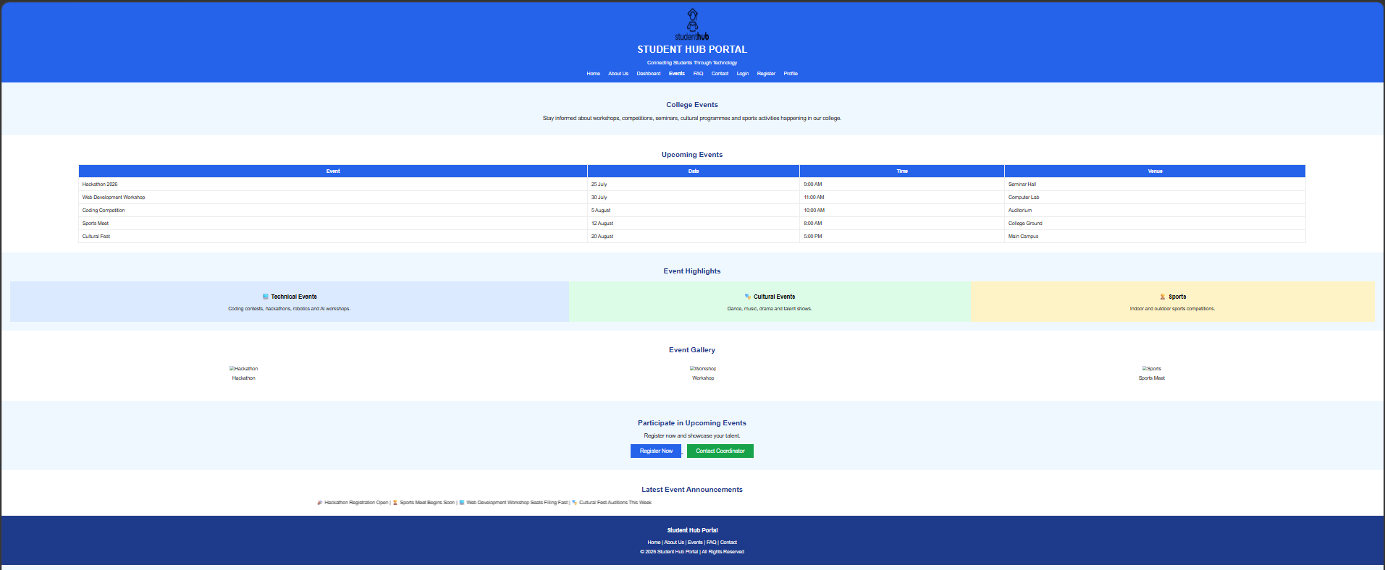
9.FAQ:-
Code:
<!DOCTYPE html>
<html lang="en">

<head>

<meta charset="UTF-8">

<meta name="viewport" content="width=device-width, initial-scale=1.0">

<title>Student Hub Portal | FAQ</title>

</head>

<body style="margin:0; background-color:#F0F8FF; font-family:Arial, sans-serif;">

<!-- ================= HEADER ================= -->

<header style="background-color:#2563EB; color:white; text-align:center; padding:20px;">

<img src="studenthublogo.png"
alt="Student Hub Logo"
width="110"
height="110">

<h1 style="margin:10px;">STUDENT HUB PORTAL</h1>

<p>Connecting Students Through Technology</p>

<nav style="margin-top:20px;">

<a href="Home.html" style="color:white;text-decoration:none;padding:12px;">Home</a>

<a href="AboutUs.html" style="color:white;text-decoration:none;padding:12px;">About Us</a>

<a href="Dashboard.html" style="color:white;text-decoration:none;padding:12px;">Dashboard</a>

<a href="Events.html" style="color:white;text-decoration:none;padding:12px;">Events</a>

<a href="FAQ.html" style="color:white;text-decoration:none;padding:12px;"><b>FAQ</b></a>

<a href="Contact.html" style="color:white;text-decoration:none;padding:12px;">Contact</a>

<a href="Login.html" style="color:white;text-decoration:none;padding:12px;">Login</a>

<a href="Register.html" style="color:white;text-decoration:none;padding:12px;">Register</a>

<a href="Profile.html" style="color:white;text-decoration:none;padding:12px;">Profile</a>

</nav>

</header>

<!-- ================= PAGE TITLE ================= -->

<section style="text-align:center;padding:40px;">

<h2 style="color:#1E3A8A;">
Frequently Asked Questions
</h2>

<p style="font-size:18px; width:80%; margin:auto; line-height:30px;">

Find answers to the most common questions about Student Hub Portal.

</p>

</section>

<!-- ================= FAQ TABLE ================= -->

<section style="padding:30px;">

<table width="90%"
align="center"
cellpadding="15"
style="background:white; border-collapse:collapse;">

<tr bgcolor="#2563EB" style="color:white;">

<th width="40%">Question</th>

<th>Answer</th>

</tr>

<tr bgcolor="#DBEAFE">

<td><b>How do I register on the portal?</b></td>

<td>Click on the Register page, fill in your details and submit the registration form.</td>

</tr>

<tr>

<td><b>How can I log in?</b></td>

<td>Use your registered email ID and password on the Login page.</td>

</tr>

<tr bgcolor="#DBEAFE">

<td><b>Can I update my profile?</b></td>

<td>Yes. Open the Profile page after logging in and edit your information.</td>

</tr>

<tr>

<td><b>Where can I see upcoming events?</b></td>

<td>Visit the Events page to view workshops, competitions and other college activities.</td>

</tr>

<tr bgcolor="#DBEAFE">

<td><b>How do I contact the college?</b></td>

<td>You can use the Contact page to send your message or enquiry.</td>

</tr>

<tr>

<td><b>Is Student Hub available on mobile?</b></td>

<td>Yes. The portal can be accessed through any modern web browser on mobile or desktop.</td>

</tr>

</table>

</section>

<!-- ================= QUICK HELP ================= -->

<section style="background:white;padding:30px;">

<h2 align="center" style="color:#1E3A8A;">

Need Quick Help?

</h2>

<table width="90%" cellpadding="20">

<tr align="center">

<td style="background:#DBEAFE;">

<h3>📧 Email Support</h3>

<p>support@studenthub.com</p>

</td>

<td style="background:#DCFCE7;">

<h3>📞 Phone Support</h3>

<p>+91 98765 43210</p>

</td>

<td style="background:#FEF3C7;">

<h3>⏰ Working Hours</h3>

<p>Monday - Friday<br>9:00 AM - 5:00 PM</p>

</td>

</tr>

</table>

</section>

<!-- ================= HELPFUL TIPS ================= -->

<section style="padding:30px;">

<h2 align="center" style="color:#1E3A8A;">

Helpful Tips

</h2>

<ul style="font-size:18px; line-height:35px; width:75%; margin:auto;">

<li>✔ Always keep your password secure.</li>

<li>✔ Check the portal regularly for new announcements.</li>

<li>✔ Update your profile whenever your details change.</li>

<li>✔ Register early for workshops and competitions.</li>

<li>✔ Contact support if you face any login issues.</li>

</ul>

</section>

<!-- ================= CONTACT BUTTON ================= -->

<section style="text-align:center;padding:40px;">

<h2 style="color:#1E3A8A;">

Didn't Find Your Answer?

</h2>

<p style="font-size:18px;">

Our support team is always ready to help you.

</p>

<a href="Contact.html">

<button style="background:#2563EB;
color:white;
border:none;
padding:12px 30px;
font-size:18px;
cursor:pointer;">

Contact Us

</button>

</a>

</section>

<!-- ================= FOOTER ================= -->

<footer style="background:#1E3A8A;
color:white;
text-align:center;
padding:20px;">

<h3>Student Hub Portal</h3>

<p>

<a href="Home.html" style="color:white;text-decoration:none;">Home</a> |

<a href="AboutUs.html" style="color:white;text-decoration:none;">About Us</a> |

<a href="Events.html" style="color:white;text-decoration:none;">Events</a> |

<a href="FAQ.html" style="color:white;text-decoration:none;">FAQ</a> |

<a href="Contact.html" style="color:white;text-decoration:none;">Contact</a>

</p>

<p>

&copy; 2026 Student Hub Portal | All Rights Reserved

</p>

</footer>

</body>

</html>

Output:
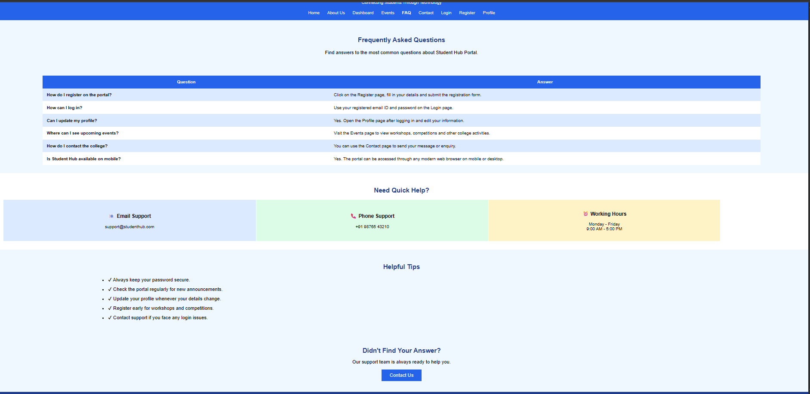
10.Feedback:-
Code:
<!DOCTYPE html>
<html lang="en">

<head>

<meta charset="UTF-8">

<meta name="viewport" content="width=device-width, initial-scale=1.0">

<title>Student Hub Portal | Feedback</title>

</head>

<body style="margin:0; background-color:#F0F8FF; font-family:Arial, sans-serif;">

<!-- ================= HEADER ================= -->

<header style="background-color:#2563EB; color:white; text-align:center; padding:20px;">

<img src="studenthublogo.png"
alt="Student Hub Logo"
width="110"
height="110">

<h1 style="margin:10px;">STUDENT HUB PORTAL</h1>

<p>Connecting Students Through Technology</p>

<nav style="margin-top:20px;">

<a href="Home.html" style="color:white;text-decoration:none;padding:12px;">Home</a>

<a href="AboutUs.html" style="color:white;text-decoration:none;padding:12px;">About Us</a>

<a href="Dashboard.html" style="color:white;text-decoration:none;padding:12px;">Dashboard</a>

<a href="Events.html" style="color:white;text-decoration:none;padding:12px;">Events</a>

<a href="FAQ.html" style="color:white;text-decoration:none;padding:12px;">FAQ</a>

<a href="Contact.html" style="color:white;text-decoration:none;padding:12px;">Contact</a>

<a href="Login.html" style="color:white;text-decoration:none;padding:12px;">Login</a>

<a href="Register.html" style="color:white;text-decoration:none;padding:12px;">Register</a>

<a href="Profile.html" style="color:white;text-decoration:none;padding:12px;">Profile</a>

<a href="Feedback.html" style="color:white;text-decoration:none;padding:12px;"><b>Feedback</b></a>

</nav>

</header>

<!-- ================= PAGE TITLE ================= -->

<section style="text-align:center;padding:40px;">

<img src="images/feedback.png"
alt="Feedback"
width="140"
height="140">

<h2 style="color:#1E3A8A;">

Student Feedback

</h2>

<p style="font-size:18px; width:80%; margin:auto; line-height:30px;">

Your feedback helps us improve the Student Hub Portal and provide better
services for all students.

</p>

</section>

<!-- ================= FEEDBACK FORM ================= -->

<section style="padding:30px;">

<form>

<table align="center"
cellpadding="12"
width="70%"
style="background:white;">

<tr bgcolor="#2563EB">

<th colspan="2" style="color:white;">

Feedback Form

</th>

</tr>

<tr>

<td><b>Full Name</b></td>

<td>

<input type="text"
placeholder="Enter your name"
style="width:100%; padding:8px;">

</td>

</tr>

<tr>

<td><b>Email Address</b></td>

<td>

<input type="email"
placeholder="Enter your email"
style="width:100%; padding:8px;">

</td>

</tr>

<tr>

<td><b>Department</b></td>

<td>

<select style="width:100%; padding:8px;">

<option>Computer Engineering</option>
<option>Information Technology</option>
<option>Mechanical Engineering</option>
<option>Civil Engineering</option>
<option>Electrical Engineering</option>

</select>

</td>

</tr>

<tr>

<td><b>Overall Experience</b></td>

<td>

<select style="width:100%; padding:8px;">

<option>Excellent</option>
<option>Very Good</option>
<option>Good</option>
<option>Average</option>
<option>Poor</option>

</select>

</td>

</tr>

<tr>

<td><b>Rate the Portal</b></td>

<td>

⭐
<input type="radio" name="rating">1

⭐
<input type="radio" name="rating">2

⭐
<input type="radio" name="rating">3

⭐
<input type="radio" name="rating">4

⭐
<input type="radio" name="rating">5

</td>

</tr>

<tr>

<td><b>What features do you use?</b></td>

<td>

<input type="checkbox"> Dashboard

<br><br>

<input type="checkbox"> Events

<br><br>

<input type="checkbox"> Profile

<br><br>

<input type="checkbox"> Notices

<br><br>

<input type="checkbox"> Study Materials

</td>

</tr>

<tr>

<td><b>Your Suggestions</b></td>

<td>

<textarea rows="6"
placeholder="Write your feedback here..."
style="width:100%;"></textarea>

</td>

</tr>

<tr>

<td><b>Would you recommend Student Hub?</b></td>

<td>

<input type="radio" name="recommend"> Yes

&nbsp;&nbsp;

<input type="radio" name="recommend"> No

</td>

</tr>

<tr align="center">

<td colspan="2">

<input type="submit"
value="Submit Feedback"
style="background:#2563EB;
color:white;
border:none;
padding:12px 30px;
font-size:16px;
cursor:pointer;">

&nbsp;&nbsp;

<input type="reset"
value="Clear"
style="background:#16A34A;
color:white;
border:none;
padding:12px 30px;
font-size:16px;
cursor:pointer;">

</td>

</tr>

</table>

</form>

</section>

<!-- ================= WHY FEEDBACK MATTERS ================= -->

<section style="background:white;padding:30px;">

<h2 align="center" style="color:#1E3A8A;">

Why Your Feedback Matters

</h2>

<table width="100%" cellpadding="20">

<tr align="center">

<td style="background:#DBEAFE;">

<h3>💡 Better Features</h3>

<p>Your suggestions help us improve the portal.</p>

</td>

<td style="background:#DCFCE7;">

<h3>🚀 Better Experience</h3>

<p>We continuously enhance usability for students.</p>

</td>

<td style="background:#FEF3C7;">

<h3>🎯 Student Satisfaction</h3>

<p>Your opinion helps us provide better services.</p>

</td>

</tr>

</table>

</section>

<!-- ================= THANK YOU ================= -->

<section style="text-align:center;padding:40px;">

<h2 style="color:#1E3A8A;">

Thank You!

</h2>

<p style="font-size:18px;">

We appreciate your valuable feedback and support.

</p>

<a href="Home.html">

<button style="background:#2563EB;
color:white;
border:none;
padding:12px 30px;
font-size:16px;
cursor:pointer;">

Return to Home

</button>

</a>

</section>

<!-- ================= FOOTER ================= -->

<footer style="background:#1E3A8A;
color:white;
text-align:center;
padding:20px;">

<h3>Student Hub Portal</h3>

<p>

<a href="Home.html" style="color:white;text-decoration:none;">Home</a> |

<a href="AboutUs.html" style="color:white;text-decoration:none;">About Us</a> |

<a href="Events.html" style="color:white;text-decoration:none;">Events</a> |

<a href="FAQ.html" style="color:white;text-decoration:none;">FAQ</a> |

<a href="Contact.html" style="color:white;text-decoration:none;">Contact</a>

</p>

<p>

&copy; 2026 Student Hub Portal | All Rights Reserved

</p>

</footer>

</body>

</html>

Output:
