 | 
Faculty of Technology and Engineering
Chandubhai S. Patel Institute of Technology (CSPIT)
Department of Computer Science & Engineering
Date: 22/07/2026
Laboratory Manul
Academic Year | : | 2026-27 | Semester | : | 3rd
Course code | : | ITUE203 | Course name | : | WEB DEVELOPMENT FRAMEWORKS

Practical – 4:
JavaScript, JavaScript DOM Manipulation, Event Handling, and UI Interactivity
Problem Statement:-
Add dynamic UI components such as collapsible FAQ, modal popup, image/content slider, notification banner, hamburger menu, and light/dark
theme switcher using JavaScript.
Objective:- To implement dynamic and interactive web page features using JavaScript DOM manipulation and event handling. The objective is to enhance user experience by creating interactive components such as collapsible FAQ sections, modal popups, image/content sliders, notification banners, hamburger menus, and light/dark theme switching. The practical focuses on selecting and modifying DOM elements, handling user events, managing UI states using class manipulation, and storing user preferences using local Storage.

Github Repository link: https://github.com/Nandani-1809/StudentPortal

Register.html:
Code:

<!DOCTYPE html>
<html lang="en">
<head>
<meta charset="UTF-8">
<meta name="viewport" content="width=device-width, initial-scale=1.0">
<title>Student Hub Portal | Register</title>
<link rel="stylesheet" href="style2.css">
</head>
<body>
<header>

<img src="studenthublogo.png"
alt="Student Hub Logo"
width="110"
height="110">

<h1>STUDENT HUB PORTAL</h1>

<p>Connecting Students Through Technology</p>
<div class="top-controls">

<button id="themeToggle" type="button">
🌙 Dark Mode
</button>

<button
id="menuToggle"
type="button"
aria-label="Toggle navigation"
aria-expanded="false">
☰
</button>
</div>

<nav>

<a href="Home.html">Home</a>

<a href="AboutUs.html">About Us</a>

<a href="Dashboard.html">Dashboard</a>

<a href="Events.html">Events</a>

<a href="FAQ.html">FAQ</a>

<a href="Contact.html">Contact</a>

<a href="Login.html">Login</a>

<a href="Register.html" class="active">Register</a>

<a href="Profile.html">Profile</a>

</nav>

</header>

<!-- ================= NOTIFICATION BANNER ================= -->

<div
id="notificationBanner"
class="notification-banner">

🎉 Welcome to Student Hub Portal!

<button
id="closeNotification"
type="button"
aria-label="Close notification">
×
</button>

</div>

<!-- ================= PAGE TITLE ================= -->

<section class="page-title">

<img src="images/register.png"
alt="Register"
width="140"
height="140">

<h2>Student Registration</h2>

<p>
Complete the registration form below to create
your Student Hub account.
</p>

</section>

<!-- ================= REGISTRATION FORM ================= -->

<section class="registration-section">

<form id="registrationForm" novalidate>

<h2>Registration Form</h2>

<!-- FIRST NAME -->

<div class="form-group">

<label for="firstName">First Name</label>

<input
type="text"
id="firstName"
name="firstName"
placeholder="Enter your first name"
>

<span
class="error"
id="firstNameError">
</span>

</div>

<!-- LAST NAME -->

<div class="form-group">

<label for="lastName">Last Name</label>

<input
type="text"
id="lastName"
name="lastName"
placeholder="Enter your last name"
>

<span
class="error"
id="lastNameError">
</span>

</div>

<!-- ENROLLMENT NUMBER -->

<div class="form-group">

<label for="enrollment">
Enrollment Number
</label>

<input
type="text"
id="enrollment"
name="enrollment"
placeholder="Example: 25CS001"
maxlength="7"
oninput="this.value = this.value.toUpperCase()"
>

<span
class="error"
id="enrollmentError">
</span>

</div>

<!-- EMAIL -->

<div class="form-group">

<label for="email">
Email Address
</label>

<input
type="email"
id="email"
name="email"
placeholder="Enter your email address"
>

<span
class="error"
id="emailError">
</span>

</div>

<!-- MOBILE NUMBER -->

<div class="form-group">

<label for="mobile">
Mobile Number
</label>

<input
type="tel"
id="mobile"
name="mobile"
placeholder="Enter 10-digit mobile number"
maxlength="10"
>

<span
class="error"
id="mobileError">
</span>

</div>

<!-- DATE OF BIRTH -->

<div class="form-group">

<label for="dob">
Date of Birth
</label>

<input
type="date"
id="dob"
name="dob"
>

<span
class="error"
id="dobError">
</span>

</div>

<!-- GENDER -->

<fieldset>

<legend>Gender</legend>

<div class="radio-group">

<label>

<input
type="radio"
name="gender"
value="Male">

Male

</label>

<label>

<input
type="radio"
name="gender"
value="Female">

Female

</label>

<label>

<input
type="radio"
name="gender"
value="Other">

Other

</label>

</div>

<span
class="error"
id="genderError">
</span>

</fieldset>

<!-- DEPARTMENT -->

<div class="form-group">

<label for="course">
Department
</label>

<select
id="course"
name="course">

<option value="">
-- Select Department --
</option>

<option value="Computer Engineering">
Computer Engineering
</option>

<option value="Information Technology">
Information Technology
</option>

<option value="Mechanical Engineering">
Mechanical Engineering
</option>

<option value="Civil Engineering">
Civil Engineering
</option>

<option value="Electrical Engineering">
Electrical Engineering
</option>

</select>

<span
class="error"
id="courseError">
</span>

</div>

<!-- YEAR -->

<div class="form-group">

<label for="year">
Year
</label>

<select
id="year"
name="year">

<option value="">
-- Select Year --
</option>

<option value="1">
First Year
</option>

<option value="2">
Second Year
</option>

<option value="3">
Third Year
</option>

<option value="4">
Fourth Year
</option>

</select>

<span
class="error"
id="yearError">
</span>

</div>

<!-- PASSWORD -->

<div class="form-group">

<label for="password">
Password
</label>

<input
type="password"
id="password"
name="password"
placeholder="Create a strong password"
>

<div class="strength-container">

<div id="strengthBar"></div>

</div>

<span
class="strength-text"
id="strengthText">
</span>

<span
class="error"
id="passwordError">
</span>

</div>

<!-- CONFIRM PASSWORD -->

<div class="form-group">

<label for="confirmPassword">
Confirm Password
</label>

<input
type="password"
id="confirmPassword"
name="confirmPassword"
placeholder="Re-enter your password"
>

<span
class="error"
id="confirmPasswordError">
</span>

</div>

<!-- TERMS -->

<div class="terms">

<label>

<input
type="checkbox"
id="terms"
name="terms">

I agree to the Terms and Conditions.

</label>

<span
class="error"
id="termsError">
</span>

</div>

<!-- BUTTONS -->

<div class="form-buttons">

<button type="submit">
Register
</button>

<button
type="reset"
class="clear-button">

Clear

</button>

</div>

<!-- SUCCESS MESSAGE -->

<div
class="success-message"
id="successMessage">
</div>

</form>

</section>

<!-- ================= BENEFITS ================= -->

<section class="benefits-section">

<h2>Why Register?</h2>

<div class="benefits-container">

<div class="benefit-card study">

<h3>📚 Study Resources</h3>

<p>
Access notes, assignments and course material.
</p>

</div>

<div class="benefit-card events">

<h3>📅 Event Registration</h3>

<p>
Participate in workshops and competitions.
</p>

</div>

<div class="benefit-card profile">

<h3>👤 Student Profile</h3>

<p>
Manage all your academic information online.
</p>

</div>

</div>

</section>

<!-- ================= FAQ ================= -->

<section class="faq-section">

<h2>Frequently Asked Questions</h2>

<div class="faq-item">
<button
class="faq-question"
type="button"
aria-expanded="false">
What is Student Hub Portal?

<span>+</span>

</button>

<div class="faq-answer">

<p>
Student Hub Portal is a platform for students
to access resources, events and academic information.
</p>

</div>

</div>

<div class="faq-item">

<button
class="faq-question"
type="button">

Who can register?

<span>+</span>

</button>

<div class="faq-answer">

<p>
Students can register by providing their
academic and contact information.
</p>

</div>

</div>

<div class="faq-item">

<button
class="faq-question"
type="button">

Can I change my profile information?

<span>+</span>

</button>

<div class="faq-answer">

<p>
Yes, registered students can manage their
profile information.
</p>

</div>

</div>

</section>

<!-- ================= MODAL ================= -->

<section class="modal-section">

<button
id="openModal"
class="modal-button"
type="button">

View Student Hub Information

</button>

</section>

<div
id="infoModal"
class="modal"
role="dialog"
aria-modal="true"
aria-labelledby="modalTitle">

<div class="modal-content">

<button
id="closeModal"
class="close-modal"
type="button"
aria-label="Close modal">

×

</button>

<h2 id="modalTitle">
Student Hub Portal
</h2>

<p>
Student Hub provides students with access to
study resources, events and profile management
facilities.
</p>

</div>

</div>

<!-- ================= CONTENT SLIDER ================= -->

<section class="slider-section">

<h2>Student Hub Features</h2>

<div class="slider">

<div class="slide active-slide">

<h3>📚 Study Resources</h3>

<p>
Access notes, assignments and learning materials.
</p>

</div>

<div class="slide">

<h3>📅 Student Events</h3>

<p>
Discover workshops, competitions and campus events.
</p>

</div>

<div class="slide">

<h3>👤 Student Profile</h3>

<p>
Manage your academic and personal information.
</p>

</div>

</div>

<div class="slider-buttons">

<button
id="prevSlide"
type="button">

Previous

</button>

<button
id="nextSlide"
type="button">

Next

</button>

</div>

</section>

<!-- ================= FOOTER ================= -->

<footer>

<h3>Student Hub Portal</h3>

<p>

<a href="Home.html">Home</a> |

<a href="AboutUs.html">About Us</a> |

<a href="Events.html">Events</a> |

<a href="FAQ.html">FAQ</a> |

<a href="Contact.html">Contact</a>

</p>

<p>
&copy; 2026 Student Hub Portal |
All Rights Reserved
</p>

</footer>
<script src="script.js"></script>
</body>
</html>
Screenshots:
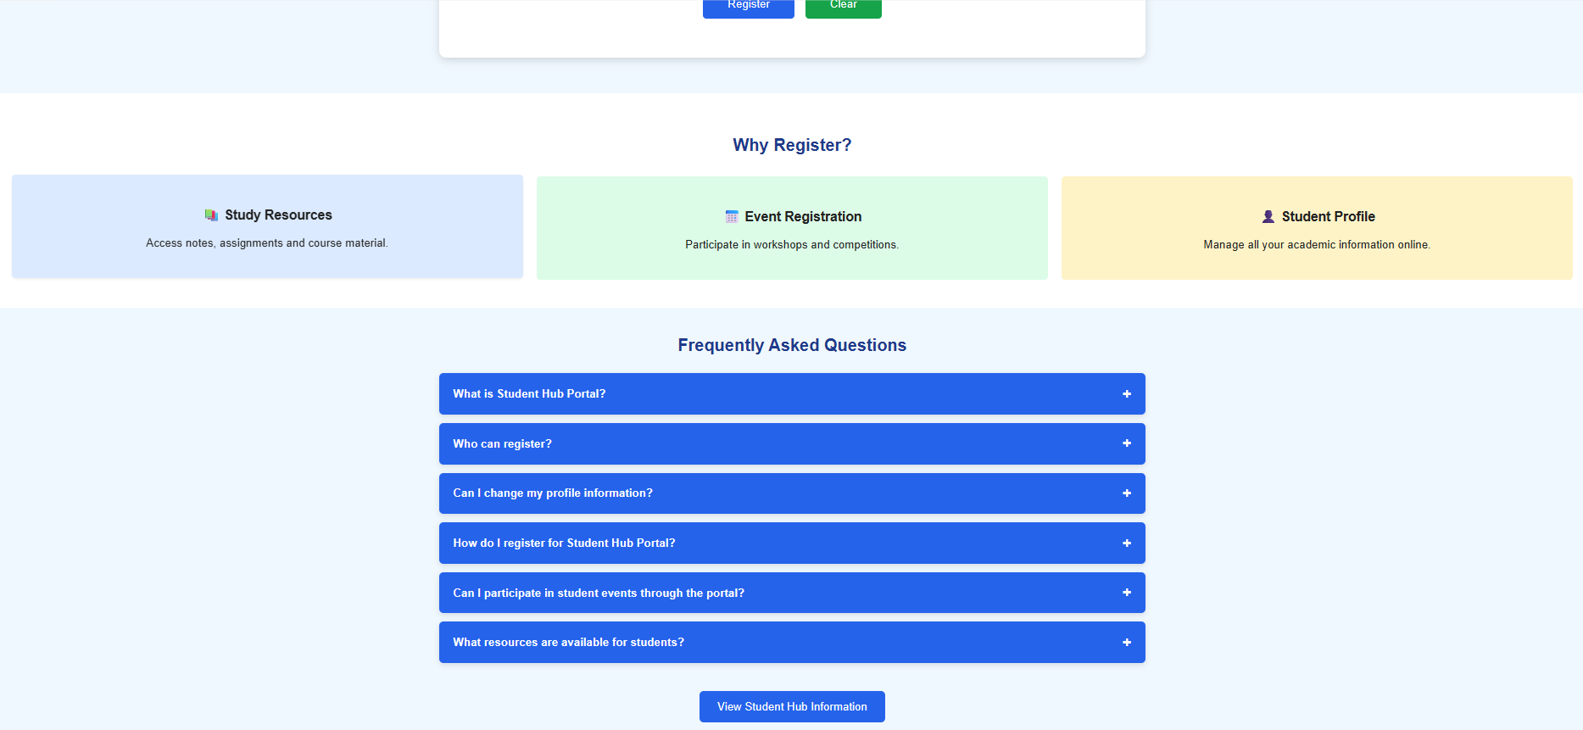

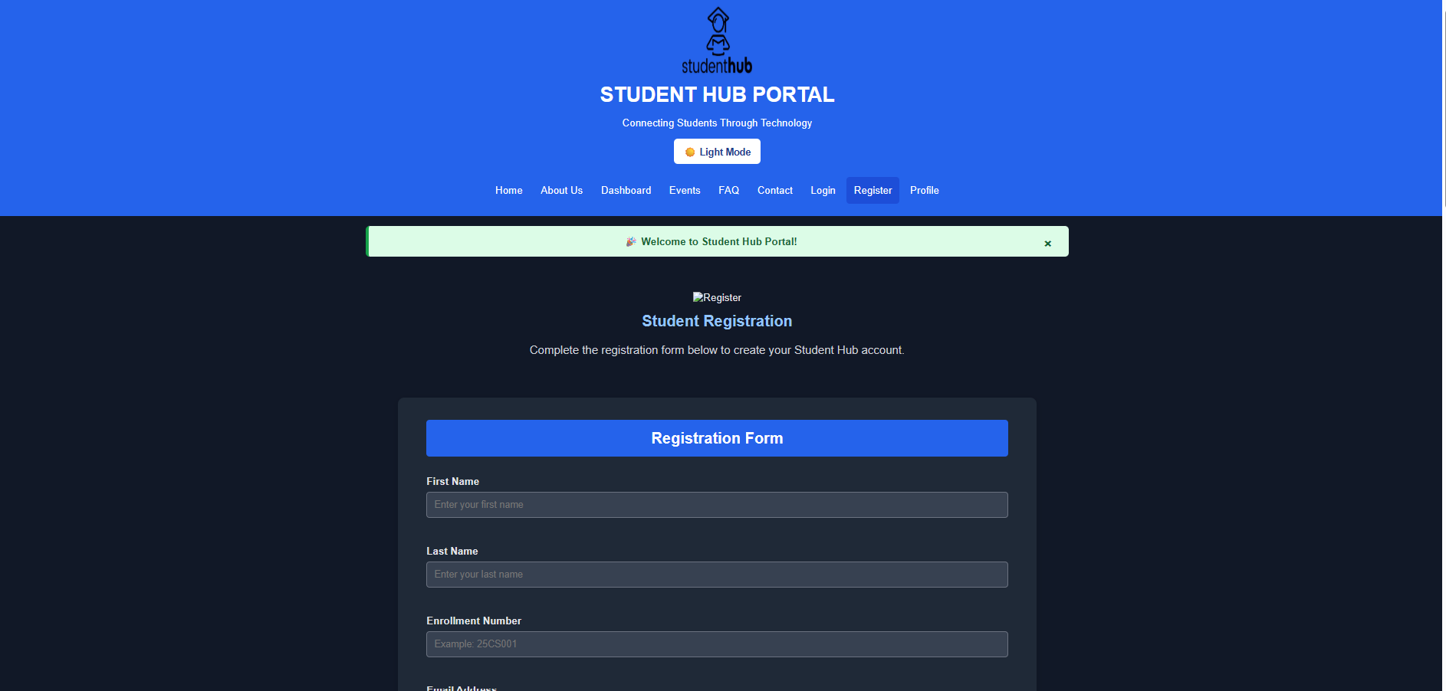

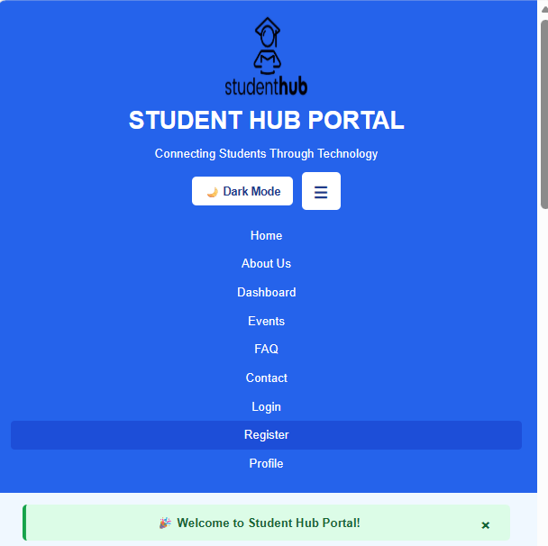

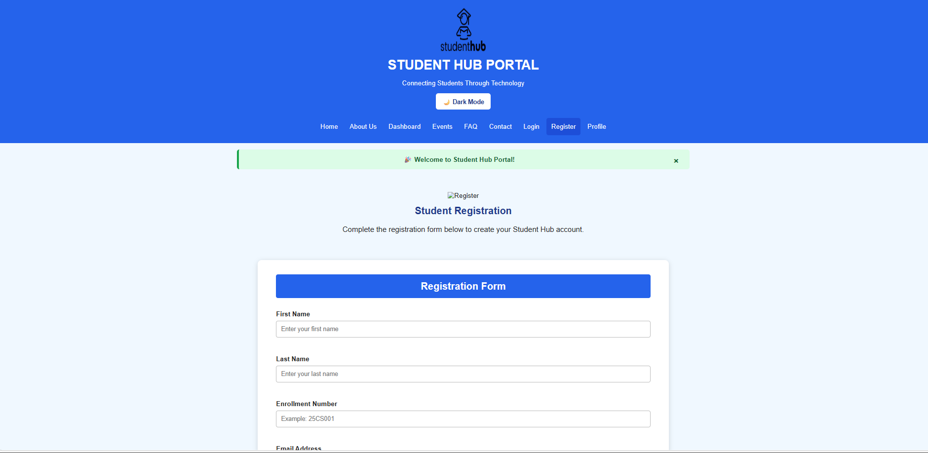

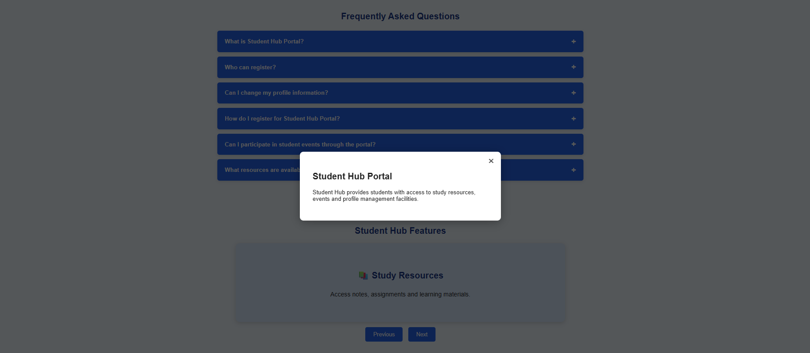

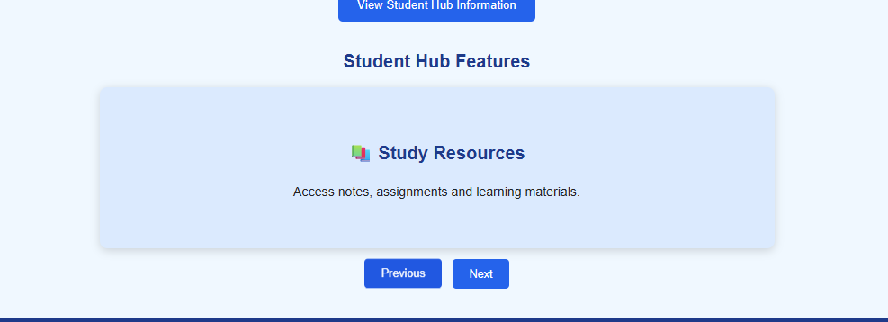

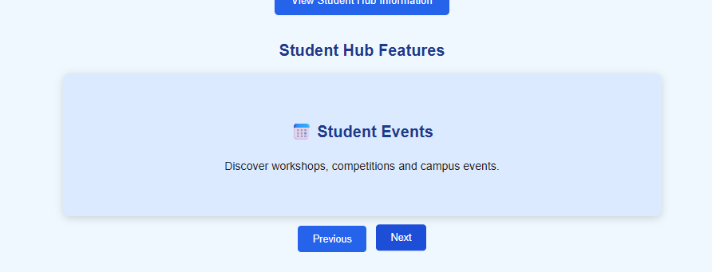

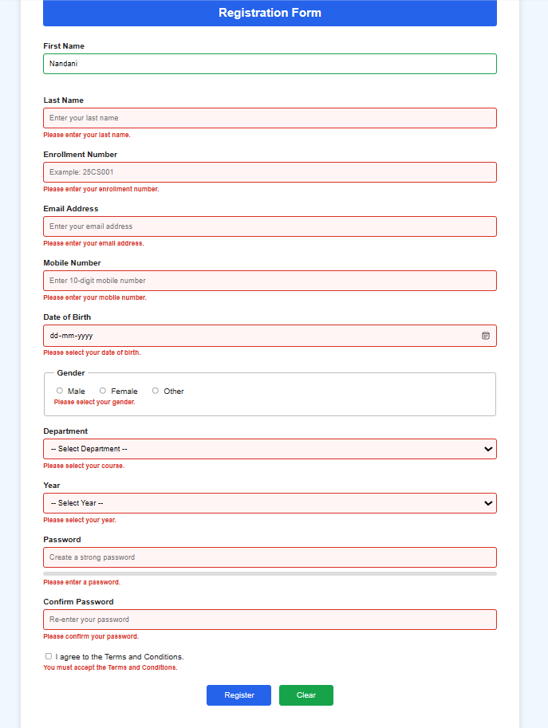

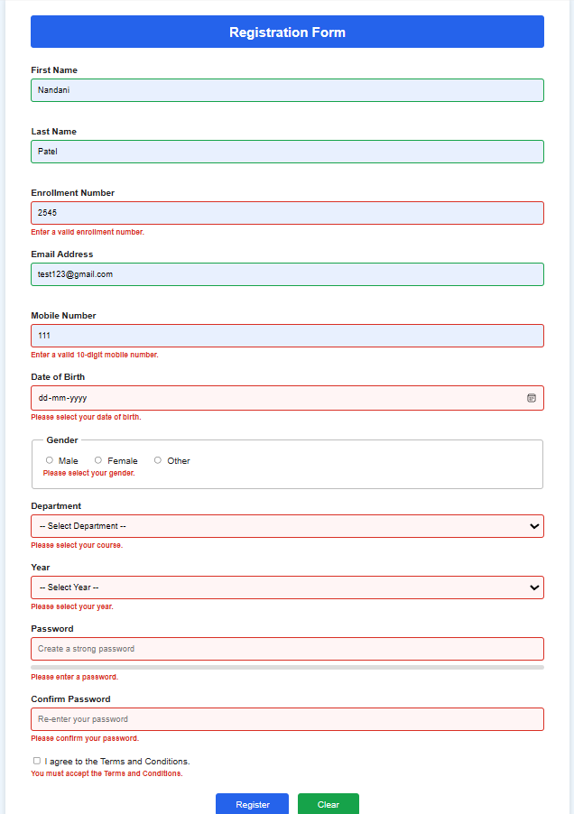

Home:
<!DOCTYPE html>
<html lang="en">

<head>

<meta charset="UTF-8">

<meta name="viewport" content="width=device-width, initial-scale=1.0">

<title>Student Hub Portal | Home</title>

</head>

<body style="margin:0; background-color:#F0F8FF; font-family:Arial, sans-serif;">
<header style="background-color:#2563EB; color:white; text-align:center; padding:20px;">
<div id="notificationBanner" class="notification-banner">

🎉 Welcome to Student Hub Portal!

<button
id="closeNotification"
type="button"
aria-label="Close notification">
×
</button>

</div>
<img src="studenthublogo.png"
alt="Student Hub Logo"
width="110"
height="110">

<h1 style="margin:10px;">STUDENT HUB PORTAL</h1>

<p>Connecting Students Through Technology</p>

<nav style="margin-top:20px;">

<a href="Home.html" style="color:white;text-decoration:none;padding:12px;">Home</a>

<a href="AboutUs.html" style="color:white;text-decoration:none;padding:12px;">About Us</a>

<a href="Dashboard.html" style="color:white;text-decoration:none;padding:12px;">Dashboard</a>

<a href="Events.html" style="color:white;text-decoration:none;padding:12px;">Events</a>

<a href="FAQ.html" style="color:white;text-decoration:none;padding:12px;">FAQ</a>

<a href="Contact.html" style="color:white;text-decoration:none;padding:12px;">Contact</a>

<a href="Login.html" style="color:white;text-decoration:none;padding:12px;">Login</a>

<a href="Register.html" style="color:white;text-decoration:none;padding:12px;">Register</a>

<a href="Profile.html" style="color:white;text-decoration:none;padding:12px;">Profile</a>

</nav>

</header>
<section>

<img src="banner.png"
alt="Student Hub Banner"
width="100%">

</section>

<!-- ================= WELCOME SECTION ================= -->

<section style="text-align:center;padding:40px;">

<h2 style="color:#1E3A8A;">

Welcome to Student Hub Portal

</h2>

<p style="font-size:18px; width:80%; margin:auto; line-height:30px;">

Student Hub Portal is a modern platform designed for students to access
academic information, register for events, receive announcements,
manage profiles and stay connected with their institution anytime,
anywhere.

</p>

<br>

<a href="Register.html">

<button style="background:#2563EB;
color:white;
border:none;
padding:12px 30px;
font-size:18px;
cursor:pointer;">

Register Now

</button>

</a>

&nbsp;&nbsp;

<a href="Login.html">

<button style="background:#16A34A;
color:white;
border:none;
padding:12px 30px;
font-size:18px;
cursor:pointer;">

Login

</button>

</a>

</section>

<!-- ================= FEATURES ================= -->

<section style="background:white;padding:30px;">

<h2 style="text-align:center;color:#1E3A8A;">

Why Choose Student Hub?

</h2>

<table width="100%" cellpadding="20">

<tr align="center">

<td>

<h3>📚 Learning</h3>

<p>Access study resources and important academic information.</p>

</td>

<td>

<h3>📅 Events</h3>

<p>Register and participate in college activities easily.</p>

</td>

<td>

<h3>👤 Profile</h3>

<p>Manage your personal and academic profile securely.</p>

</td>

<td>

<h3>📢 Notices</h3>

<p>Stay updated with the latest college announcements.</p>

</td>

</tr>

</table>

</section>

<!-- ================= EVENTS ================= -->

<section style="padding:30px;">

<h2 align="center" style="color:#1E3A8A;">

Upcoming Events

</h2>

<table border="1"
width="80%"
align="center"
cellpadding="12"
style="background:white;border-collapse:collapse;">

<tr bgcolor="#2563EB" style="color:white;">

<th>Event</th>

<th>Date</th>

<th>Venue</th>

</tr>

<tr>

<td>Hackathon 2026</td>

<td>25 July</td>

<td>Seminar Hall</td>

</tr>

<tr>

<td>Web Development Workshop</td>

<td>30 July</td>

<td>Computer Lab</td>

</tr>

<tr>

<td>Sports Meet</td>

<td>12 August</td>

<td>College Ground</td>

</tr>

</table>

</section>

<!-- ================= NOTICES ================= -->

<section style="background:white;padding:30px;">

<h2 align="center" style="color:#1E3A8A;">

Latest Notices

</h2>

<ul style="font-size:18px;line-height:35px;">

<li>Semester classes begin from 6 July.</li>

<li>Assignment submission closes this Friday.</li>

<li>Library timing has been extended till 8 PM.</li>

<li>Scholarship applications are now open.</li>

</ul>

</section>

<!-- ================= ANNOUNCEMENTS ================= -->

<section style="padding:30px;">

<h2 align="center" style="color:#1E3A8A;">

Announcements

</h2>

<marquee>

🎉 Coding Competition Registration Open |
📢 Workshop on Artificial Intelligence |
🏆 Annual Sports Day Coming Soon

</marquee>

</section>
<section class="slider-section">

<h2>Student Hub Highlights</h2>

<div class="slider">

<div class="slide active-slide">

<h3>📚 Study Resources</h3>

<p>
Access notes, assignments and learning materials.
</p>

</div>

<div class="slide">

<h3>📅 Student Events</h3>

<p>
Discover workshops, competitions and campus events.
</p>

</div>

<div class="slide">

<h3>👤 Student Profile</h3>

<p>
Manage your academic and personal information.
</p>

</div>

</div>
<div class="slider-buttons">

<button
id="prevSlide"
type="button">

← Previous

</button>
<button
id="nextSlide"
type="button">

Next →

</button>
</div>
</section>
<footer style="background:#1E3A8A;
color:white;
text-align:center;
padding:20px;">
<h3>Student Hub Portal</h3>
<p>
Home |About Us |Events |FAQ |Contact
</p>
<p>
&copy; 2026 Student Hub Portal | All Rights Reserved
</p>
</footer>
</body>
</html>

