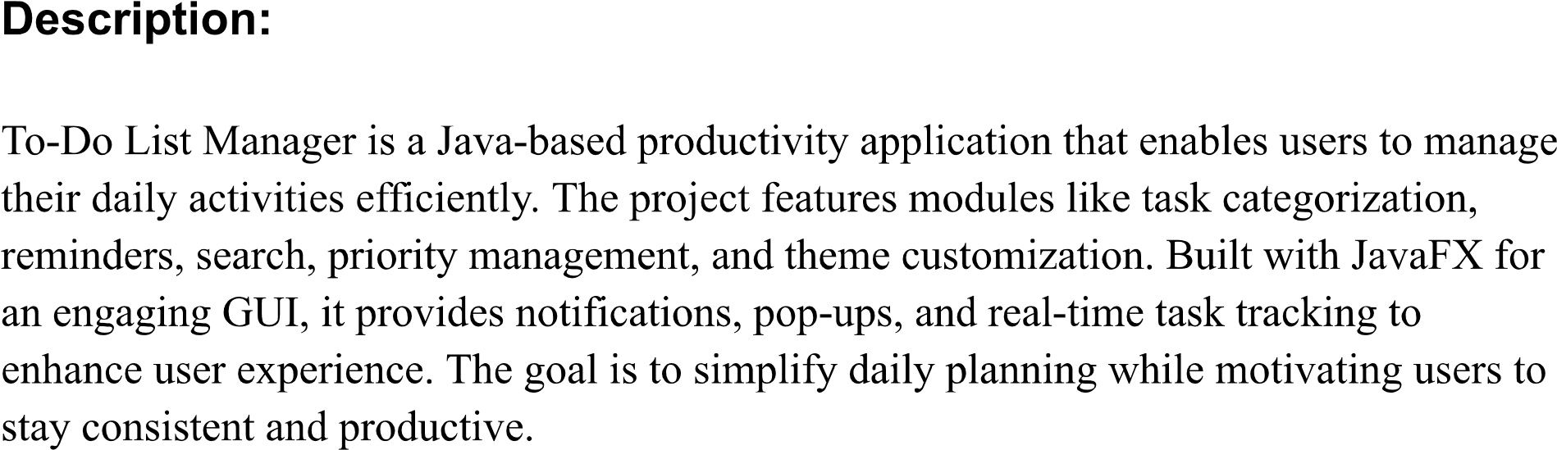
Modules:

- Registration/ Login page
- Home Page/ Dashboard (Section Pending, To-Do, In-Progress, Completed)
- Priority-Based Task
- Search Bar
- Notification (Reminder, Deadlines)

Technology:

- Tools: Netbeans, SceneBuilder
- Framework: JavaFX
- Programming Language: Java
- Database: MySQL

Module 1 – Nandani Patwa
Module 2 & 4 – Shreaya Shukla
Module 3 – Sakshi Singh
Module 5 – Shweta Gupta

