PROJECT REPORT

Title: Green Route Optimizer using Scilab
This report outlines the objectives, technical requirements, and functional logic of the Scilab-based route optimization tool.
Aim and Objective : This report outlines the objectives, technical requirements, and functional logic of the Scilab-based route optimization tool.
Software Requirements:
To execute and modify this script, the following environment is required:
Primary Software: Scilab (Version 2026.0.0 or later recommended).
Editor: SciNotes (The integrated development environment for Scilab).
Operating System: Windows 10/11, macOS, or Linux.
Libraries: Standard Scilab Graphics and Elementary Functions libraries (built-in).
Algorithm
- Initialize Delivery Points
Define the coordinates (X, Y) of all delivery locations in a matrix. a
- Determine Number of Points
Calculate the total number of delivery locations using the size() function.
- Generate Random Route
Create a random route using rand() and sort it using gsort() to avoid indexing errors.
- Define Distance Function
Create a function calcDist(p, r) to compute total distance using the Euclidean distance formula between consecutive points.
- Compute Total Distance
Call the distance function with the generated route to calculate total travel distance.
- Visualization
  - Clear previous figure using clf().
  - Plot the route using plot() with markers.
  - Label each point using xstring() for clarity.
- Display Results

Print the optimized route sequence.
Display the total distance travelled.

Code :
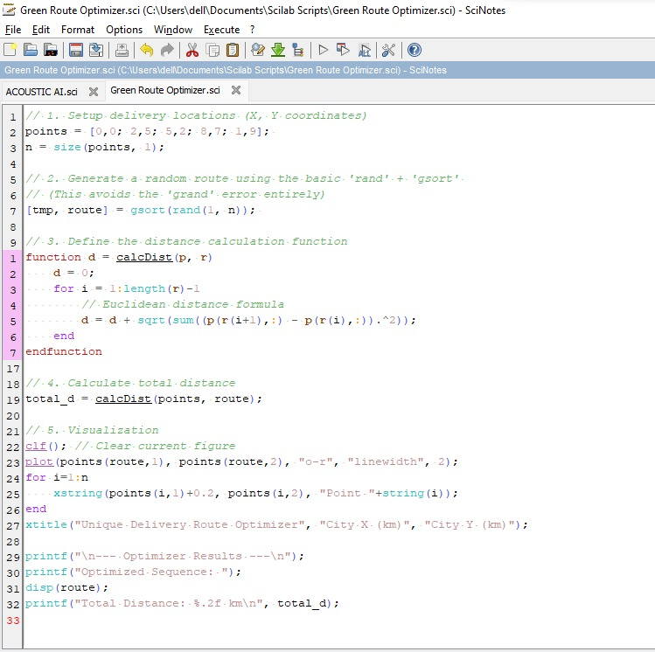
Output:
- A graphical representation of the delivery route connecting all points.
- Console output showing:
  - Optimized sequence of points
  - Total distance (e.g., 27.42 km)

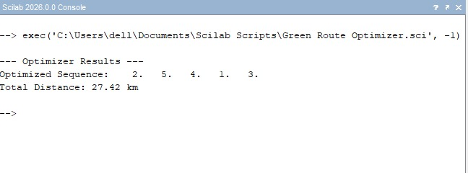

Graph:
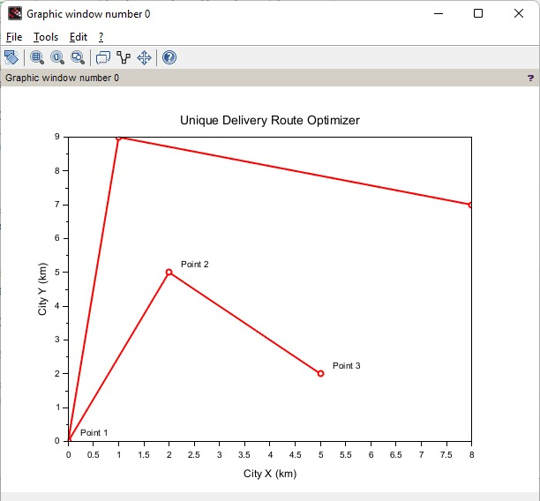
Conclusion:
The program successfully generates a delivery route and calculates the total distance between points using Euclidean distance. Although the route is randomly generated and not truly optimal, the visualization and computation provide a clear understanding of route optimization basics. This approach can be further improved using advanced optimization techniques like Genetic Algorithms or Travelling Salesman Problem (TSP) methods for better efficiency.

