Experiment 1: Case Study
Problem Statement: Choose a real-world case study such as an E-Commerce System or an ERP System, create user stories, select an appropriate software development process model, identify a suitable programming language, and propose an implementation and evaluation strategy.
Real-World Case Study: an Enterprise Resource Planning (ERP) System for a mid-size manufacturing company

1. Functional Requirements

Employee
- Register and login securely
- Mark daily attendance
- Apply for leave and view leave balance
- View and download monthly payslip
- Submit expense claims with receipts
- Submit weekly timesheets
- View assigned tasks and project status

Admin / Manager
- Manage employee records
- Approve or reject leave requests
- Process monthly payroll
- Manage inventory and stock across warehouses
- Raise and approve purchase orders
- Manage vendors and suppliers
- Generate financial and HR reports

2. User Stories
User ID | User Story | Priority
US-01 | As an employee, I want to log in securely to access the ERP portal. | High
US-02 | As an employee, I want to apply for leave and view my leave balance. | High
US-03 | As an employee, I want to view and download my monthly payslip. | High
US-04 | As an employee, I want to submit expense claims with receipts. | Medium
US-05 | As an employee, I want to mark my daily attendance. | High
US-06 | As an employee, I want to submit weekly timesheets. | Medium
US-07 | As an HR manager, I want to approve or reject leave requests. | High
US-08 | As an HR manager, I want to process monthly payroll automatically. | High
US-09 | As an inventory manager, I want to track stock levels across warehouses. | High
US-10 | As a procurement officer, I want to raise and approve purchase orders. | Medium
US-11 | As a finance officer, I want to generate consolidated financial reports. | Medium
US-12 | As an admin, I want to manage user roles and access permissions. | Medium

3. Selected Software Development Process Model
Agile Scrum

Reason for Selection
- ERP modules (HR, Inventory, Finance) can be developed and delivered incrementally.
- Frequent feedback from different departments shapes evolving requirements.
- Incremental delivery allows early adoption by individual departments.
- Shorter sprints reduce the risk of large-scale integration failures.
- Easier to prioritize and rework modules as business rules change.
- Well suited for large, modular enterprise applications.

Sprint Plan
Sprint | Features
Sprint 1 | Employee Management & Login
Sprint 2 | Attendance & Leave Management
Sprint 3 | Payroll Processing
Sprint 4 | Inventory & Procurement
Sprint 5 | Finance & Accounting Module
Sprint 6 | Reporting Dashboard
Sprint 7 | Testing & Deployment

4. Programming Language Selection

Backend
- C# (ASP.NET Core Web API)

Reasons
- Strong support for enterprise-grade applications
- Excellent integration with Active Directory and Windows environments
- Robust security and role-based access control
- Mature ORM support (Entity Framework Core)
- High performance for transaction-heavy modules

Frontend
- HTML5
- CSS3
- TypeScript
- Angular

Database
- Microsoft SQL Server

Other Technologies
- REST API
- JWT / Active Directory Authentication
- Power BI Reporting
- Git
- Docker
- Microsoft Azure Cloud

5. System Architecture
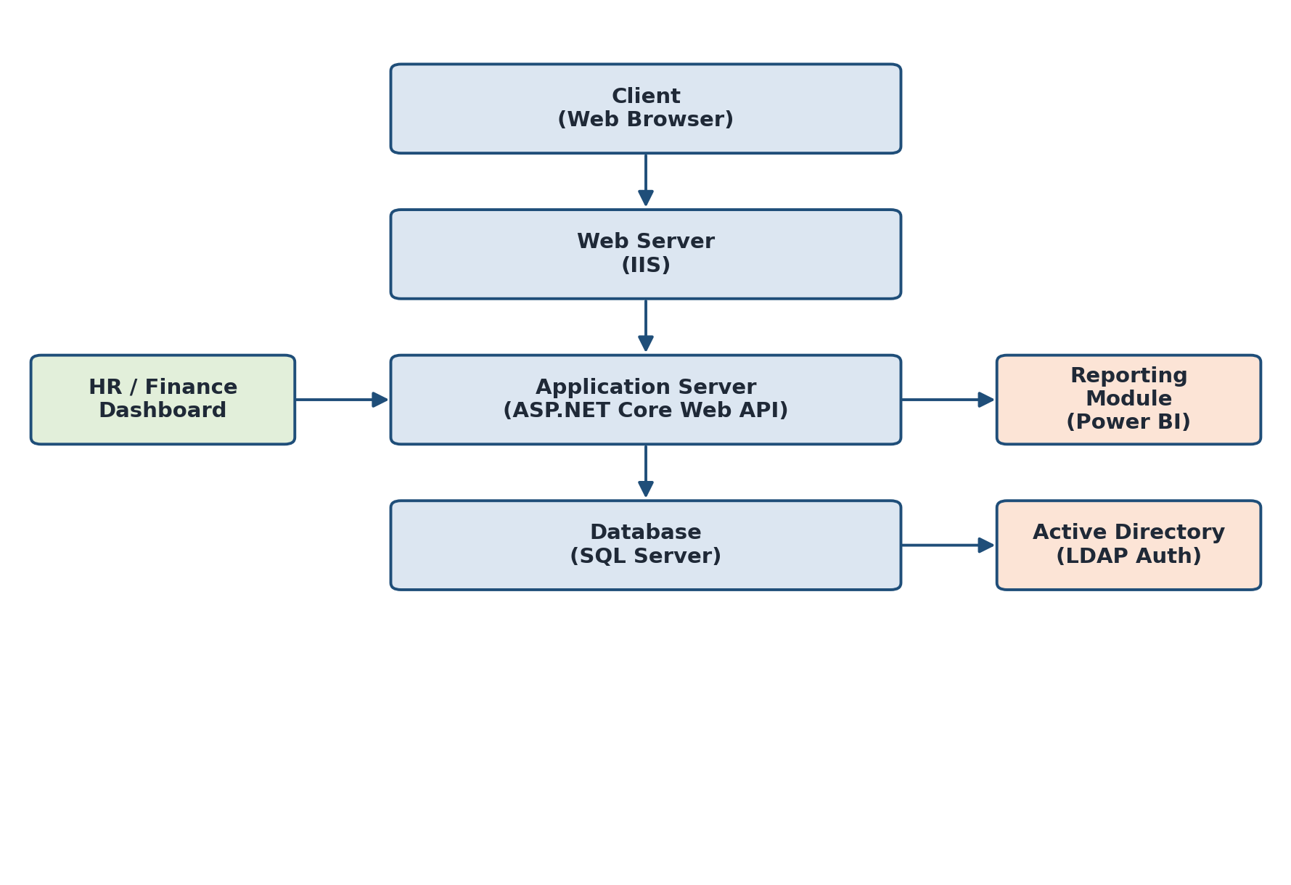

6. Implementation Strategy

Phase 1 – Requirement Analysis
- Gather requirements from HR, Finance, and Inventory departments.
- Create Software Requirement Specification (SRS).
- Prepare use case diagrams.

Phase 2 – System Design
- Design database schema for all modules.
- Design UI wireframes.
- Create UML diagrams.
- Develop system architecture.

Phase 3 – Development
- Implement user authentication and role management.
- Develop HR and payroll modules.
- Develop inventory and procurement modules.
- Develop finance and accounting module.
- Build reporting dashboard.

Phase 4 – Testing
Unit Testing
- Login
- Attendance and leave calculation
- Payroll calculation
Integration Testing
- Payroll + Attendance
- Inventory + Procurement
System Testing
- Complete application testing
User Acceptance Testing (UAT)
- Verify business requirements with department heads.

Phase 5 – Deployment
- Docker Container
- Azure App Service
- SQL Server Database
- IIS Web Server

7. Evaluation Strategy
Evaluation Parameter | Method
Functional Accuracy | Requirement verification
Performance | Load testing using Apache JMeter
Security | Role-based access and penetration testing
Reliability | Continuous monitoring
Usability | User feedback survey
Scalability | Concurrent user testing
Maintainability | Code review and documentation

8. Expected Outcomes
- Streamlined HR and payroll processing.
- Real-time visibility into inventory across warehouses.
- Accurate and timely financial reporting.
- Reduced manual paperwork and errors.
- Improved cross-department coordination.
- Improved organizational efficiency.
- Scalable, modular architecture for future enhancements.

