1. **Result**

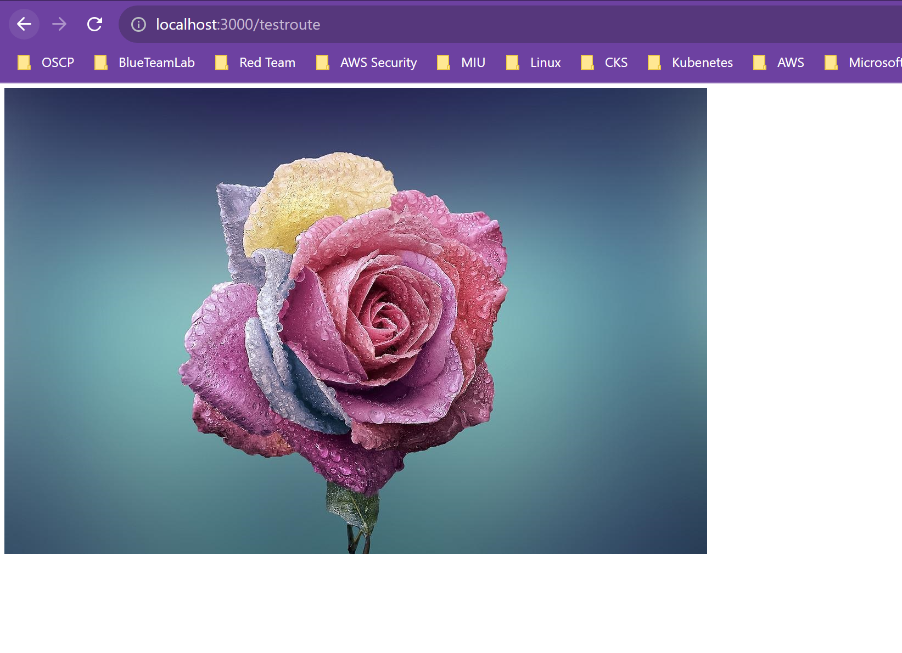

1. **/users -> Get**

1. **/users -> Post**

1. **/products -> get**

1. **/products -> post**

1. **404.html**

1. **Error Handling**

