**A PROJECT REPORT ON**

**“Electronic Thesis and Dissertation”**

FOR

Geo Mandalar IT

SUBMITTED IN PARTIAL

FULFILLMENT OF INTERNSHIP

PROJECT

UNDER THE GUIDEDANCE OF

Director

Mr.RaviChhabra

Supervisor

Dr. Ei Ei Mon

**SUBMITTED BY**

Ma Ei Po Po Aung

Ma Apirl Su

Ma Myo Myo

Ma Htet Htet Htun

Ma Su Sandi Myint Naing

Ma Shun Lae Nadi Moe

**University of Computer Studies**

**(Mandalay)**

Date

**Group** **Members**

|  |  |  |  |
| --- | --- | --- | --- |
| **Roll No** | **Name** | **Signature** | **Date** |
| 5CS – 13 | Ma Ei Po Po Aung |  |  |
| 5CS – 14 | Ma Apirl Su |  |  |
| 5CS – 15 | Ma Myo Myo |  |  |
| 5CS – 16 | Ma Htet Htet Htun |  |  |
| 5CS – 17 | Ma Su Sandi Myint Naing |  |  |
| 5CS - 18 | Ma Shun Lae Nadi Moe |  |  |

Dr. Ei Ei Mon Signature/Date

**CONTENTS**

**Page Number**

**Abstract** i

**Acknowledgement** ii

**Declaration** iii

**List of figures** iv

**CHAPTER 1 INTRODUCTION 1**

1.1 Introduction 1

1.2 Background 2 1.2.1 Evaluation of the literature relevant

to the project area 2

1.2.2 Development Life Cycle 2

1.2.3 UML 3

1.2.4 HCI 3

1.2.5 What is a firebase database? 4

1.3 Objective of the project 5

1.4 Scope of Proposed System 5

**CHAPTER 2**  **METHDOLOGY 6**

2.1 Requirement Analysis 6

2.2 Software Selection 6

2.3 Project Plan 7

**CHAPTER 3 PROJECT DEVELOPMENT 8**

3.1 Design 8

3.1.1 Flow Chart Diagram 8

3.1.2 Use Case Diagram 9

3.1.3 Sequence Disgram 10

3.1.4 ETD Function 11

**CHAPTER 4 EVALUATION AND CONCLUSION 21**

4.1 Conclusion 21

4.2 Advantages of the project 21

4.3 Disadvantages of the project 21

4.4 Further Extensions 21

**References 21**

**Abstract**

Electronic Thesis and Dissertation System is a work submitted in support of candidature for a doctorate or master’s degree. Electronic version of theses and dissertations are called ETDs. This system is kind of Education website. In our system , users can search theses and dissertations of CU (Mdy) by Year, and can see abstract of the thesis, author name, supervisor name and the major. Users can also search books and theses of otago university and Global ETD for more references.

For admin Panel, admins can insert, data into database, delete and retrieve data for database. Users can use our system with both smart phones and computers. For Front End, the system was implemented using material design (HTML, CSS).For Back End, this system was implemented using javascript and jQuery. And we also used Firebase Hosting and Database.

I

**ACKNOWLEDGEMENT**

We would like to express our very great appreciation to our rector **U Kyaw Zwa Soe**, our pro-rector **Dr. San San Tin** and our teacher **Dr. Aye Aye Chaw** for her valuable and constructive suggestion during the planning and development of this project. They willingness to give their time so generously has been very much appreciated. Advice given by other academic lectures has been a great help in building the software solution.

Also we obliged to staff members of University of Computer Studies (Mandalay) for the valuable information provided by them in their respective fields. We are grateful for their cooperation during the period of developing the system. Assistance provided infinity software development crew was greatly appreciated. Their contribution was worth a lot, in making this development a reality.

Then also thanks to **U Ravi Chhabra**, CEO of GMIT, for his trust to give us such a heavy responsibility project.

And Then greatly thankful to my supervisor **Dr. Ei Ei Mon**, Computer University (Mandalay), for her valuable guidance and patient supervisor, presentation and correctness of the project.

We especially thanks to our parents and all our friends for providing encouragement and giving us a great support during internship programme.

ii

**DECLARATION**

We declare that this project report or part of was not a copy of a document done by any organization, university any other institute or a previous student project group at Computer University (Mandalay) and was not copied from the Internet or other sources.

Project Details

|  |  |
| --- | --- |
| Project Title | Electronic Thesis and Dissertation |
| Project ID | Geo Mandalar IT |

**iii**

**List of Figures**

**Figure Page**

Figure (2.1) Project Plan

Figure (3.1) Flowchart Diagram for ETD

Figure (3.2) Usecase Diagram For ETD

Figure (3.3) Inserted Record in Database

Figure (3.4) Login Fail When Incorrect Name

Figure (3.5) Permission deny when not given Authorization

**iv**

**Chapter 1**

**Introduction**

* 1. **Introduction**

The move by Graduate Schools to allow or even require students to submit theses and dissertations as electronic or digital documents (ETDs) creates much excitement. Among the students and faculty who will be affected by this initiative to digitize these important documents. Universities failed to recognize its importance and almost managed to marginalize themselves into oblivion. The universities face in responding to an increasingly digitized and networked world are staggering. Universities need a vision allowing them to express their dearest values in new forms, rather than protect their present form at the expense of their most fundamental values.

The ETD initiatives now under way in universities around the world are about bringing fundamental change to our current concept of what constitutes a thesis or a dissertation. We make available to the ETD author a powerful of presentation and distribution tools. These tools allow the author to reveal to masters and doctoral committees.

**1**

**1.2 Background of the System**

**1.2.1 Evaluation of the literature relevant to the project area**

I have to consider about the method, approach, programming language and tools in developing the project. Methodology will be used as I structure the project plan; it will represent how the project will be processed. Thus I structure the project’s framework. I need to consider about the project development. In the project area, I can use development life cycle model such as Agile Model in the project development life cycle. We use software Architecture as MVC. I must use UML techniques to propose the business processes in the project area; I can define the process notations by using UML diagrams. In order to code the program, I can use many computer language such as javascript, css, jquery, etc…

* + 1. **Development Life Cycle**

Development life cycle is used to describe in planning the business processes to create the system development and test and arrange the information system in the project area.

**Agile Model**

Agile Model breakdowns the project development into small incremental tasks and those task are processed in iteration process. The iteration process includes requirement analysis, design, coding and unit testing. So Agile Model can apply functional process of developing project rapidly and it is flexible model for developers. Backbone of Agile model is client communication, so if client does not understand what is meant to; the development team can be forward to the wrong direction. Technique I have to need to design process notations and make diagrams for the system design in the project area.

**2**

* + 1. **UML**

Unified Modeling Language (UML) is used as to illustrate the object oriented systems and presentations. UML is a general architectural structure. It is derived from three notations; OMT(Object Modeling Technique), OOD(Object Oriented Design) and OOSE (Object Oriented Software Engineering). UML has a set of connectors and signs to use for drawing the diagram. These diagrams can represent the business process and functions from the companies or organizations by using UML. So we can model the computer code and program by using these diagrams. We can know about the business processes ideas by using UML diagrams in the project.

In this project, we can Use Case Diagram to describe a set of actions that can perform in collaboration with one or more external users of the system. We use sequence diagram to show object interactions arranged in time sequence.

* + 1. **HCI**

Human Computer Interaction is the study of how people interact with computers and to what extent computers are or not developed for successful interaction with human beings. A significant number of major corporations and academic institutions now study HCI. Human Computer Interface is joined as important part in every program or application because it defines user impressions. “User impression means how users can use the program effectively, if cannot attract the users to use.”

In this project, we use HCI to use color effectively. We have known that color blind people can see the color of blue. So, we almost used blue entire the project to accommodate with all people.

**3**

**Transaction Control Language in DBMS**

A transaction is a logical unit of work that contains one or more SQL statements. A transaction is an atomic unit. The effects of all SQL statements in a transaction can be either all committed (applied to the database) or all back (undone from the database). A transaction begins with the first executable SQL statement. A transaction ends when it is committed or rolled back, either explicitly with COMMIT or ROLLBACK statement or implicitly when DDL statement is issued.

**1.2.5 What is a firebase database?**

A database is a collection of information that is organized so that it can be easily accessed, managed and updated.

Data is organized into rows, columns and tables, and it is indexed to make it easier to find relevant information. Data gets updated, expanded and deleted as new information is added. The Firebase Realtime Database is a cloud-hosted database. Data is stored as JSON and synchronized in realtime to every connected client. When you build cross-platform apps with our iOS, Android, and JavaScript SDKs, all of your clients share one Realtime Database instance and automatically receive updates with the newest data.

Computer database typically contain aggregations of data records or files, such as attendance transactions, attendance percentage and reports.

Typically, a database manager provides users with the ability to control read^write access, specify report generation and analyze usage. Some databases offer ACID (atomicity, consistency, isolation, and durability) compliance to guarantee that data is consistent and that transactions are complete.

**4**

**1.3 Objectives of the project**

* To save time
* Helping students be better prepared as knowledge workers
* To develop university digital library services and infrastructure
* Increasing sharing and collaboration among university and students
* Enhancing access to university research

**Scope of Proposed System**

The proposed project of Electronic Thesis and Dissertation is prescribed as follow;

* Manage Home, ThesisResource, Publisher, Admin, Search, Learn More
* View Home
* View ThesisResource
* View Publisher
* View Admin
* View Search
* View Learn More

**5**

**CHAPTER 2**

**METHDOLOGY**

**2.1 Requirement Analysis**

The description of the services and constraints are the requirements for the system. Requirement Analysis is the process of deriving the system requirements through observation of existing system, discussions with potential users and procurers, task analysis. We get all information of data we use in this project from our library.

**2.2 Software Selection**

**Choose Programming Language**

I would like to use HTML, CSS, Javascript, jQuery, material design lite in my project because there are a lot of benefits to pick up languages in our windows form application.

* HTML describes the structure of Web pages using markup.
* CSS can control the layout of multiple web pages all at once.It describes how HTML elements are to be displayed on screen, paper, or in other media.
* Javascript is a high-level and interpreted programming language.
* JQuery is a fast, small, and feature-rich JavaScript library.
* Material Design Lite makes more liberal use of grid-based layouts, responsive animations and transitions, padding, and depth effects such as lighting and shadows.
* They are readily available and easy to access.

**6**

**Software Requirements**

* Firebase Database

**Hardware Requirements**

* Internet Access
* PC with Windows OS

**2.3 Project Plan**

In understanding the system requirements and testing some features, we work together. UI/UX, Developer and testing and documentation, we work together. User Access Level/Access to pages, Project Manager and System Analysis are discussed about the systems to understand the user.

**7**

**CHAPTER 3**

**PROJECT DEVELOPMENT**

**3.1 Design**

**3.1.1 Flow Chart Diagram**

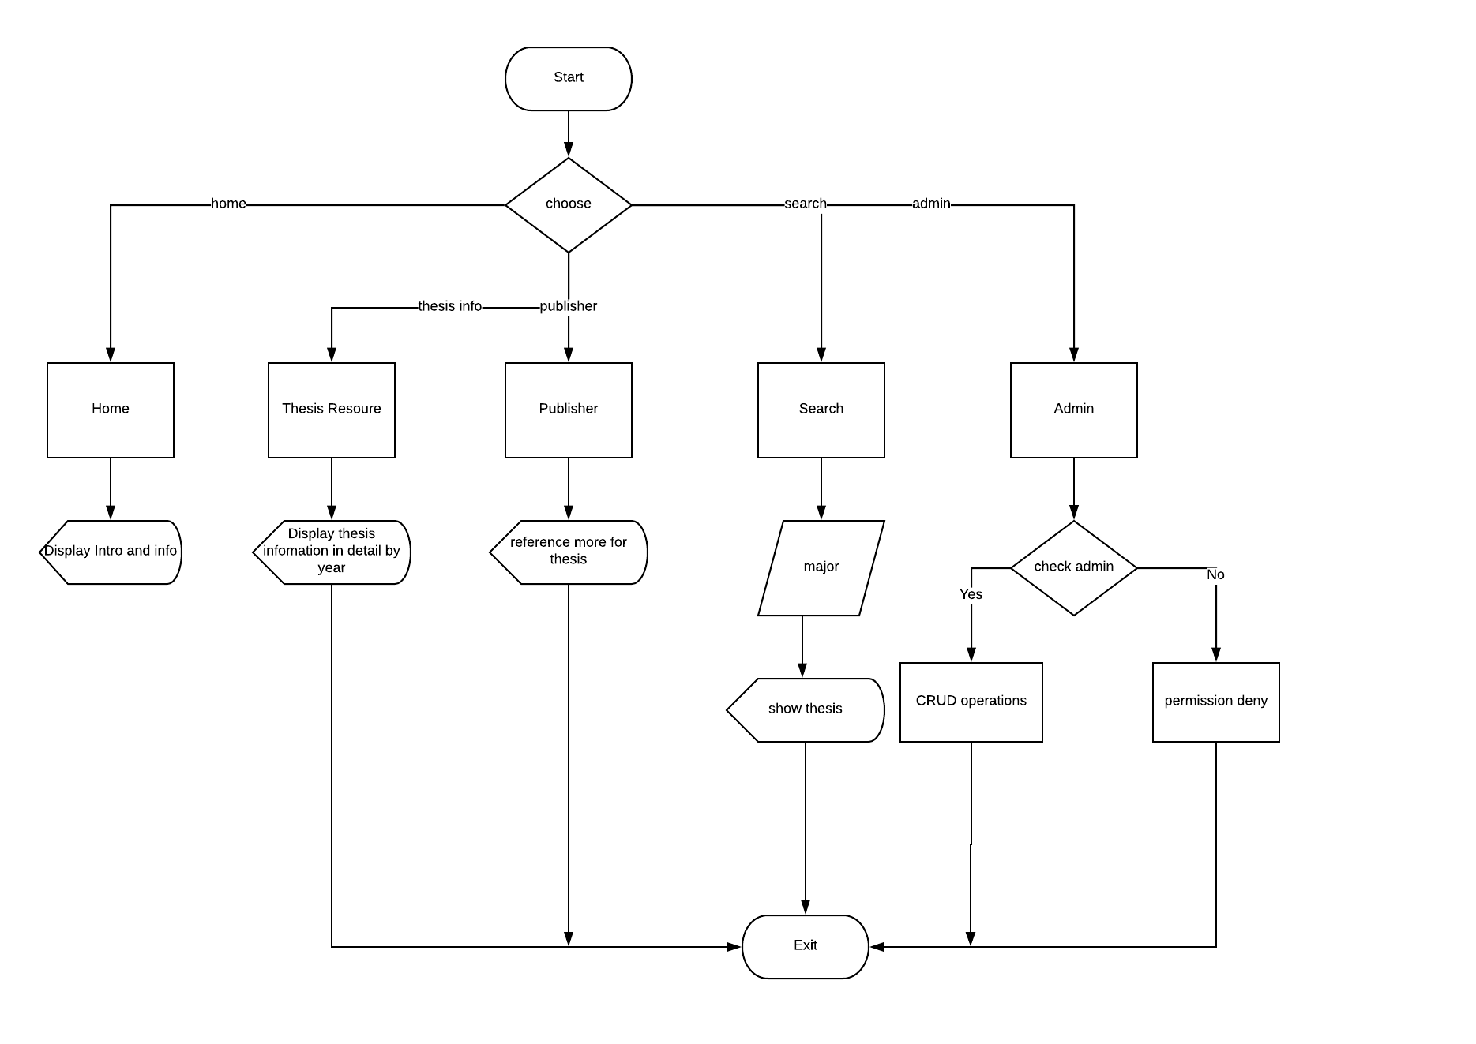

**8**

**3.1.4 ETD Function**

In this system, we use nav bar. When users click nav bar, users can see Home, ThesisResource, Publisher, Admin and Lerarn More.

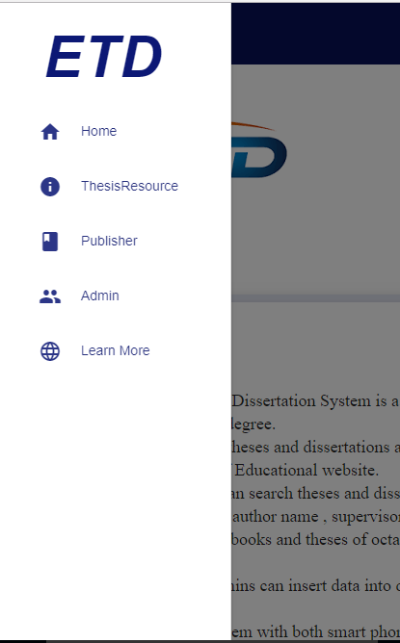

**11**

In Home Page form, we show Introduction, Type of Thesis, abstract, and objective.

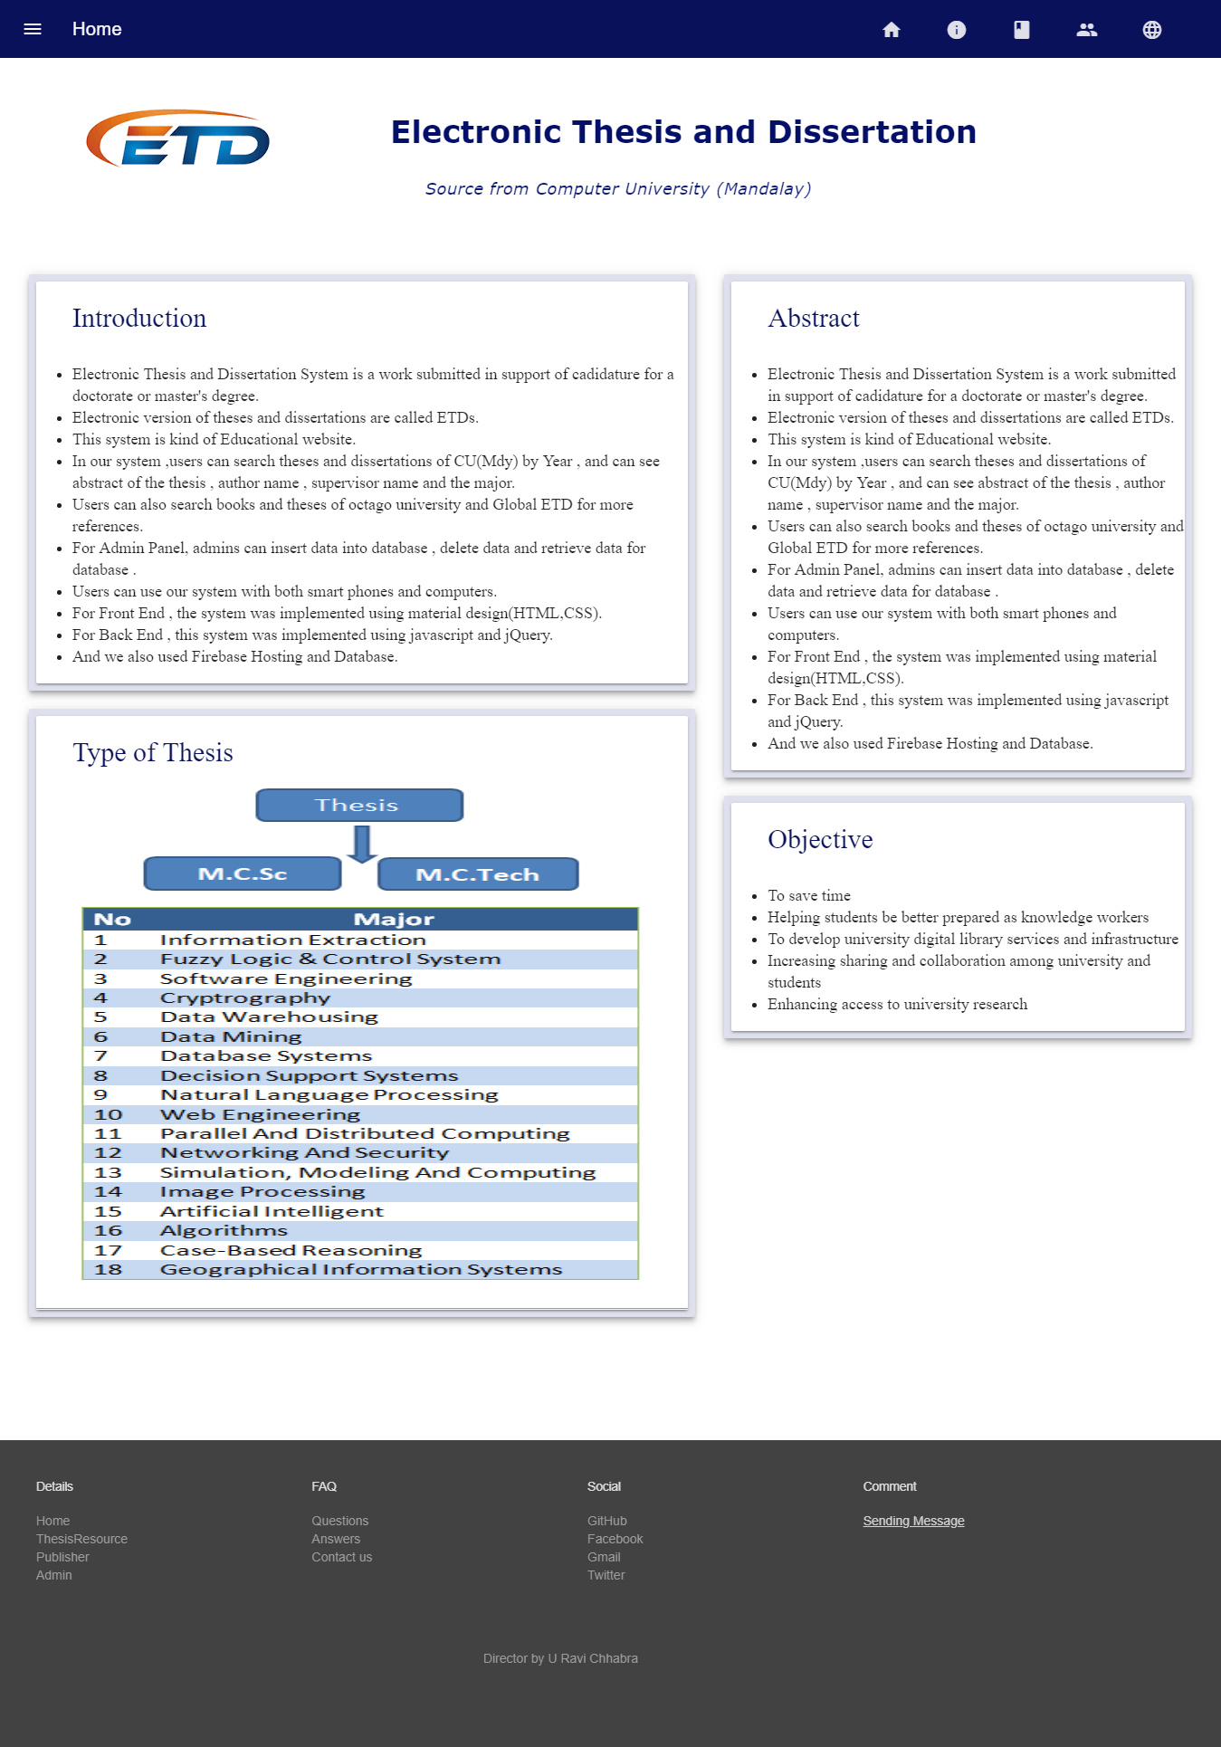

**12**

In the following form,users can see thesis resource by year from 2008 to 2016.

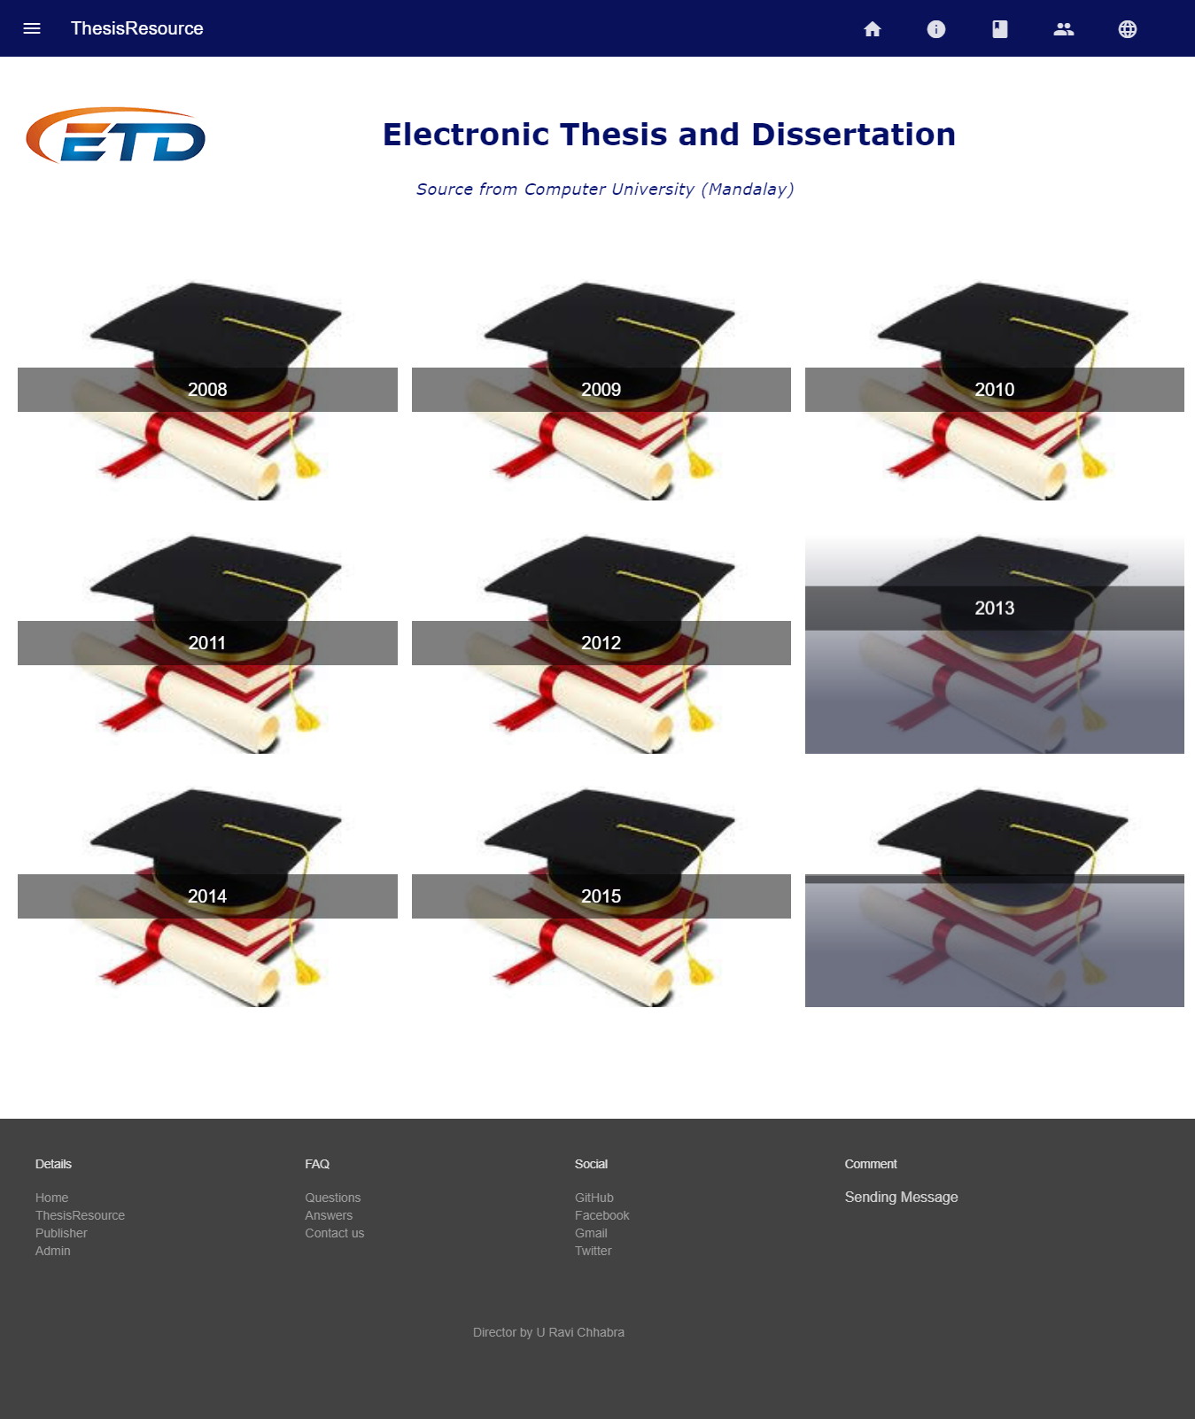

**13**

If user clicks 2008, user can see thesis titles in 2008.

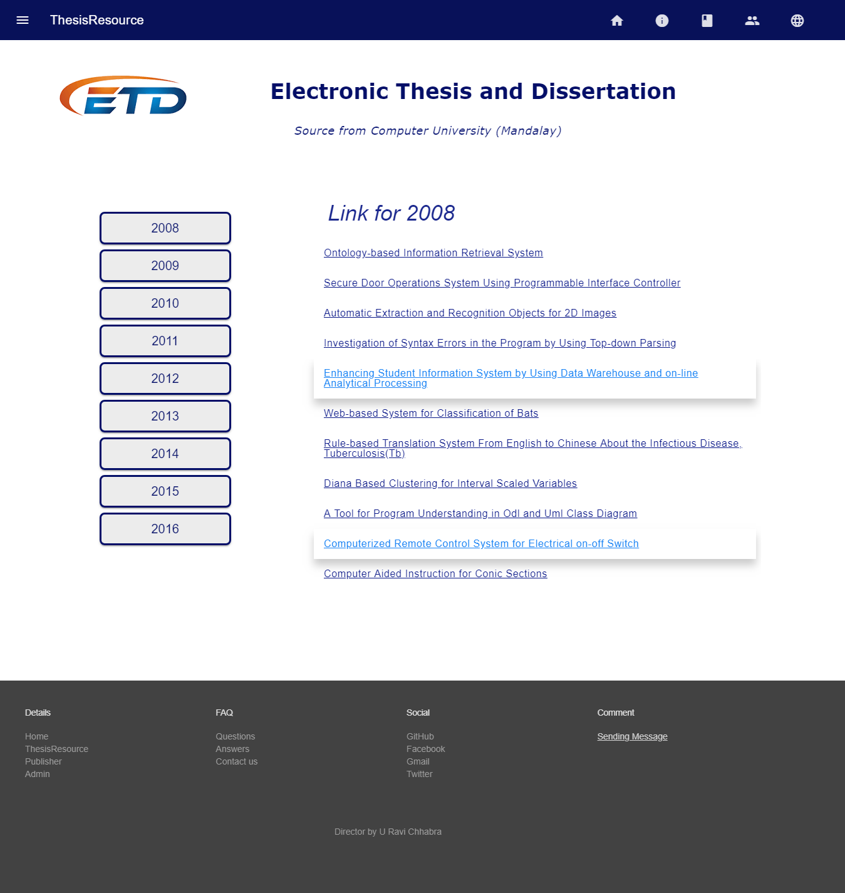

**14**

When user clicks thesis title, user can see the following form. There are Abstract of thesis, Author’s Name, Degree, Supervisor, Thesis Title, Major and Year.

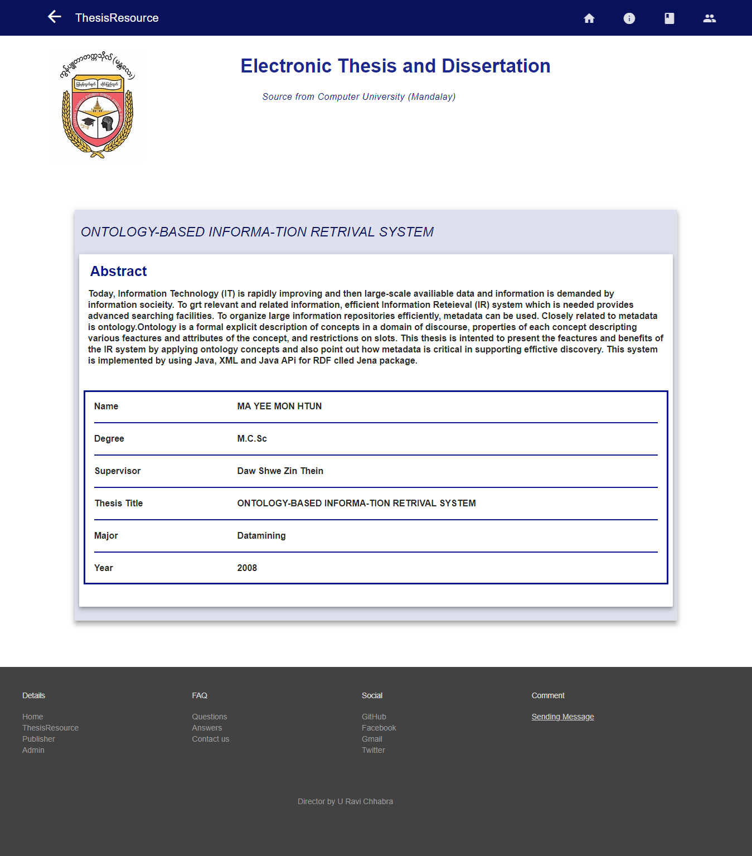

**15**

User can see Books on doing research in Publisher.

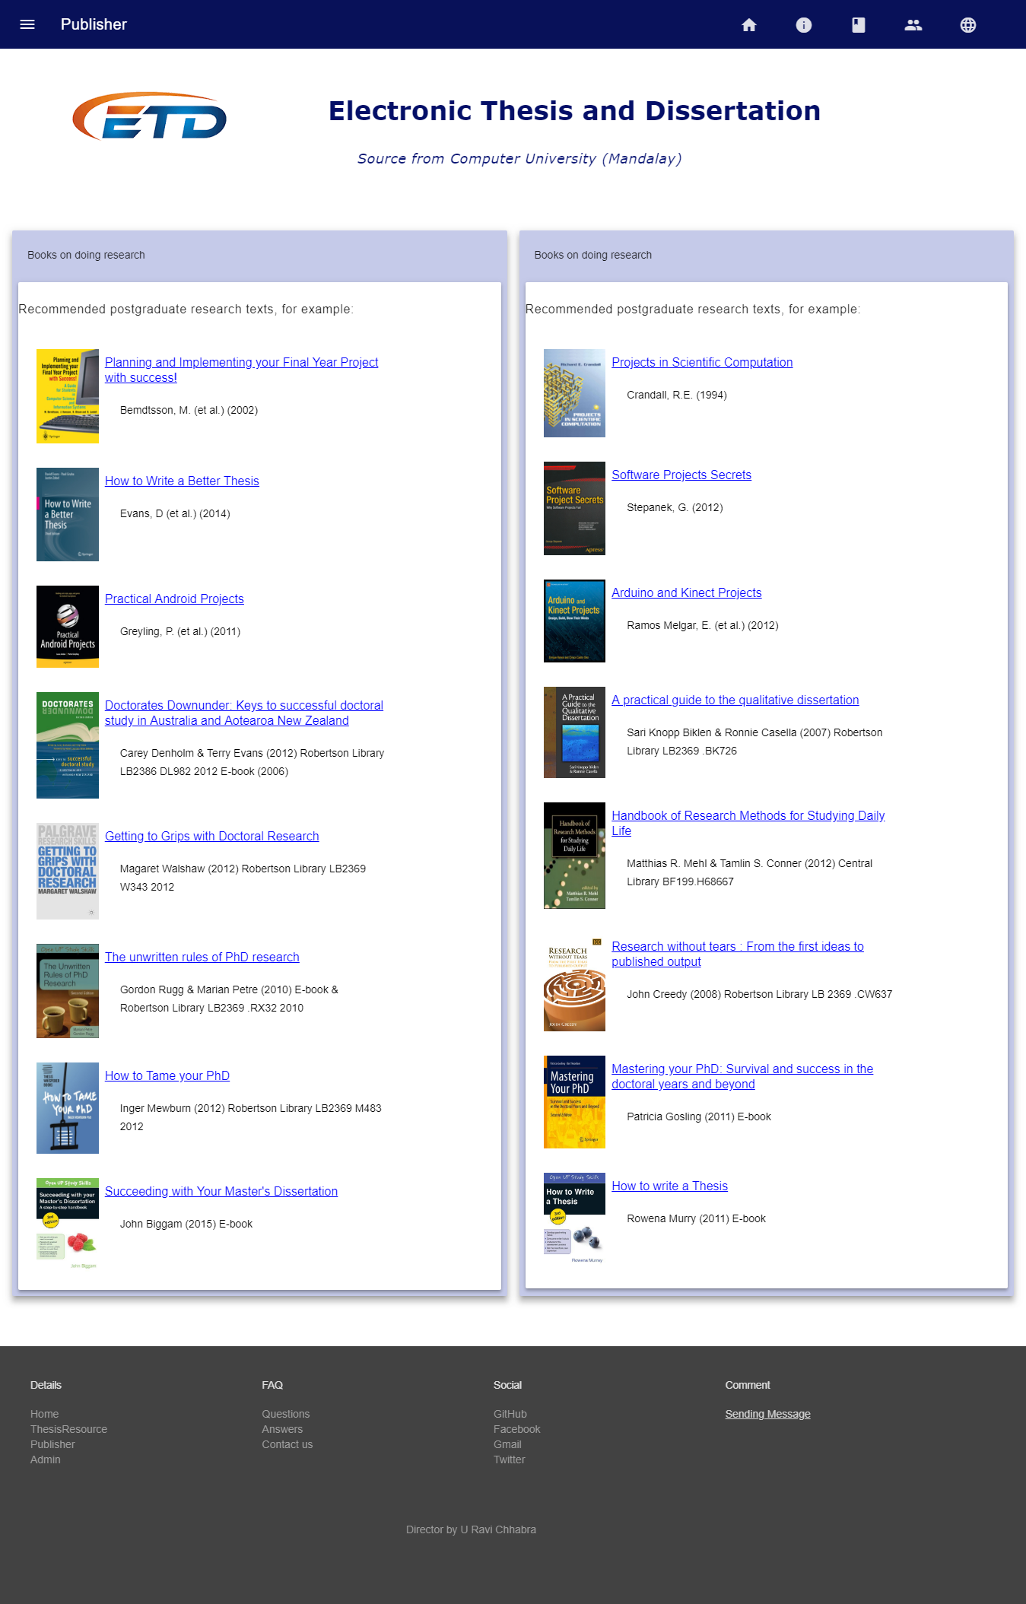

**16**

When user click any title, user can see the information of the title user click.

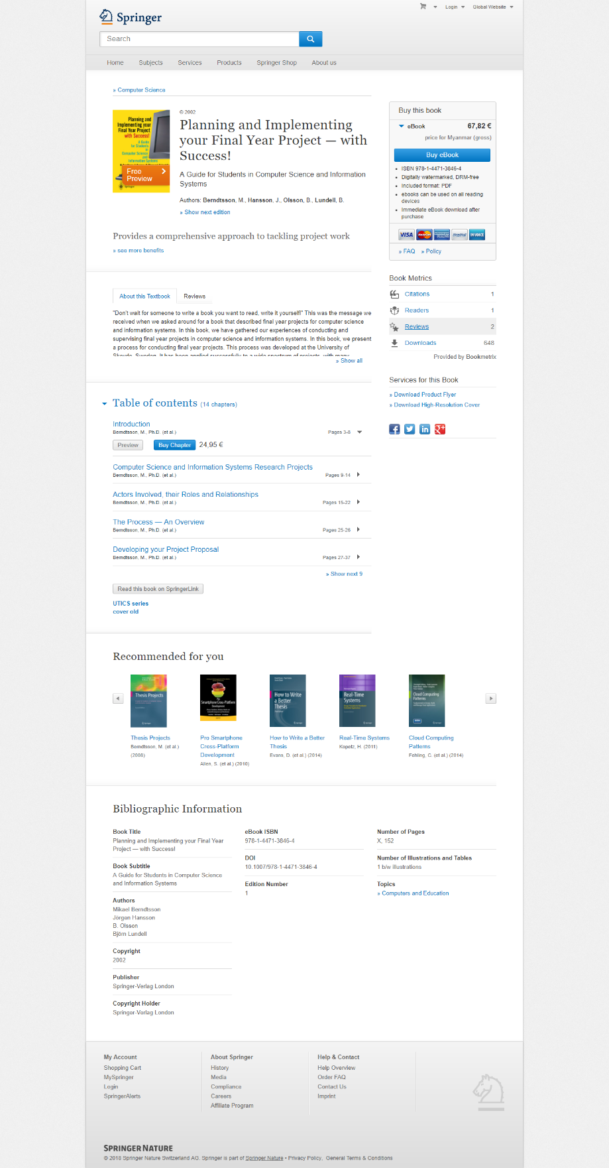

**17**

In the following form, admins can only login to create, delete, update and add data.

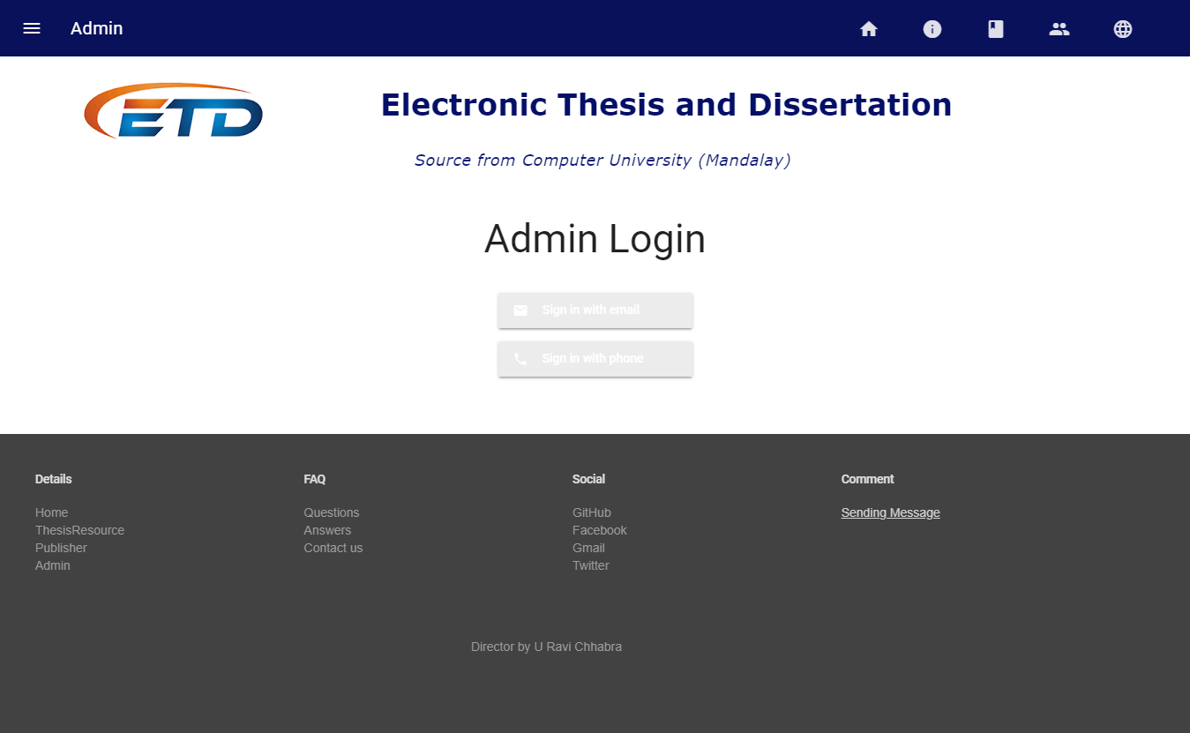

We design Admin login form to login not only email but also phone. Admin need to create account to login.

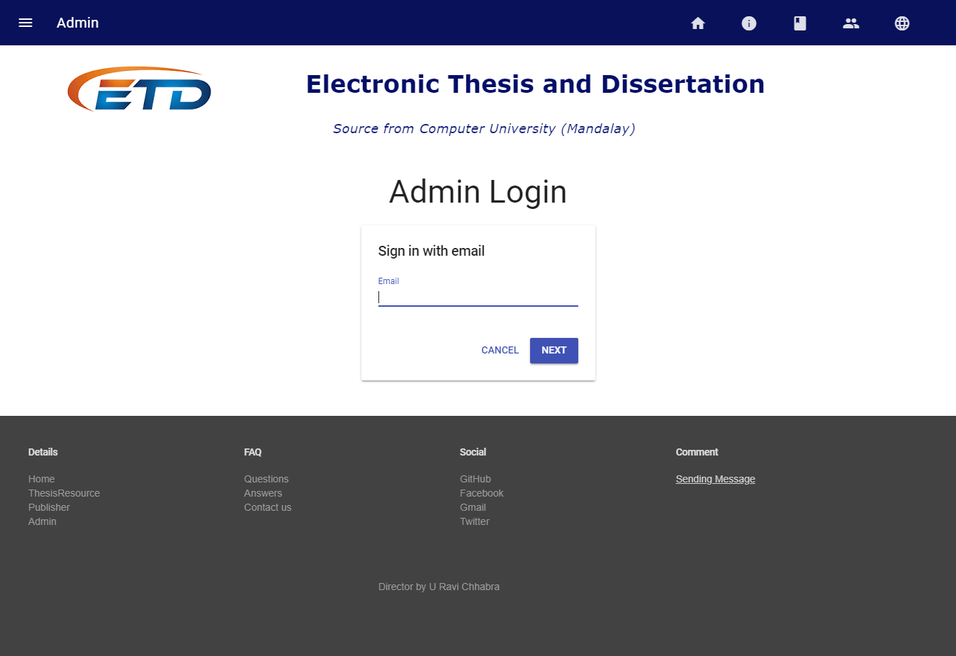

**18**

After login, admins can create, update, delete data.

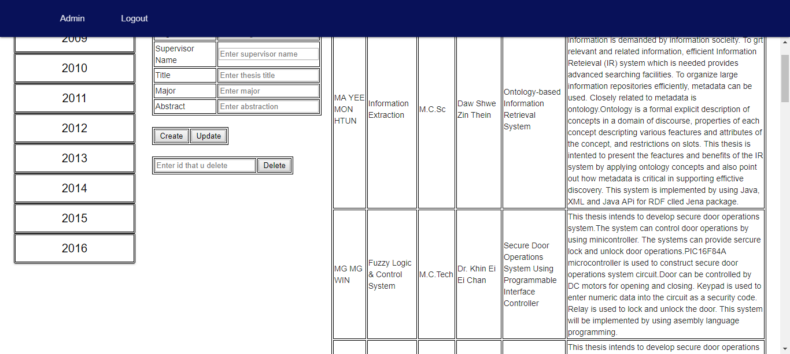

In the below form, user can search ETD in global whatever user want.

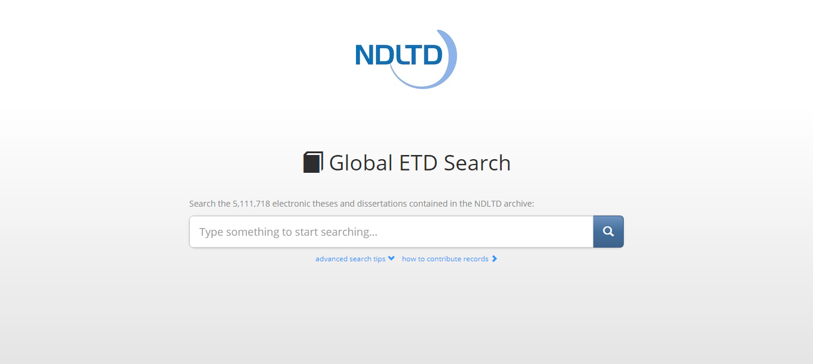

**19**

In Global ETD Search, user can see the following.

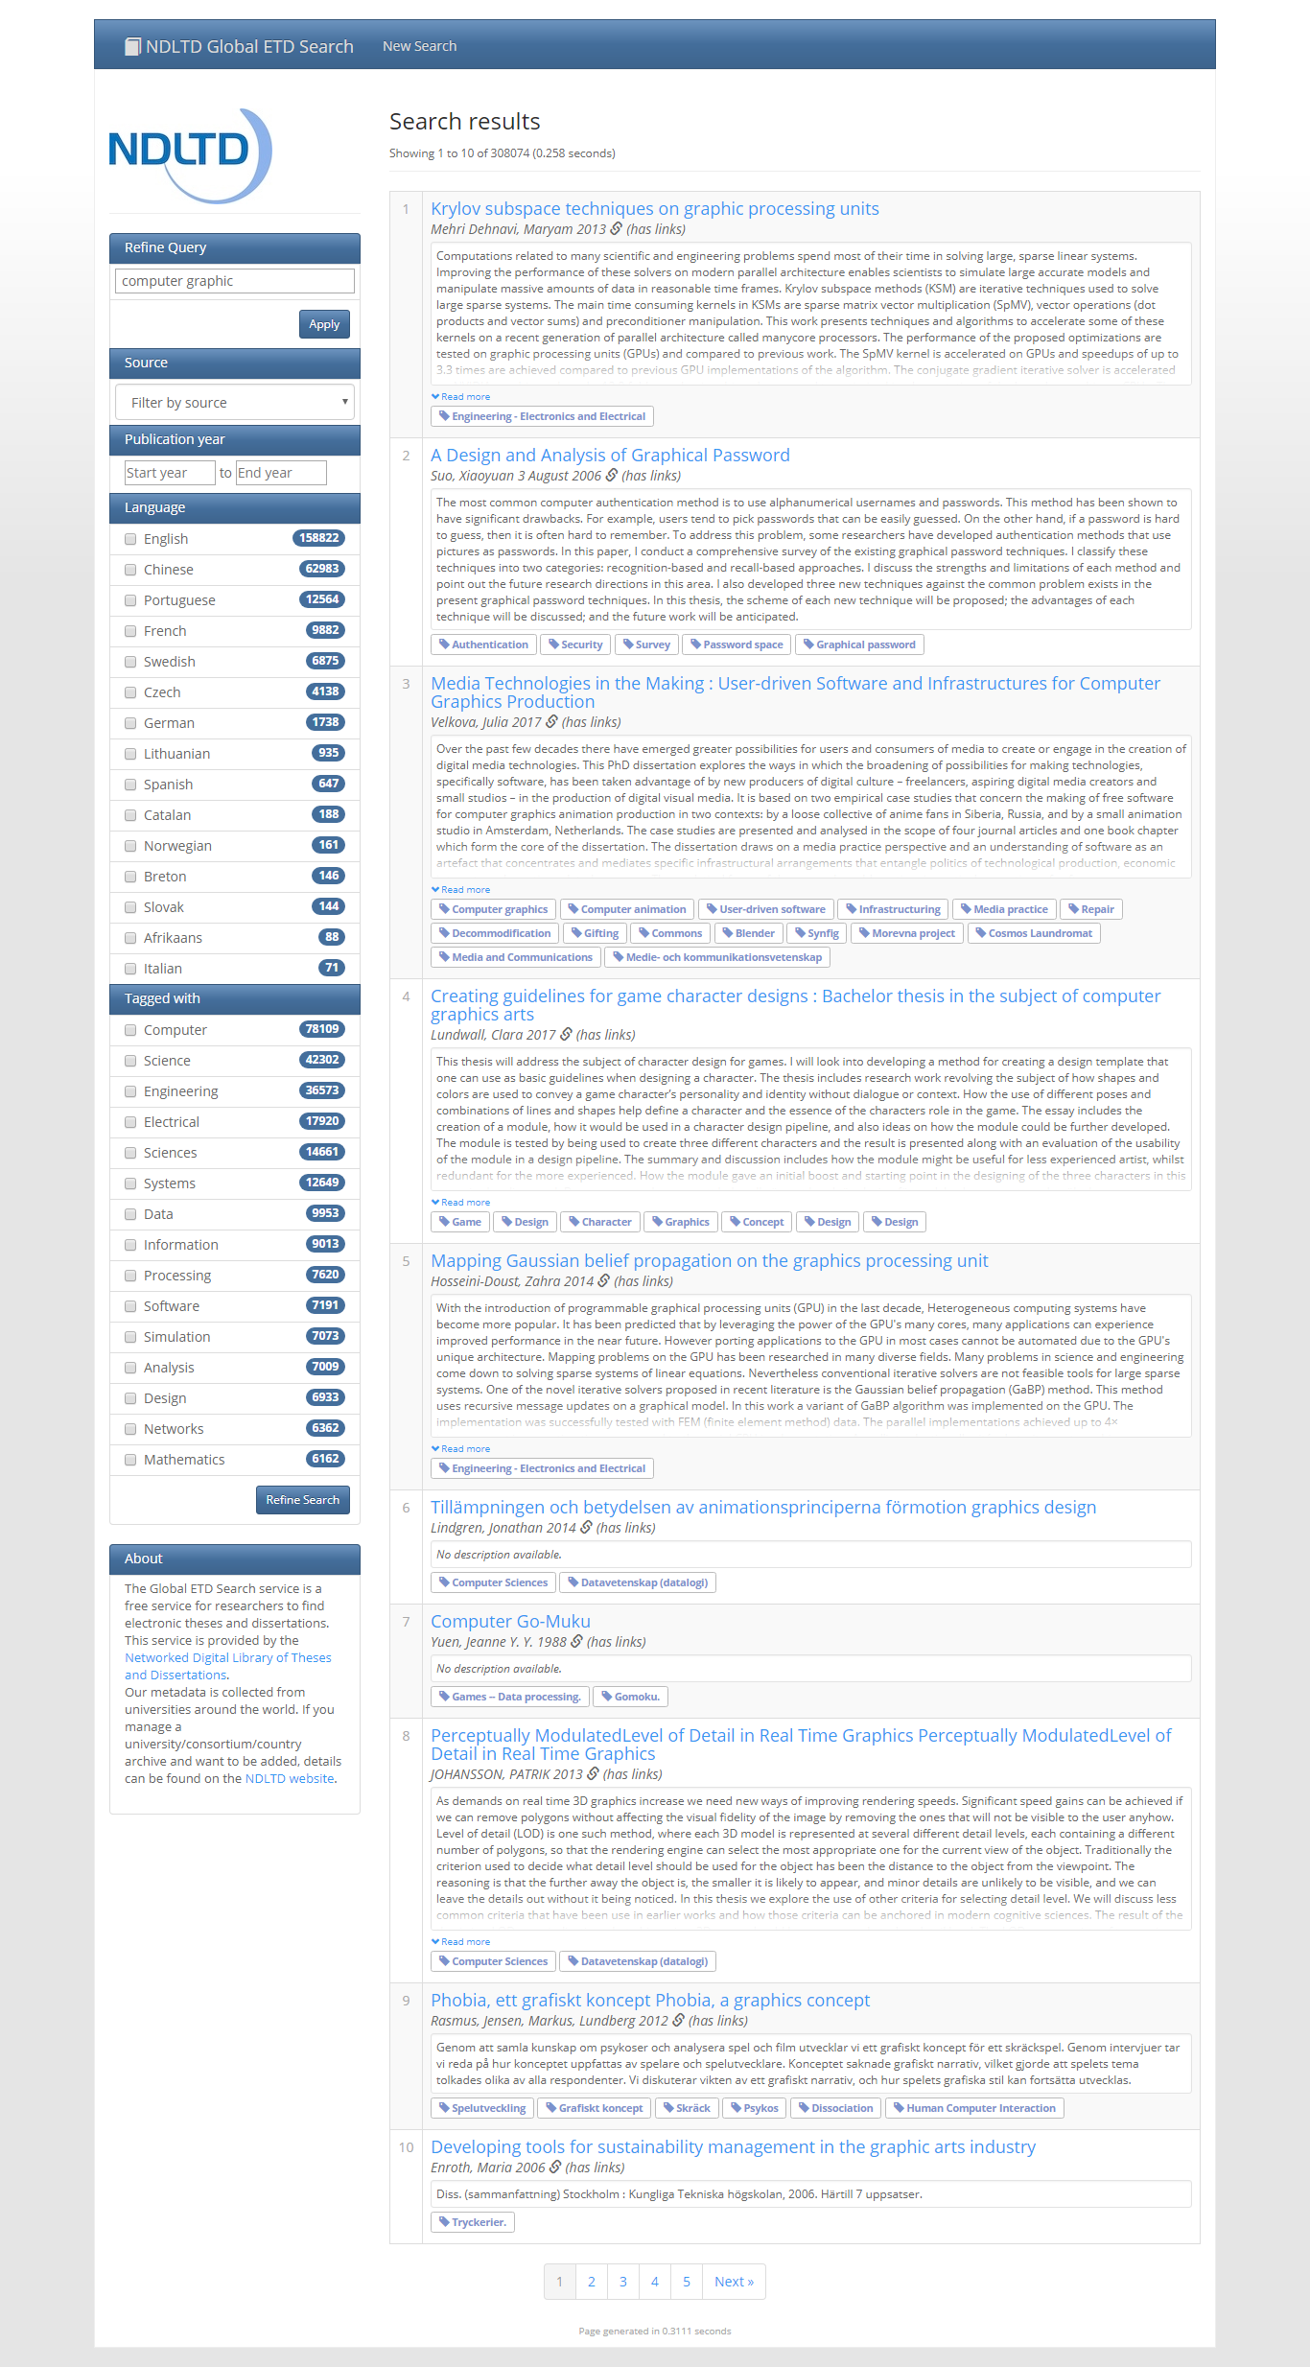

**20**

**CHAPTER 4**

**EVALUATION AND CONCLUSION**

**4.1 Conclusion**

The ETD project has provided the opportunity for fundamental change in the expression of and access to the results and scholarship done by students in research universities around the world. These tools also can easily be extended to the expression of and access to research done by faculty.

**4.2** **Advantages of the Project**

The proposed system offers the following advantages:

* It provides “faster and better” services to users.
* This is helpful in assessing what’s in progress, what has written, the writing style, how it was structured, research methods, and which reference were used.
* User can satisfy because they can search not only thesis title but also by year.
* Assisting postgraduate students to write.
* Provide facility for proper monitoring, reduces paper work and provide data security.

**4.3** **Disadvantages**

* The cost of computer hardware and software programs can be expensive.
* As mobile tablets use wireless network, they can disconnect with network if Wi Fi fails

**21**

**4.4 Further Extensions**

This application has incompleteness from various view-points. But if it is continuously developed with experts, current needs will be covered shortly, then the effectiveness will approve its property. Various functionalities can be embedded within the application.

**Reference**

* https://www.codecademy.com/learn/learn-the-command-line
* https://www.codecademy.com/learn/learn-git
* https://github.com/
* https://github.com/mayeedwin/profile
* https://vim-adventures.com/
* https://try.github.io/levels/1/challenges/1
* https://my.wikipedia.org/wiki/%E1%80%97%E1%80%9F%E1%80%AD%E1%80%AF%E1%80%85%E1%80%AC%E1%80%99%E1%80%BB%E1%80%80%E1%80%BA%E1%80%94%E1%80%BE%E1%80%AC
* https://about.gitlab.com/
* https://docs.google.com/spreadsheets/d/1L82Ozh1JsMHj5rsVLTH9LBiZNVOZ1ZLcD3xQHyX0U0g/edit
* http://ask.tiide.org/
* https://mobile.facebook.com/story.php?story_fbid=10155295368772328&id=564487327&_rdc=1&_rdr
* https://mobile.facebook.com/story.php?story_fbid=10155296307857328&id=564487327&_rdc=1&_rdr
* https://git-scm.com/download/win
* https://docs.google.com/spreadsheets/d/1Ybc9A5-dejo0K14EgXtdHXyRRT0a6Aty8Bt9OdpU72k/edit?pli=1#gid=0
* https://dashboard.heroku.com/apps
* https://dashboard.heroku.com/auth/heroku/callback?!=&code=da8daab8-227f-4a2b-bd5e-2517cd3c5a70
* https://pypi.org/project/Flask/
* https://packaging.python.org/tutorials/installing-packages/
* <https://devcenter.heroku.com/articles/heroku-cli>

**22**

* https://blog.miguelgrinberg.com/post/the-flask-mega-tutorial-part-i-hello-world
* https://www.python.org/dev/peps/pep-0008/#introduction
* https://www.jetbrains.com/pycharm/nextversion/
* https://firebase.google.com/
* http://ask.tiide.org/index.php?p=%2Fdiscussion%2F36%2Fpaper-to-digital-prototype-%E1%80%90%E1%80%8A%E1%80%BA%E1%80%86%E1%80%B1%E1%80%AC%E1%80%80%E1%80%BA%E1%80%94%E1%80%8A%E1%80%BA%E1%80%B8%2Fp1
* https://materializecss.com/
* https://docs.google.com/spreadsheets/d/13ZyoGGhtl-2IiFX8ysQTX71OV06xpP3IgKHX7kRpgrM/edit#gid=0
* https://docs.google.com/document/d/1kHfxGoFHiJBxlzocPNcSUW-9ntdqB9dvh-jQzqGGBQ8/edit
* https://gitlab.com/
* http://learn.freecodecamp.org/
* http://search.ndltd.org/
* https://otago.libguides.com/thesisinformation
* https://developers.google.com/speed/libraries/
* https://firebase.google.com/docs/?authuser=0
* https://firebase.google.com/docs/database/web/read-and-write?authuser=0
* https://www.google.com/sheets/about/
* https://getmdl.io/started/index.html
* https://www.csvjson.com/
* https://www.onlineocr.net/
* https://docs.google.com/spreadsheets/d/1GlM6T8_hr_BsRGErD9RvH-YvUfNmshNgCB8jUqkFhZM/edit#gid=1082350442
* https://www.w3schools.com/

**23**