Lab 3

Instructions:
  - Go through the below lab instructions carefully.
  - Capture the relevant screenshots of all the steps and its working.

- Use Github Copilot mentions option (@) in the chat window to scaffold a new Web Application in the technology of your choice. Few options could be:
  - Spring Boot web application with Tomcat
  - Python web application with Flask or Django
  - Basic web application with HTML, CSS and JavaScript.
  - .Net , C# combinations
Hint: @workspace /new <<give your instructions>>
Note: using @workspace mention is optional.
- The web application should be to implement a simple basic calculator. The UI could be like below
    - 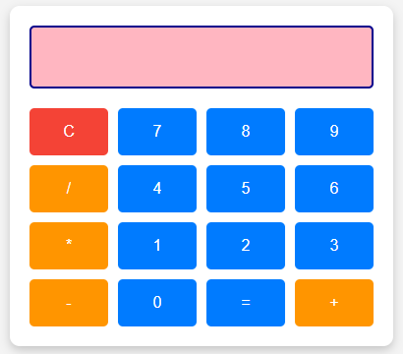
- All functionalities should work like a basic calculator.
- Above styling for the calculator UI is just an indication. You can style it accordingly.
- Use the features of Copilot as learnt:
  - Use inline/chat window for instructions
  - Use slash commands to fix, create documentation, add tests if required and get explanations of code.
  - Check whether there are any security vulnerabilities in your code
  - Use the Copilot to review your entire code.
  - View the copilot settings file to see the features that are configurable.
- Finally run your application to check its functionalities
Note:
- Optionally you can do this entire activity using the “Agent” mode.
- Instead of this calculator app, if you want to build any application of your choice from your work scenarios, please feel free to do (especially try full stack applications that involve frontend and backend and may be a Database)

