Sri_lanka

**Lying off the southern tip of India, the tropical island of Sri Lanka has attracted visitors for centuries with its natural beauty.**

But it has been scarred by a long and bitter civil war arising out of ethnic tensions between the majority Sinhalese and the Tamil minority in the north and east.

After some 26 years of violence the conflict ended in May 2009, when government forces seized the last area controlled by Tamil Tiger rebels. But recriminations over abuses by both sides continue.

The island fell under Portuguese and Dutch influence after the 16th Century. It gained independence in 1948, after nearly 150 years of British rule.

changed

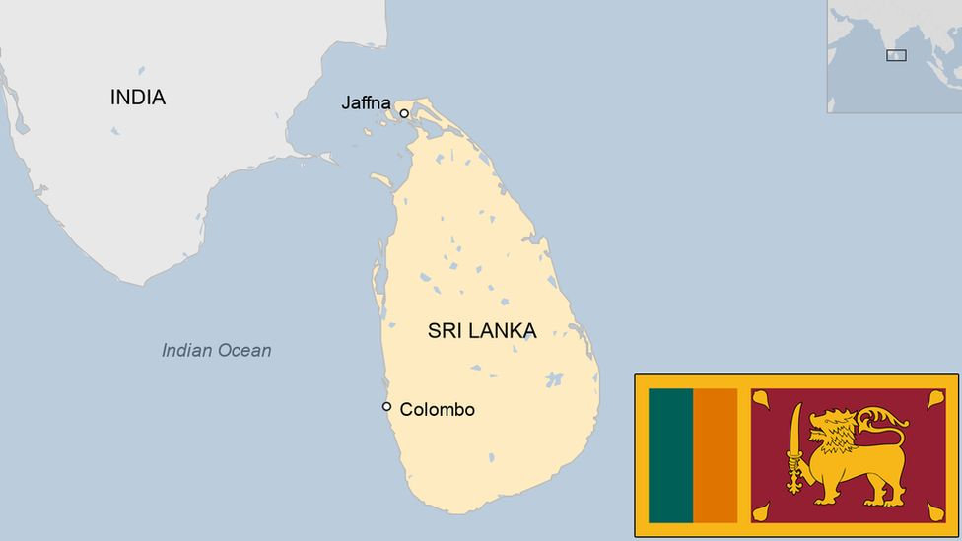

gjewkfkwgjfwvjcwkjecbwjcvjkwevjcwek