21ES790 – CAPSTONE DESIGN PROJECT
PROJECT REPORT 2

Submitted by

Balaji V (21E012)
Moirangthem Dharamaraj Singh M (21E061)
Nandha G (21E064)

MENTOR: Dr.M.MEENAKSHI DEVI, PROFESSOR


Department of Electrical and Electronics Engineering

THIAGARAJAR COLLEGE OF ENGINEERING
(An Autonomous Institution
Affiliated To
Anna University)

MADURAI – 625 015

FACULTY:
Dr. S.Arockia Edwin Xavier, ASSOCIATE PROFESSOR
Dr. D.kavitha , ASSOCIATE PROFESSOR
Objectives:
- To Enhance Accessibility for Women and Girls.
- To Improve Safety for Passengers.
- To Increase Usability of Public Transport.
- To Implement a Practical and Cost-effective Solution.
- To Provide Dual Operation Mode for Flexibility.

Methodology:

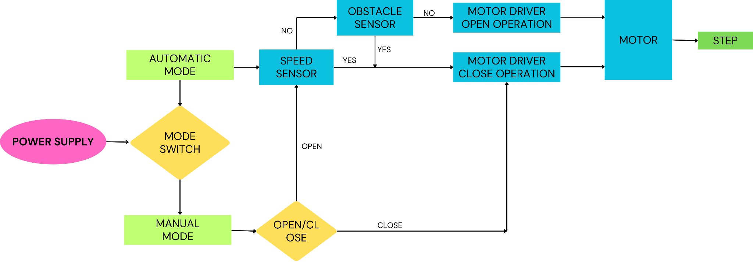
*Speed Sensor - IR sensor
*Obstacle sensor - Proximity Sensor

The foldable step system is designed to enhance bus accessibility by integrating a movable step mechanism controlled by a microcontroller. Automatic control plays a crucial role by using proximity sensors to detect when the bus is approaching a stop, automatically deploying the foldable step to provide a safer stepping height for passengers. This automation ensures that the step is always in the correct position for optimal safety and convenience during regular stops. Manual control, on the other hand, is vital for flexibility and emergency situations. It allows the driver or authorized personnel to manually extend or retract the step as needed, providing a backup if sensors or automation fail and accommodating special requirements or unforeseen circumstances.Once the bus starts moving again, the step retracts to prevent contact with the road, ensuring safety during transit.
The system uses a high-torque DC gear motor for movement, managed by an Arduino or ESP32 microcontroller, ensuring both automatic deployment based on sensor inputs and manual adjustments for comprehensive, reliable operation.

S.NO | Requirements | Quantity
1 | DC Motor- 24V & 65 RPM | 1
2 | Battery - 12V, 35Ah | 1
3 | L298N Motor Driver | 1
4 | Microcontroller -  Arduino UNO Board | 1
5 | Proximity sensor | 1
6 | IR sensor | 1
7 | Aluminum Alloy or Fiber-Reinforced Polymer (FRP)  step | 1
Hardware Requirements
3D modelling:

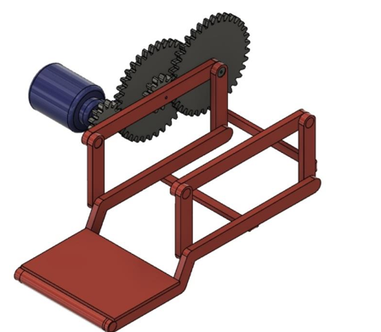

Expected Outcomes:
The streamlined boarding process will reduce bus boarding time, enhancing the efficiency of public transport schedules. The integration of microcontrollers, sensors, and automated systems will promote technological innovation within public transportation infrastructure. The proposal has the potential to contribute positively to environmental sustainability by encouraging more use of public transport over personal vehicles, thus reducing traffic congestion and carbon emissions. By improving accessibility and reducing injuries, the system may lead to long-term economic benefits, including savings in healthcare costs and a boost to the economy through increased transport inclusivity. Finally, these combined improvements will foster a more inclusive, efficient, and sustainable public transportation system, benefiting both individuals and the broader community.

Mentor Signature

