**Project Documentation**

**Description:**

Todo application is a kind of app that generally used to maintain our day-to-day tasks or list everything that we have to do. In our application we can edit the tasks like update or delete the tasks.

**Tools used:**

Eclipse ide for java developers 2023

**Languages used:**

* + Java
  + Spring boot
  + Jsp

**Screenshots & workflow:**

**Log in page:**

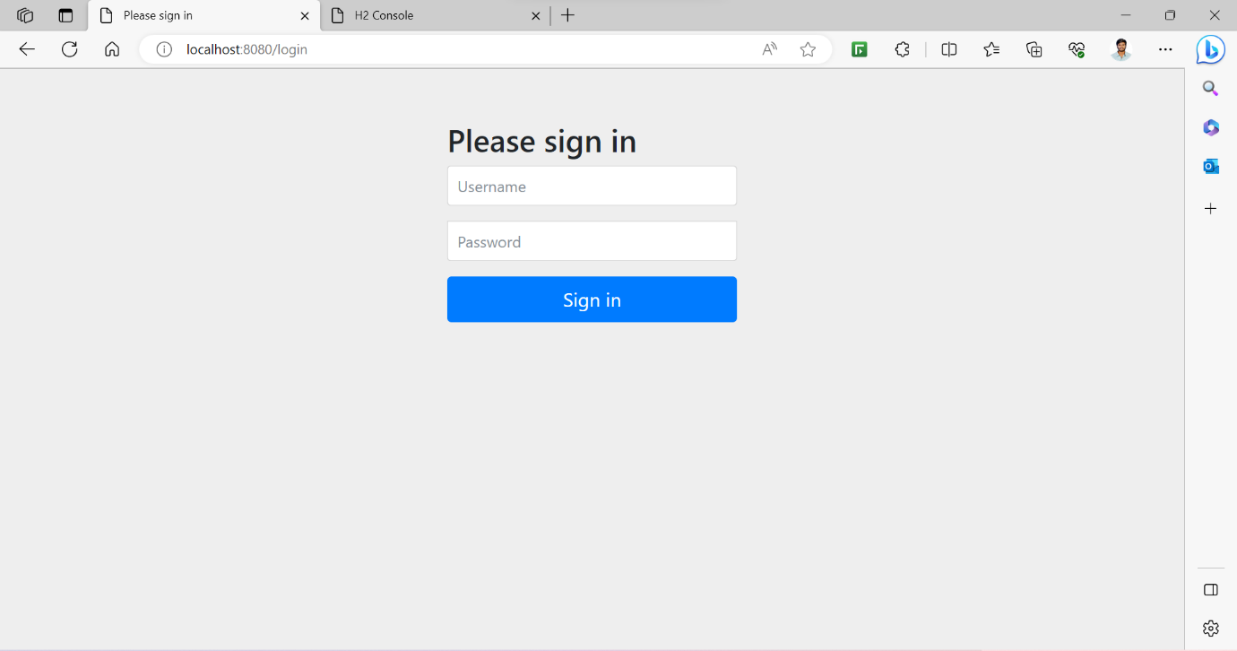

This is our log in page where user can sign in. If the user gives valid credentials the page will be redirect to the home page or else, it shows bad credentials alert.

**Home page:**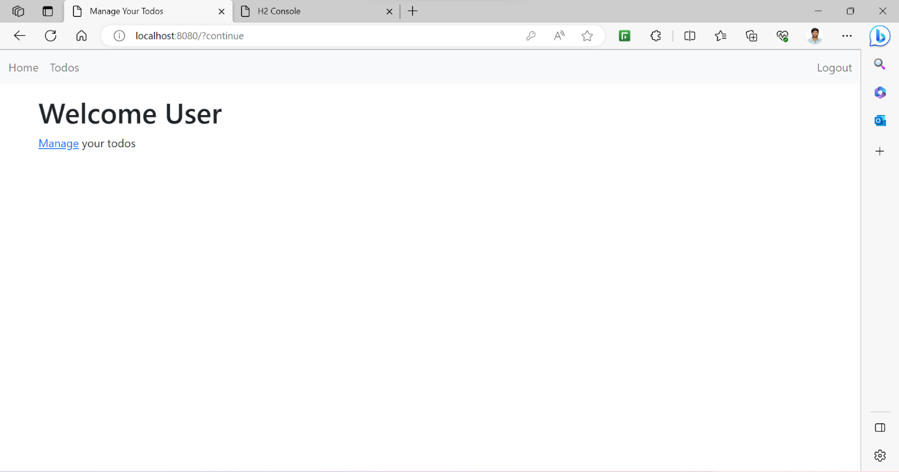

If user gives valid credentials page will be redirected to this page. In this page we can click manage to manage our todos.

**List-todos page:**

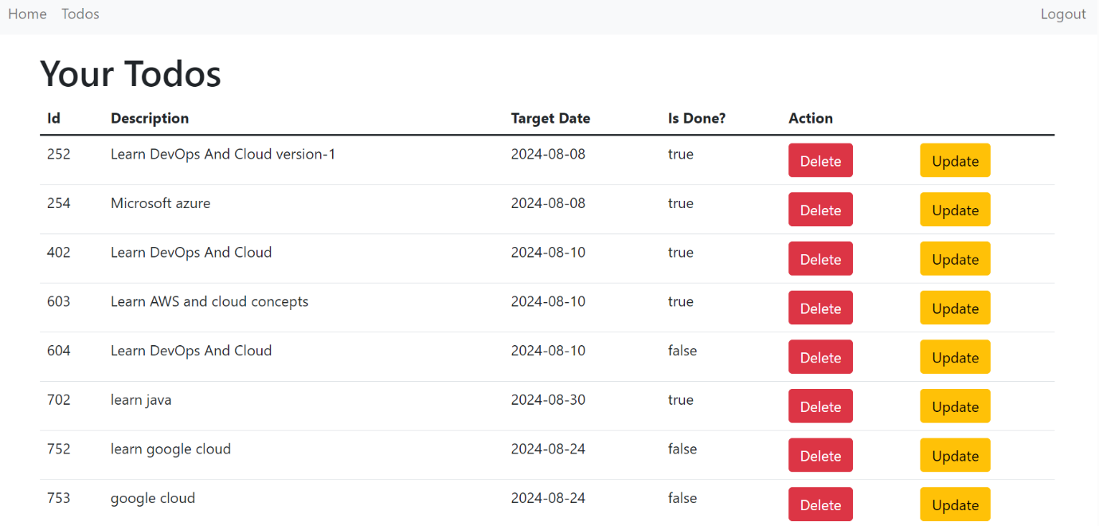

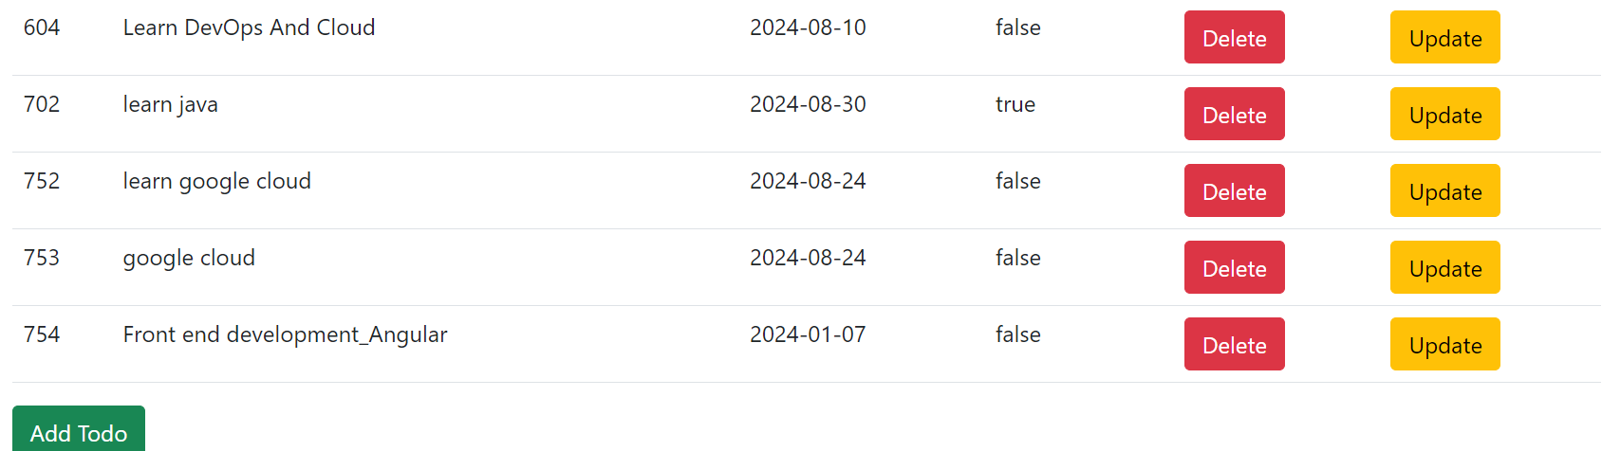

This is our list todos page where we can view, update or delete todos. If we click delete button todo will be deleted in the database. The deleted todo not be displayed in this page.

If we click the update button this page is redirected to the update page.

**Update page:**

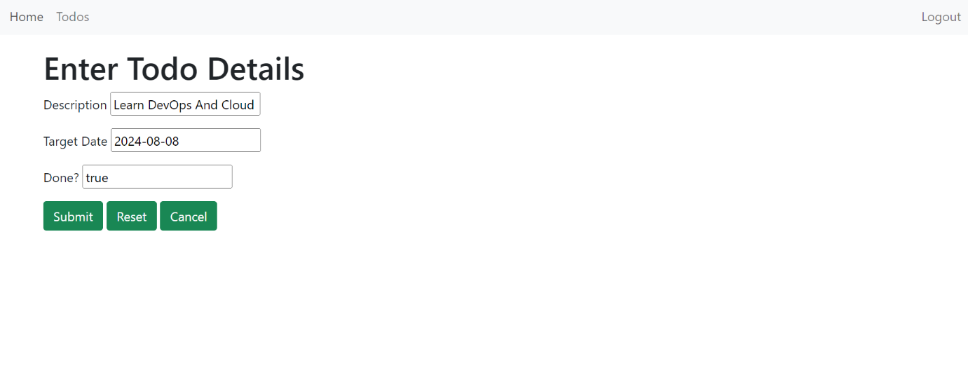

After entering the details and click submit button to update the selected todo. If we press the reset button changes made in detail are reset and if you don’t want to update the details press cancel button to cancel the updating.

**Add todo page:**

When user click add todo button the page will be redirected to the add todo page. In this page user can add new todos.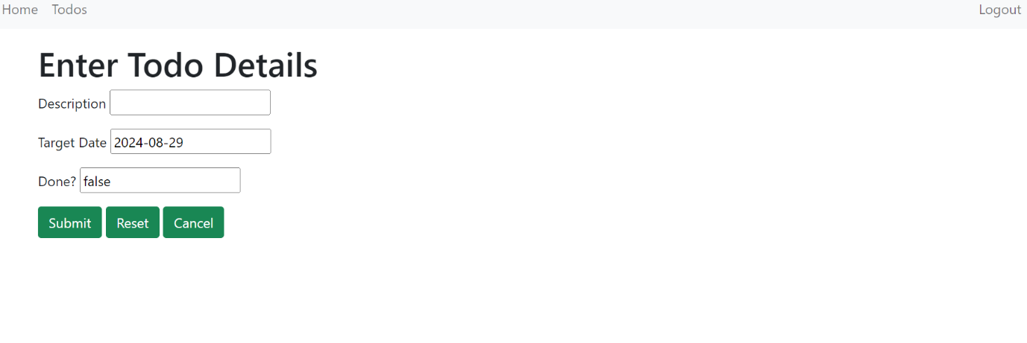

**Wrong credentials:**

If user gives wrong credentials this page will shows the alert.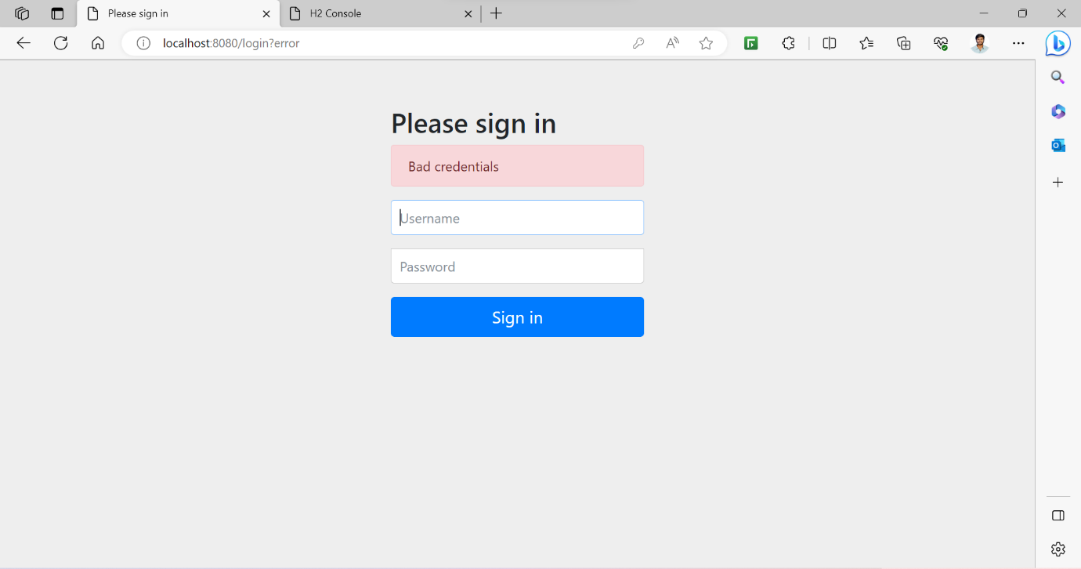

**Log out:**

If user press the log out button the page shows the following,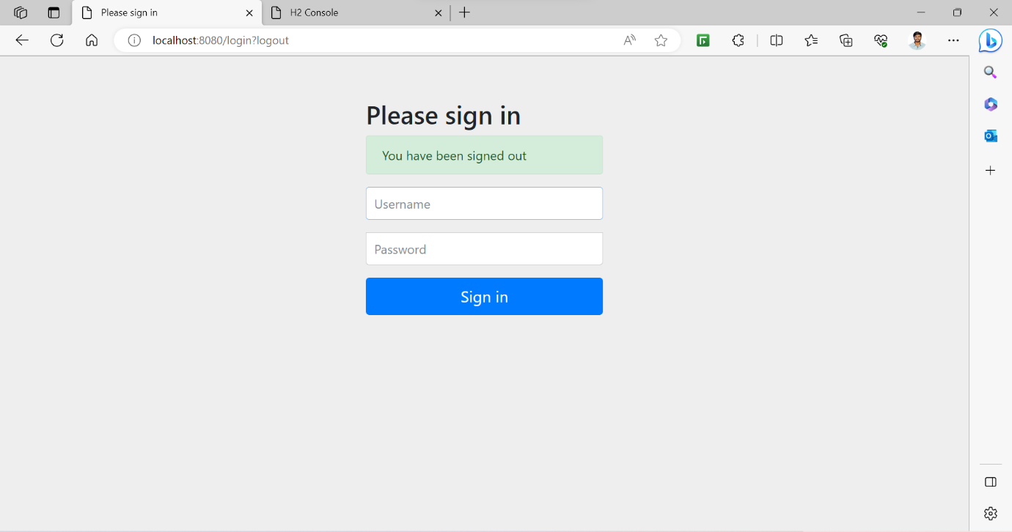

**Summary:**

Todo application created successfully with the help of lower versions of java, Jakarta server page and spring boot. After completed this projected I have updated this project to a latest technical version, and I added extra features like validation.