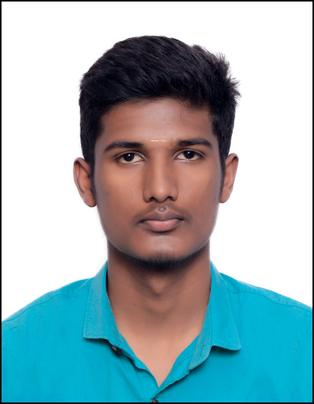

|  |
| --- |
| **Nandhakumar Nagaraj** |
| **CONTACT**  +91 9150677849   * [Nandha2536](https://github.com/vaishnavid0604) * Nandhakumar-nagaraj -458991211   [Nandha2536.github.io](https://github.com/Nandha2536/portfolio.github.io/)  [nandhakumar2536@gmail.com](mailto:nandhakumar2536@gmail.com) |
| **SKILLS**  **Languages:**  C, Python, HTML, CSS, SQL,  JavaScript, PHP.  **Tools & Technologies:**  Figma, Adobe XD, Bootstrap4, Git, Github, Xampp, SQLite, VS-Code, SQL-Server, MySQL, Wordpress,  MongoDB ,Docker.  **Soft Skills:**  Teamwork, Communication, Creativity, Time management, Leadership. |
| **HOBBIES**   * Playing badminton. * Listening to music. * Sketching. |
| **LANGUAGES** |
| * English. * Tamil. * Telugu. * Kannada. |

|  |  |
| --- | --- |
| **CAREER OBJECTIVE**  A self-motivated and hard-working student looking for a Job. I am looking to explore my career options in various sector which provides an opportunity to expand my knowledge and looking to polish my organizational skills and team workability. | |
| **CERTIFICATIONS** |  |
| **IBM Skills Build** | **Microsoft & Great Learning** |
| * Web Development Fundamentals. | * MERN Stack Fundamentals. |
| * UI-UX Fundamentals. | * GitHub Fundamentals. |
| * Word Press Fundamentals. * React JS for Beginners. | * JavaScript Fundamentals. |
| **EDUCATION** |  |
| **Bachelor of Engineering in Information Technology** | **8.27** CGPA |
| SRM Valliammai Engineering College | 2024 |
| **High School in Computer Science** | **80.16**% |
| Vailankanni Matriculation Higher Secondary School  **Secondary School**  Government Boys Higher secondary school | 2020  73.04%  2018 |
| **ACHIEVEMENTS**   * Awarded the National Means-cum-Merit Scholarship (NMMS) for academic excellence in class VIII by the Ministry of Human Resource Development, Government of India. * Received **Gold Medal** from the school for being the Topper in computer science department. * Achieved the Discipline Award in school Days-2019 * Secretary of NSS and YRC branch of our college and hosted many programs. | |
| **INTERNSHIP**   * **Retech Solutions Pvt. Ltd**  **Role: Full Stack Developer**   We developed Library Management System, a web application which helps the organization to effectively handle all the books and students.   * **InnoByte Services Role: Full Stack Developer**   We trained and developed Machine Learning System and API based solutions, a web application which helps the farmer’s to improve their crop production. | |
| **PROJECTS**   * **Database Management System, Mini Project**   As a part of mini project we developed store management application for users, store owners and distributors.   * **Agriculture Portal, Major Project**   A single platform with ML and API based solutions for farmers to improve their crop production.   * **Gemini Chat Bot**   A single page server-less, lightweight, responsive, website to call G Google's language and Image models.   |  |  | | --- | --- | | The above information provided by me is true and have all the relevant documents to authenticate the same. | | |  | Nandhakumar N | | |
|  | |
|  | |
|  | |