Nandhakumar

3 year | cse - c

MAD LAB

180501097

**INSTALLING STEPS OF ANDROID STUDIO IN WINDOWS OS:**

**1. Download the Android studio application file from the android studio website and select your computer architecture (32 bit or 64 bit)** 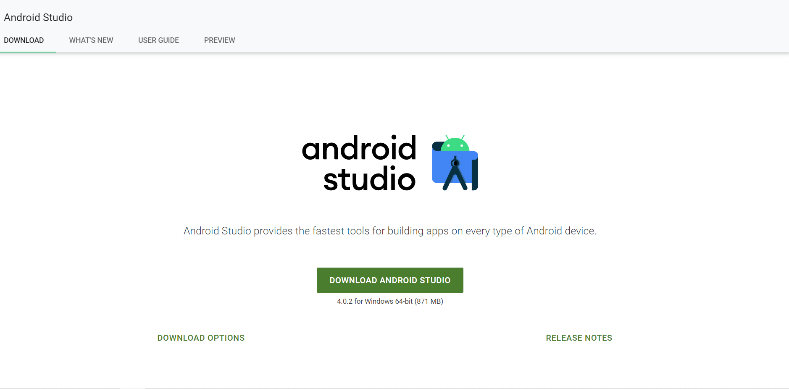

**2. After downloading the android studio files start the installation process:**

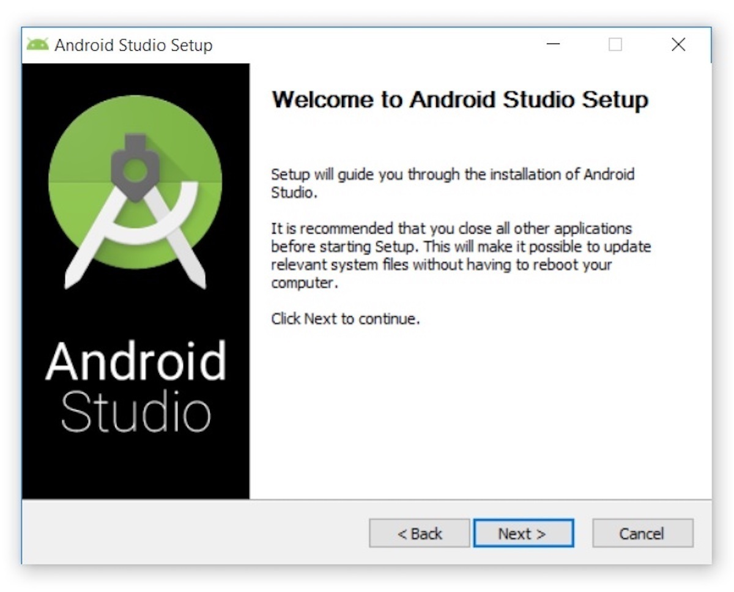

**3. Select the directory where to install the android studio files:**

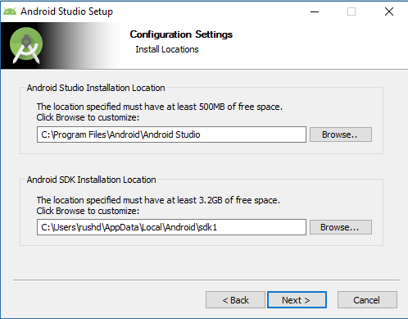

**4. Select the components to be installed and select the android virtual device:**

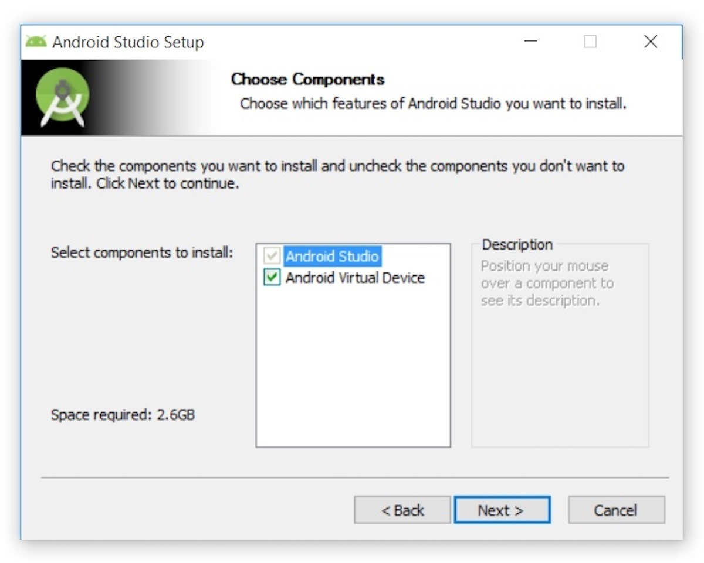

**5. After select the installation mode -> select standard:**

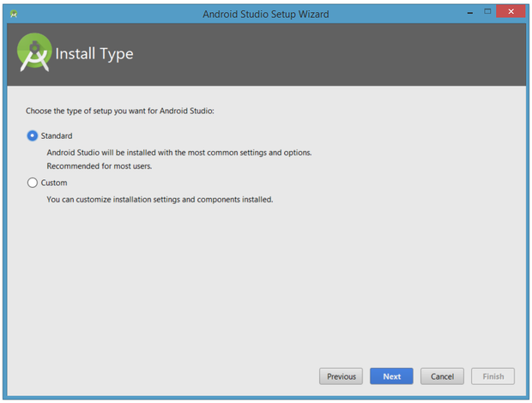

1. **STARTING THE ANDROID STUDIO APPLICATIO FOR FIRST TIME:**

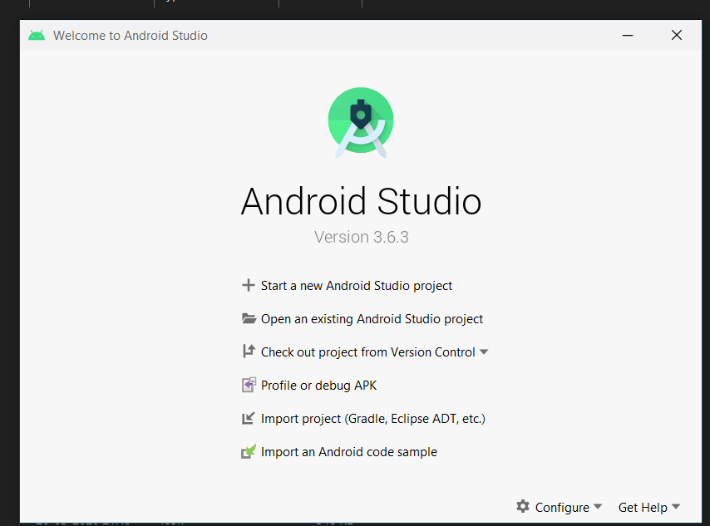

1. **Select start a new android studio project and select a new template:**

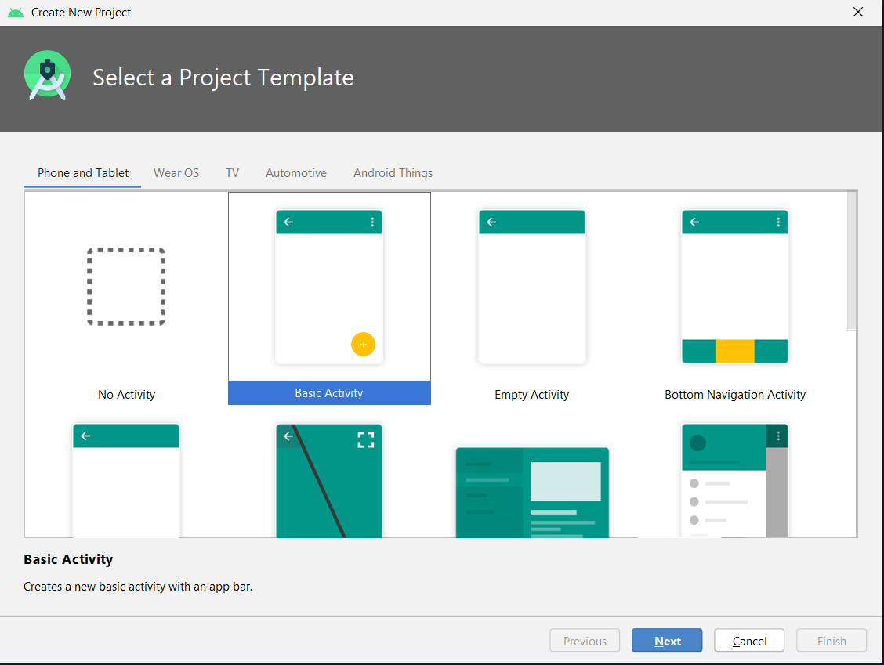

1. **Configure your project:**

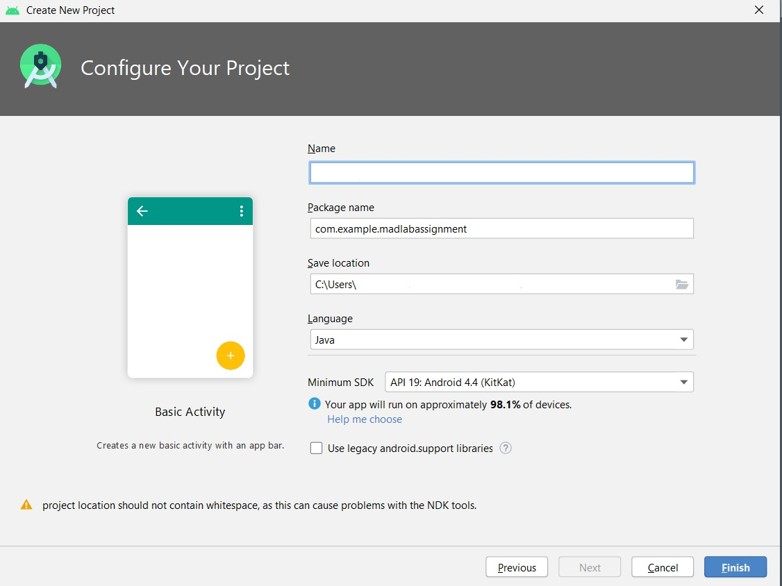

1. **Create a hello world app :**

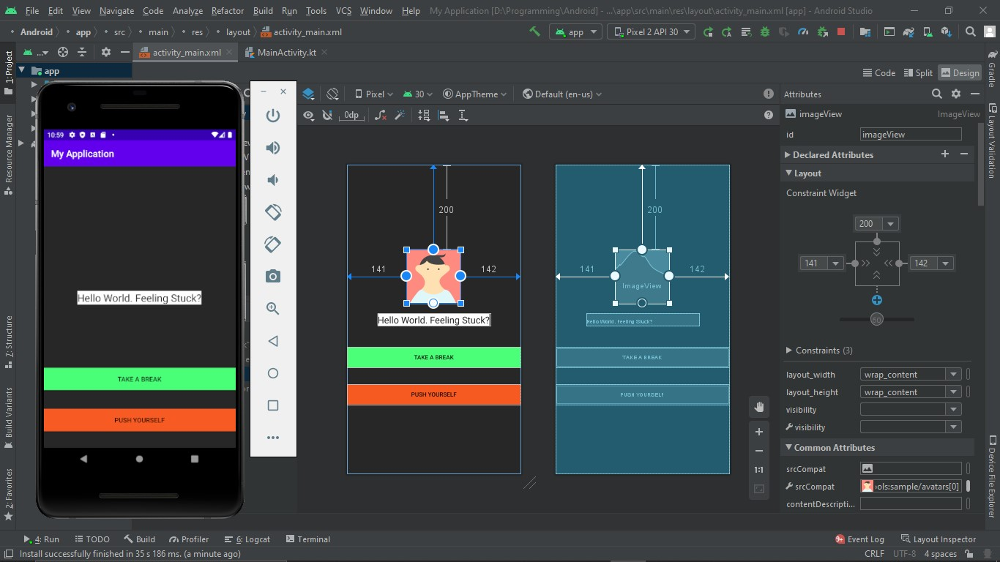

**5.output from emulator:**

