3. Solace CLI --> show session :: What is the default unit of the Timeout?

The default unit of the Timeout in Solace CLI is seconds.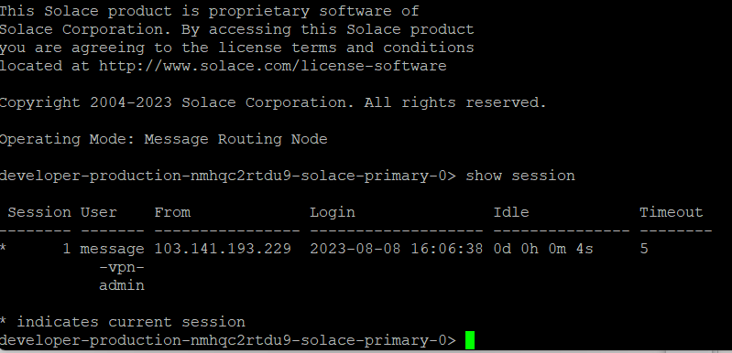

5. Practice : Queue + Topic Subscriptions in WebGUI

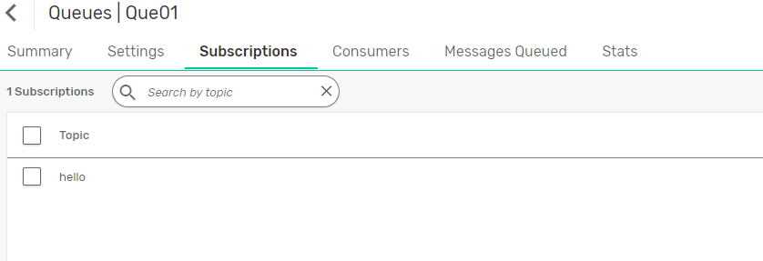

6. Try the Queue creation using Solace CLI

