1. **Try the Queue creation using Solace CLI**

Enterimg Hostname and port number first we need to solace cloud port number enable or not

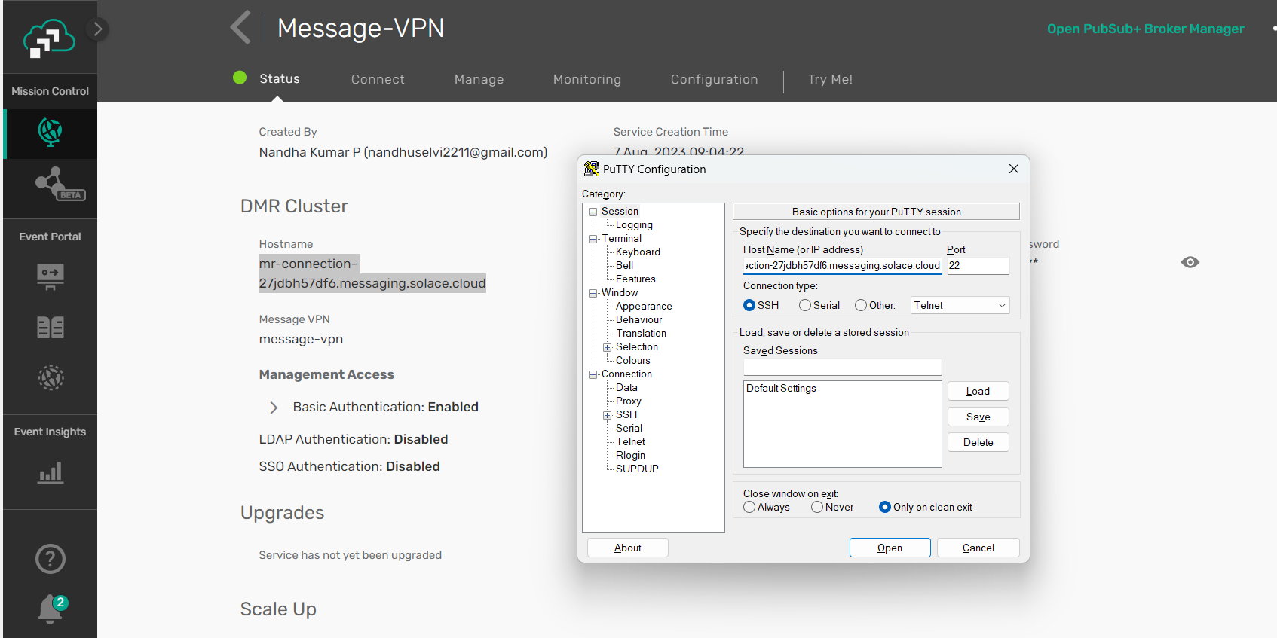

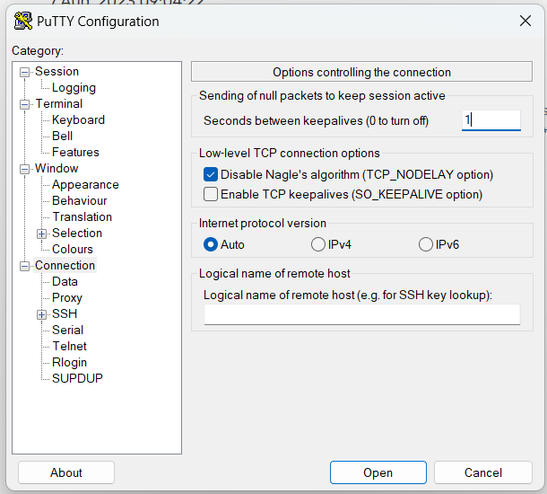

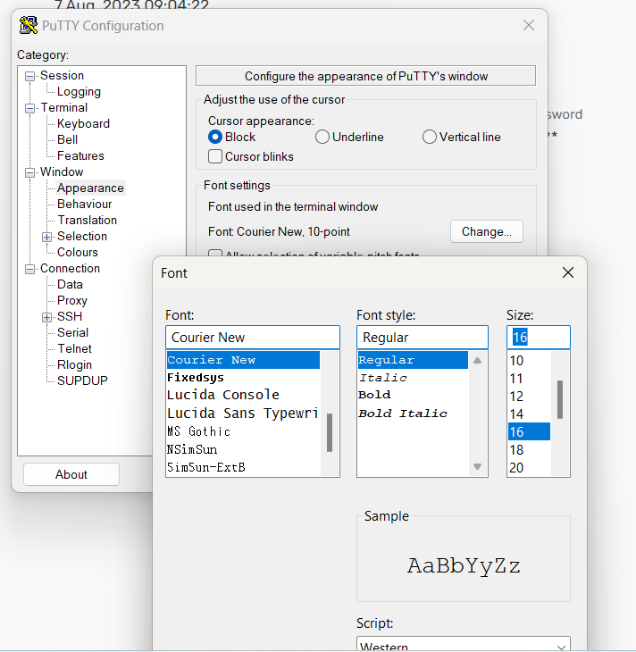

Copy the Editor username and password

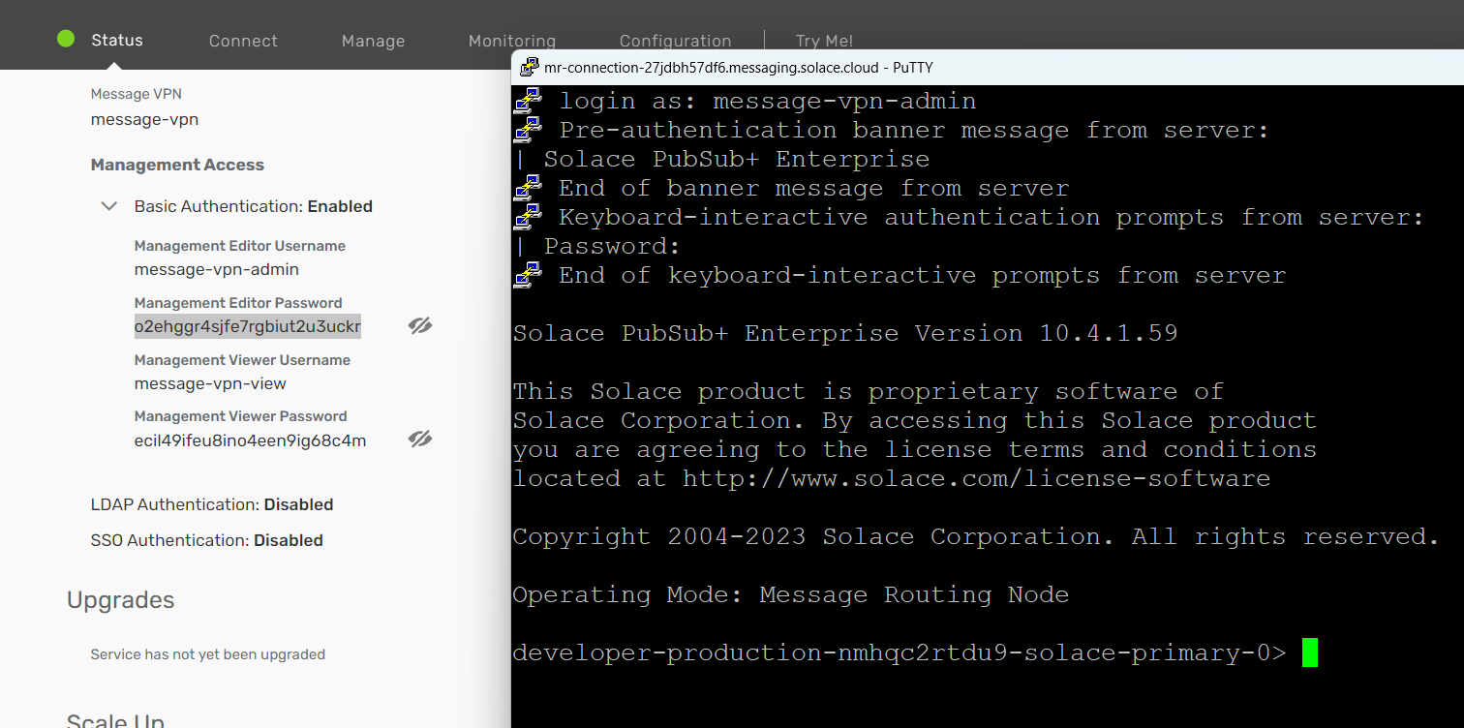

Create queue & change some properties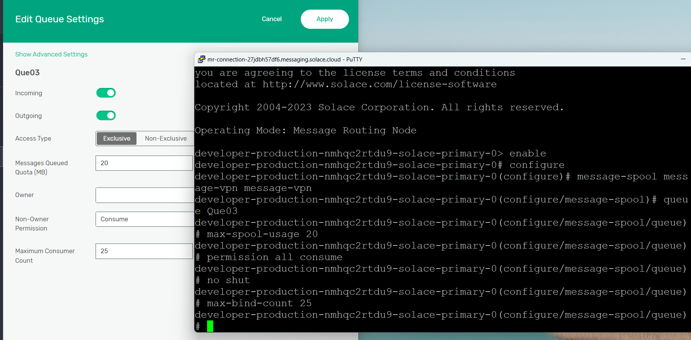

1. **Use the pub-sub services created with Atin and try to populate the queue created using Solace CLI**

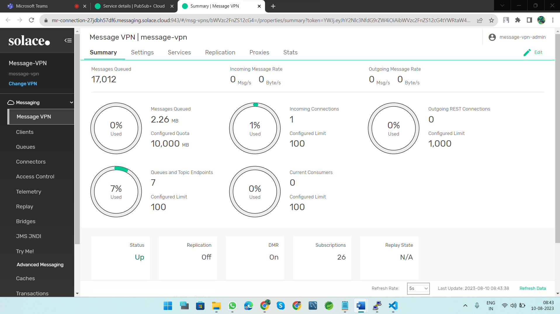

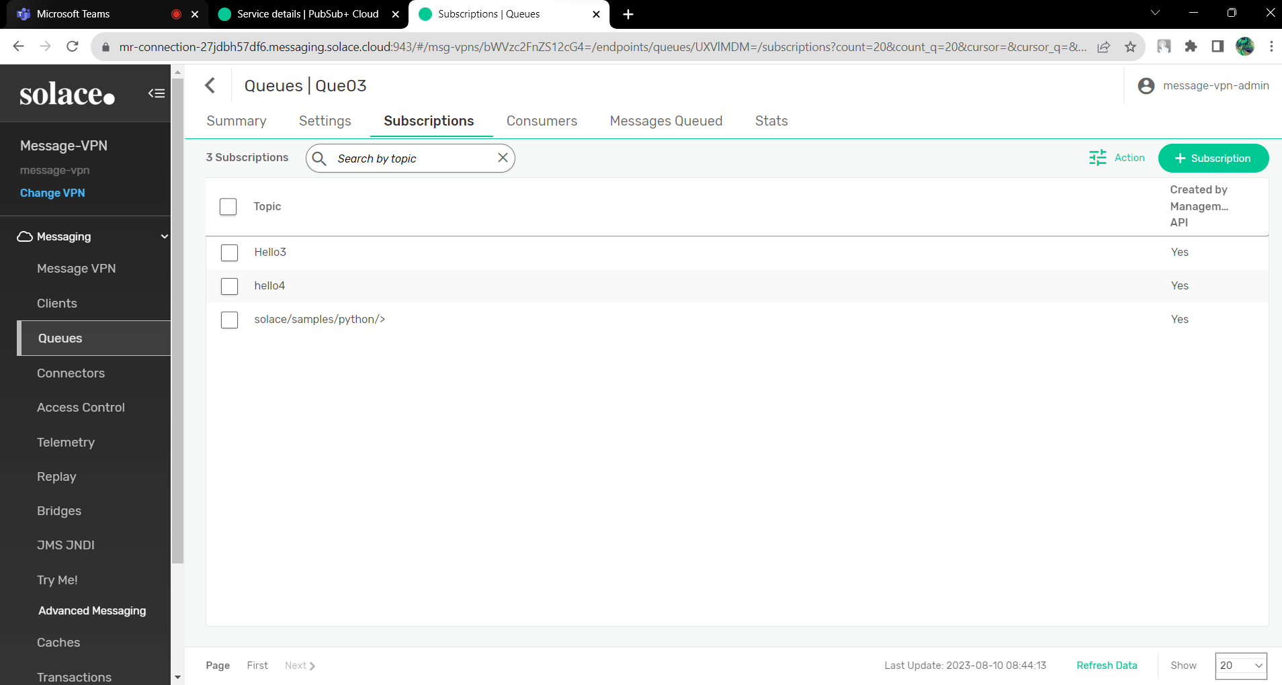

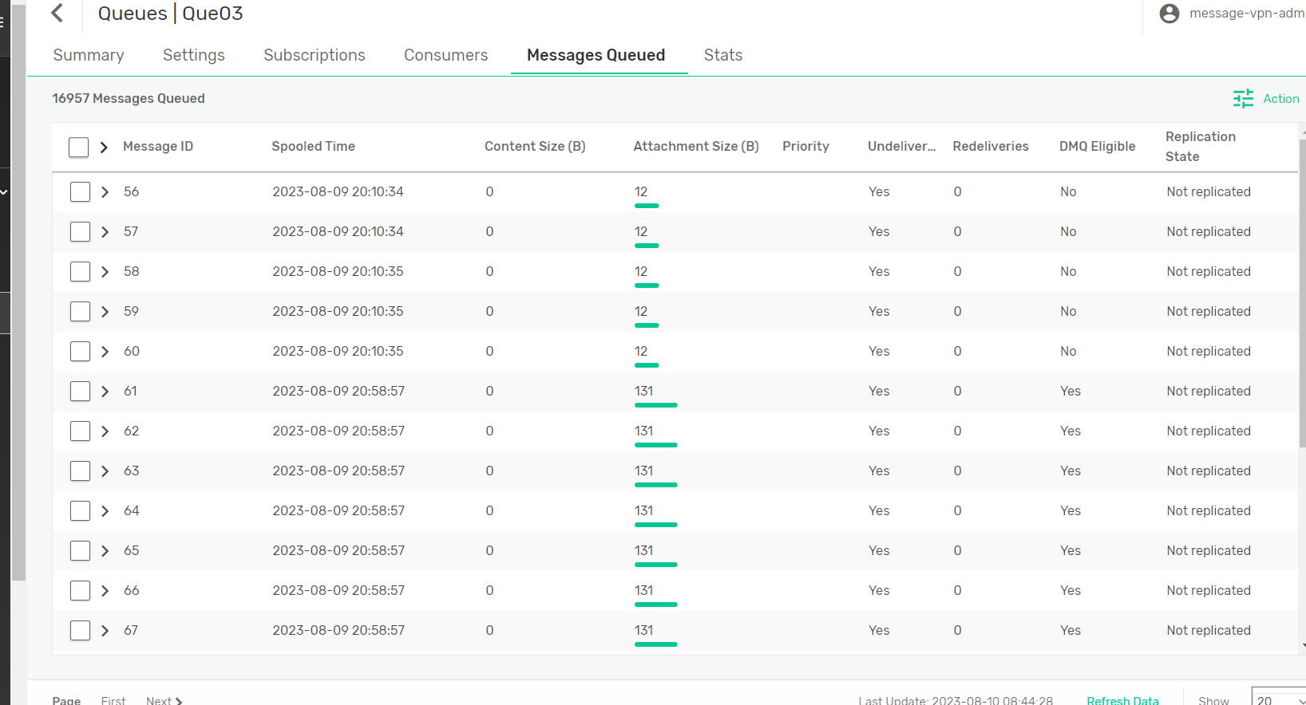

**5.Queue-template creation using WebGUI and Solace CLI with different configurations**

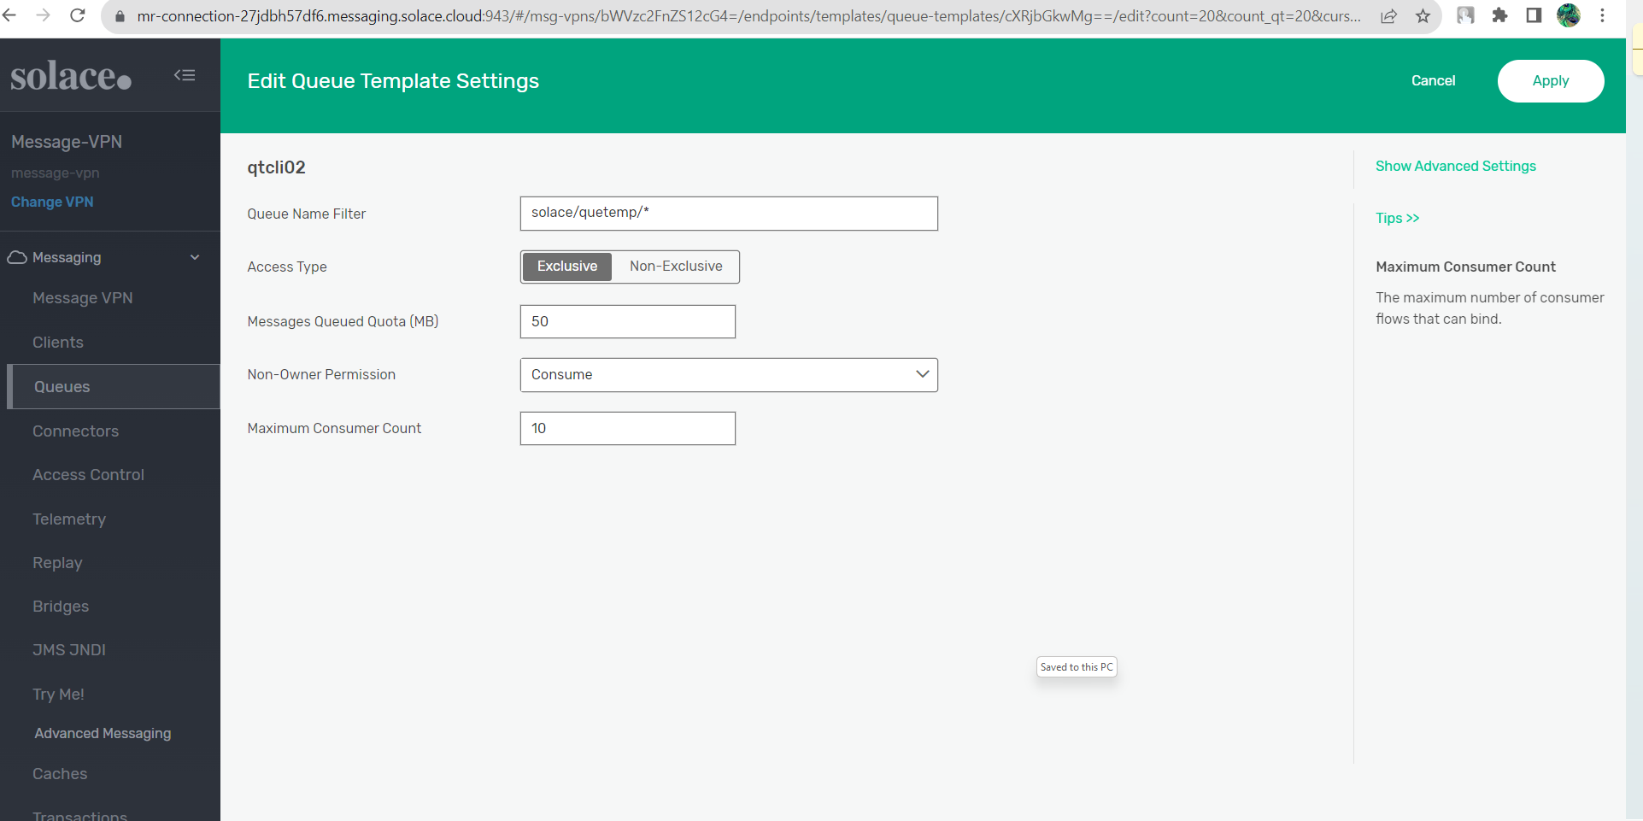

**CLI Commands**

login as: message-vpn-admin

Pre-authentication banner message from server:

| Solace PubSub+ Enterprise

End of banner message from server

Keyboard-interactive authentication prompts from server:

| Password:

End of keyboard-interactive prompts from server

enable

Solace PubSub+ Enterprise Version 10.4.1.59

This Solace product is proprietary software of

Solace Corporation. By accessing this Solace product

you are agreeing to the license terms and conditions

located at http://www.solace.com/license-software

Copyright 2004-2023 Solace Corporation. All rights reserved.

Operating Mode: Message Routing Node

developer-production-nmhqc2rtdu9-solace-primary-0> enable

developer-production-nmhqc2rtdu9-solace-primary-0# configure

developer-production-nmhqc2rtdu9-solace-primary-0(configure)# message-spool message-vpn message-vpn

developer-production-nmhqc2rtdu9-solace-primary-0(configure/message-spool)# show queue- template detail

developer-production-nmhqc2rtdu9-solace-primary-0(configure/message-spool)# show queue- template *

Message VPN Queue Template Name Filter

-------------------------------- -------------------------------- -----------

message-vpn qtcli01 zomato/cust

omers/pin

/*

message-vpn qtcli02 solace/quet

emp/*

message-vpn queuetemplate01 India/city/

*

developer-production-nmhqc2rtdu9-solace-primary-0(configure/message-spool)# queue-templ ate qtcli02

developer-production-nmhqc2rtdu9-solace-primary-0(configure/message-spool/queue-templat e)#

Inactivity timeout expired. Closing session....

login as: message-vpn-admin

Pre-authentication banner message from server:

| Solace PubSub+ Enterprise

End of banner message from server

Keyboard-interactive authentication prompts from server:

| Password:

End of keyboard-interactive prompts from server

Access denied

Keyboard-interactive authentication prompts from server:

| Password:

End of keyboard-interactive prompts from server

Solace PubSub+ Enterprise Version 10.4.1.59

This Solace product is proprietary software of

Solace Corporation. By accessing this Solace product

you are agreeing to the license terms and conditions

located at http://www.solace.com/license-software

Copyright 2004-2023 Solace Corporation. All rights reserved.

Operating Mode: Message Routing Node

developer-production-nmhqc2rtdu9-solace-primary-0> enable \

Invalid command input

enable \

^

-> unexpected parameter

developer-production-nmhqc2rtdu9-solace-primary-0> enable

developer-production-nmhqc2rtdu9-solace-primary-0# co

Invalid command input

co

^

-> ambiguous command

developer-production-nmhqc2rtdu9-solace-primary-0# configure

developer-production-nmhqc2rtdu9-solace-primary-0(configure)# message-spool message-vpn message-vpn

developer-production-nmhqc2rtdu9-solace-primary-0(configure/message-spool)# show queue- template detail

developer-production-nmhqc2rtdu9-solace-primary-0(configure/message-spool)# show queue- template

Invalid command input

show queue-template

^

-> missing parameter

developer-production-nmhqc2rtdu9-solace-primary-0(configure/message-spool)# show queue- template *

Message VPN Queue Template Name Filter

-------------------------------- -------------------------------- -----------

message-vpn qtcli01 zomato/cust

omers/pin

/*

message-vpn qtcli02 solace/quet

emp/*

message-vpn queuetemplate01 India/city/

*

developer-production-nmhqc2rtdu9-solace-primary-0(configure/message-spool)# queue-templ ate qtcli02

developer-production-nmhqc2rtdu9-solace-primary-0(configure/message-spool/queue-templat e)# name-filter solace/sample

developer-production-nmhqc2rtdu9-solace-primary-0(configure/message-spool/queue-templat e)# max-spool-usage 50

developer-production-nmhqc2rtdu9-solace-primary-0(configure/message-spool/queue-templat e)# permission all consume

developer-production-nmhqc2rtdu9-solace-primary-0(configure/message-spool/queue-templat e)# durability-override non=

COMMAND:

durability-override {none | non-durable}

developer-production-nmhqc2rtdu9-solace-primary-0(configure/message-spool/queue-templat e)# durability-override non-durable

developer-production-nmhqc2rtdu9-solace-primary-0(configure/message-spool/queue-templat e)# access-type non-exclusive

developer-production-nmhqc2rtdu9-solace-primary-0(configure/message-spool/queue-templat e)# no consumer-ack-propagation

developer-production-nmhqc2rtdu9-solace-primary-0(configure/message-spool/queue-templat e)#