1. **Practice to create and configure client-usernames**

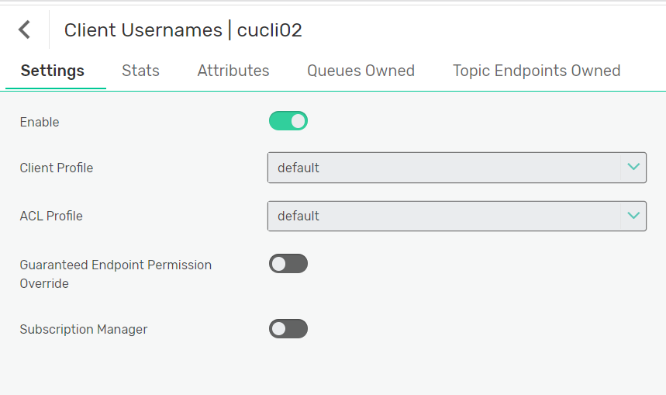

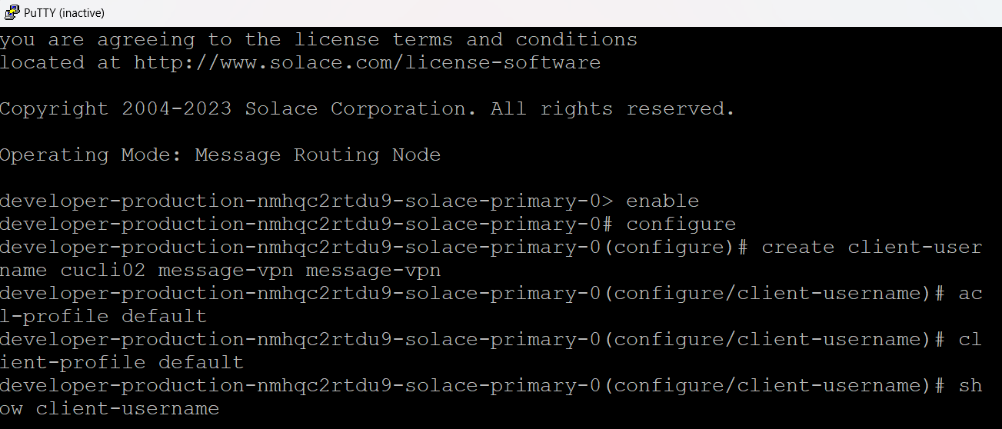

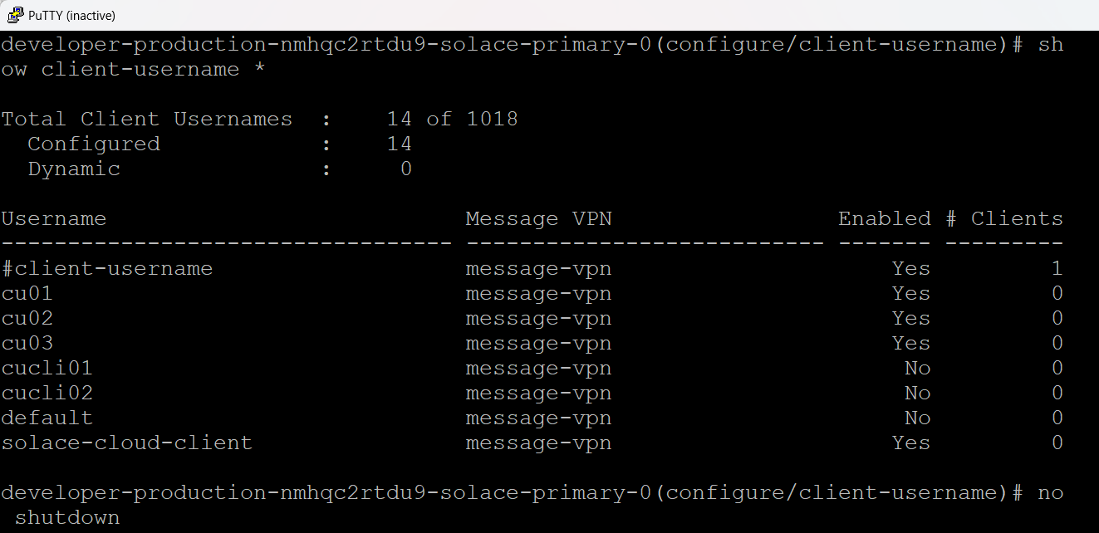

1. **Practice ACL client creation + configuration + assigning permissions to different properties [client-connect/publish-topic/subscribe-topic/etc] + Assign the exception list**

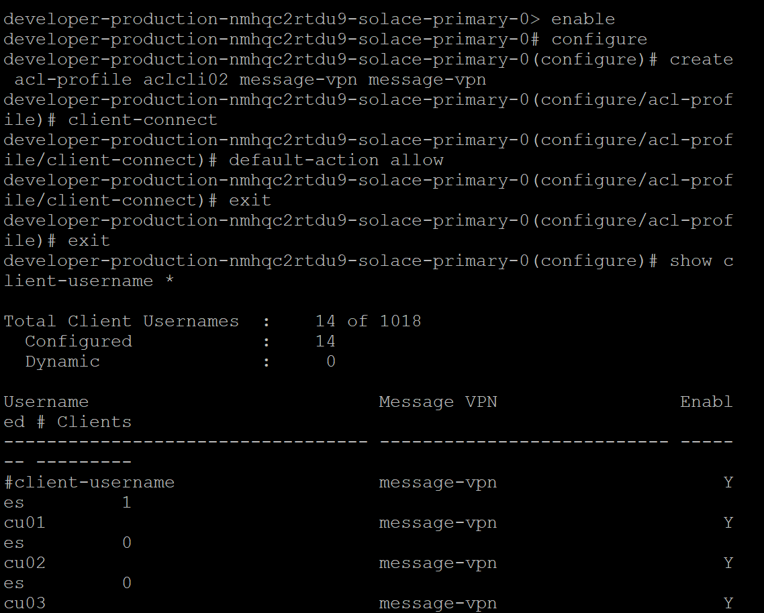

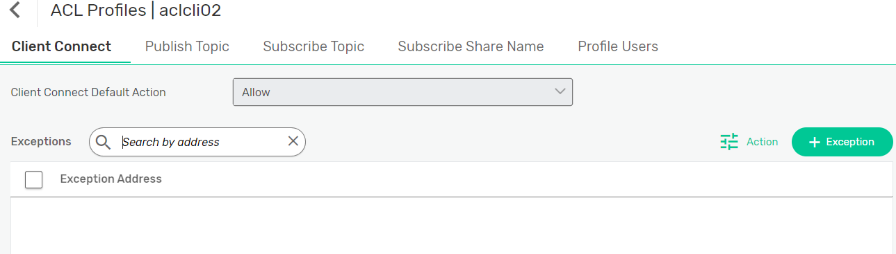

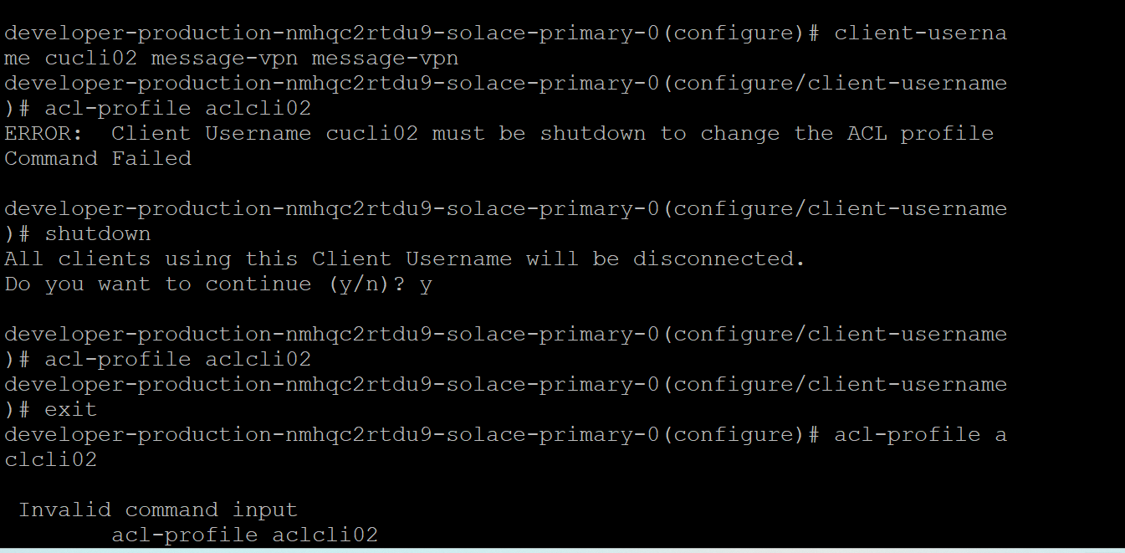

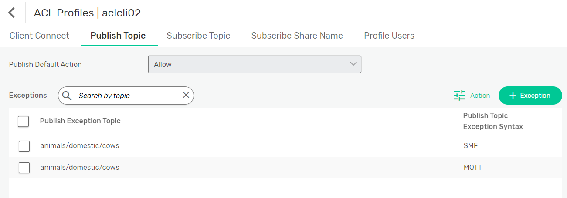

1. **ACL Pub/Sub-topics :: Exception list :: MQTT --> SMF**

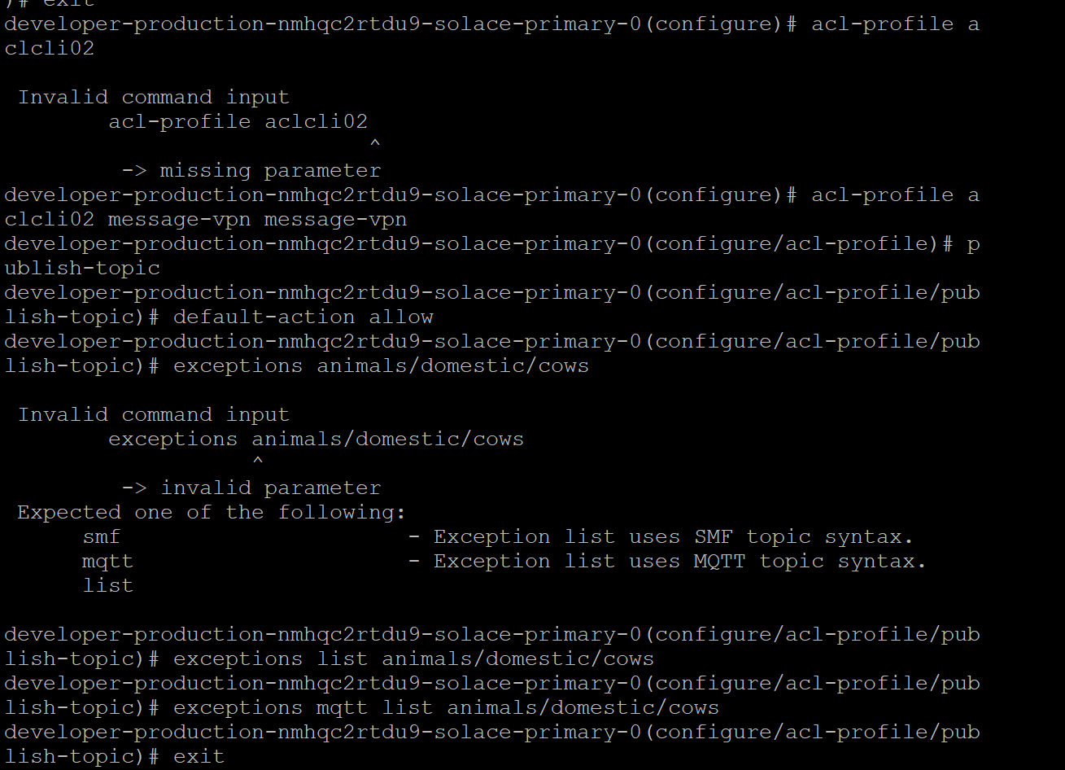

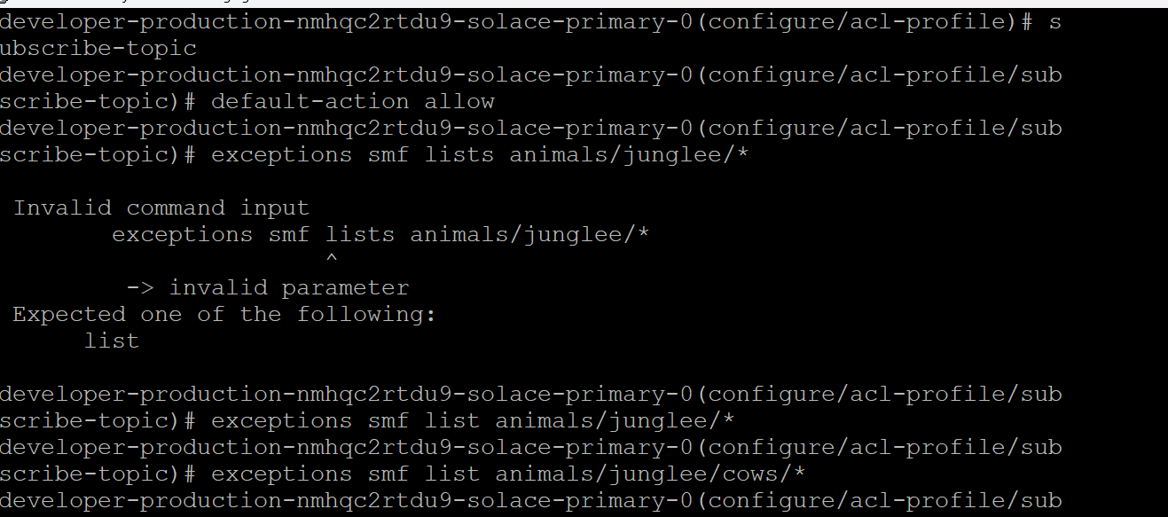

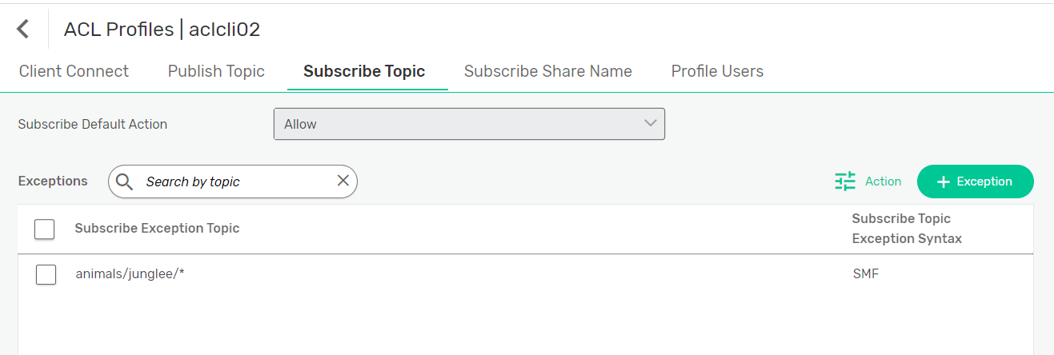

1. **How to delete a subscriber-topic exception list of ACL profile using Solace Command**

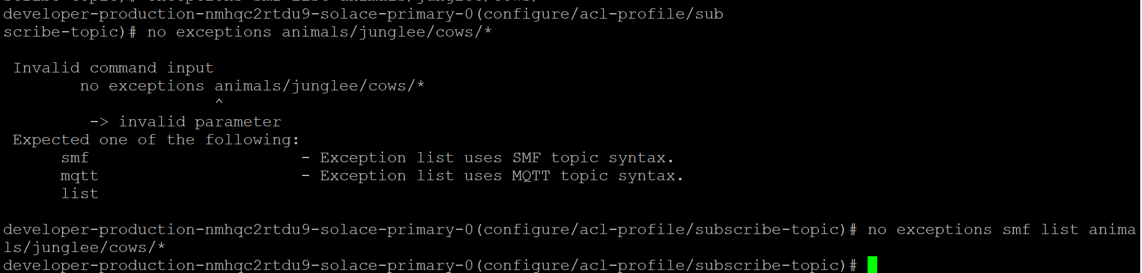

1. **Create and configure client-profiles**

