Single Phase Induction Motor with Smooth Start

The project aims at protecting the induction motor with a supply of low voltage at start and then gradually increasing the voltage so that the motor can be operated smoothly.
Due to supply of abrupt voltage at start the motor may gets damaged and many times the windings gets burnt.
Hence the project aims at giving a smooth start to the motor by using the concept of SCR firing angle control.
Two anti parallel SCR are used that are connected in series with the motor. During the start of the motor a firing angle is delayed by the delayed pulses received
from operational amplifier. The op-amp compares zero voltage pulse and develops a saw-tooth voltage which is then compared to a varying voltage produced by charging and discharging of a capacitor, thereby producing delayed pulses for triggering SCRs. For demonstration purpose, instead of motor a lamp is used in this project.

Block Diagram:

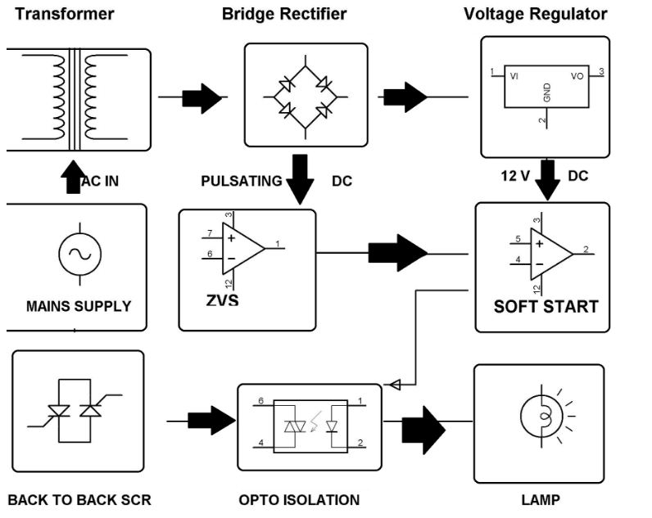

Hardware Specifications
- Transformer
- Bridge Rectifier
- Voltage Regulator
- Lamp
- SCR
- Resistors
- Capacitors
- Diodes

