Power Efficient Mini Inverter Project

ABSTRACT

Inverters are widely used in the domestic as well as industrial environments to serve as second line of source in case of power cut form the electricity utility grids. Inverter is the device that powers the electric appliances in the event of the power failure. Inverter as the name implies first converts AC to DC for charging the battery and then inverts DC to AC for powering the electric gadgets.
So here is the power efficient inverter which is small in size and which can give output voltage of 220v-230 /150w. this power efficient mini inverter can be used to power up devices such as Wifi routers, mobile chargers, Lights etc.

BLOCK DIAGRAM

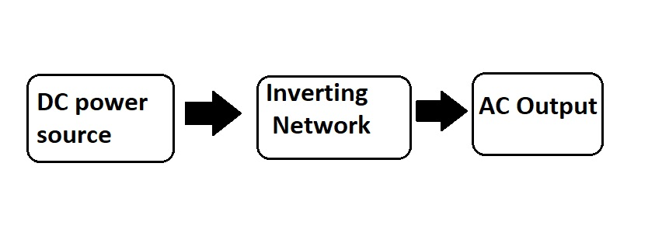

Hardware Requirements

- RECTIFIER
- FILTER
- VOLTAGE REGULATOR
- TRANSISTOR
- LED
- 1N4007
- RESISTOR
- CAPACITOR

