Footstep Power Generation System

The system generates voltage using footstep force. The system serves as a medium to generate electricity using non conventional sources (force) and /store/use it. The project is designed to be useful at public places like railway stations where a lot of people keep walking through all day. At such places these systems are to be placed at any entry points where people travel through entrance or exits and they have to step on this device to get through. These devices may then generate a voltage on every footstep and when mounted in series they will produce a sizeable amount of electricity. For this purpose we here use piezoelectric sensors that use piezoelectric effect in order to measure acceleration, force, pressure by
its conversion into electric signals. We here attach a voltmeter in order to measure its output and small led lights for demonstration.
We also use a battery and weight measurement unit for better demonstration of the system.

Block Diagram
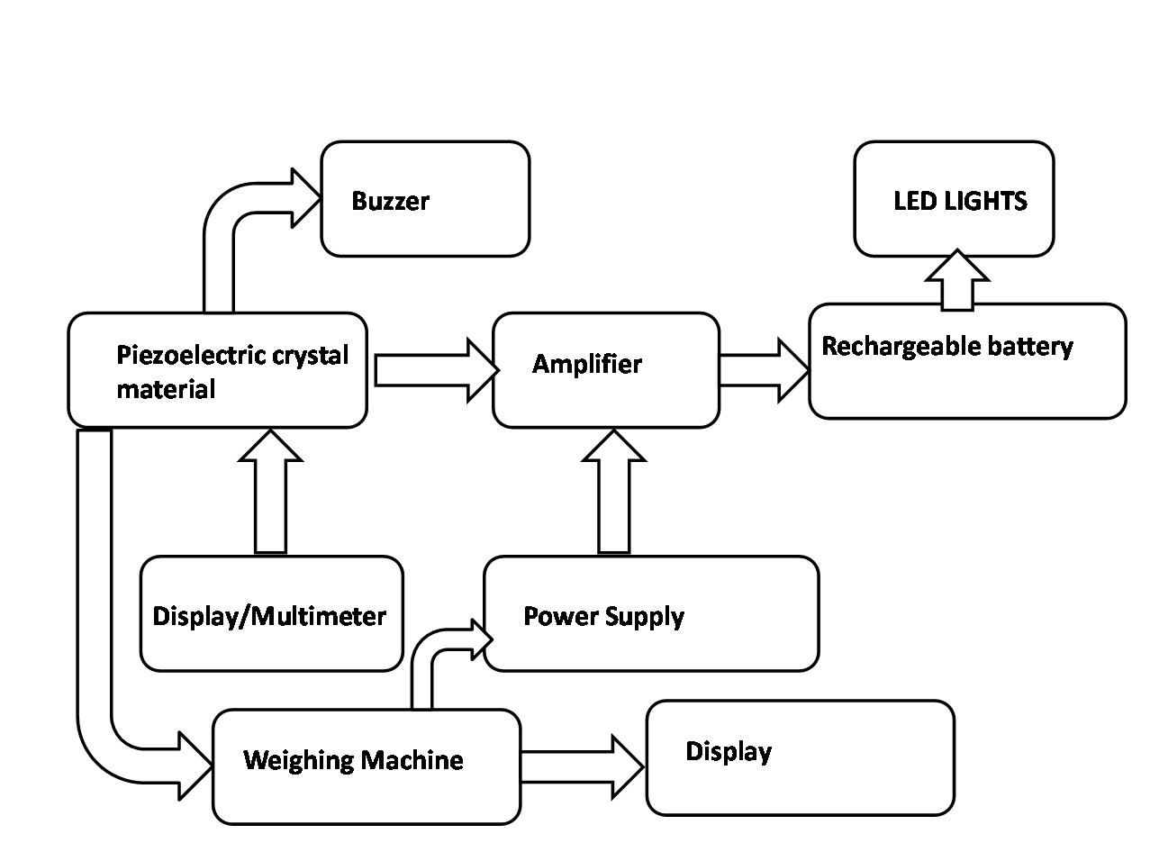

Hardware Specifications
- Piezoelectric Crystal Material
- LCD
- Buzzer
- Amplifier
- Battery
- Weight Sensor
- LED’s
- Volt Meter

