Peizo Based Visitor Sensing Welcome Mat

How smart is your doormat? Is it just a simple carpet used only for wiping feet before coming inside? Doormat should do a lot more than that. So here we have made an project which notifies you when any guest or visitor steps at doormat.
For this purpose we here use piezoelectric sensors that use piezoelectric effect in order to measure acceleration, force, pressure by its conversion into electric signals. Which then notifies with making the buzzer On. So whenever any Visitors arrive there is no need of any doorbell doormat can automatically detect visitor and notify on their behalf. With the Piezo sensor built-in, Mat is able to actively monitor any time whether there’s a change in pressure from someone or something standing or sitting on the Mat.
It’s not only a doormat, either. It’s a weight touchy layer of smart foam that you can set under your doormat or practically anyplace in your home you need pressure-sensitive responses.

Block Diagram:

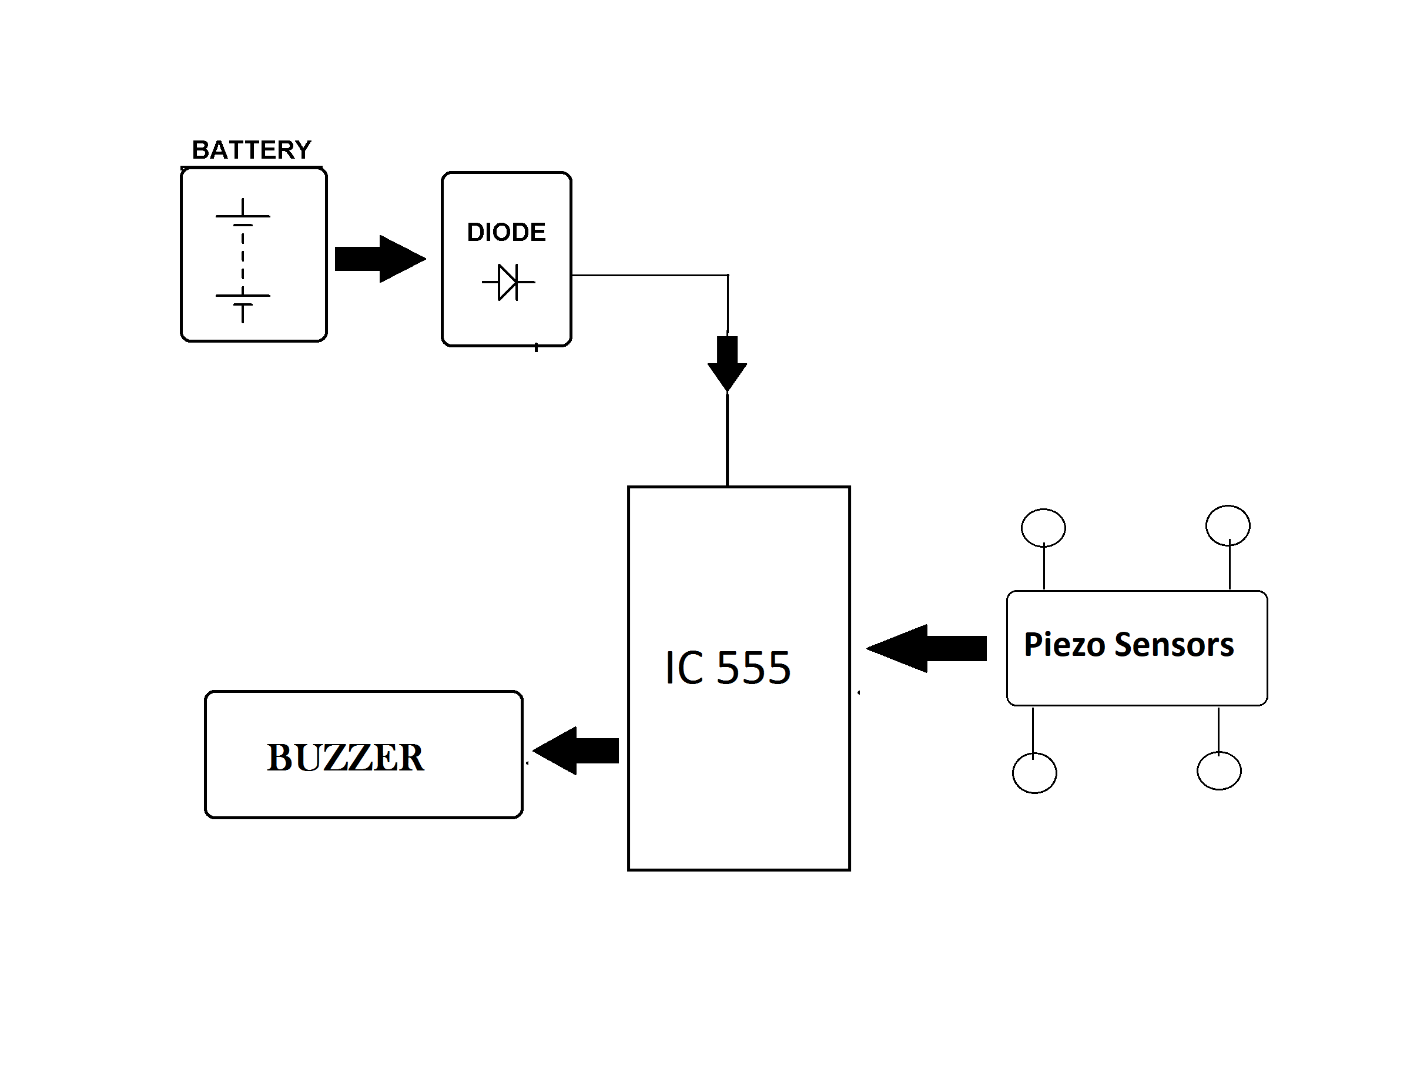

Hardware Specifications

- Piezoelectric Sensor
- 555 IC
- Resistors
- Capacitors
- Transistors
- Cables and Connectors

- Diodes

- PCB and Breadboards
- LED

- Transformer/Adapter

- Push Buttons
- Switch

