Testing Life Cycle of Electrical Loads Using Down Counter
The system is a down counter arrangement using a microcontroller of 8051 family that is used to test the life of electrical products. In industries having products like lights/bulbs/motor etc, it is important to test the lifecycle of the product.
This life cycle is tested as the number of times it is switches ON/OFF and still works.
Our project activates a relay switch that is used to switch the load On and OFF for desired number of times. Our system uses a microcontroller of the 8051 family having a keypad interfaced to it. It also has a 7 segment display to display the count.
On running the system, the user can enter the number of times (0 – 999) he wishes to run the system cycle. Based on this, the system starts the cycle switching the load and a till the counter reached 0. The counter is a down counter that counts downwards from user entered number.
On reaching zero the switching cycle is turned off.
The system can be enhanced by adding a load output measuring system that lets user know when load collapses, so that system can directly provide the load life.

Block Diagram:

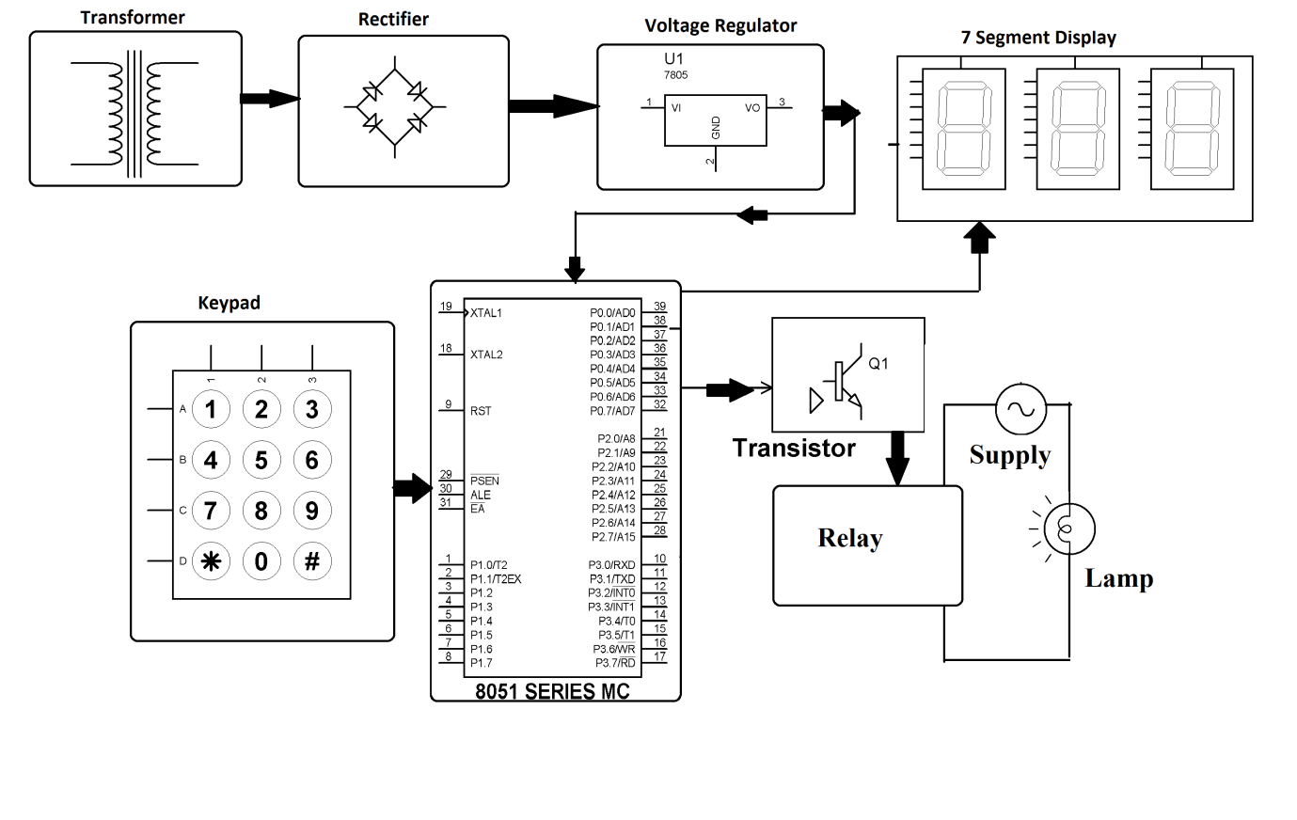

Hardware Specifications
- 8051 series Microcontroller
- Transformer
- 7 Segment Displays
- Diodes
- Capacitors
- Voltage Regulator
- Crystal
- LED
- Lamp
- Keypad
- Relay
- Switch

Software Specifications
- Keil µVision IDE
- MC Programming Language: Embedded C

